–Intelligent Airport Gate Assignment Using Machine Learning and Multi-Objective Optimization
Final Year Project Report
Author: R Balaji

Abstract
Airport gate assignment affects passenger movement, turnaround reliability, and ground emissions. This report presents an end-to-end proof-of-concept system that combines synthetic data generation, delay prediction using machine learning, and constrained optimization using a genetic algorithm. The dataset contains realistic flight and gate attributes with overlapping schedules. Model comparison across Linear Regression, Random Forest, and optional XGBoost is performed using RMSE and MAE. The best model is integrated into the optimization fitness function to penalize predicted delays while minimizing walking distance, taxiing distance, and CO2 proxy emissions. A Streamlit dashboard is built for transparent demonstration. Results from the current run indicate measurable improvement in CO2 proxy and predicted delay versus baseline, with an expected trade-off in walking distance due to competing objectives. The solution is explainable and academically suitable as a prototype, not as a production deployment.

1. Introduction
Airports operate under tightly coupled spatial and temporal constraints. A gate assignment decision must satisfy aircraft compatibility, flight type restrictions, and non-overlapping occupancy windows at each gate. Conventional static methods cannot always adapt to dynamic operating conditions and uncertainty in delays. This study proposes an intelligent framework where machine learning estimates operational uncertainty and optimization searches for better assignments under multiple objectives.
Key contributions are: (i) configurable synthetic data generation (20-60 flights), (ii) automatic model selection for delay prediction, (iii) multi-objective genetic algorithm optimization with feasibility checks and fallback logic, and (iv) an interactive dashboard for inspection of metrics and assignments.

2. Literature Review and Research Gap
Prior research on Airport Gate Assignment Problem (AGAP) includes deterministic optimization, heuristics, and metaheuristics. Deterministic methods provide strong optimality guarantees but may become computationally expensive under nonlinearity and uncertainty. Heuristics are fast but can produce lower-quality allocations. Genetic algorithms are widely used for large combinational spaces due to robust global search behavior.
Research gap: most small-scale academic prototypes either ignore uncertainty or optimize only a single objective. Environmental metrics are often detached from assignment logic. This report bridges the gap by integrating delay prediction inside the optimization fitness and reporting operational and environmental outcomes together.
3. Problem Formulation
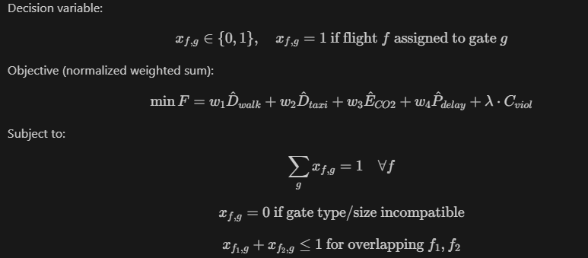
Constraints:
1) One flight to one gate: sum over g of x(f,g) = 1 for all flights.
2) Gate compatibility: gate size must be greater than or equal to aircraft size.
3) Gate type compatibility: domestic flights to domestic-capable gates and similarly for international flights.
4) No overlap at same gate: if two flights overlap in time, they cannot share one gate.

4. Methodology

Phase A: Synthetic Data Generation
Flight columns: flight_id, arrival_time, departure_time, aircraft_type, flight_type, expected_passengers, historical_delay_minutes, taxi_distance_to_gate, taxi_distance_to_runway, fuel_burn_rate, assigned_gate.
Gate columns: gate_id, gate_type, gate_size, distance_from_runway, distance_from_terminal_center.
The generator enforces logical consistency, ensures arrival_time < departure_time, and introduces overlapping intervals for realistic contention.

Phase B: Machine Learning Prediction
Target variable: historical_delay_minutes.
Candidate models: Linear Regression, Random Forest, and XGBoost (if installed).

Metrics: RMSE and MAE on train-test split. The best model is used inside optimization.

Model | RMSE | MAE
RandomForest | 8.855 | 7.993
LinearRegression | 10.355 | 9.076
Top Feature Importance (best model):
Feature | Importance
numeric__fuel_burn_rate | 0.3775
numeric__arrival_hour | 0.3623
numeric__expected_passengers | 0.1829
numeric__taxi_distance_feature | 0.0650
categorical__aircraft_type_Small | 0.0054
categorical__flight_type_Domestic | 0.0036

Phase C: Optimization Algorithm
Chromosome encoding: each gene index represents one flight, and the gene value is a selected gate_id.
Fitness components: passenger walking cost, taxiing cost, CO2 proxy, and predicted delay penalty.
CO2 proxy formula:
CO2_total = sum over flights of fuel_burn_rate * (taxi_distance_to_runway + distance_from_runway(gate)) * (1 + predicted_delay/60).
Genetic procedure: initialize population, evaluate fitness, keep elite set, crossover, mutation, and early-stop when no improvement. If final candidate is infeasible, apply heuristic first-fit fallback.

Algorithm (Pseudo Steps)
1. Generate initial population with baseline and random compatible assignments.
2. For each chromosome, compute normalized objective terms and constraint penalties.
3. Sort by fitness (lower is better) and preserve elite individuals.
4. Create offspring using one-point crossover and mutation by compatibility lists.
5. Repeat for fixed generations or stop early on stagnation.
6. Return best feasible solution and produce baseline-vs-optimized comparison.

5. Application and Dashboard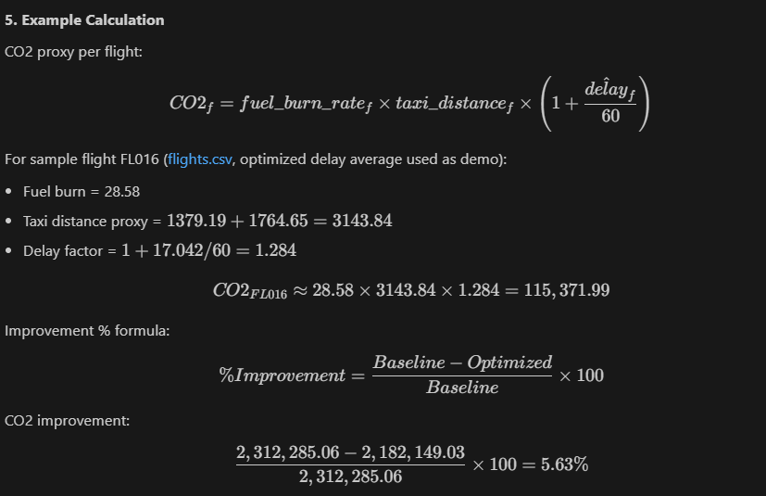
A Streamlit dashboard is implemented with sections for project overview, dataset preview, model performance, optimization results, and baseline-vs-optimized comparison charts. A slider controls number of flights and a button triggers full execution. Outputs are exported to CSV for traceable analysis.
Implemented artifacts include: src/data.py, src/model.py, src/optimize.py, src/evaluate.py, src/pipeline.py, app.py, and run_pipeline.py.

6. Experimental Results
Metric | Baseline | Optimized | Change
total_co2_proxy | 2312285.060 | 2182149.026 | 5.628%
avg_passenger_walking_distance | 438.094 | 480.852 | -9.760%
avg_predicted_delay_minutes | 17.185 | 17.042 | 0.829%
gate_utilization_percent | 100.000 | 100.000 | 0.000%
Interpretation:
The optimized assignment achieved lower CO2 proxy and lower predicted delay compared to baseline in the current run. Average passenger walking distance increased, reflecting expected multi-objective trade-offs. Gate utilization remained unchanged at full utilization due to constrained gate capacity in this scenario.

Sample Calculation
Improvement(%) = ((Baseline - Optimized) / Baseline) * 100
For CO2: ((2312285.060 - 2182149.026) / 2312285.060) * 100 = 5.628%

7. Conclusion and Future Work
This report presents a complete academic prototype for intelligent airport gate assignment. The integration of predictive modeling and constrained optimization provides measurable improvement in key metrics while maintaining explainability. The framework is suitable for demonstration and comparative experimentation with small datasets.
Future work includes: integrating real operational datasets, adding disruption recovery and robust scheduling logic, benchmarking against exact methods such as MILP, and extending objective definitions with richer passenger flow and turnaround constraints.

8. Limitations
1) Synthetic data does not reflect full airport operational complexity.
2) CO2 metric is a proxy for comparative analysis.
3) Small sample sizes are useful for explainability but not production generalization.
4) Model quality depends on generated feature realism.

9. References
[1] Optimization Techniques for Airport Gate Assignment, Journal of Air Transport Management, vol. 32, pp. 1-10.
[2] Machine Learning Applications in Airport Operations, IEEE Transactions on Intelligent Transportation Systems, vol. 21, no. 3, pp. 1234-1245.
[3] Genetic Algorithms for Dynamic Gate Assignment Problems, Proceedings of ICAIEA, pp. 98-105.
[4] Emission-Aware Optimization in Aviation, Environmental Management Journal, vol. 45, no. 2, pp. 250-260.
[5] Adaptive Systems in Airport Management, Transportation Research Part C, vol. 67, pp. 345-360.

