1. Install Power BI Desktop and share the final screenshot of the report view page which appears when power desktop starts.

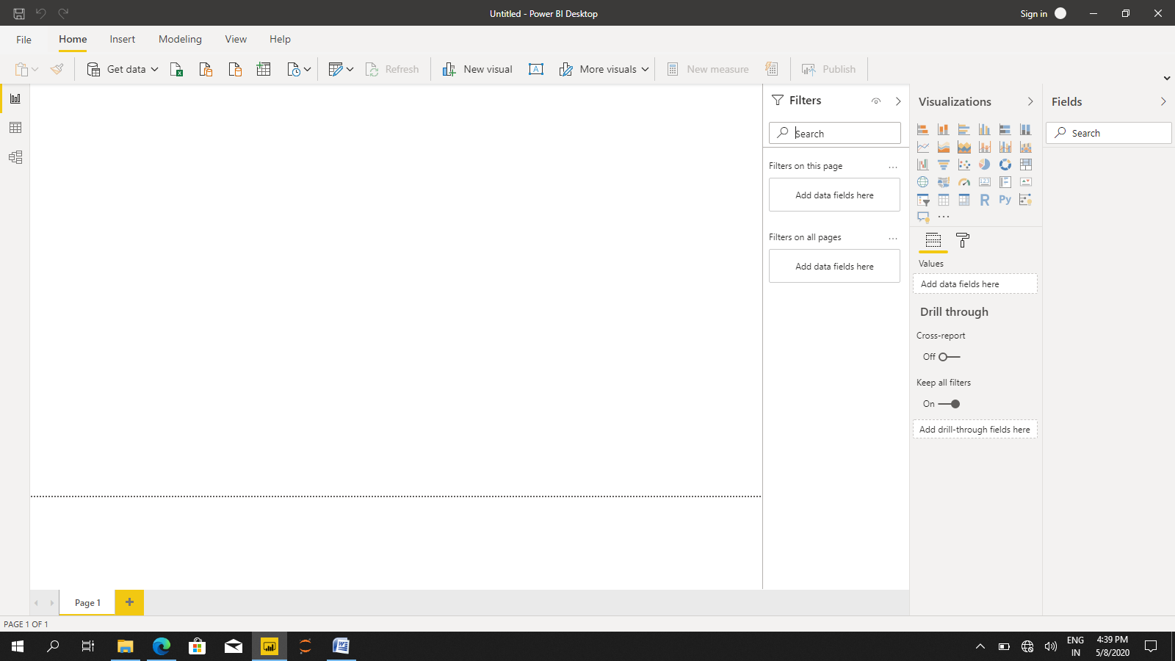

1. Prepare a document and with the following screenshot –

**Report View − Data View − Model View − Power Query Editor − Advance Editor**

**Report View**

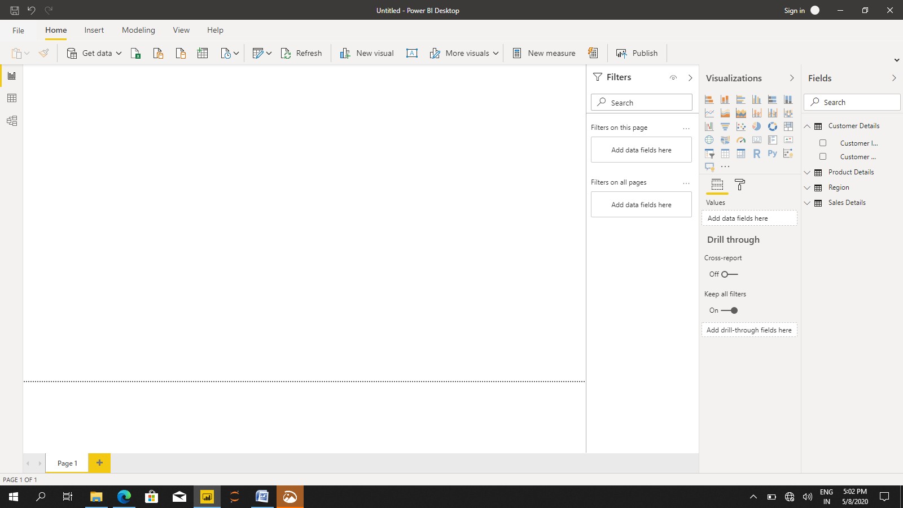 **Data View**

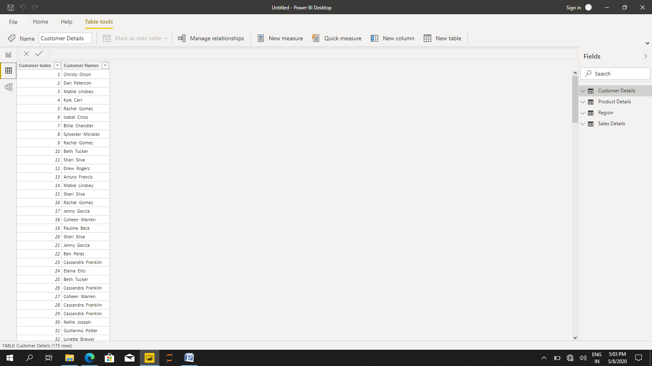

**Model view**

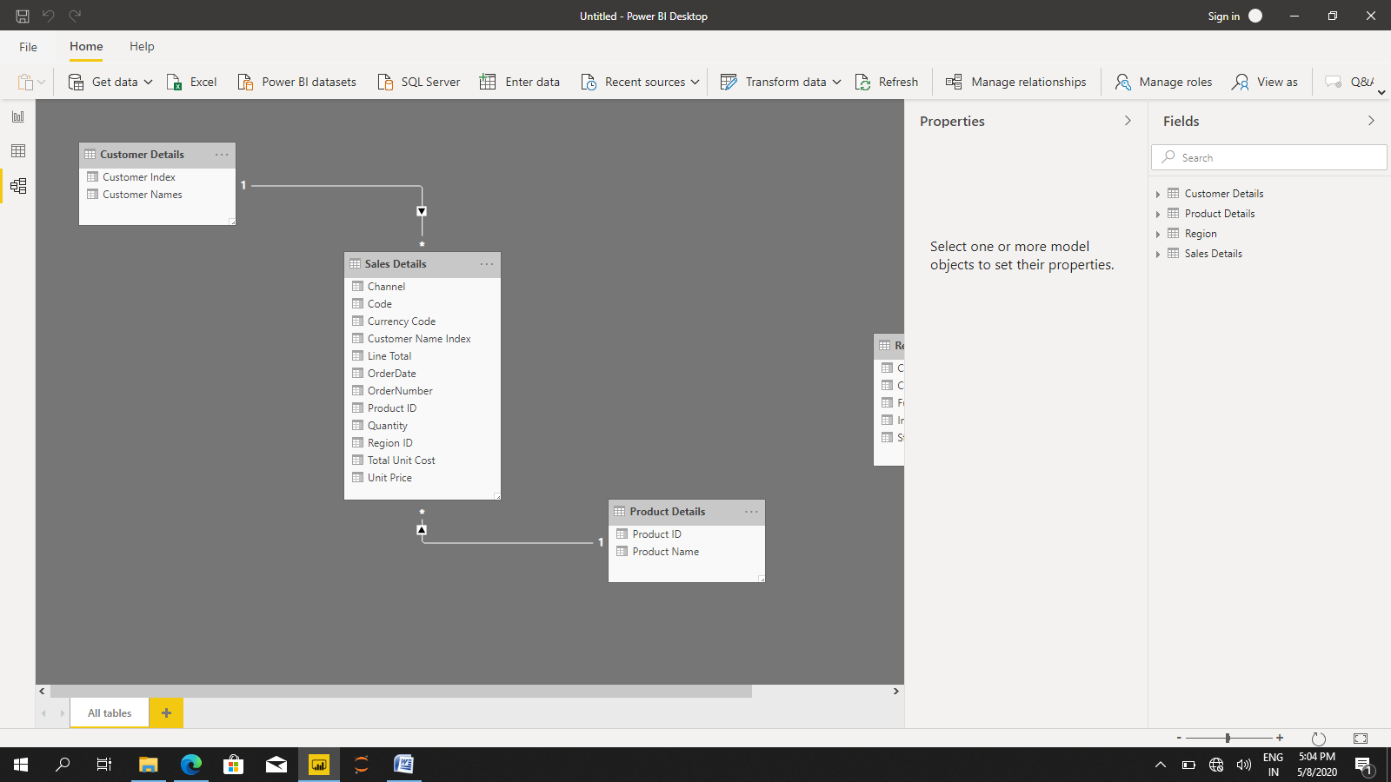

**Power Query Editor**

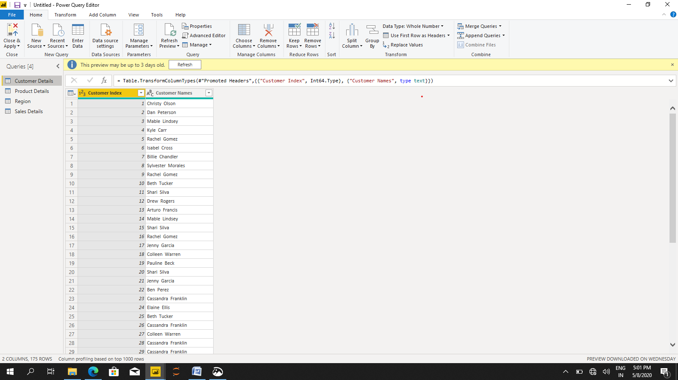

**Advanced Editor**

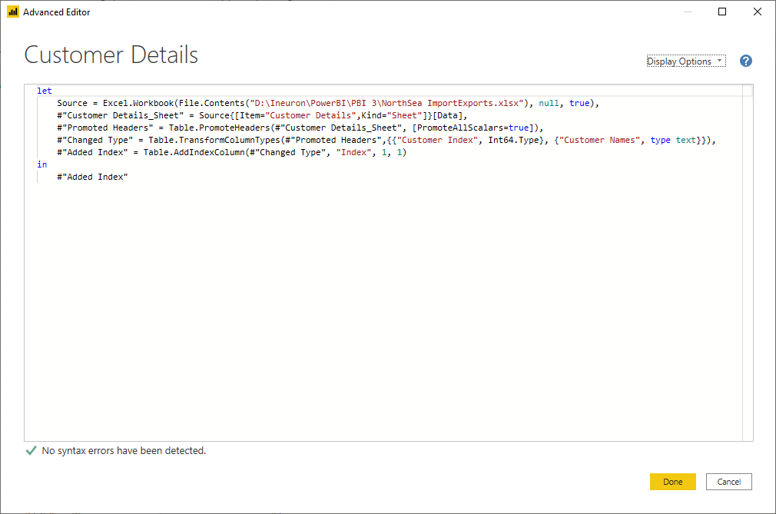

1. Prepare a document with details of the following along with their **price − Power BI Desktop − Power BI Pro − Power BI Premium**

Power BI Desktop:

Power BI Desktop is the free version of Power BI that you can install on your local computer as a program, and acts as a companion desktop application to the full version of Power BI. If you need to consolidate your data sources, create your own reports and conduct your own analysis or test it’s capabilities, it’s the perfect version to start with for all skill levels - whether you’re non-IT and want to make your reports more interactive, or analysts seeking richer detail, it's one of the best business analytics tools to use.

## Power BI Pro:

Power BI Pro is the full version of Power BI, complete with the ability to use Power BI for both building dashboards and reports and unlimited viewing, sharing and consumption of your created reports (and reports shared by others) - the latter not possible with Power BI Desktop.**Price is $9.99** per month

A breakdown of Power BI Pro’s differences against Power BI Desktop:

* Ability to embed Power BI visuals into apps (PowerApps, SharePoint, Teams, etc)
* Native integration with other Microsoft solutions (Azure Data Services)
* Share datasets, dashboards and reports with other Power BI Pro users
* Can create App Workspaces and peer-to-peer sharing

Power BI Pro is licensed by individual user

Power BI Premium:

Power BI Premium is the most expensive tier of Power BI currently available and very distinct from the other two versions available on the market. **Price is $49.95,**per month .On top of the features and functionality standard to all versions of the service, users of Power BI Premium get:

* Increased data capacity limits and maximum performance
* Access to one API surface
* Ability to embed Power BI visuals into apps (PowerApps, SharePoint, Teams, etc)
* Larger storage sizes for extended deployments
* Geo distribution, higher refresh rates, isolation, pin to memory, read-only replicas