**Milestone**

**Contents of our Project**

* **Amazon Web Services (AWS)**

**API Gateway, Lambda, Secret Manager, RDS(Relational Database Service).**

* **GitHub REST (API).**
* **Level Of Programming (Python).**
* **Input and Output.**
* **Displaying output with JSON data.**

**Amazon Web Service:**

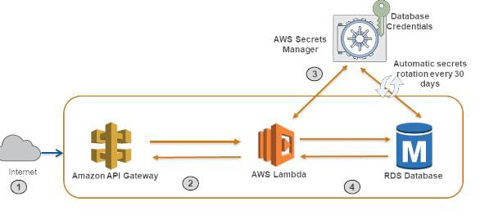

* Created AWS RDS instance using MySQL engine. Made the instance ready.
* Uploaded the lambda code in S3.
* Create the lambda function.
* Connect MySql Workbench to RDS instance.
* Create/Use database, table.
* Make a REST API in AWS API gateway to trigger the lambda.
* Call the API with query parameters.

**API Gateway:**

**API** (Application Programming Interface) and is the single-entry point for defined back-end APIs and microservices (which can be both internal and external), Improved security, since requests are managed with a single, consistent approach.

**AWS Lambda:**

It is used to Run the code in response to events and automatically manages the computing resources.

AWS lambda allows us to extend services for our Back end services that operates in performance and security.

**RDS (Relational Database Service):**

Amazon Relational Database Service (Amazon RDS) makes it easy to set up, operate, and scale a relational database in the cloud. It provides cost-efficient and resizable capacity while automating time-consuming administration tasks such as hardware provisioning, database setup, patching and backups.

* Create AWS RDS instance using MySQL engine. Made the instance ready.
* Uploaded the lambda code in S3.
* Create the lambda function.
* Connect Mysql Workbench to RDS instance.
* Create/Use database, table.
* Make a REST API in AWS API gateway to trigger the lambda.
* Call the API with query parameters

**GitHub REST (API):**

Github REST APIs) are the APIs that you can use to interact with GitHub. It allows us to create and manage repositories, branches, issues, pull requests, and many more. For fetching publicly available information (like public repositories, user profiles, ) you can call the API.

**Level Of Programming (Python):**

* Taking the inputs – date range and repository
* Getting data from Github API calling page wise
* Storing data into dataframe.
* Process the data in frames
* Create an output dictionary.
* Sending data to RDS database.
* Displaying the output dictionary.
* Displaying a JSON Response as an output.

**Input** : Repository name.

**Output**: Company domain name, along with total number of commits and total number of contributors.