Linear Search:

- Start from the leftmost element of arr[] and one by one compare x with each element of arr[]
- If x matches with an element, return the index.
- If x doesn’t match with any of elements, return -1.

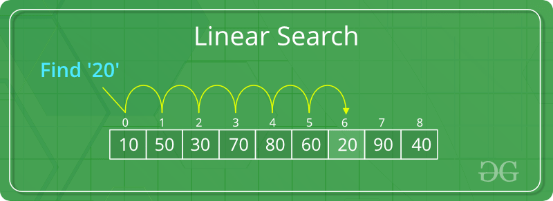

Binary Search:

- Sorted Array
- if the value at middle index is less than given key
  - take first half
- else
  - take second half
- Do until found

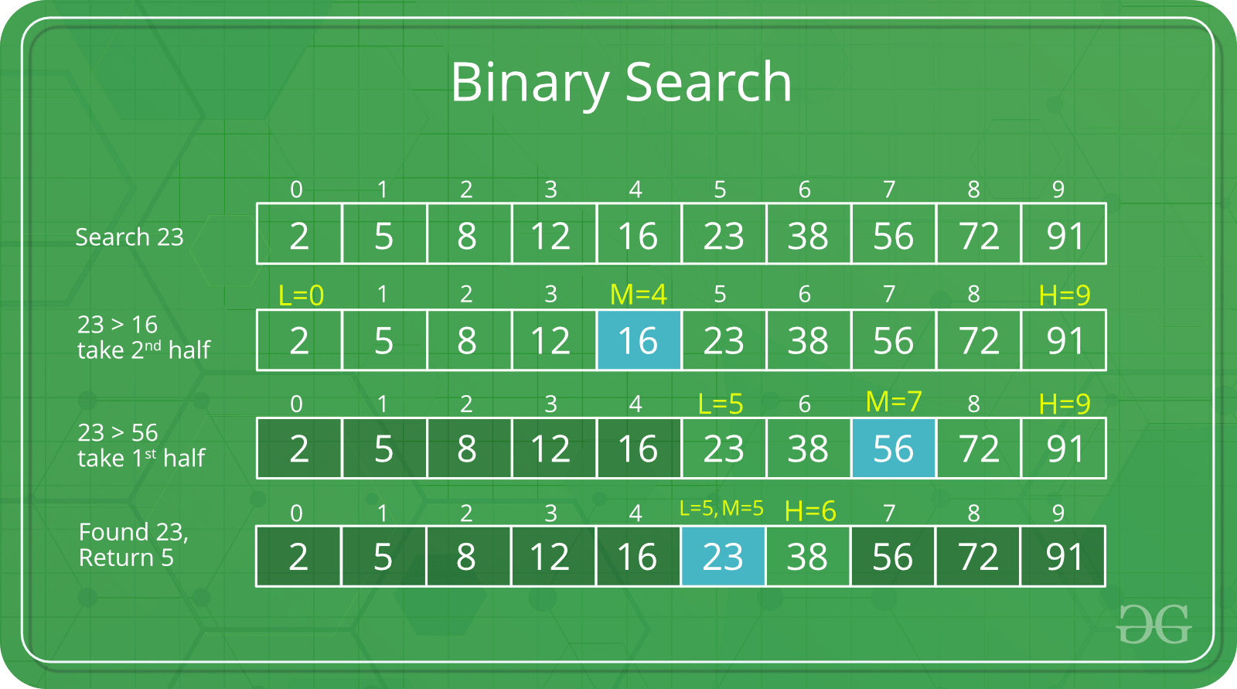

Jump Search:
- Sort array
- Select jump size m
- Jump the array arr[0], arr[m], arr[2m]...
- If the value at jump greater than key jump previous.
- Do linear search in the interval

Optimal jump size: m = √n

