**Aviva Test Assignment Execution Report Document:**

**Aviva Web Assignment consists of below files:**

1. **TestFeatureFile-🡪AvivaTest.feature**
2. **StepDefinitions file where file contains steps definitions**
3. **Pages : AvivaGoogleHomepage, ResultsPage**
4. **Utility Scripts :Baseclass**

**Step1: Steps to Execute AvivaWebAssignment from command Prompt:**

1. Extract AvivaAssignment_Saraswathi folder
2. Navigate to below path from cmd: D:\CSharp\Saraswathi\AvivaAssignment_Saraswathi\AvivaGooglesearchTest\packages\SpecRun.Runner.1.6.3\tools>
3. Run with the below command:

**SpecRun.exe run default.srprofile**

**/baseFolder:D:\CSharp\Saraswathi\AvivaAssignment_Saraswathi\AvivaGooglesearchTest\AvivaGooglesearchTest\bin\Debug /Outputfolder: D:\CSharp\Saraswathi\AvivaAssignment_Saraswathi\AvivaGooglesearchTest\TestResults /report:MyReport.html /log:specrun.log**

**OR**

**Step2: Steps to Execute AvivaWebAssignment from command Prompt:**

1. Build project from visual Studio 2015
2. Navigate to Folder AvivaGooglesearchTest
3. Double click on “ runtests.cmd”

It will launch command prompt with the execution of Specflow scripts.

Execution report will be updated with screenshots can be found at

**Path: ex: D:\CSharp\Saraswathi\AvivaAssignment_Saraswathi\AvivaGooglesearchTest\TestResults**

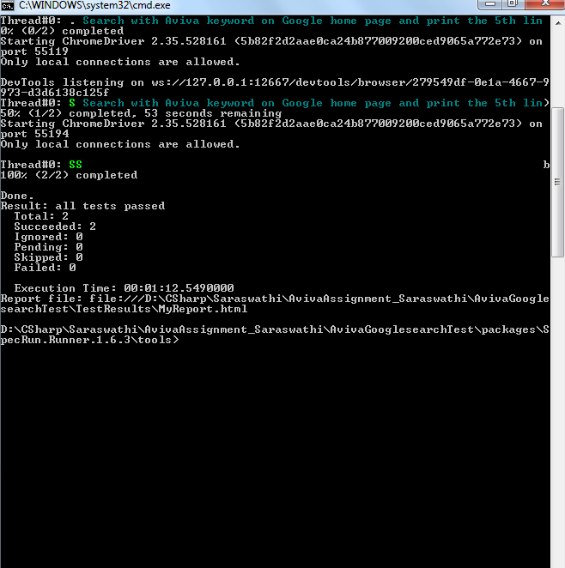

**Steps to Execute AvivaWebAssignment from Visual Studio IDE :**

1. **Extract Aviva Test Solution to a folder.**
2. **Click on AvivaWebAssignmentTest.sln to launch project in visual studio in 2015 IDE.**
3. **Build Project and click on “RUN ALL” . This will launch execution of 2 feature files positive and negative scenarios.**
4. **Execution reports can be found in output console.**

Output Screenshot :

