**After turning off configure built fire wall:**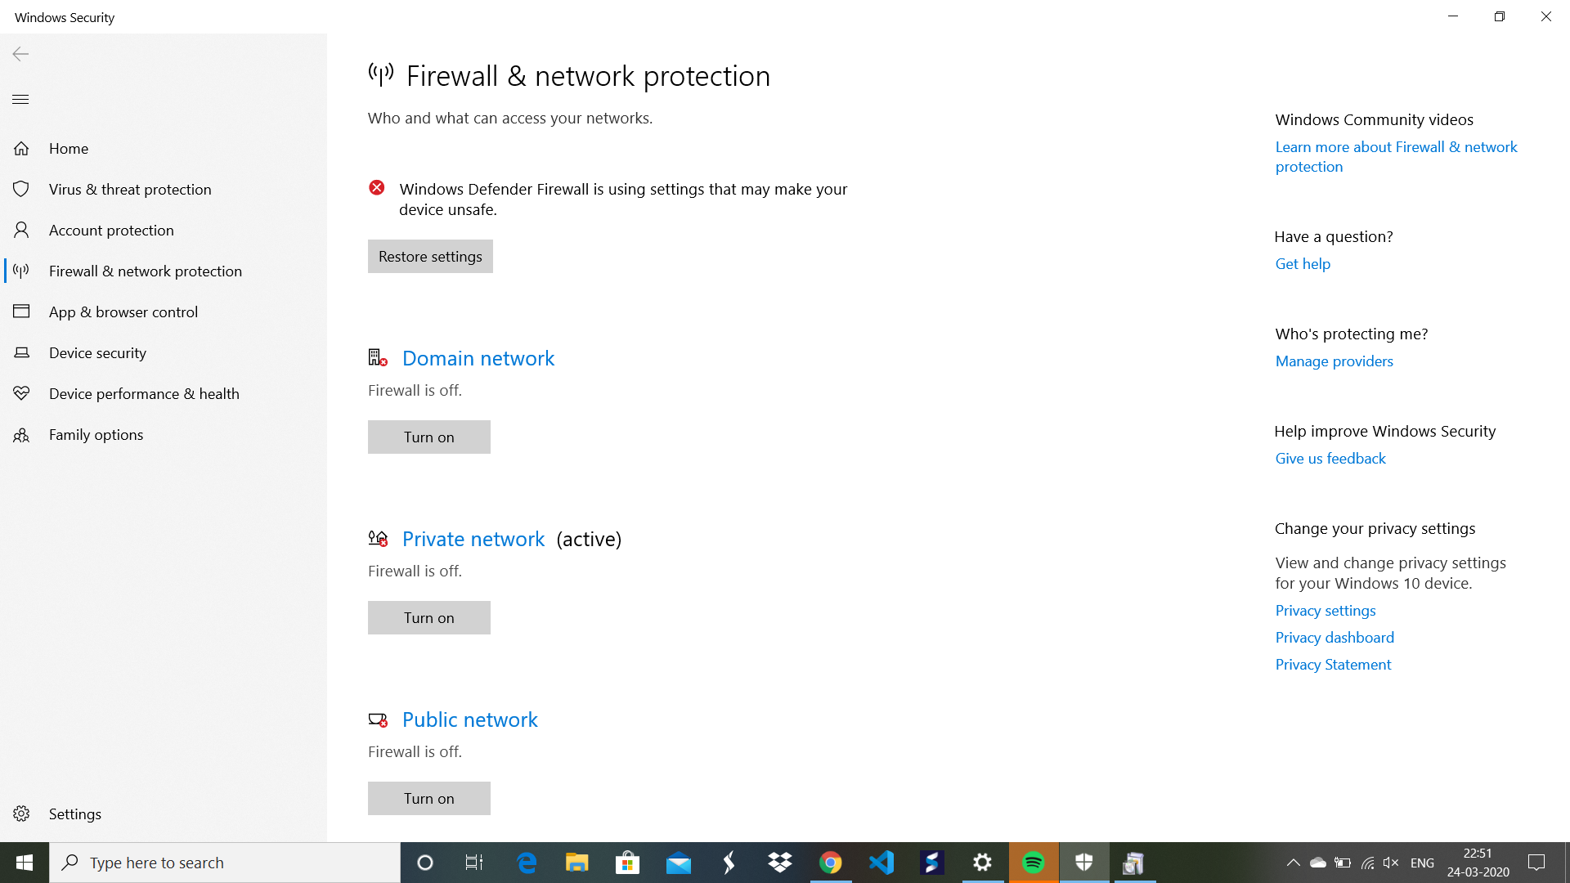

**Identifying workstations in the network:**

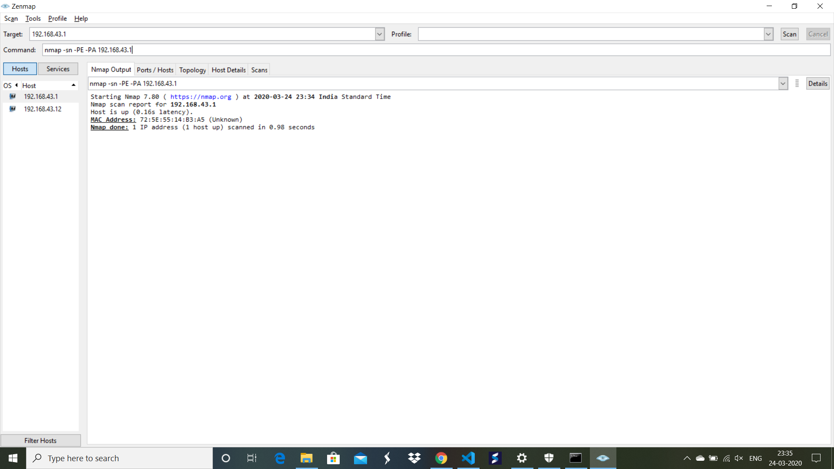

* By running the ipconfig command in the command line, we get the default gateway address.
* By running the command np gateway address,we get the above output.

**Vulnerability enumeration for machine:**

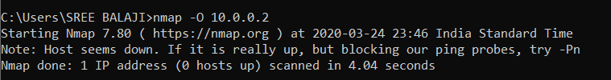

* Running of the -o parameter inorder know the target's operating system.