**Phishing Quiz:**

* Google doc is a phishing, because long presses over the doc shows you insecure information
* In fax, we could see the link at the end of the domain name
* A quick search for drop box mail will show you legitimate
* A report is also a phishing email

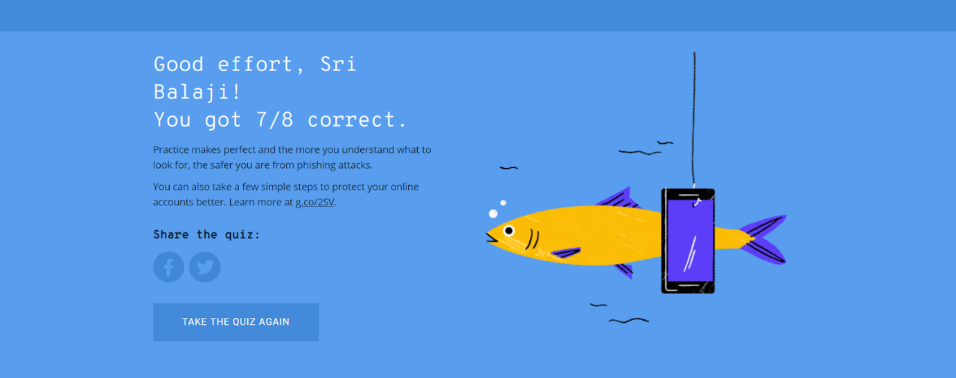

**Weak Password:**

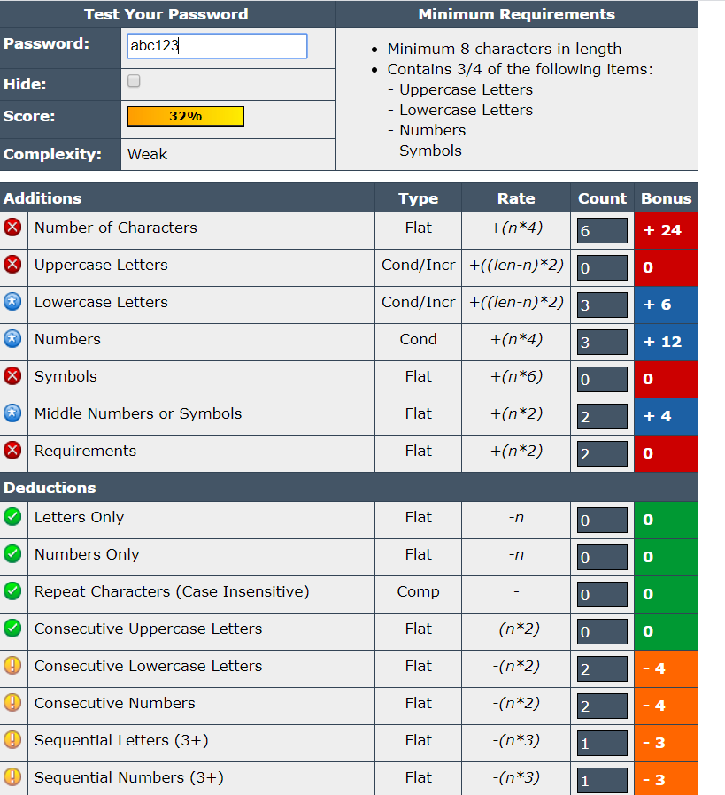

**Strong password:**

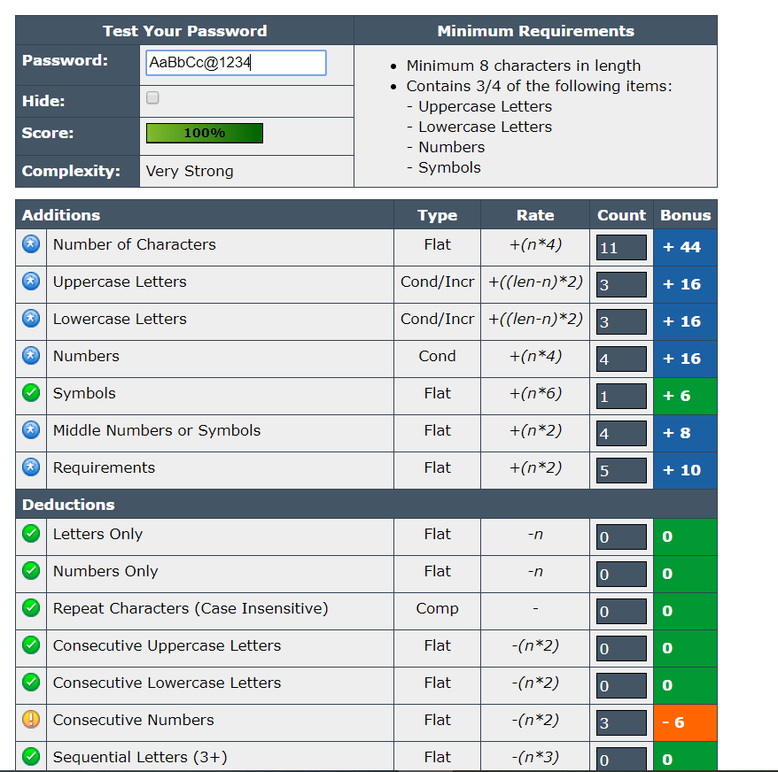

**Assignment-4:**

