NAME : BALAJI N

Reg.no :192111218

Subject : SOFTWARE ENGINEERING

Subject code : CSA 1002

Experiment-1

Aim: USE-CASE diagram for Online Voting System using CASE tools.

OUTPUT:

USE CASE DIAGRAM FOR ONLINE VOTING SYSTEM

Balaji n

192111218

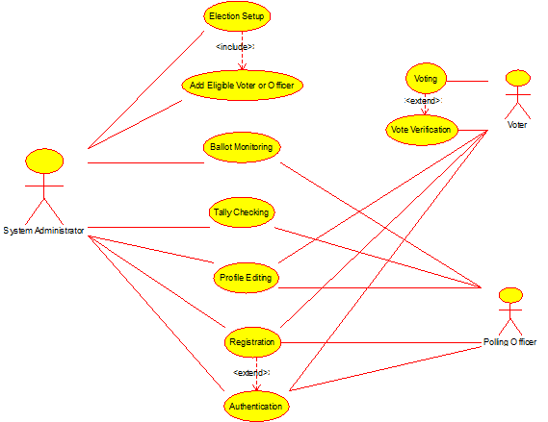

RESULT: Thus use case diagram for online voting system is implemented successfully.

EXPERIMENT-2

AIM: USE-CASE diagram for Library Management System using CASE tools.

Output:

USE CASE DIAGRAM FOR LIBRARY MANAGEMENT SYSTEM

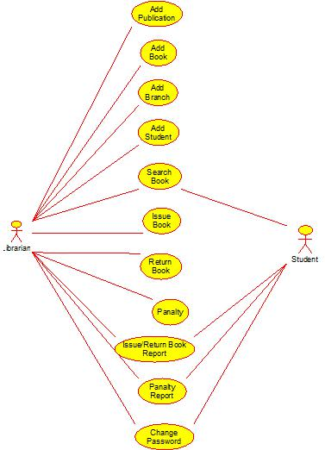

RESULT: Thus use case diagram for Library management system is implemented successfully.

EXPERIMENT-4

AIM: USE-CASE diagram for Online Shopping system using CASE tools.

OUTPUT:

USE CASE DIAGRAM FOR ONLINE SHOPPING SYSTEM

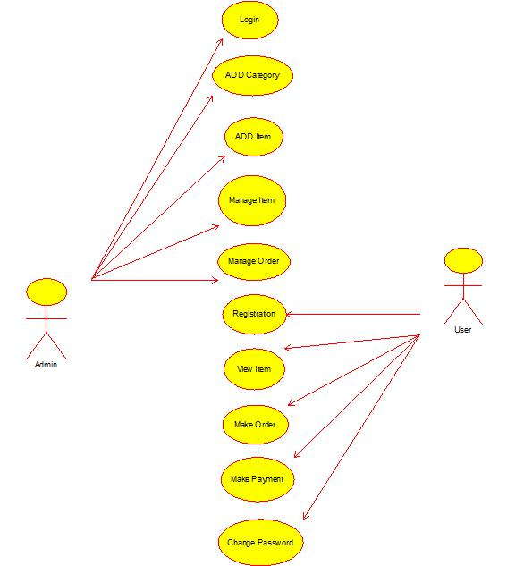

RESULT: Thus use case diagram for online shopping system is implemented successfully.

EXPERIMENT-5

AIM: USE-CASE diagram for Online Railway Reservation System using CASE tools.

Output:

USE CASE DIAGRAM FOR ONLINE RAILWAY RESERVATION SYSTEM

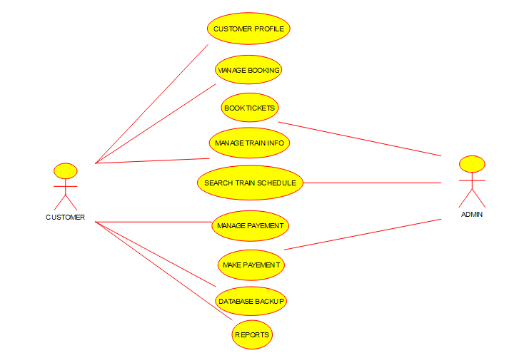

RESULT: Thus use case diagram for online Railway reservation system is implemented successfully.

Experiment-6

AIM: USE-CASE diagram for Hospital Management System using CASE tools.

OUTPUT:

USE CASE DIAGRAM FOR HOSPITAL MANAGEMENT SYSTEM

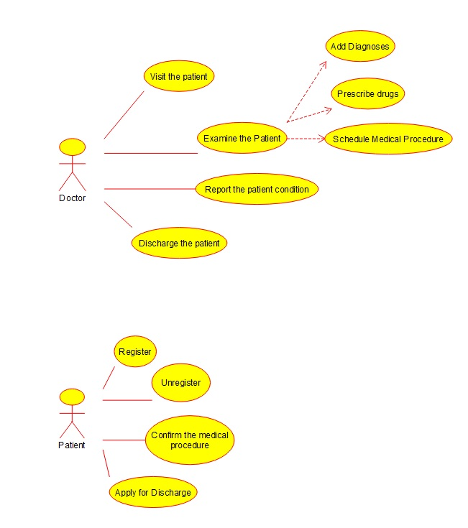

RESULT: Thus use case diagram for Hospital management system is implemented successfully.

EXPERIMENT-7

AIM: USE-CASE diagram for ATM system using CASE tools.

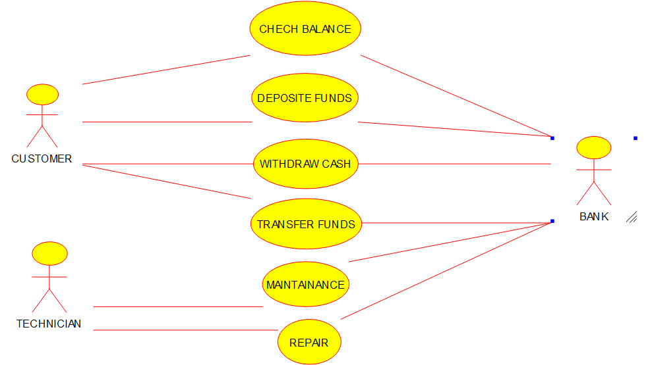

RESULT: Thus use case diagram for ATM system is implemented successfully.

EXPERIMENT-8

AIM: USE-CASE diagram for Online college management system using CASE tools.

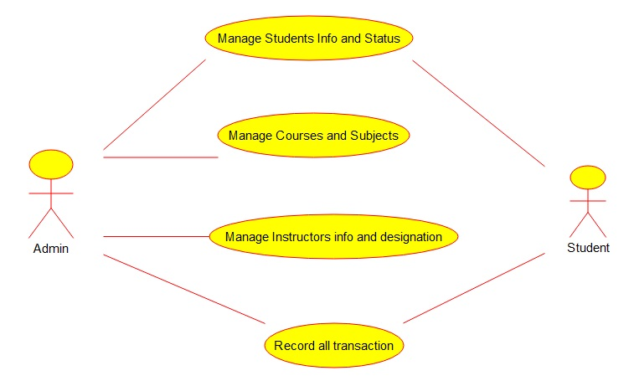

RESULT: Thus use case diagram for Online college management system is implemented successfully.

Experiment-9

AIM: USE-CASE diagram for Online Airline Reservation system using CASE tools.

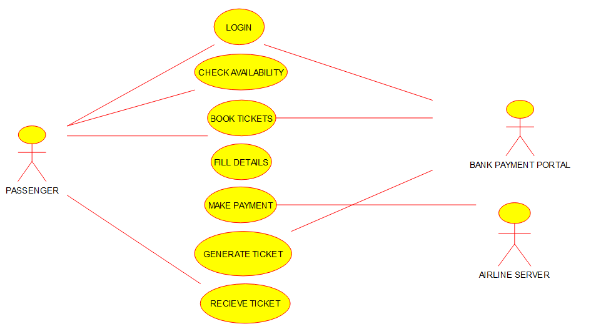

RESULT: Thus use case diagram for Online Airline reservation system is implemented successfully.

Experiment-10

AIM: Class diagram for online Airline Reservation system using CASE tools.

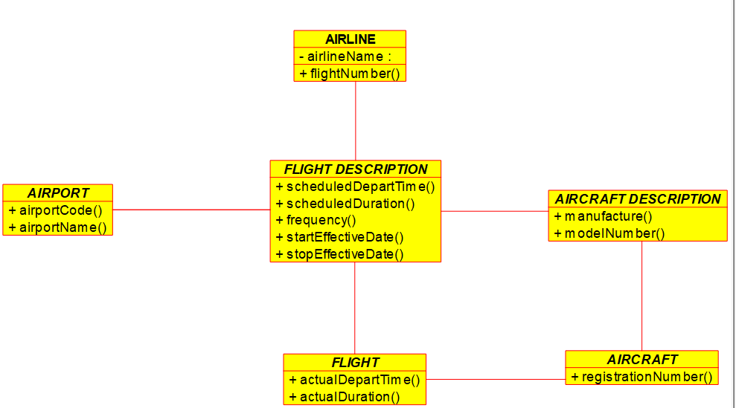

RESULT: Thus, class diagram for Online Airline reservation system is implemented successfully.

Experiment-11

AIM: Class diagram for Online Voting System using CASE tools.

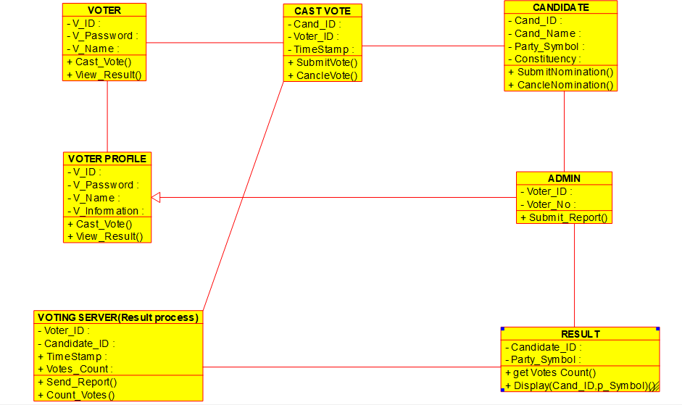

RESULT: Thus, class diagram for Online voting system is implemented successfully.

Experiment-12

AIM: To draw a class diagram for library management system using CASE tools.

**SOFTWARE USED:**

Umbrello.

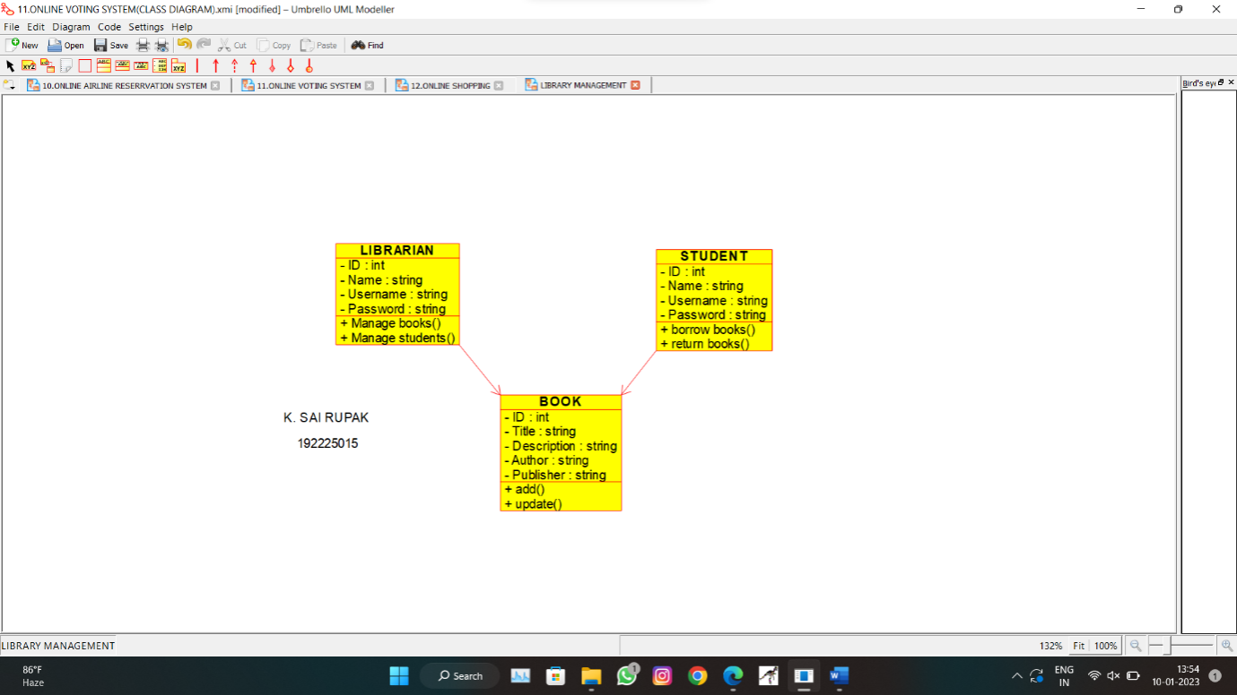

**RESULT:**

Class diagram for library management system is successfully completed.

Experiment-13

**AIM:**

To draw a class diagram for online shopping system using CASE tools.

**SOFTWARE USED:** Umbrello.

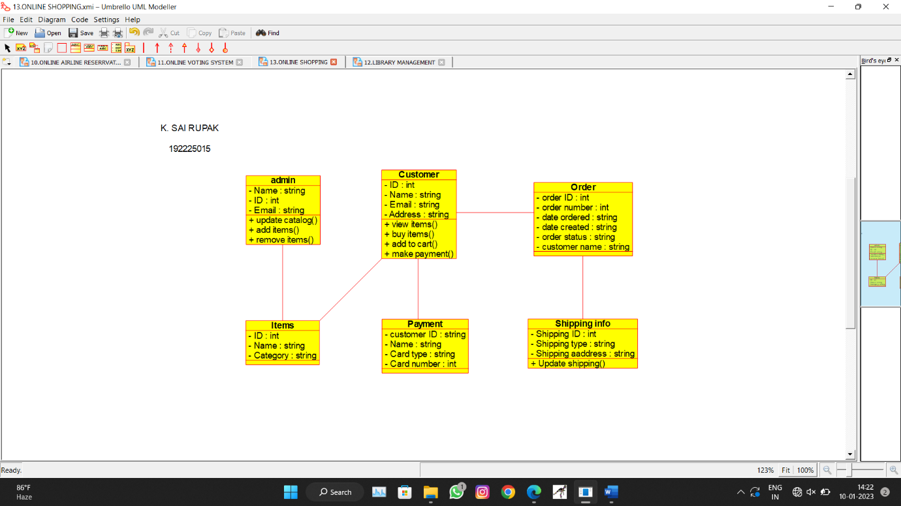

**RESULT:**

Class diagram for online shopping system is successfully completed.

Experiment-14

**AIM:**

To draw a class diagram for online railway reservation system using CASE tools.

**SOFTWARE USED:**

Umbrello.

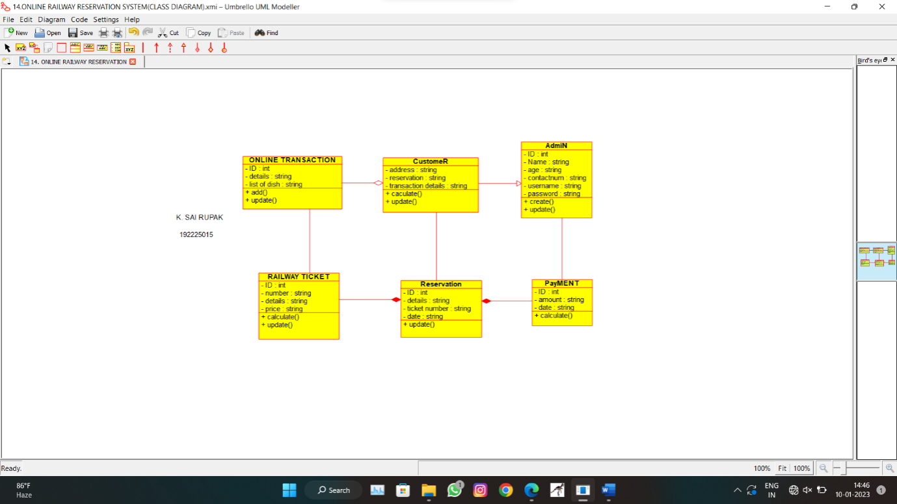

**RESULT:**

Class diagram for online railway reservation system is successfully completed.

Experiment-15

**AIM:**

To draw a class diagram for online railway reservation system using CASE tools.

**SOFTWARE USED:**

Umbrello.



**RESULT:**

Class diagram for online railway reservation system is successfully completed.

Experiment-16

**AIM:**

To draw a activity diagram for library management system using CASE tools.

**SOFTWARE USED:**

Umbrello.

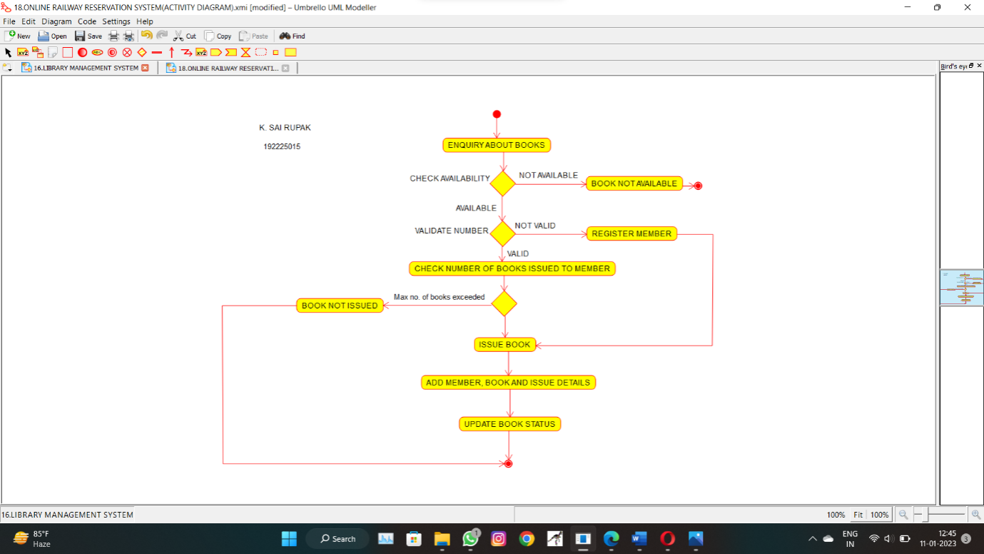

**RESULT:**

Activity diagram for library management system is successfully completed.

Experiment-17

**AIM:**

To draw a activity diagram for online shopping system using CASE tools.

**SOFTWARE USED:**

Umbrello.

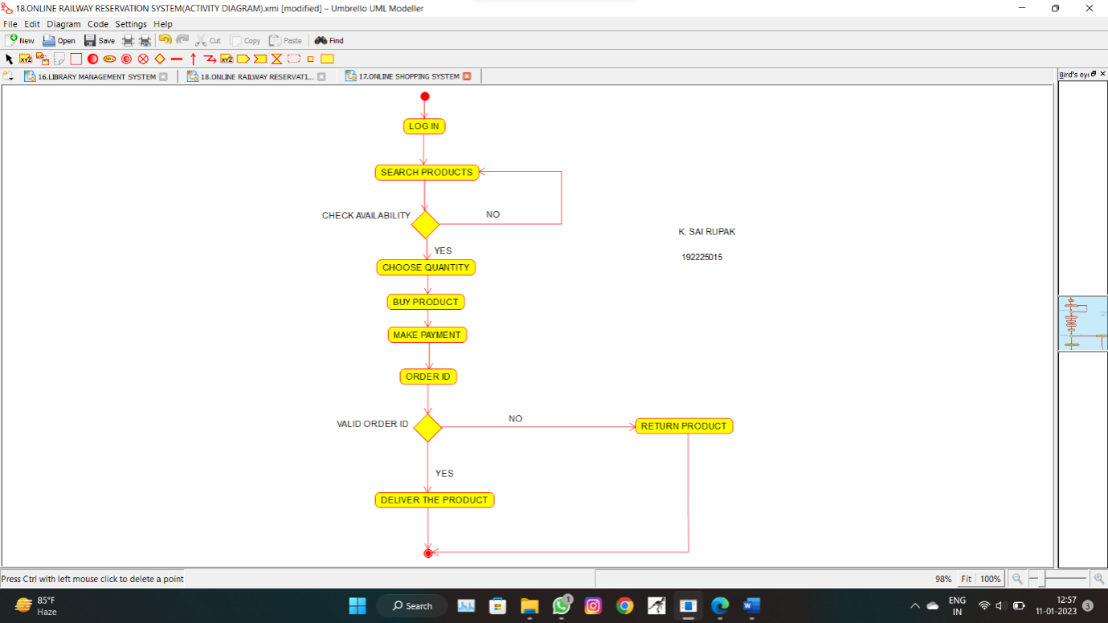

**RESULT:**

Activity diagram for online shopping system is successfully completed.

Experiment-18

**AIM:**

To draw a activity diagram for online railway reservation system using CASE tools.

**SOFTWARE USED:**

Umbrello.

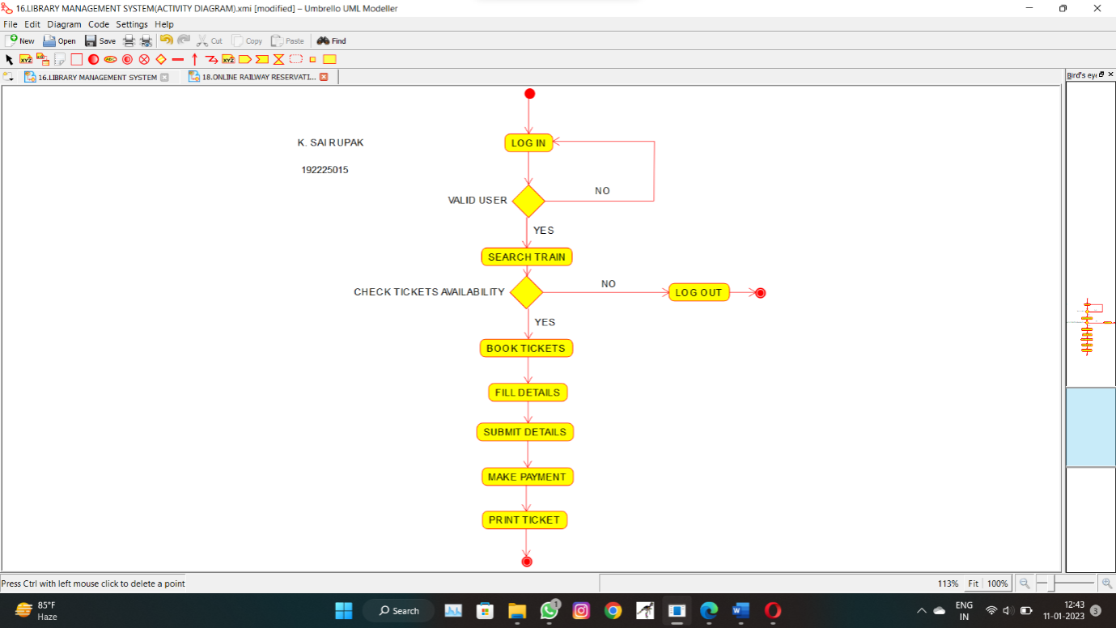

**RESULT:**

Activity diagram for online railway reservation system is successfully completed.

Experiment-19

**AIM:**

To draw a activity diagram for hospital management system using CASE tools.

**SOFTWARE USED:**

Umbrello.

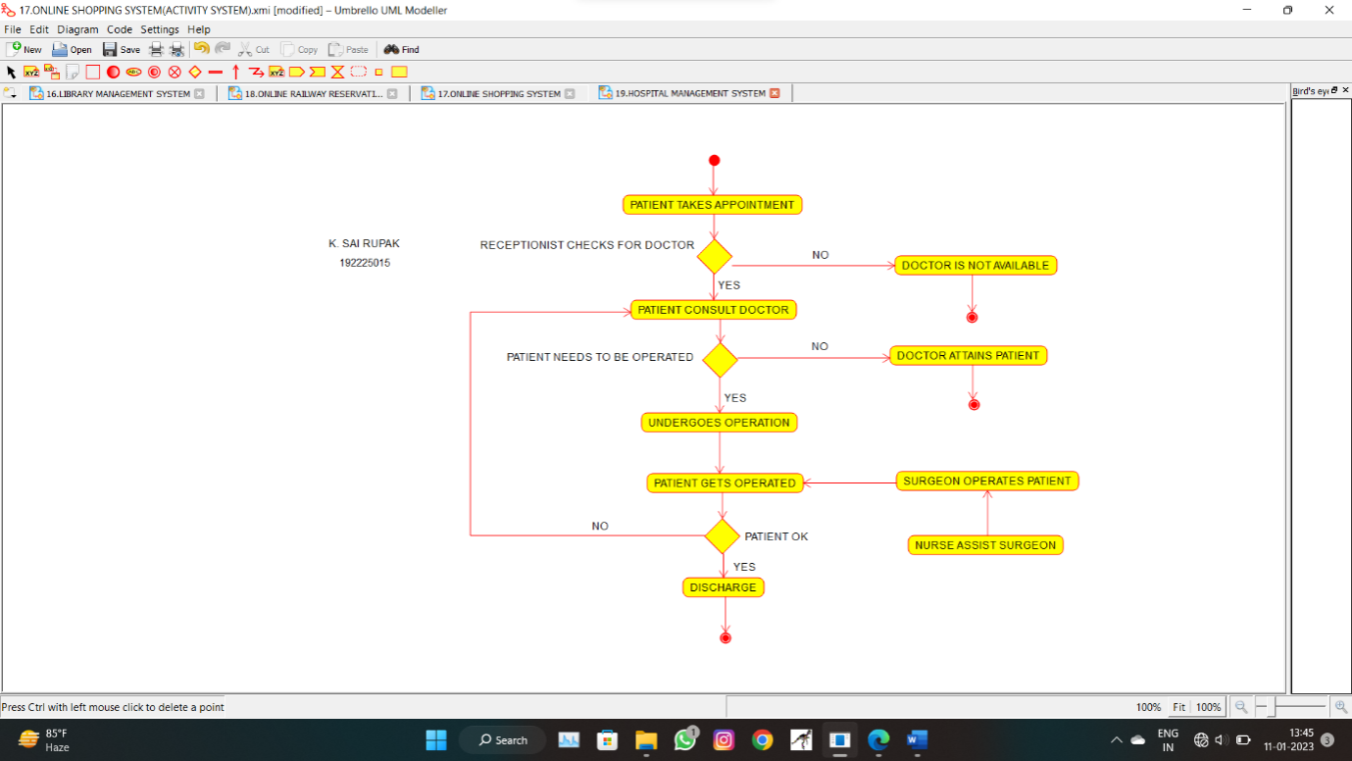

**RESULT:**

Activity diagram for hospital management system is successfully completed.

Experiment-20

**AIM:**

To draw the flowchart to check whether the given number is a palindrome or not**.**

**SOFTWARE USED:**

Raptor.

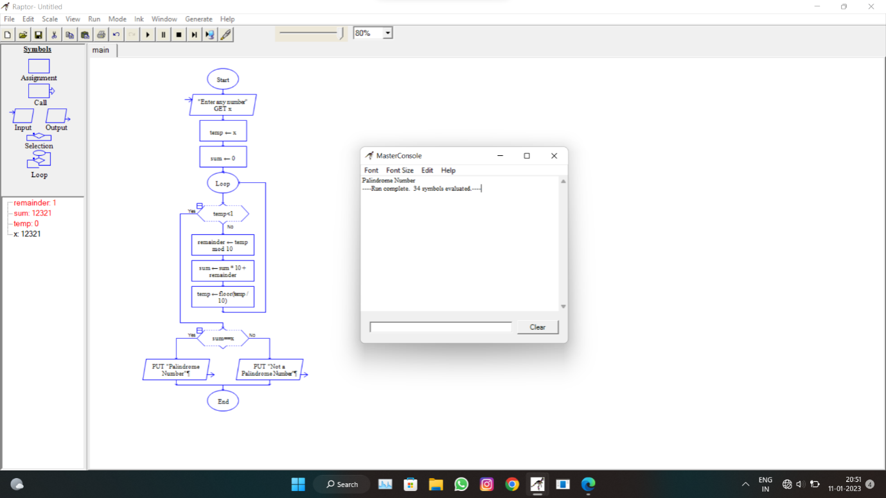

**RESULT:**

The flowchart to check whether the given number is a palindrome or not is successfully completed.

Experiment-21

**AIM:**

To draw and validate the flowchart to calculate Fibonacci series.

**SOFTWARE USED:**

Raptor.

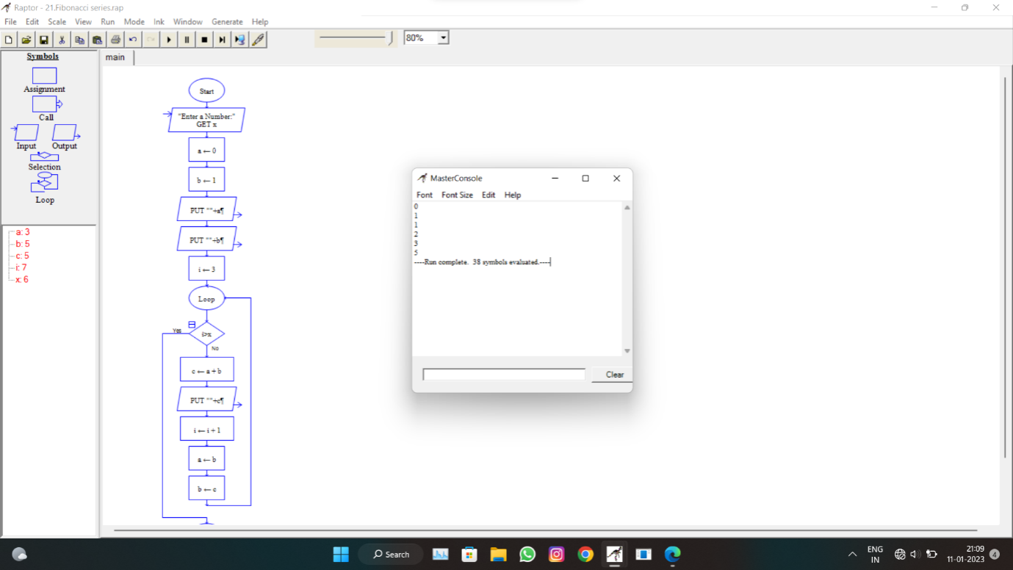

**RESULT:**

The flowchart to calculate Fibonacci series is successfully completed.

Experiment-22

**AIM:**

To draw and validate the flowchart to swap two characters.

**SOFTWARE USED:**

Raptor.

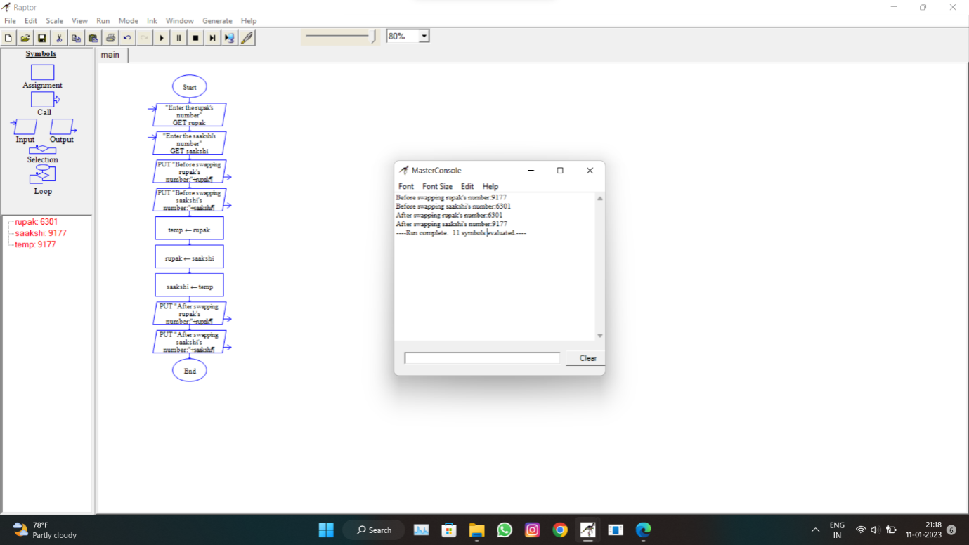

**RESULT:**

The flowchart to swap two characters is successfully completed

Experiment-23

**AIM:**

To draw the flowchart to display the length of the string.

**SOFTWARE USED:**

Raptor.

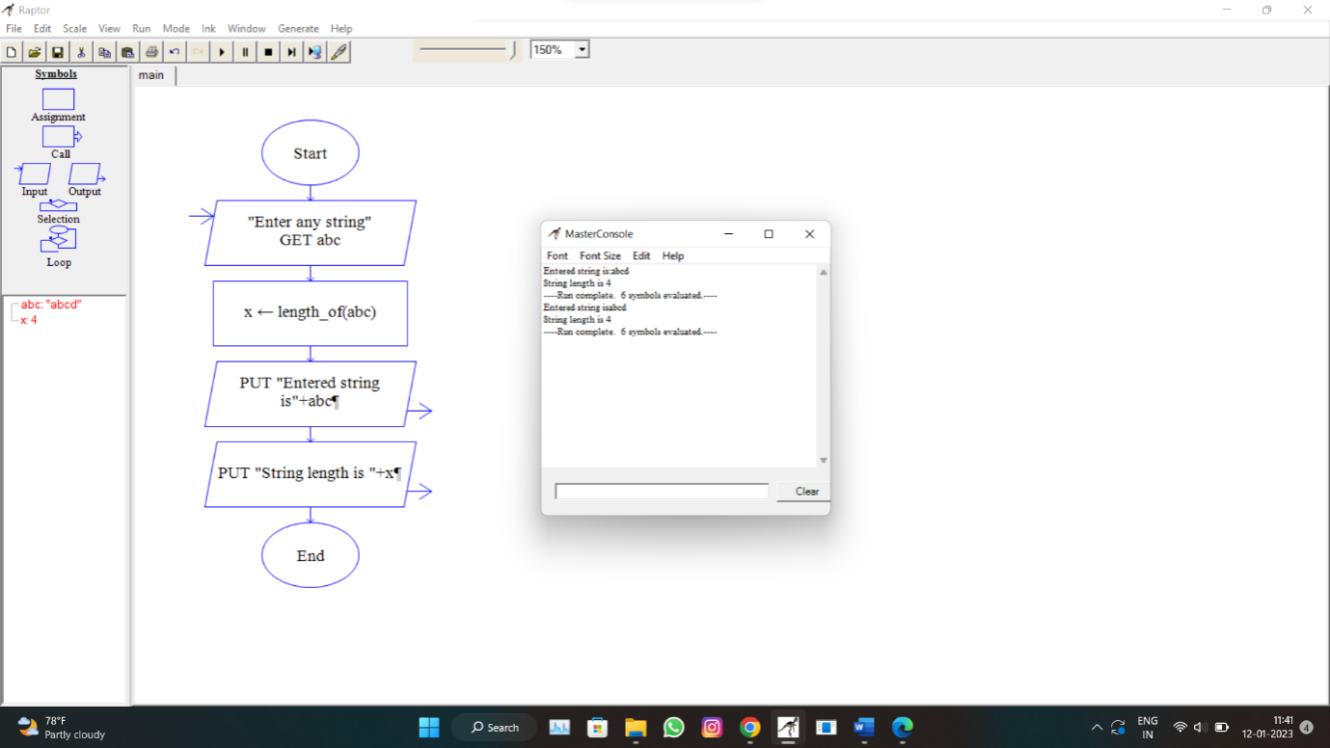

**RESULT:**

The flowchart to display the length of the string is successfully completed.

Experiment-24

**AIM:**

To draw the flowchart to find whether the given number is prime or not.

**SOFTWARE USED:**

Raptor.

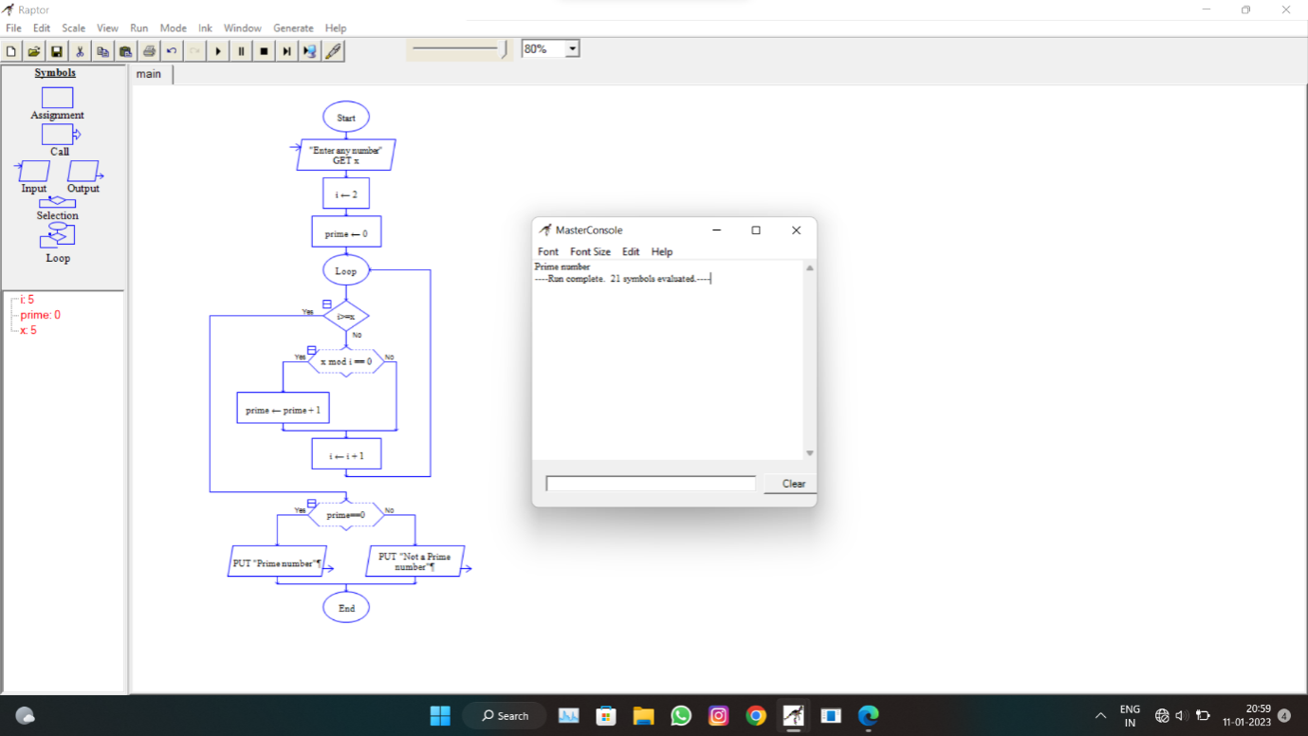

**RESULT:**

The flowchart to find whether the given number is prime or not.