# WEB App Dev

WEB App Dev 1

Frontend Scripts and Languages 2

Html 2

CSS 3

JS 9

WEB API 17

References 17

REST 18

Getting started 18

Testing 19

API security 20

Authentication and authorization 20

Claims 25

Advanced Authorization 25

Versoning 26

Monitoring 26

Protecting 26

Building 26

Consuming 26

Open API 26

Minimal API 26

Best practices 26

Misc and Questions 26

MVC 27

Program.cs 27

Razor Pages 28

Middleware 28

Model 28

View 28

Controller 28

Routing 28

## Web Scripts and Languages

### Html

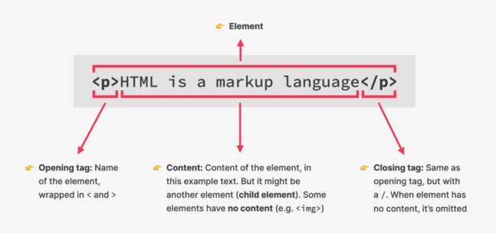

#### Basic structure

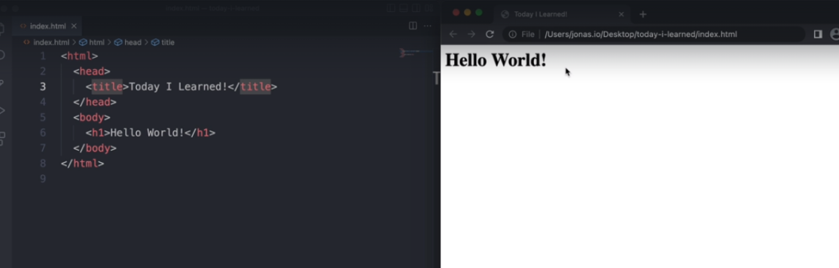

#### Attributes

<img src="img_girl.jpg" width="500" height="600">

Here **width** and **height** are known as attributes

#### Tags

List of tags: https://www.geeksforgeeks.org/html-tags-a-to-z-list/

### CSS

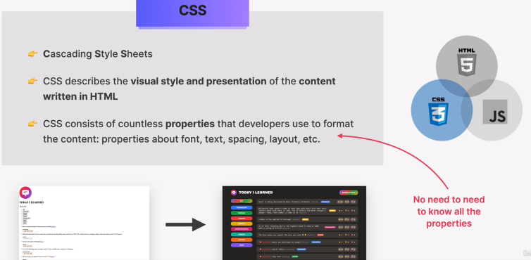

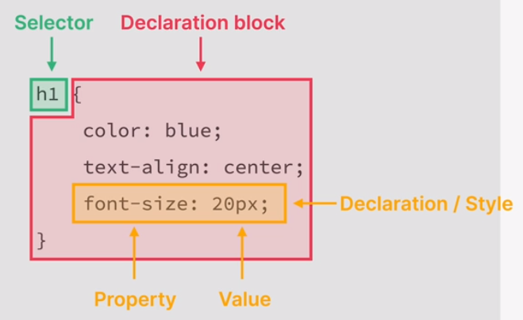

#### Ways to write CSS

Inline

<**p** style="color:#009900; font-size:50px;

             font-style:italic; text-align:center;">

        GeeksForGeeks

    </**p**>

Internal or embedded

 <**style**>

        .main {

            text-align: center;

        }

        .GFG {

            color: #009900;

            font-size: 50px;

            font-weight: bold;

        }

        .geeks {

            font-style: bold;

            font-size: 20px;

        }

    </**style**>

External

<**head**>

    <**link** rel="stylesheet" href="geeks.css" />

</**head**>

#### Selector

Dot operator is said to be class seletor. Use the while representing style for class

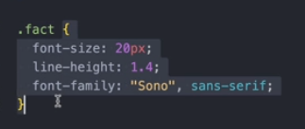

Below screenshot represents tag

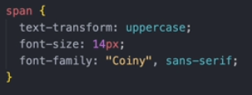

Asterick represents **global selector**. This style will be applied for all elements.

#### Units

##### Px

Pixels are a unit of measurement commonly used in web design to define the size of various elements on a web page. The "px" unit represents a fixed-size, square area on a screen.

##### Fr

Fr is a fractional unit. Its an input that automatically calculates layout divisions when adjusting for gaps inside the grid.

grid-template-columns: 1fr 1fr 1fr 1fr;

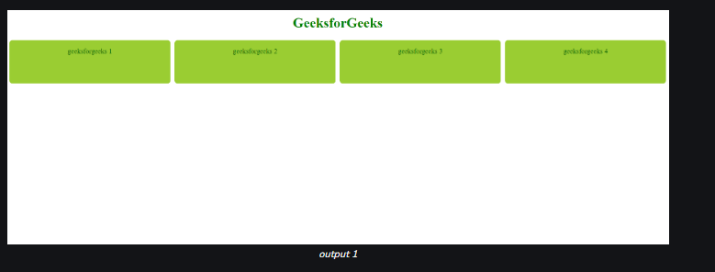

grid-template-columns: 1fr 1fr 2fr 2fr;

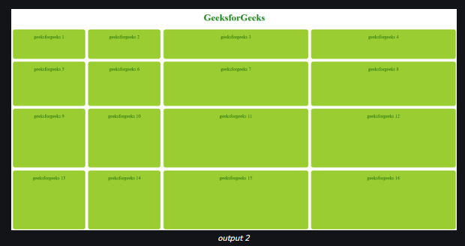

##### Rem

Rem stands for root em - Relative to the font-size of the root element of the document

Em - Relative to the font-size of its nearest parent or the element itself

html {

font-size: 16px; /* Set the base font size for the entire document */

}

body {

font-size: 1rem; /* 1rem is equal to 16px in this example */

}

h1 {

font-size: 2rem; /* 2rem is equal to 32px (2 times the base font size) */

}

p {

font-size: 1.2rem; /* 1.2rem is equal to 19.2px (1.2 times the base font size) */

}

.container {

width: 50rem; /* Width is set to 800px if the base font size is 16px (50 times the base font size) */

}

#### Pseudo class

Keywords that specify a special state of the selected elements. They allow you to style elements based on their state or position in the document. Pseudo-classes are denoted by a colon (:) followed by the pseudo-class name.

***li:nth-child(odd) {***

***background-color: #f0f0f0;***

***}***

***a:hover {***

***color: red;***

***}***

#### Property

##### Transition property

***element {***

***transition: property duration timing-function delay;***

***}***

#### Box model

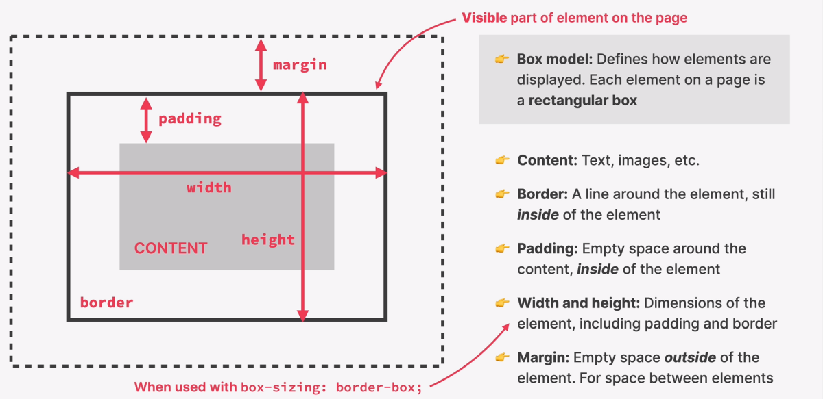

##### Property with multiple values

Padding: 16px 24px **(2)**

It can take values,

|  |  |  |
| --- | --- | --- |
| 2 | 3 | 4 |
| Top and bottom padding.  Left and right padding. | Top padding.  Left and right padding.  Bottom padding. | Top padding.  Right padding.  Bottom padding.  Left padding. |

Similarly for border, margin, etc

#### Block and inline elements

##### Block level

Starts on a new line and stretch the full width of their containing element. They create a "block" on the web page. Examples of block-level elements include <div>, <p>, <hx> , <ul>, <ol>, <li>, <table>, and others.

##### Inline level

Do not start on a new line and only take up as much width as necessary. They flow within the content and do not create a new "block." Examples of inline elements include <span>, <a>, <strong>, <em>, <img>

**Display: block** property can be used to change inline element to block level element

#### Layouts

##### Inline

For text

##### Block

For sections in a webpage

##### Table

For two-dimensional table data

##### Positioned

For explicit position of an element

##### Flexbox

This layout module makes it easier to design flexible responsive layout structure without using float or positioning.

##### CSS Grid

Refer test class in below screenshot for some of the example of grid related properties

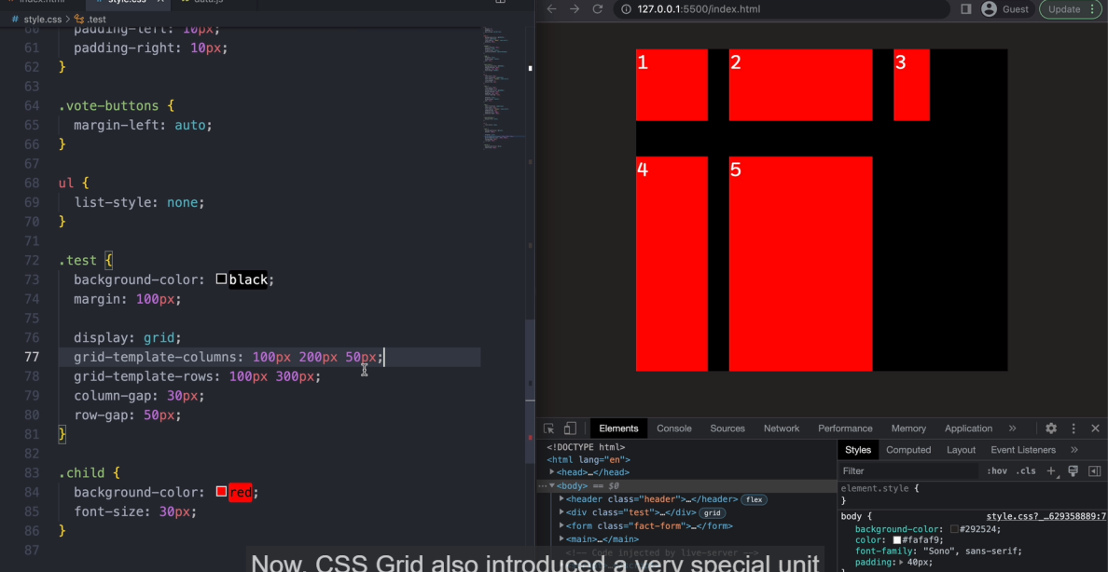

#### References

1. Use google fonts to download/get URL for required font style
2. For color palette: <https://tailwindcss.com/docs/customizing-colors>
3. Html emojis: <https://www.w3schools.com/charsets/ref_emoji_smileys.asp>
4. https://developer.mozilla.org/en-US/docs/Web/CSS

### JS

#### Definition

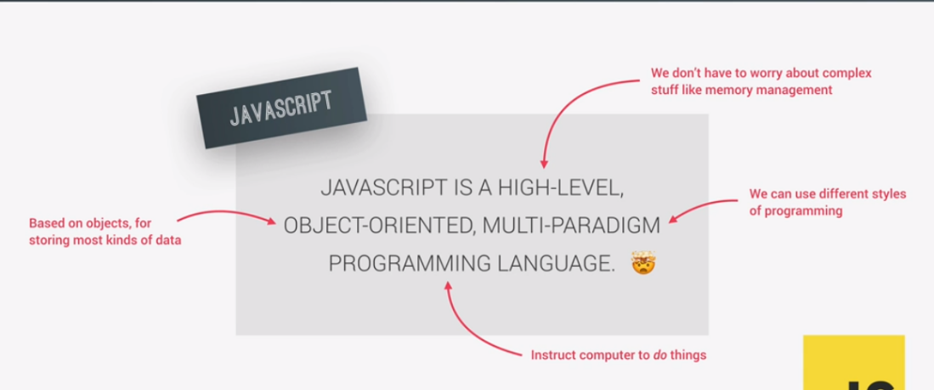

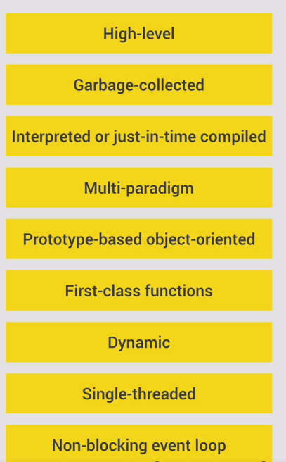

#### Strict mode

The "use strict"; directive is used in JavaScript to enable strict mode, which helps catch common coding errors and prevents the use of certain error-prone features.

*function myFunction() {*

*"use strict";*

*// The strict mode rules apply only to the code within this function.*

*// Your code here*

*var x = 10;*

*console.log(x);*

*}*

#### Versions

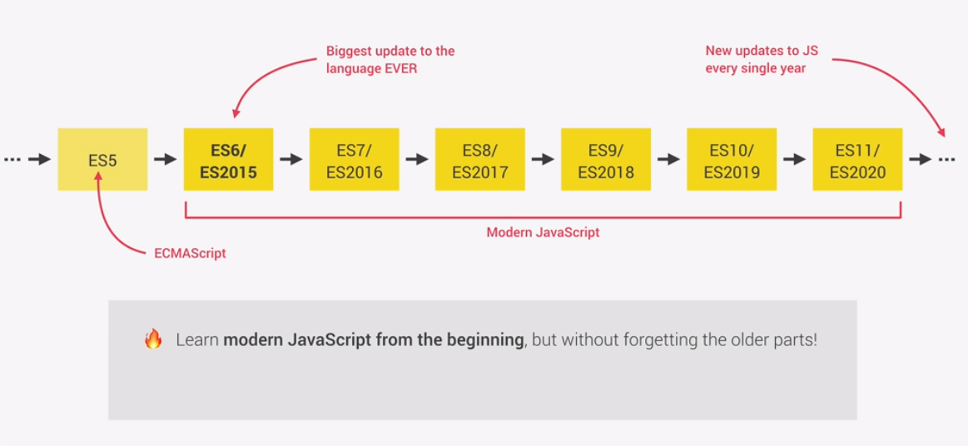

#### Hoisting

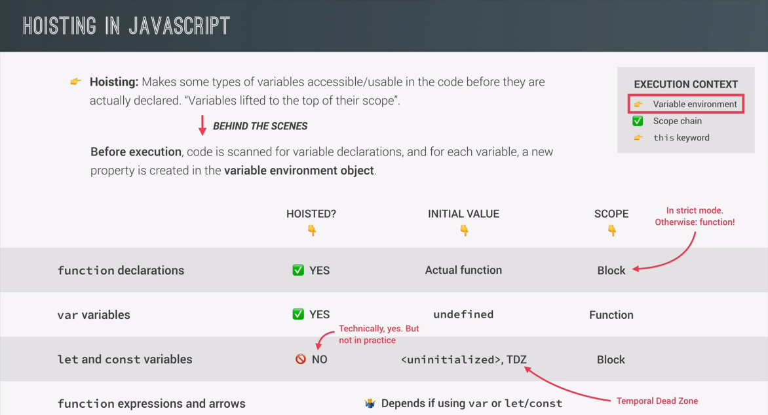

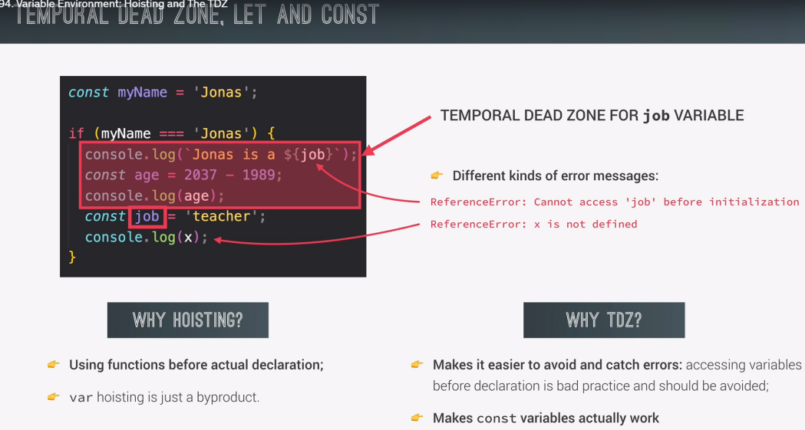

#### Types

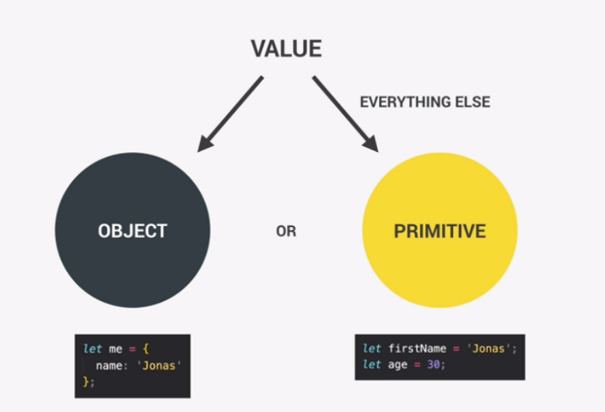

##### Var,let, const

Age=30;//Variables without any keyword

Console.log(Age);//This will not throw any error

**Var**

Mutable

Used in older js version

Can be used before declare

Age=30;

Var Age;

**Let**

Used in modern JS

*Let age=30;*

*Age=31;//This works*

*Let withoutvalue; //This works*

**Const**

Immutable variable

*Const age=30;*

*Age=31;//This line will throw error*

*Const novalue;//This will throw error. Should have some variable.*

##### Primitive types

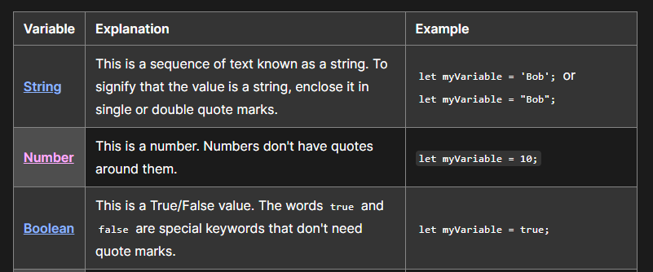

###### String

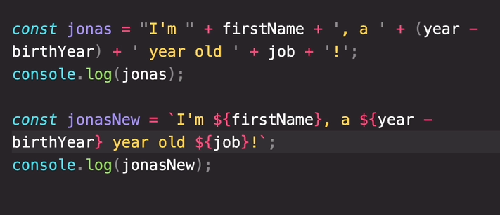

###### Bool

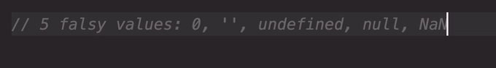

All other values will return true if we convert to bool

##### Non-primitive

###### Array

###### Object

##### Conversion and coercion

###### Conversion

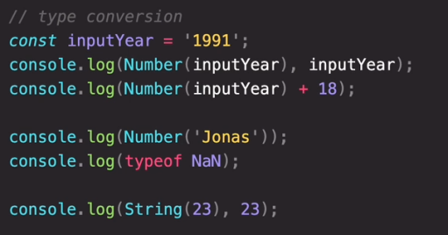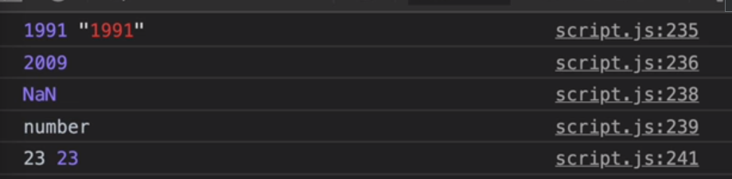

###### Coercion

**(+) Converts number to string**

var num = "5";

var sum = num + 10; // sum is "510" (num is coerced into a string before addition)

**(-, /, *) Converts string to number**

var result = "10" - 5;

console.log(result); // Output: 5 (string "10" is coerced into a number)

#### Operators

2**3 represents 2 power 3

String addition and subtraction

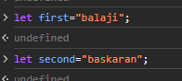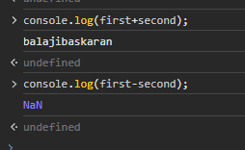

##### Equality operator

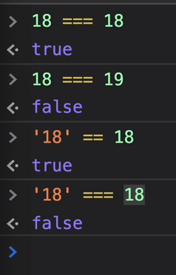

Always recommended to use ===

#### Switch

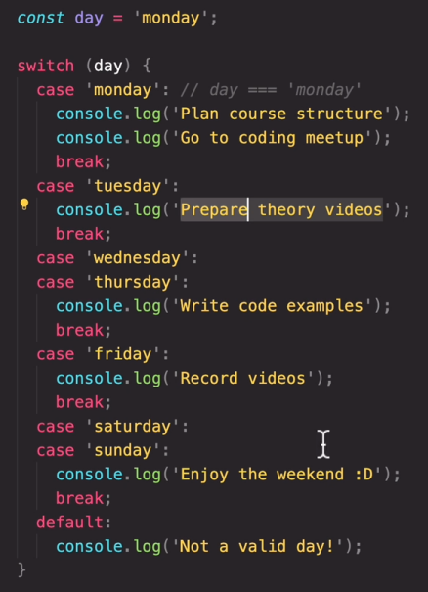

#### Function

***Refer: DotnetDev\Webpages\Udemy\JsMyRef\function.js for code***

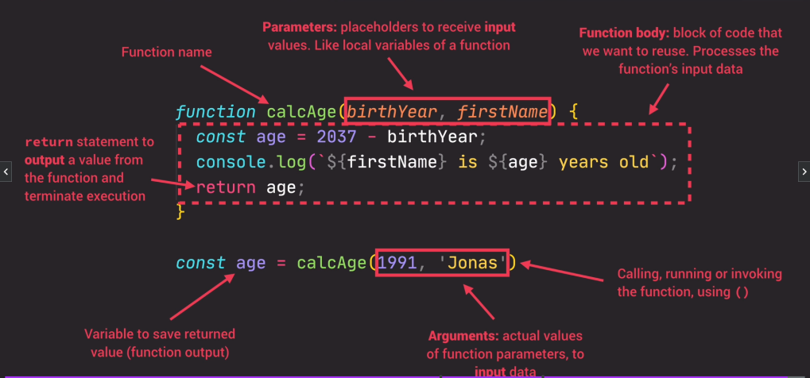

#### DOM

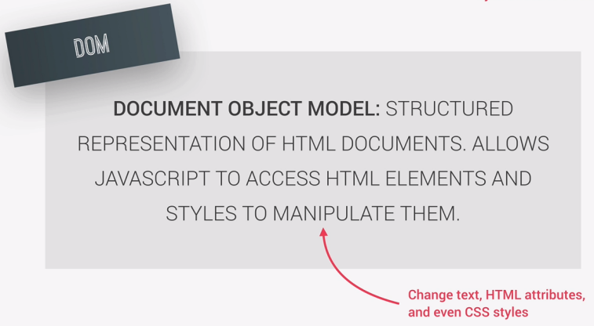

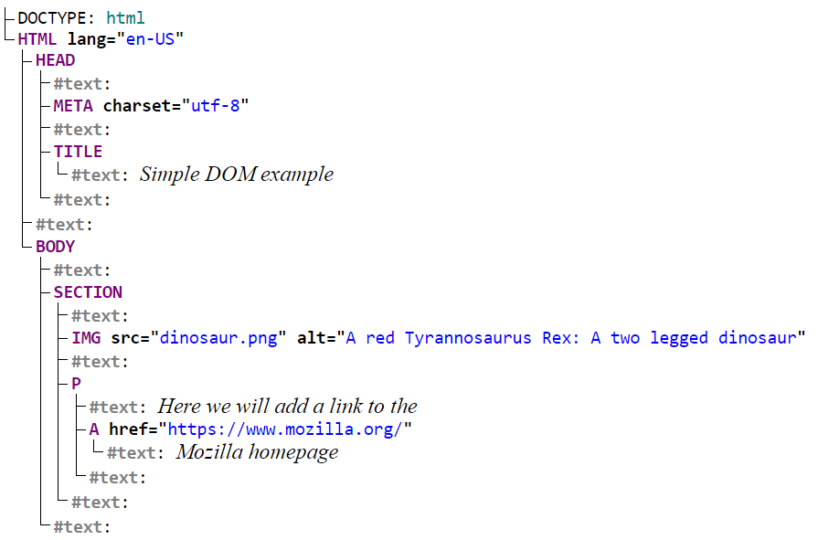

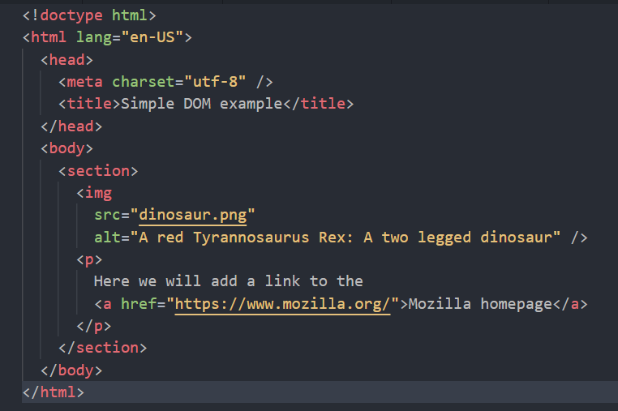

#### Spread Operator

Also known as … operator

Can be used in

1. Function calls

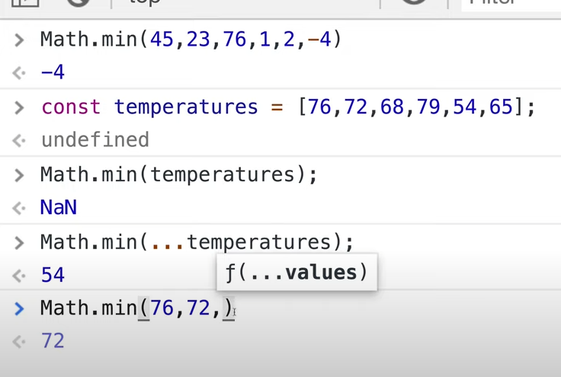

Math.min(…) takes spread operator as parameter. So ***Zero or more numbers*** can be given as input***.***

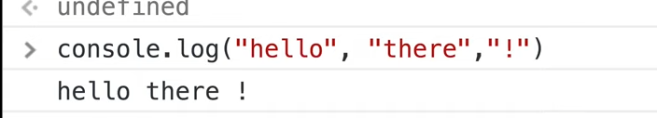

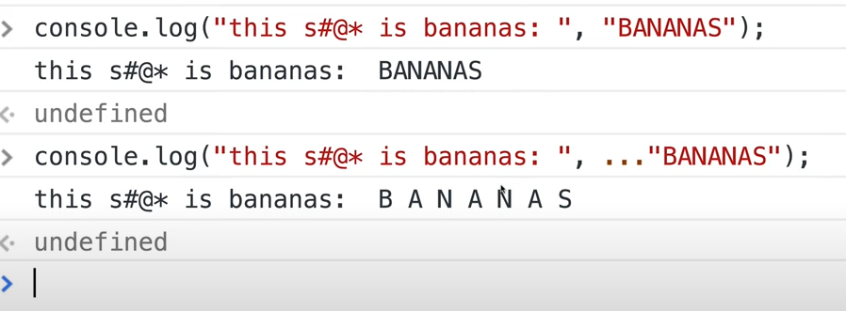

…”BANANAS” splits the string and passes each character as separate input.

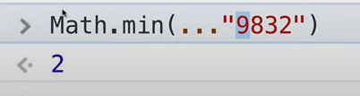

1. Array literals

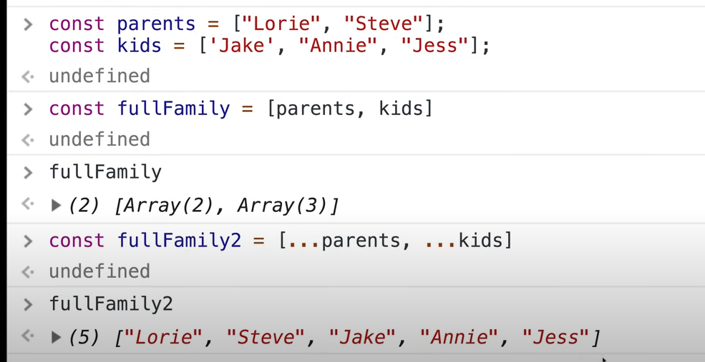

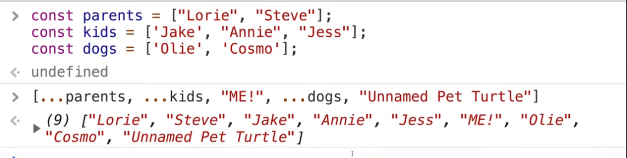

1. Object literals

### React

## WEB API

### References

Nick - Dometrain

### REST

#### Six constraints to make API services RESTful

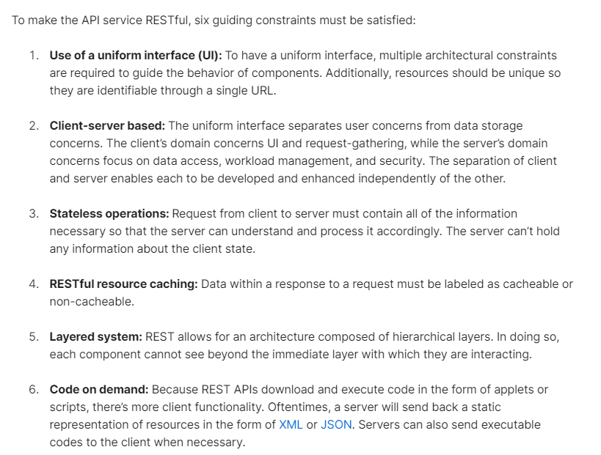

Source: [Link](https://blog.postman.com/rest-api-examples/)

### Misc and Questions

#### Interview Questions

#### Redis Output caching

Reference youtube video: <https://www.youtube.com/watch?v=_bg5dGnudPs>

## MVC

### Program.cs

Contains,

Services required by app are configured

Request handling pipeline -> Series of middleware components

#### Dependency injection (services)

***builder is a WebApplicationBuilder***

**builder.Services.**AddRazorPages();

**builder.Services.**AddControllersWithViews();

**builder.Services.**AddDbContext<RazorPagesMovieContext>(options =>

options.UseSqlServer(builder.Configuration.GetConnectionString("RPMovieContext")));

### Razor Pages

### Middleware

### Model

### View

### Controller

### Routing

#### Convention routing

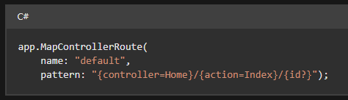

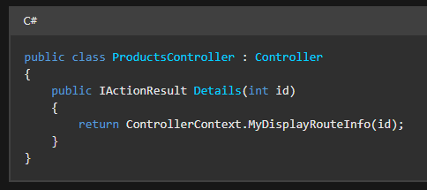

Url: /Products/Details/5

{ controller = Products, action = Details, id = 5 }

#### Attribute routing