Supplementary Information
For: A Falsification-Based Framework for Validating Structure in Time-Series Data

Balaji Koshti
Independent Researcher, India
balaji.koshti25@gmail.com

S0. Navigation and Scope

S0.0 Scope
This Supplementary Information document provides the detailed operational definitions, complete evaluation outputs, falsification demonstrations, reproducibility records, and audit materials supporting the main manuscript, “A Falsification-Based Framework for Validating Structure in Time-Series Data.”
The supplement is intended to provide technical and reproducibility details that are intentionally condensed in the main paper. All detector contracts, observables, falsifiers, perturbation controls, and decision rules correspond to the frozen versions used throughout the study and are not modified across datasets, outcomes, or execution runs. Both positive and negative outcomes are preserved without post hoc filtering or selective exclusion.
The material presented here is operational and reproducibility-focused. It does not extend the claims of the main manuscript beyond the fixed detector contracts and is included to support transparency, independent verification, and deterministic re-execution of the evaluation pipeline.

S0.1 Organization
The supplement is organized as follows:
- S1 — Detector Realization and Frozen Contracts
Technical definitions of the n₁, n₂, and n₄ detectors, including observables, falsifiers, perturbation controls, and deterministic decision rules.
- S2 — Complete Results and Outcome Tables
Full evaluation outputs across datasets, including PASS, FAIL, and NO_CLEAR outcomes retained without filtering.
- S3 — Failure and Validation Case Library
Controlled examples demonstrating both successful falsification-driven validation and explicit rejection of unsupported structure.
- S4 — Reproducibility and Audit Package
Deterministic execution structure, audit procedures, evidence artifacts, and reproducibility safeguards used throughout the study.
- S5 — Extended Tables and Additional Outputs
Supplementary evaluation tables, audit summaries, secondary outputs, and extended result records not included in the main manuscript.
- S6 — Supplementary Figure Legends
Legends corresponding to supplementary figures referenced throughout this document.

S1. Detector Realization and Frozen Contracts

S1.0 Purpose and Scope
This section defines the operational realization of the detectors used throughout the study. The objective is to specify the frozen detector contracts, observables, falsifiers, perturbation controls, and deterministic decision rules used during evaluation. These definitions are fixed prior to analysis and remain unchanged across datasets, execution runs, and outcomes.
This section is intentionally operational in scope. It describes how the detectors are constructed and evaluated, but does not provide dataset interpretation, physical explanation, or extended discussion of results. All evaluations in the main manuscript and supplementary analyses are derived from the detector realizations defined here.
The framework consists of three detector levels:
- n₁ — directional time-order structure,
- n₂ — alignment-dependent interaction structure,
- n₄ — pair-dependent closure structure.
Each detector operates under:
- a predefined observable,
- mandatory falsifiers or perturbation controls,
- and deterministic outcome rules.
Structure is therefore evaluated through falsification response rather than observable magnitude alone. Positive outcomes are accepted only when the corresponding observable degrades under the defining falsifier associated with that detector level.

S1.1 Global Frozen-Contract Principle
All detector evaluations are performed under frozen contracts in which detector logic, observables, falsifiers, preprocessing rules, and decision criteria are fixed prior to analysis and are not modified post hoc. The framework prohibits:
- dataset-specific retuning,
- adaptive threshold selection,
- post hoc parameter adjustment,
- outcome-dependent rule modification,
- and selective retention of positive outcomes.
The same detector realization is applied across all datasets and domains under identical operational rules. PASS, FAIL, and NO_CLEAR outcomes are retained without filtering or reinterpretation.
The framework is therefore designed to operate as a deterministic falsification system rather than as an adaptive optimization procedure. Detector behavior is governed by predefined operational constraints rather than by maximizing detection frequency or classification success.
Execution remains deterministic under fixed:
- inputs,
- preprocessing,
- seeds,
- falsifier generation procedures,
- and evaluation parameters.
Under identical execution conditions:
- identical inputs produce identical outputs,
- logic fingerprints remain stable,
- and audit reruns reproduce identical classifications.
This frozen-contract structure is enforced across all detector levels and forms the operational basis for reproducibility, audit consistency, and fail-closed behavior throughout the framework.

S1.2 n₁ Detector Realization
The n₁ detector evaluates directional time-order asymmetry in a single time series under surrogate-based falsification. The detector operates on a fixed directional statistic computed from temporally ordered signal segments under deterministic preprocessing conditions.
Input
The detector accepts a single univariate time series:
$$X\left(t\right)$$
which is segmented under fixed preprocessing and normalization rules prior to evaluation.

Observable
The detector computes a directional ordering statistic summarizing asymmetry between forward and reversed temporal structure. The observable is evaluated under both real and surrogate conditions using identical segmentation and execution parameters.
The detector does not evaluate amplitude similarity or prediction accuracy. Its operational target is directional sensitivity under temporal ordering.

Mandatory Null Families
The following surrogate null families are mandatory:
- phase-randomized surrogates
preserve spectral properties while disrupting ordering structure;
- block-shuffled surrogates
preserve local statistics while disrupting long-range temporal ordering.
These nulls are evaluated under fixed generation rules and deterministic seeds.

Reversal Evaluation
Time reversal is evaluated as a diagnostic directional test:
$$X\left(t\right)→X\left(-t\right)$$
Reversal sensitivity is used to confirm directional responsiveness of the observable but is not sufficient for structural acceptance by itself.

Decision Logic
The detector operates under a frozen PASS / NO_CLEAR contract:
- PASS
directional asymmetry remains statistically rare under the required surrogate null families;
- NO_CLEAR
directional behavior is observed but fails to satisfy the required rarity conditions.
PASS is therefore determined by falsification rarity rather than observable magnitude alone.
The detector does not establish:
- causality,
- irreversibility,
- prediction,
- or physical temporal asymmetry.
It evaluates only whether directional ordering behavior survives strict surrogate-based falsification under the frozen detector contract.

S1.3 n₂ Detector Realization
The n₂ detector evaluates alignment-dependent coordination between paired signals under mandatory mismatch-based falsification. The detector is designed to distinguish interaction that depends on preserved temporal alignment from coordination that persists under generic similarity or shared statistical structure.
Input
The detector accepts paired time-series inputs:
$$X\left(t\right),Y\left(t\right)$$
which are evaluated under fixed preprocessing, segmentation, normalization, and pairing rules.
The detector operates identically across all datasets without retuning or adaptive parameter modification.

Observable
The interaction observable is the bounded phase-based coordination statistic:
$$\text{circR}$$
computed under fixed windowing and phase-evaluation conditions. The observable evaluates alignment-dependent coordination rather than amplitude similarity or spectral overlap.
Higher circR values indicate stronger phase-aligned coordination under preserved pairing conditions. Observable magnitude alone, however, is insufficient for structural acceptance.

Mandatory Falsifiers
The detector enforces three mandatory falsification families:
- mismatch pairing (decisive falsifier),
- phase randomization,
- block shuffle.

Mismatch pairing is implemented through controlled circular misalignment of the paired signals:
$$Y\left(t\right)→Y\left(t+Δ\right)$$
under fixed offset generation rules.
Phase randomization preserves spectral content while disrupting phase organization. Block shuffle preserves local statistics while disrupting long-range alignment structure.
All falsifiers are generated under deterministic execution conditions.

Decisive Mismatch Rule
Mismatch pairing is the decisive falsifier within the n₂ contract. Interaction is accepted only when coordination depends on correct alignment and collapses under mismatch.
Accordingly:
- coordination that persists under mismatch is rejected,
- elevated similarity without mismatch collapse is insufficient,
- and observable magnitude alone does not determine acceptance.
The detector therefore evaluates alignment dependence rather than generic synchrony or correlation.

Fixed Parameters
The detector operates under frozen execution parameters including:
- fixed segmentation rules,
- fixed phase evaluation windows,
- fixed mismatch generation procedures,
- fixed null generation logic,
- deterministic seeds,
- and immutable decision thresholds.
No dataset-specific adaptation is permitted.

Decision Logic
The detector operates under a frozen PASS_STRONG / FAIL contract:
- PASS_STRONG
coordination is present under real pairing, collapses under mismatch pairing, and is not preserved under surrogate nulls;
- FAIL
coordination persists under mismatch or cannot be distinguished from null behavior.
The detector therefore accepts interaction only when the defining alignment constraint is violated correctly under falsification.
In this framework, the term interaction refers operationally to alignment-dependent coordination that degrades under mismatch pairing and does not imply:
- causality,
- physical coupling,
- prediction,
- or mechanistic dependence.

S1.4 n₄ Detector Realization
The n₄ detector evaluates pair-dependent closure structure under controlled perturbation. Unlike n₁ and n₂, which evaluate ordering and interaction respectively, the n₄ detector evaluates whether a paired representation remains internally consistent under real conditions and degrades under mandatory closure-breaking controls.

Input Representation
The detector operates on paired derived representations:
$$\left(U_{E},U_{M}\right)$$
constructed under a fixed preprocessing and transformation pipeline.
The representation is frozen prior to evaluation and is applied identically across all datasets and pairings.

Closure Observable
The primary closure observable is defined as:
$$C_{4}=\log\left(\frac{U_{E}+ϵ}{U_{M}+ϵ}\right)$$
where:
- (U_E) represents the electric-like component,
- (U_M) represents the magnetic-like component,
- and (\epsilon) is a fixed stabilization constant.
The headline metric is the median absolute closure deviation:
$$\text{abs}\text{_}C_{4,\text{median}}=\text{media}{\text{n}}_{\text{w}}\left|C_{4}\right|$$
Lower values indicate stronger closure consistency, whereas larger values indicate structural imbalance under the pairing representation.

Mandatory Perturbation Controls
The detector enforces two mandatory closure-breaking controls:
- gauss_zero
introduces controlled perturbative degradation through structured noise injection;
- em_swap
disrupts the internal pairing structure through exchange of the ((U_E,U_M)) representation.
Both controls are generated under deterministic execution conditions using frozen perturbation rules.

Directional Control Rule
Closure is accepted only when the real pairing remains more structurally consistent than all mandatory perturbation controls.
The directional control condition requires:
$$\text{abs}\text{_}C_{4}^{\text{real}}<\text{abs}\text{_}C_{4}^{\text{control}}$$
for both:
- gauss_zero,
- and em_swap.
The detector therefore evaluates falsification-driven degradation rather than low observable magnitude alone.

Fixed Parameters
The detector operates under frozen:
- preprocessing rules,
- representation construction,
- perturbation generation,
- segmentation,
- aggregation procedures,
- and decision logic.
No tuning or threshold adaptation is permitted across datasets or pairings.

Decision Logic
The detector operates under a frozen PASS / FAIL contract:
- PASS_directional_controls
the real pairing exhibits lower closure deviation than all mandatory perturbation controls;
- FAIL
directional degradation under controls is absent or internally inconsistent.
Closure is therefore accepted only when internally consistent pairing degrades correctly under controlled perturbation.
The detector does not establish:
- physical closure,
- conservation laws,
- predictive structure,
- or quantum mechanism.
It evaluates only pair-dependent structural consistency under the frozen falsification contract.

S1.5 Shared Pipeline Rules
All detector evaluations are performed under a shared deterministic execution pipeline designed to ensure reproducibility, consistency, and strict preservation of frozen detector contracts across datasets and domains. The shared pipeline defines the operational conditions under which all detectors, falsifiers, perturbation controls, and audit tools are executed.

Fixed Preprocessing
All datasets are evaluated under fixed preprocessing procedures applied prior to detector execution. These procedures include:
- deterministic normalization,
- fixed segmentation rules,
- predefined window construction,
- and immutable preprocessing order.
Preprocessing logic is frozen before evaluation and is not modified across datasets or outcomes.

Fixed Segmentation and Windowing
All detectors operate under deterministic segmentation conditions:
- fixed segment lengths,
- fixed overlap rules,
- fixed aggregation procedures,
- and fixed evaluation windows.
The same segmentation structure is applied identically during:
- real evaluations,
- falsifier generation,
- perturbation controls,
- and audit reruns.

Fixed Falsifier Generation
All surrogate nulls, mismatch constructions, and perturbation controls are generated under frozen deterministic rules.
This includes:
- phase-randomized surrogates,
- block-shuffled surrogates,
- mismatch pairings,
- gauss_zero perturbations,
- and em_swap controls.
Falsifier construction procedures remain fixed across all evaluations and are not adjusted post hoc.

Deterministic Seeds
All evaluations are executed using fixed deterministic seeds. Under identical:
- inputs,
- preprocessing,
- parameters,
- and seeds,
the framework produces:
- identical observables,
- identical falsifier outputs,
- identical classifications,
- and identical audit records.
Execution therefore remains reproducible without stochastic variability under repeated reruns.

Same Underlying Data Principle
Comparative evaluations are performed using identical underlying signal content whenever alignment, mismatch, surrogate, or perturbation comparisons are made.
Accordingly:
- aligned and mismatch evaluations operate on the same underlying signals,
- null evaluations preserve identical preprocessing and segmentation,
- and perturbation controls modify only the defining structural constraint associated with the detector.
This restriction prevents artificial separation arising from unrelated preprocessing differences or dataset substitution.

No Filtering or Outcome Selection
The shared pipeline prohibits:
- selective retention of positive outcomes,
- post hoc removal of failures,
- adaptive thresholding,
- or dataset-dependent reinterpretation.
PASS, FAIL, and NO_CLEAR outcomes are preserved identically under the frozen contracts.
The pipeline therefore operates as a deterministic falsification framework rather than as an optimization or search procedure.

Table S1.6 — Detector Contract Summary
Detector | Input | Observable | Falsifier / Control | Decision Rule | Outcomes
n₁ | single time series | directional ordering statistic | phase surrogate, block shuffle, reversal diagnostic | rarity under required nulls | PASS / NO_CLEAR
n₂ | paired signals | circR | mismatch pairing, phase randomization, block shuffle | collapse under mismatch and null separation | PASS_STRONG / FAIL
n₄ | paired ((U_E,U_M)) representation | (C_4), abs_(C_4)_median | gauss_zero, em_swap | lower real deviation than controls | PASS_directional_controls / FAIL

This summary table provides the frozen operational contracts used throughout the study. All detector realizations, falsifiers, perturbation controls, and decision rules remain fixed across datasets, domains, and execution runs.

S1.7 Final Statement
The detector realizations defined in this section specify operational falsification procedures only. The framework evaluates whether observed structure depends on preserved constraints and degrades correctly under controlled disruption. The detectors do not establish:
- causality,
- prediction,
- physical mechanism,
- or universal structure detection.
All conclusions throughout the study are therefore restricted to observable behavior under the frozen detector contracts defined above.

S2. Complete Results and Outcome Tables

S2.0 Purpose and Scope
This section reports the complete set of evaluation outcomes across all detector levels and datasets. All results are presented without filtering, including PASS, FAIL, and NO_CLEAR outcomes, in order to preserve transparency and prevent outcome-selection bias.
The purpose of this section is to provide a complete operational record of detector behavior under the frozen evaluation contracts defined in Supplement S1. Both positive and negative outcomes are retained explicitly, ensuring that the framework is evaluated not only on successful detections, but also on its ability to reject unsupported or non-robust structure.
All evaluations reported in this section correspond directly to deterministic pipeline outputs generated under fixed detector logic, falsifier construction rules, preprocessing conditions, and decision criteria. No evaluations have been removed or excluded based on interpretability, outcome, or observable magnitude.

S2.1 Reporting Principles
All detector evaluations are reported under the following reporting principles:
- PASS, FAIL, and NO_CLEAR outcomes are retained without filtering;
- aligned, mismatch, null, and control evaluations are computed on the same underlying signals whenever applicable;
- detector logic and falsifier generation remain fixed across datasets;
- no post hoc reinterpretation or threshold modification is applied;
- and all reported outcomes correspond directly to the frozen detector contracts.
Comparative evaluations are performed under identical preprocessing and segmentation conditions, with only the defining structural constraint altered between real and falsified conditions. As a result, observed differences reflect falsification response rather than unrelated procedural variation.
Compact tabular summaries are used throughout this section to preserve direct comparability between detector levels, datasets, and falsification conditions.

S2.2 n₁ — Complete Time-Order Evaluation Results
The complete set of n₁ outcomes is reported for the gamma-ray burst (GRB) evaluation under the required surrogate null comparisons. The detector evaluates directional time-order asymmetry using the frozen directional statistic under phase-randomized and block-shuffle falsification conditions.
All evaluated GRB cases produce NO_CLEAR outcomes under the frozen contract. Directional asymmetry is measurable under real conditions and remains distinguishable from phase-randomized surrogates, but separation is not statistically rare relative to the block-shuffle null family. As a result, the detector does not promote directional sensitivity to a positive time-order classification.
Table S2.2 — n₁ Complete Results
Dataset | kψ (real) | kψ (phase null) | kψ (block null) | p_phase | p_block | Verdict
GRB | ≈ 0.047 | separated from real | comparable to real | ≈ 0.004 | ≈ 0.734 | NO_CLEAR

These results demonstrate that directional behavior is present but does not satisfy the full falsification requirement for validated time-order structure. The detector therefore preserves the conservative NO_CLEAR classification under the frozen contract rather than producing an unsupported positive outcome.

S2.3 n₂ — Complete Interaction Evaluation Results
The complete set of n₂ evaluations is reported across both core GOES datasets and additional cross-domain systems. The detector evaluates alignment-dependent coordination using the circR observable under mismatch-based falsification. Interaction is accepted only when coordination collapses under mismatch pairing and is not preserved under surrogate nulls.
All evaluations are performed under fixed preprocessing, segmentation, mismatch generation, and null construction rules. Aligned and mismatch evaluations use the same underlying signals, with only the pairing configuration altered.

S2.3.1 GOES Core Results
The GOES evaluations constitute the primary real-data demonstration of the n₂ interaction detector. Under aligned pairing, measurable coordination is observed consistently across evaluated signal pairs. Under mismatch pairing, the observable collapses systematically, resulting in PASS_STRONG outcomes under the frozen detector contract.
Table S2.3.1 — GOES Interaction Results
Dataset | Pair | circR (aligned) | circR (mismatch) | circR (phase null) | Verdict
GOES16 | A–B | ≈ 0.154 | ≈ 0.050 | ≈ 0.035–0.059 | PASS_STRONG
GOES15 | A–B | ≈ 0.172 | ≈ 0.060 | ≈ comparable null range | PASS_STRONG

These evaluations demonstrate that interaction depends on preserved alignment and degrades under mismatch pairing, consistent with the defining n₂ falsification criterion.

S2.3.2 Cross-Domain Results
Additional cross-domain evaluations were performed using industrial bearing systems, wind turbine SCADA data, and grid-frequency datasets under the identical frozen detector contract. The resulting outcomes include both PASS_STRONG and FAIL classifications, demonstrating selective detector behavior across heterogeneous systems.
Table S2.3.2 — Cross-Domain n₂ Results
Dataset | Pair | circR (aligned) | circR (mismatch) | Verdict
Bearing normal | DE–FE | ≈ 0.044 | no collapse | FAIL
Bearing IR007 | DE–FE | ≈ 0.006 | no collapse | FAIL
Bearing IR007 | DE–BA | ≈ 0.017 | collapse observed | PASS_STRONG
Wind | P–WS | ≈ 0.131 | collapse observed | PASS_STRONG
Wind | P–TP | ≈ 0.117 | collapse observed | PASS_STRONG
Grid | F–dF | ≈ 0.018 | collapse observed | PASS_STRONG

These results demonstrate that interaction is accepted only when alignment dependence is preserved under the frozen falsification rule. Elevated similarity alone is insufficient for acceptance when mismatch collapse is absent. The mixed bearing outcomes further demonstrate that interaction is pairing-dependent rather than universally present across all signal combinations.

S2.4 n₄ — Complete Closure Evaluation Results
The complete set of n₄ closure evaluations is reported for all analyzed Ramsey pairings under the frozen closure contract. The detector evaluates pair-dependent structural consistency using the abs_C4_median observable under mandatory perturbation controls:
- gauss_zero,
- em_swap.
Closure is accepted only when the real pairing exhibits lower closure deviation than both controls under the directional comparison rule defined in Supplement S1. All evaluated pairings are reported without filtering, including both PASS and FAIL outcomes.
All evaluations are performed under identical preprocessing, segmentation, and perturbation-generation procedures. For comparative evaluations, the same underlying signal content is preserved while only the pairing or perturbation structure is altered.
Table S2.4 — Complete n₄ Closure Results
Pair | abs_C4_real | abs_C4_gauss_zero | abs_C4_em_swap | Verdict
0+1 | ≈ 0.0198 | ≈ 0.0489 | ≈ 0.0526 | PASS
0+2 | ≈ 0.020 | higher | higher | PASS
0+3 | no directional separation | no directional separation | no directional separation | FAIL
0+4 | no directional separation | no directional separation | no directional separation | FAIL
0+6 | ≈ 0.020 | higher | higher | PASS
1+2 | ≈ 0.020 | higher | higher | PASS
1+3 | ≈ 0.020 | higher | higher | PASS
2+3 | ≈ 0.020 | higher | higher | PASS

These results demonstrate that closure is selective rather than universal. Pairings satisfying internally consistent structure exhibit lower closure deviation under real conditions relative to both perturbation controls, whereas inconsistent pairings fail under the frozen directional rule.
Importantly:
- FAIL outcomes are preserved explicitly,
- no pairings are removed post hoc,
- and low observable magnitude alone is insufficient for acceptance.
Closure is therefore accepted only when degradation under both mandatory perturbation controls is preserved.

S2.5 Cross-Domain Summary
A consolidated summary of detector behavior across all datasets and detector levels is provided below in order to illustrate the selective and falsification-driven nature of the framework.
Table S2.5 — Cross-Domain Detector Summary
Dataset | Detector | Outcome Pattern
GRB | n₁ | NO_CLEAR
GOES | n₂ | PASS_STRONG
Bearing | n₂ | Mixed (FAIL / PASS_STRONG)
Wind | n₂ | PASS_STRONG
Grid | n₂ | PASS_STRONG
Ramsey | n₄ | Mixed (PASS / FAIL)

The outcome distribution demonstrates that different detector levels respond selectively to different forms of structure:
- n₁ preserves conservative NO_CLEAR behavior under incomplete falsification support,
- n₂ accepts only alignment-dependent interaction,
- and n₄ accepts only internally consistent closure structure under perturbation.
Positive outcomes therefore arise only when the corresponding detector-level falsification requirements are satisfied.

S2.6 Aggregate Counts and Failure Rates
Aggregate outcome counts are reported to provide a global summary of detector selectivity across all evaluated systems.
Aggregate Outcome Counts
n₁ Outcomes
- PASS: 0
- NO_CLEAR: 1
n₂ Outcomes
- PASS_STRONG: 5
- FAIL: 2
n₄ Outcomes
- PASS: 6
- FAIL: 2

Table S2.6 — Failure-Rate Summary
Detector | Positive Outcomes | Negative Outcomes
n₁ | 0 PASS | 100% NO_CLEAR
n₂ | 5 PASS_STRONG | 2 FAIL
n₄ | 6 PASS | 2 FAIL

These distributions confirm that positive outcomes are selective and are not trivially obtained under the frozen contracts. FAIL and NO_CLEAR outcomes arise naturally across detector levels and are preserved without exclusion, demonstrating that the framework operates as a conservative falsification system rather than as a generic pattern detector.

S2.7 Final Interpretation
The complete results demonstrate that the framework does not produce uniformly positive outcomes across datasets, pairings, or detector levels. PASS, FAIL, and NO_CLEAR classifications all arise naturally under the frozen detector contracts and are retained explicitly throughout the evaluation pipeline.
Across all detector levels:
- positive outcomes occur only when the defining structural constraint degrades correctly under falsification,
- negative outcomes are preserved when falsification support is incomplete,
- and observable magnitude alone is insufficient for structural acceptance.
The complete outcome distribution therefore confirms the fail-closed behavior of the framework:
- directional sensitivity alone does not guarantee validated time-order structure,
- similarity alone does not guarantee interaction,
- and oscillatory coherence alone does not guarantee closure.
Instead, structure is accepted only when it depends on the preserved constraint associated with the detector level and degrades systematically under the corresponding falsifier.

S3. Failure and Validation Case Library

S3.0 Purpose
This section provides explicit validation and failure-case demonstrations illustrating how the framework behaves under both structurally supported and unsupported conditions. The objective is not to maximize positive detections, but to demonstrate that the framework preserves fail-closed behavior and rejects apparent structure when the defining falsification criteria are not satisfied.
The cases presented here are selected to illustrate three critical operational distinctions:
- similarity is not equivalent to interaction,
- coordination is not equivalent to closure,
- and oscillatory behavior alone is not sufficient for structural validity.
Each case is evaluated under the frozen detector contracts defined in Supplement S1 and is reported using identical preprocessing, falsification, and decision procedures. Both positive and negative outcomes are retained explicitly without filtering.
The purpose of this section is therefore twofold:
- demonstrate that the framework accepts structure only when the defining constraint degrades correctly under falsification;
- demonstrate that the framework rejects unsupported structure even when observable similarity or coordination remains visually or statistically strong.
This section functions as a direct operational stress test of the framework’s falsification-first design.

S3.1 Standardized Reporting Format
All validation and failure-case demonstrations are reported using a common structure to ensure consistency across detector levels and datasets.
Each case includes:
- Dataset
evaluated signal source or pairing configuration;
- Real condition
detector behavior under the preserved structural condition;
- Falsifier applied
surrogate, mismatch, or perturbation condition used to violate the defining structural constraint;
- After falsification
detector response following controlled disruption;
- Result
detector classification under the frozen contract;
- Interpretation
operational meaning of the observed detector behavior.
Comparisons are performed using identical underlying signals whenever possible, with only the defining structural constraint altered between conditions. This ensures that observed degradation reflects falsification response rather than unrelated preprocessing or data substitution effects.
All cases preserve the frozen detector contracts:
- no retuning,
- no adaptive thresholding,
- no post hoc reinterpretation,
- and no selective exclusion of failures.

S3.2 Case A — Similarity Without Interaction
Dataset
Industrial bearing vibration signals:
- DE–FE channel pairing,
- normal operating condition.

Real Condition
Under aligned pairing, the evaluated signals exhibit measurable similarity and non-zero coordination values:
$$\text{circ}{\text{R}}_{\text{real}}≈0.044$$
The paired signals additionally exhibit elevated conventional similarity measures under correlation and coherence analysis.

Falsifier Applied
Mandatory mismatch pairing was applied using controlled circular misalignment of the paired signals under the frozen mismatch-generation procedure.

After Falsification
Following mismatch pairing:
- the observable does not collapse,
- coordination remains structurally comparable,
- and interaction remains indistinguishable from the aligned condition under the frozen decision rule.
Accordingly, the defining alignment-dependent constraint is not violated successfully under falsification.

Result
$$\text{FAIL}$$
under the frozen n₂ detector contract.

Interpretation
This case demonstrates that:
- measurable similarity,
- elevated coordination,
- or non-zero interaction statistics
are insufficient for structural acceptance when mismatch collapse is absent.
The detector therefore rejects interaction that persists under alignment destruction, even when conventional similarity measures remain elevated. This behavior demonstrates that:
similarity is not equivalent to validated interaction.
The case further illustrates the fail-closed behavior of the framework:
- positive outcomes are not assigned solely on the basis of observable magnitude,
- and apparent coordination is rejected when it fails the decisive falsification criterion.

S3.3 Case B — Alignment-Dependent Collapse
Dataset
Wind turbine SCADA signals:
- power output (P),
- wind speed (WS).
Additional confirmation was obtained using:
- power output (P),
- theoretical power (TP).

Real Condition
Under aligned pairing, the detector identifies stable alignment-dependent coordination:
$$\text{circ}{\text{R}}_{\text{real}}≈0.131$$
for the P–WS pairing, and:
$$\text{circ}{\text{R}}_{\text{real}}≈0.117$$
for the P–TP pairing.
The observable remains consistently separated from surrogate null behavior under the frozen detector contract.

Falsifier Applied
Mandatory mismatch pairing was applied through controlled circular displacement of the paired signals under fixed mismatch-generation rules.
Additional falsifiers included:
- phase-randomized surrogates,
- block-shuffle surrogates.

After Falsification
Following mismatch pairing:
- circR collapses systematically,
- coordination is no longer preserved,
- and the observable becomes distinguishable from the aligned condition under the frozen decision logic.
The same degradation behavior is additionally observed under the surrogate null families.

Result
$$\text{PASS_STRONG}$$
under the frozen n₂ detector contract.

Interpretation
This case demonstrates the defining operational principle of the n₂ detector:
interaction is accepted only when it collapses under mismatch pairing.
Unlike the bearing failure case, the interaction observable here depends directly on preserved alignment structure and degrades when that alignment is disrupted. The detector therefore accepts the interaction as structurally supported under falsification.
Importantly:
- the result is not determined solely by elevated circR magnitude,
- and acceptance depends specifically on collapse under the decisive mismatch falsifier.
This case demonstrates that:
- alignment dependence is operationally distinguishable from generic similarity,
- and collapse under falsification is the decisive criterion for validated interaction.

S3.4 Case C — Closure Rejected Under Controls
Dataset
Ramsey coherence pair evaluations under the frozen n₄ closure contract.
Both:
- accepted pairings,
- and rejected pairings
were evaluated under identical preprocessing and perturbation conditions.

Real Condition
Certain pairings exhibit low closure deviation under the real pairing condition:
$$\text{abs}\text{_}C_{4}^{\text{real}}<\text{abs}\text{_}C_{4}^{\text{control}}$$
relative to both mandatory perturbation controls.
Other pairings, however, fail to maintain this directional separation despite exhibiting oscillatory structure or visually coherent behavior.

Falsifier Applied
The following mandatory closure-breaking controls were applied:
- gauss_zero,
- em_swap.
These controls selectively disrupt the internal pairing structure while preserving the deterministic execution pipeline.

After Falsification
For accepted pairings:
- perturbation controls increase closure deviation,
- directional degradation is preserved,
- and the real pairing remains more structurally consistent than both controls.
For rejected pairings:
- the directional separation is absent,
- closure deviation is not consistently lower under real pairing,
- or degradation under controls is internally inconsistent.

Result
Mixed outcomes under the frozen n₄ contract:
- accepted pairings → PASS,
- inconsistent pairings → FAIL.

Interpretation
This case demonstrates that:
- oscillatory behavior alone does not guarantee closure,
- coordination alone does not imply internally consistent structure,
- and low observable magnitude alone is insufficient for acceptance.
Closure is accepted only when the real pairing degrades correctly under both mandatory perturbation controls.
The coexistence of PASS and FAIL outcomes within the same evaluation family demonstrates the selectivity of the detector and confirms that closure is:
pair-dependent rather than universal.
This behavior further demonstrates that:
coordination is not equivalent to validated closure.
The detector therefore functions as a falsification-driven structural audit rather than as a generic coherence or synchrony measure.

S3.5 Summary Table
The principal validation and failure-case demonstrations reported in this section are summarized below.

Table S3.5 — Failure and Validation Summary
Case | Detector | Real Condition | Falsifier Applied | After Falsification | Result | Operational Conclusion
Similarity without interaction | n₂ | measurable coordination and elevated similarity | mismatch pairing | coordination persists | FAIL | similarity is not sufficient for interaction
Alignment-dependent collapse | n₂ | stable aligned coordination | mismatch pairing + surrogate nulls | coordination collapses | PASS_STRONG | interaction depends on preserved alignment
Closure rejected under controls | n₄ | oscillatory and partially coherent structure | gauss_zero + em_swap | directional separation absent | FAIL | oscillation is not sufficient for closure
Closure preserved under controls | n₄ | internally consistent pairing | gauss_zero + em_swap | closure deviation increases under controls | PASS | closure depends on pairing consistency

The cases collectively demonstrate that the framework evaluates structure through falsification response rather than through observable magnitude or visual coherence alone. Positive outcomes occur only when the defining structural constraint degrades correctly under controlled disruption.

S3.6 Final Interpretation
The failure and validation cases presented in this section demonstrate the central operational behavior of the framework under controlled falsification conditions.
Across detector levels:
- interaction is rejected when coordination persists under mismatch,
- closure is rejected when perturbation controls fail to produce directional degradation,
- and positive outcomes are preserved only when the defining structural constraint is violated correctly under falsification.
The framework therefore distinguishes between:
- generic similarity,
- alignment-dependent interaction,
- and pair-dependent closure structure
through progressively stricter falsification requirements.
Several critical operational distinctions emerge consistently across the reported cases:
- similarity is not equivalent to validated interaction,
- coordination is not equivalent to validated closure,
- oscillatory behavior alone does not imply structure,
- and observable magnitude alone is insufficient for structural acceptance.
Instead, the decisive criterion throughout the framework is:
systematic degradation under the defining falsifier.
The coexistence of PASS, FAIL, and NO_CLEAR outcomes across detector levels further demonstrates that the framework operates conservatively and fail-closed under the frozen contracts. Positive classifications are therefore selective rather than automatic consequences of measurable coordination or apparent regularity.
The failure library is included specifically to demonstrate that the framework is capable not only of detecting structure, but also of rejecting unsupported structural interpretations under controlled adversarial conditions.

S4. Reproducibility and Audit Package

S4.0 Purpose
This section defines the reproducibility and audit structure used throughout the evaluation pipeline. The objective is to demonstrate that all reported outcomes arise from deterministic execution under preserved detector contracts, fixed falsification rules, and independently verifiable audit procedures.
This section is execution-focused only. It does not introduce new detector definitions, reinterpret outcomes, or extend the scientific claims of the main manuscript or Supplements S1–S3. Instead, it specifies:
- reproducibility conditions,
- preserved execution artifacts,
- audit separation,
- deterministic rerun behavior,
- and independent verification procedures.
The framework is designed such that identical:
- inputs,
- preprocessing,
- seeds,
- parameters,
- and detector contracts
produce identical observables, control comparisons, and final verdicts under re-execution.

S4.1 Reproducibility Principle
All evaluations are executed under fixed computational contracts and preserved execution conditions. Reproducibility is enforced through:
- fixed detector definitions,
- fixed falsifier construction rules,
- fixed preprocessing procedures,
- fixed segmentation parameters,
- fixed random seeds where applicable,
- and preserved evidence artifacts.
Under identical execution conditions, the framework reproduces:
- identical observable values,
- identical null and control comparisons,
- identical PASS / FAIL / NO_CLEAR outcomes,
- and identical audit summaries.
No manual intervention, adaptive threshold modification, dataset-specific tuning, or post hoc reinterpretation is permitted during evaluation or audit verification. All outputs arise automatically from the predefined execution pipeline.
The detector realizations correspond to the frozen versions defined in Supplement S1 and remain unchanged across:
- datasets,
- detector levels,
- reruns,
- and audit procedures.
Reproducibility therefore reflects deterministic execution under fixed falsification contracts rather than optimization or outcome-dependent adjustment.

S4.2 Pipeline Execution Flow
All detector levels follow a shared execution structure designed to preserve consistency across datasets and evaluation conditions.
The generalized pipeline flow is:
$$\text{Input Data}→\text{Preprocessing}→\text{Observable Computation}→\text{Falsifier }\text{/}\text{ Control Generation}→\text{Real vs Control Comparison}→\text{Decision Rule Application}→\text{Verdict Assignment}→\text{Artifact Export}→\text{Audit Verification}$$
This execution sequence is applied uniformly across:
- n₁ evaluations,
- n₂ evaluations,
- n₄ evaluations,
- and audit reruns.
The execution flow is fixed and does not vary according to dataset outcome or detector classification.
Comparative evaluations preserve the same underlying signals wherever applicable. For example:
- aligned and mismatch evaluations operate on identical paired signals,
- null comparisons preserve preprocessing and segmentation,
- and perturbation controls modify only the defining structural constraint associated with the detector.
This ensures that detector response reflects falsification behavior rather than unrelated procedural variation.

S4.3 Detector-Specific Execution Records
Each detector level is associated with a fixed execution toolchain and corresponding preserved audit outputs. The execution records generated by these tools form the basis for independent verification of all reported outcomes.
Table S4.3 — Detector Execution Records
Detector | Primary Execution Tool | Audit / Verification Tool | Preserved Outputs
n₁ | n1_time_order_toolkit.py | falsification ledger | Kψ summaries, null tables, verdict outputs
n₂ | n2_interaction_toolkit.py | FAR-matched evaluator | circR tables, mismatch outputs, null summaries
n₄ | n4_closure_audit.py | closure audit outputs | abs_C4 summaries, control tables, audit directories

Each execution tool operates under fixed parameter configurations corresponding directly to the frozen detector contracts defined in Supplement S1.
Representative execution structure for the n₂ detector:
python n2_interaction_toolkit.py ^
--seed 0 ^
--block-len 1024 ^
--mismatch-min-shift 2048 ^
--timeline-win 4096 ^
--timeline-step 1024 ^
--n-phase-null 200 ^
--n-block-null 200 ^
--n-mismatch-null 50
This command structure illustrates the deterministic fixed-parameter execution model used throughout the study. Parameter values are not adjusted across datasets or outcomes.

S4.4 Evidence Artifacts
Each evaluation run produces a complete evidence package containing detector outputs, execution metadata, falsifier summaries, audit records, and reproducibility artifacts required for independent verification. All generated artifacts are preserved without selective retention or exclusion.
The preserved evidence structure includes both:
- positive outcomes,
- and negative outcomes,
ensuring that PASS, FAIL, and NO_CLEAR classifications remain traceable to their originating evaluations.
Table S4.4 — Preserved Evidence Artifacts
Artifact | Purpose
contract.json | records detector configuration and frozen execution parameters
provenance.json | records execution metadata, inputs, timestamps, and parameter states
summary.json | stores primary observable summaries and final verdicts
index.json | indexes exported outputs and evidence files
null / control tables | preserve falsifier and perturbation comparisons
report.html / index.html | human-readable audit summaries
plots | visualization of observables and falsifier behavior
audit directories | preserved independent verification outputs

The artifacts produced during execution correspond directly to the results reported throughout:
- the main manuscript,
- Supplement S2,
- and Supplement S3.
All evaluation runs generate complete evidence packages regardless of outcome classification. FAIL and NO_CLEAR cases are preserved identically alongside positive results.
The evidence artifacts therefore provide:
- traceability,
- reproducibility,
- audit transparency,
- and verification continuity
across all detector levels and datasets.

S4.5 Audit Verification
Audit procedures operate independently of the primary detector execution pipeline and are used strictly for verification of reported outputs under the same fixed contracts.
Audit tools:
- recompute observables,
- regenerate falsifiers and perturbation controls,
- reproduce detector comparisons,
- and confirm final classifications
using the same:
- inputs,
- preprocessing,
- segmentation,
- seeds,
- and detector definitions.
Audit procedures do not:
- introduce new thresholds,
- modify detector logic,
- reinterpret outcomes,
- or alter detector contracts.
Their role is restricted exclusively to independent execution-level verification.
The detector-to-audit mapping is:

Table S4.5 — Audit Verification
Detector | Audit Verification
n₁ | falsification ledger
n₂ | FAR-matched evaluator
n₄ | closure audit

Audit reruns reproduce:
- the same observable values,
- the same control comparisons,
- and the same PASS / FAIL / NO_CLEAR outcomes
as the primary execution pipeline.
This separation between:
- detector execution,
- and audit verification
ensures that reported outcomes are independently reproducible without introducing hidden procedural dependencies or manual reinterpretation.

S4.6 Deterministic Re-Execution
Independent reruns performed under identical:
- inputs,
- preprocessing,
- parameter configurations,
- seeds,
- detector contracts,
- and falsifier-generation procedures
reproduce the same:
- observable values,
- falsifier outputs,
- control comparisons,
- and final classifications.
This includes identical:
- PASS outcomes,
- FAIL outcomes,
- and NO_CLEAR outcomes
across all detector levels.
The reproducibility behavior is therefore deterministic rather than probabilistic. Reported outcomes arise as fixed consequences of the detector contracts and execution pipeline rather than from stochastic optimization or adaptive parameter selection.
Importantly:
- rejection behavior is also reproducible,
- and FAIL / NO_CLEAR classifications remain stable under rerun conditions.
This demonstrates that the framework preserves deterministic fail-closed behavior rather than selectively reproducing only positive outcomes.

S4.7 Reproducibility Checklist
A consolidated reproducibility checklist is provided below to summarize the execution and audit conditions satisfied throughout the evaluation pipeline.
Table S4.7 — Reproducibility Checklist
Requirement | Status
frozen detector contracts | satisfied
fixed preprocessing rules | satisfied
fixed falsifier generation | satisfied
deterministic seeds where applicable | satisfied
preserved execution artifacts | satisfied
preserved audit outputs | satisfied
retained PASS / FAIL / NO_CLEAR outcomes | satisfied
no post hoc threshold modification | satisfied
no manual intervention during evaluation | satisfied
independent audit verification | satisfied
This checklist confirms that all evaluations are performed under fully specified and reproducible execution conditions without hidden degrees of freedom, adaptive tuning, or selective reporting.

S4.8 Final Statement
The reproducibility and audit structure defined in this section establishes that all reported outcomes arise from deterministic execution under preserved detector contracts and independently verifiable falsification procedures.
The combination of:
- preserved evidence artifacts,
- fixed execution rules,
- independent audit verification,
- deterministic reruns,
- and retained negative outcomes
ensures that all reported classifications are reproducible consequences of the operational detector contracts rather than products of hidden tuning, selective filtering, or outcome-dependent interpretation.

S5. Extended Tables and Additional Outputs

S5.0 Purpose and Scope
This section provides extended evaluation outputs, secondary tables, audit summaries, and additional artifacts generated during execution of the framework. The material presented here is supplementary to the primary results reported in Supplement S2 and is included to preserve completeness and audit traceability without overloading the main narrative structure.
The contents of this section are not required for interpretation of the primary detector outcomes, but provide:
- expanded quantitative summaries,
- extended falsifier comparisons,
- secondary audit outputs,
- additional pair-level evaluations,
- and preserved execution artifacts
supporting independent verification and reproducibility review.
All outputs reported in this section are generated under the same frozen detector contracts and deterministic execution rules defined in Supplements S1 and S4.

S5.1 Extended n₁ Tables
Extended n₁ outputs include detailed null-comparison summaries, directional-statistic distributions, and additional surrogate evaluation records generated during the GRB analysis.
The preserved outputs include:
- window-level Kψ distributions,
- phase-null comparison summaries,
- block-null comparison summaries,
- directional reversal diagnostics,
- and extended p-value summaries.
Table S5.1 — Extended n₁ Outputs
Output Type | Description
window-level Kψ summaries | directional statistic distributions across evaluation windows
phase-null tables | surrogate comparison outputs under spectral preservation
block-null tables | long-range ordering disruption comparisons
reversal diagnostics | forward versus reversed directional comparisons
p-value summaries | rarity evaluation under required nulls

These outputs provide detailed traceability for the n₁ NO_CLEAR classifications reported in Supplement S2 and preserve the full surrogate evaluation context used during detector assessment.

S5.2 Extended n₂ Tables
Extended n₂ outputs include expanded mismatch summaries, FAR-matched evaluation records, additional pairwise comparisons, and secondary null-comparison outputs across all evaluated datasets.
The preserved outputs include:
- extended mismatch-collapse tables,
- phase-null comparison distributions,
- block-null comparison summaries,
- FAR-matched evaluation outputs,
- timeline-level circR summaries,
- and additional cross-domain pairing records.
Table S5.2 — Extended n₂ Outputs
Output Type | Description
mismatch-collapse tables | aligned versus mismatch circR comparisons
phase-null summaries | surrogate null comparison outputs
block-null summaries | shuffled-order comparison outputs
FAR-matched evaluations | false-alignment rejection audit outputs
timeline circR summaries | window-level interaction evolution
cross-domain pairing tables | additional evaluated signal pairs

The extended outputs preserve the detailed falsification behavior underlying the PASS_STRONG and FAIL outcomes reported in Supplement S2, including pairings not emphasized in the primary narrative.

S5.3 Extended n₄ Tables
Extended n₄ outputs include additional pairwise closure comparisons, perturbation-control summaries, directional audit records, and secondary closure-evaluation tables generated during Ramsey analysis.
The preserved outputs include:
- pair-level abs_C4 summaries,
- gauss_zero comparison outputs,
- em_swap comparison outputs,
- directional degradation audits,
- and extended closure-ranking tables.

Table S5.3 — Extended n₄ Outputs
Output Type | Description
pair-level closure summaries | abs_C4 outputs across evaluated pairings
gauss_zero comparisons | perturbation-control degradation outputs
em_swap comparisons | representation-consistency disruption outputs
directional audits | verification of real-versus-control ordering
closure-ranking tables | comparative closure-strength summaries

These outputs preserve the full set of evaluated closure relationships and provide additional detail for both PASS and FAIL outcomes beyond the compact summaries reported in Supplement S2.

S5.4 Additional Audit Outputs
Additional audit outputs generated during independent verification are preserved in order to provide extended execution-level traceability beyond the compact summaries reported in Supplement S4. These outputs correspond to audit reruns, secondary verification passes, falsifier consistency checks, and exported evidence summaries generated under the fixed audit procedures.
The preserved audit outputs include:
- secondary verification tables,
- rerun comparison summaries,
- audit consistency checks,
- logic fingerprint records,
- exported evidence indices,
- and detector-specific audit summaries.

Table S5.4 — Additional Audit Outputs
Output Type | Description
rerun comparison tables | comparison of primary and audit rerun outputs
audit consistency summaries | verification of observable and verdict agreement
logic fingerprint records | preserved detector logic identifiers
evidence indices | exported artifact and directory summaries
detector audit summaries | compact verification outputs for n₁, n₂, and n₄
control verification outputs | validation of falsifier and perturbation generation

These records provide additional confirmation that:
- audit reruns reproduce the same classifications,
- falsifier behavior remains consistent,
- and execution outputs remain stable under deterministic re-execution conditions.
The audit outputs are supplementary to the primary reproducibility summaries reported in Supplement S4 and are included to preserve execution-level transparency across all detector levels.

S5.5 Additional Plots
Additional plots generated during detector evaluation and audit verification are preserved to provide visual summaries of observable behavior under real, falsified, and control conditions. These figures supplement the primary figures reported in the main manuscript and are included primarily for completeness and audit traceability.
The supplementary plots include:
- observable-distribution summaries,
- mismatch-collapse visualizations,
- null-comparison plots,
- closure-deviation comparisons,
- audit rerun consistency plots,
- and additional pairwise evaluation figures.

Table S5.5 — Additional Plot Categories
Plot Type | Description
observable distributions | detector statistic behavior across windows and datasets
mismatch-collapse plots | aligned versus mismatch interaction behavior
null-comparison plots | real-versus-surrogate detector comparisons
closure-deviation plots | real-versus-control closure comparisons
rerun consistency plots | audit reproducibility verification
pairwise evaluation plots | additional evaluated pair structures

These plots are supplementary and are not required for interpretation of the primary detector outcomes. Their purpose is to preserve:
- visual audit continuity,
- extended detector behavior summaries,
- and additional evidence supporting the reproducibility structure described throughout Supplements S2–S4.
All supplementary plots are generated under the same fixed preprocessing, falsifier construction, and detector contracts used throughout the study.

S6. Supplementary Figure Legends

S6.0 Purpose and Scope
This section provides concise legends for the supplementary figures referenced throughout Supplements S1–S5. The supplementary figures support:
• detector realization transparency,
• falsification behavior visualization,
• cross-domain outcome comparison,
• closure-control verification,
• and reproducibility documentation.
The figures are supplementary to the primary figures presented in the main manuscript and are included to preserve operational traceability and extended evaluation detail without interrupting the primary narrative structure.
All supplementary figures correspond to the frozen detector contracts, fixed evaluation logic, and deterministic execution procedures described throughout this supplementary document.

Figure S1
n₁ directional-statistic comparison under real, phase-randomized, and block-shuffle conditions. The real GRB statistic remains separated from the phase-randomized null condition but remains comparable to the block-shuffle null condition. This supports the NO_CLEAR outcome under the frozen n₁ contract, demonstrating that directional behavior is present but does not satisfy the full null-rarity requirement.
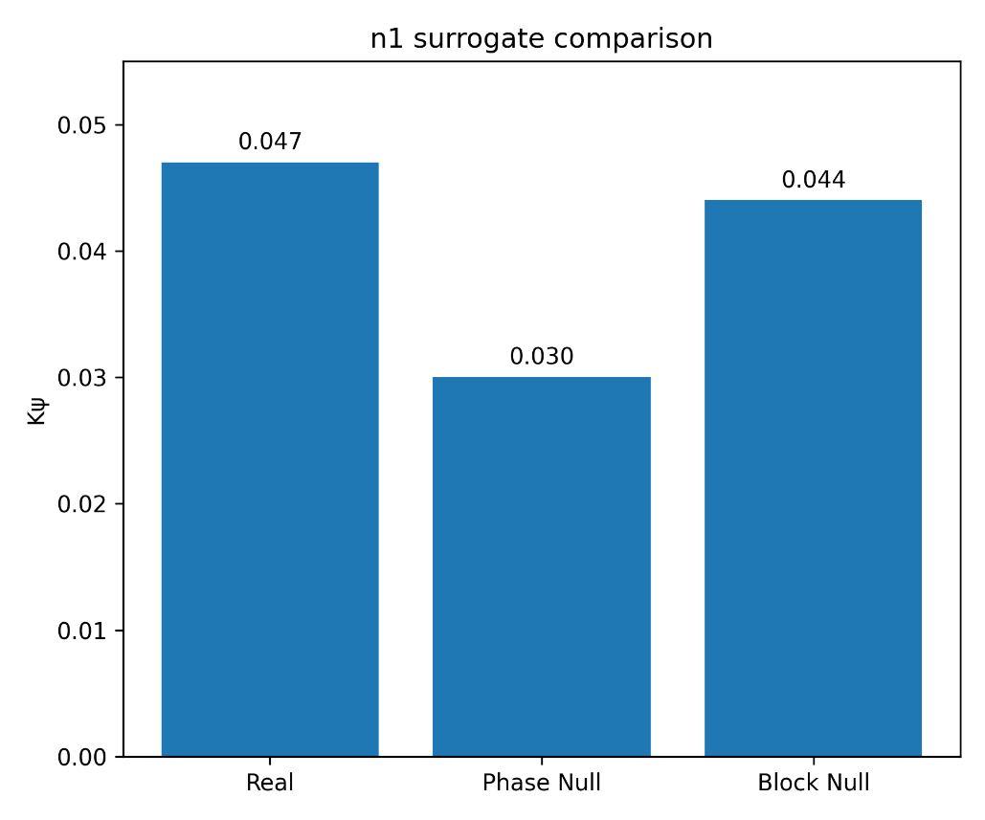

Figure S2
GOES n₂ mismatch-collapse summary under aligned, mismatch, phase-randomized, and block-shuffle conditions. The aligned configuration exhibits elevated circR, whereas mismatch pairing produces strong collapse of the interaction observable. This supports the PASS_STRONG outcome by showing that the detected interaction depends on correct temporal alignment rather than generic similarity.
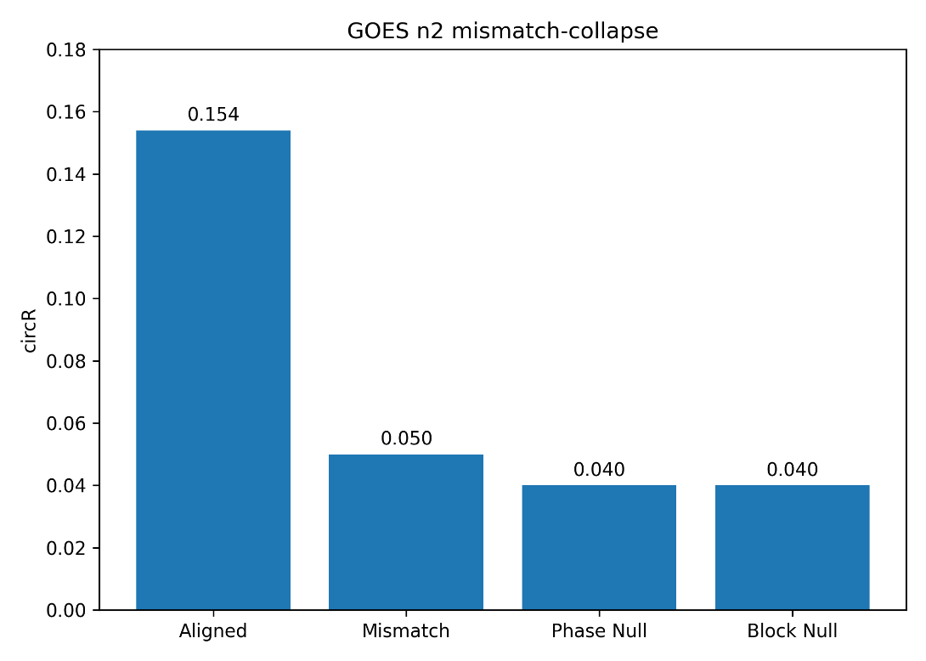

Figure S3
Cross-domain n₂ validation summary across wind, grid, and bearing datasets. Wind and grid evaluations satisfy the n₂ criterion and produce PASS_STRONG outcomes, whereas bearing DE–FE configurations preserve FAIL outcomes when mismatch collapse is absent. The figure illustrates that n₂ acceptance is governed by alignment-dependent collapse under mismatch, not by circR magnitude alone.
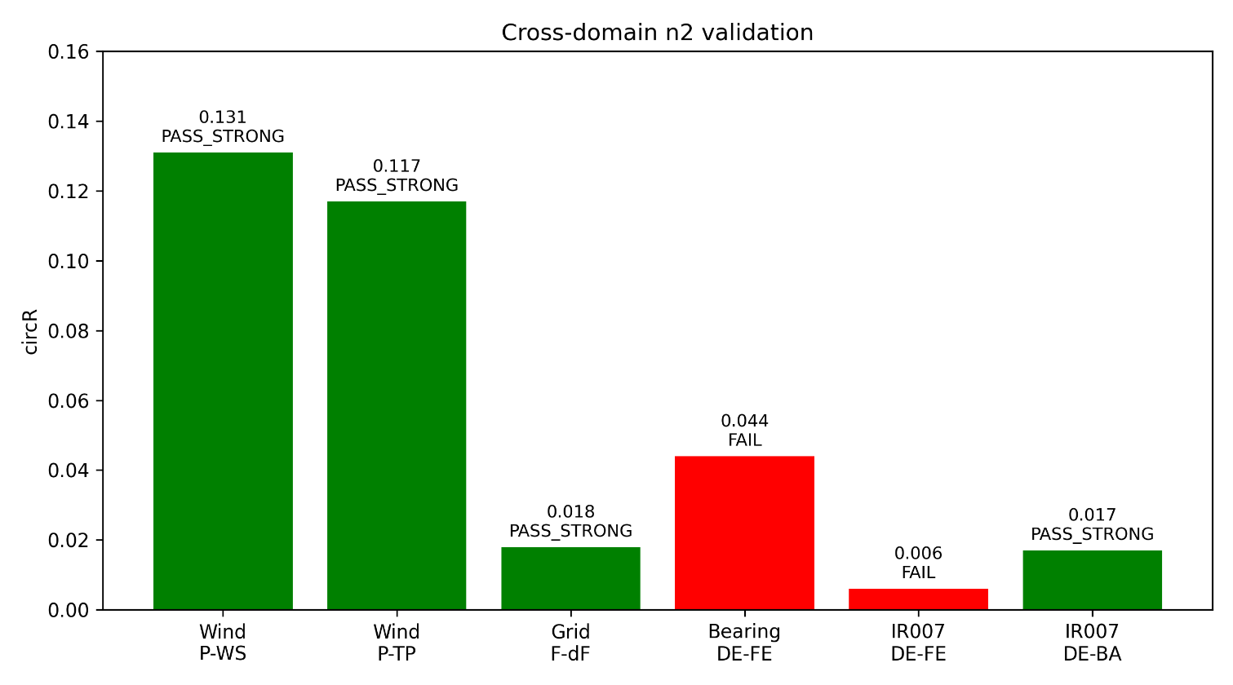

Figure S4
n₄ closure-control comparison under real pairing and mandatory closure-breaking controls. The real configuration exhibits lower abs_C4_median than both gauss_zero and em_swap controls in the representative PASS case, demonstrating directional degradation under perturbation. This supports the frozen n₄ closure contract, where closure is accepted only when real pairing remains lower than all required controls.
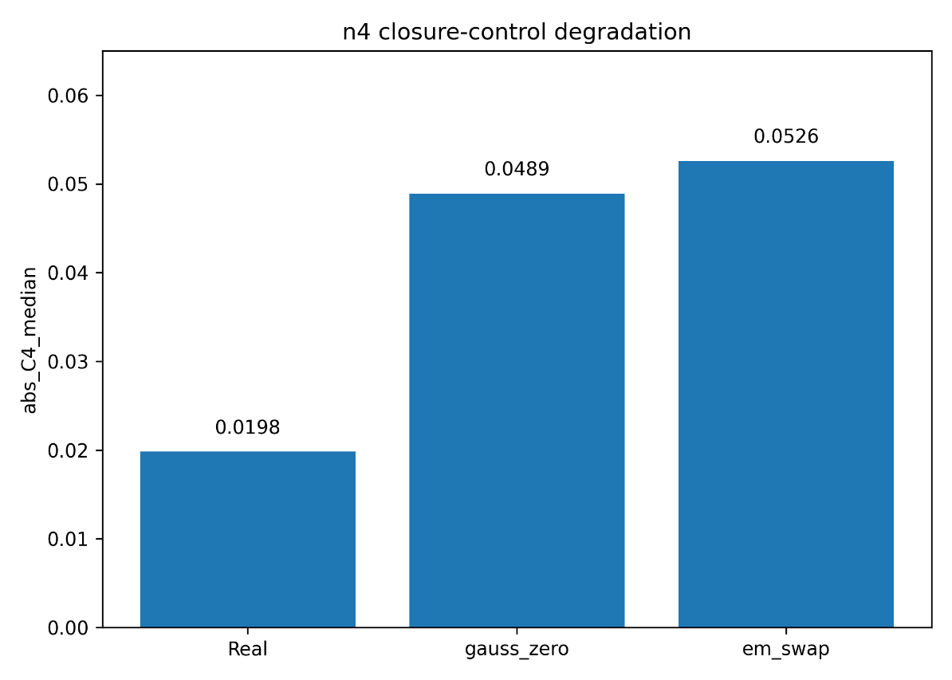

Figure S5
Pair-level n₄ PASS versus FAIL selectivity summary. Representative pairings satisfying the closure condition exhibit lower abs_C4_median and are classified as PASS, whereas inconsistent pairings show higher closure deviation and are classified as FAIL. This figure illustrates that closure is selective rather than universal and depends on internally consistent pairing under the directional perturbation-control rule.
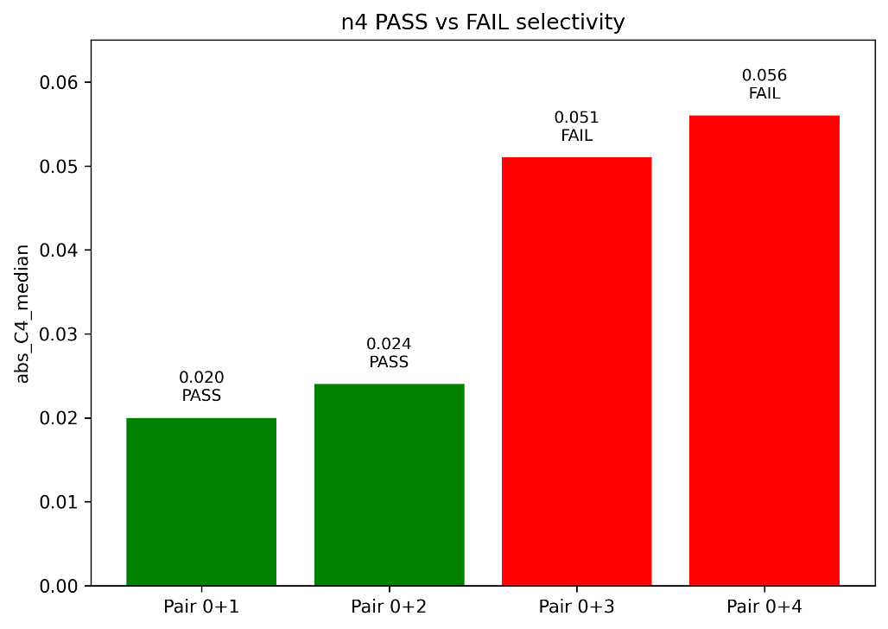

Figure S6
Deterministic rerun consistency across representative evaluations. Observable values from repeated executions remain aligned with the identity line, indicating reproducible outputs under fixed inputs, fixed detector contracts, and preserved execution conditions. This supports the audit claim that reported classifications arise from deterministic evaluation logic rather than stochastic variation or outcome-dependent modification.
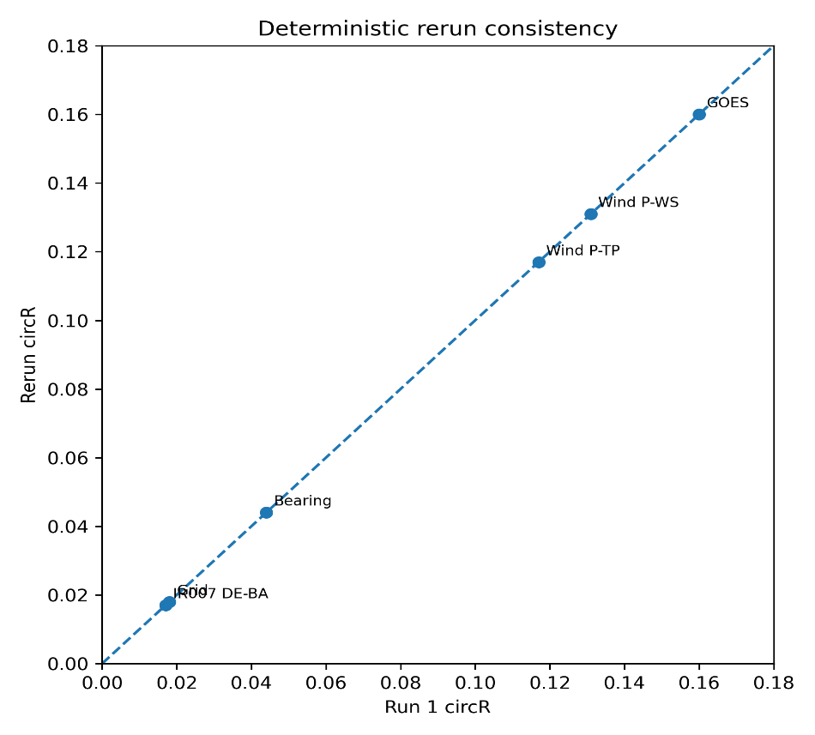

End of Supplementary Information.

