1. Architecture Diagram for DGB IBM MQ Integration

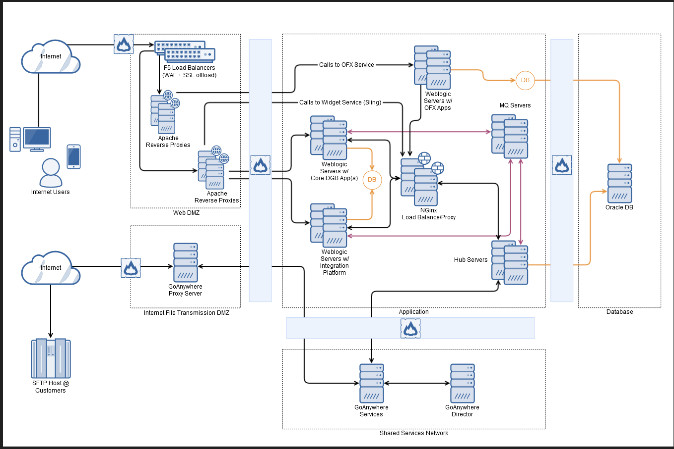

1. Digital Banking integration with Nginx (HA Load Balance within DGB)

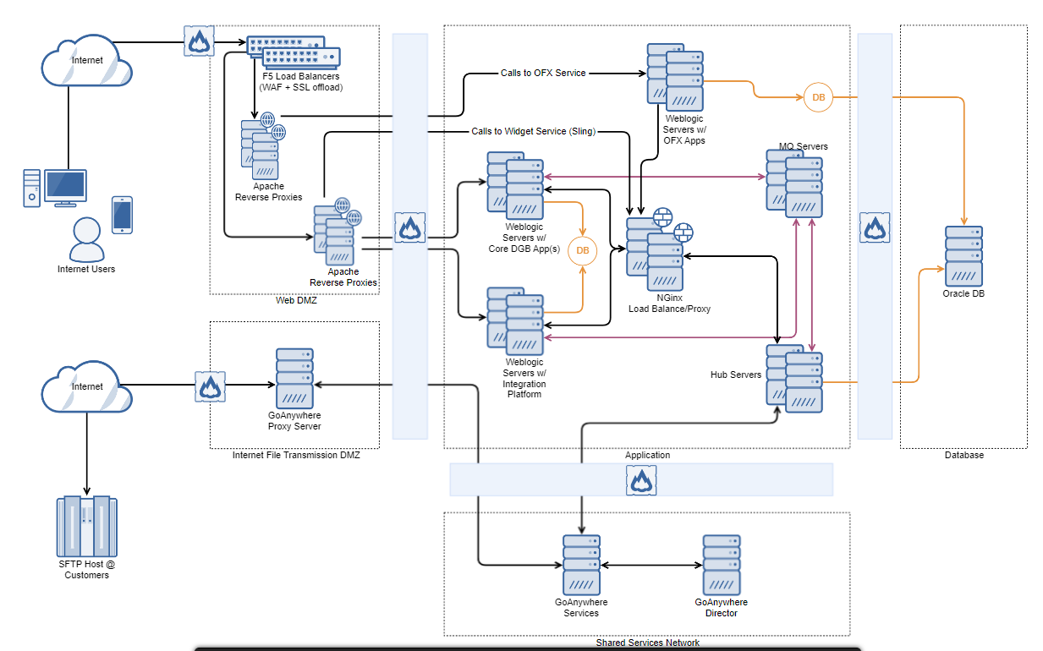

1. Digital Banking integration with Oracle RDBMS

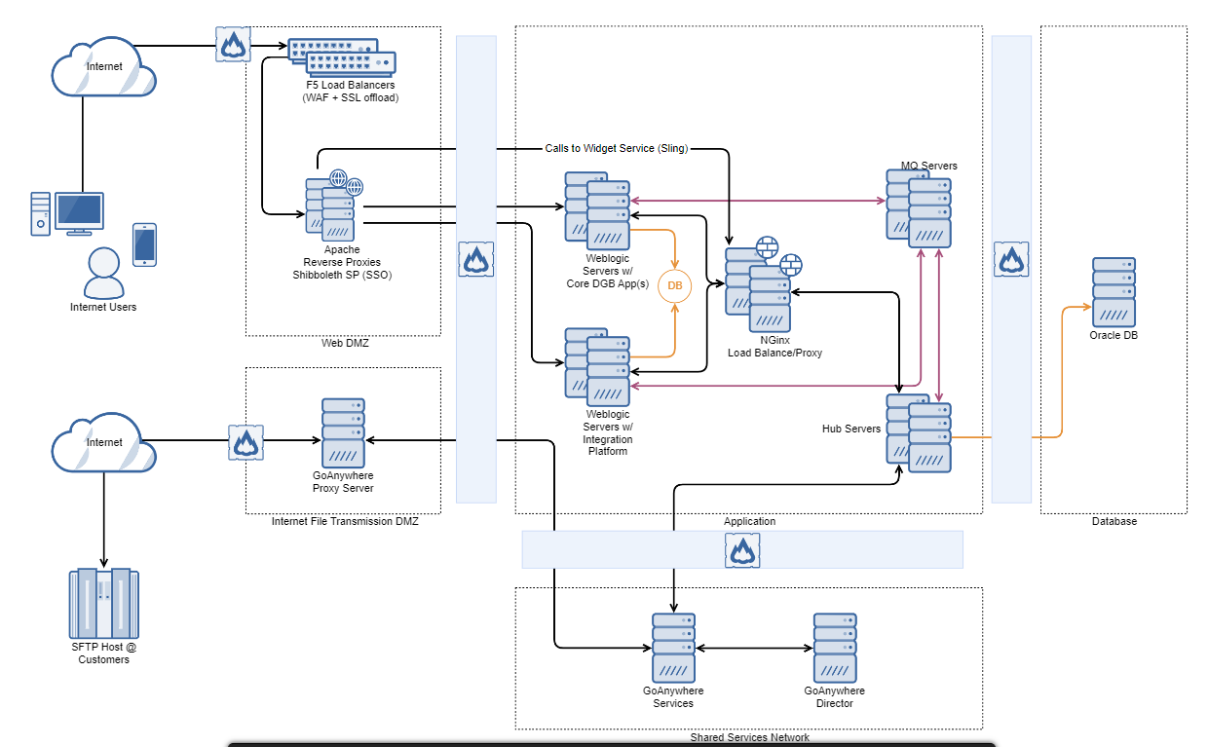

1. Digital Banking integration with Oracle WebLogic

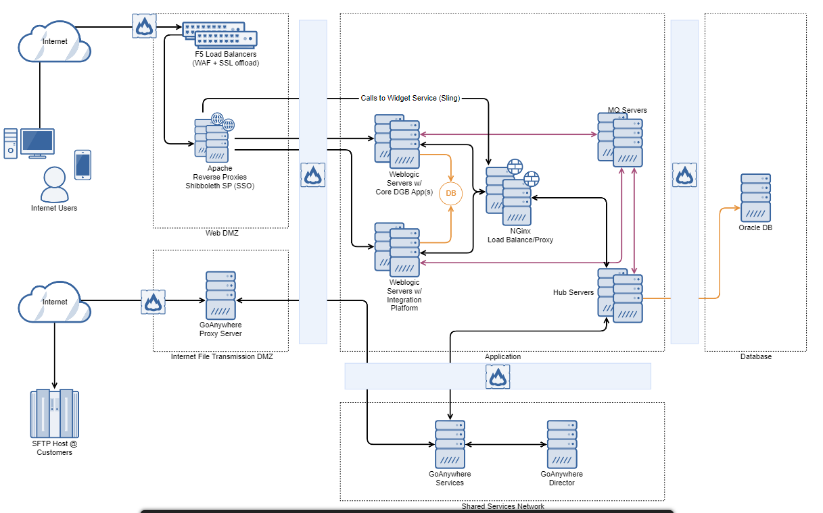

1. Digital Banking integration with pushNotification

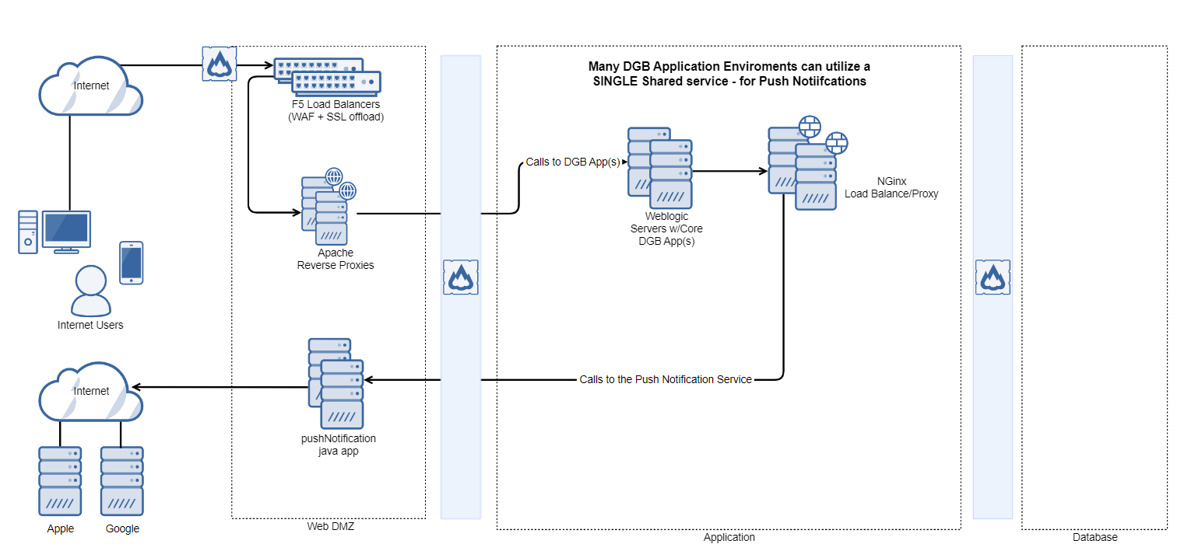

1. Digital Banking integration with Web Payment Fraud (WPF)

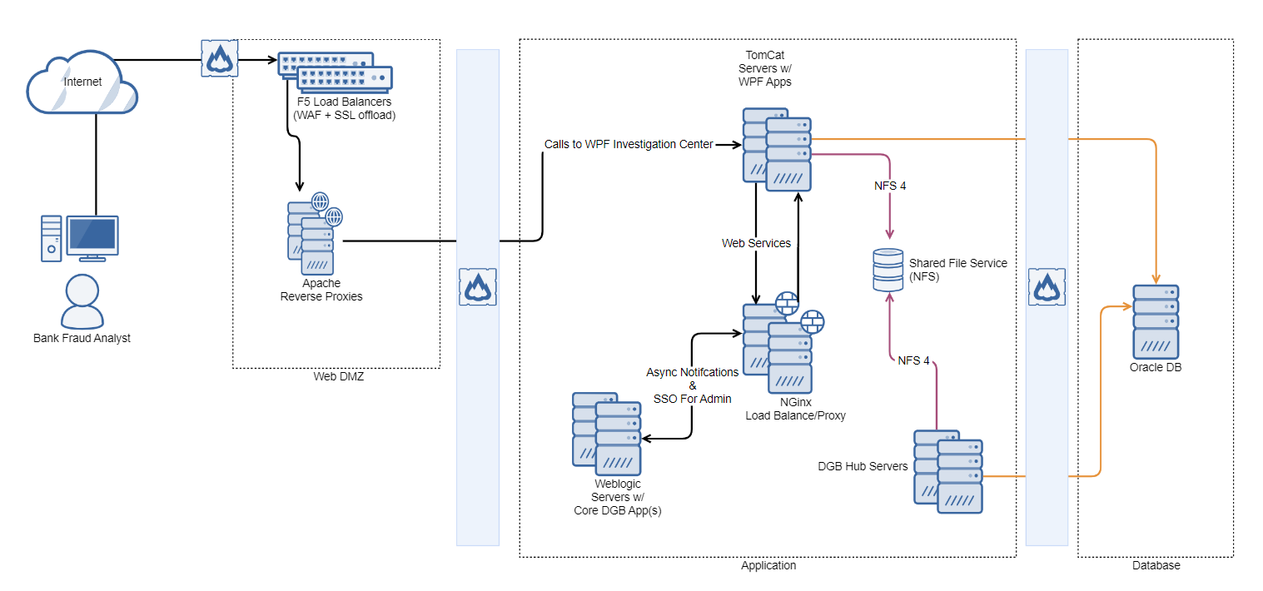

1. Digital Banking integration with Widget Service (Sling)

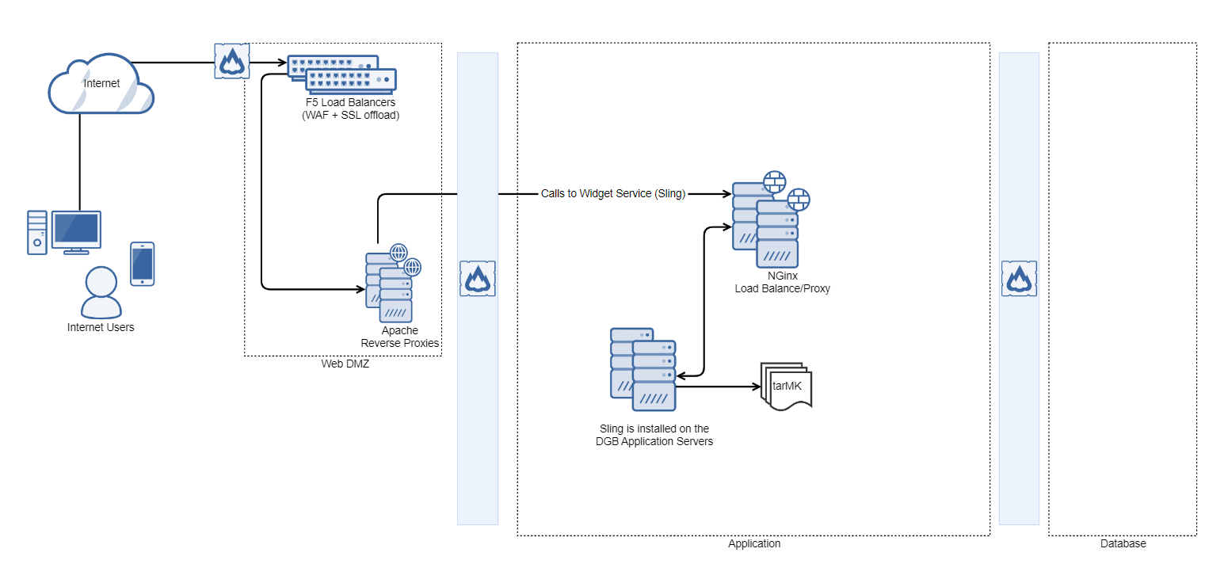

1. Digital Banking integration with Apache Webserver and Shibboleth SP (SSO)

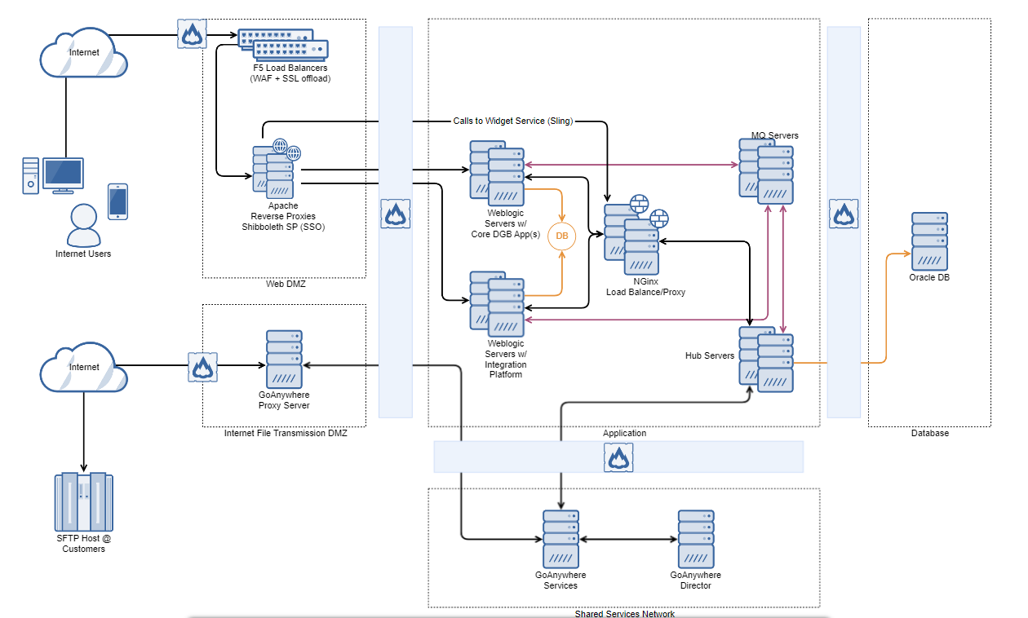

1. Digital Banking - Core Solution Architecture

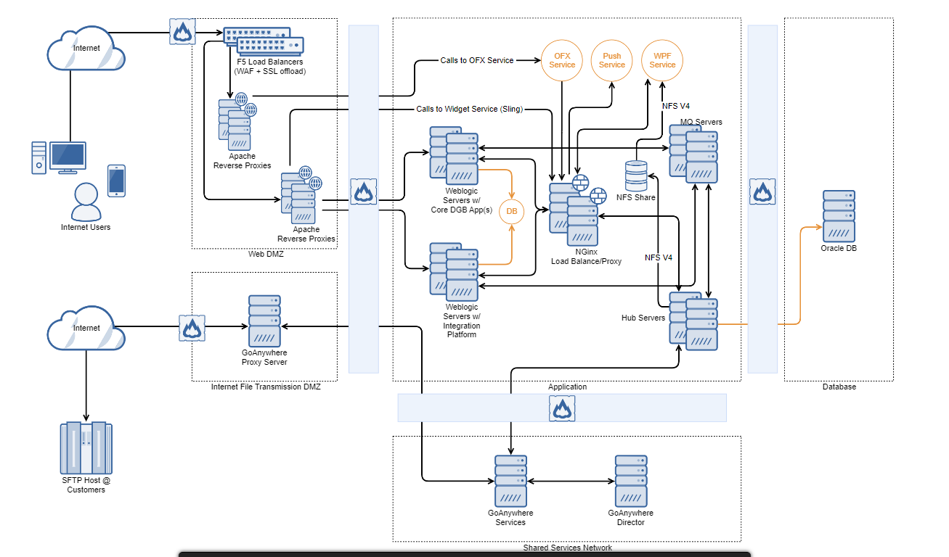

1. Digital Banking - Application Monitoring (APM) via NewRelic

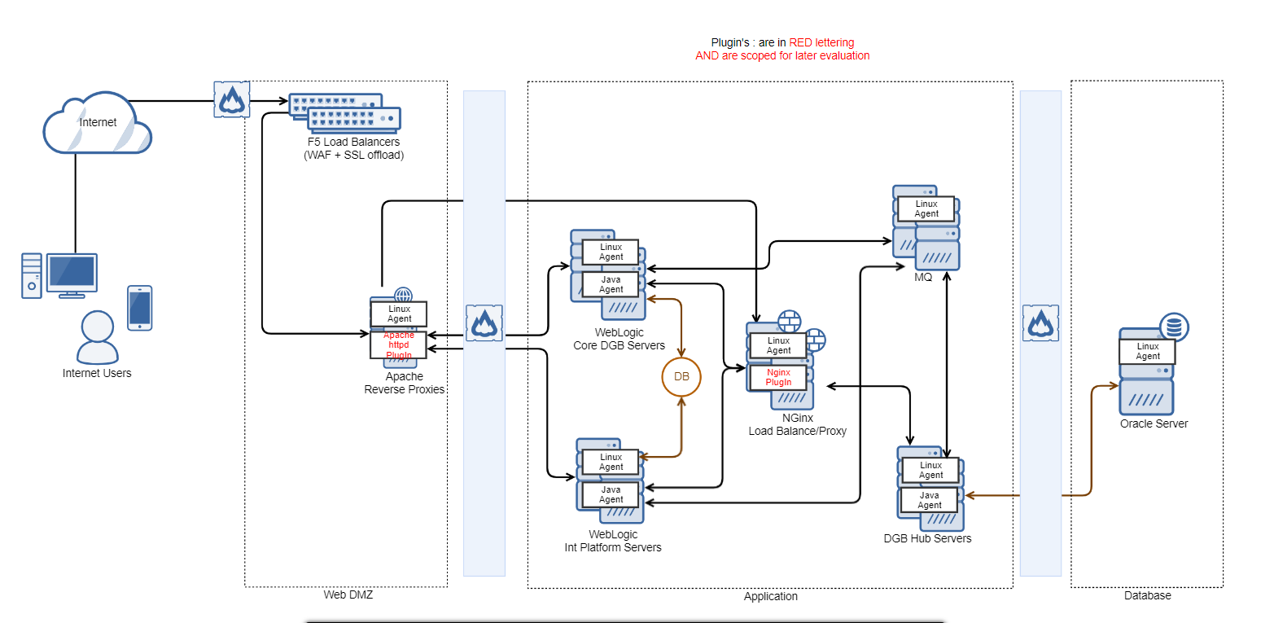

1. Digital Banking integration with OFX (EEI product)

