|  |  |  |
| --- | --- | --- |
| Information Required | Data | |
| Submitted by: | | Sue Holland |
| Date SOP Approved: | |  |
| Approved by: | |  |
| References: | |  |
| Access Required to Execute SOP: | | Database / HUB / Bastion Server |

TOPICS

[How do I notify the bank? 1](#_Toc76493151)

[If any BAI File fails, what is the process? 2](#_Toc76493152)

[Triage 2](#_Toc76493153)

[Commonly seen issues/errors 2](#_Toc76493154)

[Application Gatekeeper locked for GIR. Waiting to Retry 2](#_Toc76493155)

[Hub Cache Issue 2](#_Toc76493156)

[Unable to get a stable set of rows 3](#_Toc76493157)

[Long running SQLs 3](#_Toc76493158)

[AWR URL 3](#_Toc76493159)

[Monitoring The BAI File Loader Process 3](#_Toc76493160)

[PD File Reload 3](#_Toc76493161)

[CD File Reload/Hub Cache Issue 7](#_Toc76493162)

[SOP for Manual BAI Balance Update - Post Proc Errored Out 9](#_Toc76493163)

[SOP for Manual BAI Balance Update – Post Proc Latency 9](#_Toc76493164)

**Purpose:** How to properly respond as a L2 Engineer. There are a dozen scenarios that could take place, but the same general principles apply no matter the situation.

# How do I notify the bank?

1. If during BAU, contact the ESAM first.
2. If this occurs while you are on PagerDuty during the weekend, use the Incident Management Dashboard to page the OIC and gather all necessary parties
3. If the bank did not report the incident, they will also need to be informed of the situation.

# If any BAI File fails, what is the process?

## Triage

* Use the SQL below to locate the cause of failure. NB The trace IDs 42, 43, 44 and 45 are various events used by the BAI loader, but some banks may use one event whereas another bank may use a different event. Adjust your SQL accordingly for the event you need to triage. Always review the stack trace (TRACEINFO) column which provides more details on the cause of the failure.

SELECT \* FROM DGBWEB.MESSAGELOG WHERE MESSAGE\_ID>(SELECT MAX(MESSAGE\_ID)-10000 FROM DGBWEB.MESSAGELOG) and traceid in ('42','43','44','45') and trunc(sysdate) = trunc (logtime) order by logtime desc;

* The BAI loader consists of 2 processes
  1. Part 1 - Loads balance and transactions to GIRBALANCEDETAILBASE and GIRTRANSACTIONDETAILBASE tables
  2. Inserts record to FILELOADADMIN table / File moves to Done/Bad dir
  3. Part 2 - Post proc executes which updates the balances to the GIRDAILYBALANCETOTALS
  4. Other tables are also updated and referenced but for the purpose of this document, the main tables are above
* With the current code, as of 07/05/21, there is a bug that writes the loaded file out to the FILELOADADMIN table as the loader calls the post proc. The FILELOADADMIN table does not give accurate results for load times and you should review the messagelog table to confirm when the event is complete. When the post proc is called, the file is also moved to the Done directory

# Commonly seen issues/errors

## Application Gatekeeper locked for GIR. Waiting to Retry

* + Seen when the PD and CD events collide and attempt to load a BAI file at the same time
  + One event is held with the gatekeeper error whilst the other event continues to load data into the DB
  + Can result in row locks in the DB which may be seen in AWRs. If the events seen to be running for a long time, engage a DBA and check on the SQLs running
  + Can also be seen when another process runs that will need access to the GIR tables i.e. SWIFT Statement Loader/Lockbox loader
  + NOTE – if you abort one of the BAI events due to them colliding, as part of the backout process, the code backs out everything with the GIR class. This means that if PD was executing and the CD event was stuck with the application gatekeeper lock, if you abort the CD event, all PD transactions would be backed out

## Hub Cache Issue

* + Often seen in the TRACEINFO column with the below message but sometimes the GIRTRANSACTIONDETAILSBASE trigger is also referenced. BBVA and M&T see this a lot at the moment - [NH-167867](https://jira.bottomline.tech/browse/NH-167867)

java.sql.BatchUpdateException: ORA-01403: no data found

ORA-06512: at "WEB.GIRBALANCEDE\_PARENTUSERGROUP", line 6

ORA-04088: error during execution of trigger 'WEB.GIRBALANCEDE\_PARENTUSERGROUP'

## Unable to get a stable set of rows

See 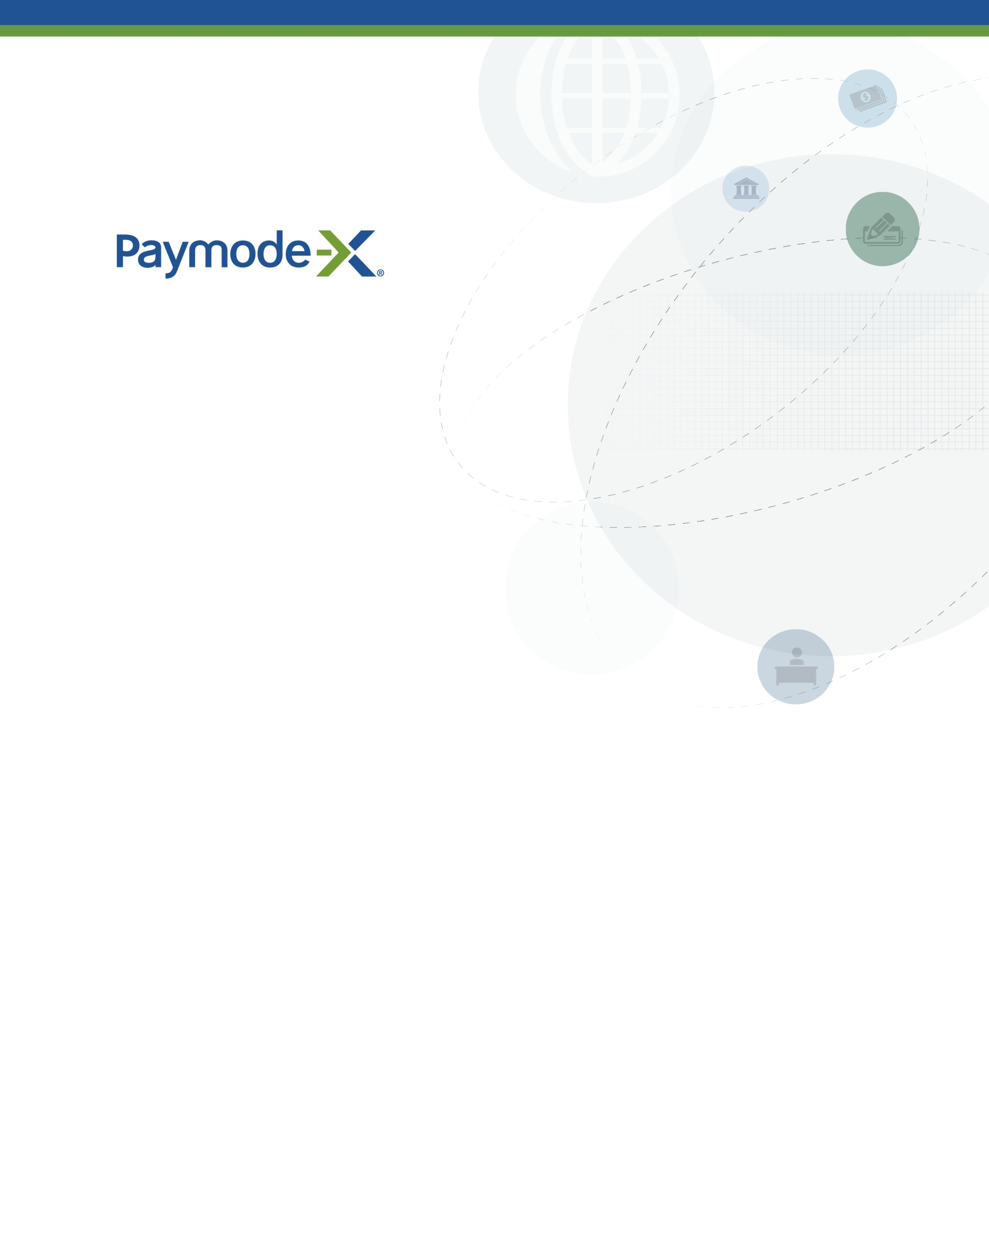attached SOP Manual BAI Balance Update - Post Proc Errored Out attachment for recovery

* + Multiple causes but often seen when 2 post dates or account numbers are included on the file. When the system queries the database for the data, move than one row is returned. Citizens see this a lot after a bank holiday i.e. [DBPS-20942](https://jira.bottomline.tech/browse/DBPS-20942)

java.sql.SQLException: ORA-30926: unable to get a stable set of rows in the source tables

ORA-06512: at "DGBWEB.LOADGIRPDCASHPOSITIONS", line 47

ORA-06512: at line 1

## Long running SQLs

* Long running SQLs can be seen during both Part 1 and Part2 of the BAI processes.
* You need to determine in which process the latency is seen by querying the Messagelog, FileLoadAdmin, checking AWRs
* Most often than not, they are seen during the are seen during the post proc and you will see entries in the AWR relating to the Merge/Delete/Insert on LoadGIRPDCASHPOSITIONS
* Usually our DBA can see these from their side, but also check AWRs and review timings for the post proc in the Messagelog.
  1. Check previously loaded good files for an idea of the timings that should be seen from the MESSAGELOG/FILELOADADMIN table
  2. Long running SQLs may need to be killed off by our DBA
  3. If the post proc has not errored out with an entry in the Messagelog, then we can kill off the long running SQLs and run the post proc manually

## AWR URL

From the Bastion server open <http://dgb-sbx-fi9214-db01.saas-p.com/>

## Monitoring The BAI File Loader Process

* Usually when performing a reload of a PD file, entries are written to the Messagelog informing of the progress for some banks
* Monitoring the actual loader is not quite straight forward due to the nature of the code
* One process that can be used is below for Part 1 of the BAI loaders

1. Use the result of the first query, to select a single record back on the second query

select max(message\_id) from dgbweb.girbalancedetailbase;

select\* from dgbweb.girbalancedetailbase where message\_id =’REPLACE\_MAX\_MESSAGE\_ID\_FROM\_STEP1’;

1. Then use the account number to search the bai file to see what line it’s on

## PD File Reload

1. Login to the Production Bastion and connect to the Event Monitor
2. Once the app is open, click File > Server list > Right-click the Connection > Connect > pwd: password  
   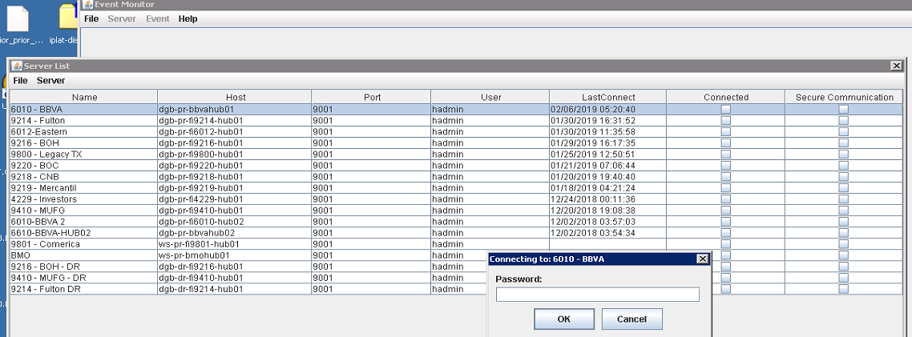
3. If the current day and prior day events collide in the morning, deactivate the Current Day Loader on the Event monitor. We must reload the PD file(s) first. Right click the event, (Event ID 43), and click deactivate:  
   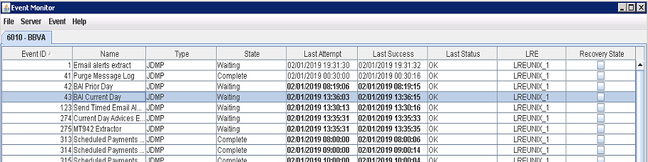  
   Deactivating the event will allow the currently executing CD Loader to “finish up” the current CD file before aborting. This will allow the PD Loader to resume control over the available CPU.
4. Once the event is in a ‘Complete’ State, logon to the HUB using FileZilla/WinSCP.  
   Host information: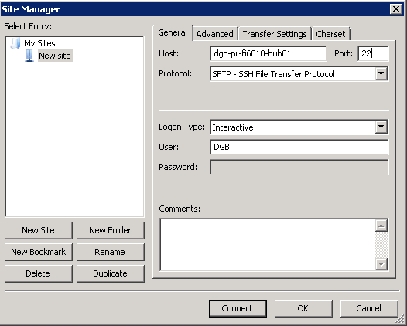 **Example shown is for BBVA – change the Host accordingly**
5. Once the Prior Day Event has finished executing, check the following directories to obtain the PD and CD files that collided during the time both Events were executing simultaneously:

/opt/bt/hub/bankdata/load/bai/Bad **OR** /opt/bt/hub/bankdata/load/bai/Done

1. Download the files by right-clicking it, and save it to your bastion desktop:

**How do I load a missed PD file / reload a PD file**

1. If needed to be reloaded, remove the suffix of the file that trails the “.bai” for both the PD and CD files
2. Prior Day Only: Add the word “\_Reload” to the file (in the right location) to let all parties who could view this file know that this wasn’t the original load:   
    **Before**  
    **After**
3. The naming schema can be found under the INPUTOUTPUTCODE.NAME field, note, these ARE case sensitive.  
   SELECT \* FROM DGBWEB.INPUTOUTPUTCODE WHERE UPPER(DESCRIPTION) LIKE ‘%BAI%’;  
   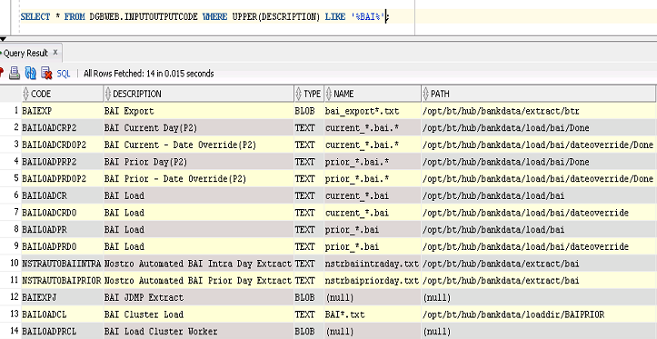Once you have done all of the above, open up the BAI files using Notepad++
4. Note that the record in Line 2, Field Position 4 is the Group Header Record Flag. No matter what, this record will be denoted by the “1” flag when incoming from the bank, untouched by BT. The ‘1’ stands for ‘Add’  
    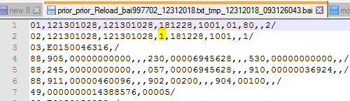  
   Change that ‘1’ to a ‘3’ ONLY FOR PD FILES. CD files cannot be reloaded with a 3 flag.Explained in Topic IV. During the actual loading of the files, the ‘3’ flag removes all data that had previously loaded with that file’s data, and adds a new/clean record with our modified file in addition to adding any payments that were missed.
5. NOTE: Some banks BAI files can contain more than one 02 record. FIND ALL OF THEM for PD files and make sure they each have their ‘1’ changed to a ‘3’ as well.
6. NOTE: If the PD file type ended up in the DONE directory rather than the BAD one, you will also need to change the sequence number located on the 01 Record, and EVERY 02 Record throughout the file. For example, the sequence number in the above snip is ‘1001’. Simply change it to the next numerical value, ‘1002’ throughout. This sequence number will be in the same location in all BAI files in the 01 and 02 records.
7. Save your files
8. Copy all your file(s) that need reloading back to the Production bastion desktop. Note, zipping these files will cut down on time if you have a lot to transfer back over
9. Note, at this point you should have your modified PD files (‘1’ to ‘3’s & sequence number changed if needed) that have the word “Reload” in them and suffix removed, and the CD BAI file(s) that just have the suffix removed after the .bai in their filename
10. It is pertinent that all files are loaded sequentially from oldest to newest, otherwise the account balances will be incorrect for information reporting. If you have more than one file for more than one day to load, follow the above. If you are loading more than 1 file for the same day, it does not matter which files are loaded first.
11. Once the event is scheduled, your files are modified/renamed/prepped, the modified files are unzipped and on the bastion host, you are ready to load/reload the PD BAI files. Open up FileZilla on the HUB as performed in Section II Step 4.
12. Deactivate the Prior Day loader on the Event Monitor by right-clicking it and pressing “Deactivate”. This is performed to allow time for a larger file to be moved over. You may need to move files in a specific order as per the banks requirements. Any current waiting PD files can be moved to the Stage Dir unless our failed file has been reloaded.
13. At this point, you should have your PD file(s) prepped with the suffix removed and data updated within the file itself. Copy the file(s) back to the bastion host, and place it on the /opt/bt/hub/bankdata/load/bai directory.
14. Refresh the Prior Day loader by right-clicking it and pressing “Refresh”. This will allow the event to execute, and will allow the file upload fully/completely from the bastion host to the loader directory before the event begins to process the file. It is crucial to have the file(s) fully uploaded to the loader before the Event begins to execute.
15. Ensure the first file loads successfully by checking the messagelog under traceid 42 and 45:  
     SELECT \* FROM DGBWEB.MESSAGELOG  
    WHERE MESSAGE\_ID > (SELECT MAX(MESSAGE\_ID)-10000 FROM DGBWEB.MESSAGELOG)  
    AND TRACEID IN (‘42’,‘45’)  
    AND TRUNC(LOGTIME) = TRUNC(SYSDATE)   
    ORDER BY LOGTIME DESC;

NOTE: If you are copying this SQL, you will need to remove the single quotes around the ‘45’ and re-add them once you get into SQL dev, otherwise you will receive an invalid character error.

If you see WARN severity messages for invalid accounts, that is OK.

1. Verify there is one set of transactions loaded into the GIRTRANSACTIONDETAILBASE table. Use an example 16 Record in the BAI file that you loaded first. 16 Records are transaction records, and the 03 Record that precedes the transaction is the account number. Check an account at the beginning of the file, the middle of the file, and at the end of the file to ensure completeness.

*SELECT \* FROM DGBWEB.GIRTRANSACTIONDETAILBASE WHERE HOST\_FILENAME = ‘prior\_your\_new\_file.bai.12345’;*

1. After the verification is completed, you are all set to load your next file if more than one PD. Repeat Steps 15-17 for each of your remaining files to ensure that balances are being reflected correctly. Remember to load the files historically from oldest to newest, and if there are more than one files on the same day, those can be loaded in any order.
2. At this point, there will be several files “backed-up” in the /load/bai directory as it was aborted during the PD Reload process. When all the PD files are completed, refresh Event 43, the Current Day BAI Loader. Track the event the same way in Step 16 using traceid = ‘43’.
3. Ensure event completeness and that all files loaded correctly.

## CD File Reload/Hub Cache Issue

1. Obtain the file that needs reloading from the HUB as described above
2. If the file failed due to a caching issue, non-event collision induced, one will need to login to the production Admin Application. Navigate through to Menu > Events > Event Id 43 > Actions > Modify > Deselect the ‘Schedule’ Box > Save. NB not all banks allow us access to update the event from the Admin app.  
   **Note: Steps 2-5 outlined in this section do not need to be actioned if the issue was part of the CD/PD loader collision.**
3. Connect to the Event Monitor using Part II Steps 1-2 as your guide.
4. Go to Server > All Events > Add/Remove. You should see Event 43 disappear from this list of scheduled events:  
   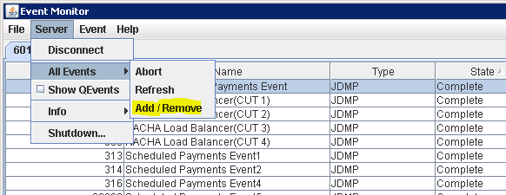
5. Repeat Steps 2-4 above, except this time you will be scheduling the Event rather than unscheduling it. This will include performing an Add / Remove. This process clears the stored cache for the Current Day Loader i.e. hub cache issue. You should see Event 43 re-populate in the Event Monitor view after performing the above steps.
6. Note, the BAI Backout Function in the Admin Application **DOES NOT WORK!** You will have to back out the file manually which will require a Production Database SQL executed and a DBA on-call to run the script as described in Part I, Step 3
7. **CD BAI process** **DOES NOT ALLOW FOR RELOADS WITH THE ‘3’ MODIFICATION FLAG**. In order to “back out” this file manually, one will have execute a DELETE SQL in Prod with the appropriate CD filename that needs the back out/reloading.
8. First, you need to identify the IMPORTID of the BAI file. This can be done by checking your CD file against the File Load Admin table:  
   --1 - LOCATE IMPORTID FROM FILE LOAD ADMIN - CHANGE FILE NAME   
   SELECT \* FROM DGBWEB.FILELOADADMIN WHERE FILENAME = ‘current\_CHANGE\_ME.bai.123’;
9. Confirm if transactions have loaded for the file by running the following
10. Have the following SQL executed in Production by the DBA

--1 - LOCATE IMPORTID FROM FILE LOAD ADMIN - CHANGE FILE NAME   
SELECT \* FROM DGBWEB.FILELOADADMIN WHERE FILENAME = ‘current\_CHANGE\_ME.bai.123’;  
  
--2 - DELETE FROM BACKOUT TABLE - CHANGE IMPORT ID TO THE ONE FROM STEP1   
DELETE FROM DGBWEB.GIRBACKOUT WHERE IMPORTID = 'CHANGE\_IMPORTID';  
  
--3 - DELETE THE TRANSACTIONS - CHANGE IMPORT ID TO THE ONE FROM STEP1   
DELETE FROM DGBWEB.GIRTRANSACTIONDETAILBASE WHERE IMPORTID = 'CHANGE\_IMPORTID';  
COMMIT;

1. Page out to the DBA and create a CLOUD Database Administration ticket with the desired above SQL, and the database host connections:
2. On your local machine, remove the trailing information in the filename following the ‘.bai’. For example, if the CD filename ended with current\_bai.12345, remove the ‘.12345’.
3. Deactivate the Current Day loader on the Event monitor by right-clicking it and pressing “Deactivate”
4. At this point, you should have the SQL executed by now with your CD file prepped with the suffix removed and nothing else touched within the file itself. Copy this file back to the bastion host, and place it on the /opt/bt/hub/bankdata/load/bai directory.
5. Refresh the Current Day loader by right-clicking it and pressing “Refresh”. This will allow the event to execute, and will allow the file upload fully/completely from the bastion host to the loader directory before the event begins to process the file. It is crucial to have the file fully uploaded to the loader before the Event begins to execute.
6. Ensure all 16 (transaction) records appear once in the GIRTRANSACTIONDETAILBASE table with the correct HOST\_FILENAME (the name of the CD file you just reloaded + the new suffix it received once being placed on the loader), and with the Posted\_Flag being ‘I’ for Intraday.

## BT__DPA_DocCover.jpgSOP for Manual BAI Balance Update - Post Proc Errored Out



## SOP for Manual BAI Balance Update – Post Proc Latency

