|  |  |  |
| --- | --- | --- |
| Information Required | Data | |
| Submitted by: | | Scott Langille |
| Date SOP Approved: | |  |
| Approved by: | |  |
| References: | |  |
| Access Required to Execute SOP: | |  |

**Topic:** **Obtaining a thread dump**

**Purpose:** Creating a java thread dump

If the file threaddump.sh does not exist in /tmp

**As DGB or weblogic cd /tmp**

**Type vi threaddump.sh (for vi editor)**

**Select i (insert)**

**Paste in this script**

**if [ $# -eq 0 ]; then**

**echo >= 2 "Usage: threaddump <pid>"**

**exit 1**

**fi**

**pid=$1**

**count=3**

**delay=5**

**while [ $count -gt 0 ]**

**do**

**jstack $pid >jstack.$pid.$(date +%H%M%S)**

**echo -n "."**

**sleep $delay**

**let count--**

**done**

**type :wq (write/quite)**

**It will exit out of the vi editor**

**Cd the command prompt type**

**chmod 777 threaddump.sh**

**To setup the properties for the jstack in the script**

**at the command prompt**

**Note: Need to get the correct java path from** /opt/bt/java, then need to update the accordingly in below path

type

export JAVA_HOME=/opt/bt/java/jdk1.8.0_45-x86_64/

then type

export PATH=$PATH:$JAVA_HOME/bin

export PATH=$PATH:/opt/bt/java/jdk1.8.0_172-x86_64/bin/

Now collect the PID for the specific Java Instance

For example

Type

ps -ef |grep java|grep LREUNIX

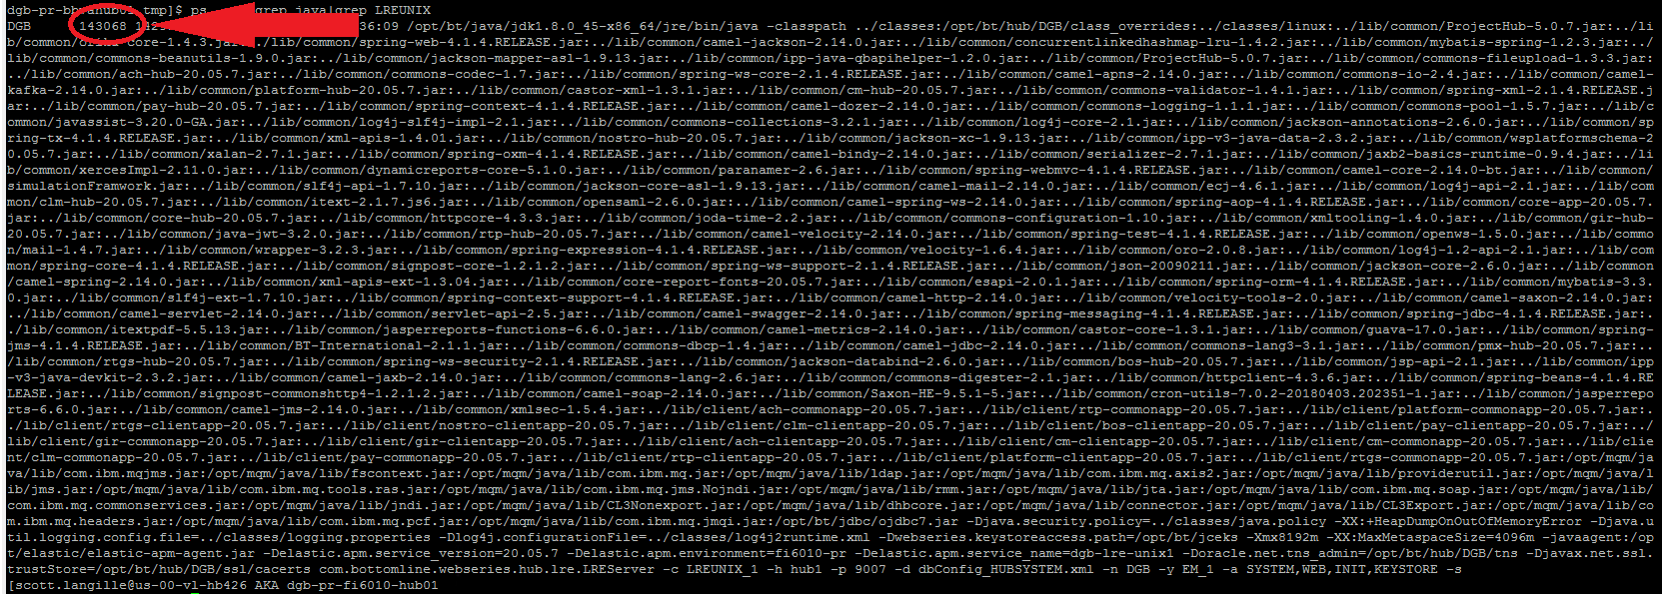

Then type ./threaddump.sh 143068

There will be dots appearing as it processes the threaddumps

There will be three jstack files for example

dgb-pr-bbvahub01 tmp]$ ls -ltr jstack*

-rwxrwxrwx 1 DGB DGB 200086 Nov 10 11:07 jstack.143068.160741

-rwxrwxrwx 1 DGB DGB 200277 Nov 10 11:07 jstack.143068.160746

-rwxrwxrwx 1 DGB DGB 200061 Nov 10 11:07 jstack.143068.160752

Then type

chmod 777 jstack* (three most recent jstack files)

You will need to tar up the files

tar cvf jstatckxxxxx.tar jstack*

you will then need to change the permission on that tar file

chmod 777 jstatckxxxxx.tar

Using filezilla/WinSCP copy the file down to be used for evaluation

For example on your own laptop you can use 7-zip to extract the files

Each one of those jstack files can be reviewed using this site

<https://fastthread.io/>