**Project: Detection of Malicious network traffic using two-stage approach**

**Team members: Sai Suraj Nuthanakalva, Balaji Pujari**

**STEPS TO BE FOLLOWED:**

1. Extract the zip file and save it.

2. CICIDS2017 dataset contains information about different types of attacks performed over a week. This dataset has around 79 columns, and around 28,00,000 rows.

3. Open model.py in PyCharm editor.

4. import and install all the required libraries mentioned in the code.

5. Change the directory_path in the code to the local path of the folder

6. Run the code(model.py file)

7.Once the classifiers are generated , Run the script.py file to get the predictions.

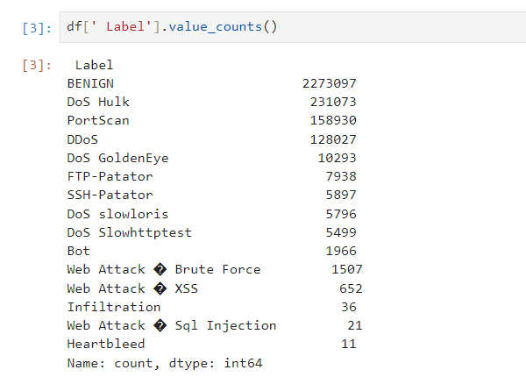

**Fig: Depicting different types of attacks in the datasets**

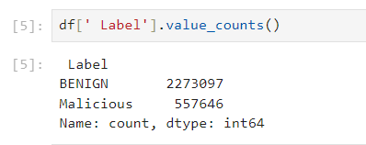

**Fig: Showing the value count of Benign and malicious data in the dataset**

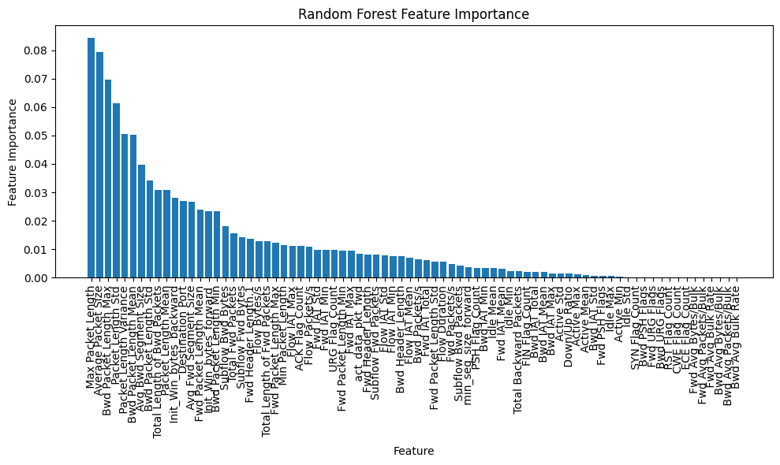

**Fig: Plot diagram for the data after down sampling and applying RF classifier**

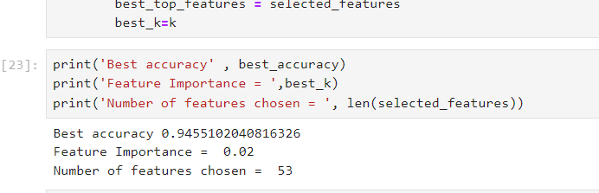

**Fig: Accuracy of our approach**

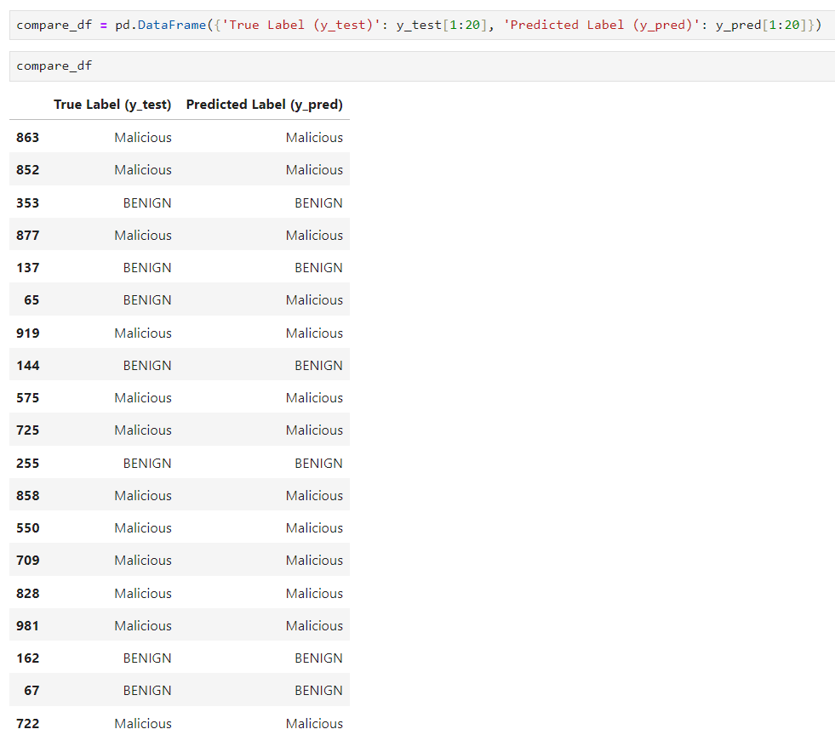

These are predictions from some of the values from our dataset, here we took 20 data points from X_test from test purpose only. We can change the path of test file as our need and get predictions.