Ragamalika

Login: admin Password: ragamalika

http://ragamalika.bajjiserver.com

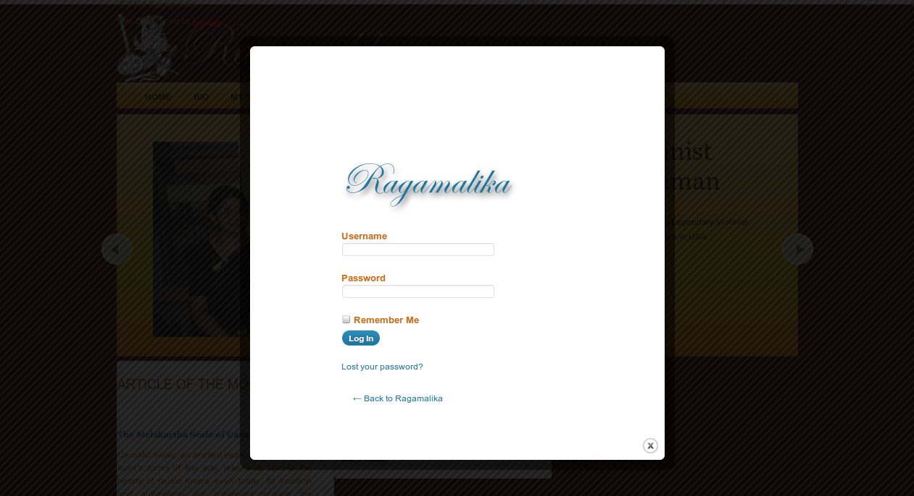
Approve Students

Click Admin in the Menu


It will provide you the list of students need to approved / rejected.

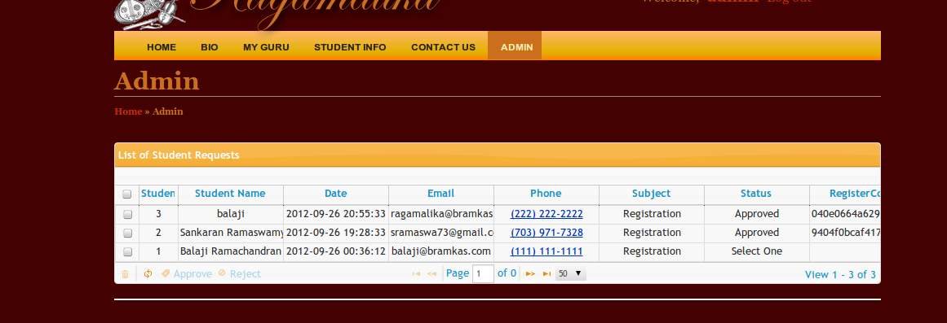
Selec the student and Click Approve button.
Once it is approved, system will send an email to student with the registration code.

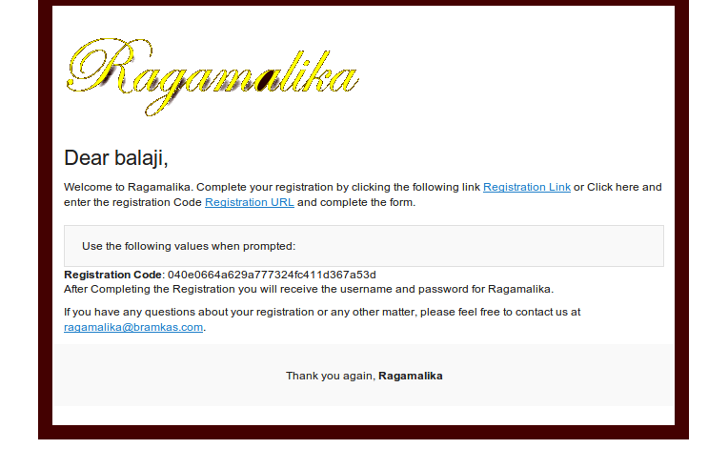
Sometime email goes to SPAM folder, make sure watch out.

By clicking the Registration Link user will be taken into registration page.

User will fillout the Registration form
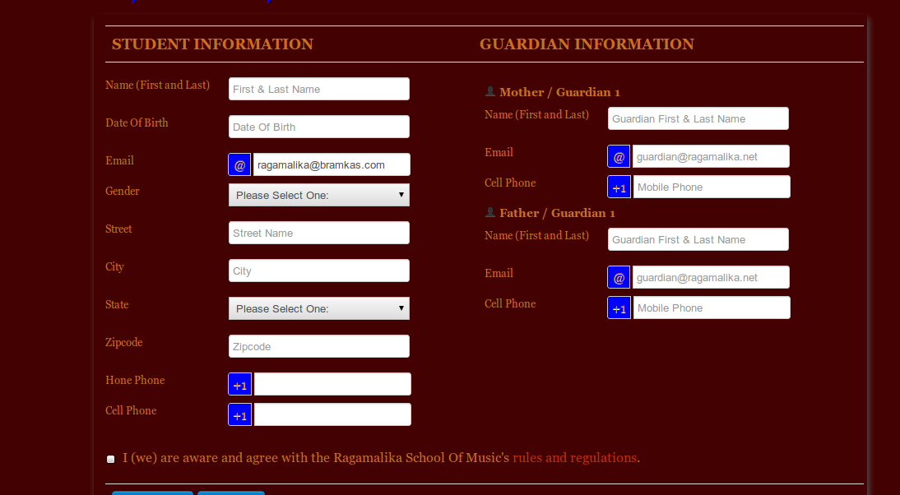
Once it is submitted user will receive an email with username and password.
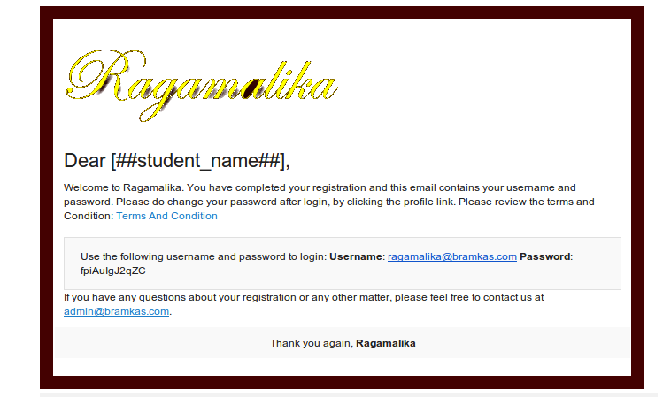
Profile,
After login to the website, by clicking the username in the top / My Profile in the footer
Where here user can update the following:
- Address
- Password
- Phone No
- Guardian Details

