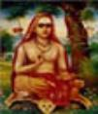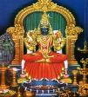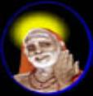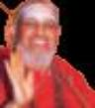

OHM SHRI GURUBHYO NAMAHA

SRI KANCHI MAHASWAMIGAL

PEETAROHANA SATABDHI JAYANTHI YEAR

Kanchi Kamakoti Seva Foundation, Washington DC
invites you to participate in the

113th Jayanthi Celebrations
of

Sri Chandrasekarendra Saraswati Mahaswamigal
on
Saturday June 10, 2006
at
The Durga Temple, Fairfax Station, VA 22039

PROGRAM:

2:30 PM – 5:00 PM: - PADUKA PUJA

Swasthi Vachanam, Guru Vandanams, Sri Vigneswara Puja, Abhishekham to Holy Padukas of Maha Swamigal With Sri Rudram and Sri Chamakam Parayanams. Ashtotra Archanas to Lord Siva, Sri Kamakshi, Sri Mahaswamigal and to Sri Jayendra Saraswati Swamigal. Mantra Pushpam, Thotakashtakam and Slokas recitations. Prasadams distribution.

5:00 PM - 7:00 PM - CARNATIC MUSIC VOCAL CONCERT:

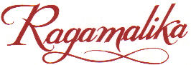
5:00 pm – 6:00 pm - Smt. Jaishree Sankaran

6:00 pm – 7:00 pm - Smt. Maragatham Ramaswamy
and students of Ragamalika

7:15 PM - DINNER WILL BE SERVED
ALL ARE WELCOME ! FREE AND OPEN TO all devotees and music lovers
Directions: Please see Durga Temple website at www.durgatemple.org

For more information on this function please contact:
D. Sundararaman | (301) 937-3083 | Venkat Gopalan (Gopi) / Lakshmi | (703) 803-8841
Chandra Mouli | (301) 838-0254 | V.G Kannan | (703) 644-0557
Ananthakrishna Sarma | (703) 793-3077 | Shankar A. Iyer | (571) 432-5333
K.G. Venkatraman (Ramani) | (301) 646-1232 | Vittal Venkataraman | (703) 455-5950
 |  | Lakshmi Mukundan | (703) 793-1045
or E-mail us at: dsunda@comcast.net or vgopalan@cybsol.com
HARA HARA SANKARA JAYA JAYA SANKARA

