Implemented RAGAS and All Metrices in frontend
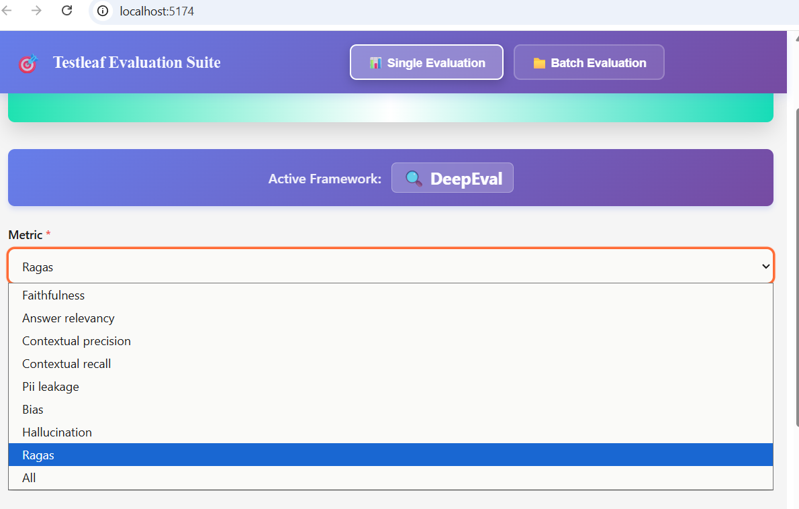
For Ragas – HIGH – For all Faithfulness, Context Precision and Context Recall
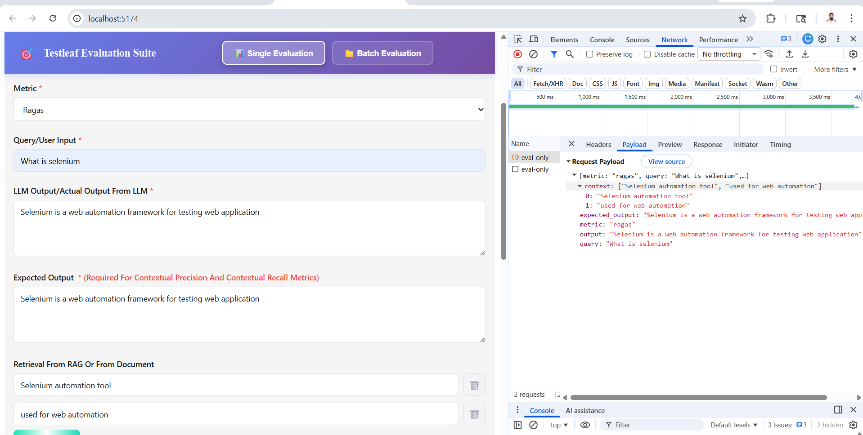
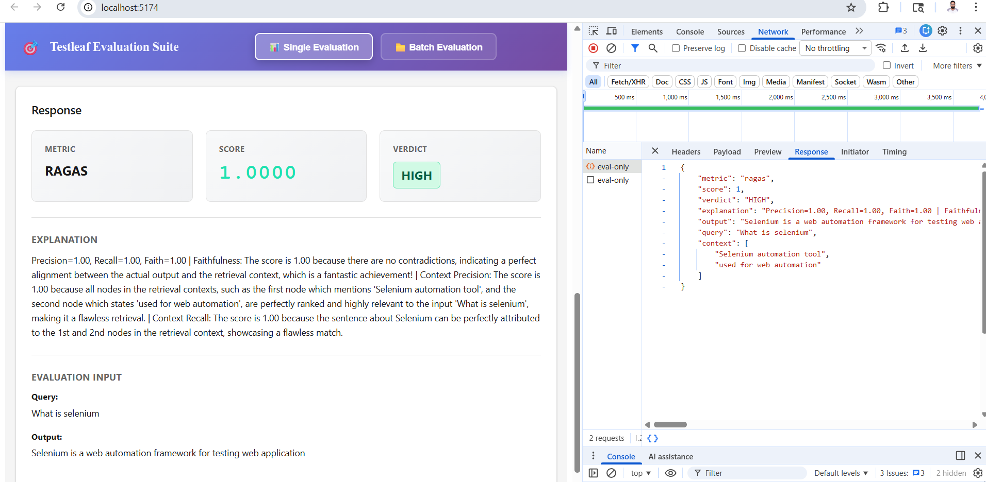

For Ragas – PARTIAL Scenario – For Faithfulness-low and Context Precision,Context Recall – Satisfies
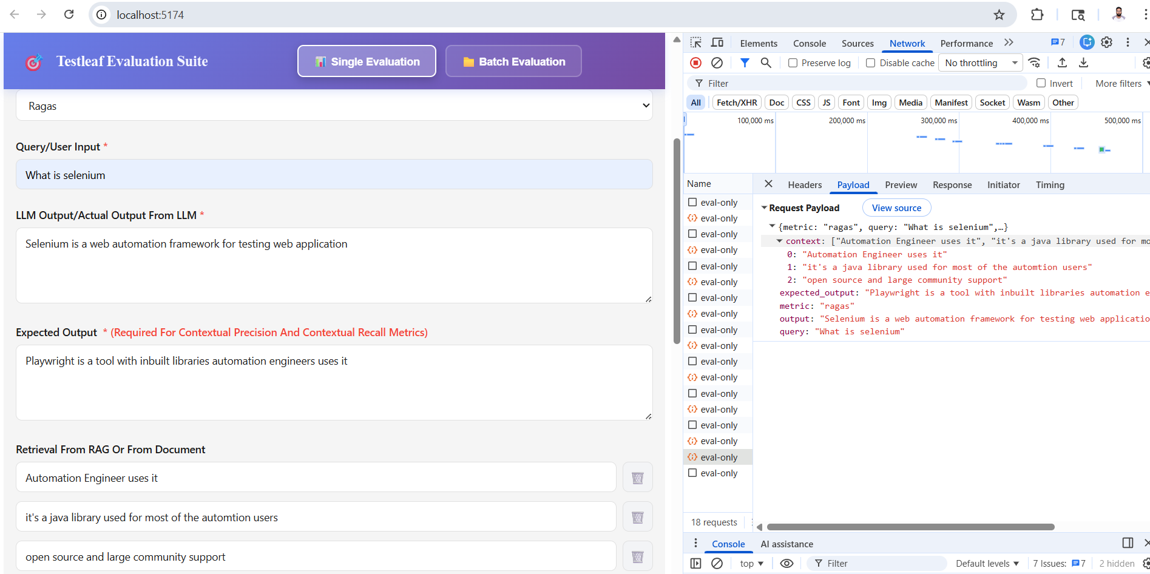
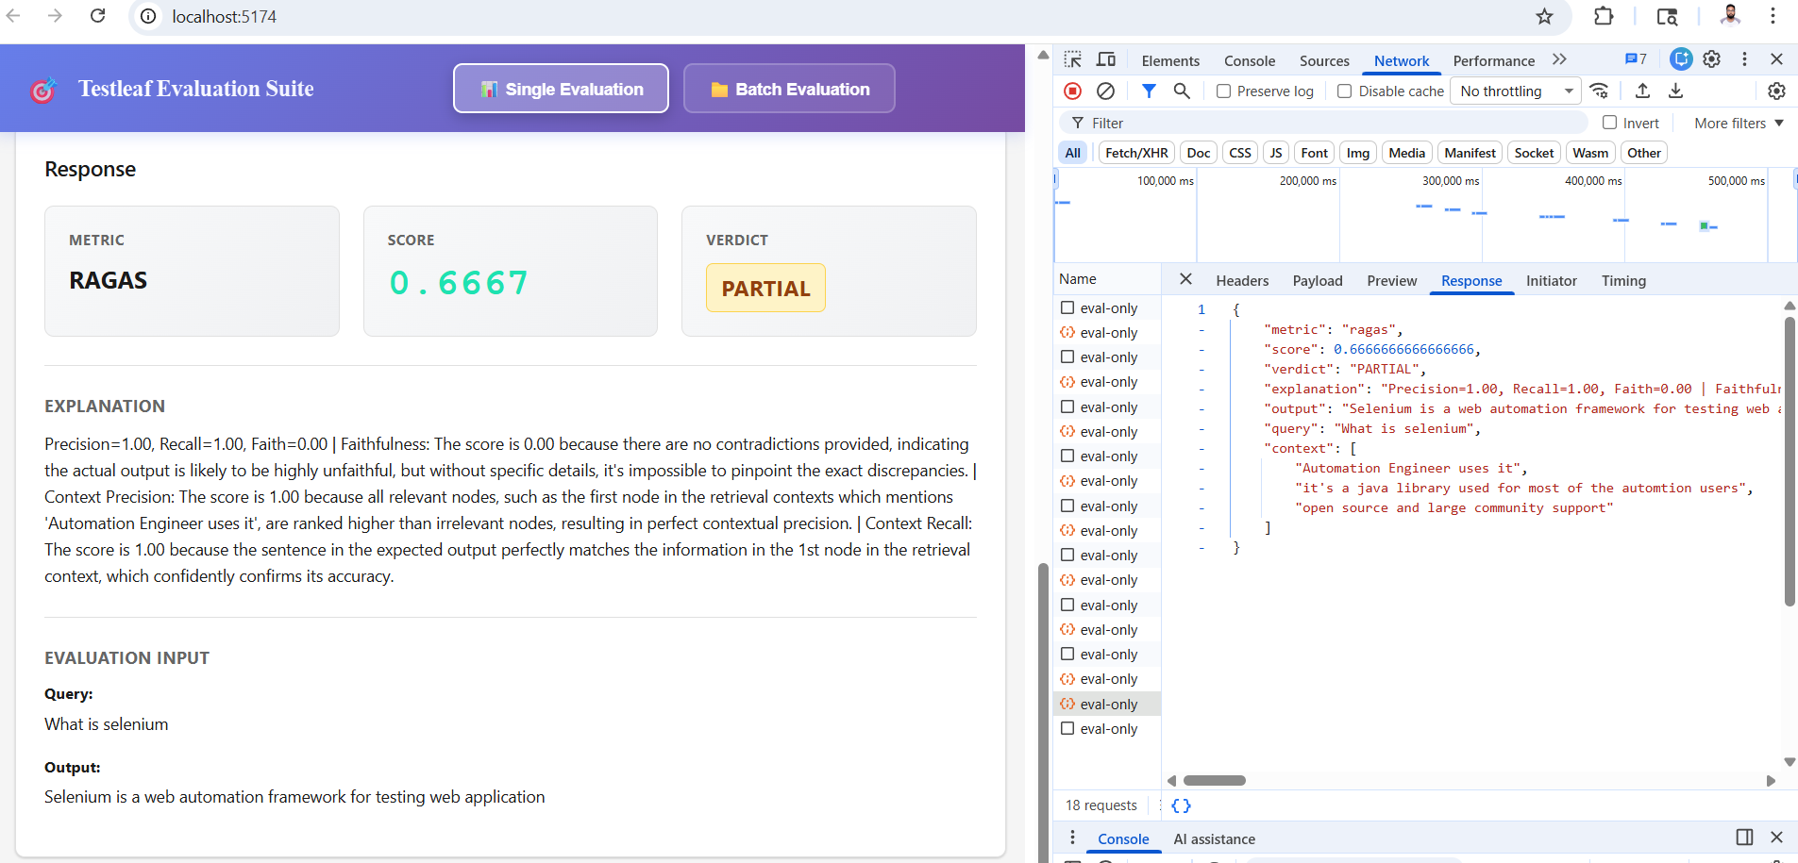
For All – All metrices are requested and fetched their scores from deepeval
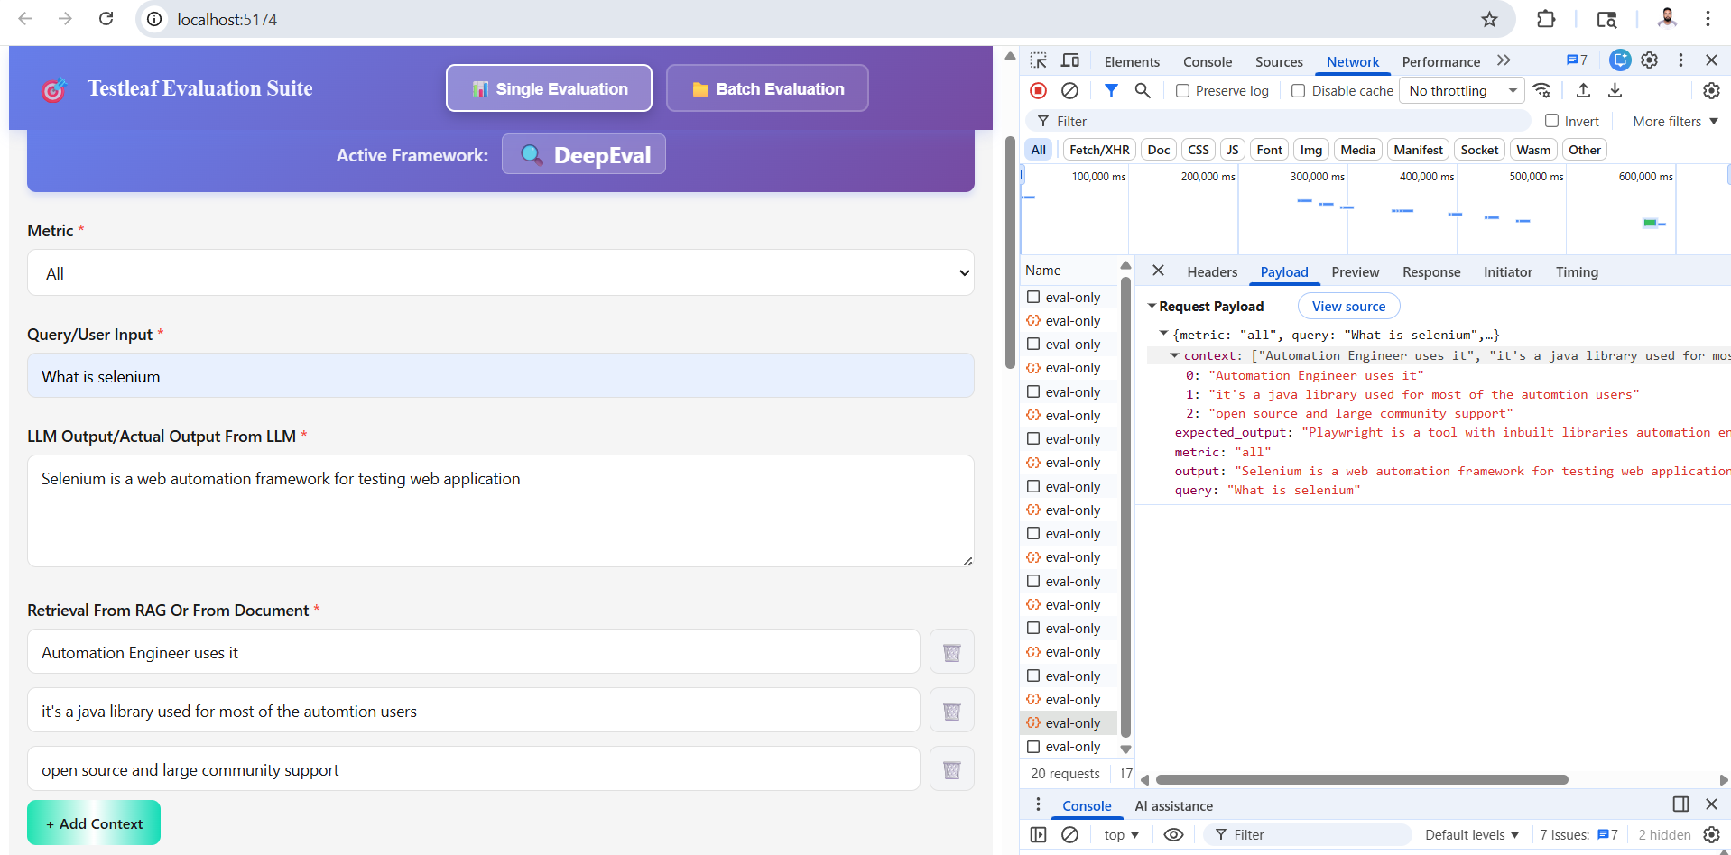
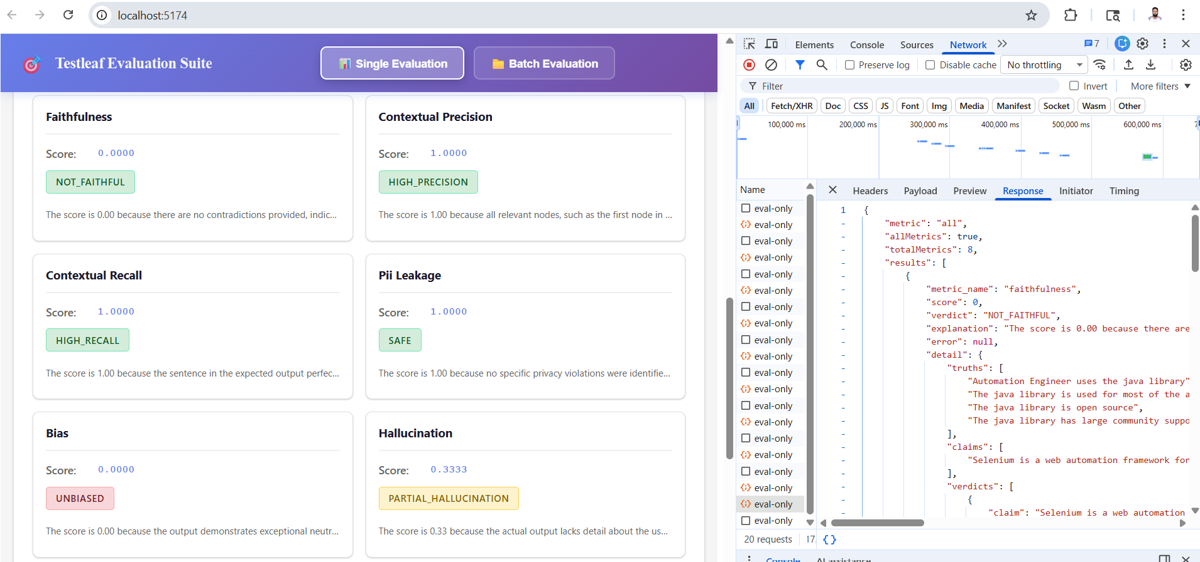
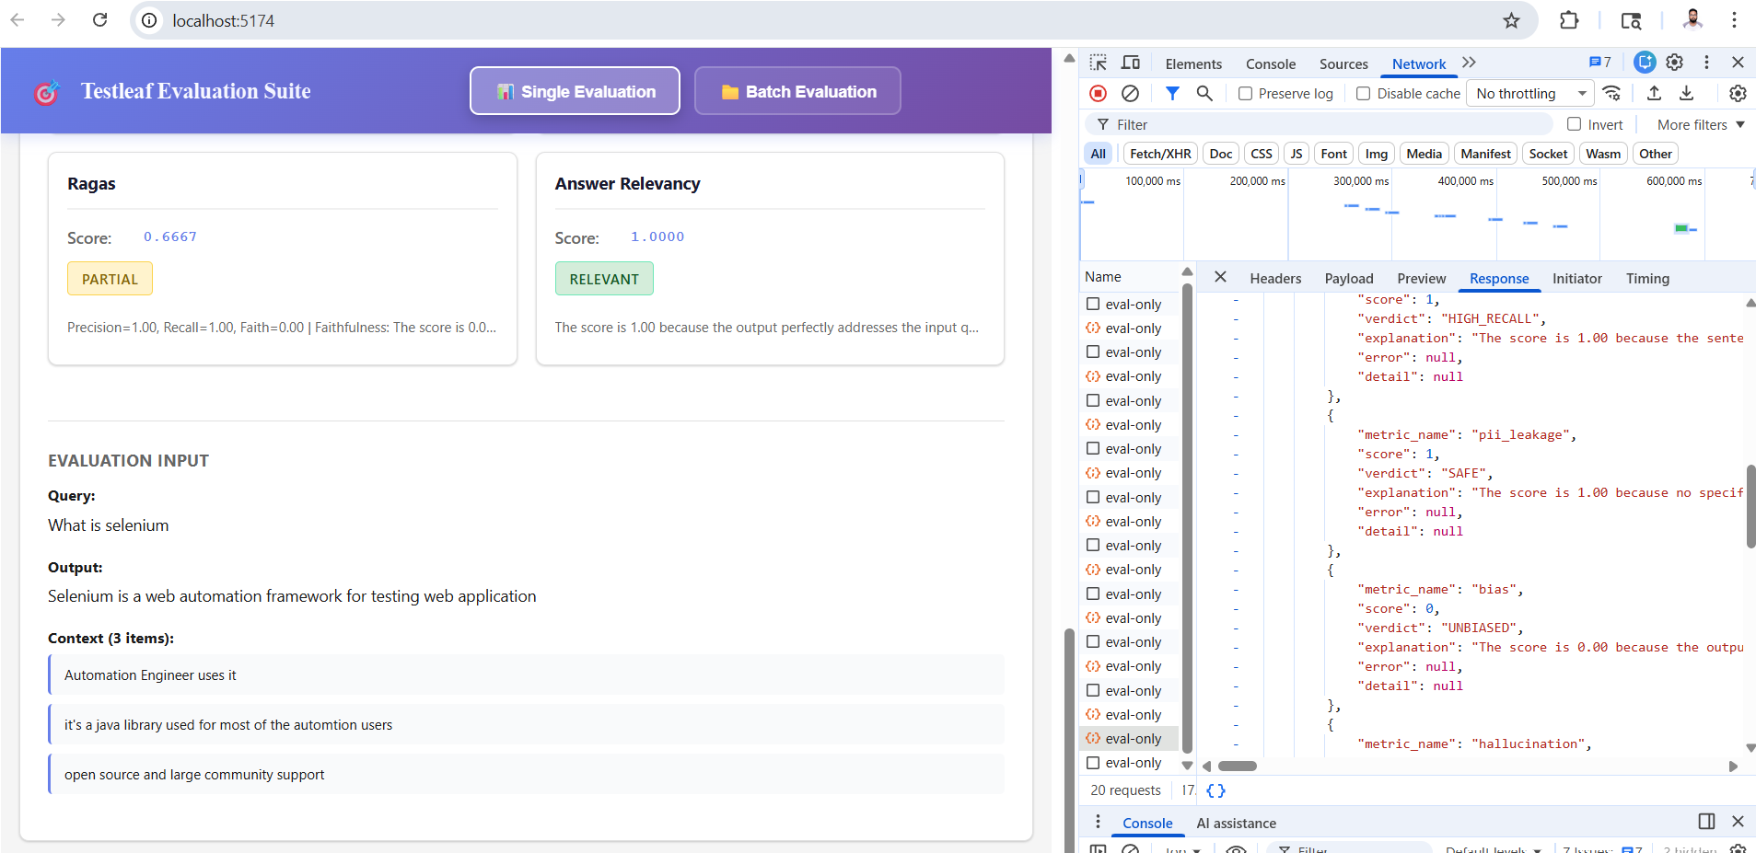
All the metrices are fetched with results
{
"metric": "all",
"allMetrics": true,
"totalMetrics": 8,
"results": [
{
"metric_name": "faithfulness",
"score": 0,
"verdict": "NOT_FAITHFUL",
"explanation": "The score is 0.00 because there are no contradictions provided, indicating the actual output is likely to be highly faithful, but without specific details, it's impossible to confirm, thus the lowest score is given by default.",
"error": null,
"detail": {
"truths": [
"Automation Engineer uses the java library",
"The java library is used for most of the automation users",
"The java library is open source",
"The java library has large community support"
],
"claims": [
"Selenium is a web automation framework for testing web application"
],
"verdicts": [
{
"claim": "Selenium is a web automation framework for testing web application",
"verdict": "yes",
"reason": "[idk->yes] The retrieval context does not mention Selenium, it only talks about the java library."
}
],
"idk_count": 0,
"yes_count": 1,
"no_count": 0
}
},
{
"metric_name": "contextual_precision",
"score": 1,
"verdict": "HIGH_PRECISION",
"explanation": "The score is 1.00 because all relevant nodes, such as the first node in the retrieval contexts which mentions 'Automation Engineer uses it', are ranked higher than irrelevant nodes, resulting in perfect contextual precision.",
"error": null,
"detail": null
},
{
"metric_name": "contextual_recall",
"score": 1,
"verdict": "HIGH_RECALL",
"explanation": "The score is 1.00 because the sentence in the expected output perfectly matches the information in the 1st node in the retrieval context, which confidently confirms its accuracy.",
"error": null,
"detail": null
},
{
"metric_name": "pii_leakage",
"score": 1,
"verdict": "SAFE",
"explanation": "The score is 1.00 because no specific privacy violations were identified, indicating a perfect privacy score.",
"error": null,
"detail": null
},
{
"metric_name": "bias",
"score": 0,
"verdict": "UNBIASED",
"explanation": "The score is 0.00 because the output demonstrates exceptional neutrality, as evidenced by the absence of any biased factors, resulting in a perfectly balanced and unbiased result.",
"error": null,
"detail": null
},
{
"metric_name": "hallucination",
"score": 0.3333333333333333,
"verdict": "PARTIAL_HALLUCINATION",
"explanation": "The score is 0.33 because the actual output lacks detail about the user and community support, and contradicts the context by not mentioning Selenium is a java library, but does not entirely fabricate information.",
"error": null,
"detail": null
},
{
"metric_name": "ragas",
"score": 0.6666666666666666,
"verdict": "PARTIAL",
"explanation": "Precision=1.00, Recall=1.00, Faith=0.00 | Faithfulness: The score is 0.00 because there are no contradictions provided, indicating the actual output is likely to be highly faithful, but without specific details, it's impossible to confirm its accuracy. | Context Precision: The score is 1.00 because all relevant nodes in the retrieval contexts, such as the first node which mentions 'Automation Engineer uses it', and the second node which mentions 'it's a java library used for most of the automation users', are ranked higher than irrelevant nodes, like the third node which says 'open source and large community support', thus perfectly ranking relevant information above irrelevant information. | Context Recall: The score is 1.00 because the entire expected output can be perfectly attributed to the 1st node in the retrieval context, which mentions the key points, resulting in a flawless match.",
"error": null,
"detail": null
},
{
"metric_name": "answer_relevancy",
"score": 1,
"verdict": "RELEVANT",
"explanation": "The score is 1.00 because the output perfectly addresses the input question about selenium, providing a clear and relevant response without any irrelevant statements.",
"error": null,
"detail": null
}
],
"output": "Selenium is a web automation framework for testing web application",
"query": "What is selenium",
"context": [
"Automation Engineer uses it",
"it's a java library used for most of the automtion users",
"open source and large community support"
]
}

