Faitfulness Metrices Validation
Scenario 1
Input (User question): What is selenium
Actual output (Models Actual output): Selenium is a web automation framework for testing web application
Retrieval context -Selenium is a web automation framework for testing web application
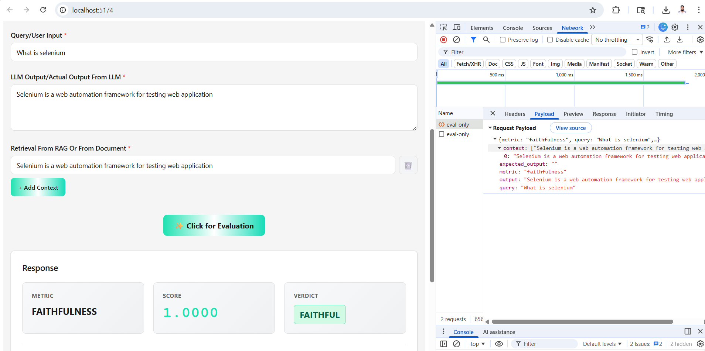
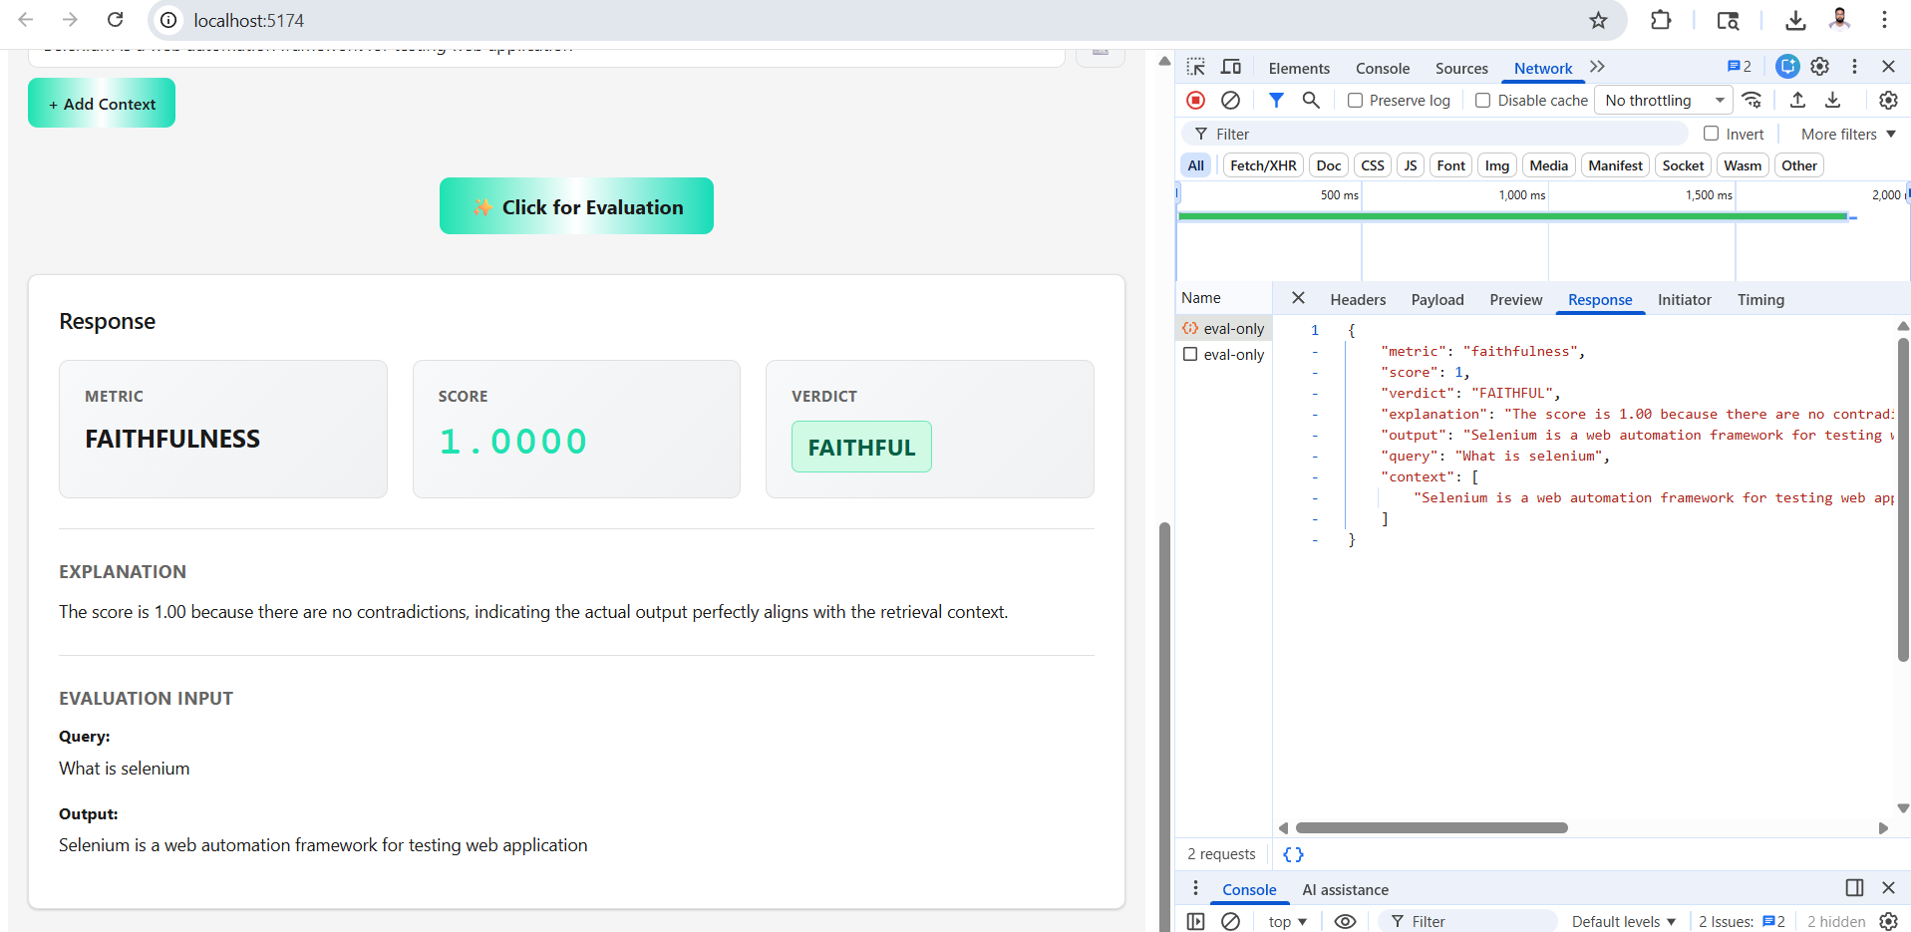
FAITHFULL Scenario

Scenario 2
Input:What is selenium
Actual output (Models Actual output):Selenium is a web automation framework for testing web application
Retrieval context-Selenium is a rare element
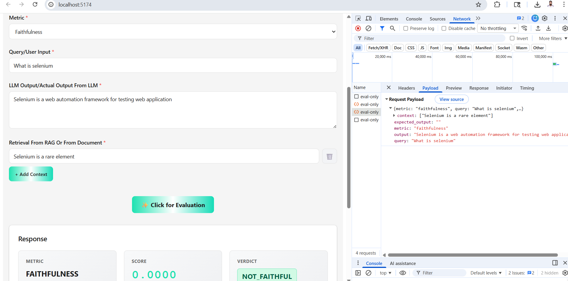
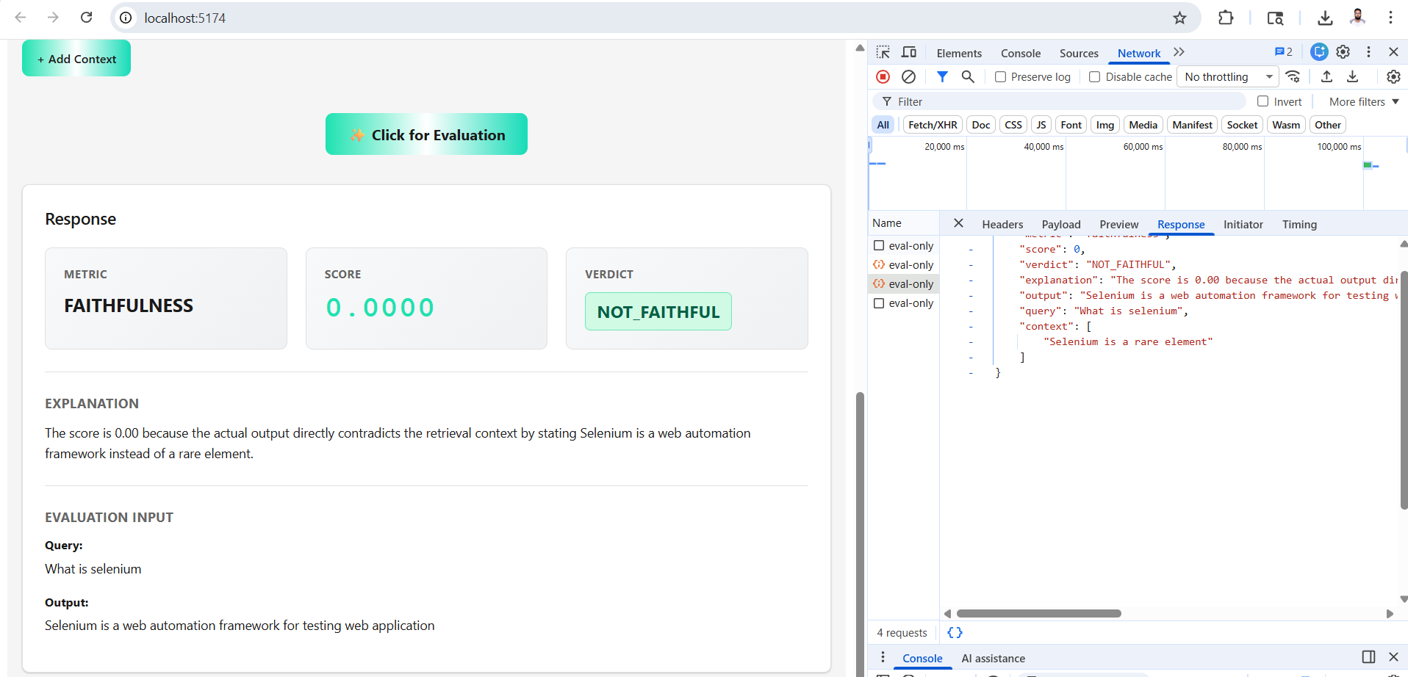
NOT FAITHFUL Scenario

Scenario 3
Input (User question):What is selenium
Actual output (Models Actual output):Selenium is a automation framework for testing web and desktop application
Retrieval context -Selenium is a web automation framework for testing web application(From Mongo)
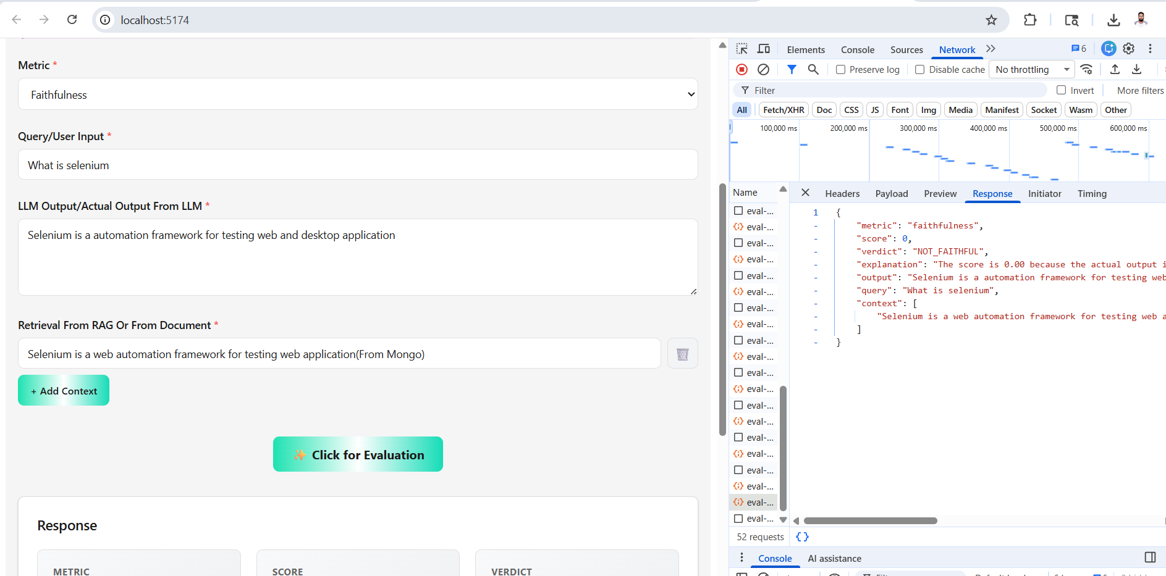
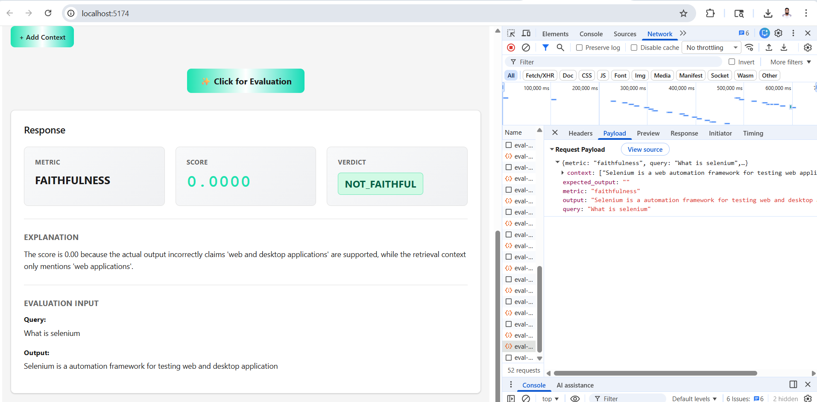
NOT FAITHFUL Scenario

Scenario 4
LLM Output - Baahubali is brave.
Baahubali fights Bhallaladeva.
Retrived Context - Baahubali is brave.
Baahubali fights Bhallaladeva.
Baahubali goes to space.
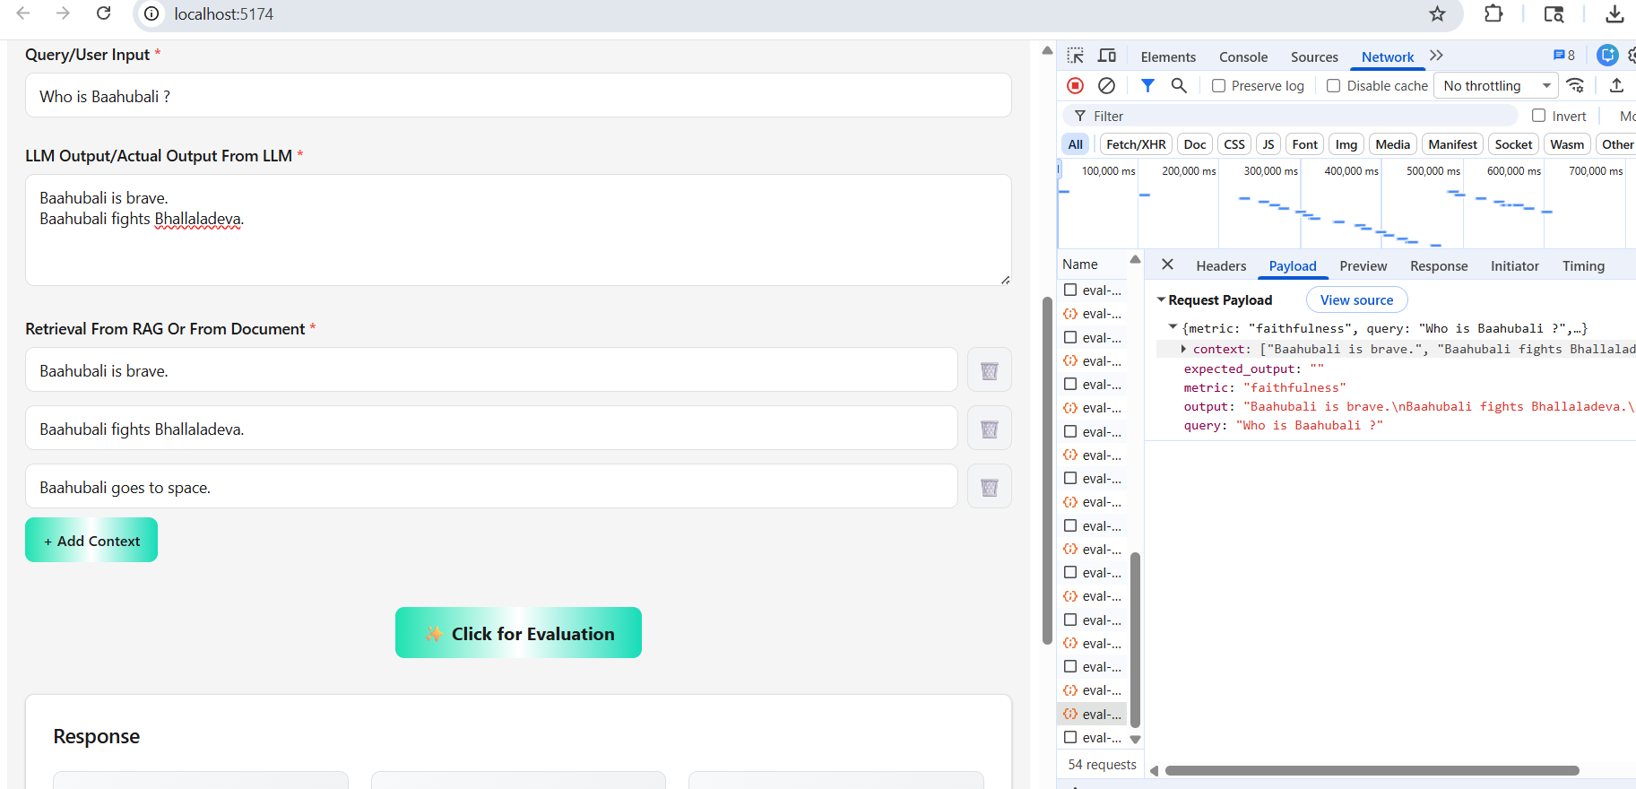
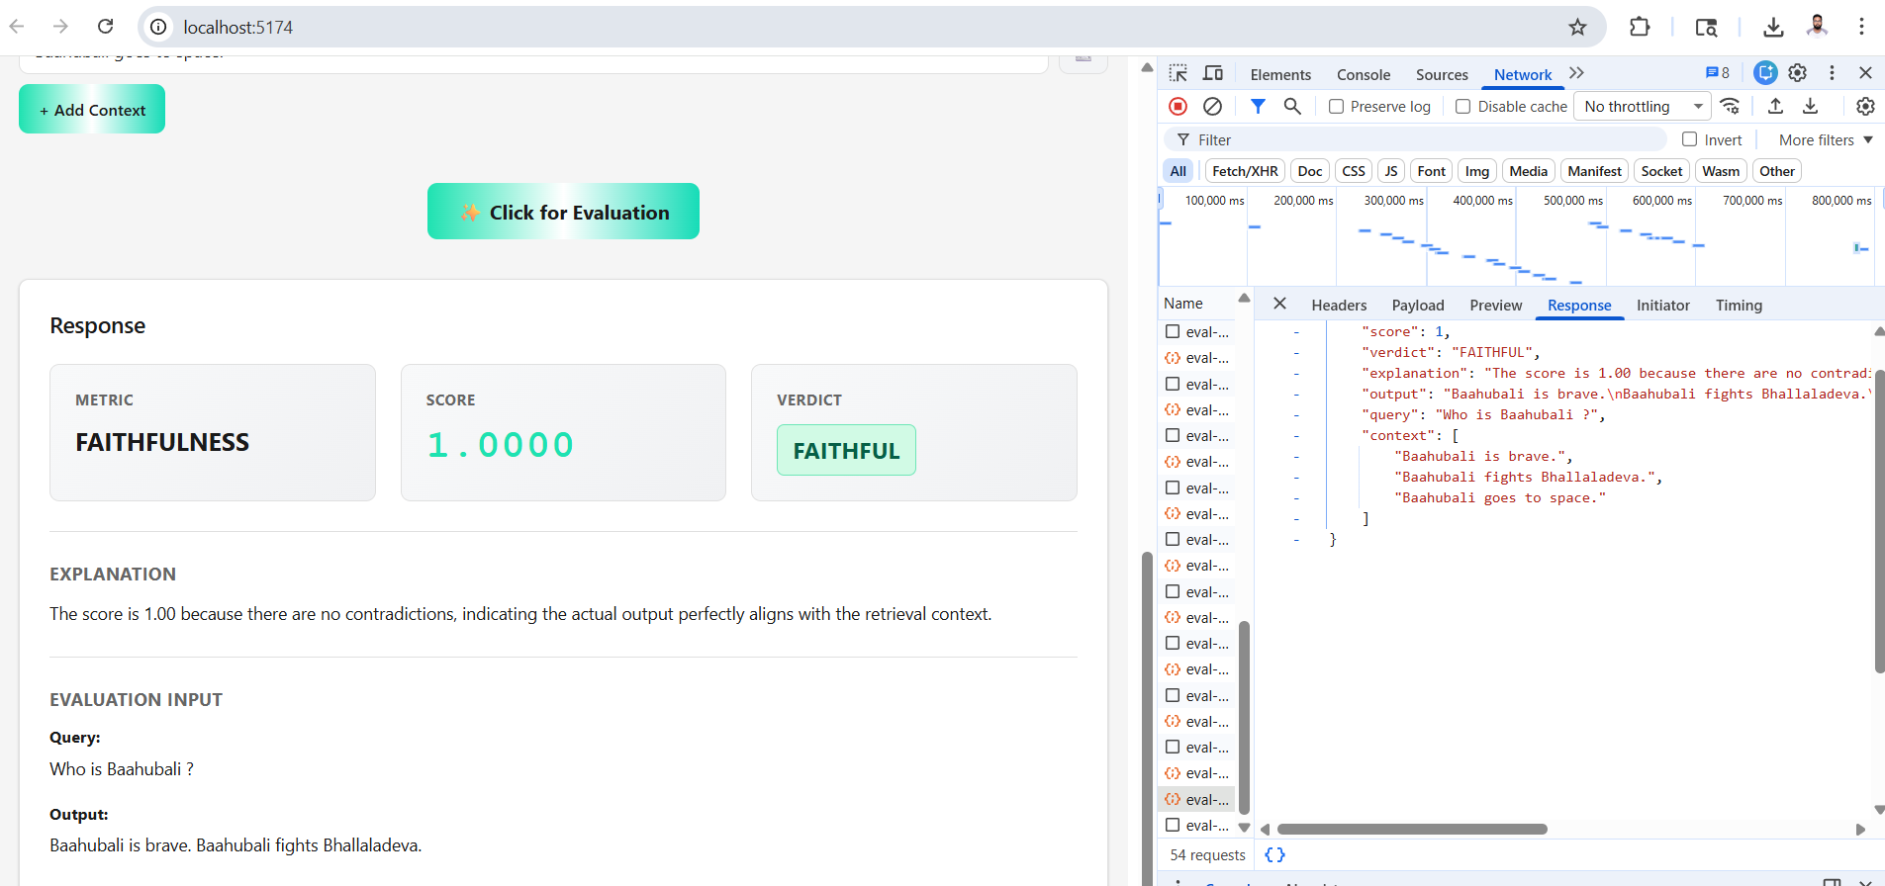

Scenario 5
Velu is a Kabaddi player.
Velu saves Dhanalakshmi from Muthupandi.
Velu hides her in Chennai.
Velu is a Kabaddi player.
Velu saves Dhanalakshmi from Muthupandi.
Velu hides her in Chennai.
Velu later becomes the Chief Minister of Tamil Nadu.
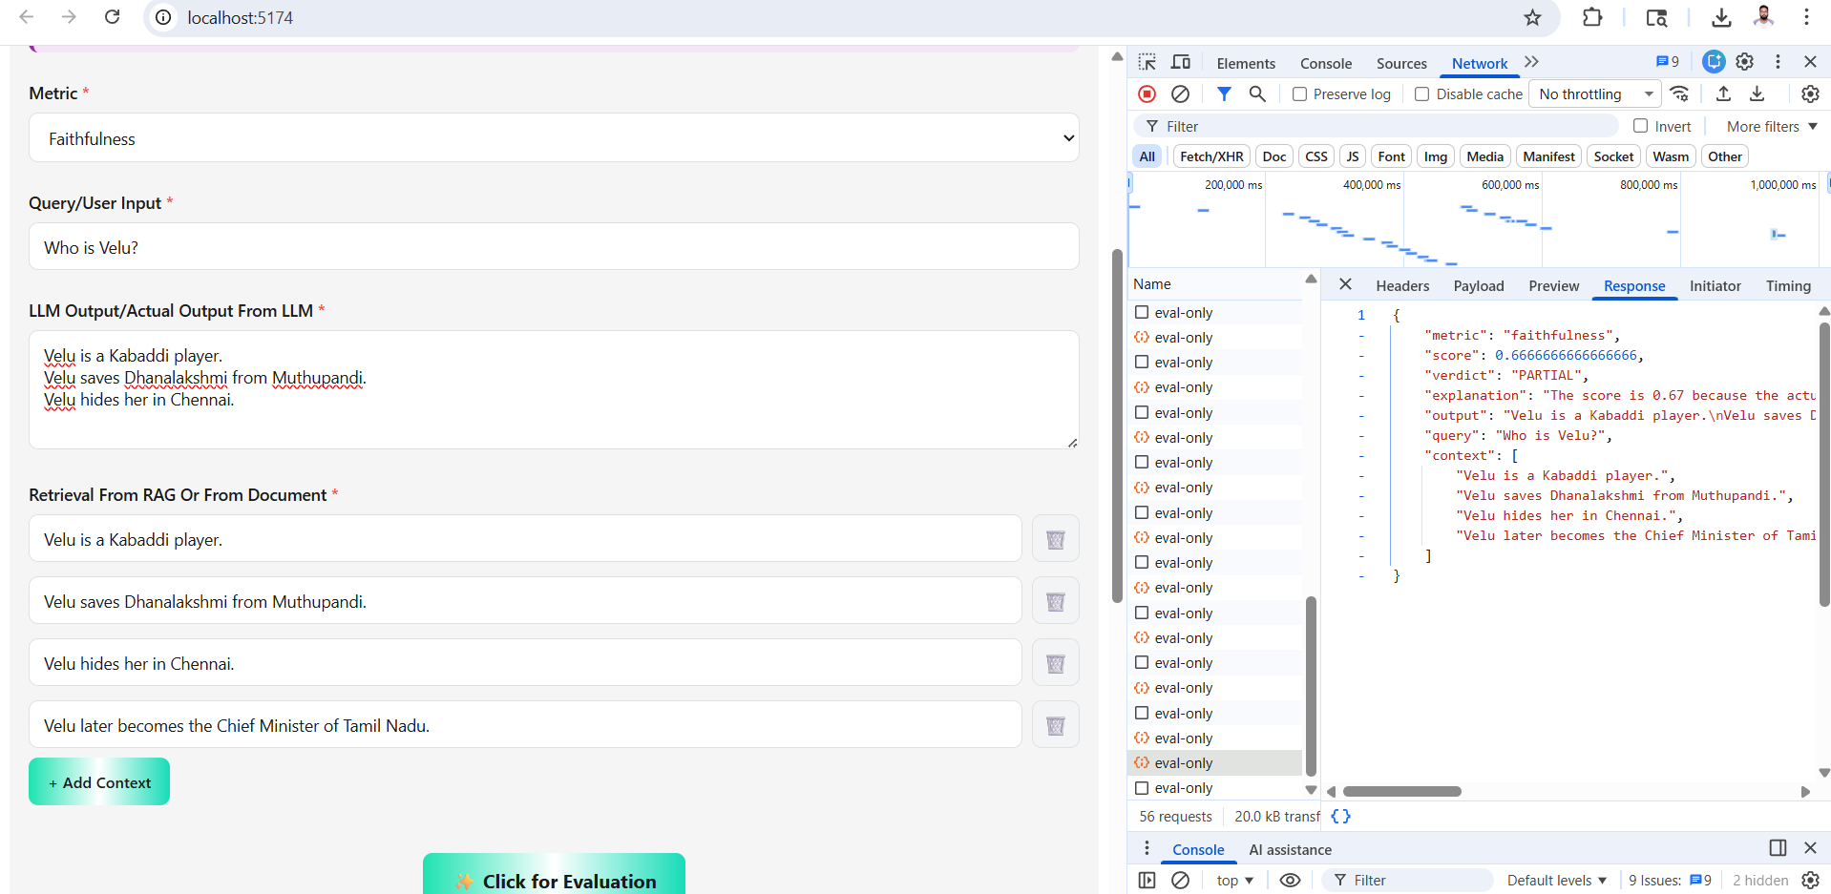
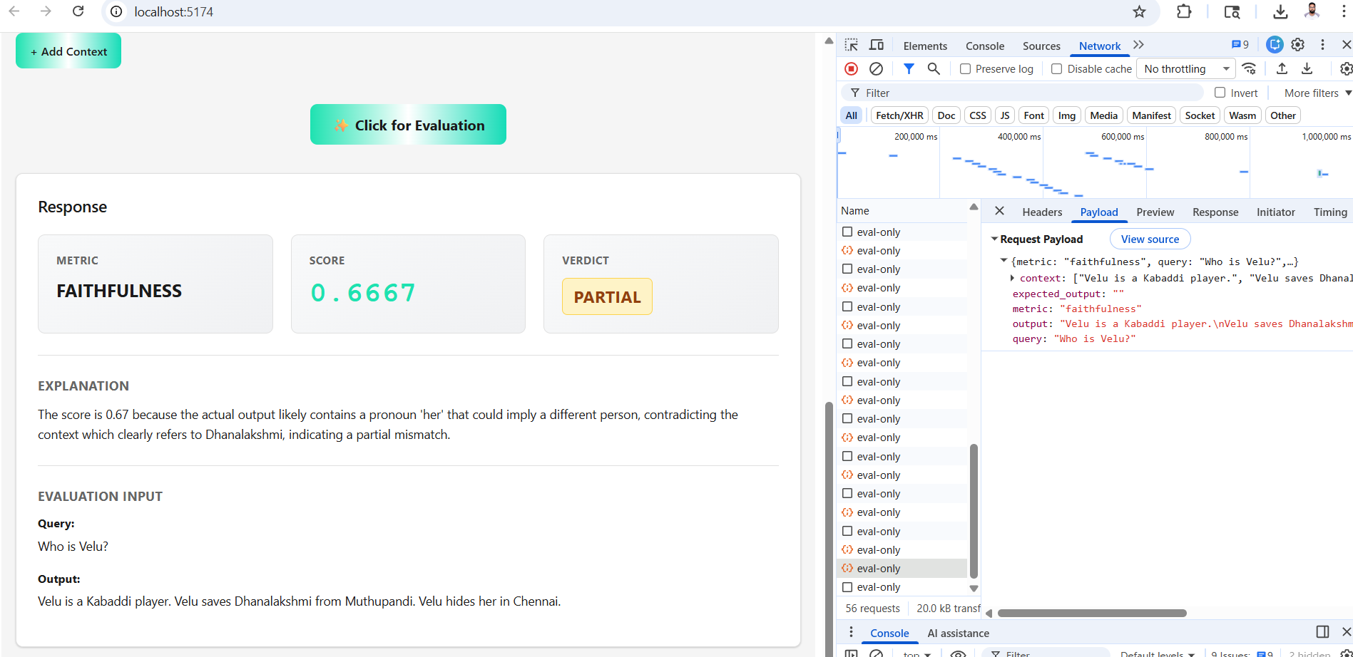
PARTIAL Faithful scenario

