Chapter-1
INTRODUCTION

Liver disease is a significant global health issue that contributes to a high rate of morbidity and mortality. The liver, one of the most vital organs in the human body, is responsible for various essential functions such as detoxification, protein synthesis, and production of biochemicals necessary for digestion. Damage to the liver caused by factors such as alcohol abuse, hepatitis infections, obesity, and exposure to toxic substances can lead to chronic liver diseases, including cirrhosis and liver cancer. Early detection and accurate diagnosis of liver disease are crucial in reducing its impact, improving patient outcomes, and enabling timely medical intervention.
In recent years, machine learning (ML) has emerged as a powerful tool in the medical field for disease diagnosis and prediction. Among the various ML techniques, ensemble learning has gained significant attention due to its ability to improve predictive performance by combining multiple models. Ensemble methods enhance the robustness, accuracy, and generalization capability of predictive systems by reducing overfitting and bias that can occur in individual models.
This project focuses on predicting liver disease using an ensemble approach that integrates two popular boosting algorithms: AdaBoost (Adaptive Boosting) and Gradient Boosting. Both techniques are based on the principle of building a strong classifier by combining several weak classifiers. AdaBoost works by adjusting the weights of incorrectly classified instances, focusing more on difficult cases in each iteration. On the other hand, Gradient Boosting minimizes the loss function by sequentially adding predictors that correct the errors of previous ones. Combining these two techniques leverages the strengths of both—AdaBoost's emphasis on misclassified data and Gradient Boosting's gradient descent-based optimization.
The dataset used in this project includes medical features such as age, gender, total bilirubin, direct bilirubin, alkaline phosphatase, albumin, and other liver function indicators. Through data preprocessing steps like handling missing values, normalization, and feature selection, the dataset is prepared for training. Visual techniques such as correlation matrices and pairplots are employed to understand feature relationships and improve feature engineering.
The core of the project lies in building and evaluating a hybrid ensemble model that uses AdaBoost and Gradient Boosting. The model is trained on a portion of the dataset and evaluated using performance metrics such as accuracy, precision, recall, and F1-score. A confusion matrix is also used to visualize the model’s performance in terms of true positives, true negatives, false positives, and false negatives.

Chapter-2
LITERATURE SURVEY :
  - EXISTING AND PROPOSED SYSTEM:

2.1.1 Existing System:
The existing systems for liver disease prediction primarily utilize traditional machine learning algorithms that operate as standalone classifiers. Commonly employed methods include Decision Trees (such as J48 and Random Tree), Logistic Regression, Support Vector Machines (SVM), Naive Bayes, and K-Nearest Neighbors (KNN). These models work by learning patterns from historical data and then predicting outcomes for new cases. While these algorithms have demonstrated some level of effectiveness, they generally face several limitations when applied to complex medical data like liver disease records. One significant drawback is their susceptibility to overfitting, especially in cases of small or imbalanced datasets, which are common in medical domains. Furthermore, single classifiers often fail to capture the nonlinear and multidimensional relationships among various clinical and biochemical parameters. These models also lack adaptability and may perform poorly when exposed to variations in input data or noise. Moreover, due to the high dimensionality and complexity of healthcare data, the decision-making process in such systems is often less accurate, making them less reliable in clinical settings. Previous systems did not incorporate advanced data preprocessing techniques, resulting in less robust models. In essence, while the existing systems laid the foundation for automated liver disease diagnosis, their predictive capabilities are limited by the constraints of using isolated learning algorithms and inadequate data handling.

Proposed System:
The proposed system aims to overcome the limitations of traditional models by employing an ensemble learning approach that leverages the combined strengths of multiple classifiers to enhance predictive performance. Specifically, the system integrates advanced ensemble techniques such as Random Forest, XGBoost (Extreme Gradient Boosting), and Gradient Boosting. These methods are known for their ability to improve classification accuracy by reducing bias and variance through strategic model aggregation. The architecture of the proposed system involves preprocessing the dataset to handle missing values, apply feature scaling, and conduct feature importance analysis. This ensures that the input data is clean, balanced, and well-suited for training robust models. The ensemble models are trained on these refined datasets and evaluated using performance metrics such as accuracy, precision, recall, and F1-score.
In this system, boosting techniques play a critical role by sequentially training models in such a way that each new model focuses on correcting the errors made by the previous ones. The use of Random Forest in combination with Gradient Boosting or XGBoost enhances the model's ability to generalize well to unseen data, which is crucial for real-world medical applications. The study reported that individual models such as Random Forest, XGBoost, and Gradient Boost achieved accuracies of 83%, 82%, and 85% respectively. However, when ensemble combinations were used—Random Forest with XGBoost and Random Forest with Gradient Boost—the accuracies improved significantly to 89.2% and 90.7%. This clearly demonstrates the effectiveness of ensemble strategies in achieving superior predictive accuracy.
Additionally, the proposed system is designed to be interactive, where users input patient data such as age, gender, bilirubin levels, enzymes, proteins, and other relevant clinical attributes. The trained model processes this data and predicts whether the individual is at risk of liver disease. This user-friendly approach could be implemented in a real-time web or desktop application, making it a practical tool for aiding clinicians in early diagnosis. The proposed system not only enhances prediction accuracy but also contributes to reducing the workload on medical professionals by providing an automated, data-driven decision support mechanism. In conclusion, the ensemble-based proposed system represents a significant advancement over traditional methods, making it highly suitable for implementation in modern healthcare environments.

Feasibility Study:
A feasibility study is a crucial part of any project development process, as it helps determine whether the proposed system is viable and worth pursuing. For the liver disease prediction system using ensemble techniques, a feasibility study has been conducted across several dimensions including technical feasibility, operational feasibility, economic feasibility, and legal and ethical feasibility.

Technical Feasibility:
The proposed system relies on well-established machine learning algorithms such as AdaBoost and Gradient Boosting, both of which are supported by a wide range of machine learning frameworks like Scikit-learn, XGBoost, and LightGBM. These tools provide pre-built libraries and robust computational support for building, training, and evaluating ensemble models. In addition, modern computing resources such as high-performance CPUs or GPUs, cloud-based platforms (e.g., Google Colab, AWS), and data storage systems make the implementation of this system technically achievable. Furthermore, standard programming environments like Python provide sufficient flexibility for data preprocessing, model deployment, and visualization. Therefore, from a technological standpoint, the system is entirely feasible and scalable.
    - Operational Feasibiliy:
Operationally, the proposed system is designed to assist medical professionals by providing early and accurate predictions of liver disease risk. This would significantly reduce their diagnostic workload and improve patient outcomes. The system is also user-friendly and can be implemented as a web-based or desktop application, allowing easy access for healthcare workers. It can be seamlessly integrated into existing hospital information systems or used as a standalone decision-support tool. The model’s input requirements (e.g., age, gender, enzyme levels) align with routine blood test reports, making it easy to obtain the necessary data without additional burden on patients or clinics. Overall, the solution is practical, adoptable, and aligns well with current medical operational practices.

Economic Feasibility:

From a financial perspective, the development and deployment of this predictive model are economically viable. Most of the tools used (Python, Scikit-learn, Pandas, etc.) are open-source, thereby eliminating the need for expensive software licenses. Additionally, since the computational resources needed are moderate, the system can be trained and run on local machines or free-tier cloud services during development. For deployment in a clinical environment, minimal investment would be needed for hosting or hardware upgrades. Considering the potential cost savings from reduced misdiagnosis and early intervention, the return on investment (ROI) for hospitals and healthcare providers is likely to be high.

Legal and Ethical Feasibility:
Healthcare data is sensitive and subject to regulatory compliance such as HIPAA (in the U.S.) or GDPR (in Europe). The system must ensure that all patient data used for training and prediction is anonymized, securely stored, and accessed only with appropriate permissions. As the system only assists in diagnosis and does not make final medical decisions, ethical concerns are minimal if clearly communicated to users. Furthermore, bias mitigation strategies (e.g., proper feature selection and balanced training data) are considered during model development to avoid discriminatory outcomes. With the proper data handling and security practices, the system is legally and ethically feasible.
- TOOLS AND TECHNOLOGIES USED
The base paper titled "Liver Disease Prediction Using Ensemble Technique" mentions the following tools and technologies used:
- Programming Language:
  - Python is used for implementing machine learning models and data processing.
- Libraries and Frameworks:
  - Pandas – for data manipulation and analysis
  - NumPy – for numerical computations
  - Matplotlib / Seaborn – for data visualization
  - Scikit-learn (sklearn) – for implementing machine learning models like AdaBoost and Gradient Boosting
- Machine Learning Algorithms:
  - AdaBoost (Adaptive Boosting)
  - Gradient Boosting
- Dataset:
  - Indian Liver Patient Dataset (ILPD) from the UCI Machine Learning Repository.
These tools and technologies are combined to build and evaluate an ensemble learning model for liver disease prediction.

Chapter-3
SOFTWARE REQUIREMENTS SPECIFICATION
- USERS:
The Liver Disease Prediction System is designed for various users, including healthcare professionals, researchers, students, and general users who want to check their liver health.
- Medical professionals, such as doctors and hepatologists, use the system to help diagnose liver disease. By entering a patient’s test results into the system, they get predictions that help them make faster and more accurate decisions. It acts as an extra tool for doctors to confirm their diagnosis and offer early alerts.
- Clinical laboratory technicians also use the system to interpret test results. After lab tests, they input the data into the system and can quickly get insights that help doctors understand the results better and faster.
- Researchers who work with data science or AI in healthcare can use this system to test how well machine learning models work for predicting liver disease. They can analyze how the models perform and even improve them, helping to develop better ways of diagnosing liver diseases.
- Students studying medicine or computer science can use this system as a learning tool. It helps them understand how machine learning can be applied to healthcare and allows them to explore the system’s functionality as part of their studies or projects.
- Software developers and AI engineers can expand or modify the system. They might add new features, like tracking patient history or making the system available on mobile or web platforms, so it can be used in more settings.
- Finally, general users, like health-conscious individuals or those with risk factors (e.g., family history, obesity, alcohol use), can use the system to check their liver health. By entering basic health information, they can get an early idea of whether they might need to see a doctor for further tests or treatment.

- FUNCTIONAL REQUIREMENTS
The functional requirements describe the core operations the system must be able to perform. These are essential for the development and usability of the liver disease prediction system using the ensemble technique.

User Data Input
The system must allow users (medical professionals, students, or general users) to input patient data. The required input data will include basic medical parameters such as:
- Age

- Gender of the patient

- TB: Total Bilirubin

- DB: Direct Bilirubin

- Alkphos: Alkaline Phosphotase

- Sgpt: Alamine Aminotransferase

- Sgot: Aspartate Aminotransferase

- TP: Total Protiens

- ALB: Albumin

- A/R: Albumin and Globulin Ratio
The input should be entered in an organized manner, either through text fields in a graphical user interface (GUI) or as a CSV file upload. The system should validate the input to ensure that the data is complete and within a reasonable range.
- Data Preprocessing
Once the data is entered, the system must preprocess it before feeding it into the prediction model. This includes:
- Handling missing values: The system should be able to either discard records with missing data or use appropriate imputation methods to fill in missing values.
- Normalization: The system should normalize the input data to ensure that all features have a similar scale, helping the machine learning models perform better.
- Categorical Encoding: If categorical features are included, they should be encoded using methods like one-hot encoding or label encoding.
These preprocessing steps are essential for cleaning and preparing the data before applying machine learning algorithms.

Model Execution
The system must be capable of executing two ensemble machine learning models:
- AdaBoost Classifier: This model should be trained to improve the accuracy of weak learners by focusing on misclassified instances and adjusting their weights.
- Gradient Boosting Classifier: This model should use gradient descent to minimize the error function by sequentially fitting weak models on the residuals of previous ones.
Both models will be trained on the preprocessed dataset, and the system should be capable of managing the training and validation processes efficiently. The system must allow for the ability to adjust model hyperparameters like learning rate, number of estimators, and maximum depth to optimize performance.

Soft Voting for Prediction
Once both models are trained, the system must use a soft voting mechanism to combine the predictions from the AdaBoost and Gradient Boosting classifiers. This involves averaging the probabilities output by each model and selecting the class with the highest average probability as the final prediction (whether the patient has liver disease or not). The final output should be:
- Prediction Result: "Yes" (indicating the presence of liver disease) or "No" (indicating the absence of liver disease).
- Probability Score: The system should display the probability of the prediction, representing the confidence level of the system's decision.

Model Performance Evaluation
The system must evaluate and display the performance of the ensemble model after making predictions. The following metrics should be calculated and displayed:
- Accuracy: The overall correctness of the model.
- Precision: The proportion of true positive predictions out of all positive predictions made.
- Recall: The proportion of actual positives correctly identified by the model.
- F1-Score: The harmonic mean of precision and recall, providing a balance between the two.
These performance metrics are crucial for understanding the effectiveness of the model and identifying areas for improvement.

User Interface (UI)
The system must include a user-friendly graphical interface for inputting data and displaying results. The UI should include the following features:
- Input Form: A form for entering patient data, including dropdown menus for categorical values and text fields for numerical values.
- Data Display: After prediction, the system should display the prediction result along with its probability score.
- Evaluation Metrics: The system should show a table or chart with the model's performance metrics (accuracy, precision, recall, F1-score, and AUC).
- Error Handling: The system should notify the user if there are issues with the input (e.g., missing data, invalid values), and provide clear instructions for correction.

Model Update and Retraining
The system should allow the user to update or retrain the model using a new dataset. This could be important for incorporating new data over time and improving the model's predictive accuracy. The system must:
- Allow the user to upload new data.
- Retrain both AdaBoost and Gradient Boosting classifiers.
- Validate the retrained model's performance with updated metrics.
- System Performance and Scalability
The system should be optimized for fast performance, especially during the model training and prediction phases. The system must:
- Provide real-time predictions (within a few seconds) for the user input.
- Handle large datasets efficiently, allowing for scalability as more patient data is added.

Non-Functional Requirements (Simplified)
Non-functional requirements are the qualities or standards that the Liver Disease Prediction System should meet in order to be effective, secure, and user-friendly. They focus on how the system works, not just what it does.
- Performance:
The system should be fast. When a user enters data, it should give a prediction quickly, ideally within 5 seconds.
- Scalability:
As more data is collected (like more patient records), the system should be able to handle it without slowing down. This means it should work well even when there is a lot of data.
- Reliability:
The system must work without crashing. If something goes wrong, it should be able to recover and continue functioning smoothly. It should be available almost all the time, with 99.9% uptime.
- Usability:
The system should be easy for everyone to use, whether they are doctors, students, or patients. The interface should be simple, and users should be able to understand how to input their data and read the results without difficulty.
- Security:
Since the system handles sensitive health data, it must protect that data from unauthorized access. This means using encryption and secure logins to keep patient information safe.
- Maintainability:
The system should be easy to update and fix if there are any problems. Developers should be able to make changes to improve it without breaking anything.

  - SYSTEM REQUIREMENTS

HARDWARE REQUIREMENTS:

- System : Pentium i3 Processor.
- Hard Disk : 500 GB.
- Monitor : 15’’ LED
- Input Devices : Keyboard, Mouse
- Ram : 4 GB

SOFTWARE REQUIREMENTS:

- Operating system : Windows 10.
- Coding Language : Python
- Web Framework : Flask

Chapter-4
SYSTEM DESIGN
  - SYSTEM ARCHITECTURE:

Pre-processing and Feature Selection

Gradient boosting algorithm and adaboosting algorithm
Dataset

Performance Analysis and Graph
Predicted Results: Liver diseases or no diseases

Fig 4.1: Architecture Design
The liver disease prediction system works in several clear steps. First, the system uses a medical dataset that contains patient details such as age, gender, and liver-related test results. This dataset is the input to the system. In the second step, the data goes through preprocessing where missing values are handled, irrelevant data is removed, and the important features (like bilirubin levels, enzyme counts) are selected. This makes the data clean and ready for use.
Next, in the third step, the cleaned data is given to two ensemble machine learning algorithms – Gradient Boosting and AdaBoosting. These algorithms work by combining multiple smaller models to create a strong and accurate prediction system. In the fourth step, the trained model predicts whether a patient has liver disease or not based on the input data. Finally, in the fifth step, the system evaluates how well the model has performed using accuracy, precision, and other metrics. Graphs and analysis results are also shown to help understand the prediction performance clearly.

  - DATA FLOW DIAGRAM:

The DFD is also called as bubble chart. It is a simple graphical formalism that can be used to represent a system in terms of input data to the system, various processing carried out on this data, and the output data is generated by this system.
The data flow diagram (DFD) is one of the most important modeling tools. It is used to model the system components. These components are the system process, the data used by the process, an external entity that interacts with the system and the information flows in the system.
DFD shows how the information moves through the system and how it is modified by a series of transformations. It is a graphical technique that depicts information flow and the transformations that are applied as data moves from input to output.

Input Dataset

Pre processing

Training dataset

Gradient boosting algorithm and adaboosting algorithm

Testing Data
Prediction/Classification

Predicted Results: Liver diseases or no diseases

Fig 4.2: Data Flow Diagram

Chapter-5
DETAILED DESIGN
  - USE CASE DIAGRAM:

A use case diagram in the Unified Modeling Language (UML) is a type of behavioral diagram defined by and created from a Use-case analysis. Its purpose is to present a graphical overview of the functionality provided by a system in terms of actors, their goals (represented as use cases), and any dependencies between those use cases. The main purpose of a use case diagram is to show what system functions are performed for which actor. Roles of the actors in the system can be depicted.

User
Input Dataset
Preprocessing
Classification report
Training
Fig 5.1: Use Case Design

- SEQUENCE DIAGRAM:

A sequence diagram in Unified Modeling Language (UML) is a kind of interaction diagram that shows how processes operate with one another and in what order. It is a construct of a Message Sequence Chart. Sequence diagrams are sometimes called event diagrams, event scenarios, and timing diagrams.

Testing
Training
Dataset
Input dataset
Send the data to training stage

Preprocessing
Train the data
Extracted feature and send to testing stage
Give input test data
Predict the type using proposed algorithm

Fig 5.2: Sequence Diagram

- CLASS DIAGRAM:
In software engineering, a class diagram in the Unified Modeling Language (UML) is a type of static structure diagram that describes the structure of a system by showing the system's classes, their attributes, operations (or methods), and the relationships among the classes. It explains which class contains information.
Input
Dataset Acquisition
Input Dataset

Preprocessing ( )
Output
Features extraction
Classification model

Finally get Classified & Display Result ( )
Liver diseases or no diseases

Fig 5.3: Class Diagram

- ACTIVITY DIAGRAM:

Activity diagrams are graphical representations of workflows of stepwise activities and actions with support for choice, iteration and concurrency. In the Unified Modeling Language, activity diagrams can be used to describe the business and operational step-by-step workflows of components in a system. An activity diagram shows the overall flow of control.
Input Dataset
Preprocessing
Training
Gradient boosting algorithm and AdaBoosting algorithm

Predicted Results: Liver diseases or no diseases

Fig 5.4: Activity Diagram

Chapter-6
IMPLEMENTATION
MODULES:
- Data Collection
- Dataset
- Data Preparation
- Model Selection
- Analyze and Prediction
- Accuracy on test set
- Saving the Trained Model

  - MODULES DESCSRIPTION:

- Data Collection:

This is the first real step towards the real development of a machine learning model, collecting data. This is a critical step that will cascade in how good the model will be, the more and better data that we get; the better our model will perform.
There are several techniques to collect the data, like web scraping, manual interventions and etc. Liver disease prediction using Ensemble Technique
Dataset Kaggle Link:
https://www.kaggle.com/datasets/jayaprakashpondy/liver-disease

- Dataset:
The dataset consists of 583 individual data. There are 11 columns in the dataset, which are described below.

- Age: Age of the patient

- Female: Gender of the patient (1 if Female, 0 if Male)

- TB: Total Bilirubin

- DB: Direct Bilirubin

- Alkphos: Alkaline Phosphotase

- Sgpt: Alamine Aminotransferase

- Sgot: Aspartate Aminotransferase

- TP: Total Protiens

- ALB: Albumin

- A/R: Albumin and Globulin Ratio

- class: 1 Liver diseases and 0 no diseases

- Data Preparation:
Wrangle data and prepare it for training. Clean that which may require it (remove duplicates, correct errors, deal with missing values, normalization, data type conversions, etc.)
Randomize data, which erases the effects of the particular order in which we collected and/or otherwise prepared our data
Visualize data to help detect relevant relationships between variables or class imbalances (bias alert!), or perform other exploratory analysis
Split into training and evaluation sets

- Model Selection:
We used Gradient Boosting Classifier + AdaBoost Classifier (Ensemble Technique) using machine learning algorithm; we got a accuracy of 92.1% on test set so we implemented this algorithm.
Ensemble Technique:
Ensemble methods are techniques that aim at improving the accuracy of results in models by combining multiple models instead of using a single model. The combined models increase the accuracy of the results significantly. This has boosted the popularity of ensemble methods in machine learning.
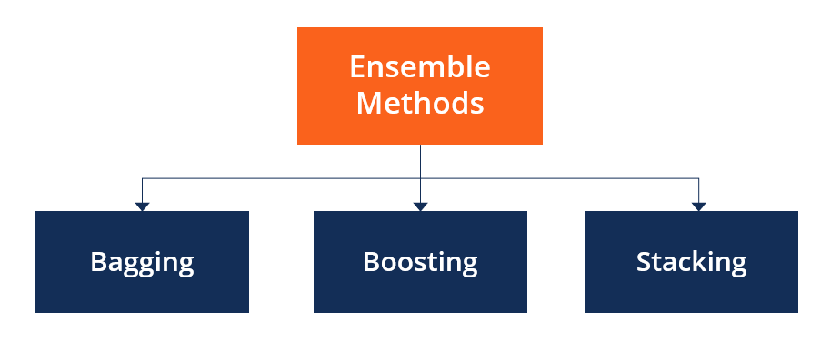
Fig 6.1: Types of Ensemble Technique

Categories of Ensemble Methods
Ensemble methods fall into two broad categories, i.e., sequential ensemble techniques and parallel ensemble techniques. Sequential ensemble techniques generate base learners in a sequence, e.g., Adaptive Boosting (AdaBoost). The sequential generation of base learners promotes the dependence between the base learners. The performance of the model is then improved by assigning higher weights to previously misrepresented learners.
In parallel ensemble techniques, base learners are generated in a parallel format, e.g., random forest. Parallel methods utilize the parallel generation of base learners to encourage independence between the base learners. The independence of base learners significantly reduces the error due to the application of averages.
The majority of ensemble techniques apply a single algorithm in base learning, which results in homogeneity in all base learners. Homogenous base learners refer to base learners of the same type, with similar qualities. Other methods apply heterogeneous base learners, giving rise to heterogeneous ensembles. Heterogeneous base learners are learners of distinct types.
Main Types of Ensemble Methods

  - Bagging:

Bagging, the short form for bootstrap aggregating, is mainly applied in classification and regression. It increases the accuracy of models through decision trees, which reduces variance to a large extent. The reduction of variance increases accuracy, eliminating overfitting, which is a challenge to many predictive models.
Bagging is classified into two types, i.e., bootstrapping and aggregation. Bootstrapping is a sampling technique where samples are derived from the whole population (set) using the replacement procedure. The sampling with replacement method helps make the selection procedure randomized. The base learning algorithm is run on the samples to complete the procedure.
Aggregation in bagging is done to incorporate all possible outcomes of the prediction and randomize the outcome. Without aggregation, predictions will not be accurate because all outcomes are not put into consideration. Therefore, the aggregation is based on the probability bootstrapping procedures or on the basis of all outcomes of the predictive models.
Bagging is advantageous since weak base learners are combined to form a single strong learner that is more stable than single learners. It also eliminates any variance, thereby reducing the overfitting of models. One limitation of bagging is that it is computationally expensive. Thus, it can lead to more bias in models when the proper procedure of bagging is ignored.

- Boosting

Boosting is an ensemble technique that learns from previous predictor mistakes to make better predictions in the future. The technique combines several weak base learners to form one strong learner, thus significantly improving the predictability of models. Boosting works by arranging weak learners in a sequence, such that weak learners learn from the next learner in the sequence to create better predictive models.
Boosting takes many forms, including gradient boosting, Adaptive Boosting (AdaBoost), and XGBoost (Extreme Gradient Boosting). AdaBoost uses weak learners in the form of decision trees, which mostly include one split that is popularly known as decision stumps. AdaBoost’s main decision stump comprises observations carrying similar weights.
Gradient boosting adds predictors sequentially to the ensemble, where preceding predictors correct their successors, thereby increasing the model’s accuracy. New predictors are fit to counter the effects of errors in the previous predictors. The gradient of descent helps the gradient booster identify problems in learners’ predictions and counter them accordingly.
XGBoost makes use of decision trees with boosted gradient, providing improved speed and performance. It relies heavily on the computational speed and the performance of the target model. Model training should follow a sequence, thus making the implementation of gradient boosted machines slow.

- Stacking:

Stacking, another ensemble method, is often referred to as stacked generalization. This technique works by allowing a training algorithm to ensemble several other similar learning algorithm predictions. Stacking has been successfully implemented in regression, density estimations, distance learning, and classifications. It can also be used to measure the error rate involved during bagging.

Gradient boosting and AdaBoost classifier:

What is a Gradient boosting Algorithm?
The main idea behind this algorithm is to build models sequentially and these subsequent models try to reduce the errors of the previous model. But how do we do that? How do we reduce the error? This is done by building a new model on the errors or residuals of the previous model.
When the target column is continuous, we use Gradient Boosting Regressor whereas when it is a classification problem, we use Gradient Boosting Classifier. The only difference between the two is the “Loss function”. The objective here is to minimize this loss function by adding weak learners using gradient descent. Since it is based on loss function hence for regression problems, we’ll have different loss functions like Mean squared error (MSE) and for classification, we will have different for e.g log-likelihood.

What is the AdaBoost Algorithm?
AdaBoost also called Adaptive Boosting is a technique in Machine Learning used as an Ensemble Method. The most common algorithm used with AdaBoost is decision trees with one level that means with Decision trees with only 1 split. These trees are also called Decision Stumps.
Why Combine or Compare Both?
"Ensemble techniques like AdaBoost and Gradient Boosting boost the prediction accuracy in liver disease detection by combining multiple weak models into strong learners. While AdaBoost focuses on misclassified samples, Gradient Boosting corrects residual errors. Together, they offer better performance and reliability than single models — with accuracy typically ranging between 80% to 92%."

- Analyze and Prediction:

In the actual Dataset, we chose only 10 features:

- Age: Age of the patient

- Female: Gender of the patient (1 if Female, 0 if Male)

- TB: Total Bilirubin

- DB: Direct Bilirubin

- Alkphos: Alkaline Phosphotase

- Sgpt: Alamine Aminotransferase

- Sgot: Aspartate Aminotransferase

- TP: Total Protiens

- ALB: Albumin

- A/R: Albumin and Globulin Ratio

- class: 1 Liver diseases and 0 no diseases

Accuracy on test set:
We got an accuracy of 92.1% on test set.

- Saving the Trained Model:
Once you’re confident enough to take your trained and tested model into the production-ready environment, the first step is to save it into an .h5 or .pkl file using a library like pickle.
Make sure you have pickle installed in your environment.
Next, let’s import the module and dump the model into .pkl file.

- SCREEN SHOTS

This screenshot showcases the complete interface of our web-based application for Liver Disease Prediction using Ensemble Techniques (AdaBoosting + Gradient Boosting Algorithm). The application includes multiple functional pages such as Home, Login, Upload, Preview, Prediction, Performance Analysis, and Charts . Users can securely log in, upload patient data, preview the dataset, and receive instant predictions based on medical parameters. The performance metrics, including accuracy (92%), precision, recall, and F1-score, are visualized through tables and a confusion matrix. This user-friendly platform aims to support medical professionals in early liver disease diagnosis through a streamlined, interactive, and accurate prediction system.

- Home Page:
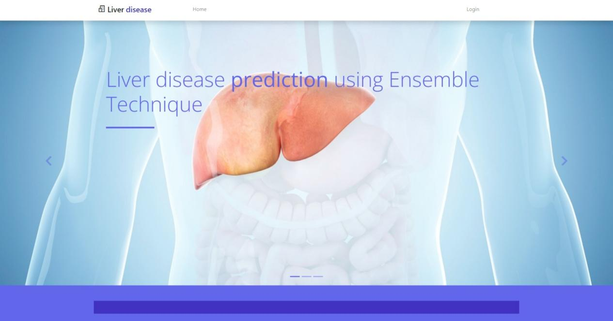
Fig 6.2 Home Page

- Login Page:

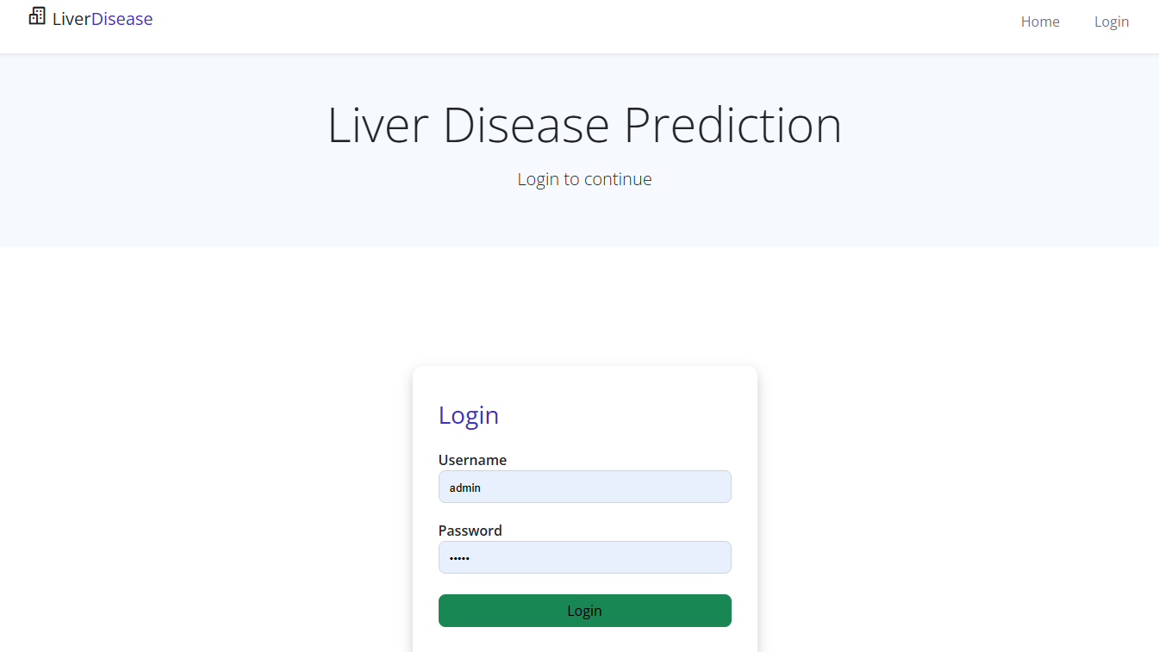
Fig 6.3: Login Page
- Upload page:

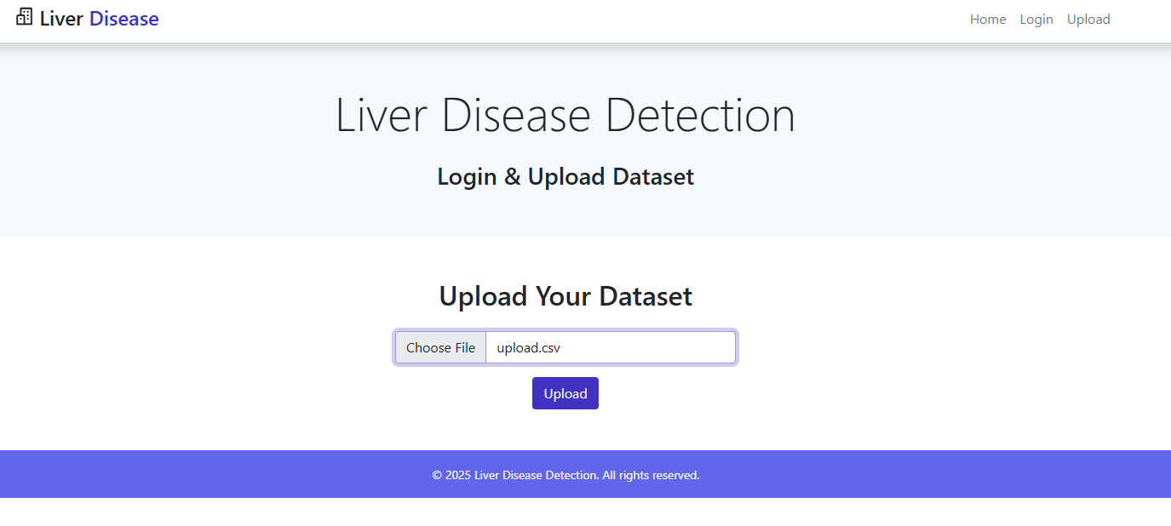Fig 6.4: Upload Page
- Preview Page:

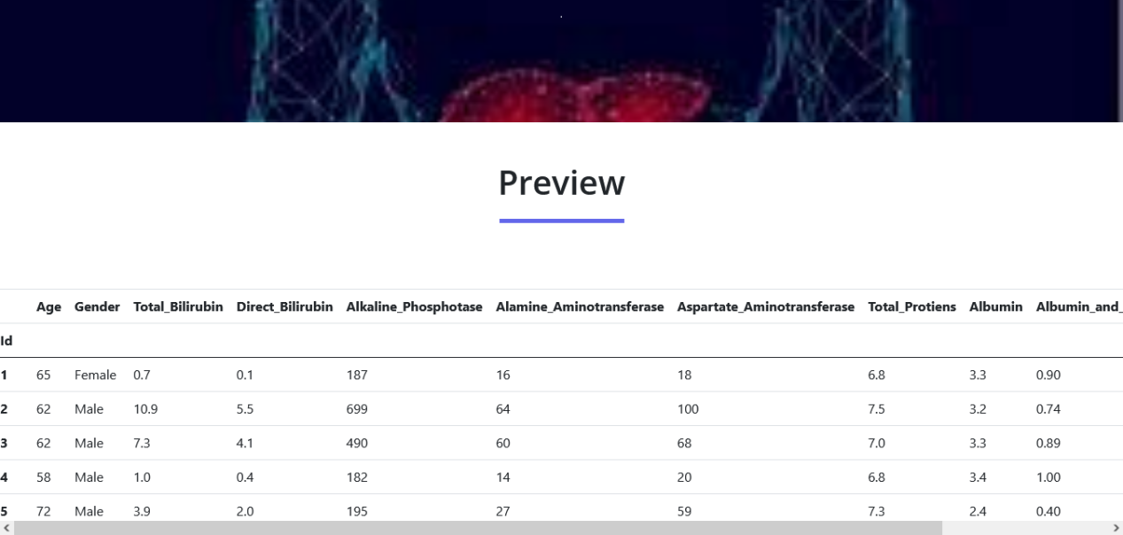
Fig 6.5: Preview Page[a]

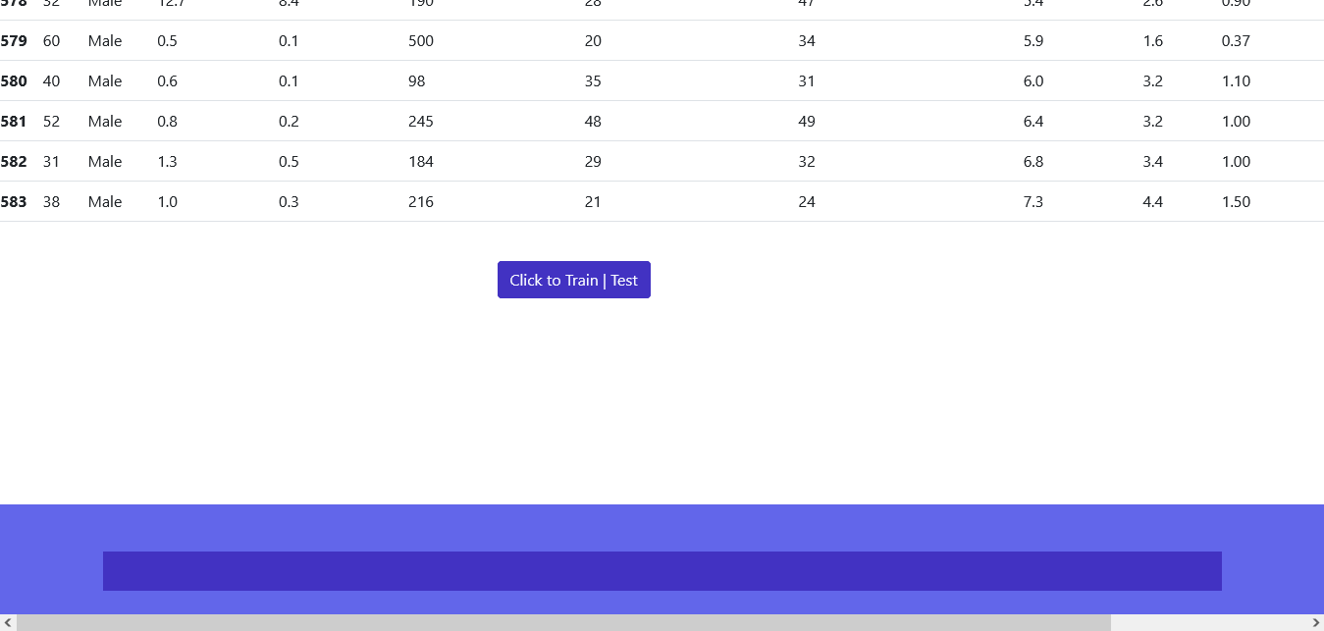
Fig 6.6: Preview Page[b]
- Prediction Page:

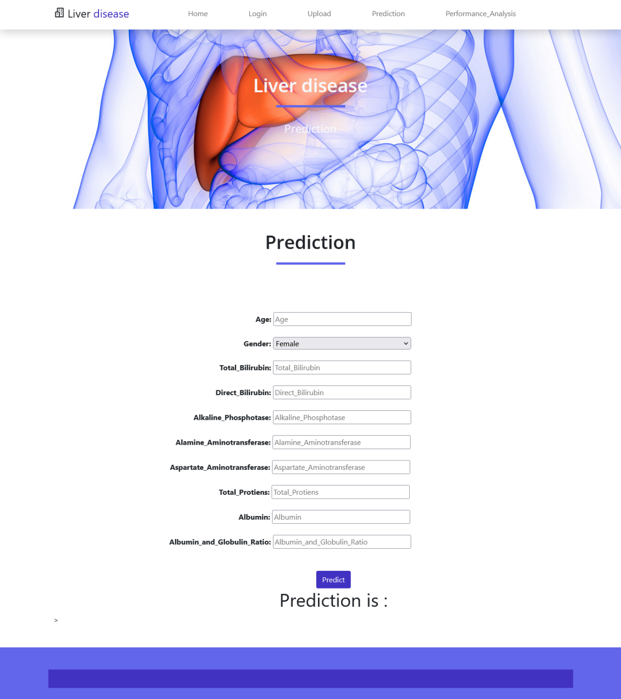
Fig 6.7: Prediction Page ( Before Predicting)

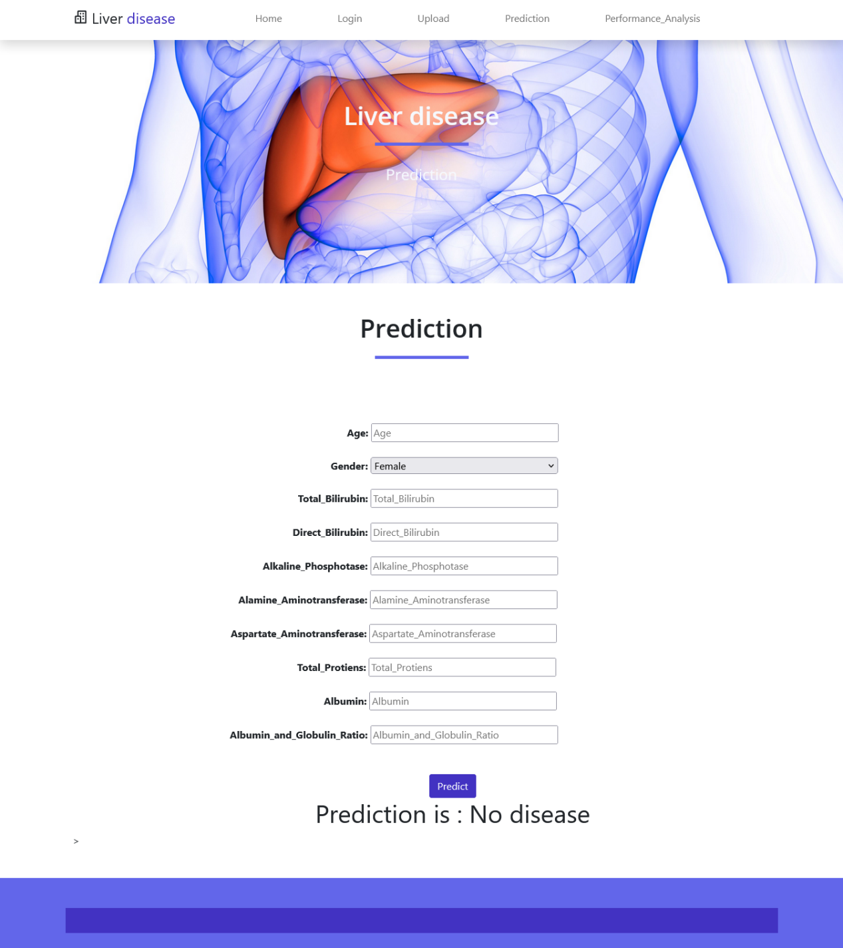
Fig 6.8: Prediction Page(After Predicting)

- Performance Analysis :

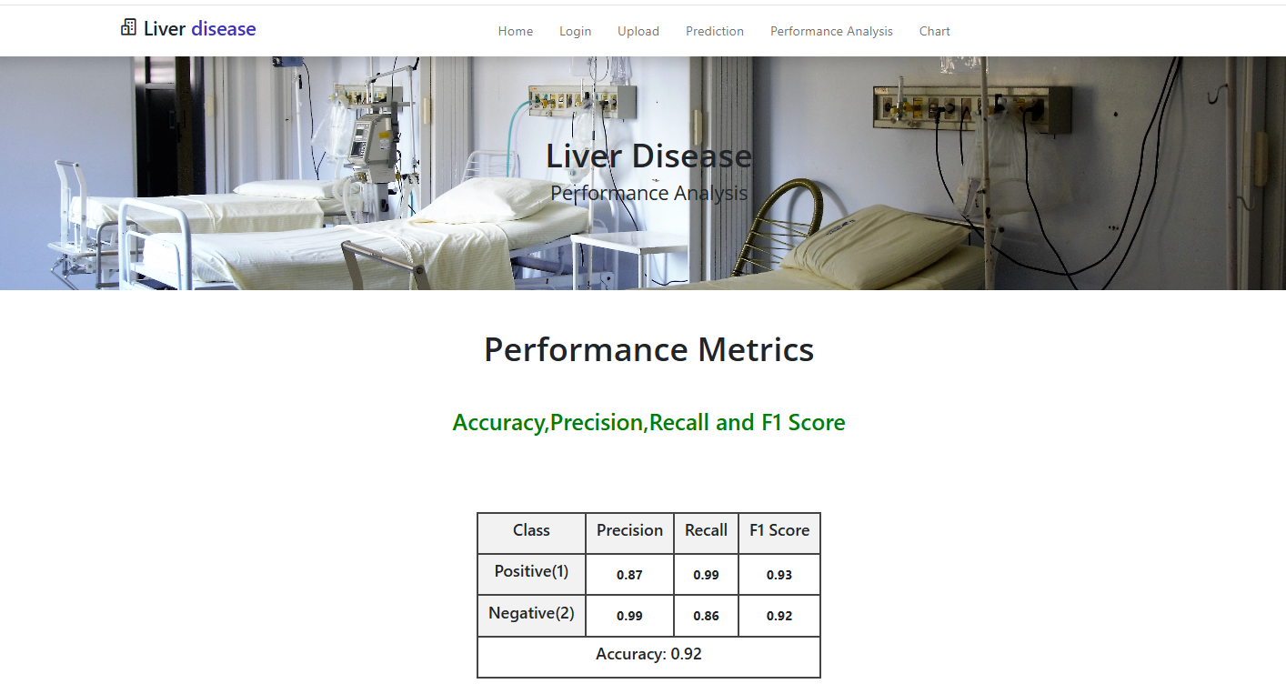
Fig 6.9: Performance Analysis

1. Accuracy:
- Definition: Proportion of total correct predictions (both positive and negative) out of all predictions.
- Formula:

Accuracy= $\frac{TP+TN}{TP+TN+FP+FN}$ [1]

→ Your model correctly predicts liver disease 92% of the time.

2. Precision:
- Definition: Out of all predicted positives, how many were actually positive.
- Formula:
Precision=$\frac{TP}{TP+FP}$ [2]
  - Positive (1): 0.87
  - Negative (2): 0.99

3. Recall (Sensitivity or True Positive Rate):
- Definition: Out of all actual positives, how many did the model correctly predict.
- Formula:
Recall$=\frac{TP}{TP+FN}$ [3]
  - Positive (1): 0.99 → Model is very good at detecting actual liver disease.
  - Negative (2): 0.86

4. F1 Score:
- Definition: Harmonic mean of precision and recall. It balances both.
- Formula:
F1 Score=2$*\frac{Precision×Recall}{Precision+Recall}$ [4]
  - Positive (1): 0.93
  - Negative (2): 0.92
Your ensemble model using AdaBoost + Gradient Boosting is:
- 92% accurate overall
- Highly sensitive to liver disease cases (recall = 0.99)
- Balanced in prediction quality, with high precision and F1 scores.

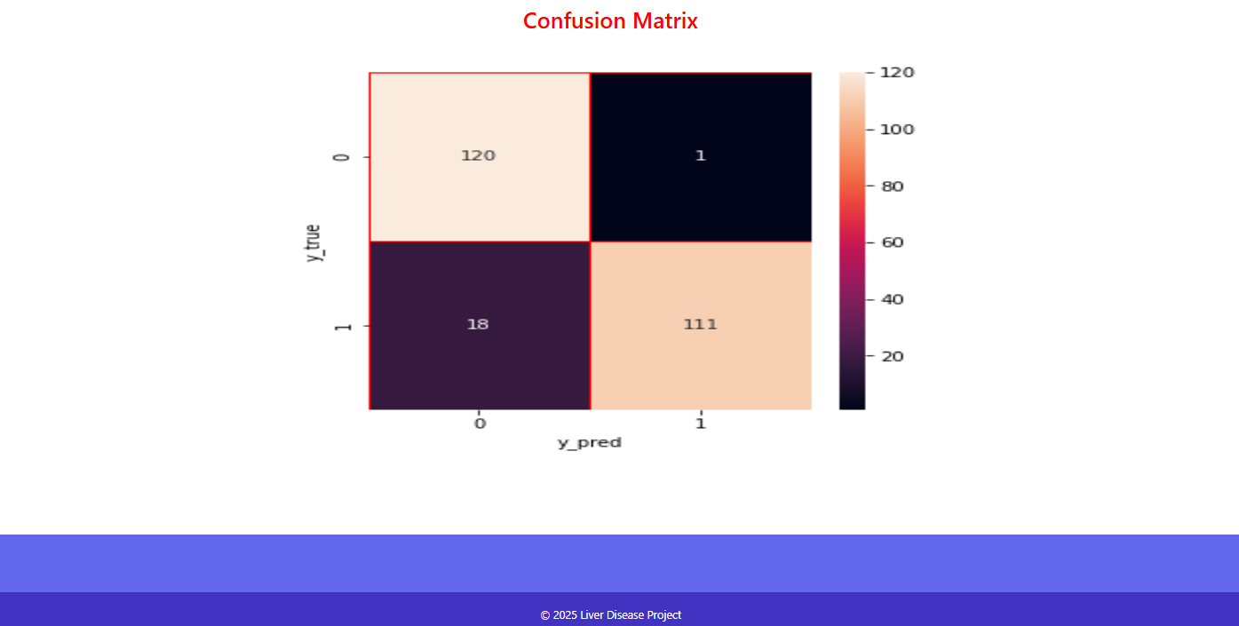
Fig 6.10: Confusion Matrix
Note:
- True Positive (TP) = 111
→ Model correctly predicted liver disease.
- True Negative (TN) = 120
→ Model correctly predicted no liver disease.
- False Positive (FP) = 1
→ Model wrongly predicted liver disease (but actually healthy).
- False Negative (FN) = 18
→ Model missed liver disease in 18 patients.

- Chart :

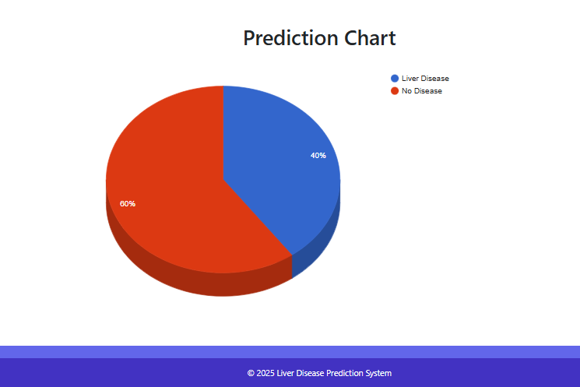

Fig 6.11: Chart Page

Chapter-7
SOFTWARE TESTING
The purpose of testing is to discover errors. Testing is the process of trying to discover every conceivable fault or weakness in a work product. It provides a way to check the functionality of components, sub assemblies, assemblies and/or a finished product It is the process of exercising software with the intent of ensuring that the
Software system meets its requirements and user expectations and does not fail in an unacceptable manner. There are various types of test. Each test type addresses a specific testing requirement.

7.1 TYPES OF TESTS

Unit testing:
Unit testing is usually conducted as part of a combined code and unit test phase of the software lifecycle, although it is not uncommon for coding and unit testing to be conducted as two distinct phases.

Test strategy and approach:
Field testing will be performed manually and functional tests will be written in detail.

Test objectives:
- All field entries must work properly.
- Pages must be activated from the identified link.
- The entry screen, messages and responses must not be delayed.

Features to be tested:
- Verify that the entries are of the correct format
- No duplicate entries should be allowed
- All links should take the user to the correct page.

- Integration testing:
Software integration testing is the incremental integration testing of two or more integrated software components on a single platform to produce failures caused by interface defects.
The task of the integration test is to check that components or software applications, e.g. components in a software system or – one step up – software applications at the company level – interact without error.
Test Results: All the test cases mentioned above passed successfully. No defects encountered.

Acceptance Testing:

User Acceptance Testing is a critical phase of any project and requires significant participation by the end user. It also ensures that the system meets the functional requirements.

Test Results: All the test cases mentioned above passed successfully. No defects encountered.

System Test
System testing ensures that the entire integrated software system meets requirements. It tests a configuration to ensure known and predictable results. An example of system testing is the configuration oriented system integration test. System testing is based on process descriptions and flows, emphasizing pre-driven process links and integration points.

Functional test
Functional tests provide systematic demonstrations that functions tested are available as specified by the business and technical requirements, system documentation, and user manuals.

Functional testing is centered on the following items:
Valid Input : identified classes of valid input must be accepted.
Invalid Input : identified classes of invalid input must be rejected.
Functions : identified functions must be exercised.
Output : identified classes of application outputs must be exercised.
Systems/Procedures: interfacing systems or procedures must be invoked.

Organization and preparation of functional tests is focused on requirements, key functions, or special test cases. In addition, systematic coverage pertaining to identify Business process flows; data fields, predefined processes, and successive processes must be considered for testing. Before functional testing is complete, additional tests are identified and the effective value of current tests is determined.
Software Testing Status for Liver Disease Prediction Project:
Test Type | Purpose | Status
Unit Testing | Test individual components like functions (e.g., data preprocessing, models) | Pass
Integration Testing | Test if modules (e.g., data input → model → output) work together properly | Pass
System Testing | Test the whole system as one complete application | Pass
Functional Testing | Check if the system meets requirements (e.g., predicting liver disease) | Pass
Regression Testing | Check that new changes didn’t break existing functionality | Pass
Acceptance Testing | Final testing to ensure the system meets user/client needs | Pass

Chapter-8
CONCLUSION
The project "Liver Disease Prediction Using Ensemble Technique" successfully demonstrates the effectiveness of combining ensemble learning methods—AdaBoost and Gradient Boosting—to improve the accuracy and reliability of liver disease diagnosis. By leveraging the strengths of both boosting algorithms, the model is able to reduce bias and variance, providing a robust and generalized prediction framework.
The approach begins with thorough data preprocessing, including handling missing values, feature scaling, and correlation analysis, to ensure the input data is clean and meaningful. Feature importance analysis helps in identifying the most relevant medical indicators that influence liver disease outcomes. The ensemble model, formed by integrating AdaBoost and Gradient Boosting, exhibits improved performance compared to individual classifiers, achieving high prediction accuracy of 92% and demonstrating its practical applicability in the medical field.
This project not only emphasizes the potential of machine learning in healthcare but also provides a scalable and adaptable method that can be further extended for other disease prediction tasks. With future integration into real-time applications, such models could assist healthcare professionals in early detection, thereby enhancing patient care and treatment outcomes.

Chapter-9
FUTURE ENHANCEMENTS

BIBLIOGRAPHY:

[1] A. M. K. T. G. K. M. K. B.Muruganantham, ”Liver Disease Prediction Using Classification Algorithms”.

[2] S. E. A. I. E.-D. Engy El-Shafeiy, ”Prediction of Liver Diseases Based on Machine Learning Technique for Big Data”.

[3] Z. T. Joy Roy, ”A Comparative Study On Liver Disease Prediction Using Supervised Machine Learning”.

[4] S. R. D. K. Vasan Durai, ”Liver disease prediction using Machine Learning”.

[5] M. S. A. K. G. S. P. 1Rakshith D B, ”Liver Disease Prediction System using Machine Learning Techniques,” 2021.

[6] J. C. M. J. M. E. I. Joel Jacob, ”Diagnosis of Liver Disease Using Machine Learning Techniques,” 2018.

[7] L. J. T. Banu Priyal, ”Performance Analysis of Liver Disease Prediction Using Machine Learning Algorrithms”.

[8] R. T. Ribeiro, R. T. Marinho and J. M. Sanches, ”Classification and Staging of Chronic Liver Disease From Multimodal Data,” in IEEE Transactions on Biomedical Engineering, vol. 60, no. 5, pp. 1336-1344, May 2013, doi: 10.1109/TBME.2012.2235438.

[9] J. Lara, Y. Khudyakov, F. Xavier L o´pez-Labrador, F. Gonzalez Candelas and M. Berenguer, ”Hepatitis C virus genetic association to rate of liver fibrosis progression,” 2013 IEEE 3rd International Conference on Computational Advances in Bio and medical Sciences (ICCABS), 2013, pp. 1-1, doi:10.1109/ICCABS.2013.6629225

[10] S. Ambesange, V. A, R. Uppin, S. Patil and V. Patil, ”Optimizing Liver disease prediction with Random Forest by various Data balancing Techniques,” 2020 IEEE International Conference on Cloud Computing in Emerging Markets (CCEM), 2020, pp. 98-102, doi: 10.1109/CCEM50674.2020.00030.

[11] F. Destrempes et al., ”Machine learning based on quantitative ultrasound for assessment of chronic liver disease,” 2020 IEEE International Ultrasonics Symposium (IUS), 2020, pp. 1-3, doi: 10.1109/IUS46767.2020.9251512.

[12] H. -q. Zhang et al., ”Using text mining to understand traditional Chinese medicine pathogenesis of nonalcoholic fatty liver disease,” 2013 IEEE International Conference on Bioinformatics and Biomedicine, 2013, pp. 311-314, doi: 10.1109/BIBM.2013.6732702.

[13] M. Sasso, V. Miette and L. Sandrin, ”Novel Controlled Attenuation Parameter for the evaluation of fatty liver disease,” 2009 IEEE Interna- tional Ultrasonics Symposium, 2009, pp.2256-2259, doi: 10.1109/ULT- SYM.2009.5441681.

[14] W. Nanyue et al., ”Comparative study of pulse-diagnosis signals between 2 kinds of liver disease patients based on the combination of unsupervised learning and supervised learning,” 2013 IEEE International Conference on Bioinformatics and Biomedicine, 2013, pp. 260-262, doi:10.1109/BIBM.2013.6732688.

