**Difference Between Document & Window Object in JS**

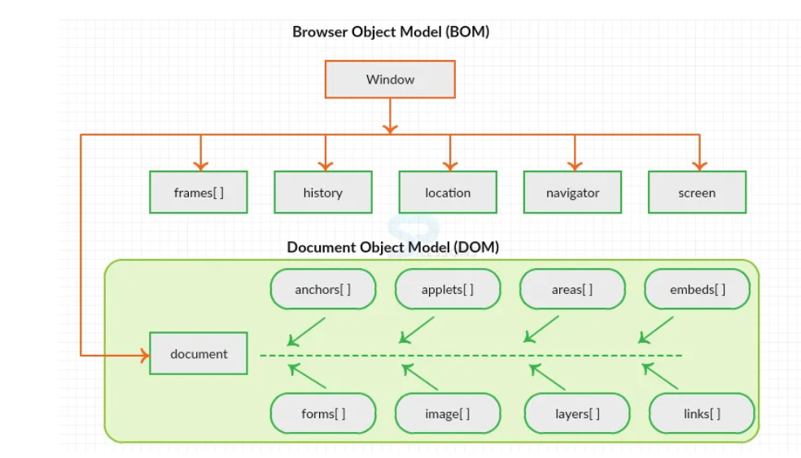

**Document Object** :

The document object represents a web page that is loaded in the browser. By accessing the document object, we can access the element in the HTML page. With the help of document objects, we can add dynamic content to our web page. The document object can be accessed with a **window.document** or just **document.**

**Syntax:** document.property_name;  
 (or)  
window.document.propertyname;

Each HTML document that gets loaded into a window becomes a document object. The document contains the contents of the page. Using document object, JavaScript can modify, add and delete the HTML elements, attributes CSS styles in the page.browser.

The window object represents a window/tab containing a DOM document where as document object is property of window object that points to the DOM document loaded in that window.

We can access a document object either using window.document property or using document object directly as window is global object. In the below example, title is the property of document object.

The other major difference is that both window object and document object have properties and methods. Few method names are same in both objects but with different behavior. In the below example window.open() opens a new tab or window and document.open() creates a blank document within the window.

**Window Object:**

The window object is the topmost object of the DOM hierarchy. It represents a browser window or frame that displays the contents of the webpage. Whenever a window appears on the screen to display the contents of the document, the window object is created.

**Syntax :** window.property_name;

The first thing that gets loaded into the browser is the window and the properties related to that window are stored in the window object. Properties related to window objects are length, innerWidth, innerHeight, caches, etc.

|  |  |
| --- | --- |
| **Document Object** | **Window Object** |
| * It represents the document loaded inside the window or browser. | * It represents the browser window in which you are seeing the content. |
| * The properties related to it are stored in the document object. | * The properties related to it are stored in the window object. |
| * It is loaded after the loading window because the window contains a document. | * It is loaded before the document because window container document. |
| * It is the root element of the document object model. | * The window is the global element for all objects, functions, etc. |
| * It is an object of window. | * It is an object of the browser. |
| * We can not access windows objects properties inside the document. | * We can access document object properties inside the window. |
| * Logically : document:{properties} | * Logically : window:{document:{properties}} |
| * Example: document.title will return the title of the document | * Example: window.document.title will return the title of the document. |