 

INSTITUTE FORADVANCED COMPUTING AND SOFTWARE DEVELOPMENT AKURDI, PUNE

DocumentationOn

**“Online Medical Passport”**

PG-DAC FEB 2020

*Submitted By:*

**Group No: 49**

**Amey.A.S.Patil 1174**

**Balaji.V.Kadam 1145**

**PrashantKarhale Mr.KashinathPatil**

**CentreCoordinator ProjectGuide**

# Table of Contents

1. Introduction 1

DocumentPurpose 2

ProblemStatement 2

ProductScope 2

Aim&Objectives 2

1. OverallDescription 3

ProductPerspective 3

Benefits of Online Medical Passport 3

UserandCharacteristics 3

OperatingEnvironment 3

Design andImplementationConstraints 3

1. RequirementsSpecification 4

ExternalInterfaceRequirements 4

Non-FunctionalRequirements 12

1. SystemDiagram 11

ActivityDiagram 11

DataFlowDiagram 13

ER Diagram 16

Use CaseDiagram 16

1. TableStructure 17

User 17

Doctor 17

Description 17

Admins 18

1. Conclusion 19

FutureScope 19

1. References 20

**List of Figures**

Figure 1 AdminActivityDiagram 11

Figure 2 UserActivityDiagram 12

Figure 3 Doctor ActivityDiagram 12

Figure 4 Level 0 DataFlowDiagram 13

Figure 5 Level 1 DataFlow Diagram 13

Figure 6 Level 2 Data Flow DiagramforAdmin 14

Figure 7 Level 2 Data Flow Diagram forDoctor 14

Figure 8 Level 2 Data Flow DiagramforUser 15

Figure 9 UseCaseDiagram 16

Figure 10 ERDiagram 16

# Introduction

In our country, a medical details of a patient such as patient records, medical history, prescriptions, etc are stored manually on a paper form. There is no automated process for this maintaince and sorting of this records. As well as there is no method to keep a track of last medical medicalkeepup for serious conditions and senior citizens. Online medical passport helps to keep a one-stop solution for health record management and tracking of previous health checkup. It also has a feature of compulsory health check-up in a interval of every 6-months. This system also raises a alert flag for user who is unfit to travel or have not checked up in more than 6 months.

## Document Purpose

The advancement in Information Technology and internet penetration has greatly enhanced various business processes and communication between patients and their doctors who are providing medical facility. This Society online medical passport is developed to provide the following services:

Enhance Processing Speed:

To be able to use internet technology and database management software via a server-side platform for faster record entry, processing and deletion as well as global sharing of medical history.

Online Record Management:

To be able to Keep a online record of every individual user which can be accessed by every citizen or doctor from any part and changes can be made.

Automatic Check-up reminder:

The system automatically generates a reminder for health check-up for user at an interval of 6-months due to check an proper health-care of every citizen is maintained. A flag is also generated automatically if the checkup is not done or the patient is unfit to travel.

## Problem Statement

Existing methods for maintaining medical records were based on the traditional paper and register format. Access to this methods where not easily possible as physical access was required. It was hard to maintain such a huge record and searching and sorting was a tedious job the medical authority and it was hard to keep a track of every patient and its checkup dates. Hence this system can overcome the flaws found in the traditional medical record management system and can automate the management process.

## ProductScope

This project traverses a lot of areas ranging from business concept to computing field, and required to perform several researches to be able to achieve the project objectives.

The area covers include:

• Medical industry: This includes study on how the daily medical authority work actually is being done, process involved and opportunity that exist for improvement.

• J2EE Technology used for the development of the application.

• General endusers as well as the hospital staff will be able to use the system effectively.

• Web-platform means that the system will be available for access 24/7 except when there is a temporary server issue which is expected to be minimal.

## Aims &Objectives

Specific goals are: -

• To produce a web-based system that allow the admin to add user, doctors and provide functionalities to its role.

• To ease doctors by providing different functionalities to it.

• To ease user to help him add and track his health records efficiently.

# 2. Overall Description

## Product Perspective:

Existing system function:

**PROPOSEDSYSTEM:**

Product functionality:

Online medical passport provides the features for admin, doctors and users. It includes several functionalities describes as below:

Patient Management: It provides facility to view our heath description status. We can also keep a trace of health checkup records and missed chrkup dates.

Doctor Management: It provides facility to add, update, delete and view the patients who are registered under this system. We can view their details and also update it if that particular patient had a health chekup.

Admin Management: It provides facility to add, update, delete and view the patients and doctors who are registered under this system. We can view their details and also update it if that particular patient had a health chekup.

## Benefits of Online Medical Passport

This online medical passport solution is fully functional and flexible.

• It is very easy to use.

• This online medical passport helps in medical back office administration by streamlining and standardizing the procedures.

• It saves a lot of time, money and labour.

• Eco-friendly: The monitoring of the medical records becomes easy and includes the least of paper work.

• The application acts as an office that is open 24/7.

• It increases the efficiency of the management at offering quality services to the customers.

• It provides custom features development and support with the application.

## 

## Users and Characteristics:

Admin:

•Admin can login to the system.

•View the list of all users in the system.

• Add new user.

• Add new Doctor

•Delete doctor

• Delete user.

•Update user.

• Search users.

Doctors:

• Doctor can login to the system.

• View his/her details.

• View users.

• Add users.

• Delete users.

• Update users.

•search users.

Users:

• User can login to the system

• View his/her details

## Operating Environment:

Server Side:

MySql Database

**Spring Boot**

**Processor:** Intel CORE i5

**HDD:** Minimum 500GB Disk Space

**RAM:** Minimum 2GB **OS:** Windows 10 , Linux 6

Client Side (minimum requirement):

Angular 11

**Processor:** Intel CORE i5

**HDD:** Minimum 80GB Disk Space

**RAM:** Minimum 1GB

**OS:** Windows 10, Linux

Tools Used:

Eclipse IDE

Visual Studio Code

MySql Workbench

## Design and Implementation Constraints:

* TheapplicationwilluseAngular asmainwebtechnologies.
* HTTP and FTP protocols are used as communication protocols. FTP is used to upload the web application in live domain and the client can access it via HTTP protocol.
* Several types of validations make this web application a secured one and SQL Injections can also beprevented.
* Since Online Medical Passport is a web-based application, internet connection must beestablished.
* TheOnline Medical Passport willbeusedonPCsandwillfunctionviainternet or intranet in any webbrowser.

# 

# 3. RequirementsSpecification

## External Interface Requirements:

User Interfaces:

* + All the users will see the same page when they enter in this website. This page asks the users a username and apassword.
  + After being authenticated by correct username and password, user will be redirect to their corresponding profile where they can do variousactivities.
  + Theuserinterfacewillbesimpleandconsistence,usingterminologycommonly understood by intended users of the system. The system will have simple interface,consistencewithstandardinterface,toeliminateneedforusertraining of infrequentusers.

Hardware Interfaces:

* + No extra hardware interfaces areneeded.
  + The system will use the standard hardware and data communicationresources.
  + This includes, but not limited to, general network connection at the server/hosting site, network server and network managementtools.

Application Interfaces:

**OS:** Windows 10, Linux

**Web Browser:**

The system is a web-based application; clients need a modern web browser such as Mozilla Firebox, Internet Explorer, Opera, and Chrome. The computer must have an Internet connection in order to be able to access the system.

Communications Interfaces:

* + This system uses communication resources which includes but not limited to, HTTP protocol for communication with the web browser and web server and TCP/IP network protocol with HTTPprotocol.
  + This application will communicate with the database that holds all the booking information. Users can contact with server side through HTTP protocol by means of a function that is called HTTP Service. This function allows the application to use the data retrieved by server to fulfil the request fired by the user.

**4.SystemDiagram**

## ActivityDiagram

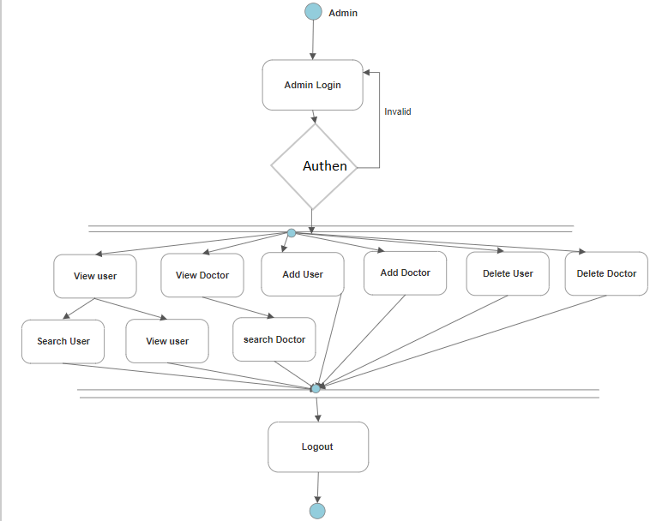

**Figure 1: Admin Activity Diagram**

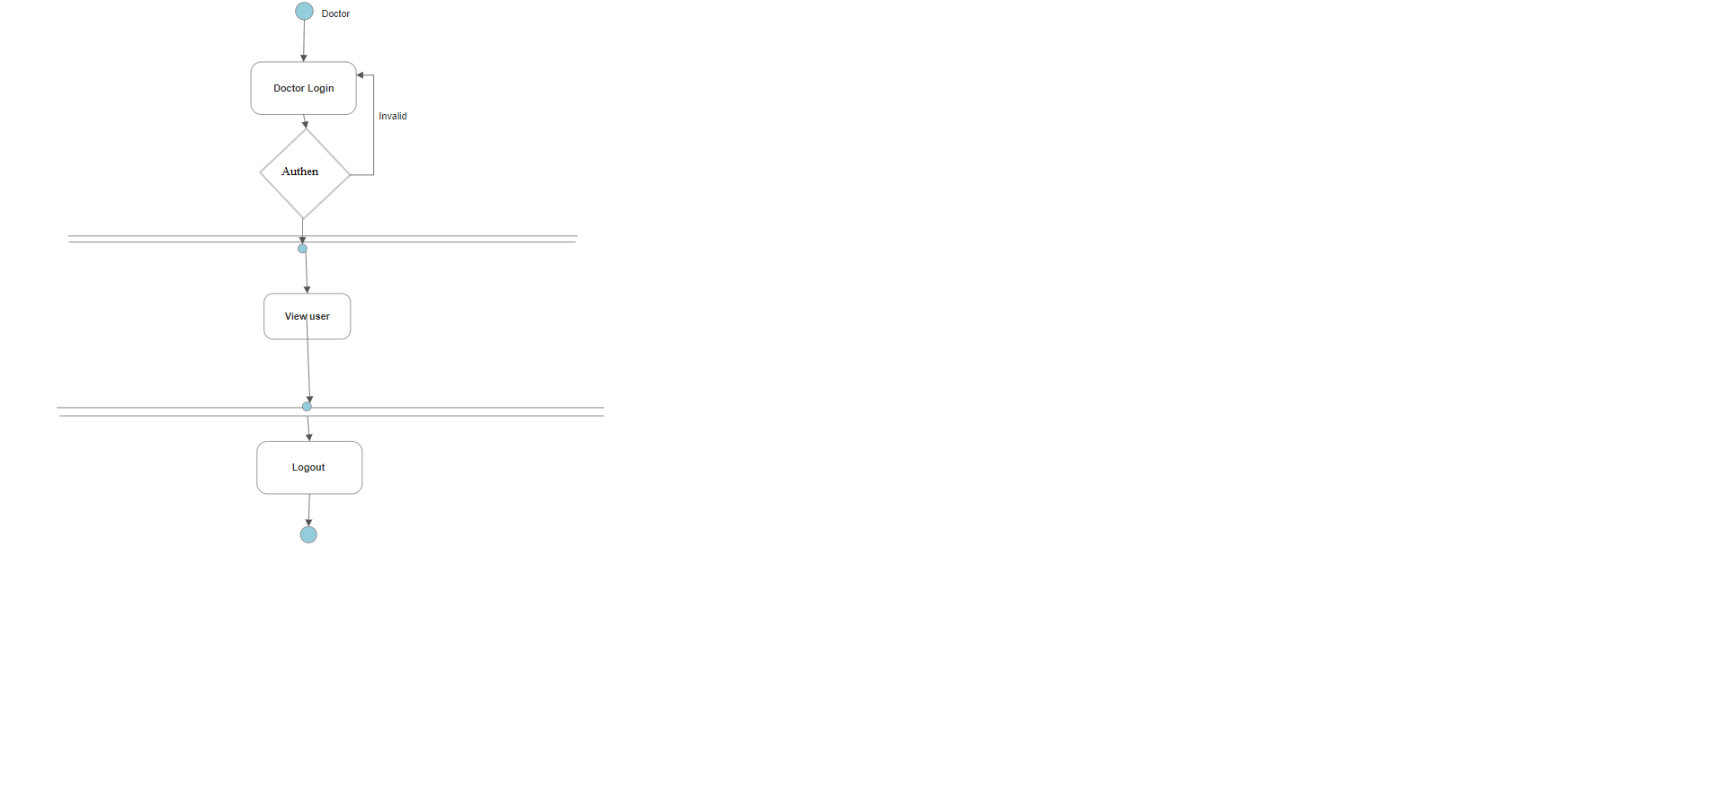

**Figure 2: UserActivityDiagram**

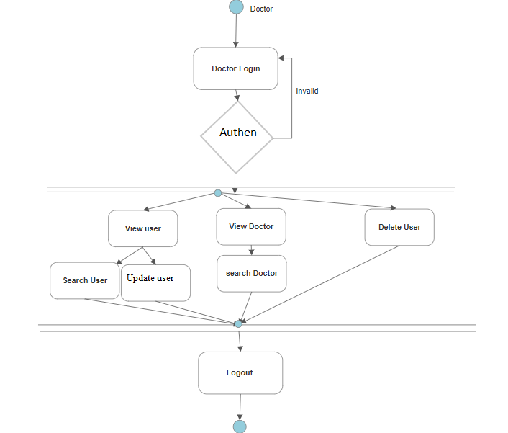

**Figure 3: DoctorActivityDiagram**

## Data Flow Diagram

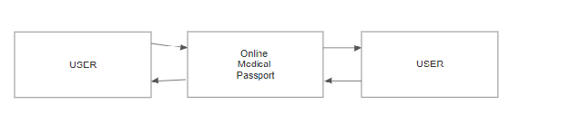

**Figure 4: Level 0 Data FlowDiagram**

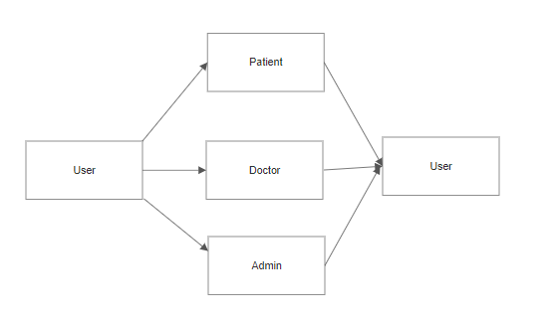

**Figure 5: Level 1 Data FlowDiagram**

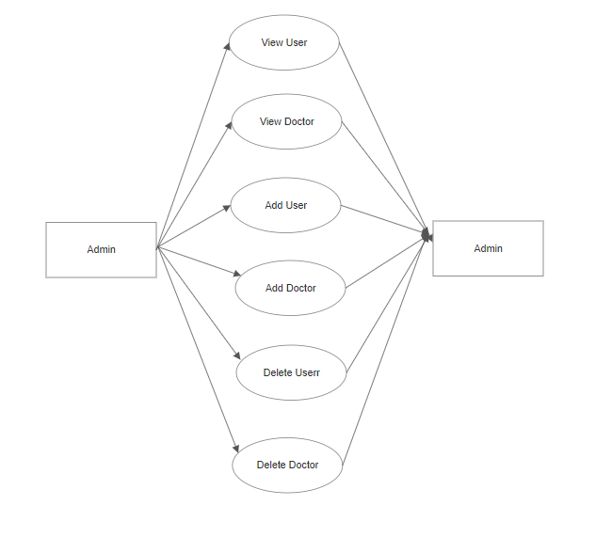

**Figure 6: Level 2 Data Flow Diagram for Admin**

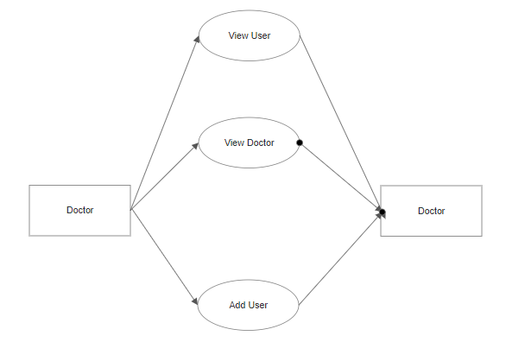

**Figure 7: Level 2 Data Flow Diagram for Doctor**

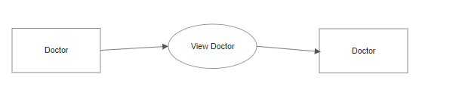**Figure 8: Level 2 Data Flow Diagram for User**

## ER Diagram

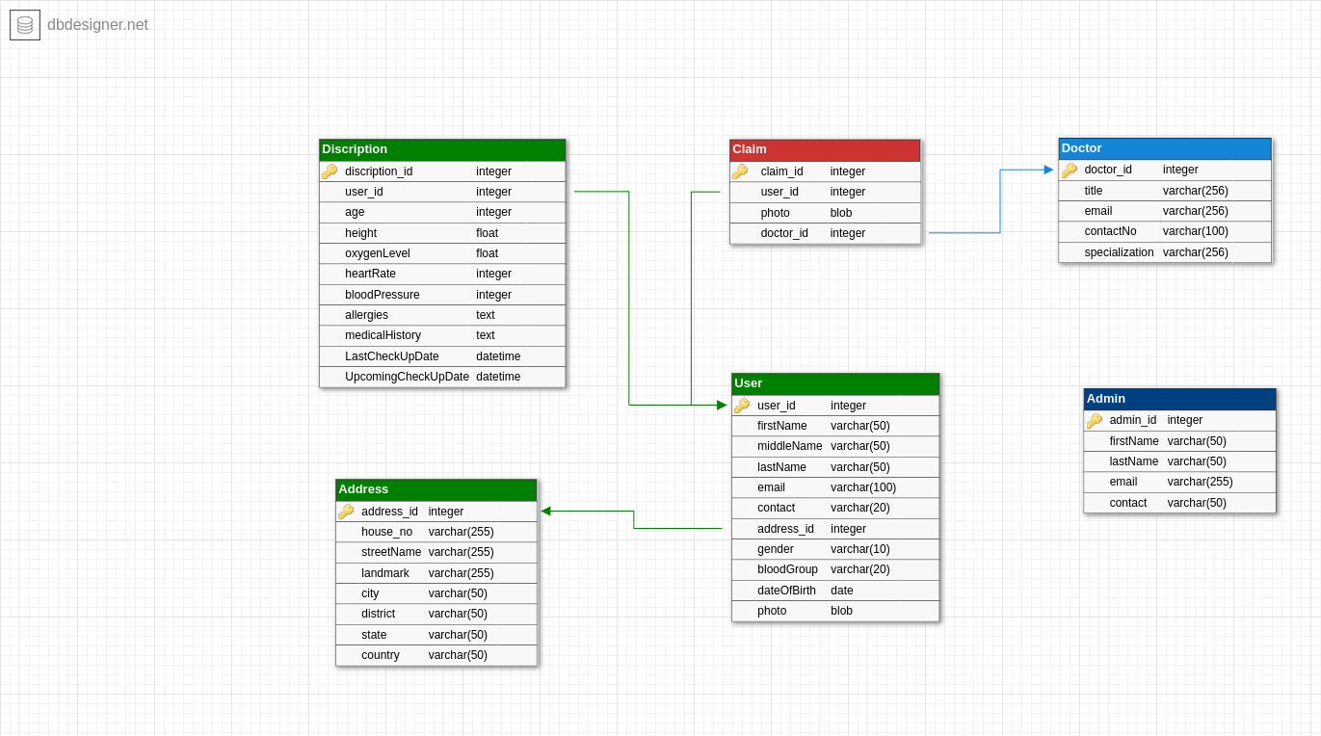

**Figure 9 : ER Diagram**

## Use Case Diagram

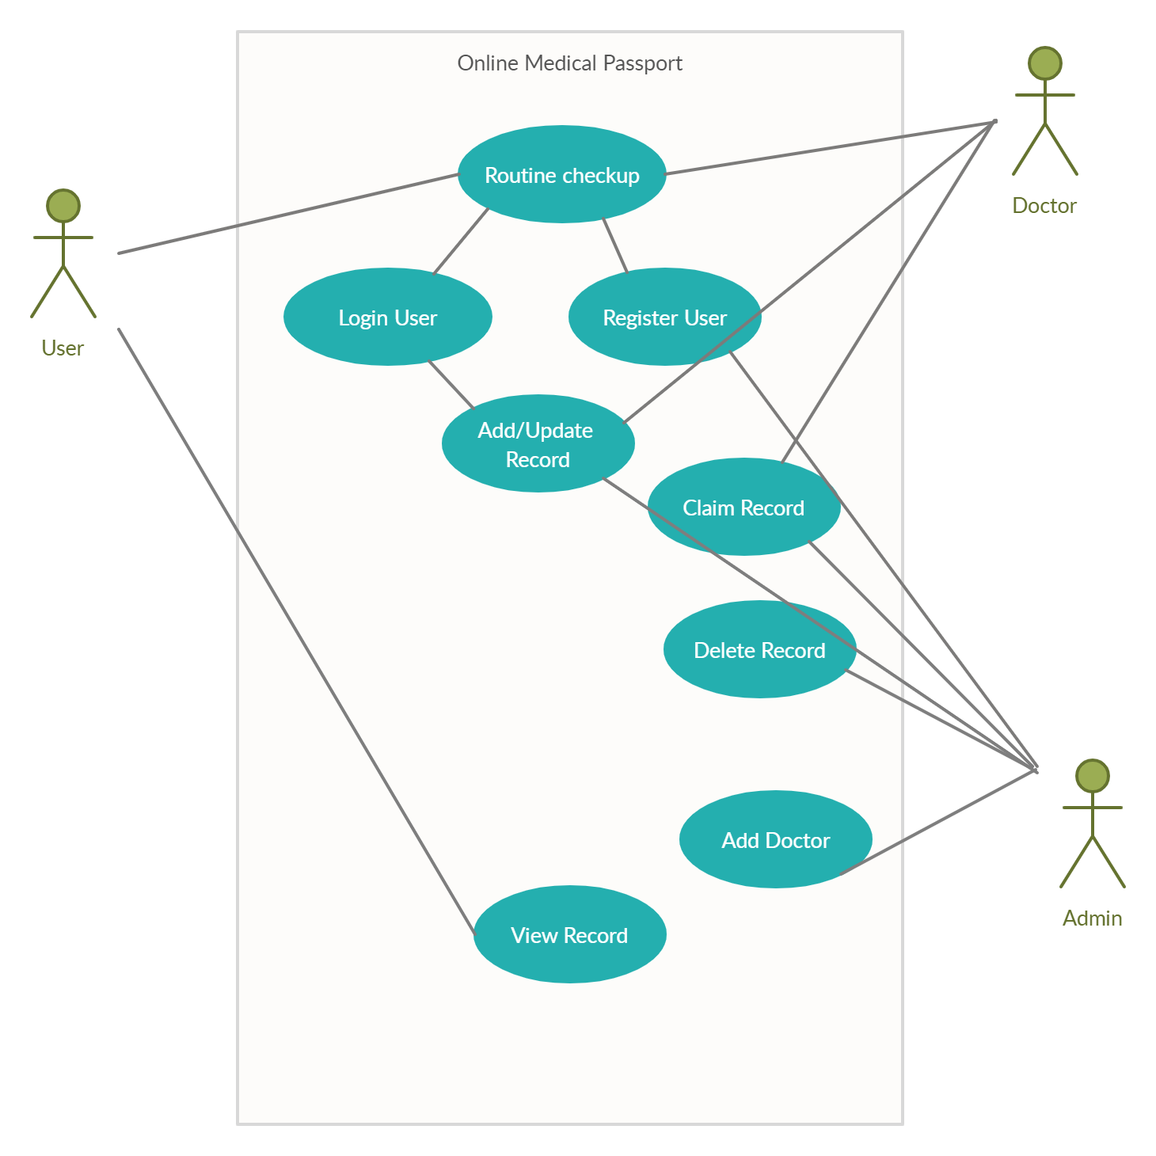

**Figure 10 : Use Case Diagram**

# 5. Table Structure

## Users:

|  |  |  |  |  |  |
| --- | --- | --- | --- | --- | --- |
| Field | Type | Null | Key | Default | Extra |
| user_id | int | NO | PRI | NULL | Auto_increment |
| blood_group | varchar(255) | YES |  | NULL |  |
| contact_no | varchar(255) | YES |  | NULL |  |
| date_of_birth | date | YES |  | NULL |  |
| Email | varchar(255) | YES | UNI | NULL |  |
| Firstname | varchar(255) | YES |  | NULL |  |
| gender | varchar(255) | YES |  | NULL |  |
| last_name | varchar(255) | YES |  | NULL |  |
| middle_name | varchar(255) | YES |  | NULL |  |
| password | varchar(255) | YES |  | NULL |  |
| doctors_id | int | YES | MUL | NULL |  |

## Doctors:

|  |  |  |  |  |  |
| --- | --- | --- | --- | --- | --- |
| Field | Type | Null | Key | Default | Extra |
| doctors_id | int | NO | PRI | NULL | Auto_increment |
| contact_no | varchar(255) | YES |  | NULL |  |
| email | varchar(255) | YES |  | NULL |  |
| hospital_area | varchar(255) | YES |  | NULL |  |
| hospital_city | varchar(255) | YES |  | NULL |  |
| hospital_name | varchar(255) | YES |  | NULL |  |
| name | varchar(255) | YES |  | NULL |  |
| password | varchar(255) | YES |  | NULL |  |
| speacilization | varchar(255) | YES |  | NULL |  |
| title | varchar(255) | YES |  | NULL |  |

## 

## Description:

|  |  |  |  |  |  |
| --- | --- | --- | --- | --- | --- |
| Field | Type | Null | Key | Default | Extra |
| Descriptionid | Int | NO | PRI | NULL | Auto_increment |
| age | varchar(255) | YES |  | NULL |  |
| allergies | varchar(255) | YES |  | NULL |  |
| blood_pressure | Int | NO |  | NULL |  |
| heart_rate | Int | NO |  | NULL |  |
| height | float | NO |  | NULL |  |
| lastcheckupdate | date | YES |  | NULL |  |
| Medicalhistory | varchar(255) | YES |  | NULL |  |
| oxygen_level | float | NO |  | NULL |  |
| upcomingcheckupdate | date | YES |  | NULL |  |
| doctors_id | Int | YES | MUL | NULL |  |
| user_id | Int | YES | MUL | NULL |  |

## 

## Admins:

|  |  |  |  |  |  |
| --- | --- | --- | --- | --- | --- |
| Field | Type | Null | Key | Default | Extra |
| adminid | Int | NO | PRI | NULL | Auto_increment |
| Contact | varchar(255) | YES |  | NULL |  |
| email | varchar(255) | YES | UNI | NULL |  |
| first_name | varchar(255) | YES |  | NULL |  |
| last_name | varchar(255) | YES |  | NULL |  |
| password | varchar(255) | YES |  | NULL |  |

**6. Conclusion**

Online medical passport puts forth the actual working of a medical database.Administartion management, patient management, searching for patients,updating heath history,etc. similar to physical record ,maintainance are the key feature of our project. User and doctor can access services and functionalities from the system from anywhere and anytime for their own comfort.

# Future Scope

This project can be enhanced further access to the booking webistes,visa booking websites to check for health status before confirmation of any booking.Jobrecuirters can also check for candidates health status. The software is flexible enough to be modified and implemented as per future requirements. We have tried our best to present this free and user–friendly website to every patient. Message and Email alerts for various health updates from the hospital can be added to the system so that users do not miss the updates and health checkups.

# 7. References

1. <https://www.javainuse.com/spring/ang7-hello>
2. <https://spring.io/guides/gs/relational-data-access/>
3. <https://www.baeldung.com/spring-boot-angular-web>
4. <https://www.baeldung.com/rest-with-spring-series>