**Oral Diseases Classification Using Dental Images: A Hybrid Methodology**

Mr. S. Nirmala

*Computer Science and Engineering,*

*GMR Institute of Technology, Razam, Andhra Pradesh, India.*

[@gmrit.edu.in](mailto:varun.2394.be21@chitkara.edu.in)

Yegireddi Eswari

*Computer Science and Engineering,*

*GMR Institute of Technology, Razam, Andhra Pradesh, India.*

21341A05J7[@gmrit.edu.in](mailto:varun.2394.be21@chitkara.edu.in)

Tirumala U S S N L Durga Devi

*Computer Science and Engineering,*

*GMR Institute of Technology, Razam, Andhra Pradesh, India.*

21341A05I2[@gmrit.edu.in](mailto:varun.2394.be21@chitkara.edu.in)

Gadi Jagadeesh

*Computer Science and Engineering,*

*GMR Institute of Technology, Razam, Andhra Pradesh, India.*

22345A0519[@gmrit.edu.in](mailto:varun.2394.be21@chitkara.edu.in)

Pichchika Balaji

*Computer Science and Engineering,*

*GMR Institute of Technology, Razam, Andhra Pradesh, India.*

21341A05D9[@gmrit.edu.in](mailto:varun.2394.be21@chitkara.edu.in)

Rajana Prasad

*Computer Science and Engineering,*

*GMR Institute of Technology, Razam, Andhra Pradesh, India.*

22345A0518[@gmrit.edu.in](mailto:varun.2394.be21@chitkara.edu.in)

***Abstract*—** **Oral diseases are often not diagnosed, which can have a negative impact on health. In this study, we use a deep learning method for internal image-based oral disease detection. Our approach proposes a hybrid methodology that combines EfficientNet for feature extraction and Channel Block Attention Module (CBAM) for classification. We use a two-step procedure: first we use EfficientNet to extract features from the last layer, then we use CBAM for classification. A hybrid approach uses attention mechanisms and feature extraction to improve accuracy. Once the disease is classified, we will recommend treatment or preventive measures to reduce the effects of the disease. Our approach uses deep learning algorithms and internal imaging techniques to provide early diagnosis and preventative measures. The accuracy of our hybrid model is 94.6%. The site effectively categorizes uploaded images into each of the five disease classifications and recommends preventative measures for each disease. In addition to using intraoral images to diagnose diseases, the website also uses symptoms to classify diseases into seven classifications. There are a total of 19 distinct symptoms in this study, from which the user can choose any three to recognise the disease and recommend the right kind of treatment. It uses deep learning algorithms and a hybrid approach to combat oral diseases, providing a useful tool for individuals and health professionals.**

*Keywords: Healthcare, Dentistry, Classification, Image analysis, oral diseases, Deep learning, Hybrid methodology, Intraoral Images,*

*Symptoms.*

1. INTRODUCTION

A substantial global health burden, oral illnesses impact millions of individuals globally. In order to effectively manage this problem and avoid consequences, an immediate and precise diagnosis is essential. In modern era, advances in artificial intelligence (AI) and image processing have led to innovative approaches to detecting oral diseases. The integration of deep learning techniques has revolutionized several areas of medicine, especially in diagnostic imaging and disease detection.

While disciplines such as radiology and pathology have seen advances in deep learning, the adoption of this technology in dentistry has been slower. However, the potential impact of deep learning techniques in dentistry field, particularly when it comes to using dental images to diagnose oral illnesses. Deep learning developments have greatly advanced medical specialty analysis, leading to more accurate and efficient disease diagnosis in many specialties. Conversely, despite the need for better methods to diagnose oral diseases, dentistry has lagged behind in taking advantage of these technological advances.

Undiagnosed oral diseases such as periodontal disease, tooth decay, and mouth ulcers can have serious consequences if left untreated. If left untreated, gum disease can progress to periodontitis, causing irreparable damage to the tooth's supporting structures. Tooth decay, commonly known as tooth decay, can lead to tooth loss and systemic health problems if not treated immediately. Mouth ulcers, although usually benign, can be a symptom of a systemic condition or oral cavity, highlighting the importance of timely diagnosis.

To diagnose oral disease in the past, dentists have depended on palpation, visual inspection, and radiographic imaging. Although these methods remain indispensable in clinical practice, they are not without limitations. Visual examination can miss early signs of disease, especially in inaccessible areas, while radiographic imaging techniques such as X-rays are expensive and can expose patients to ionizing radiation. Furthermore, relying on the subjective judgments of clinicians introduces variability and can lead to missed diagnoses.

Public ignorance about the importance of regular dental checkups and the potential consequences of untreated oral disease fuel this problem. Too many people wait until their symptoms are worse before seeking dental care, which can lead to delayed diagnosis and worsening of oral health problems. New approaches using deep learning and computational imaging in dentistry are needed to overcome these barriers to early diagnosis.

In this context, the development of an intelligent machine for oral diseases detection using dental images represents a significant step towards improving oral healthcare outcomes. By leveraging a hybrid methodology that integrates deep learning algorithms for feature extraction and classification, this research aims to enhance the accuracy and efficiency of oral diseases diagnosis. Through early detection and intervention facilitated by intelligent machines, the burden of oral diseases can be mitigated, resulting in better patient outcomes and lower medical expenses.

The field of dentistry and deep learning has many opportunities to improve oral health. Intelligent robots have the potential to revolutionize dental practice, overcoming challenges associated with traditional disease detection methods and ushering in a new era of proactive oral health management by understanding the importance of early intervention. Therefore, in this study, we use a deep learning approach to develop our model as a way to apply deep learning in the dental field in the future.

1. LITERATURE REVIEW

Chau, R. C. W. et al., [1] Research using DeepLabv3+ architecture to detect dental disease in internal images. Through this approach, they successfully identify the affected areas in the image and determine whether they are healthy, diseased or suspicious. There are some images in the database used. They only use Chinese interior design. They achieved a high sensitivity and specificity of 0.92 and 0.94, respectively. However, an advantage arises due to the limited number of images in the database. Although the accuracy is high, expanding the database to cover additional diseases over a wider range may improve the generalizability of the model.

Rashid, Jet al., [2] developed a model capable of classifying oral and oral diseases into 7 categories using InceptionResNetV2. The developed model achieved an accuracy of 99.51 compared to the previous model. The database has a limited number of images, so redundancy has occurred. The model has an accuracy of 99.51%, a recall of 99.33 and an F1 score of 99.33, with the potential to cover additional diseases in a wider and public database.

Park, S. et al.[3] The proposed model is designed to overcome the challenge of limited training data and accurately classify dental images into three groups: calculus, swelling, and normal. This model has an accuracy of 74.54% and an F1 score of 99.99%. Using the proposed model, a mobile application can be developed to classify periodontal images.

Park, EY et al., [4] Researchers developed a deep learning model for caries detection by segmenting tooth surfaces using internal images. On the other hand, the performance of the model in tooth classification and localization of complex lesions is comparable to X-ray images, where the internal image cannot provide information about the interior of the tooth or the interproximal surface of the tooth. The proposed model has an accuracy of 0.813, a sensitivity of 0.867, and an accuracy of 0.779.

Imack, A. et al., [5] This study used periapical pictures and developed a multi-input deep convolutional neural network ensemble (MI-DCNNE) technique to automatically diagnose dental caries. There are 340 photos in the database—120 with

caries and 220 without caries. The MI-DCNNE method provides dental caries detection with 99.13% accuracy, 98% sensitivity, 100% specificity, 100% accuracy and 98.99% F1 score.

Shreyansh A. et al., [6] The paper focus the challenge of accurate classification of dental diseases using labelled dataset of 251 Radio Visio Graphy X-ray images across three classes. They used transfer learning with VGG16 model for better accuracy and they got 88.46% accuracy. The limitation of this study is they used a small dataset consisting of 251 RVG (Radio Visio Graphy) X-ray images.

Ngnamsie Njimboum S. et al., [7] proposed a method to predict dental caries using multimodal data, that is, digital data and images applied to a hybrid neural network. It uses multimodal data, i.e. numerical and image data. The accuracy of the model is low. The model provides 90% precision, 89% F1 score, 90% recall, and 89% precision. From this study, we can understand that more methods that can capture different types of data should be developed to classify or detect caries.

Zhang, X. et al., [8] This paper presents The evaluation and development of a deep learning model for the identification of

dental caries from oral images are presented in this work.They use consumer camera oral photos to detect dental caries, which can greatly enhance the evaluation of dental health across a broad population. The limitation of this research is that the data was collected from one organization. The model provides an accuracy of 85.65%.

Siwari, E. et al., [9] Through published research on dental disease classification, detection, and segmentation, they offer a comprehensive overview of the current state of research in this area. Compared to other industries, the analysis shows that deep learning and AI applications in dentistry have come a long way and need further development. Since the use of AI in dentistry is still in its infancy compared to other fields, the newly developed deep learning model can find application in this field.

Patil, S. et al., [10] It provides us with an explanation of the different uses of AI in dentistry as well as the difficulties encountered and solutions for these difficulties. They discussed the various works and how accurate they were for the various dental conditions separately. They discussed the paucity of research on dental conditions. The review papers should also provide an explanation of the research done on disease detection, categorization, etc.

Alalharith, D. M et al., [11] Researchers built a model that classifies patients with gingivitodontia using R-CNN. This model exhibits significant potential in the early diagnosis of periodontal disease through the integration of two ResNet-50 models: one for tooth detection and one for periodontal disease. It focuses on the gingival approach area precisely and has a higher accuracy than other models that focus on the entire gingival approach area. Nevertheless, more instruments are required to enhance tumour identification in these individuals. More generally, a number of methods have been studied with good outcomes for disease identification and classification.

Kawazu, T et al., [12] In this study for the purpose of identifying and diagnosing dental caries in intraoral photos captured with a mobile device, the YOLOV3 algorithm is crucial. We are able to develop a useful and reasonably priced programme that produces precise outcomes by using photographs from smartphones. The model can forecast events with a high degree of precision, but it is unable to ascertain the occultation's precise accuracy. Their study is limited by the short size of the dataset, which should include photos of teeth in all orientations.The accuracy in detecting primary caries is 93.33%, recall is 69.42%, and the F1-score is 0.80. The accuracy in detecting secondary caries is 100%, recall is 52.38%, and the F1-score is 0.69.

Zhou, M. et al., [13] In order to classify and detect recurrent aphthous ulcers (RAU) using oral pictures, the researchers constructed a convolutional neural network (CNN). They discovered that the deep learning model can precisely and accurately identify RAU with high accuracy and recall. Nevertheless, this model is unable to forecast different oral mucosal conditions. ResNet50 provided 92.86% accuracy and 91.84% recall for classification, while YOLOV5 achieved 98.70% accuracy for detection.

Shreyansh A. et al., [14] The paper focus the challenge of accurate classification of dental diseases using labelled dataset of 251 Radio Visio Graphy X-ray images across three classes. They used transfer learning with VGG16 model for better accuracy and they got 88.46% accuracy. The limitation of this study is they used a small dataset consisting of 251 RVG (Radio Visio Graphy) X-ray images.

Almalki YE. Et al., [15] They proposed an approach to detect and classify four diseases: cavities, root canals, dental crowns, and root canal cracks using the YOLOV3 model, which uses X-ray images to detect diseases. The proposed method outperforms existing state-of-the-art methods in terms of accuracy and has many applications in dentistry and computer-aided diagnosis. A limitation of this study is the use of a new version of YOLO. Accuracy 99.93%, F1 score 0.99, precision 0.99.

**Graph-1: Representation of models and accuracies performed on particular disease.**

1. METHODOLOGY

The methodology used in this approach is a hybrid methodology where the output of one model is given as input to another model to perform a better classification. Our study used intraoral images and examined five different disease classes. In a dataset of five classes, three represent diseases, one represents conditions, and the rest represent health. The below figure shows the methodology we followed in this study.

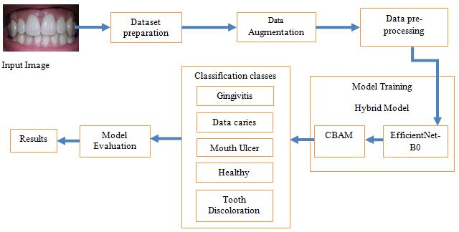

**Fig-1.Explaining the Flow of Methodology**

**Dataset Preparation:** The database we receive is an open source database. Oral Disease Name Database. We modified the database by removing unnecessary classes and folders and duplicate images that are not used much to train the model. Then we see 4 classes from the database such as Gingivitis, Data caries, tooth discoloration, oral ulcers. We have also collected images of a new class called Healthy and added them to the database. We then split the dataset into train, test and validation folder in the ratio of 0.8: 0.1: 0.1.

**Data Augmentation:** The dataset contains five classes they were Healthy, Gingivitis, Tooth Discoloration, Mouth Ulcer, Data Caries. Here Healthy folder contains 120 images in total, Gingivitis folder contains 1879 images in total, Tooth Discoloration folder contains 146 images in total, Mouth Ulcer folder contains 212 images in total and Data Caries folder contains 175 images in total. We observed that the dataset is imbalanced as the there was a wide range of difference in number of images in each folder.

So to balance the dataset we used the augmentation techniques. We used the techniques like rotation, zoom, vertical flip, horizontal flip etc to generate new images from original images. We applied the data augmentation techniques on all classes except the Gingivitis as already it was having more number of images.

The number of augmented images generated for the healthy class were 1655, for Tooth Discoloration class were 1637, for Mouth Ulcer were 1740 and for Data caries were 1455.So after performing the data augmentation the Healthy folder was containing the 1775 images in total, Gingivitis folder was containing 1879 images in total, Tooth Discoloration folder containing 1783 images in total, Mouth Ulcer folder containing 1952 images in total and Data Caries folder containing 1630 images in total.

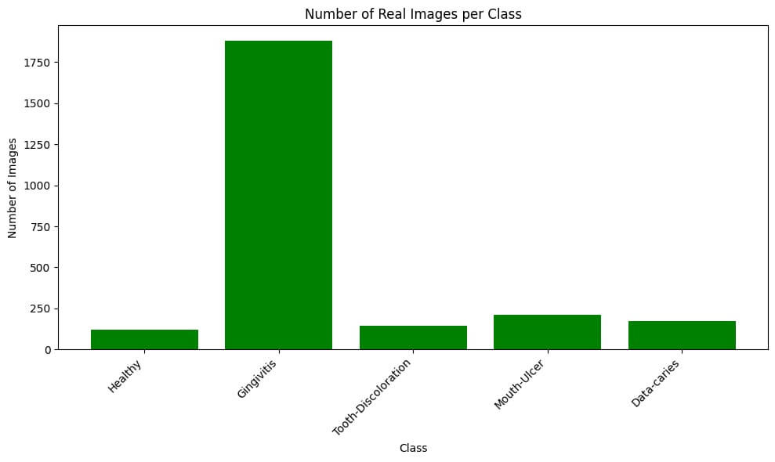

**Fig-2: Dataset Before Augmentation**

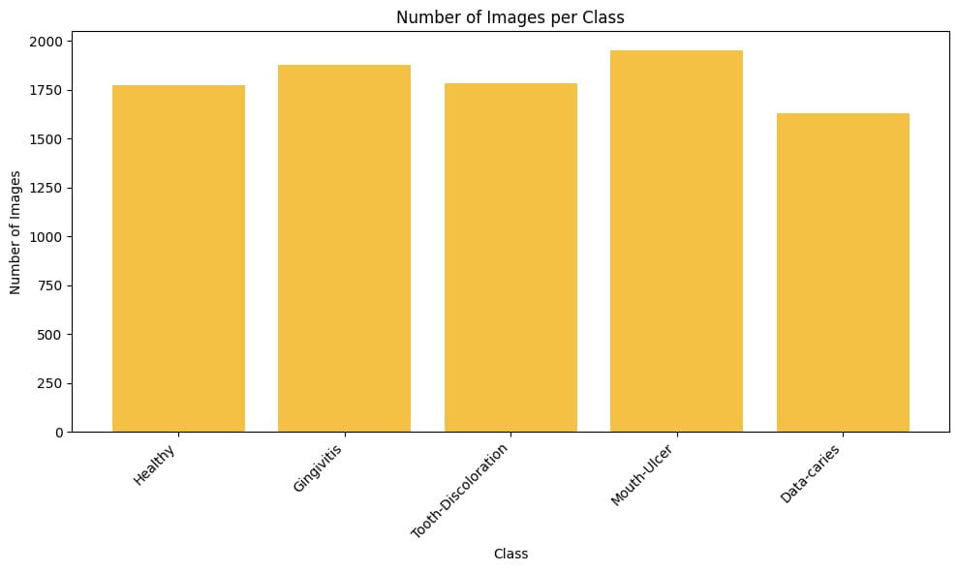

**Fig 3 Dataset After Augmentation**

**Data Pre-processing:** The train folder was now containing 5 folders in which each folder contain the real folder and augmented folders. The real folder contains the real images and augmented folder contains the augmented images. The images in the train folder, test folder, validation folder are loaded by using the ImageDataGenerator. We considered the target size as 224,224 and the color mode as RGB.

**Model Training:** We considered the Hybrid model for our work. Our Hybrid model consists of two models one was for feature extraction and other is for classification.

**EfficientNet:** The EfficientNetB0 was considered for the feature extraction. First we gave the train images to the pretrained EfficientNet and extracted the last layer features from the model. We not included the fully connected layers (top layers) of the model. The shape of the input images that the model will accept was (224, 224, 3). The last layer of our EfficientNetB0 was block7a_project_bn. So the features that were extracted from this layer were stored in a variable.

**CBAM-Channel Attention:** After extracting the last layer features we gave those features to the CBAM Channel Attention. So by using those features the channel attention was used for the classification task. So, here we extracted the last layer features by using the EfficientNetB0 and gave those features as an input for CBAM-Channel Attention inorder to perform the classification task.

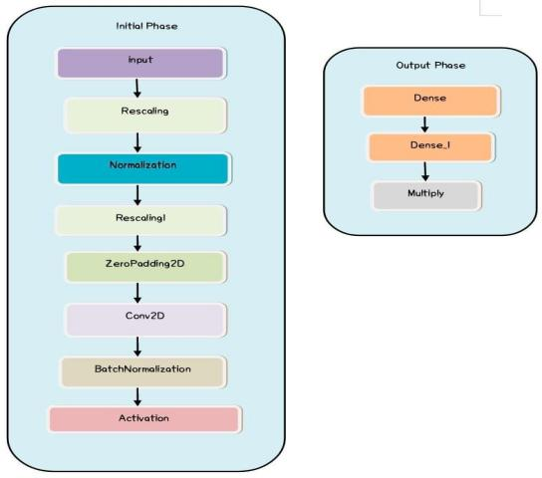

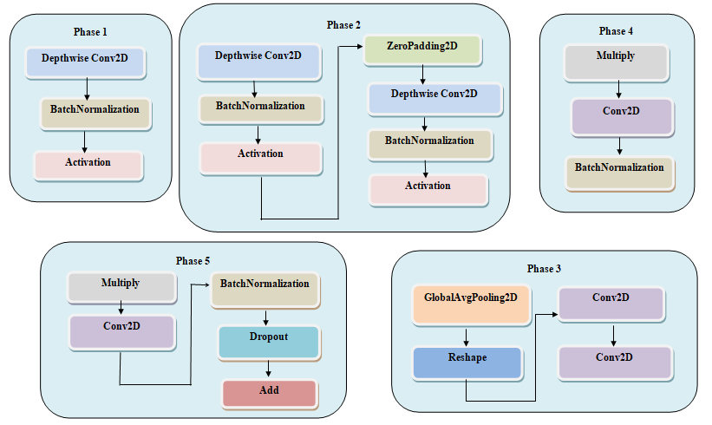

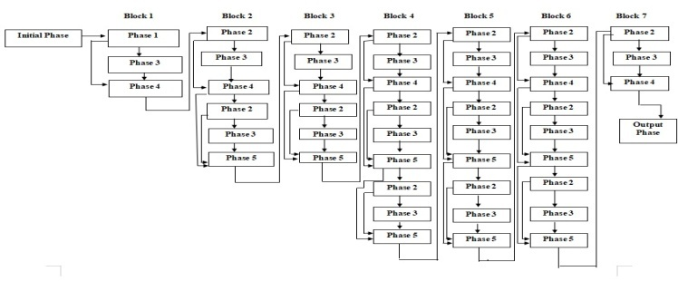

**Fig-4: Model Architecture**

**Model Evaluation:** We trained the model by using the metrics like accuracy, precision, recall and AUC. We used the Adam as an optimizer and categorical cross entropy as loss function. The model performed well on the test data. The model also predicted the new unseen data very well.

**Top of Form**

**Accuracy:** Accuracy measures the overall correctness of the model's predictions and is calculated as the ratio of correctly predicted instances to the total number of instances in the dataset. It provides a general assessment of how well the model performs across all classes.



**Precision:** Precision measures the proportion of true positive predictions out of all positive predictions made by the model. It focuses on the relevance of the positive predictions and is particularly useful when the cost of false positives is high.



**Recall:** Recall measures the ability of the model to correctly identify all relevant instances, or true positives, out of all actual positive instances in the dataset. It is also known as sensitivity or true positive rate.



**Table-1: Showing the values of metrics during training:**

|  |  |  |  |  |  |
| --- | --- | --- | --- | --- | --- |
| **Phase** | **Accuracy** | **Precision** | **Recall** | **AUC** | **Loss** |
| **Training** | 0.9931 | 0.9934 | 0.9928 | 0.9995 | 0.0277 |
| **Validation** | 0.9375 | 0.9375 | 0.9375 | 0.9941 | 0.1927 |

1. RESULTS AND DISCUSSION

The model achieved the accuracy of 94.6%, precision of 0.9511, recall of 0.9460, AUC of 0.9960, loss of 0.1606. The model also performed well on the unseen data. We randomly given some images other than the dataset that we collected inorder to test the performance of the model. The model predicted the disease well on those data. We also trained the EfficientNetB0 model and CBAM model individually on the dataset. We got better results by training the Hybrid model.

From the table below we can conclude that the Hybrid model has given better results compared to other models. Future research may focus on optimizing the performance of intelligent machines through continuous model improvement and validation on real patient databases. A mobile application can be developed to detect oral diseases, which will be useful for everyone. In addition, multimodal data integration studies can improve the predictive ability and support comprehensive patient care, and should include mobile camera images in the database.

**Table-2: Comparing the metrics of different models:**

|  |  |  |  |
| --- | --- | --- | --- |
| **Model Name** | **Phase** | **Accuracy** | **Loss** |
| **EfficientNetB0** | **Training** | 0.9639 | 0.1249 |
| **Validation** | 0.9306 | 0.2631 |
| **Testing** | 0.9333 | 0.1833 |
| **CBAM** | **Training** | 0.9838 | 0.0514 |
| **Validation** | 0.9406 | 0.2177 |
| **Testing** | 0.9235 | 0.2172 |
| **Hybrid Model** | **Training** | 0.9931 | 0.0277 |
| **Validation** | 0.9375 | 0.1927 |
| **Testing** | 0.9460 | 0.1606 |

1. CONCLUSION

In conclusion, our study addresses the lag in technological development in dentistry compared to other fields, especially in the context of deep learning methods. We provide the first solution to address this gap by developing a robust model for oral disease classification using internal images. Our research results show the effectiveness of our hybrid model, which achieved an effective accuracy rate of 94.6%. In addition, we translate our research into practical applications by creating a user-friendly website where individuals can upload internal images to predict disease. Our focus on internal imaging demonstrates cost-effectiveness compared to conventional radiographic imaging and makes our approach more suitable for widespread implementation. By ensuring early disease detection, our research enables people to take proactive action and receive timely treatment, ultimately improving oral health outcomes and reducing healthcare costs.

REFERENCES

1. Chau, R. C. W., Li, G., Tew, I. M., Thu, K. M., McGrath, C., Lo, W., Ling, W.,Hsung,T., & Lam, W. Y. H. (2023). “Accuracy of Artificial Intelligence-Based Photographic detection of gingivitis.” International Dental Journal, 73(5), 724–730.
2. Rashid, J., Qaisar, B. S., Faheem, M., Akram, A., Amin, R. U., & Hamid, M. (2023). “Mouth and oraldisease classification using InceptionResNetV2 method.” Multimedia Tools and Applications.
3. Park, S., Erkinov, H., Hasan, M. a. M., Nam, S., Kim, Y., Shin, J., & Chang, W. (2023). “Periodontal Disease Classification with Color Teeth Images Using Convolutional Neural Networks.” Electronics, 12(7), 1518.
4. Park, E. Y., Cho, H., Kang, S., Jeong, S., & Kim, E. (2022). “Caries detection with tooth surface segmentation on intraoral photographic images using deep learning.” BMC Oral Health,22(1).
5. Imak, A., Celebi, A., Siddique, K., Turkoglu, M., Sengur, A., & Salam, I. (2022). “Dental caries detection using score-based multi-input deep convolutional neural network.” IEEE Access, 10, 18320-18329.
6. Shreyansh A. Prajapati, R. Nagaraj and Suman Mitra, (2017). “Classification of Dental Diseases Using CNN and Transfer Learning”, IEEE Xplore, 70-74.
7. Ngnamsie Njimbouom S, Lee K, Kim J-D.(2022) “MMDCP: Multi-Modal Dental Carie Prediction for Decision Support System Using Deep Learning.” International Journal of Environmental Research and Public Health. 19(17):10928.
8. Zhang, X., Liang, Y., Li, W., Liu, C., Gu, D., Sun, W., & Miao, L. (2022). “Development and evaluation of deep learning for screening dental caries from oral photographs.” Oral diseases, 28(1), 173-181.
9. Sivari, E., Senirkentli, G. B., Bostancı, E., Güzel, M. S., Açıcı, K., &Aşuroğlu, T. (2023). “Deep Learning in Diagnosis of Dental Anomalies and Diseases: A Systematic review.” Diagnostics, 13(15), 2512.
10. Patil, S., Albogami, S., Hosmani, J., Mujoo, S., Kamil, M. A., Mansour, M. A.,Abdul, H. N., Bhandi, S., & Ahmed, S. S. S. J. (2022). “Artificial Intelligence in the Diagnosis of Oral Diseases: Applications and Pitfalls.” Diagnostics (Basel, Switzerland), 12(5), 1029.
11. Alalharith, D. M., Alharthi, H. M., Alghamdi, W. M., Alsenbel, Y. M., Aslam, N., Khan, I. U. Shahin, S. Y., Dianišková, S., Alhareky, M. S., & Barouch, K. K. (2020). “A Deep Learning Based Approach for the Detection of Early Signs of Gingivitis in Orthodontic Patients Using Faster Region-Based Convolutional Neural Networks.” International journal of environmental research and public health, 17(22), 8447.
12. Kawazu, T., Takeshita, Y., Fujikura, M., Okada, S., Hisatomi, M., &Asaumi, J. (2024).“Preliminary study of dental caries detection by deep Neural Network applying Domain-Specific Transfer Learning.” Journal of Medical and Biological Engineering.
13. Zhou, M., Jie, W., Tang, F., Zhang, S., Mao, Q., Liu, C., & Hao, Y. (2024). “Deep learning algorithms for classification and detection of recurrent aphthous ulcerations using oral clinical photographic images.” Journal of Dental Sciences, 19(1), 254-260.
14. Shreyansh A. Prajapati, R. Nagaraj and Suman Mitra, (2017). “Classification of Dental Diseases Using CNN and Transfer Learning”, IEEE Xplore, 70-74.
15. Almalki YE, Din AI, Ramzan M, Irfan M, Aamir KM, Almalki A, Alotaibi S, Alaglan G, Alshamrani HA, Rahman S.(2022) “Deep Learning Models for Classification of Dental Diseases Using Orthopantomography X-ray OPG Images.” Sensors. 22(19):7370.
16. Elsayed, A., Mostafa, H., Tarek, R., Mohamed, K., Hossam, A., & Selim, S. (2022, July). “OralDental Diagnosis Using Deep Learning Techniques: A Review.” In Annual Conference on Medical Image Understanding and Analysis (pp. 814-832). Cham: Springer International Publishing.
17. Kumar A, Bhadauria HS, Singh A. (2021) “Descriptive analysis of dental X-ray images using various practical methods: A review.” PeerJComput Sci. 2021 Sep 13;7:e620.
18. Jaiswal, P., &Bhirud, S. (2023). “An intelligent deep network for dental medical image processing system.” Biomedical Signal Processing and Control, 84, 104708.
19. Zhao, S., Liu, C., & Luo, Q. (2019, August). “Dental data analysis based on dental x-raypanorama.” In Proceedings of the Third International Symposium on Image Computing and Digital Medicine (pp. 133-137).
20. M. Muthu Lakshmi & Dr. P. Chitra (2020). “Classification of Dental Cavities from X-ray images using Deep CNN algorithm”, IEEE Xplore, 774-779.
21. Abdulaziz A. Al Kheraif, Ashraf A. Wahba, H. Fouad, (2019) “Detection of dental diseases from radiographic 2d dental image using hybrid graph-cut technique and convolutional neural network”,Science Direct, 146, 333-342.
22. Hu Chen, Hong Li, Yijiao Zhao, Jianjiang Zhao, Yong Wang, (2021). “Dental disease detection on periapical radiographs based on deep convolutional neural networks”, Springer, 16, 649–661.
23. Kabir, T., Lee, C. T., Nelson, J., Sheng, S., Meng, H. W., Chen, L., ... & Shams, S. (2021, December). “An end-to-end entangled segmentation and classification convolution3al neural network for periodontitis stage grading from periapical radiographic images.” In 2021 IEEE international conference on bioinformatics and biomedicine (BIBM) (pp. 1370-1375). IEEE.
24. Yu, H., Lin, Z., Liu, Y., Su, J., Chen, B., & Lu, G. (2020). “A new technique for diagnosis of dental caries on the children’s first permanent molar.” Ieee Access, 8, 185776-185785.
25. Mohammad‐Rahimi, H., Motamedian, S. R., Rohban, M. H., Krois, J., Uribe, S., Nia, E. M., Rokhshad, R., Nadimi, M., &Schwendicke, F. (2022). “Deep learning for caries detection: A systematic review.” Journal of Dentistry, 122, 104115.
26. Lian L, Zhu T, Zhu F, Zhu H.(2021) “Deep Learning for Caries Detection and Classification.” Diagnostics. 11(9):1672.
27. Mima, Y., Nakayama, R., Hizukuri, A. et al. (2022) “Tooth detection for each tooth type by application of faster R-CNNs to divided analysis areas of dental panoramic X-ray images.’ Radiol Phys Technol 15, 170–176 .
28. T. Dhake and N. Ansari, "A Survey on Dental Disease Detection Based on Deep Learning Algorithm Performance using Various Radiographs” ,2022 5th International Conference on Advances in Science and Technology (ICAST), Mumbai, India, 2022, pp. 291-296.
29. A., Suresh, Kumar., Manivel, Kandasamy., P., Anitha. (2023). “Analysis of Panoramic Images using Deep Learning For Dental Disease Identification.”
30. M., B., H., Moran., Marcelo, Faria., Marcelo, Faria., Gilson, A., Giraldi., Luciana, Freitas, Bastos., Larissa, F.C., de, Oliveira., Aura, Conci. (2021). “Classification of Approximal Caries in Bitewing Radiographs Using Convolutional Neural Networks.” Sensors.