1. **INTRODUCTION**

Oral diseases pose a significant global health burden, affecting millions of individuals worldwide and contributing to substantial healthcare costs. Timely and accurate detection of these conditions is crucial for effective treatment and prevention of complications. In recent years, advancements in artificial intelligence (AI) and image processing have paved the way for innovative approaches to oral diseases detection. The integration of deep learning techniques has revolutionized various fields of medicine, particularly in diagnostic imaging and disease detection.

While disciplines such as radiology and pathology have embraced the advancements brought about by deep learning, the adoption of these technologies in dentistry has been relatively slower. However, the potential impact of deep learning in dentistry cannot be understated, particularly in the realm of oral diseases detection using dental images. The rise of deep learning has enabled remarkable strides in medical image analysis, leading to more accurate and efficient disease diagnosis across multiple specialties. Radiologists and pathologists have witnessed significant improvements in diagnostic accuracy and speed through the use of deep learning algorithms trained on vast amounts of medical imaging data. In contrast, dentistry has lagged behind in leveraging these technological advancements, despite the pressing need for improved methods of oral diseases detection.

The consequences of undetected oral diseases such as gingivitis, dental caries, and mouth ulcers can be severe if left untreated, underscoring the critical importance of early detection and intervention. Gingivitis, if untreated, can progress to periodontitis, leading to irreversible damage to the supporting structures of the teeth. Dental caries, commonly known as tooth decay, can result in tooth loss and systemic health complications if not addressed promptly. Mouth ulcers, although often benign, can be symptomatic of underlying systemic conditions or oral malignancies, highlighting the significance of timely diagnosis.

Traditionally, dentists rely on visual inspection, palpation, and radiographic imaging for the detection of oral diseases. While these methods remain indispensable in clinical practice, they are not without limitations. Visual inspection may overlook early signs of disease, especially in inaccessible areas, while radiographic imaging techniques such as X-rays can be costly and expose patients to ionizing radiation. Moreover, the reliance on subjective assessments by clinicians introduces variability and may lead to missed diagnoses.

Compounding these challenges is the lack of awareness among the general population regarding the importance of regular dental check-ups and the potential consequences of untreated oral diseases. Many individuals fail to seek dental care until symptoms become severe, resulting in delayed diagnoses and exacerbation of oral health issues. Addressing these barriers to early detection requires innovative approaches that harness the power of deep learning and computational imaging in dentistry

In this context, the development of an intelligent machine for oral diseases detection using dental images represents a significant step towards improving oral healthcare outcomes. By leveraging a hybrid methodology that integrates deep learning algorithms for feature extraction and classification, this research aims to enhance the accuracy and efficiency of oral diseases diagnosis. Through early detection and intervention facilitated by intelligent machines, the burden of oral diseases can be mitigated, leading to improved patient outcomes and reduced healthcare costs.

In conclusion, the convergence of deep learning and dentistry holds immense promise for advancing oral healthcare delivery. By overcoming the challenges associated with traditional methods of disease detection and raising awareness about the importance of early intervention, intelligent machines have the potential to revolutionize the field of dentistry and usher in a new era of proactive oral health management.

**Gingivitis:**

Gingivitis is a common and mild form of gum disease (periodontal disease) that causes irritation, redness, and swelling (inflammation) of your gingiva, the part of your gum around the base of your teeth. While gingivitis itself is generally not serious, if left untreated, it can lead to more severe forms of gum disease, such as periodontitis. Periodontitis involves damage to the tissues and bone that support the teeth, leading to tooth loss. Furthermore, untreated gingivitis can have systemic effects beyond just the mouth. Research suggests that the bacteria associated with gum disease can enter the bloodstream and contribute to other health problems, including heart disease, stroke, and diabetes.

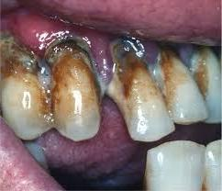

**Figure 1.1- Gingivitis Disease**

**Mouth Ulcer:**

Mouth ulcers, also known as canker sores or aphthous ulcers, are small, painful lesions that form in the mouth, typically on the inside of the lips, cheeks, gums, or on the tongue. They can be white, gray, or yellow in color, with a red border. While they're usually harmless and resolve on their own within a week or two, they can be quite uncomfortable and may interfere with eating, drinking, and speaking. If mouth ulcers are not recognized early or if they persist for an extended period, they can potentially indicate an underlying health issue that requires medical attention. Additionally, persistent or recurrent mouth ulcers could be a sign of a more serious condition, such as oral cancer or an immune system disorder.

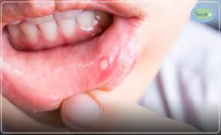

**Figure 1.2- Mouth Ulcer**

**Data caries:**

Dental caries, commonly known as tooth decay or cavities, is a prevalent oral health issue caused by the demineralization of tooth enamel by acids produced by bacteria in plaque. If left untreated, dental caries can lead to various consequences, including Tooth pain and sensitivity, Infection and abscess, Tooth loss, Compromised oral health and impact on overall health like poor oral health, including untreated dental caries, has been linked to various systemic health problems, such as cardiovascular disease, diabetes, and respiratory infections.

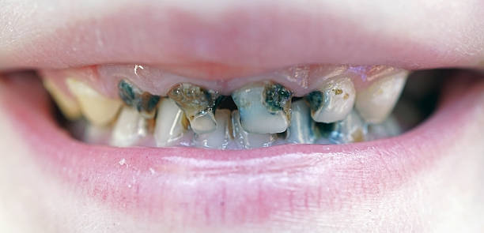

**Figure 1.3- Data caries**

**Tooth Discoloration:**

Tooth discoloration, while not necessarily a disease, is a common dental issue that can occur due to various factors. It can manifest as stains, yellowing, or darkening of the teeth and can be caused by both extrinsic and intrinsic factors. Extrinsic factors refer to external sources that can stain the outer layer of the tooth (enamel), such as: Food and beverages, Tobacco use, Poor oral hygiene.

Intrinsic factors involve changes within the tooth structure itself, which can result in more severe or permanent discoloration. These factors may include Dental trauma, Dental decay, Medications, Fluorosis. While tooth discoloration itself may not be harmful, it can have negative effects on a person's self-esteem and confidence, impacting their social and professional interactions. Additionally, tooth discoloration can sometimes indicate underlying dental problems, such as decay or trauma, which, if left untreated, can lead to more significant issues.

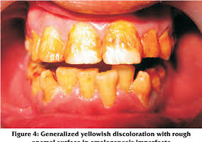

**Figure 1.4- Tooth Discoloration**

**Major Challenges:**

Despite the potential of deep learning algorithms for oral disease detection, there are several major challenges that must be addressed before they can be widely adopted in dentistry. Limited training data is a significant challenge as dentistry has not embraced deep learning as much as other medical fields, resulting in a lack of high-quality image data to train the algorithms effectively., subjectivity in diagnosis remains an issue, even with the help of deep learning, particularly for complex cases. The accuracy and bias of the algorithms are also a concern, as the accuracy can be limited, and there is a risk of bias depending on the data used to train them.

**Solutions to challenges:**

Techniques like data augmentation and transfer learning can further enrich training datasets. Additionally, continuous refinement and validation alongside dentists can ensure algorithm accuracy and mitigate bias, paving the way for reliable integration of deep learning into dental practice.

**Overview of dataset:**

The Dental Condition Dataset is a comprehensive collection of images specifically curated for dental research and analysis. This dataset encompasses a wide range of dental conditions, including caries, calculus, gingivitis, tooth discolouration, ulcers, and hypodontia. It serves as a valuable resource for dental professionals, researchers, and machine learning enthusiasts interested in developing and training models for dental condition detection and classification

**Image Sources:** The dataset is a compilation of images sourced from multiple hospitals and reputable dental websites. These sources ensure the diversity and authenticity of the dental conditions depicted in the dataset.

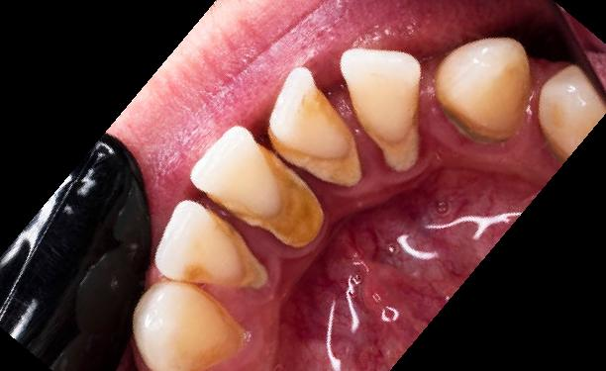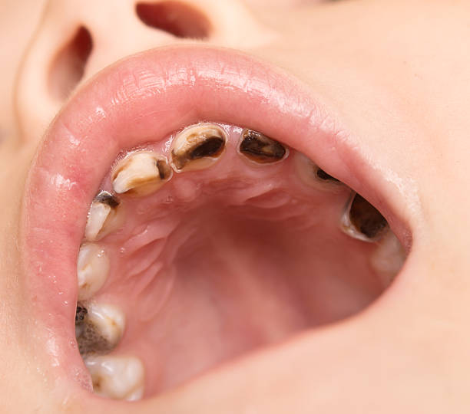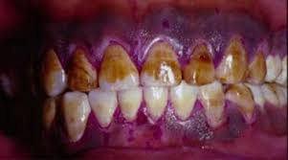

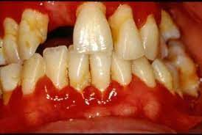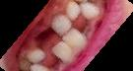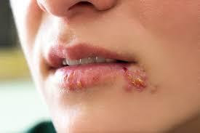

**Figure 1.5- Random images from dataset**

1. **LITERATURE SURVEY**

Chau, R. C. W. et al.,[1] The researchers used the DeepLabv3+ architecture to detect dental disease in internal images. Through this approach, they successfully identify affected areas in the image and classify them as healthy, diseased or suspicious. The database used contains a small number of images. They only use Chinese internal images. They achieved a high sensitivity and specificity of 0.92 and 0.94, respectively. However, due to the limited number of images in the database, an advantage occurs. Despite the high accuracy, expanding the database to cover additional diseases in a wider range can improve the generalization of the model.

Rashid, Jet al., [2] They developed a model that can classify the the mouth and oral diseases into 7 categories by using InceptionResNetV2.The developed model achieved accuracy of 99.51 compared to previous models.The dataset contains the limited amount of images due to which the overfitting happened. The model has an accuracy of 99.51%, recall of 99.33 and F1 Score of 99.33 There is a chance to cover additional diseases on a wider and more generalizable dataset.

Park, S. et al., [3] In their study, researchers proposed a model to classify tooth images based on periodontal disease using convolutional neural networks (CNN). The proposed model is designed to overcome the challenge of limited training data and accurately classify dental images into three groups: calculus, swelling, and normal. This model has an accuracy of 74.54% and an F1 score of 99.99%. A mobile application can be developed to classify periodontal images using the proposed model.

Sivari, E. et al., [4] They provided a comprehensive overview of the current state of research in these areas in a review of published articles on the classification, detection, and segmentation of dental diseases. The review shows that deep learning and AI applications in dentistry have advanced quite a bit compared to other fields, indicating potential for growth.The new emerging deep learning models can be used in the field of dentistry as the AI usage in the dentistry field is lagging when compared to other fields.

Patil, S. et al., [5] It explains us the various applications of AI in the dentistry field and explains about the challenges occurred while dealing with AI in dentistry and how to overcome these challenges. They explained about the different works and their accuracy took place on different dental diseases separately. They explained about the less works on dental diseases. The review papers should also explain about the works on disease classification, detection etc.

Alalharith, D. M et al., [6] Researchers have developed a model that uses R-CNN to classify gingivitodontic patients. By combining two ResNet-50 models, one for tooth detection and one for periodontal disease, this model shows great promise in the early detection of periodontal disease. Unlike other models that focus on the entire gingival approach area, it has a higher level of accuracy and specifically targets that area. However, additional tools are needed to improve tumor detection in these patients. More broadly, various approaches have been investigated in disease classification and detection with excellent results.

Park, E. Y. et al., [7] Researchers developed a deep learning model to detect caries by segmenting tooth surfaces using internal images. On the other hand, the performance of the model in tooth classification and localization of complex lesions is comparable to X-ray images, where intraoral images cannot provide information about the interior of the tooth or the interproximal surface of the tooth. The proposed model achieved precision of 0.813, sensitivity 0.867 and accuracy 0.779.

Kawazu, T et al., [8] The YOLOV3 algorithm is important for the detection and diagnosis of dental caries in intraoral images taken by mobile phones. Using smartphone photos, we can create a practical and affordable application that delivers accurate results. Although the model is able to make predictions with high accuracy, it cannot determine the absolute accuracy of the occultation. One of the limitation of their study is the dataset is relatively small and the dataset should contains images of all teeth orientations. Primary caries are detected with precision of 93.33%, recall of 69.42% and F1-Score of 0.80 and secondary caries are detected with precision of 100%,recall of 52.38% and F1-score of 0.69.

Imak, A. et al., [9] In this study, a multi-input deep convolutional neural network ensemble (MI-DCNNE) method was developed for automatic diagnosis of dental caries using periapical images. The database consists of 340 images (120 caries and 220 non-caries). The MI-DCNNE method provides dental caries detection with 99.13% accuracy, 98% sensitivity, 100% specificity, 100% accuracy, and 98.99% F1 score.

Zhou, M. et al., [10] They developed a convolutional neural network (CNN) to classify and detect recurrent aphthous ulcers (RAU) using oral images, the researchers found that the deep learning model can accurately and accurately identify RAU with high accuracy and recall. However, this model fails to predict various oral mucosal diseases. Using ResNet50 for classification gave 92.86% accuracy and 91.84% recall, while YOLOV5 for detection reached 98.70% accuracy.

Elsayed, A. et al., [11] They reviewed this paper through deep learning in the field of dental health, and researchers found that different models of the nervous system are used for dental diagnosis. More cases need to be investigated and the results validated to improve the accuracy of AI models in dental healthcare. By doing so, the efficiency of this model can be further developed and refined for more favourable results.

Kumar A, et al., [12] The article provides a comprehensive survey of dental image segmentation and analysis, covering more than 130 research studies using various dental imaging techniques. The survey divides current research into three main categories: image processing, machine learning and deep learning approaches. However, one limitation is the lack of a database, which can hinder the development and evaluation of segmentation algorithms.

Jaiswal, P. et al., [13] Researchers have developed an advanced image analysis and classification neural model (IALCNM) to accurately identify and classify dental diseases such as wear and periodontitis from X-ray images. Through rigorous training and testing, IALCNM has demonstrated better accuracy in segmenting affected parts and predicting diagnosis with an accuracy rate of 77%. In addition, the ability of the model is not only limited to segmentation, but also facilitates early detection of periodontitis (tooth disease) in its early stages.

Zhao, S. et al., [14] This study investigated the use of tooth segmentation for dental X-ray panoramas and evaluated tooth identification by pixel statistical analysis. They used a deep leaning model named U-net. The study found a difference in graycolor intensity between healthy and unhealthy teeth, resulting in an accuracy of 99.78%. In addition, research studies must focus on recognition of dental conditions and dental analysis, which provide valuable insight into the diagnosis and treatment of dental problems.

M. Muthu Lakshmi et al., [15] The method in the paper uses a deep convolutional neural network (CNN) and Sobel edge detection for the initial detection of tooth cavities from X-ray images. The authors tested their method using only 1900 images, provided an accuracy of 96.08%. In addition, they must derive statistical features to predict other dental diseases such as osteoporosis, periodontal and gum disease.

Abdulaziz A. et al., [16] The paper proposes a deep learning based convolutional neural network to detect dental diseases from radiographic 2D dental images.The model deep learning based CNN attains high accuracy compare with other models.They used only 1500 dental 2d X-ray images for their model. the model provided accuracy of 97.07%. They must increase the number of 2D X-ray images, the model accuracy will be increase.

Shreyansh A. et al., [17] The paper focus the challenge of accurate classification of dental diseases using labelled dataset of 251 Radio Visio Graphy X-ray images across three classes.They used transfer learning with VGG16 model for better accuracy and they got 88.46% accuracy. The limitation of this study is they used a small dataset consisting of 251 RVG (Radio Visio Graphy) X-ray images.

Hu Chen et al., [18] Theyaimed to explore the potential of deep CNNs in developing an assisted diagnosis system for dental periapical radiography, focusing on lesion detection. Deep CNNs are capable of detecting severe disease in clinical dental periapical radiographs. Then, they collected a total of 2,900 dental periapical radiographs to train the model. The limitation of this study is that they have to increase the number of classes to improve the model.

NgnamsieNjimbouom S. et al., [19] They proposed a method to predict dental caries using multimodal data, namely numerical data and images applied to a hybrid neural network. It uses multi-modal data, i.e. numerical and image data. The accuracy of the model is low. The model provided an accuracy of 90%, F1 score of 89% , recall of 90% and precision of 89%. From this study we can understand that more methods need to be developed that can receive different types of data to classify or detect caries.

Almalki YE. Et al., [20] They proposed an approach to detect and classify four diseases: cavities, root canals, dental crowns, and cracked root canals using the YOLOV3 model which uses X-ray images for disease detection. The proposed method outperforms existing state-of-the-art methods in terms of accuracy and has many applications in dentistry and computer-aided diagnosis. The limitation of this study is to use a new version of YOLO. It provided accuracy of 99.93%, F1-score of 0.99, precision of 0.99.

Kabir, T. et al., [21] HYNETS combines segmentation and classification problems to provide accurate and consistent results. It combines segmentation and classification problems using a multi-objective learning strategy to achieve accurate and consistent results. The limited sample size and heterogeneity of the data may affect the generalizability of the results. It can test the generalization of the proposed model on larger and more diverse data sets to ensure its effectiveness in different populations and imaging settings.

Li, X. et al.,[22] This study aims for classification of periodontitis based on dental images and also used the deep learning models for identifying the stages of the periodontitis disease. The study provides a flowchart of the selection process and inclusion and exclusion criteria. They didn’t included the variation in screening tests that were used to classify periodontitis among participants. It provided an sensitivity of 0.88 and specificity of 0.82.

Zhang, X. et al., [23] This paper presents the development and evaluation of a deep learning model for dental caries detection from oral photographs. They detected the dental caries using oral images from consumer cameras which can significantly improve the assessment of dental health in a large population. The limitation of this research is that the data was collected from one organization. The model provided an accuracy of 85.65% .

Yu, H. et al.,[24] This study presented a systematic review and meta-analysis of deep learning methods for the classification of periodontitis stages using tooth images, low-cost and high-performance for detecting dental caries in the first permanent molars of children. The article does not discuss the potential challenges or limitations of implementing the UCDA framework in real clinical settings. It achieved an accuracy of 95%.

Mohammad‐Rahimi, H. et al., [25] They used deep learning methods to detect caries lesions, classify different radiographic extensions on panoramic films, and compare the classification results with those of expert dentists. The advantage of this model is the performance of deep learning methods was similar to that of expert dentists. The limitation is that reference dataset used in their research is not fully generalizable.The proposed segmentation model achieved accuracy of 0.986,sensitivity of 0.821, specificity of 1.000 and precision:1.000. The proposed classification model achieved accuracy of 0.957, precision of 0.812 and sensitivity of 0.765.

Mima, Y. et al., [27] They used a faster R-CNN model to detect panoramic X-ray images. They used computer-aided diagnosis (CAD) scheme for dental panoramic radiographs is one of the advantage of this study. The model achieved an classification Accuracy of 91.7% and detection rate of 98.9% . The future gap of this study is to investigate the generalization of the proposed method by testing it on a larger and different database.

T. Dhake et al., [28] They used a deep learning algorithm to diagnose dental diseases based on different radiographs. The deep learning model of dental image analysis for the detection and diagnosis of dental problems, such as tooth identification, caries. They do not exclude specific databases used to train, validate, and test deep learning models, and further research is needed to investigate the performance of hybrid models such as CNN-SVM on large databases.

A. Suresh et al.,[29] They used a deep learning algorithm to detect dental disease in panoramic images. The use of a panoramic imaging system provides a comprehensive view of the maxillofacial area, including all teeth, allowing accurate diagnosis of dental diseases. They do not discuss the potential challenges or limitations of using a panoramic imaging system such as OPG to diagnose dental disease. Different databases and populations should be analyzed to evaluate their effectiveness in different clinical settings.

Moran et al., [30] They introduced the image processing and CNN for dentition detection and classification in bite radiographic images using convolutional neural networks. The use of convolutional neural networks allows automatic and objective analysis of bite images. The model achieved an accuracy of 73.3%. Additional research is needed to evaluate the performance of the proposed method on a larger database with different dental conditions.

**Figure 2.1**

**Figure 2.2**

|  |  |  |  |  |  |  |  |
| --- | --- | --- | --- | --- | --- | --- | --- |
| **Sl no** | **Title** | **year** | **Description** | **Advantages** | **Limitations** | **Performance**  **Metrics** | **Future**  **Gaps** |
| **1** | Accuracy of Artificial Intelligence-Based Photographic Detection of Gingivitis. | 2023 | They used the DeepLabv3+ architecture to detect the gingivitis by using intraoral images. | They detected the various effected regions in the images and classified them into healthy , diseased, questionable. | The dataset they used contains the less amount of images. They used the intraoral images of only Chinese people. | Sensitivity: 0.92  Specificity: 0.94 | The images must be collected from all nation people and the dataset must be large. |
| **2** | Mouth and oral disease classification using InceptionResNetV2 method. | 2023 | They developed a model that can classify the the mouth and oral diseases into 7 categories by using InceptionResNetV2. | The developed model achieved accuracy of 99.51 compared to previous models. | The dataset contains the limited amount of images due to which the overfitting happened. | Accuracy: 99.51  Recall: 99.33  F1 Score:99.33 | There is a chance to cover additional diseases on a wider and more generalizable dataset. |
| **3** | Periodontal Disease Classification with Color Teeth Images Using Convolutional Neural Networks. | 2023 | They presented a model for periodontal diseases classifications from color teeth images with convolutional neural network. | They proposed a model that was designed to classify teeth images calculi and inflammation, especially when the amount of the training data was insufficient. | All the teeth images are taken with the mouth opener. | Classification Accuracy: 74.54  F1 score: 99.99 | A mobile application can be developed that can classify the periodontal images |
| **4** | Deep Learning in Diagnosis of Dental Anomalies and Diseases: A Systematic review. | 2023 | They performed a review on the papers that were published on dental diseases classification, detection and segmentation. | The review they performed gave an complete insight on no.of disease classification, segmentation and detection works took place till today. | Deep learning and AI is lagging behind in the dentistry when compared with other fields . | ---- | The new emerging deep learning models can be used in the field of dentistry. |
| **5** | Artificial Intelligence in the Diagnosis of Oral Diseases: Applications and Pitfalls. | 2022 | It explains us the various applications of AI in the dentistry field and explains about the challenges occurred while dealing with AI in dentistry and how to overcome these challenges. | They explained about the different works and their accuracy took place on different dental diseases separately. | They explained about the less works on dental diseases. | ---- | The review papers should also explain about the works on disease classification, detection etc. |
| **6** | A Deep Learning-Based Approach for the Detection of Early Signs of Gingivitis in Orthodontic Patients Using Faster Region-Based Convolutional Neural Networks. | 2020 | They developed a model that can detect the early signs of gingivitis in Orthodontic patients by using Faster R-CNN. They used two ResNet-50 models in which one used to detect teeth and other to identify gingivitis. | The model helpful for the orthodontic patients to detect the periodontal disease in early stage. | The model only focuses on the particular region of gingiva not the entire region. | Teeth detection Model:  Accuracy:100%  Recall:100%  Precision:100% | The accuracy of Inflammation detection model need to be increased. |
| Inflammation detection model:  Accuracy:77.12%, Precision:88.02%, recall:41.75% |
| **7** | Caries detection with tooth surface segmentation on intraoral photographic images using deep learning | 2022 | They developed a deep learning model for caries detection through the segmentation of the tooth surface using intraoral images. | Training CNN algorithms to predict the tooth surface in each photographic image can improve its performance in terms of both tooth classification and localisation of carious lesions. | Compared with an X-ray image, intraoral photographic images cannot express the inside of the tooth and the interproximal tooth surface. | Accuracy:0.813  Sensitivity: 0.867  Precision: 0.779 | The relatively low sensitivity and negative predictive value need to be improved along with the general improvement of all the evaluation indexes. |
| **8** | Preliminary study of dental caries detection by deep Neural Network applying Domain-Specific Transfer Learning | 2024 | They explored the value of YOLOV3 algorithm for detection and diagnosis of dental caries in intraoral images captured by mobiles. | They used the images that are captured using smartphones that can help us in building a real world application. | The model can’t make definitive predictions of occult carries. | Primary caries:  Precision: 93.33%  Recall: 69.42%  F1-Score:  0.80 | The dataset is relatively small  And the dataset should contains images of all teeth orientations. |
| Secondary caries:  Precision:  100%  Recall:52.38%  F1-score:0.69 |
| **9** | Dental Caries Detection Using Score-Based Multi-Input Deep Convolutional Neural Network | 2022 | They used a multi-input deep convolution neural network ensemble method(MI-DCNNE) | Provides efficient decision support system for dental caries detection. | Lack of publicly available dataset for dental caries studies. | Accuracy:99.13%  Sensitivity:98%  Specificity:100%  Precision:100%  F1-score:98.99% | the statistical analysis of the results from the various deep CNN models is investigated to determine how reliable the reported differences in mean accuracy scores. |
| **10** | Deep learning algorithms for classification and detection of recurrent aphthous ulcerations using oral clinical photographic images | 2023 | Deep learning models are used for classification and detection ResNet50,  YOLOV5. | Deep learning models classify and detect recurrent aphthous ulcerations accurately. | Cannot predict a wide range of oral mucosal disease. | ResNet50 for classification :  Precision:92.86%  Recall:91.84% | Future multi-center large samples studies for wide range of oral mucosal disease. |
| YOLOV5 for detection:  Precision:98.70%. |
| **11** | Oral Dental Diagnosis Using Deep Learning Techniques: A Review | 2022 | Deep leaning models are used | Various neural networks models are used for efficient dental diagnosis. | Lack of detailed mathematical representations in some diagnosis techniques. | -----  - | Verify accuracy of AI models in dental healthcare with more cases |
| **12** | Caries detection with tooth surface segmentation on intraoral photographic images using deep learning | 2022 | Convolution neural network namely, U-Net, ResNet-18, and Faster R-CNN, were applied. | Improved accuracy and area under the receiver operating characteristic | It is a limit for finding all carious lesions without x-ray images or tactile examinations. | Accuracy:0.837 | Other diagnostic tools to complement the intraoral photographic images should be used as a data set to evaluate the performance of AI models. |
| **13** | An intelligent deep network for dental medical image processing system | 2023 | Developed IALCNM method using python | Enhanced accuracy in segmenting affected parts and disease prediction. | ---- | Accuracy:77% | Implement early detection of periodontitis in the form of gingivitis. |
| **14** | Dental Data Analysis Based on Dental X-ray Panorama | 2019 | Using optimized U-net model for dental x-ray panorama | Significant grayscale intensity differences between healthy and unhealthy teeth | ---- | Accuracy:99.78% | Research on tooth position recognition and dental analysis. |
| **15** | Classification of Dental Cavities from X-ray images using Deep CNN algorithm | 2020 | The paper proposes a method for early diagnosis of dental cavities using deep CNN and Sobel edge detection from X-ray images. | The method allows for early detection of dental cavities, enabling timely intervention and treatment. | They performed on only one dental disease called dental cavities and used only 1900 dental x-ray images. | Accuracy: 96.08% | To using statistical feature extraction of dental disease like Osteoporosis, Periodontal, and Gum prediction by using Deep CNN. |
| **16** | Detection of dental diseases from radiographic 2d dental image using hybrid graph-cut technique and convolutional neural network | 2019 | The paper proposes a deep learning based convolutional neural network to detect dental diseases from radiographic 2D dental images. | The model deep learning based CNN attains high accuracy compare with other models. | They used only 1500 dental 2d X-ray images for their model. | Accuracy: 97.07% | Increasing the number of 2D X-ray images, the model accuracy will be increase. |
| **17** | Classification of Dental Diseases Using CNN and Transfer Learning | 2017 | The paper focus the challenge of accurate classification of dental diseases using labeled dataset of 251 Radio Visio Graphy X-ray images across three classes. | They used transfer learning with VGG16 model for better accuracy and they got 88.46% accuracy | They used a small dataset consisting of 251 RVG (Radio Visio Graphy) X-ray images. | Accuracy: 88.46% | To achieve high accuracy, classify three dental diseases by using more RVG X-ray images. |
| **18** | Dental disease detection on periapical radiographs based on deep convolutional neural networks | 2021 | The paper aims to explore the potential of deep CNNs in developing an auxiliary diagnosis system for dental periapical radiographs, focusing on lesion detection. | The deep CNNs are able to detect lesions with severe levels and diseases on clinical dental periapical radiographs. | In this, they totally collected 2900 digital dental periapical radiographs to train the model. | ---- | Increase the number of classes to make the model much better. |
| **19** | MMDCP: Multi-Modal Dental Caries Prediction for Decision Support System Using Deep Learning | 2022 | The introduced a method to predict the dental caries using multi-modal data i.e the numerical and image data applied to an hybrid neural network. | They used the multi modal data i.e the numerical and image data. | The accuracy of the model is less. | Accuracy: 90%, F1-score:89%, recall:90% precision: 89%. | The more methods should be developed that can accept the several types of data to classify or detect caries. |
| **20** | Deep Learning Models for Classification of Dental Diseases Using Orthopantomography X-ray OPG Images | 2022 | The paper proposed a approach for detecting and classifying the four diseases: cavities, root canals, dental crowns and broken-down root canals by using YOLOV3 model using X-ray images. | The proposed method outperforms existing state-of-the-art methods in terms of accuracy, and has a wide range of applications in computer-assisted tooth treatment and diagnosis. | The newer versions of YOLO should be used. | Accuracy: 99.93%  F1-score: 0.99  Precision:0.99 | The real time application need to be build by using these models. |
| **21** | An End-to-end Entangled Segmentation and Classification Convolutional Neural Network for Periodontitis Stage Grading from Periapical Radiographic Images | 2021 | HYNETS combines segmentation and classification tasks to provide accurate and consistent results. | Combines segmentation and classification tasks, leveraging a multi-task learning strategy, to achieve highly accurate and consistent results. | Limited sample size and data diversity may affect the generalizability of the results. | ---- | The paper could explore the generalizability of the proposed model by testing it on a larger and more diverse dataset to ensure its effectiveness across different populations and imaging conditions . |
| **22** | Deep learning for classifying the stages of periodontitis on dental images: a systematic review and meta-analysis | 2023 | classification of periodontitis based on dental images. | Provides a flow chart of the study selection process and inclusion and exclusion criteria. | Variation in the reference tests used for periodontitis classification among the included. | sensitivity: 0.88  specificity: 0.82 | ---- |
| **23** | Development and evaluation of deep learning for screening dental caries from oral photographs. | 2020 | This paper presents the development and evaluation of a deep learning model for screening dental caries from oral photographs. | Dental caries using oral photographs from consumer cameras, which can significantly improve dental health assessment among large populations. | The limitations of this study include a dataset collected from a single organization. | Accuracy: 85.65% | Deep learning classifier to reduce false-positive predictions of dental caries. |
| **24** | A New Technique for Diagnosis of Dental Caries on the Children’s First Permanent Molar | 2020 | This paper presents a systematic review and meta-analysis of deep learning methods for classifying periodontitis stages using dental images. | Low cost and high performance for the diagnosis of dental caries on the children’s first permanent molar. | The paper does not discuss the potential challenges or limitations of implementing the UCDA framework in real-world clinical settings, | Accuracy: 95% | The paper proposes a unified caries detection and assessment (UCDA) framework and introduces the Child-OID database. |
| **25** | Deep learning for caries detection: A systematic review. | 2022 | The paper provides a systematic review on deep learning models on caries detection using different kinds of images. | The review they provided gave an complete insight on current works of caries detection using deep learning models. | ----- | ----- | The paper suggested that the study and report quality should be better. |
| **26** | Deep Learning for Caries Detection and Classification. | 2021 | They used deep learning methods to detect caries lesions, classify different radiographic extensions on panoramic films, and compare the classification results with those of expert dentists. | The performance of deep learning methods was similar to that of expert dentists. | Reference dataset used in their research is not fully generalizable. | Segmentation model:  Accuracy:0.986Sensitivity:  0.821  Specificity:  1.000  Precision:1.000 | Well-trained neural networks in random and prospective designs. |
| Classification model:  Accuracy: 0.957  Precision: 0.812  Sensitivity: 0.765 |
| **27** | Tooth detection for each tooth type by application of faster R‑CNNs to divided analysis areas of dental panoramic X‑ray images | 2022 | They used Faster R-CNN model for the detection of panoramic X-ray images. | To development of a computer-aided diagnosis (CAD) scheme for dental panoramic X-ray images | The full range of variations in panoramic dental X-ray images, such as the presence of metals, missing teeth, and implants | Classification Accuracy:91.7%  Detection Rate :98.9% | investigate the generalizability of the proposed method by testing it on larger and more diverse datasets |
| **28** | A Survey on Dental Disease Detection Based on Deep Learning Algorithm Performance using Various Radiographs | 2022 | They utilizes deep learning algorithms for dental disease detection based on various radiographs. | The deeep learning model of dental image analysis for the detection and diagnosis of dental problems,such as tooth identification, caries. | They does not mention the specific datasets used for training, validation, and testing of the deep learning models | ------- | Further research is needed to explore the performance of hybrid models, such as CNN-SVM on large datasets. |
| **29** | Analysis of Panoramic Images using Deep Learning  For Dental Disease Identification | 2023 | They utilizes deep learning algorithms for dental disease identification in panoramic images. | The use of panoramic imaging systems  provides a  comprehensive view of the maxillofacial region, including all the teeth, allowing for accurate detection of dental diseases | They does not discuss the potential challenges or limitations of using panoramic imaging systems, such as OPG, for dental disease detection. | ----------- | The different datasets and populations should be investigated to assess its effectiveness in diverse clinical settings |
| **30** | Classification of Approximal Caries in Bitewing Radiographs  Using Convolutional Neural Networks | 2021 | They introduced the image processing and CNN to identify and classify dental caries in bitewing radiographic images. | The use of convolutional neural networks allows for automated and objective analysis of bitewing images. | The study did not provide information on the specific criteria used by the experts to label the tooth images, | Accuracy:73.3% | further research is needed to assess the proposed method's performance in larger datasets and with a more diverse range of dental conditions |

**Table 2.1 showing the literature work**

1. **DESIGN**
2. **Initial Phase:**

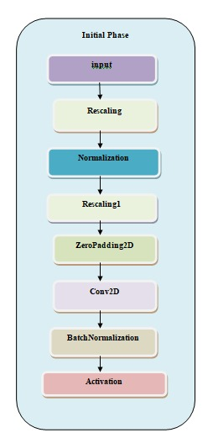

**Figure 3.1- Architecture of Initial Phase**

* + **Initial Phase** - This layer refers to the input layer, where the initial image data is fed into the CNN. In image recognition tasks, this data typically consists of a 3D tensor representing the image’s pixels.
  + **Rescaling** - This layer performs rescaling on the input data. There are several reasons why an image might be rescaled before feeding it into a CNN. For instance, it can help improve the training speed and stability of the network.
  + **Normalization** - This layer performs normalization on the data. Normalization is a technique that scales the data to a specific range, which can also improve the training speed and stability of the CNN.
  + **Rescalingl** - There might be a typo here. It’s likely this layer performs another rescaling operation on the data, possibly for a different purpose than the initial rescaling step.
  + **ZeroPadding2D** - This layer performs zero-padding on the input data. Zero-padding is a technique where zeros are added to the edges of the image data. This can be useful for ensuring the output size of certain filter operations, like convolutions, remains the same.
  + **Conv2D** - This layer represents a 2D convolutional layer. Convolution is a fundamental operation in CNNs that’s used to extract features from the input data. These features are like building blocks that the CNN uses to recognize patterns in the image.
  + **Batch Normalization** - This layer performs batch normalization on the data. Batch normalization is a technique that can improve the training speed and stability of CNNs.
  + **Activation** - This layer applies an activation function to the data. Activation functions introduce non-linearity into the network, allowing it to learn more complex patterns in the data.

1. **Phase 1:**

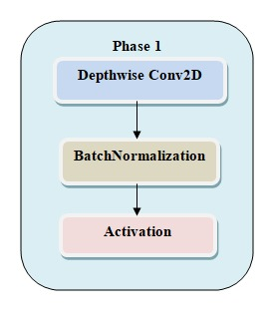

**Figure 3.2- Architecture of Phase 1**

* + **Depthwise Conv2D** - This layer represents a depthwise convolution operation. Depthwise convolution is a type of convolution where each filter applies only to one input channel, as opposed to standard convolutions where a single filter can span all channels. This can help reduce the number of parameters in the network, which can improve its efficiency.
  + **BatchNormalization** - This layer performs batch normalization on the data. Batch normalization is a technique that helps to address the problem of internal covariate shift, which can occur during the training process of neural networks. Internal covariate shift refers to the changes in the distribution of the activations of the hidden layers of the network as training progresses. Batch normalization helps to address this problem by normalizing the activations of each layer, which can help to improve the training speed and stability of the network.
  + **Activation** - This layer applies an activation function to the data. Activation functions introduce non-linearity into the network, allowing it to learn more complex patterns in the data.

1. **Phase 2:**

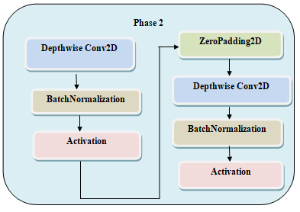

**Figure 3.3- Architecture of Phase 2**

* + **Depthwise Conv2D** - This layer represents a depthwise convolution operation. Depthwise convolution is a specific type of convolution where each filter applies only to one input channel, as opposed to standard convolutions where a single filter can span all channels. This can help reduce the number of parameters in the network, making it more efficient.
  + **ZeroPadding2D** - While not explicitly shown in the image, a ZeroPadding2D layer might be present before the Depthwise Conv2D layer. Zero-padding is a technique where zeros are added to the edges of the image data. This can be useful for ensuring the output size of certain filter operations, like convolutions, remains the same.
  + **Batch Normalization** - This layer performs batch normalization on the data. Batch normalization is a technique that addresses the problem of internal covariate shift, which can occur during neural network training. Internal covariate shift refers to the changes in the distribution of the activations of the hidden layers of the network as training progresses. Batch normalization helps to address this problem by normalizing the activations of each layer, which can improve the training speed and stability of the network.

1. **Phase 3:**

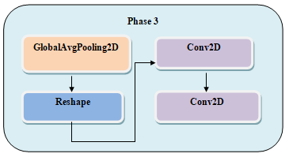

**Figure 3.4- Architecture of Phase 3**

* + **Global Average Pooling** - This layer performs global average pooling on the input data. Global average pooling is a technique that reduces the dimensionality of the data by taking the average value of each feature map. This can be useful for tasks like image classification, where the network is trying to classify the entire image into one of several categories.
  + **Conv2D** - This layer represents a 2D convolutional layer. Convolution is a fundamental operation in CNNs that’s used to extract features from the input data. These features are like building blocks that the CNN uses to recognize patterns in the image.

1. **Phase 4:**

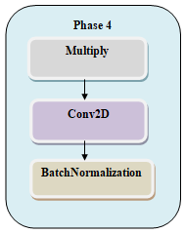

**Figure 3.5- Architecture of Phase 4**

* + **Multiply** - This layer represents a multiplication operation performed on the input data. In batch normalization, this multiplication is typically part of the process of normalizing the activations of the data across a mini-batch.
  + **Conv2D** - This layer represents a 2D convolutional layer. Convolution is a fundamental operation in CNNs (convolutional neural networks) that's used to extract features from the image data. These features are like building blocks that the CNN uses to recognize patterns in the image.
  + **Batch Normalization** - This layer performs batch normalization on the data. Batch normalization is a technique that helps to address the problem of internal covariate shift, which can occur during the training process of neural networks. Internal covariate shift refers to the changes in the distribution of the activations of the hidden layers of the network as training progresses. Batch normalization helps to address this problem by normalizing the activations of each layer, which can improve the training speed and stability of the network.

1. **Phase 5:**

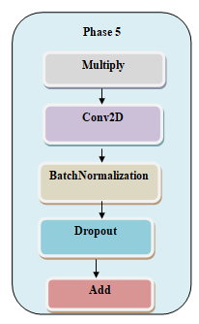

**Figure 3.6- Architecture of Phase 5**

* + **Multiply** - This layer represents a multiplication operation performed on the batch normalization data. In batch normalization, this multiplication is typically part of the process of normalizing the activations of the data across a mini-batch.
  + **Add** - This layer represents an addition operation performed on the batch normalization data. Batch normalization involves normalizing the activations of the data, followed by scaling and shifting them using learned parameters. This addition operation likely represents the addition of the scaled data with the bias term.
  + **Batch Normalization** - This layer performs batch normalization on the data. Batch normalization is a technique that helps to address the problem of internal covariate shift, which can occur during the training process of neural networks. Internal covariate shift refers to the changes in the distribution of the activations of the hidden layers of the network as training progresses. Batch normalization helps to address this problem by normalizing the activations of each layer, which can improve the training speed and stability of the network.

1. **Output Phase:**

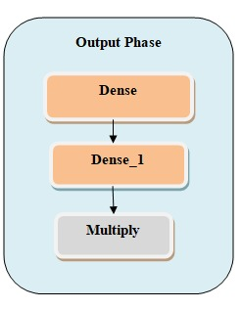

**Figure 3.7- Architecture of Output Phase**

* + **Dense** - This layer represents a fully-connected layer, also commonly called a dense layer. In a dense layer, all the neurons in the layer are connected to all the neurons in the previous layer. This layer is typically used in the later stages of a CNN to classify the image data into one of several categories.
  + **Dense_1** - This layer likely represents another fully-connected layer, potentially with a different number of neurons than the previous dense layer. Dense layers are often stacked together to create more complex models capable of learning intricate patterns in the data.
  + **Multiply** - This layer represents a multiplication operation performed on the data. In CNNs, multiplication is a fundamental part of the convolution operation, which is used to extract features from the input data. These features are like building blocks that the CNN uses to recognize patterns in the image.

Now integrating all these phases we can get the overall architecture of our model.

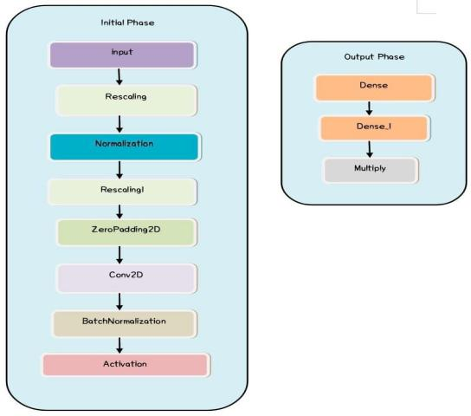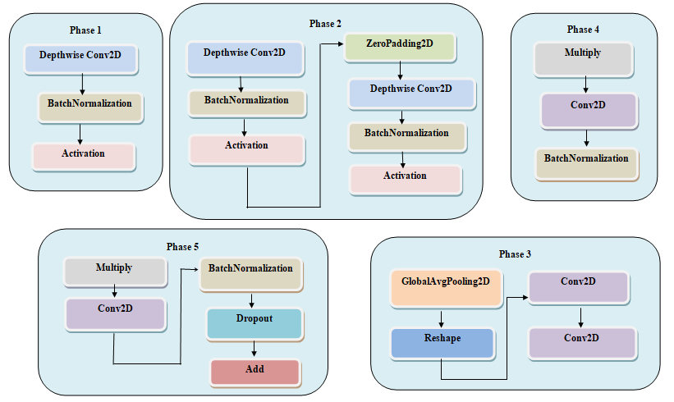

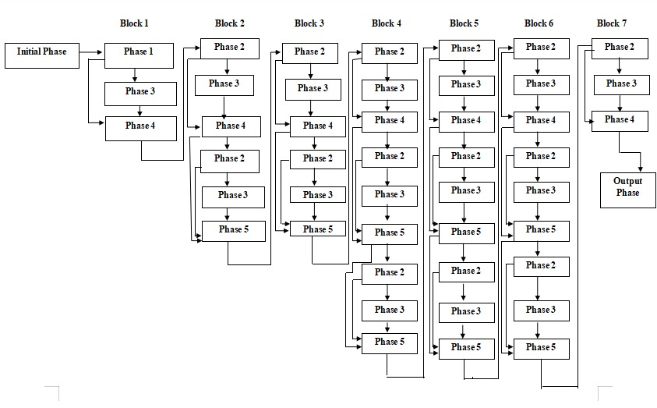

**Figure 3.8 - Model Architecture**

The above figure depicts the model architecture in which the layers are some repeating so we divided the repeating phases into the different phases. The initial phase describes the layers that are involved in the input rescaling, normalization etc. Then there are a total of 5 phases in the model architecture. There is also a output phase. Here in the EfficientNetB0 there are total of 7 blocks in which the different phases are repeated. After passing through the all blocks there is an output block where we will get the output.

1. **METHODOLOGY**

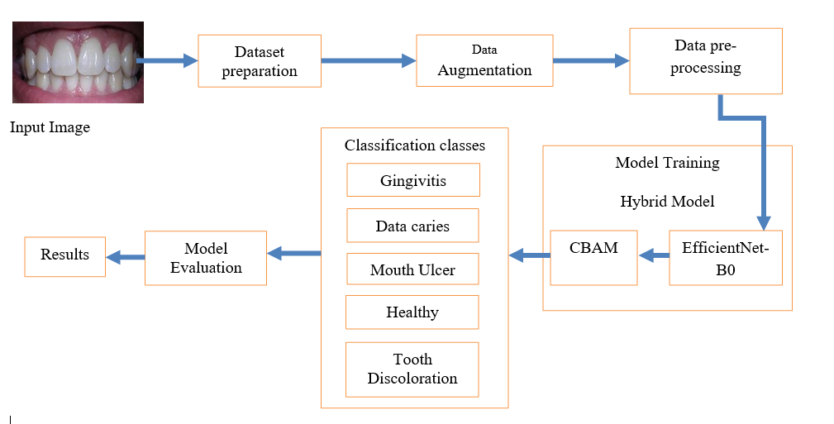

**Figure 4.1- Methodology diagram**

**Dataset Preparation:**

The dataset we took was an open source dataset. The name of the dataset was Oral Diseases. We modified the dataset by removing the unnecessary classes and the folders with augmented images which were not much useful for training the model. Then we considered 4 classes from the dataset those were Gingivitis, Data caries, Tooth Discoloration, Mouth Ulcer. We also collected images of new class named Healthy and added it to the dataset. After this we split the dataset into train, test, validation folders in the ratio of 0.8:0.1:0.1.

**Data Augmentation:**

The dataset contains five classes they were Healthy, Gingivitis, Tooth Discoloration, Mouth Ulcer, Data Caries. Here Healthy folder contains 120 images in total, Gingivitis folder contains 1879 images in total, Tooth Discoloration folder contains 146 images in total, Mouth Ulcer folder contains 212 images in total and Data Caries folder contains 175 images in total. We observed that the dataset is imbalanced as the there was a wide range of difference in number of images in each folder.

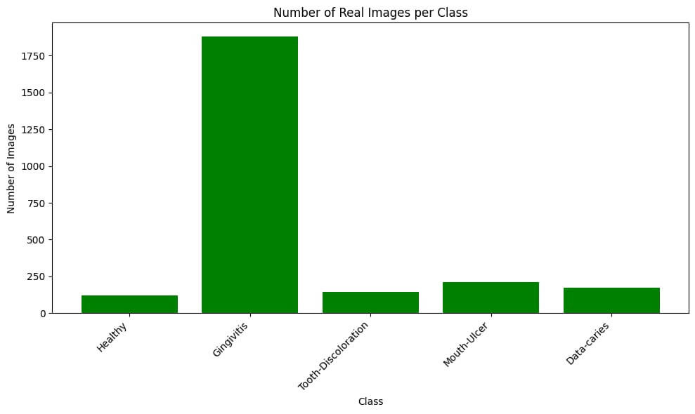

**Figure 4.1- Dataset before augmentation**

So to balance the dataset we used the augmentation techniques. We used the techniques like rotation, zoom, vertical flip, horizontal flip etc to generate new images from original images. We applied the data augmentation techniques on all classes except the Gingivitis as already it was having more number of images.

The number of augmented images generated for the Healthy class were 1655, for Tooth Discoloration class were 1637, for Mouth Ulcer were 1740 and for Data caries were 1455.

**Sample augmented images generated:**

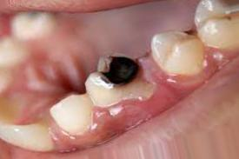 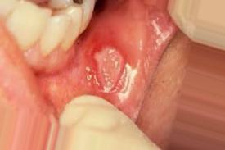 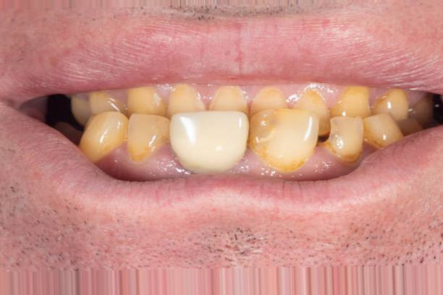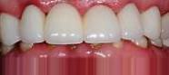

**Figure 4.2**

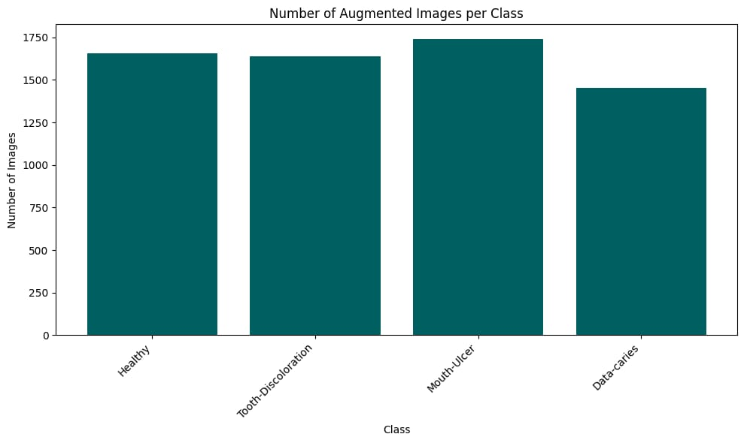

**Figure 4.3- Classes performed augmentation**

So after performing the data augmentation the Healthy folder was containing the 1775 images in total, Gingivitis folder was containing 1879 images in total, Tooth Discoloration folder containing 1783 images in total, Mouth Ulcer folder containing 1952 images in total and Data Caries folder containing 1630 images in total. By observing the below graph we can concluded that the dataset is balanced.

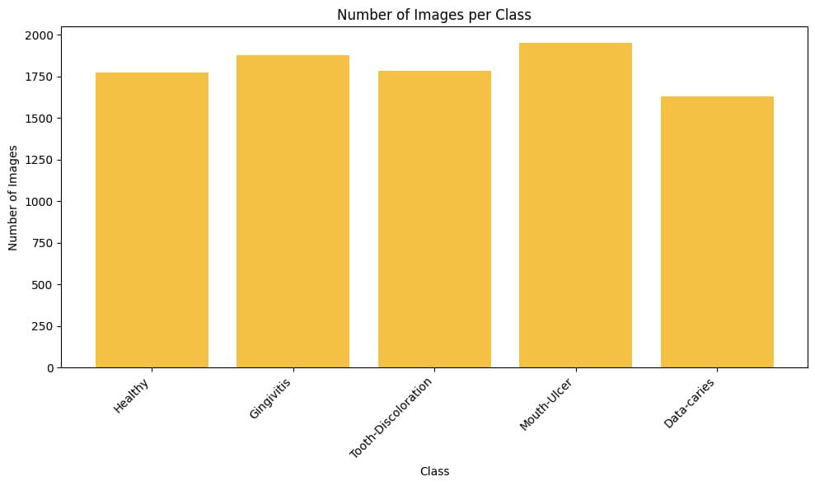

**Figure 4.4- Dataset after augmentation**

**Data Pre-processing:**

The train folder was now containing 5 folders in which each folder contain the real folder and augmented folders. The real folder contains the real images and augmented folder contains the augmented images. The images in the train folder, test folder, validation folder are loaded by using the ImageDataGenerator. We considered the target size as 224,224 and the color mode as RGB.

**Model Training:**

We considered the Hybrid model for our work. Our Hybrid model consists of two models one was for feature extraction and other is for classification.

1. **EfficientNet:**

The feature extraction process utilizing EfficientNetB0 commenced with the provision of training images to the pretrained model, circumventing the inclusion of fully connected layers, and proceeded to extract features from the final layer, block7a_project_bn. This layer typically captures high-level abstract representations of the input images due to its position towards the end of the network architecture. To ensure compatibility with the model's requirements, the input images were resized to dimensions of (224, 224, 3). Leveraging the prelearned representations encapsulated within EfficientNetB0, renowned for its efficiency and remarkable performance in image classification tasks, proved instrumental in this process. Extracting features directly from block7a_project_bn enabled the capture of intricate visual patterns and semantic information embedded within the images, which are crucial for subsequent tasks like classification or regression. This method not only mitigates computational burden by capitalizing on pretrained weights but also harnesses the deep representations ingrained within EfficientNetB0 from its extensive training on large-scale image datasets. The extracted features, stored in a designated variable, serve as valuable assets for downstream operations, including fine-tuning on specific datasets or training classifiers for image recognition and various computer vision applications. By exclusively focusing on feature extraction and abstaining from integrating the top layers, the core visual representations encoded within the neural network are preserved, facilitating efficient and effective utilization of the model's capabilities across a spectrum of image processing tasks and effective utilization of the model's capabilities for diverse image processing tasks..

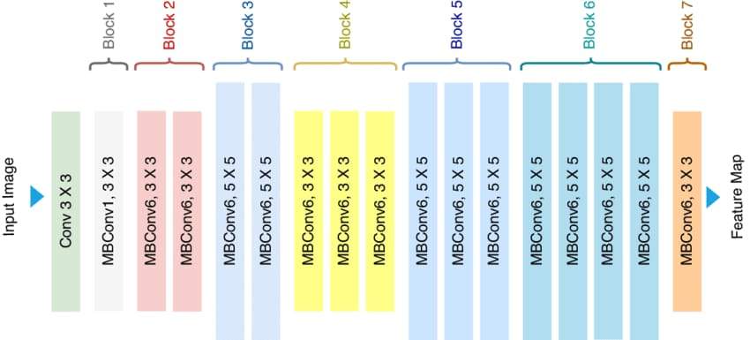

**Figure 4.5 - Explaining the EfficientNetB0 Archiecture**

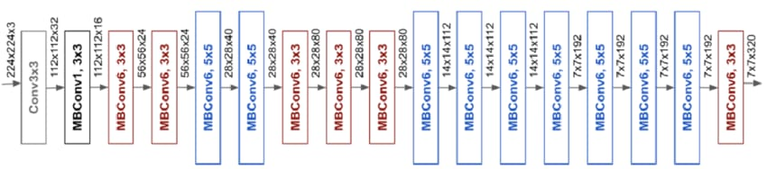

**Figure 4.6 – Explaining the layer by layer EfficientNetB0 architecture**

1. **CBAM- Channel Attention:**

Here's a detailed breakdown of how CBAM Channel Attention is integrated after feature extraction from EfficientNetB0 to improve classification performance:

**1. Feature Extraction with EfficientNetB0 (as described previously):**

* Preprocess and feed your images into the pre-trained EfficientNetB0 model (excluding fully connected layers).
* Extract features from the final layer (block7a_project_bn), obtaining a tensor representing high-level features for each image.

**2. CBAM Channel Attention Integration:**

* Apply the CBAM module to the extracted features from EfficientNetB0.
  + CBAM analyzes the feature maps across different channels (think of channels as representing different aspects of the image).
* **Channel Attention Mechanism:**
  + Within CBAM, a channel attention mechanism is employed. This mechanism calculates a weight for each channel in the feature map.
  + These weights determine the **importance** of each channel. Informative channels that contribute significantly to classification are assigned higher weights, while less relevant channels receive lower weights.
* **Recalibrating Feature Responses:**
  + The calculated weights are used to **recalibrate** the feature responses in each channel. Essentially, features considered more important are amplified, and less important ones are suppressed. This process refines the feature representation, focusing on the most discriminative information for the classification task.
* **Inter-channel Dependencies:**
  + By analyzing feature maps across channels, CBAM considers the relationships between channels. This allows the model to exploit these dependencies and focus on features that complement each other, leading to a more robust understanding of the image content.
* **Adaptive Feature Refinement:**
  + The weights calculated by CBAM are data-driven, meaning they adapt based on the specific features extracted from the images. This ensures the refinement process is tailored to the classification task at hand.

**Benefits of CBAM Channel Attention:**

* **Enhanced Discriminative Power:** By emphasizing informative features and suppressing irrelevant ones, CBAM improves the ability of the features to distinguish between different classes, leading to better classification accuracy.
* **Focus on Salient Features:** The attention mechanism directs the model to focus on the most critical aspects of the image for accurate classification.
* **Robustness:** By considering inter-channel dependencies, CBAM creates a more comprehensive understanding of the image content, making the classification process less susceptible to noise or variations in the images.

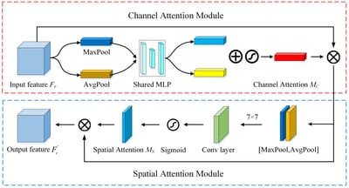

**Figure 4.7 – Explaining the CBAM architecture**

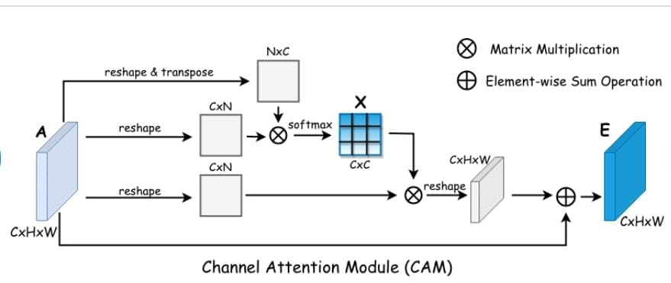

**Figure 4.8 – Explaining the architecture of CBAM channel attention**

Here we are discussing the how we are using the EfficientNet and CBAM channel attention in our model:

1. **EfficientNet:** The EfficientNetB0 was considered for the feature extraction. First we gave the train images to the pretrained EfficientNet and extracted the last layer features from the model. We not included the fully connected layers (top layers) of the model. The shape of the input images that the model will accept was (224, 224, 3). The last layer of our EfficientNetB0 was block7a_project_bn. So the features that were extracted from this layer were stored in a variable.
2. **CBAM-Channel Attention:** After extracting the last layer features we gave those features to the CBAM Channel Attention. So by using those features the channel attention was used for the classification task. So, here we extracted the last layer features by using the EfficientNetB0 and gave those features as an input for CBAM-Channel Attention inorder to perform the classification task.

**Model Evaluation:**

We trained the model by using the metrics like accuracy, precision, recall and AUC. We used the Adam as an optimizer and categorical cross entropy as loss function. The model performed well on the test data. The model also predicted the new unseen data very well.

**Accuracy:** Accuracy measures the overall correctness of the model's predictions and is calculated as the ratio of correctly predicted instances to the total number of instances in the dataset. It provides a general assessment of how well the model performs across all classes.



**Equation 4.1**

**Precision:** Precision measures the proportion of true positive predictions out of all positive predictions made by the model. It focuses on the relevance of the positive predictions and is particularly useful when the cost of false positives is high.



**Equation 4.2**

**Recall:** Recall measures the ability of the model to correctly identify all relevant instances, or true positives, out of all actual positive instances in the dataset. It is also known as sensitivity or true positive rate.



**Equation 4.3**

**Table 4.1 showing the values of metrics during training:**

|  |  |  |  |  |  |
| --- | --- | --- | --- | --- | --- |
| **Phase** | **Accuracy** | **Precision** | **Recall** | **AUC** | **Loss** |
| **Training** | 0.9931 | 0.9934 | 0.9928 | 0.9995 | 0.0277 |
| **Validation** | 0.9375 | 0.9375 | 0.9375 | 0.9941 | 0.1927 |

**A graph illustrating the model's Accuracy across epochs was plotted:**

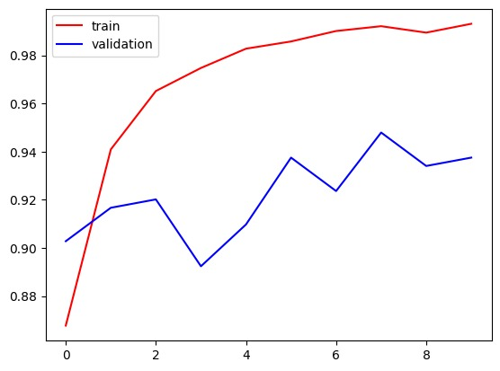

**Figure 4.9**

**A graph illustrating the model's Precision across epochs was plotted:**

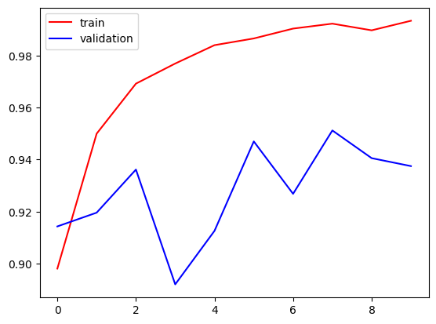

**Figure 4.10**

**A graph illustrating the model's Loss across epochs was plotted:**

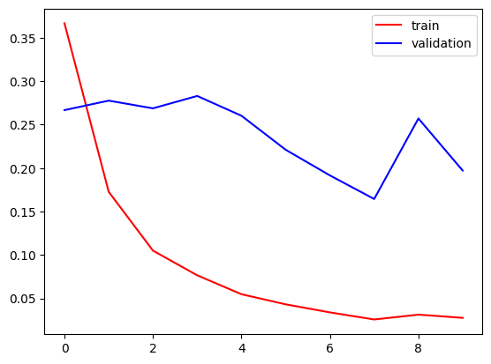

**Figure 4.11**

**A graph illustrating the model's Recall across epochs was plotted:**

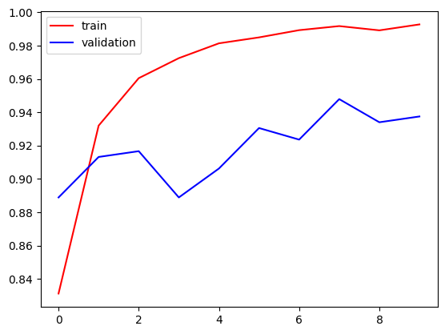

**Figure 4.12**

**Implementation (code):**

**Displaying the class labels:**

import os

dataset_root = '/content/drive/MyDrive/dataset/train'

class_labels = os.listdir(dataset_root)

print("Class labels:",class_labels)

Class labels: ['Healthy', 'Gingivitis', 'Tooth-Discoloration', 'Mouth-Ulcer', 'Data-caries']

**Loading images and preprocessing:**

from keras.preprocessing.image import ImageDataGenerator

trdata = ImageDataGenerator()

traindata = trdata.flow_from_directory(directory="/content/drive/MyDrive/dataset/train", batch_size=32, target_size=(224,224),color_mode='rgb')

tsdata = ImageDataGenerator()

testdata = tsdata.flow_from_directory(directory="/content/drive/MyDrive/dataset/test", batch_size=32, target_size=(224,224),color_mode='rgb')

vldata = ImageDataGenerator()

validatedata = vldata.flow_from_directory(directory="/content/drive/MyDrive/dataset/validation", batch_size=32, target_size=(224,224),color_mode='rgb')

Found 9019 images belonging to 5 classes.

Found 315 images belonging to 5 classes.

Found 319 images belonging to 5 classes.

**Import necessary libraries:**

import numpy as np

import tensorflow as tf

from tensorflow.keras.applications import EfficientNetB0

from tensorflow.keras.preprocessing.image import ImageDataGenerator

from tensorflow.keras import datasets, layers, metrics

from tensorflow.keras.optimizers import Adam

import matplotlib.pyplot as plt

from keras.models import load_model

from PIL import Image

from keras_visualizer import visualizer

**Preprocessing the data:**

# Preprocess the data

train_datagen = ImageDataGenerator(preprocessing_function=tf.keras.applications.efficientnet.preprocess_input)

valid_datagen = ImageDataGenerator(preprocessing_function=tf.keras.applications.efficientnet.preprocess_input)

traindata = train_datagen.flow_from_directory('/content/drive/MyDrive/dataset/train', target_size=(224, 224), batch_size=32,color_mode='rgb')

validatedata = valid_datagen.flow_from_directory('/content/drive/MyDrive/dataset/validation', target_size=(224, 224), batch_size=32,color_mode='rgb')

Found 9019 images belonging to 5 classes.

Found 319 images belonging to 5 classes.

**Hybrid Model:**

**Model for feature extraction is EfficientNet:**

# Load the pre-trained EfficientNet model

efficientnet_model = EfficientNetB0(weights='imagenet', include_top=False, input_shape=(224, 224, 3))

# Freeze the layers of the pre-trained model

efficientnet_model.trainable = False

# Get the output tensor from the last block (block 7)

last_block_output = efficientnet_model.get_layer('block7a_project_bn').output

Downloading data from https://storage.googleapis.com/keras-applications/efficientnetb0_notop.h5

16705208/16705208 [==============================] - 0s 0us/step

**Model for classification is CBAM:**

def channel_attention(input_feature, ratio=8):

    channel = input_feature.shape[-1]

    shared_layer_one = tf.keras.layers.Dense(channel // ratio, activation='relu')(input_feature)

    shared_layer_two = tf.keras.layers.Dense(channel, activation='sigmoid')(shared_layer_one)

    attention = tf.keras.layers.Multiply()([input_feature, shared_layer_two])

    return attention

# Apply channel attention

channel_attention_output = channel_attention(last_block_output)

x = tf.keras.layers.GlobalAveragePooling2D()(channel_attention_output)

x = tf.keras.layers.Dense(128, activation='relu')(x)

outputs = tf.keras.layers.Dense(5, activation='softmax')(x)

**Compiling the model:**

# Create the final model

model = tf.keras.Model(efficientnet_model.input, outputs)

model.compile(loss='categorical_crossentropy', optimizer='adam', metrics=['accuracy',

                       metrics.Precision(),

                       metrics.Recall(),

                       metrics.AUC()],run_eagerly=True)

**Training the model:**

# Calculate steps per epoch and validation steps

steps_per_epoch = traindata.samples // traindata.batch_size

validation_steps = validatedata.samples // validatedata.batch_size

# Train the model

history = model.fit(

    traindata,

    epochs=10,

    steps_per_epoch=steps_per_epoch,

    validation_data=validatedata,

    validation_steps=validation_steps

Epoch 1/10

281/281 [==============================] - 2547s 9s/step - loss: 0.3666 - accuracy: 0.8677 - precision: 0.8981 - recall: 0.8312 - auc: 0.9830 - val_loss: 0.2667 - val_accuracy: 0.9028 - val_precision: 0.9143 - val_recall: 0.8889 - val_auc: 0.9903

Epoch 2/10

281/281 [==============================] - 1968s 7s/step - loss: 0.1727 - accuracy: 0.9409 - precision: 0.9500 - recall: 0.9320 - auc: 0.9958 - val_loss: 0.2776 - val_accuracy: 0.9167 - val_precision: 0.9196 - val_recall: 0.9132 - val_auc: 0.9854

Epoch 3/10

281/281 [==============================] - 1940s 7s/step - loss: 0.1050 - accuracy: 0.9652 - precision: 0.9692 - recall: 0.9605 - auc: 0.9983 - val_loss: 0.2688 - val_accuracy: 0.9201 - val_precision: 0.9362 - val_recall: 0.9167 - val_auc: 0.9845

Epoch 4/10

281/281 [==============================] - 1934s 7s/step - loss: 0.0766 - accuracy: 0.9747 - precision: 0.9770 - recall: 0.9725 - auc: 0.9991 - val_loss: 0.2830 - val_accuracy: 0.8924 - val_precision: 0.8920 - val_recall: 0.8889 - val_auc: 0.9889

Epoch 5/10

281/281 [==============================] - 1987s 7s/step - loss: 0.0549 - accuracy: 0.9828 - precision: 0.9840 - recall: 0.9814 - auc: 0.9993 - val_loss: 0.2602 - val_accuracy: 0.9097 - val_precision: 0.9126 - val_recall: 0.9062 - val_auc: 0.9882

Epoch 6/10

281/281 [==============================] - 1950s 7s/step - loss: 0.0432 - accuracy: 0.9858 - precision: 0.9866 - recall: 0.9850 - auc: 0.9997 - val_loss: 0.2211 - val_accuracy: 0.9375 - val_precision: 0.9470 - val_recall: 0.9306 - val_auc: 0.9895

Epoch 7/10

281/281 [==============================] - 2028s 7s/step - loss: 0.0339 - accuracy: 0.9901 - precision: 0.9904 - recall: 0.9893 - auc: 0.9996 - val_loss: 0.1915 - val_accuracy: 0.9236 - val_precision: 0.9268 - val_recall: 0.9236 - val_auc: 0.9964

Epoch 8/10

281/281 [==============================] - 1960s 7s/step - loss: 0.0258 - accuracy: 0.9921 - precision: 0.9923 - recall: 0.9918 - auc: 0.9996 - val_loss: 0.1644 - val_accuracy: 0.9479 - val_precision: 0.9512 - val_recall: 0.9479 - val_auc: 0.9957

Epoch 9/10

281/281 [==============================] - 1960s 7s/step - loss: 0.0314 - accuracy: 0.9894 - precision: 0.9898 - recall: 0.9892 - auc: 0.9997 - val_loss: 0.2571 - val_accuracy: 0.9340 - val_precision: 0.9406 - val_recall: 0.9340 - val_auc: 0.9863

Epoch 10/10

281/281 [==============================] - 2004s 7s/step - loss: 0.0277 - accuracy: 0.9931 - precision: 0.9934 - recall: 0.9928 - auc: 0.9995 - val_loss: 0.1972 - val_accuracy: 0.9375 - val_precision: 0.9375 - val_recall: 0.9375 - val_auc: 0.9941

**Testing The Model:**

evaluation = model.evaluate(testdata)

print("Loss: ",evaluation[0])

print("Accuracy: ",evaluation[1])

10/10 [==============================] - 71s 7s/step - loss: 0.1606 - accuracy: 0.9460 - precision: 0.9521 - recall: 0.9460 - auc: 0.9960

Loss: 0.16055642068386078

Accuracy: 0.9460317492485046

**Random Prediction:**

class_labels = ['Data-caries', 'Gingivitis', 'Healthy', 'Mouth-Ulcer', 'Tooth Discoloration']

image_path = "/content/drive/MyDrive/dataset/test/Mouth Ulcer/5473.jpg"  # Replace with the path to your image

image = Image.open(image_path)

plt.imshow(image)

image = image.resize((224, 224))

# Convert the image to numpy array

image = np.array(image)

image = np.expand_dims(image, axis=0)

predictions = model.predict(image)

predicted_class = np.argmax(predictions, axis=1)

#print("Predicted class:", class_labels[predicted_class[0]])

for i,prob in enumerate(predictions[0]):

  label=class_labels[i]

  print(f"{label}:{prob*100}%")

print("Predicted class:", class_labels[predicted_class[0]])

1/1 [==============================] - 0s 229ms/step

Data-caries:0.0002368554532949929%

Gingivitis:0.006665166438324377%

Healthy:0.0016829180822242051%

Mouth-Ulcer:99.99057054519653%

Tooth Discoloration:0.000851035747473361%

Predicted class: Mouth-Ulcer

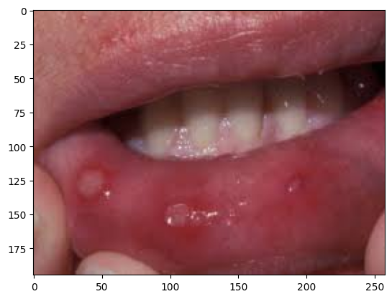

class_labels = ['Data-caries', 'Gingivitis', 'Healthy', 'Mouth-Ulcer', 'Tooth Discoloration']

image_path = "/content/drive/MyDrive/dataset/train/Healthy/real/3869.jpg"  # Replace with the path to your image

image = Image.open(image_path)

plt.imshow(image)

image = image.resize((224, 224))

# Convert the image to numpy array

image = np.array(image)

image = np.expand_dims(image, axis=0)

predictions = model.predict(image)

predicted_class = np.argmax(predictions, axis=1)

#print("Predicted class:", class_labels[predicted_class[0]])

for i,prob in enumerate(predictions[0]):

  label=class_labels[i]

  print(f"{label}:{prob*100}%")

print("Predicted class:", class_labels[predicted_class[0]])

1/1 [==============================] - 0s 233ms/step

Data-caries:1.8544271895848397e-06%

Gingivitis:0.0001423874095962674%

Healthy:99.9997615814209%

Mouth-Ulcer:3.940700992188795e-05%

Tooth Discoloration:6.098531457610079e-05%

Predicted class: Healthy

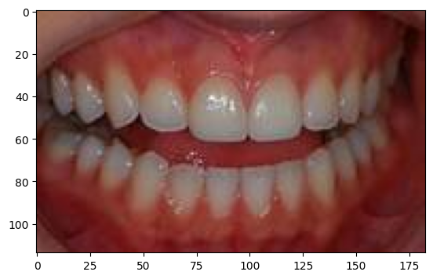

1. **RESULTS**

The model achieved the accuracy of 94.6%, precision of 0.9511, recall of 0.9460, AUC of 0.9960, loss of 0.1606. The model also performed well on the unseen data. We randomly given some images other than the dataset that we collected inorder to test the performance of the model. The model predicted the disease well on those data. We also trained the EfficientNetB0 model and CBAM model individually on the dataset. We got better results by training the Hybrid model.

**Table 5.1 comparing the metrics of different models:**

|  |  |  |  |
| --- | --- | --- | --- |
| **Model Name** | **Phase** | **Accuracy** | **Loss** |
| **EfficientNetB0** | **Training** | 0.9639 | 0.1249 |
| **Validation** | 0.9306 | 0.2631 |
| **Testing** | 0.9333 | 0.1833 |
| **CBAM** | **Training** | 0.9838 | 0.0514 |
| **Validation** | 0.9406 | 0.2177 |
| **Testing** | 0.9235 | 0.2172 |
| **Hybrid Model** | **Training** | 0.9931 | 0.0277 |
| **Validation** | 0.9375 | 0.1927 |
| **Testing** | 0.9460 | 0.1606 |

From this table we can conclude that the Hybrid model gave the better results when compared to the other models. The Hybrid model gave the better results when compared to other models due to integration of the EfficientNetB0 and CBAM channel attention. After predicting the disease the website was giving the precautions related to that disease. The website also contain the symptom checker page where the user can select the any of three symptoms and then the predicted disease will be displayed and also the related treatment will be displayed. Here in the table we can observe the individual EfficientNetB0 and CBAM models gave the accuracy of 93.33% and 92.35% respectively.

**Website pictures:**

**Home page:**

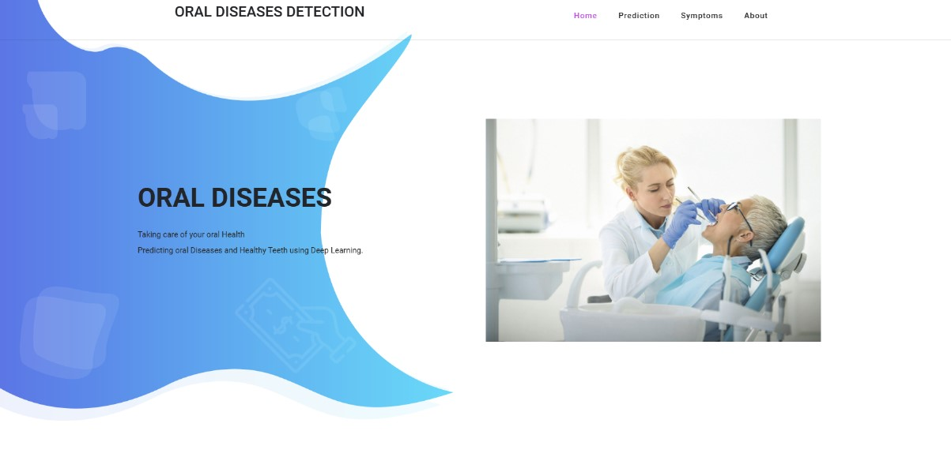

**Figure 5.1**

**About Page:**

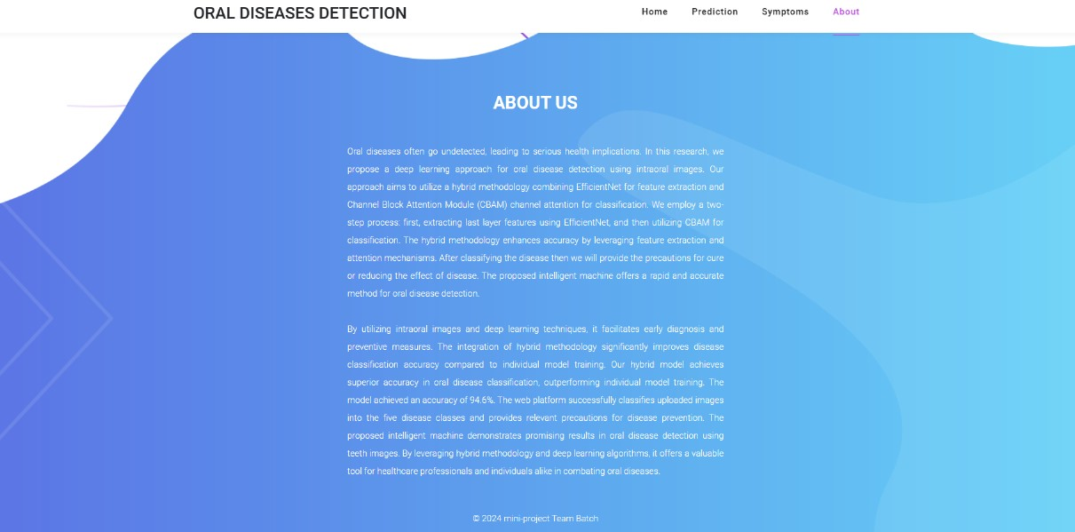

**Figure 5.2**

**Image based prediction:**

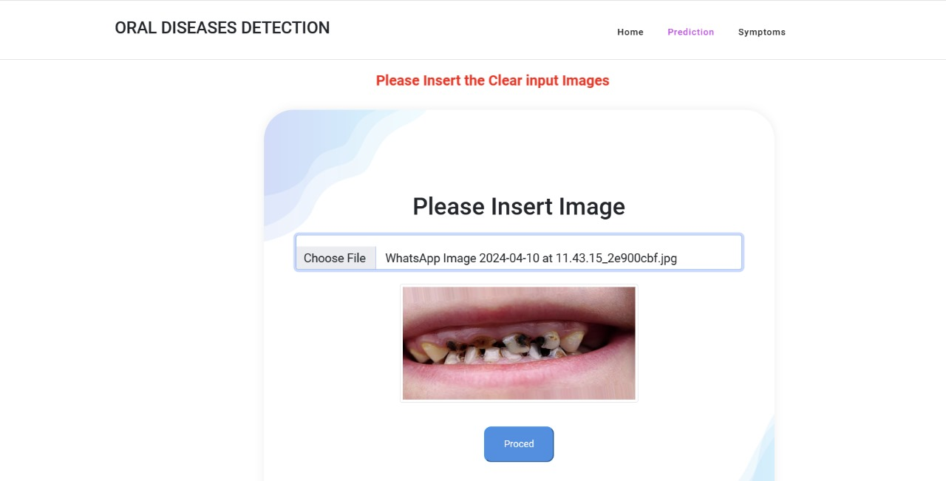

**Figure 5.3**

**Prediction Result:**

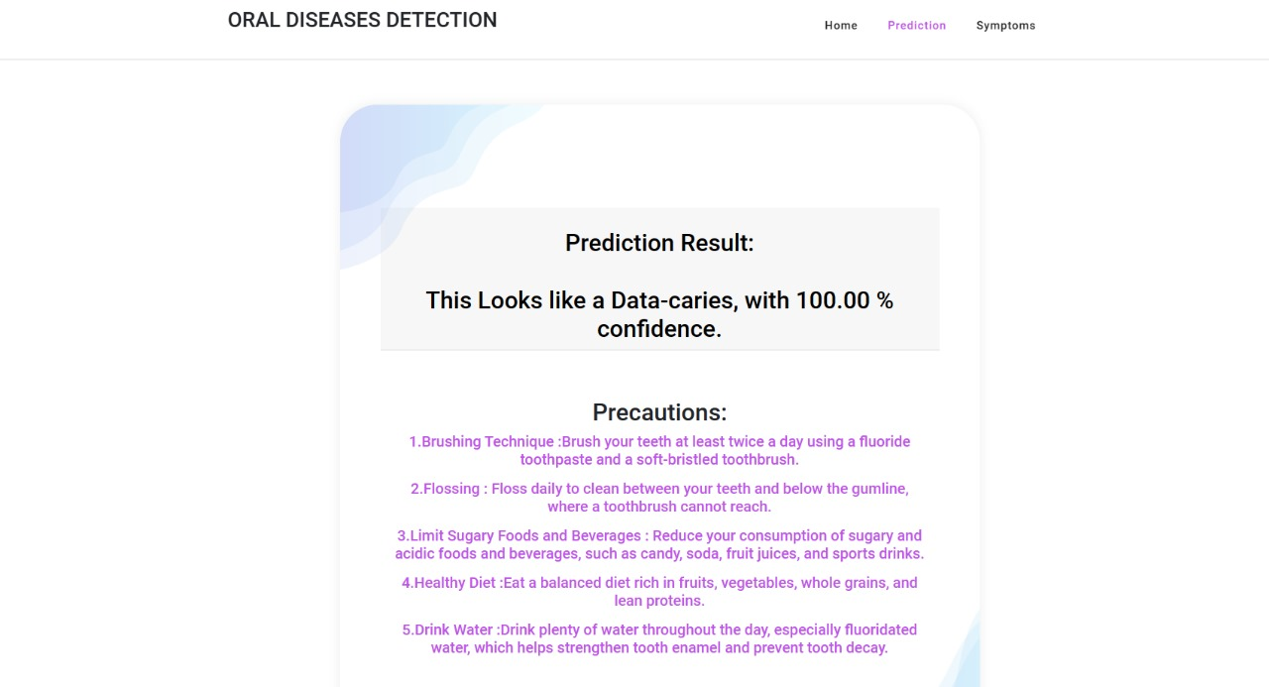

**Figure 5.4**

**Symptoms based prediction:**

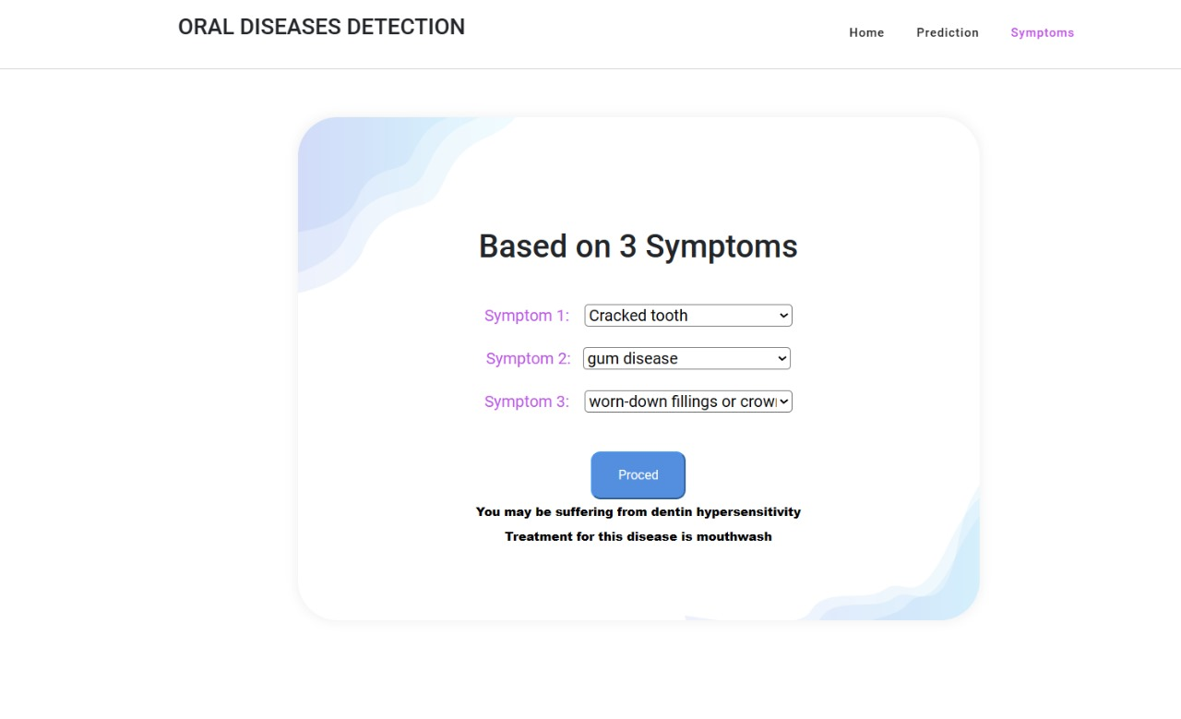

**Figure 5.5**

1. **DISCUSSION**

Our study presents a pioneering approach in utilizing deep learning for oral diseases detection, showcasing the potential of intelligent machines in transforming dental diagnostics. By employing a hybrid methodology, we achieved commendable accuracy in identifying various oral conditions from dental images. This breakthrough holds significant promise for revolutionizing oral healthcare, particularly in early disease detection and intervention.The integration of deep learning into dentistry addresses longstanding challenges associated with traditional diagnostic methods. Visual inspection and radiographic imaging, while valuable, are subjective and may miss early disease indicators. The Hybrid model gave the better accuracy when compared with the other models. Future research avenues may focus on optimizing intelligent machine performance through continued model refinement and validation on real-world patient datasets. An mobile app can be built for oral disease detection so that it can be helpful to everyone. Moreover, exploring multimodal data integration could enhance predictive capabilities and support comprehensive patient care and also the dataset must contain the mobile camera images.

1. **CONCLUSION**

In conclusion, our study addresses the lag in technological advancement within dentistry compared to other fields, particularly in the context of deep learning techniques. We provide a pioneering solution to bridge this gap by developing a robust model for oral disease classification using intraoral images. The results of our study demonstrate the effectiveness of our hybrid model, which achieved an impressive accuracy rate of 94.6%.Furthermore, we have translated our research into practical application by developing a user-friendly website where individuals can upload intraoral images for disease prediction. This tool not only facilitates early detection but also promotes accessibility to dental care, especially for those with limited resources or awareness of oral health issues.Our focus on intraoral images highlights their cost-effectiveness compared to traditional radiographic images, making our approach more feasible for widespread implementation. By enabling early disease detection, our study empowers individuals to take proactive measures and seek timely treatment, ultimately improving oral health outcomes and reducing healthcare costs.Through our efforts, we aim to raise awareness and empower individuals to prioritize their oral health, thereby enhancing overall well-being and quality of life.

1. **REFERENCES**

[1] Chau, R. C. W., Li, G., Tew, I. M., Thu, K. M., McGrath, C., Lo, W., Ling, W.,Hsung,T., & Lam, W. Y. H. (2023). “Accuracy of Artificial Intelligence-Based Photographic detection of gingivitis.” International Dental Journal, 73(5), 724–730.

[2] Rashid, J., Qaisar, B. S., Faheem, M., Akram, A., Amin, R. U., & Hamid, M.(2023). “Mouth and oraldisease classification using InceptionResNetV2 method.” Multimedia Tools and Applications.

[3] Park, S., Erkinov, H., Hasan, M. a. M., Nam, S., Kim, Y., Shin, J., & Chang, W. (2023). “Periodontal Disease Classification with Color Teeth Images Using Convolutional Neural Networks.” Electronics, 12(7), 1518.

[4] Sivari, E., Senirkentli, G. B., Bostancı, E., Güzel, M. S., Açıcı, K., &Aşuroğlu, T. (2023). “Deep Learning in Diagnosis of Dental Anomalies and Diseases: A Systematic review.” Diagnostics, 13(15), 2512.

[5] Patil, S., Albogami, S., Hosmani, J., Mujoo, S., Kamil, M. A., Mansour, M. A.,Abdul, H. N., Bhandi, S., & Ahmed, S. S. S. J. (2022). “Artificial Intelligence in the Diagnosis of Oral Diseases: Applications and Pitfalls.” Diagnostics (Basel, Switzerland), 12(5), 1029.

[6]Alalharith, D. M., Alharthi, H. M., Alghamdi, W. M., Alsenbel, Y. M., Aslam, N., Khan, I. U. Shahin, S. Y., Dianišková, S., Alhareky, M. S., & Barouch, K. K. (2020). “A Deep Learning Based Approach for the Detection of Early Signs of Gingivitis in Orthodontic Patients Using Faster Region-Based Convolutional Neural Networks.” International journal of environmental research and public health, 17(22), 8447.

[7] Park, E. Y., Cho, H., Kang, S., Jeong, S., & Kim, E. (2022). “Caries detection with tooth surface segmentation on intraoral photographic images using deep learning.” BMC Oral Health,22(1).

[8]Kawazu, T., Takeshita, Y., Fujikura, M., Okada, S., Hisatomi, M., &Asaumi, J. (2024).“Preliminary study of dental caries detection by deep Neural Network applying Domain-Specific Transfer Learning.” Journal of Medical and Biological Engineering.

[9] Imak, A., Celebi, A., Siddique, K., Turkoglu, M., Sengur, A., & Salam, I. (2022). Dental caries detection using score-based multi-input deep convolutional neural network. IEEE Access, 10, 18320-18329.

[10]Zhou, M., Jie, W., Tang, F., Zhang, S., Mao, Q., Liu, C., & Hao, Y. (2024). Deep learningalgorithms for classification and detection of recurrent aphthous ulcerations using oral clinical photographic images. Journal of Dental Sciences, 19(1), 254-260.

[11] Elsayed, A., Mostafa, H., Tarek, R., Mohamed, K., Hossam, A., & Selim, S. (2022, July). OralDental Diagnosis Using Deep Learning Techniques: A Review. In Annual Conference on Medical Image Understanding and Analysis (pp. 814-832). Cham: Springer International Publishing.

[12]Kumar A, Bhadauria HS, Singh A. (2021) Descriptive analysis of dental X-ray images using various practical methods: A review. PeerJComput Sci. 2021 Sep 13;7:e620.

[13] Jaiswal, P., &Bhirud, S. (2023). An intelligent deep network for dental medical imageprocessing system. Biomedical Signal Processing and Control, 84, 104708.

[14]Zhao, S., Liu, C., & Luo, Q. (2019, August). Dental data analysis based on dental x-raypanorama. In Proceedings of the Third International Symposium on Image Computing and Digital Medicine (pp. 133-137).

[15]M. Muthu Lakshmi & Dr. P. Chitra (2020). “Classification of Dental Cavities from X-ray images using Deep CNN algorithm”, IEEE Xplore, 774-779.

[16]Abdulaziz A. Al Kheraif, Ashraf A. Wahba, H. Fouad, (2019) “Detection of dental diseases from radiographic 2d dental image using hybrid graph-cut technique and convolutional neural network”,Science Direct, 146, 333-342.

[17]Shreyansh A. Prajapati, R. Nagaraj and Suman Mitra, (2017). “Classification of Dental Diseases Using CNN and Transfer Learning”, IEEE Xplore, 70-74.

[18] Hu Chen, Hong Li, Yijiao Zhao, Jianjiang Zhao, Yong Wang, (2021). “Dental disease detection on periapical radiographs based on deep convolutional neural networks”, Springer, 16, 649–661.

[19] NgnamsieNjimbouom S, Lee K, Kim J-D.(2022) “MMDCP: Multi-Modal Dental Carie Prediction for Decision Support System Using Deep Learning.” International Journal of Environmental Research and Public Health. 19(17):10928.

[20]Almalki YE, Din AI, Ramzan M, Irfan M, Aamir KM, Almalki A, Alotaibi S, Alaglan G, Alshamrani HA, Rahman S.(2022) “Deep Learning Models for Classification of Dental Diseases Using Orthopantomography X-ray OPG Images.” Sensors. 22(19):7370.

[21] Kabir, T., Lee, C. T., Nelson, J., Sheng, S., Meng, H. W., Chen, L., ... & Shams, S. (2021, December). An end-to-end entangled segmentation and classification convolution3al neural network for periodontitis stage grading from periapical radiographic images. In 2021 IEEE international conference on bioinformatics and biomedicine (BIBM) (pp. 1370-1375). IEEE.

[22] Li, X., Zhao, D., Xie, J., Wen, H., Liu, C., Li, Y., ... & Wang, S. (2023). Deep learning for classifying the stages of periodontitis on dental images: a systematic review and meta-analysis. BMC Oral Health, 23(1), 1017.

[23] Zhang, X., Liang, Y., Li, W., Liu, C., Gu, D., Sun, W., & Miao, L. (2022). Development and evaluation of deep learning for screening dental caries from oral photographs. Oral diseases, 28(1), 173-181.

[24] Yu, H., Lin, Z., Liu, Y., Su, J., Chen, B., & Lu, G. (2020). A new technique for diagnosis of dental caries on the children’s first permanent molar. Ieee Access, 8, 185776-185785.

[25] Mohammad‐Rahimi, H., Motamedian, S. R., Rohban, M. H., Krois, J., Uribe, S., Nia, E. M., Rokhshad, R., Nadimi, M., &Schwendicke, F. (2022). Deep learning for caries detection: A systematic review. Journal of Dentistry, 122, 104115.

[26] Lian L, Zhu T, Zhu F, Zhu H.(2021) Deep Learning for Caries Detection and Classification. Diagnostics. 11(9):1672.

[27] Mima, Y., Nakayama, R., Hizukuri, A. et al. Tooth detection for each tooth type by application of faster R-CNNs to divided analysis areas of dental panoramic X-ray images. Radiol Phys Technol 15, 170–176 (2022).

[28] T. Dhake and N. Ansari, "A Survey on Dental Disease Detection Based on Deep Learning Algorithm Performance using Various Radiographs," 2022 5th International Conference on Advances in Science and Technology (ICAST), Mumbai, India, 2022, pp. 291-296.

[29] A., Suresh, Kumar., Manivel, Kandasamy., P., Anitha. (2023). Analysis of Panoramic Images using Deep Learning For Dental Disease Identification.

[30] M., B., H., Moran., Marcelo, Faria., Marcelo, Faria., Gilson, A., Giraldi., Luciana, Freitas, Bastos., Larissa, F.C., de, Oliveira., Aura, Conci. (2021). Classification of Approximal Caries in Bitewing Radiographs Using Convolutional Neural Networks.. Sensors.