# Solar Panel Subsidy Simplified: How to Claim Yours in India 2024

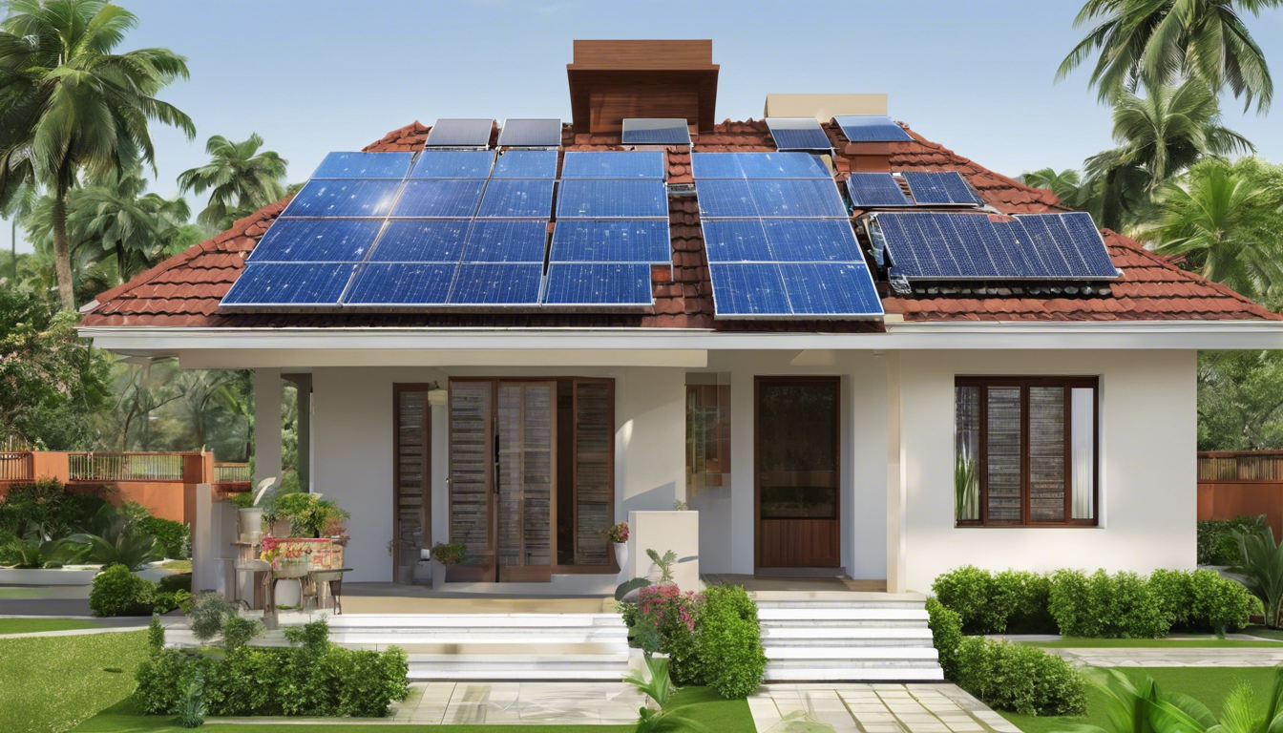

With the escalating need for renewable energy sources, the Indian government, through initiatives like the Ministry of New and Renewable Energy (MNRE) and government schemes such as PM Surya Ghar Yojana, has made significant strides in promoting the adoption of solar energy. The subsidy on solar panels, available through the national portal for rooftop solar, exemplifies the government's commitment to accelerating India's transition to a greener future. This push not only addresses the urgent environmental concerns but also eases the financial burden on individuals and businesses eager to contribute to this shift.

This article aims to demystify the process of obtaining a subsidy for solar panels in India, outlining the eligibility criteria, application process, and the financial benefits and limitations of such subsidies. Additionally, it explores the impact and future outlook of solar subsidies within the country, underscoring the vital role they play in India's energy landscape. Understanding these aspects is crucial for anyone looking to leverage government schemes like the solar panel installation subsidy under the umbrella of the national portal for rooftop solar and the broader MNRE initiatives.

## Overview of the Solar Power Plant Subsidy in India

### What is the Solar Power Plant Subsidy?

The Solar Power Plant Subsidy in India represents a significant initiative by the government to promote the use of solar energy among homeowners. This program is designed to make solar installations more accessible and affordable, offering financial incentives or support mechanisms to encourage the installation and use of solar panels for generating electricity. A pivotal component of this initiative is the new subsidy scheme launched in February, which allocates 75 billion rupees ($9 billion) in subsidies for installing grid-connected rooftop solar systems on approximately 10 million homes. This move is aimed at reducing electricity bills for consumers when the sun shines and allowing them to sell extra units back to the grid, thereby earning some money. The enhanced solar panel subsidy, announced in January 2024, includes a 23% increase in the Central Financial Assistance (CFA) to further support homeowners across the. The government has extended this initiative until March 31, 2026, ensuring that homeowners who install solar panels on their rooftops before this deadline can avail of the financial benefits.

### Objectives of the Subsidy Program

The primary goal of the Solar Power Plant Subsidy is to facilitate a sustainable and energy-secure future by making solar energy more affordable for homeowners. This strategic move is not just about financial incentives; it aims to accelerate the adoption of renewable energy sources, contributing to India's commitment to a greener future. The program is expected to create 30 gigawatts (GW) of solar capacity in homes, which could lead to a reduction of 720 million tonnes of CO2 equivalent planet-heating emissions over the 25-year lifespan of the rooftop systems. Another key objective is to provide free or low-cost electricity to 10 million households by generating up to 300 units of electricity per month through rooftop solar installations. This initiative, part of the PM Surya Ghar: Muft Bijli Yojana scheme, aims to support the installation of rooftop solar plants with subsidy support from the central government, establishing minimum technical specifications for eligibility. The scheme also emphasizes the importance of using domestically manufactured solar modules to qualify for the CFA, reinforcing the government's vision for India to become self-reliant in the energy sector as it transitions to the era of electric vehicles.

## Eligibility Criteria for the Solar Power Plant Subsidy

### Who Can Apply?

To be eligible for the National Rooftop Solar Scheme in 2024, applicants must fulfill several criteria. They must be permanent citizens of India and over 18 years old. Ownership of the house where the solar panels are to be installed is mandatory, along with an annual income of less than Rs 1 or 1.5 lakh. Those involved in government service are not eligible for this subsidy. Additionally, the maximum capacity for availing subsidy is set at 10kW for solar panels for homes and businesses. For residential consumers with a grid-connected solar plant, the Central Financial Assistance (CFA) is available, and group housing societies and Resident Welfare Associations (RWAs) with solar capacities up to 500kW can also avail the incentive. It is important to note that this subsidy is only available for Residential Homes, including Individual Homes and Big Apartments, specifically for Grid Connected Solar Systems without a Battery System.

### Necessary Documents for Application

To apply, consumers are required to pay a down payment of 20%–30% and must provide income proof, such as ITR files for the last three years, the most recent electricity bill for the last six months, and KYC documents. Other necessary documents include proof of identity, proof of address, an electricity bill, and a roof ownership certificate. The entire solar project must be implemented through the national portal, from application to technical feasibility check to installation. Consumers must get their system installed through empaneled vendors, listed state-wise on the portal, and use only domestically manufactured solar panels (both module and cells). Compliance with all MNRE guidelines and technical specifications is mandatory.

### State-specific Eligibility Requirements

Eligibility criteria and the process for availing solar subsidies can vary depending on the state and the specific scheme. However, some common eligibility criteria include the applicant being a resident of India and the owner of the property where the solar panels will be installed. The property must be a residential or commercial building with a clear title. Applicants must not have availed of any solar subsidy in the past, and the solar panels must be installed by a recognized and registered vendor approved by the state nodal agency.

## Application Process for the Solar Power Plant Subsidy

### Step-by-Step Guide to Apply

To facilitate the application process for the solar power plant subsidy, the Ministry of New and Renewable Energy (MNRE) has streamlined a series of steps. Applicants begin by gathering all necessary documents, including identification proof, address proof, and proof of property ownership. The initial step involves downloading the Sandes App from the National subsidy portal. Subsequently, applicants must register on the national subsidy portal and submit their application, ensuring that the name matches the one on the recent electricity bill. Uploading a recent electricity bill is a mandatory requirement. Following submission, applicants will receive feasibility approval from DISCOM via their registered email ID. Once the solar panel installation is completed, a work completion report and the net meter installation request must be submitted. After the installation of the net meter and inspection by DISCOM, a commissioning certificate will be generated from the portal. The final steps include submitting bank account details and a cancelled cheque through the portal, after which the subsidy is disbursed to the provided bank account.

### Important Deadlines

The release of the Central Financial Assistance (CFA)/subsidy for applications submitted on the National Portal will resume after the end of the Model Code of Conduct for General Elections, 2024. This highlights the importance of being aware of the political calendar and its impact on subsidy disbursement timings. Applicants should ensure their applications are complete and submitted well in advance of such deadlines to avoid delays in receiving the subsidy.

### How to Use the National Portal for Rooftop Solar

The National Portal for Rooftop Solar plays a crucial role in the application process for the solar power plant subsidy. Vendors and applicants alike are required to register on this portal. For vendors, the registration process involves submitting an application along with a declaration at www.solarrooftop.gov.in http://www.solarrooftop.gov.in and depositing a Performance Bank Guarantee (PBG) of Rs. 2,50,000/- valid for at least five years. The DISCOM updates the list of registered vendors every month, and the details of the registered vendors are uploaded on the National Portal. Applicants, on the other hand, apply on the National Portal and receive a unique application ID. They select the vendor for their rooftop solar installation, with the help of various decision-making tools available on the portal. The rates, system specifications, and design customization are mutually decided between the beneficiary and the vendor, subject to the minimum technical specifications mandated under the scheme. This collaborative platform ensures transparency and ease in the application and installation process, contributing significantly to the promotion of solar energy in India.

## Financial Benefits and Limitations of the Subsidy

### Subsidy Amounts and Caps

The government's initiative to boost the adoption of rooftop solar systems includes a structured subsidy scheme. For residential installations, subsidies vary based on the system capacity. Systems up to 3 kW receive up to Rs 18,000 per kW in general states and Rs 20,000 per kW in special category states, aiming to cover the higher costs associated with solar panels and incentivize households. For systems exceeding 3 kW, the total subsidy available to customers is capped at USD 936, ensuring a broad distribution of benefits while managing fiscal resources. Additionally, for rooftop solar plants installed for residential use, the Central Financial Assistance (CFA) offers Rs. 9,000 per kW for capacities above 3 kW and up to 10 kW, with the subsidy amount fixed for systems above 10 kW capacity.

### Comparative Analysis Across States

Different states in India exhibit varying levels of progress in their solar energy initiatives, which can influence the financial benefits received from subsidies. States like Haryana aim to significantly increase their solar capacity, whereas others like Jharkhand, Bihar, West Bengal, and Uttar Pradesh show slower progress and face structural challenges in their electricity transition. This disparity affects how subsidies are utilized and the subsequent financial benefits that can be accrued by residents of different states.

### Potential Drawbacks and Common Issues

While the financial incentives are substantial, there are notable limitations and challenges associated with the subsidy scheme. One significant issue is the disparity in the buyback rates for surplus solar electricity sold back to the grid. Consumers like Narayan, who have installed a 6 kW solar system, face issues with debt-ridden DISCOMs which offer low tariffs for surplus solar electricity - at times as low as 1.5 rupees per unit, compared to the 8 rupees per unit charged for grid electricity. Additionally, fixed charges added by the electricity distribution companies can undermine the financial benefits, as highlighted by Narayan's experience of being charged a fixed fee of 500 rupees on his monthly bill regardless of consumption. Another drawback is the exclusion of hybrid systems from the subsidy scheme, which could otherwise provide a solution during power outages, especially in peak summer months. These financial benefits and limitations illustrate the complex landscape of solar subsidies in India, highlighting both the opportunities for savings and the challenges that need addressing to optimize the impact of these government initiatives.

## Impact and Future of Solar Subsidies in India

### Current Achievements and Statistics

India's initiative to promote solar energy has seen significant progress, with the installation of 82.63 GW of solar capacity as of April 2024, a substantial increase from previous years. This growth is part of India's broader commitment to enhancing its renewable energy capacity, which now stands at more than 199.85 GW, including large hydro and nuclear, representing about 45.1% of the country's total capacity. The government's ambitious target to achieve 500 GW of non-fossil fuel-based energy by 2030 highlights the scale of India's renewable energy expansion plans.

### Government Plans and Future Targets

The Indian government has outlined several strategic initiatives to further boost solar energy adoption. These include the National Green Hydrogen Mission, with an initial outlay of INR 19,744 Cr, aiming to support the production of 5 Mn Tonnes of green hydrogen by 2030, powered by 125 GW of renewable energy capacity. Additionally, the government has approved 50 solar parks with an aggregate capacity of 37.49 GW and set an offshore wind energy target of 30 GW by 2030. The PLI scheme in Solar PV manufacturing, with financial outlays of INR 24,000 Cr, is another critical component of India's strategy to enhance its solar capacity under the Aatma Nirbhar Bharat initiative.

### Impact on Renewable Energy Adoption in India

The impact of solar subsidies on renewable energy adoption in India has been transformative. By reducing the upfront costs of solar installations, these subsidies have made solar energy more accessible and affordable, particularly for homeowners in rural. The government's commitment to meeting over 50% of energy requirements from renewables by 2030 and reducing cumulative emissions by one billion tonnes underscores the pivotal role of solar energy in achieving these goals. Furthermore, the introduction of innovative policies like the Delhi Solar Policy 2024, which includes generation-based incentives and capital subsidies, is expected to drive a surge in rooftop solar installations, thereby enhancing household affordability and contributing to economic growth. The continued expansion of solar energy facilitated by these subsidies is crucial for India to meet its energy needs sustainably while combating climate change and reducing its carbon footprint. As Balaji Powertech contributes to this green transition, the future of solar energy in India looks promising, with substantial benefits for both the environment and the economy.

## Conclusion

Throughout this discussion, we've explored the intricacies of India's subsidy scheme for solar panel installations, elucidating the eligibility criteria, application process, financial benefits, and potential limitations. This comprehensive overview not only sheds light on the government's commitment to fostering a sustainable and energy-secure future but also underscores the pivotal role of individual and collective action in catalyzing the transition towards renewable energy sources. By harnessing solar power, households across India can contribute to a greener future, benefit financially through reduced electricity bills, and potentially earn by selling excess energy back to the grid, all while playing a part in the nation's ambitious climate goals.

As the landscape of solar energy in India continues to evolve, the importance of staying informed and proactive cannot be overstated. For those looking to embark on this renewable journey, the synergy between government initiatives and private sector participation offers a path forward. To navigate the complexities of solar power plant installation and make the most of the available subsidies, reaching out to knowledgeable partners like Balajipowertech can be a wise first step. Their expertise in the field can provide the guidance and support necessary to make solar energy a viable and rewarding investment. With the collective efforts of government, industry players like Balajipowertech, and the citizenry, the vision of a sustainable and energy-independent India becomes increasingly attainable.

## FAQs

### Understanding Solar Subsidy in India for 2024

**1. What does the solar subsidy entail in India for the year 2024?**

In 2024, the Indian government is offering a solar subsidy where systems up to 2 kW capacity can receive up to ₹30,000 per kW. For systems with a capacity of 3 kW, a subsidy of ₹78,000 is available. Any system capacity beyond 3 kW will be eligible for a fixed subsidy of ₹78,000.

**2. How can one apply for the solar subsidy in India?**

To apply for the solar subsidy, individuals should visit the official website at https://pmsuryaghar.gov.in https://pmsuryaghar.gov.in and select the “Apply for Rooftop Solar” option. The application process requires registration, where you must provide your State, Electricity Distribution Company, Electricity Consumer Number, Mobile Number, and Email.

**3. What is the 2024 solar policy in Madhya Pradesh (MP)?**

The 2024 solar policy in Madhya Pradesh aims to reach a 4 GW residential solar installation target. The government offers subsidies specifically for rooftop solar projects to promote solar adoption among homeowners across MP and other states.

**4. Can you explain the solar subsidy available in Punjab in 2024?**

In Punjab, the Rooftop Solar Programme Phase II scheme offers Central Financial Assistance (CFA)/Solar Subsidy Support. This subsidy provides a predetermined amount for every kW of system size installed. It is available exclusively to residential consumers and housing societies.