MuleSoft to Spring boot Migration

Contents
1. Business Context & Goals 3
1.1 Background 3
1.2 Problem Statement 3
1.3 POC Objectives 4
2. Architecture Overview 4
2.1 Architecture Diagram 4
2.2 Component Purpose & Responsibilities 4
2.2.1 Application Scanner 4
2.2.2 API Decomposer 5
2.2.3 Flow Analyzer 5
2.2.4 Trace Generator 5
2.2.5 Requirements Extractor 5
2.2.6 Test Bed Creator 5
2.2.7 Code Generator 5
3. Input & Output 5
4. Decomposition Strategy 6
5. Trace Document Format 7
2.6 User Story Template for LLM Prompt 8
2.7 Naming Conventions 9

1. Business Context & Goals

1.1 Background
AIG currently operates 1000+ MuleSoft APIs across multiple business units, incurring $50M+ annual licensing costs while utilizing only 5-10% of available features. The organization seeks to migrate to a cost-effective, open-source stack (like Spring Boot) to reduce operational costs and gain greater flexibility.

1.2 Problem Statement
- Manual migration is infeasible: Cannot manually refactor 1000+ APIs within acceptable timeline/budget
- Lack of structured requirements: Most MuleSoft APIs lack formal documentation of flow logic and dependencies
- Testing gap: No/less automated test coverage for existing MuleSoft APIs → Risk during migration
- Knowledge loss: DWL (DataWeave) logic embedded in XML files lacks portable documentation

1.3 POC Objectives
- Demonstrate feasibility of AI-driven API migration (Python utilities + LLM)
- Validate accuracy of automated requirement extraction and test case generation
- Prove code quality of LLM-generated Spring Boot projects (60-70% completeness)
- Establish repeatable process applicable to 1000+ APIs

2. Architecture Overview

2.1 Architecture Diagram
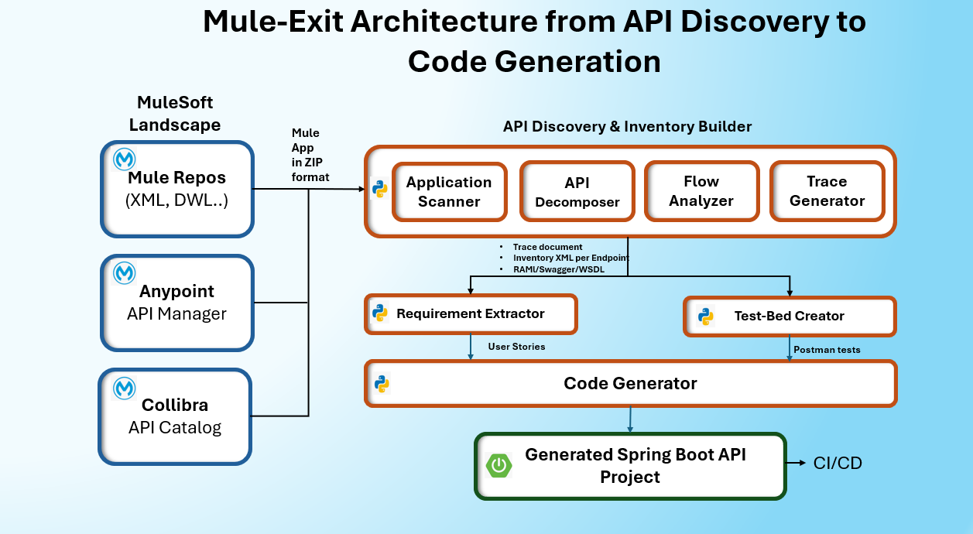

2.2 Component Purpose & Responsibilities

2.2.1 Application Scanner
Purpose: Scans and Analyzes the MuleSoft application/project in the landscape
Responsibility: Scans folders/repositories → identifies Mule APIs → extracts metadata

2.2.2 API Decomposer
Purpose: Breaks monolithic Mule project into per-endpoint mini-projects. Each mini project can contain mule xml file and any another configuration files to make sure it is executable without any failures.
Responsibility: Parses configuration files → splits flow per endpoint → creates deployable mini projects

2.2.3 Flow Analyzer
Purpose: Analyzes the flow in each mini project and builds API inventory per endpoint.
Responsibility: Parses the mini projects XML → captures steps/components/properties/dependencies → builds API inventory xml per endpoint

2.2.4 Trace Generator
Purpose: Generates the trace document in human readable format, which helps to compare with generated inventory xml
Responsibility: Analyzes mini projects → extracts the execution flow → generates trace document

2.2.5 Requirements Extractor
Purpose: Uses LLM to convert Trace → human-readable requirements/user stories
Responsibility: LLM prompt engineering → Level 1+2 stories → test cases → SB mapping

2.2.6 Test Bed Creator
Purpose: Generates executable test collections (for Postman) from Trace, inventory XML and RAML/Swagger/WSDL
Responsibility: Creates Postman collections → happy path + error tests → assertions

2.2.7 Code Generator
Purpose: Uses LLM (like Open Router) to generate complete Spring Boot projects from requirements
Responsibility: Generates Spring boot project with all required files (including pom.xml, Controller, Service, DTO, JUnit Tests etc.) for production-ready

3. Input & Output
Component | Input | Output | Example
Application Scanner | Mule project folders/ZIP file | Meta Data file with all project details | projects.json
API Decomposer | Meta Data file with all project details | Per-endpoint mini projects | decomposed/calculator-add/,  decomposed/calculator-sub/
Flow Analyzer | Per-endpoint mini projects | API inventory per endpoint | XML
Trace Generator | API inventory per endpoint | Trace CSV | trace_calculator-add.csv
Requirements Extractor | Trace CSV + RAML/OAS/WSDL + mini project | User stories | calculator-add_user_stories.txt
Test Bed Creator | Trace CSV + RAML/OAS/WSDL + mini project | Postman collections | postman_calculator-add. json
Code Generator | User stories for all endpoints per API + test cases | Complete Spring Boot project | spring-boot-calculator-add/pom.xml,  spring-boot-calculator-add/src/…

4. Decomposition Strategy

Original Mule Project:
calculator-api/
├── src/main/mule/
│ ├── mule-app.xml
│ ├── shared-flows.xml
│ └── transformations.xml
├── src/main/resources/
│ ├── config.yaml
│ └── secrets.yaml
└── pom.xml

Decomposed Mini Projects:
↓

decomposed/
├── calculator-add/
│ ├── src/main/mule/calculator-add.xml
│ └── src/main/resources/config.yaml
├── calculator-subtract/
│ ├── src/main/mule/calculator-subtract.xml
│ └── src/main/resources/config.yaml
├── calculator-multiply/
│ ├── src/main/mule/calculator-multiply.xml
│ └── src/main/resources/config.yaml
├── calculator-divide/
│ ├── src/main/mule/calculator-divide.xml
│ └── src/main/resources/config.yaml

The sample mini project may have the following project structure:

<mini-project-name>/
├── pom.xml # Maven build configuration
├── mule-artifact.json # Mule artifact metadata
├── src/
│ └── main/
│ ├── mule/
│ │ ├── <endpoint>-api.xml # Main flow with endpoint implementation
│ │ ├── global.xml # Global configurations
│ │ ├── common-flow.xml # Reusable backend API call sub-flow
│ │ └── error-handling.xml # Comprehensive error handlers
│ └── resources/
│ ├── api/
│ │ └── <endpoint>-api.raml # RAML API specification
│ ├── config/
│ │ └── dev.yaml # Configuration properties
│ └── log4j2.xml # Logging configuration

5. Trace Document Format
Key Columns in the trace document can be:
Column | What it Contains | Examples
Execution Step ID | Sequential flow order (0, 1, 1.1, 1.2, etc.) | 0, 1, 1.1, 1.2, 5.3
Endpoint | API endpoint name | /getitems, /additem, /updateitem/{id}
HTTP Method | REST verb (GET, POST, PUT, DELETE) | GET, POST, PUT, DELETE, N/A
Mule API Path | Path Mule listens on | /api/getitems, /api/, /console/
Mule Listener Port | Port number | 8082
Mule Listener URL | Full Mule API URL | http://localhost:8082/api/getitems
Request Content-Type | Client request format | application/json, text/html, null
Response Content-Type | Response format | application/json, text/html
Backend Service Host | External service domain | api.restful-api.dev
Backend Endpoint Path | Backend resource path | /objects, /users, /items
Backend Full URL | Complete backend URL | https://api.restful-api.dev/objects
Component Type | Mule component class | HTTP Listener, Transformation, HTTP Request, APIKit Router
Component Name | Component instance name | ee:transform, itemtrack restapi service
Connector Name | Mule connector plugin | HTTP Connector, APIKit Module, Mule EE Core
Config Reference | Configuration object | itemtrack-restapi-sample-config
Input Parameters | Received data | path, method, queryParameters, id
Output Parameters | Produced data | id, name, data, datecreated
Status Code | HTTP response codes | 200, 500, 400, 404
Error Handling | Error handling strategy | APIKIT error handler, HTTP error handling
Action Required | Component action | Call Backend API, Create Input Variables
Dependency | Maven dependency | mule-http-connector:1.11.0
Remarks | Additional notes/issues | Known bugs, Configuration details

2.6 User Story Template for LLM Prompt
Generate Spring Boot code for the following user story:

User Story:
Title: {{USER_STORY_TITLE}}
Description: {{USER_STORY_DESCRIPTION}}

Requirements:
1. Create an endpoint: {{HTTP_METHOD}} {{ENDPOINT_PATH}} (e.g., POST /calculator/add).
2. Input: {{INPUT_FORMAT}} (JSON/XML) with fields: {{INPUT_FIELDS}}.
3. Output: {{OUTPUT_FORMAT}} (JSON/XML) with fields: {{OUTPUT_FIELDS}}.
4. Business Logic: {{BUSINESS_LOGIC_DESCRIPTION}}.
5. Persistence: Use {{DATABASE_TYPE}} (e.g., PostgreSQL) and persist data in table {{TABLE_NAME}} with columns: {{COLUMN_DETAILS}}.
6. Common Functions: {{COMMON_FUNCTIONS}} (e.g., sanitize input, error handling).
7. Validation & Error Handling: {{VALIDATION_RULES}}.
8. External Connectors: {{EXTERNAL_CONNECTORS}} (e.g., message queues, APIs, or third-party services).

Standards:
1. Follow Spring Boot best practices
2. Use Controller-Service-Repository pattern
3. Re-use code wherever possible
4. Include code comments
5. Implement Mockito based JUnit test cases
6. Run JUnit test cases
7. Make sure 100% code coverage is done

Expectations:
- Provide full Spring Boot structure (Controller, Service, Repository, Entity, DTO, Utility classes).
- Include request/response models.
- Add proper annotations (@RestController, @PostMapping, @Entity, etc.).
- Use Spring Data JPA for persistence.
- Implement exception handling and input validation.
- Add comments explaining each section.
- Ensure code is clean, modular, and maintainable.

Acceptance Criteria:
- API should accept {{INPUT_FORMAT}} and return {{OUTPUT_FORMAT}}.
- Validate all required fields; reject invalid or missing data.
- Persist data correctly in {{TABLE_NAME}} with timestamp.
- Return HTTP 201 on success and appropriate error codes on failure.
- Integration with {{EXTERNAL_CONNECTORS}} should be tested and functional.
- Code should follow clean architecture and include comments for clarity.

Technology Stack:
- Java Version: {{JAVA_VERSION}}
- Spring Boot: {{SPRING_BOOT_VERSION}}
- Build Tool: {{GRADLE_VERSION (DO NOT USE MAVEN)

Project Configuration:
Name: {{PROJECT_NAME}}
Package: {{PACKAGE_NAME}}
Version: {{PROJECT_VERSION}}
Description: {{PROJECT_DESCRIPTION}}
Output Path: {{OUTPUT_LOCATION}}

2.7 Naming Conventions
Artifact | Pattern | Example
Mini-projects | decomposed/{endpoint_name}/ | decomposed/calculator-add/
Trace document | trace_{endpoint_name}.csv | trace_calculator-add.csv
User stories | {endpoint_name}_user_stories.md | calculator-add_user_stories.md
Postman collections | postman_{endpoint_name}.json | postman_calculator-add.json
Spring Boot projects | spring-boot-{endpoint_name}/ | spring-boot-calculator-add/

