MuleSoft to Spring boot Migration

Contents
1. Business Context & Goals 3
1.1 Background 3
1.2 Problem Statement 3
1.3 POC Objectives 4
2. Architecture Overview 4
2.1 Architecture Diagram 4
2.2 Component Purpose & Responsibilities 4
2.2.1 Application Scanner 4
2.2.2 API Decomposer 5
2.2.3 Flow Analyzer 5
2.2.4 Trace Generator 5
2.2.5 Requirements Extractor 5
2.2.6 Test Bed Creator 5
2.2.7 Code Generator 5
3. Input & Output 5
4. Decomposition Strategy 6
5. Trace Document Format 7
2.6 User Story Template for LLM Prompt 8
2.7 Naming Conventions 9

1. Business Context & Goals

1.1 Background
AIG currently operates 1000+ MuleSoft APIs across multiple business units, incurring $50M+ annual licensing costs while utilizing only 5-10% of available features. The organization seeks to migrate to a cost-effective, open-source stack (like Spring Boot) to reduce operational costs and gain greater flexibility.

1.2 Problem Statement
- Manual migration is infeasible: Cannot manually refactor 1000+ APIs within acceptable timeline/budget
- Lack of structured requirements: Most MuleSoft APIs lack formal documentation of flow logic and dependencies
- Testing gap: No/less automated test coverage for existing MuleSoft APIs → Risk during migration
- Knowledge loss: DWL (DataWeave) logic embedded in XML files lacks portable documentation

1.3 POC Objectives
- Demonstrate feasibility of AI-driven API migration (Python utilities + LLM)
- Validate accuracy of automated requirement extraction and test case generation
- Prove code quality of LLM-generated Spring Boot projects (60-70% completeness)
- Establish repeatable process applicable to 1000+ APIs

2. New Approach in v2.0

2.1 Reasons for the Change (Directly from the Analysis)

2.1.1. Inconsistent LLM Outputs with Single-Shot Prompting
Our earlier approach relied on large, multi-purpose prompts that asked LLM to perform several tasks at once. This led to:
- Highly inconsistent outputs — sometimes good, sometimes unexpectedly poor.
- Unpredictable behavior even with the same model, API, and input structure.
- Clear guidance from the prompt coach that single-shot prompting is not reliable for complex or multi-part workflows.
Insight:
Breaking the workflow into smaller, focused prompts significantly improve stability, quality, and reproducibility.

2.1.2 Risks with the Current Mule Decomposition Utility
The existing Python-based utility, created without deep MuleSoft expertise, works only for a basic/simple API. However, it presents serious risks:
- It may miss flows, sub flows, and edge cases in more complex or diverse AIG APIs.
- Dependency assumptions easily break when APIs follow different naming or structural conventions.
- There is no end-to-end traceability or guarantee of correctness at enterprise scale (1000+ APIs).
Concern:
This approach is not reliable or scalable for real-world, heterogeneous Mule API landscapes.

2.1.3. Excessive Context Leading to Inefficiency and High Costs
Large APIs—especially those with dozens of DWL files—produce massive JSON metadata. Passing these large payloads directly into the LLM causes:
- Very high token consumption and increased cost.
- Context window exhaustion for more complex APIs.
- Cognitive overload for the model, reducing accuracy.

Solution:
Preprocessing and slicing data into smaller, endpoint-specific JSONs ensures the LLM receives granular, focused input rather than massive unstructured blobs.

2.2 What We Are Trying to Avoid
We aim to avoid heavy, multi-step tasks packed into a single prompt, with large prompts being a secondary concern.

2.2.1 Core Issues We Intend to Eliminate

2.2.1.1. Heavy, Multi-Step Tasks
The original workflow attempted to do everything at once,
e.g.:
Get endpoints + derive logic + fetch error behaviors + generate summaries for all flows.

This overloaded the LLM and caused inconsistent outputs.

Coach Recommendation:
“You’re trying to do too many things in one prompt. Single-shot works only for small tasks. Break it into multiple steps.”
Fix:
Shift to a multi-level prompting strategy — small, predictable steps that guarantee consistency.

2.2.1.2. Large, Unoptimized Prompts
Massive reference files significantly increased:
- Token cost
- Chance of hitting context limits
- Noise in the actual LLM processing
Fix:
Apply pre-processing to split large files into clean, manageable, per-endpoint inputs before feeding them to the LLM.

2.3 Our Goal
Design an approach where each LLM call receives:
- A single, focused task, and
- Simple, clean, pre-processed input
- Structured pre- and post-processing pipelines
This ensures higher accuracy, better determinism, improved scalability, and lower cost—while avoiding the pitfalls of large, overloaded prompts.

3. Architecture Overview

3.1 Architecture Diagram
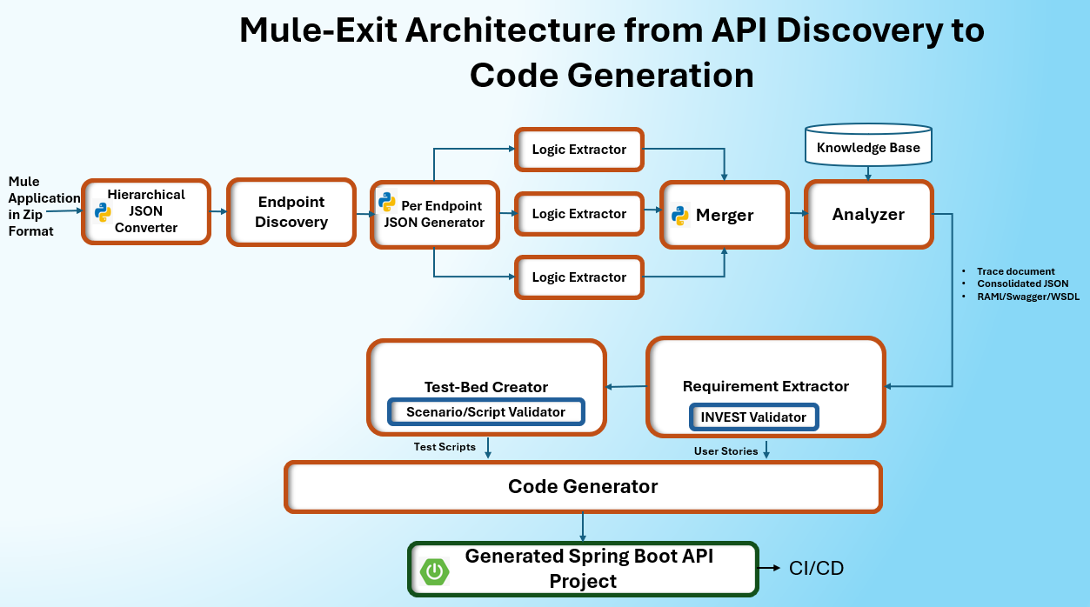

3.2 Revised Mule API to Spring Boot Workflow
3.2.1. Step 1: Preprocessing - API to Hierarchical JSON
Convert the entire Mule API (all XMLs, properties, etc.) into a single hierarchical JSON. This file will maintain parent-child relationships and use references for files like DWL and properties, rather than inlining them, to keep the initial object manageable.

3.2.2. Step 2: AI - Endpoint Discovery
- Input: The complete hierarchical JSON from Step 1.
- Action: Call LLM with a strict output schema.
- Output: A structured JSON that lists all entry points, such as REST/SOAP endpoints and scheduled jobs etc.
3.2.3. Step 3: Preprocessing : Create Per-Endpoint JSONs
- Iterate through each endpoint discovered in Step 2.
- For each endpoint, programmatically trace its dependencies through the hierarchical JSON and generate a new, smaller JSON object that only contains the flows and configurations relevant to that single endpoint.
- During this process, inline the content of any referenced DWL files or property values into the smaller JSON.
3.2.4. Step 4: AI - Per-Endpoint Analysis (Parallel execution)
- Input: The smaller, self-contained endpoint JSONs from Step 3.
- Action: In parallel, make an LLM call for each endpoint to extract its detailed logic. This is where inline DWL/any business logic is converted to natural language business logic descriptions.
- Output: A structured JSON for each endpoint containing its business logic descriptions, component details, error handling, etc.
3.2.5. Step 5: Preprocessing : Consolidate Results
- Merge all the individual endpoint analysis JSONs from Step 4 back into a single, consolidated structured JSON file, representing the entire API's logic

3.2.6. Step 6 : AI - Global Dependency Analysis
- Input: The consolidated logic JSON (from Step 5) and Knowledge Base (KB) of known connectors and components.
- Action: Call the LLM to cross-reference the components used in the API against the KB.
- Output: An "Analyzer" JSON that details all dependencies, such as database connections, internal/external APIs, and flags any unknown connectors.
3.2.7. Step 7 : AI - Generate User Stories
- Input: The detailed logic for each endpoint (from Step 5).
- Action: For each endpoint, call the LLM to generate a well-defined user story.
- Output: Generated user stories.
3.2.8. Step 8: AI - Check User Story Quality (INVEST)
- Input: The generated user stories from Step 7.
- Action: For each story, make a separate LLM call to score it against the INVEST framework.
- Output: A quality score. If the score is below a set threshold, loop back to Step 7 to regenerate the story with feedback.
3.2.9. Step 9: AI - Generate Test Scenarios
- Input: The quality-validated user stories.
- Action: For each user story, call the LLM to generate a list of test scenarios.
- Output: Generated test scenarios.
3.2.10. Step 10: AI - Check Test Scenario Quality
- Input: The user stories and their corresponding test scenarios.
- Action: Call LLM to evaluate the quality and completeness of the scenarios. If the quality is low, regenerate(Step 9).
3.2.11. Step 11: AI - Generate Test Scripts
- Input: The validated user stories and test scenarios.
- Action: Call the LLM to generate concrete test scripts (e.g., Postman collections, REST Assured code).
- Output: The test script files/code.
3.2.12: Step 12: AI - Check Test Script Quality
- Input: The user stories and the generated test scripts.
- Action: A final quality gate where the LLM validates the generated scripts. If needed, regenerate(Step 11).
3.2.13. Step 13: AI - Generate Spring Boot Code
- Input: The high-quality, validated user stories, analyzer output (for dependencies), and logic details (from Step 5).
- Action: Call LLM to generate the final Spring Boot application code based on all the structured information gathered.

5. Trace Document Format
Key Columns in the trace document can be:
Column | What it Contains | Examples
Execution Step ID | Sequential flow order (0, 1, 1.1, 1.2, etc.) | 0, 1, 1.1, 1.2, 5.3
Endpoint | API endpoint name | /getitems, /additem, /updateitem/{id}
HTTP Method | REST verb (GET, POST, PUT, DELETE) | GET, POST, PUT, DELETE, N/A
Mule API Path | Path Mule listens on | /api/getitems, /api/, /console/
Mule Listener Port | Port number | 8082
Mule Listener URL | Full Mule API URL | http://localhost:8082/api/getitems
Request Content-Type | Client request format | application/json, text/html, null
Response Content-Type | Response format | application/json, text/html
Backend Service Host | External service domain | api.restful-api.dev
Backend Endpoint Path | Backend resource path | /objects, /users, /items
Backend Full URL | Complete backend URL | https://api.restful-api.dev/objects
Component Type | Mule component class | HTTP Listener, Transformation, HTTP Request, APIKit Router
Component Name | Component instance name | ee:transform, itemtrack restapi service
Connector Name | Mule connector plugin | HTTP Connector, APIKit Module, Mule EE Core
Config Reference | Configuration object | itemtrack-restapi-sample-config
Input Parameters | Received data | path, method, queryParameters, id
Output Parameters | Produced data | id, name, data, datecreated
Status Code | HTTP response codes | 200, 500, 400, 404
Error Handling | Error handling strategy | APIKIT error handler, HTTP error handling
Action Required | Component action | Call Backend API, Create Input Variables
Dependency | Maven dependency | mule-http-connector:1.11.0
Remarks | Additional notes/issues | Known bugs, Configuration details

2.6 User Story Template for LLM Prompt
Generate Spring Boot code for the following user story:

User Story:
Title: {{USER_STORY_TITLE}}
Description: {{USER_STORY_DESCRIPTION}}

Requirements:
1. Create an endpoint: {{HTTP_METHOD}} {{ENDPOINT_PATH}} (e.g., POST /calculator/add).
2. Input: {{INPUT_FORMAT}} (JSON/XML) with fields: {{INPUT_FIELDS}}.
3. Output: {{OUTPUT_FORMAT}} (JSON/XML) with fields: {{OUTPUT_FIELDS}}.
4. Business Logic: {{BUSINESS_LOGIC_DESCRIPTION}}.
5. Persistence: Use {{DATABASE_TYPE}} (e.g., PostgreSQL) and persist data in table {{TABLE_NAME}} with columns: {{COLUMN_DETAILS}}.
6. Common Functions: {{COMMON_FUNCTIONS}} (e.g., sanitize input, error handling).
7. Validation & Error Handling: {{VALIDATION_RULES}}.
8. External Connectors: {{EXTERNAL_CONNECTORS}} (e.g., message queues, APIs, or third-party services).

Standards:
1. Follow Spring Boot best practices
2. Use Controller-Service-Repository pattern
3. Re-use code wherever possible
4. Include code comments
5. Implement Mockito based JUnit test cases
6. Run JUnit test cases
7. Make sure 100% code coverage is done

Expectations:
- Provide full Spring Boot structure (Controller, Service, Repository, Entity, DTO, Utility classes).
- Include request/response models.
- Add proper annotations (@RestController, @PostMapping, @Entity, etc.).
- Use Spring Data JPA for persistence.
- Implement exception handling and input validation.
- Add comments explaining each section.
- Ensure code is clean, modular, and maintainable.

Acceptance Criteria:
- API should accept {{INPUT_FORMAT}} and return {{OUTPUT_FORMAT}}.
- Validate all required fields; reject invalid or missing data.
- Persist data correctly in {{TABLE_NAME}} with timestamp.
- Return HTTP 201 on success and appropriate error codes on failure.
- Integration with {{EXTERNAL_CONNECTORS}} should be tested and functional.
- Code should follow clean architecture and include comments for clarity.

Technology Stack:
- Java Version: {{JAVA_VERSION}}
- Spring Boot: {{SPRING_BOOT_VERSION}}
- Build Tool: {{GRADLE_VERSION (DO NOT USE MAVEN)

Project Configuration:
Name: {{PROJECT_NAME}}
Package: {{PACKAGE_NAME}}
Version: {{PROJECT_VERSION}}
Description: {{PROJECT_DESCRIPTION}}
Output Path: {{OUTPUT_LOCATION}}

2.7 Naming Conventions
Artifact | Pattern | Example
Trace document | trace_{endpoint_name}.csv | trace_calculator-add.csv
User stories | {endpoint_name}_user_stories.md | calculator-add_user_stories.md
Postman collections | postman_{endpoint_name}.json | postman_calculator-add.json
Spring Boot projects | spring-boot-{endpoint_name}/ | spring-boot-calculator-add/

