DEVOPS

TASK-3

BALAJI B R-22ISR006

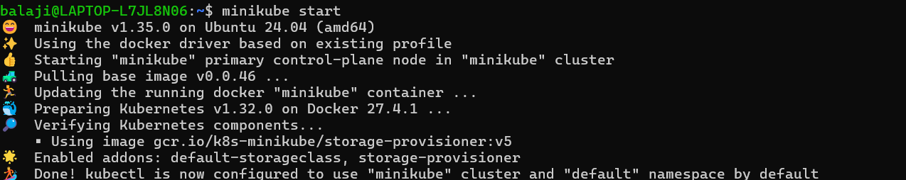

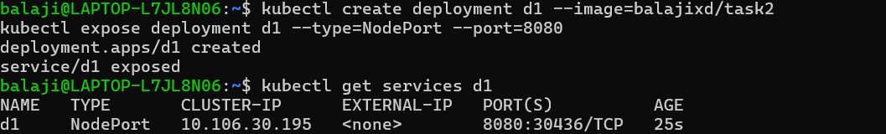

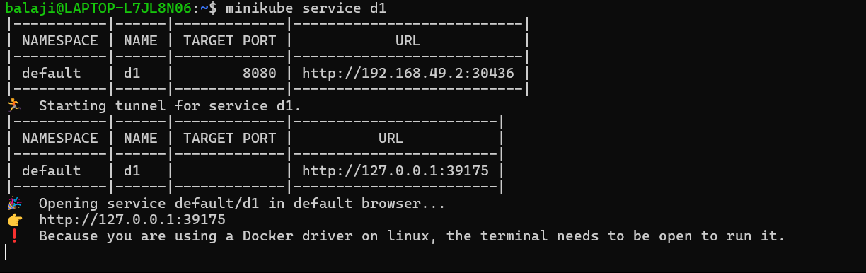

OUTPUT: