CREATE TABLE Empl (

empno INT PRIMARY KEY,

ename VARCHAR(50),

job VARCHAR(50),

mgr INT,

hiredate DATE,

sal DECIMAL(10, 2),

comm DECIMAL(10, 2),

deptno INT

);

INSERT INTO Empl (empno, ename, job, mgr, hiredate, sal, comm, deptno) VALUES

(8369, 'SMITH', 'CLERK', 8902, '1990-12-18', 800.00, NULL, 20),

(8499, 'ANYA', 'SALESMAN', 8698, '1991-02-20', 1600.00, 300.00, 30),

(8521, 'SETH', 'SALESMAN', 8698, '1991-02-22', 1250.00, 500.00, 30),

(8566, 'MAHADEVAN', 'MANAGER', 8839, '1991-04-02', 2985.00, NULL, 20),

(8654, 'MOMIN', 'SALESMAN', 8698, '1991-09-28', 1250.00, 1400.00, 30),

(8698, 'BINA', 'MANAGER', 8839, '1991-05-01', 2850.00, NULL, 30),

(8882, 'SHIVANSH', 'MANAGER', 8839, '1991-06-09', 2450.00, NULL, 20),

(8888, 'SCOTT', 'ANALYST', 8566, '1992-12-09', 3000.00, NULL, 20),

(8839, 'AMIR', 'PRESIDENT', NULL, '1991-11-18', 5000.00, NULL, 10),

(8844, 'KULDEEP', 'SALESMAN', 8698, '1991-09-08', 1500.00, 0.00, 30);

Queries

a)

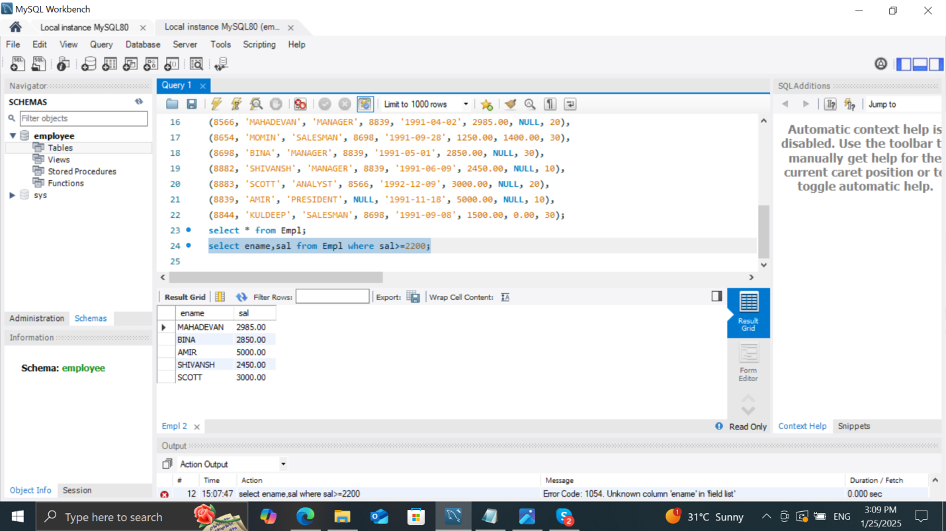

b)

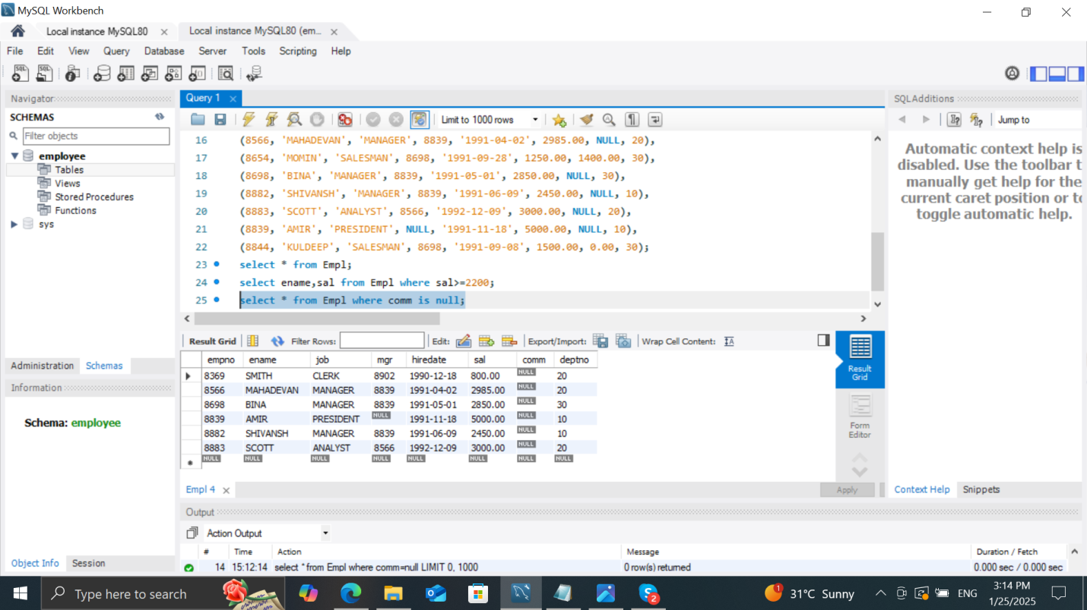

c)

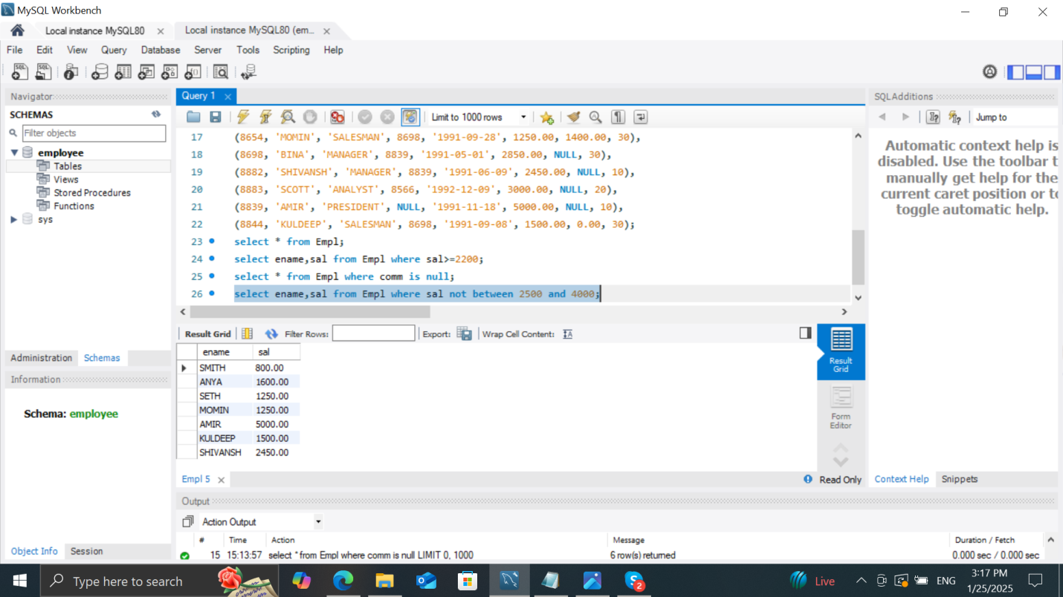

d)

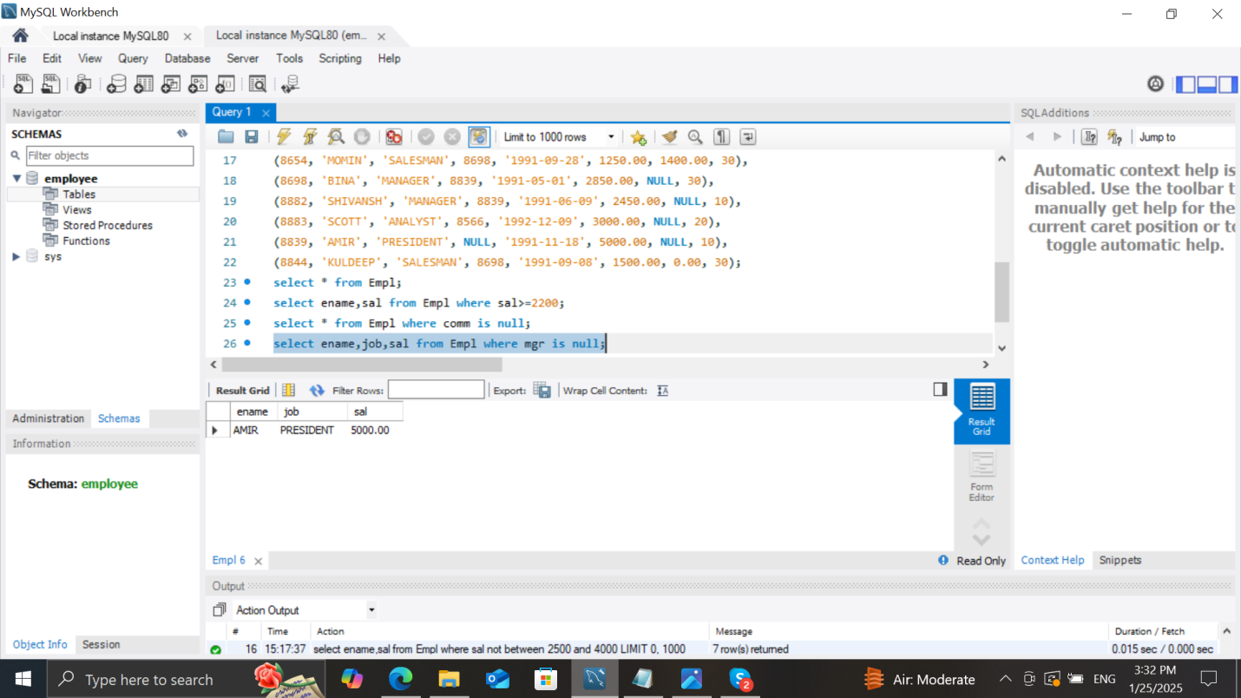

e)

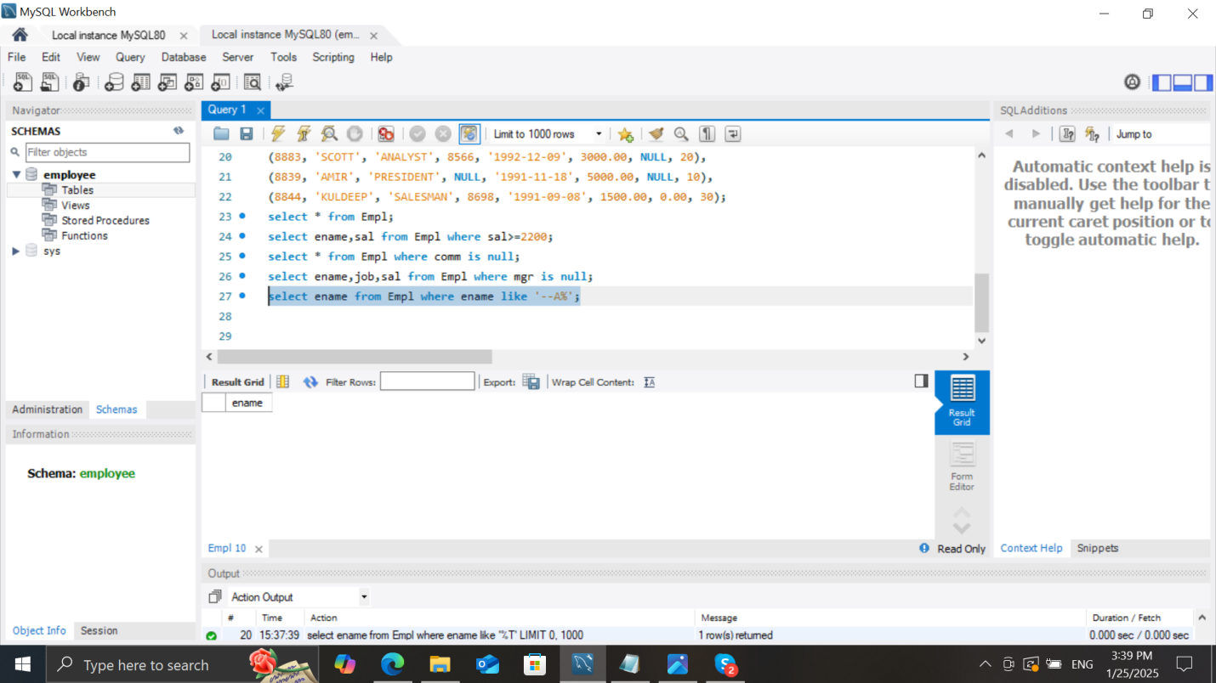

f)