**HANDSMEN THREADS**

**ELEVATING THE ART OF SOPHISTICATION IN MEN’S FASHION**

**ABSTRACT:**

This project presents the implementation of a customized Salesforce CRM solution for **HandsMen Threads**, a premium men's fashion and tailoring brand. The objective was to streamline business operations, enhance customer engagement, and maintain data integrity across departments.

The solution involves designing a robust data model featuring five key custom objects: Customer, Order, Product, Inventory, and Marketing Campaign. Business processes were automated using Record-Triggered Flows, Scheduled Flows, Email Alerts, and Apex to handle order confirmations, loyalty status updates, and proactive stock alerts.

To ensure clean and reliable data, validation rules were established, and a role-based security model was implemented for the Sales, Inventory, and Marketing teams. The solution also includes a scheduled batch job using Apex to update low stock quantities.

This end-to-end CRM implementation improves customer experience through personalized communication, ensures operational efficiency with automation, and lays a scalable foundation for future business growth using the Salesforce Platform.

**OBJECTIVES:**

The Salesforce project for HandsMen Threads is designed to transform the way the brand manages its operations, data, and customer interactions. By integrating automation, validation, and a strong data model, the system aims to streamline processes, improve efficiency, and deliver a superior customer experience. To achieve these outcomes, the project is guided by the following key objectives:

**1. Build a Centralized Data Model:**

Develop a robust structure to store and manage customer, order, product, inventory, and financial data in a single, unified system.

**2. Ensure Data Accuracy and Integrity:**

Implement validation rules and role-based access to maintain consistent, reliable, and secure information.

**3. Automate Key Business Processes:**

Streamline workflows such as order confirmations, loyalty program updates, stock alerts, and bulk order processing to reduce manual effort and improve efficiency.

**4. Enhance Customer Experience:**

Strengthen customer relationships through timely communication, personalized loyalty programs, and transparent order updates.

**5. Optimize Inventory Management:**

Prevent stockouts or overselling by setting up proactive alerts and automated updates to track and manage stock levels effectively.

**TECHNOLOGY DESCRIPTION:**

**Salesforce:**

Salesforce is a cloud-based customer relationship management (CRM) platform that helps businesses manage and improve their relationships with customers. It provides tools for sales, service, marketing, commerce, and IT teams to connect with customers, manage data, and streamline operations. Essentially, it helps businesses understand and engage with their customers more effectively.

**Custom Objects:**

In Salesforce, custom objects are user-defined database tables used to store information specific to your organization, going beyond the standard objects provided by Salesforce.

**Example:**

**1. Customer(**Customer__c) – Stores details like name, contact info, loyalty status, and purchase history.

**2.Order**(Order_c) – Tracks customer purchases, order status, payment, and delivery details.

**3.Product**(Product_c) – Holds product details such as style, size, color, price, and availability.

**4.Inventory** – Monitors stock levels, warehouse location, and restocking alerts.

**Tabs:**

Tabs are user interface elements that provide access to different objects, apps, and features within the platform. They act as shortcuts, allowing users to quickly navigate and interact with various parts of the system.

**Example:**

**Customers (**Customer__c )**–** To view and manage all customer records.

**Orders** (Orders_c)-To track and update customer purchases.

**Custom App:**

An App in Salesforce is a collection of tabs grouped together for a specific business purpose.

**App Manager:**

App Manager is a centralized tool for creating, managing, and customizing Salesforce apps, both for Lightning Experience and Classic.

**Profiles:**

Profile is a set of permissions that defines what a user can do in the system.

**Example:**

**System Administrator –** Full access to everything in Salesforce, including managing other users and customizing the system.

**Standard User –** Can create, read, edit, and delete records for most standard objects but cannot customize Salesforce.

**Read Only User –** Can only view records but cannot create or modify them.

**Roles:**

A Role in Salesforce defines a user’s position in the role hierarchy, which mainly controls record-level access (who can see whose data).

**Example:**

CEO, Sales Manager, Sales Representative, Inventory Manager, Marketing Manager.

**Permission sets:**

Permission Sets grant additional permissions to users without changing their profile.

**Validation Rules:**

A Validation Rule is a rule that ensures data entered into a record meets specific criteria before it can be saved. If the data doesn’t meet the condition, Salesforce shows an error message and prevents the record from being saved until the error is corrected.

**Example:**

**Phone Number Format** - Ensure that a customer’s phone number contains exactly 10 digits.

**Email Validation** - Require that the email field contains “@” and “.com”.

Example:

* Email must contain @gmail.com
* Stock cannot be negative

**Email Templates:**

Salesforce email templates allow users to standardize and streamline email communication by providing pre-formatted email layouts with customizable content.

Predefined formats for sending emails to customers or users. Example:

* "Order Confirmation" template

**Email Alerts:**

An email alert is an email generated by an automated process and sent to the designated recipients.

**Example:**

When a new order is created, an email is sent to the customer confirming their purchase.

**Flows:**

Salesforce Flows are a powerful automation tool within Salesforce that allows users to automate complex business processes without writing code, using a visual, point-and-click interface. They enable users to create automated workflows for various tasks, including data manipulation, guiding user interactions, and automating actions within Salesforce or external systems.

**Types of flows:**

**Record-Triggered Flow:** Runs automatically when a record is created, updated, or deleted.

**Scheduled-Triggered Flow:** Runs at a specified time and frequency (e.g., daily at midnight).

**Screen Flow:** Provides a user interface for guided data entry (like a step-by-step form or wizard).

**Autolaunched Flow:** Runs in the background without user interaction (often called from Apex, Processes, or other flows).

**Example:**

**Order Confirmation Flow (Record-Triggered):**

When a new order is created, send a confirmation email to the customer automatically.

**Apex:**

Apex is a proprietary, strongly-typed, object-oriented programming language used to build custom business logic and functionality.

**Example Triggers:**

* Update Total_Amount__c in orders
* Reduce inventory stock

**DETAILED EXECUTION OF PROJECT PHASES:**

**1. DEVELOPER ORG SETUP:**

Creating a developer org in salesforce.

* Go to <https://developer.salesforce.com/signup>
* Enter the details in the fields provided

1.First name & Last name

2.Email

3.Role: Developer

4.Company: College Name

5.County: India

6.Postal Code: pin code

7.Username: should be a combination of your name and company

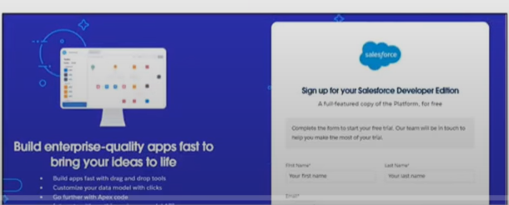

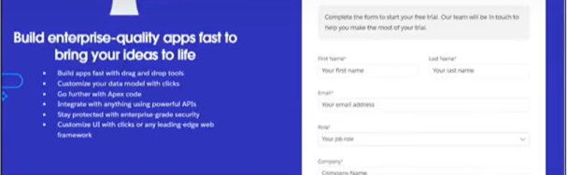

Click on sign me up after filling the details and create a password and gain access to the Salesforce set up page.

**2. CUSTOM OBJECT CREATION:**

Five custom objects were created to store business-critical data:

* **HandsMen Customer** – Stores customer info like email, phone, loyalty status.
* **HandsMen Product** – Stores product catalog details like SKU, price, and stock.
* **HandsMen Order** – Stores orders placed by customers, including quantity and status.
* **Inventory** – Tracks stock quantity and warehouse location.
* **Marketing Campaign** – Stores promotional campaigns and scheduling.

**Steps to create Custom Object:**

**To Navigate to Setup page:**

* Click on gear icon → click setup

**To create an object:**

* From the setup page → Click on Object Manager → Click on Create → Click on Custom Object.
* Enter the label name, Plural label name, Enter Record Name Label and Format, Record Name, Data Type.
* Click on Allow reports,
* Allow search → Save.

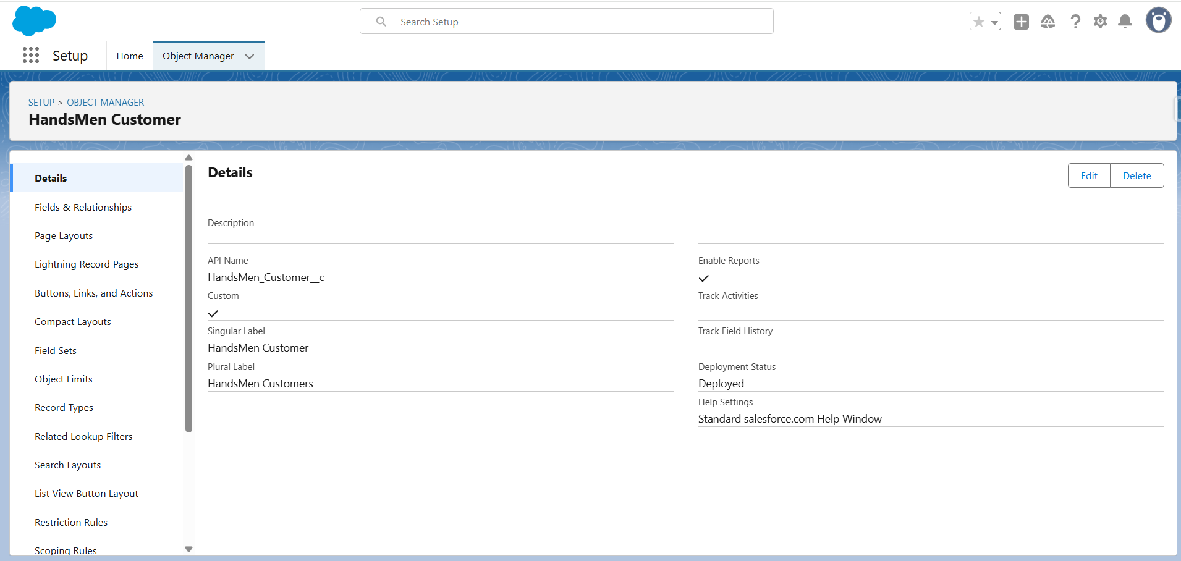

**3. CREATING TABS:**

1. Go to setup page → type Tabs in Quick Find bar → click on tabs → New

2. Select Object→ Select any tab style → Next (Add to profiles page) keep it as default → Next (Add to Custom App) keep it as default → Save.

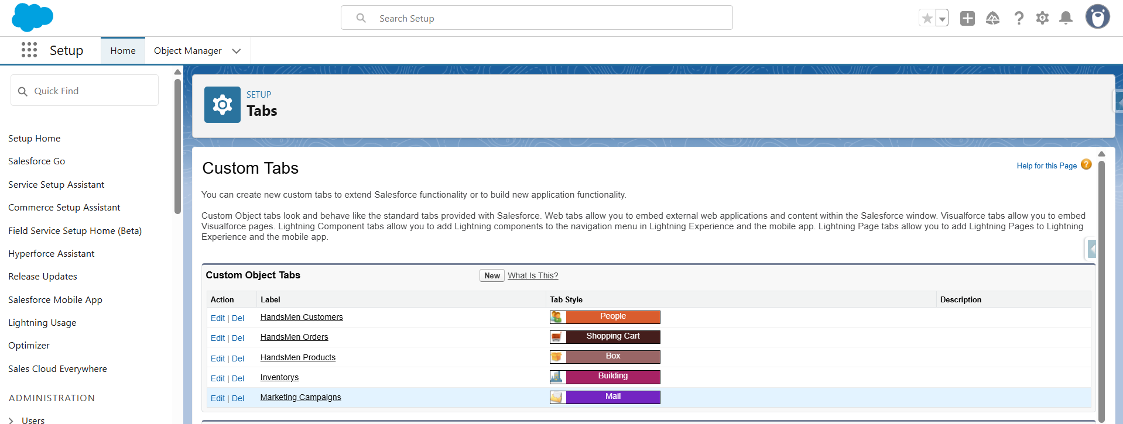

**4. CREATING LIGHTING APP:**

Go to setup page → search “app manager” in quick find → select “app manager” → click on New lightning App.

A new custom lighting app is created.

* **Added App Details**: Set HandsMen Threads as name, description added, defaults kept.
* **Navigation Items**: Added required items (Customer, Order, Inventory, Product, Reports, Dashboard, Account, Contact, Marketing Campaign).
* **User Profiles**: Added System Administrator and saved.

**5. CREATING VALIDATION RULES:**

1. Go to setup → click on Object Manager → type object name in quick find bar→ click on the object.

2. Click on the validation rule → click New.

**Validation rule for order object:**

Prevents saving if “Total_Amount__c <= 0”.

Error: Please Enter Correct Amount.

**Validation rule for Inventory object:**

Prints an error message if “Stock_Quantity__c < = 0”

Error: the inventory count is never less than zero.

**Validation rule for HandsMen Customer object:**

Validates if entered email contains “@gmail.com” or not.

Error: Please fill Correct Gmail.

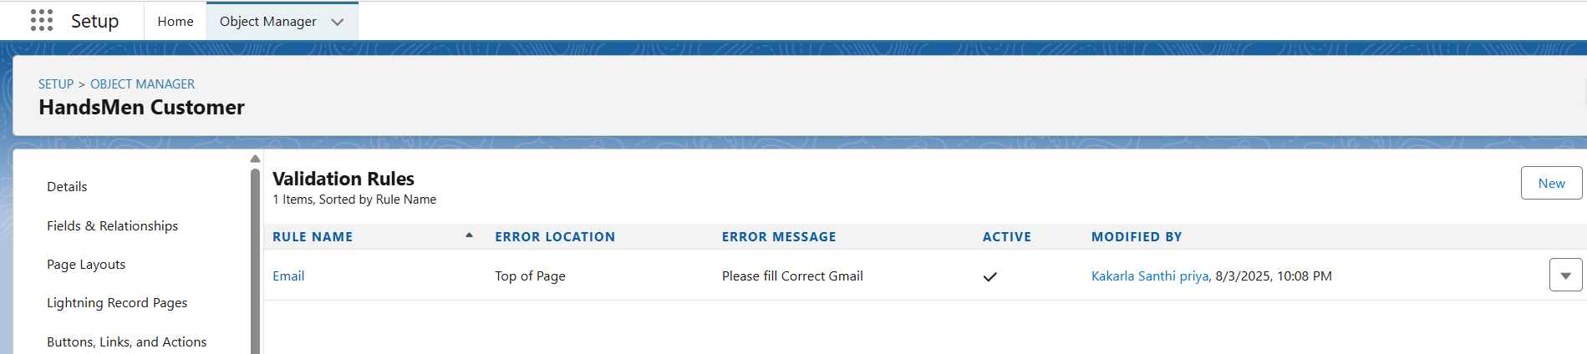

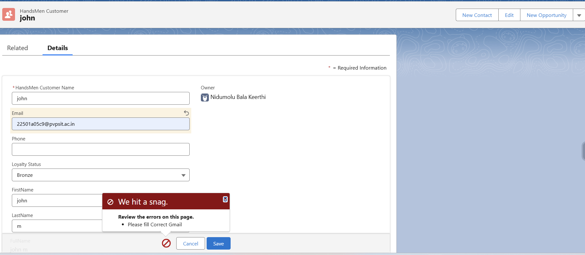

**6. USER PROFILES:**

Go to setup → type profiles in quick find box → click on profiles → clone the desired profile (Standard user) → enter profile name (Platform 1) → Save.

**7. USER ROLES:**

Go to quick find → Search for Roles → click on set up roles

Created roles for different Departments

* Sales manager
* Inventory manager
* Marketing Team

**8. USERS CREATION:**

1. Go to setup → type users in quick find box → select users → click New user

2. Fill the fields and click on save.

**Created users:**

Nicklause Mikaelson – Role assigned –> Sales

Kol Mikaelson – Role assigned -> Inventory

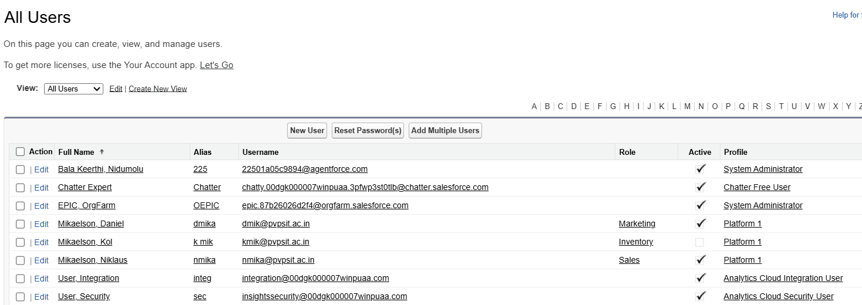

**9. EMAIL TEMPLATES AND ALERTS:**

Designed three email templates:

* **Order Confirmation** – Triggered when the order status was confirmed.
* **Low Stock Alert** – Triggered when inventory dropped below 5 units.
* **Loyalty Program Email** – Triggered when loyalty status changed.

Corresponding email alerts were configured using these templates and integrated into automation flows.

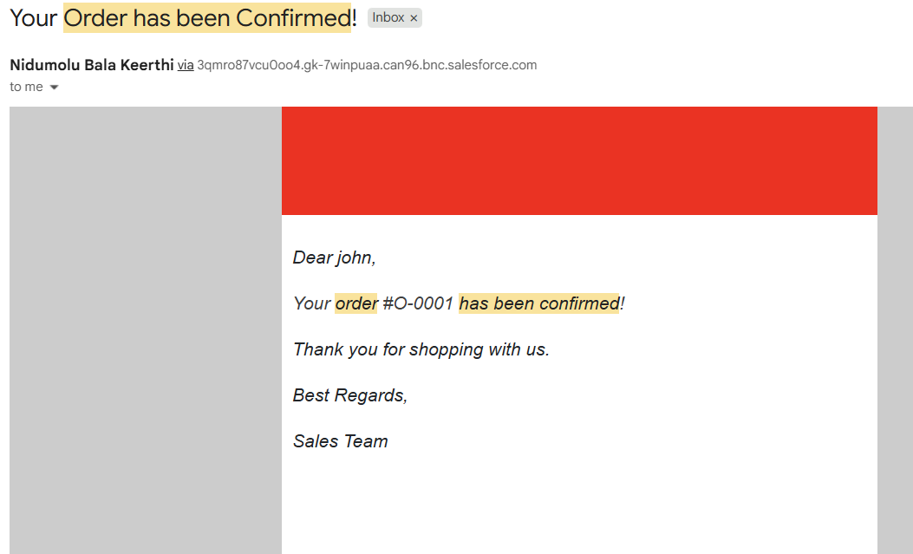

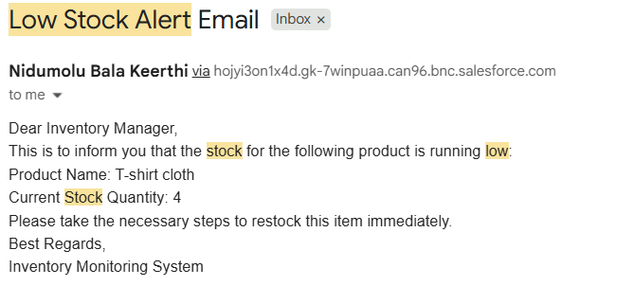

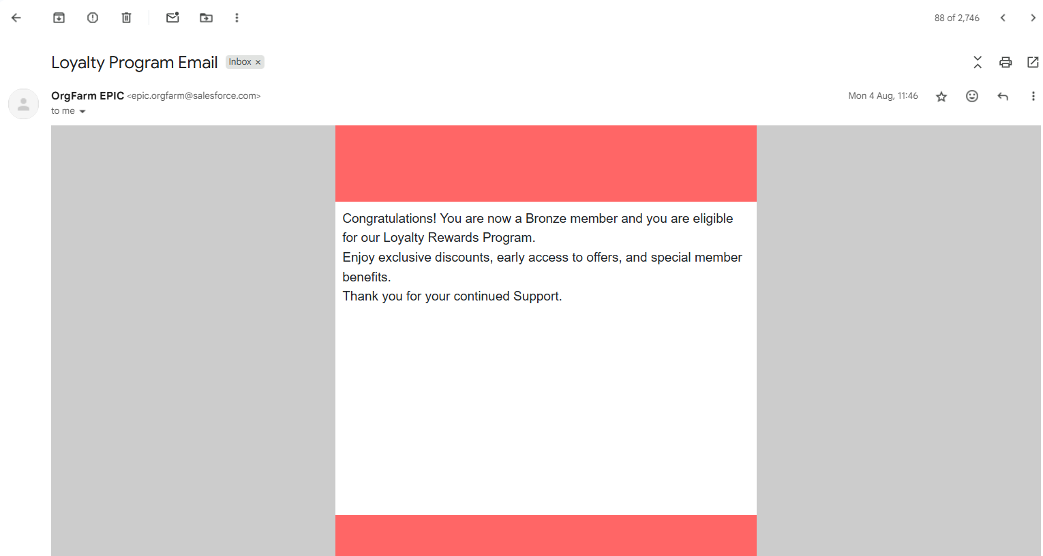

**10. CREATING FLOWS:**

Go to Setup → Flow.

**Order confirmation Email Flow:**

* The flow was triggered when an Order__c record was updated with Status__c = "Confirmed".
* It executed only when the record update met the specified condition (status changed to Confirmed).
* Sends an Order Confirmation Email to the user.

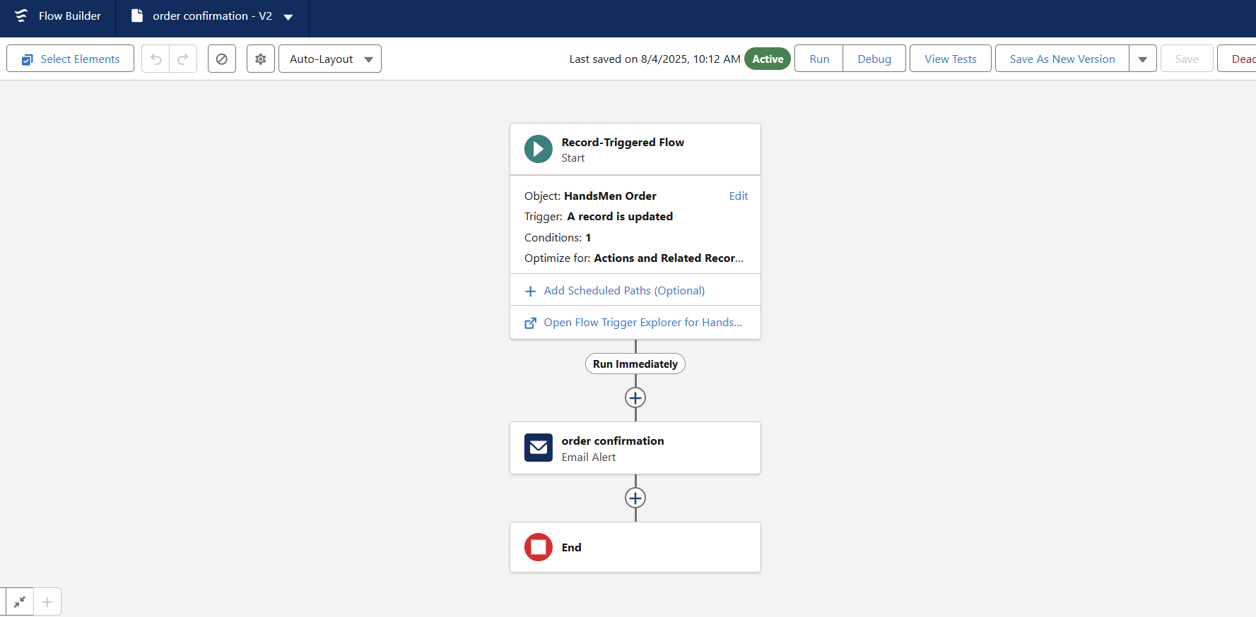

**Stock Alert Email Flow:**

* Whenever an Inventory__c record is created or updated, the flow checks if Stock_Quantity__c is less than 5.
* If the condition is true, the flow executes the configured action, which in this case is sending an Email Alert.

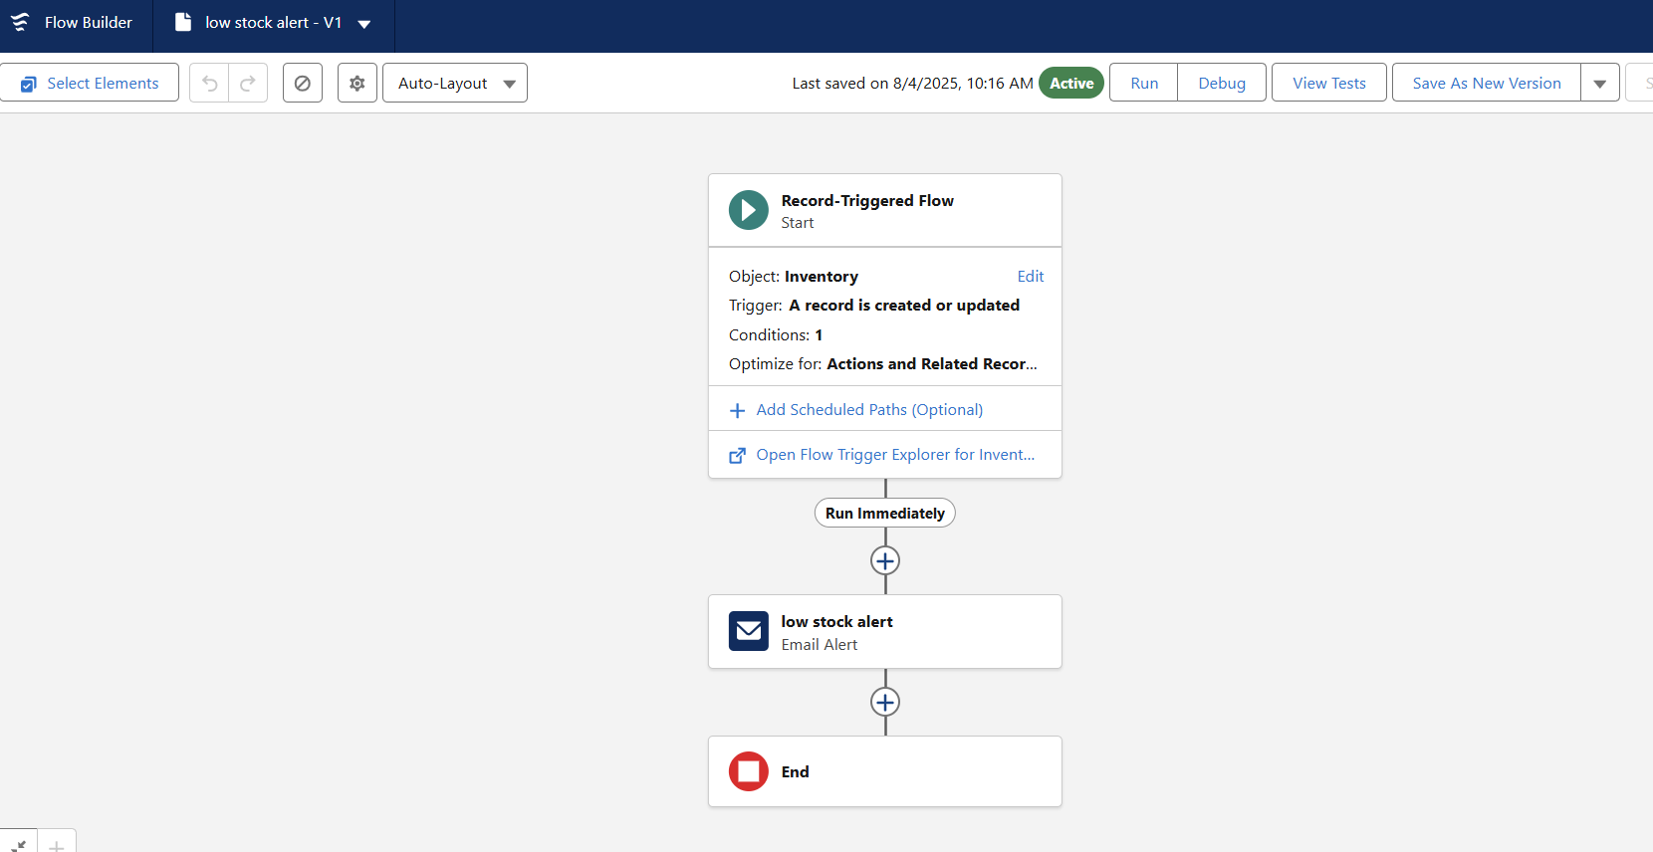

**Loyality Status Update:**

* At the scheduled time every day, the flow retrieves all records from the HandsMen_Customer__c object using the Get Records element.
* The flow loops through each customer and checks their Total_Purchases__c value to determine the appropriate loyalty status:

**Gold** if purchases > 1000

**Silver** if purchases between 500 and 1000

**Bronze** if purchases < 500

* The flow updates the Loyalty_Status__c field for each customer based on the decision outcome, ensuring loyalty tiers are always up to date automatically.

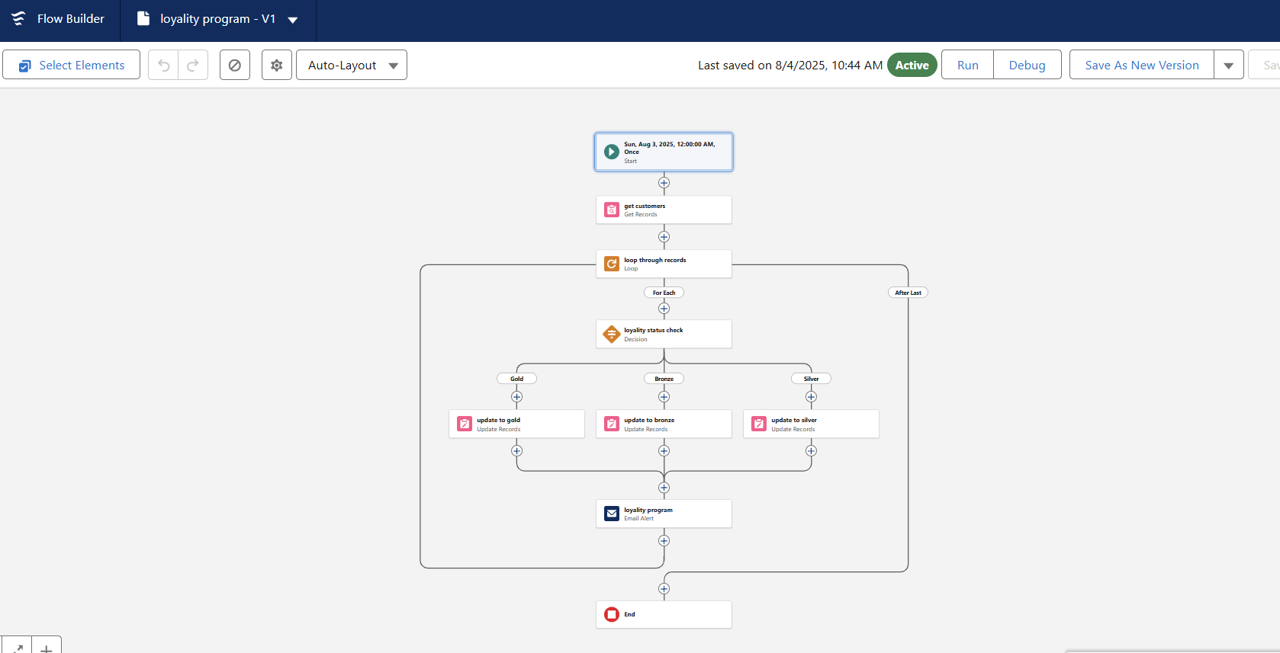

**11. APEX TRIGGERS:**

* **Update Order Total -** Automatically calculate and update Total_Amount__c whenever an order is created or updated.
* **Stock Deduction -** Reduce inventory stock when an order is confirmed.
* **Loyalty Status Update -** Upgrade loyalty status based on total purchases.

**REAL WORLD EXAMPLES:**

**1. Centralized Data Model**

* **Purpose:**Stores all business data like customers, orders, products, inventory in a single Salesforce system.
* **Real-World Example:**When a customer named John Smith places an order for a T-shirt, his information (contact, loyalty status), order details (product, quantity, price), and inventory (stock update) are all stored and updated in one place, ensuring no discrepancies between teams.

**2. Data Accuracy and Validation**

* **Purpose:**Validation rules prevent wrong data from being saved.
* **Real-World Example:**If a customer enters an wrong email then an error message will be shown

**“**Require that the email field contains “@” and “.com”.

**3. Automated Order Confirmation**

* **Purpose:**When an order is confirmed, the system sends an Order Confirmation Email automatically.
* **Real-World Example:**After John Smith T-shirt order is confirmed, he instantly receives an email.

**4. Inventory Stock Alerts**

* **Purpose:**Sends an email to the Inventory Manager when stock is below 5 units.
* **Real-World Example:**The stock for the T-shirt drops to 3 units. Salesforce sends an alert:  
  *“*Stock Alert: Only 4 units left for T-shirt. Please take the necessary steps to restock items.”

**5. Loyalty Status Update:**

* **Purpose:**Automatically upgrades customers based on purchase history using a scheduled flow.
* **Real-World Example:**John Smith total purchases reach ₹1,200. At midnight, the scheduled flow updates his Loyalty_Status__c to Gold, triggering a loyalty email.

**6. Order Total Calculation (Trigger)**

* **Purpose:**Automatically calculates the Total_Amount__c as Quantity * Unit Price.
* **Real-World Example:**John Smith orders 2 T-shirts at ₹3,000 each. When the order is saved, the system calculates:  
  Total_Amount__c = ₹6,000  
  No manual calculation needed, reducing human errors.

**7. Stock Deduction After Order**

* **Purpose:**Deducts stock quantity after an order is confirmed.
* **Real-World Example:**John Smith’s order of 2 T-shirts reduces the inventory count from 10 units to 8 units automatically, ensuring accurate stock levels for the next order.

**8. Scheduled Bulk Updates**

* **Purpose:**Every midnight, the system runs a batch process to update financial records and inventory data.
* **Real-World Example:**At 12:00 AM, Salesforce processes all orders placed during the day, updates customer loyalty points, adjusts stock, and prepares accurate reports for the next day’s business.

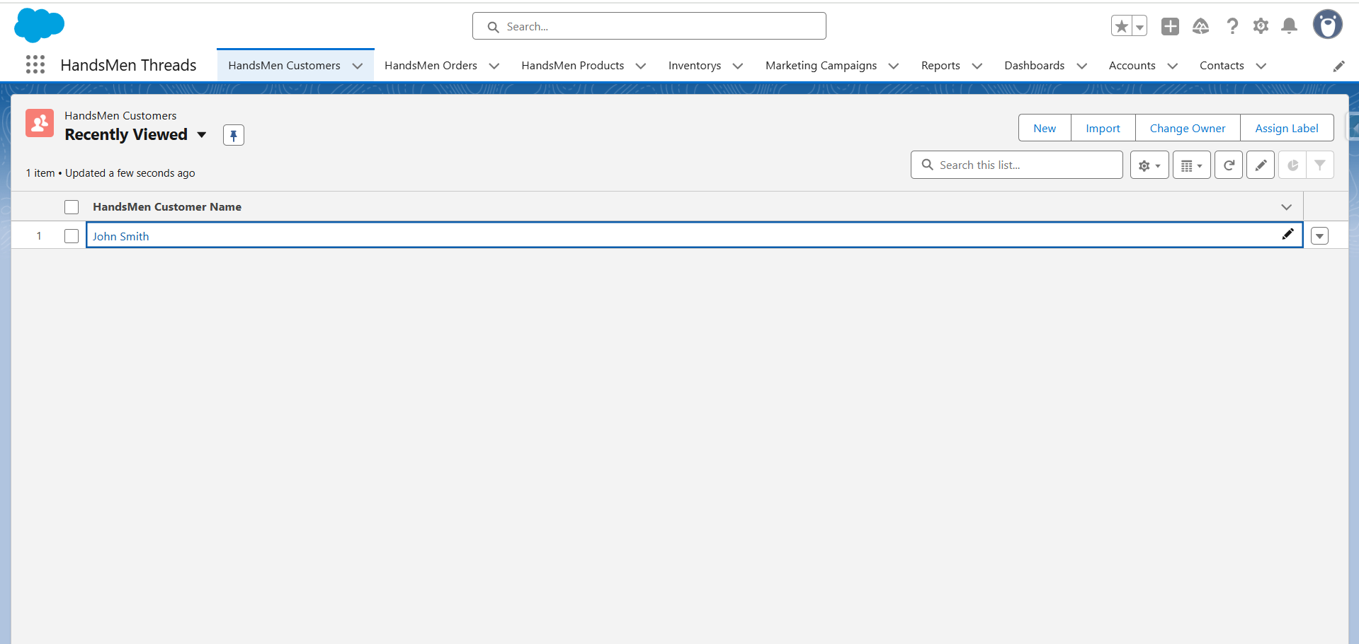

**Custom App – HandsMen Threads**

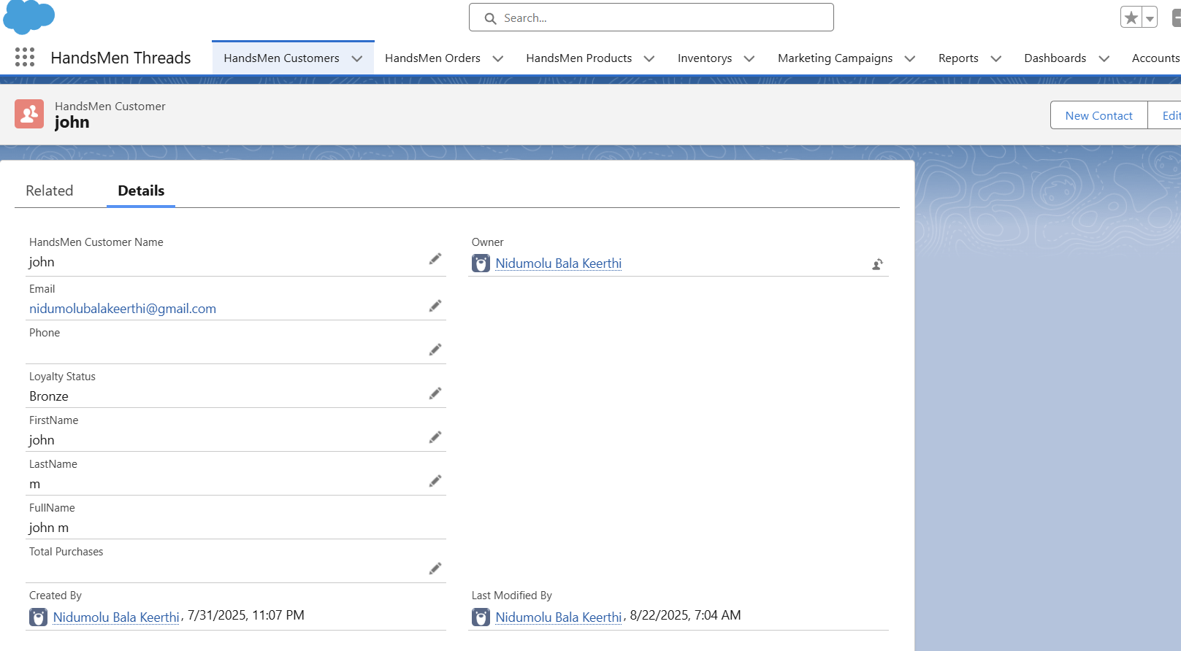

**Created Customer in HandsMen Customers**

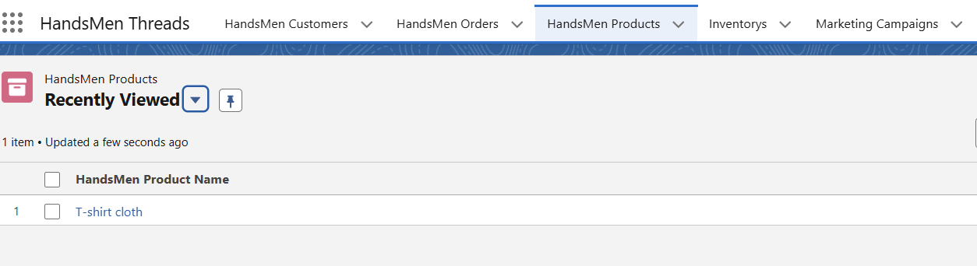

**Products in HandsMen Products**

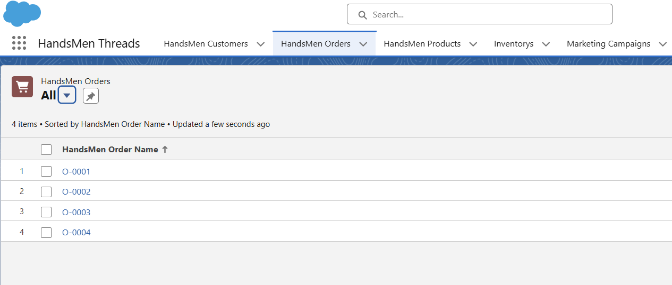

**Orders made by Customers**

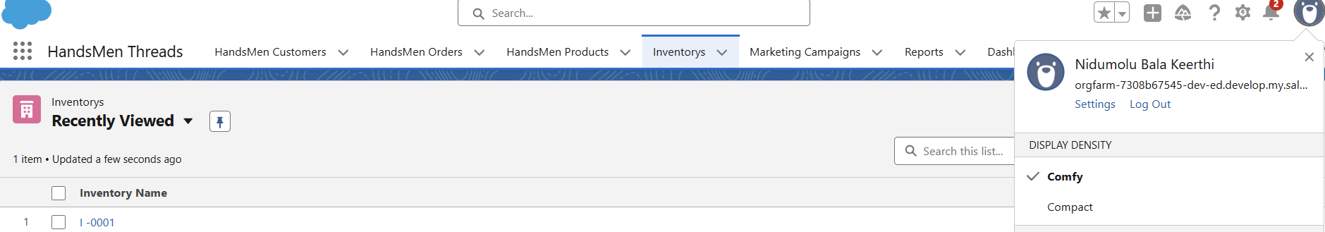

**Inventory’s to track stock quantity**

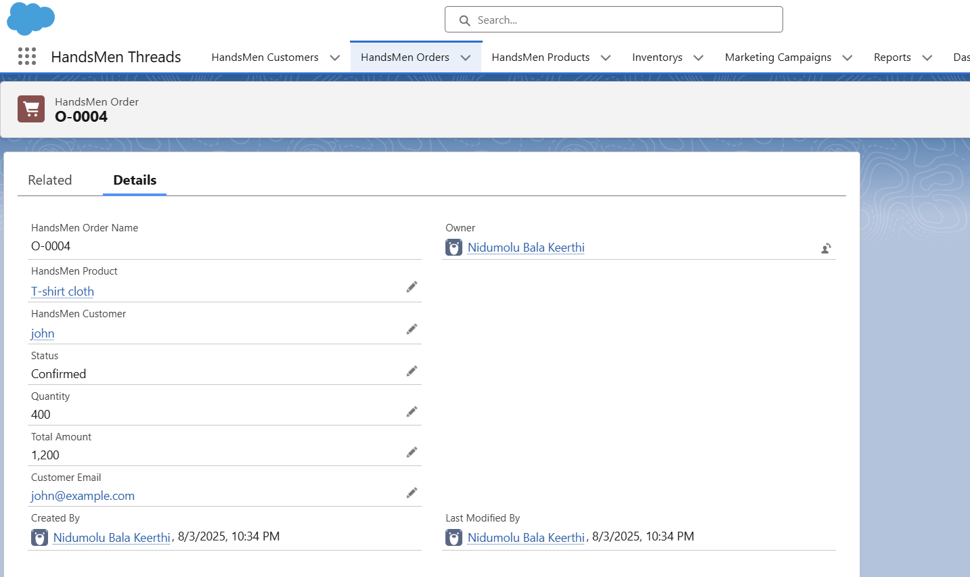

**Order Confirmation**



**Order Confirmation Email**

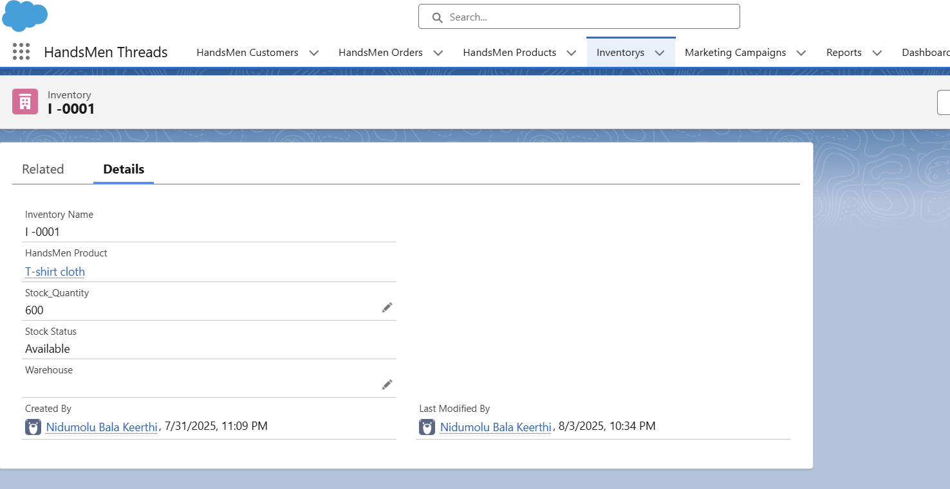

**Low stock for T-shirts**



**Low stock email Alert**



**Loyalty program email to the customer**

**CONCLUSION:**

The Salesforce solution for HandsMen Threads successfully centralizes business data, enforces accuracy through validations, and automates key operations such as order confirmations, stock alerts, and loyalty updates. By reducing manual effort and improving real-time communication, the system enhances customer satisfaction, streamlines internal processes, and ensures scalability for future growth in the competitive fashion industry.