SRI CHANDRASEKHARENDRA SARASWATHI VISWA MAHAVIDYALAYA

(UNIVERSITY ESTABLISHED under section 3 of UGC Act 1956)

ENATHUR, KANCHIPURAM – 631 561



OPERATING SYSTEM LAB

LABORATORY RECORD

Name : Balakrishna R

Reg. No : 112514025

Class : II Year B.Sc. (Computer Science with Cyber Security)

Subject : BSCY233P60

SRI CHANDRASEKHARENDRA SARASWATHI

VISWA MAHAVIDYALAYA

(University Established under section 3 of UGC Act 1956)



BONAFIDE CERTIFICATE

This is to certify that this is the bonafide record of work done by Mr./Ms. Balakrishna R, with Reg.No 112514025 of II Year B.Sc. (CS with Cy) in the Opearting System Lab during the year 2026.

Staff-in-charge Head of the Department

Submitted for the Practical Examination held on ________________________

Internal Examiner External Examiner

INDEX

S No. | Date | Title | Page | Sign
1 | 02Jul2026 | Basic Linux Commands | 4
2 | 09Jul2026 | Shell Scripting and Command-Line Arguments | 7
3 | 23Jul2026 | Linux File and Directory Operations Using C System Calls | 10
4 | 30Jul2026 | Process Creation and Management Using Linux System Calls | 16
5 | 13Aug2026 | Signal Handling in Linux | 22
6 |  | Inter-Process Communication Using Pipes and FIFO | 25
7 |  | Inter-Process Communication Using Shared Memory | 29
8 |  | CPU Scheduling Algorithms | 34
9 |  | Memory Management – Page Replacement Algorithms | 39
10 |  | Linux File Permissions and File Information | 45

1 | Basic Linux Commands | 02Jul2026
AIM :
To familiarize students with basic Linux commands for file, directory, and system management, compare them with equivalent DOS commands, and execute them in a Linux environment.

CONTEXT:
This C program demonstrates how to execute Linux shell commands within a C program using the system() function (provided by <stdlib.h> library).

SOME OF THE LINUX COMMANDS:
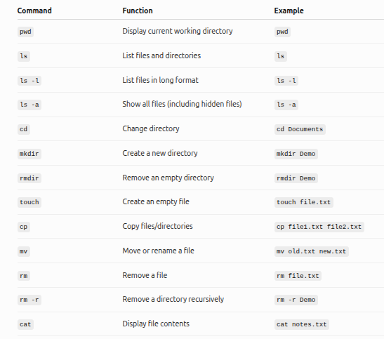

SOURCE CODE:
#include <stdio.h>
#include <stdlib.h>

int main()
{
printf("Current Directory\n");
system("pwd");

printf("\nFiles\n");
system("ls -l");

printf("\nCreating Directory\n");
system("mkdir Demo");

printf("\nListing Files Again\n");
system("ls");

printf("\nRemoving Directory\n");
system("rmdir Demo");

return 0;
}

HOW TO EXECUTE:
Compile (in Terminal): gcc exp1.c -o exp1
Run: ./exp1

OUTPUT :

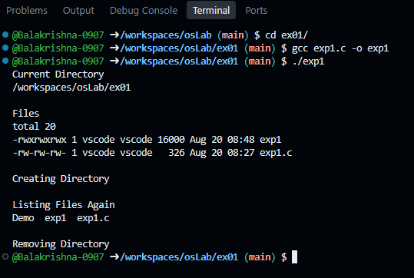

RESULT :
Thus the program is compiled and executed successfully with verified output.
2 | Shell Scripting and Command-Line Arguments | 09Jul2026

AIM :
To develop shell scripts for performing basic arithmetic, file handling, decision making, loops, and command-line argument processing using the Bash shell.

CONTEXT:
Shell scripting in Linux is the practice of writing a sequence of commands into a plain text file (extn:sh) to automate repetitive system tasks, configure environments, and manage software deployments. The file is interpreted line by line by a command-line interpreter known as a shell, with the GNU Bourne-Again Shell (Bash) being the most common default version across major Linux distributions.

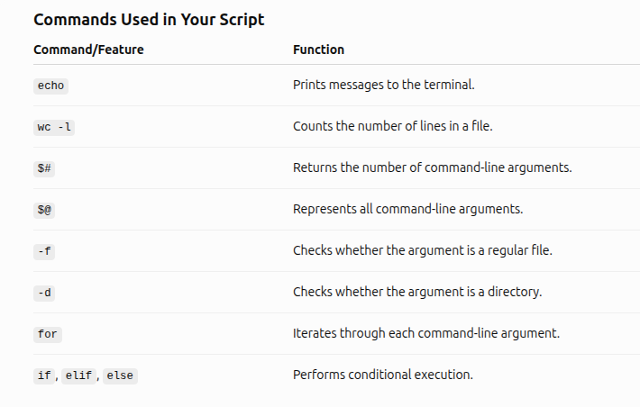

SOURCE CODE :
#!/bin/bash

echo "Number of arguments supplied: $#"

for item in "$@"
do
if [ -f "$item" ]
then
echo "$item is a file"
lines=$(wc -l < "$item")
echo "Number of lines: $lines"
elif [ -d "$item" ]
then
echo "$item is a directory"
else
echo "$item does not exist"
fi
done

HOW TO EXECUTE:
Steps to create:
1. nano checkfile.sh
2. Paste the code given above
3. To save: ctrl+o and press enter
4. To exit: ctrl+x

Execute:
Step 1: chmod u+x checkfile.sh
Step 2: ./checkfile.sh file1.txt testdir sample.txt
OUTPUT :

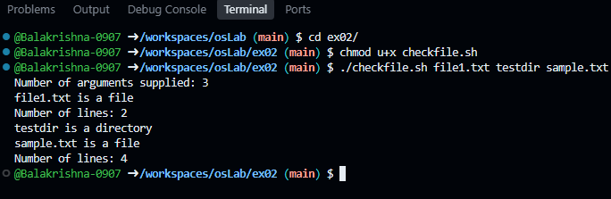

RESULT :
Thus the program is compiled and executed successfully with verified output.
3 | Linux File and Directory Operations Using C System Calls | 23Jul2026

AIM :
To implement basic file and directory operations using Linux system calls such as open(), read(), write(), close(), stat(), mkdir(), opendir(), and readdir().

CONTEXT:
This C program demonstrates the use of Linux system calls for performing file and directory operations.

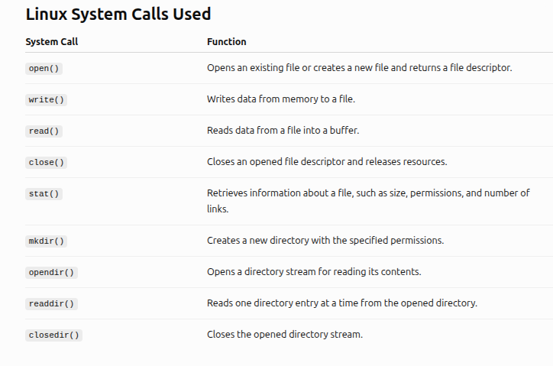

SOURCE CODE :
#include <stdio.h>
#include <fcntl.h> // open()
#include <unistd.h> // read(), write(), close()
#include <sys/stat.h> // stat(), mkdir()
#include <dirent.h> // opendir(), readdir()
#include <string.h>

int main()
{
int fd;
char buffer[100];
struct stat fileInfo;
DIR *dir;
struct dirent *entry;

// PART 1: Create and write data into a file using open() and write()

printf("\n--- Creating and Writing File ---\n");

fd = open("student.txt", O_CREAT | O_WRONLY, 0644);

if (fd < 0)
{
printf("File creation failed\n");
return 1;
}

char data[] = "Linux System Calls Experiment\n"
"B.Sc Cyber Security Laboratory";
write(fd, data, strlen(data));
close(fd);

printf("Data written successfully\n");

// PART 2: Read file contents using open() and read()

printf("\n--- Reading File Content ---\n");

fd = open("student.txt", O_RDONLY);

if (fd < 0)
{
printf("File opening failed\n");
return 1;
}

int bytes = read(fd, buffer, sizeof(buffer) - 1);
buffer[bytes] = '\0';

printf("%s\n", buffer);
close(fd);

//PART 3: Display file information using stat()

printf("\n--- File Information ---\n");

if (stat("student.txt", &fileInfo) == 0)
{
printf("File Size : %ld bytes\n", fileInfo.st_size);

printf("Number of Links: %ld\n", fileInfo.st_nlink);

printf("Permissions : %o\n", fileInfo.st_mode & 0777);
}
else
{
printf("Unable to get file information\n");
}

//PART 4: Create directory using mkdir()

printf("\n--- Creating Directory ---\n");

if (mkdir("TestDirectory", 0755) == 0)
{
printf("Directory created successfully\n");
}
else
{
printf("Directory may already exist\n");
}

// PART 5: Display directory contents using opendir() and readdir()

printf("\n--- Directory Contents ---\n");

dir = opendir(".");

if (dir == NULL)
{
printf("Cannot open directory\n");
return 1;
}
while ((entry = readdir(dir)) != NULL)
{
printf("%s\n", entry->d_name);
}
closedir(dir);

printf("\nProgram completed successfully\n");

return 0;
}

HOW TO EXECUTE:
Compile (in Terminal): gcc file_operation.c -o file_operation
Run: ./file_operation

OUTPUT :

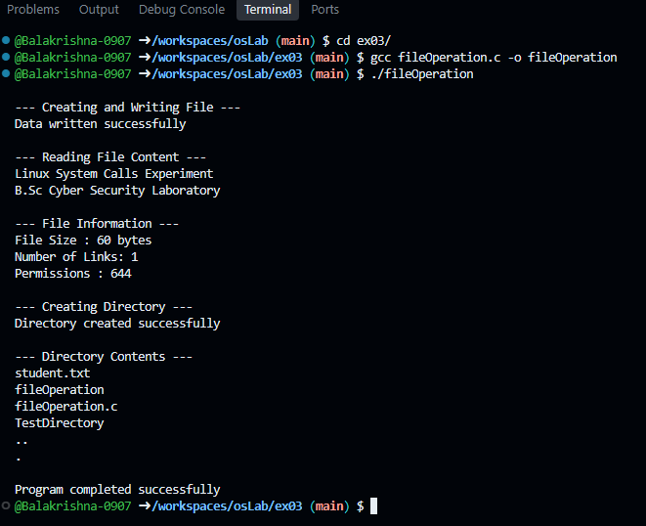

RESULT :
Thus the program is compiled and executed successfully with verified output.
4 | Process Creation and Management Using Linux System Calls | 30Jul2026

AIM :
To study process creation, execution, and synchronization using Linux process system calls:
• fork()
• exec()
• wait()
• getpid()
• getppid()
and to understand parent-child process relationships.

CONTEXT:
A process is a program that is currently being executed. Linux allows a process to create another process (called a child process) and manage its execution.

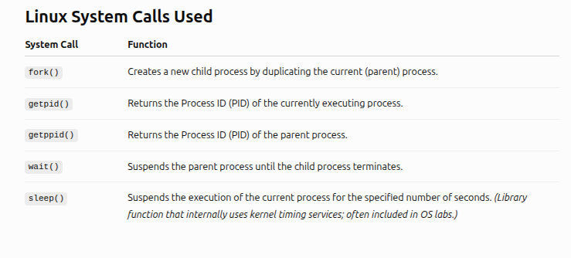

SOURCE CODE :
- forkDemo.c
#include <stdio.h>
#include <unistd.h> // fork(), getpid(), getppid()
#include <fcntl.h>

int main()
{
pid_t pid; // Variable to store process ID returned by fork()

printf("Program execution started\n");

pid = fork(); // Create a child process

if (pid < 0) // Check whether process creation failed
{
printf("Unable to create child process\n");
return 1;
}

//Child process block, pid value will be 0 inside child process.

else if (pid == 0)
{
printf("\n--- Child Process ---\n");

// Display child's own process ID
printf("Child Process ID : %d\n", getpid());

// Display parent's process ID
printf("Parent Process ID : %d\n", getppid());
}

//Parent process block, pid contains the child process ID.

else
{
printf("\n--- Parent Process ---\n");

// Display parent's own process ID
printf("Parent Process ID : %d\n", getpid());

// Display child process ID
printf("Child Process ID : %d\n", pid);
}
printf("\nProcess execution completed\n");
return 0;
}

HOW TO EXECUTE:
Compile (in Terminal): gcc fork_demo.c -o fork_demo
Run: ./fork_demo

2. waitDemo.c
#include <stdio.h>
#include <unistd.h> // fork(), getpid(), sleep()
#include <sys/wait.h> // wait()

int main()
{
pid_t pid;
pid = fork(); // Create a child process
if (pid < 0) // Check process creation failure
{
printf("Process creation failed\n");
return 1;
}

else if (pid == 0) //Child Process, pid == 0 indicates child execution.
{
printf("\n--- Child Process Started ---\n");
printf("Child Process ID : %d\n", getpid());

sleep(3); // Simulate some processing time
printf("Child Process Completed\n");
}
else
{
//Parent waits for child completion.
printf("\n--- Parent Process Started ---\n");
printf("Parent is waiting for child process...\n");

// wait() suspends parent execution until child process terminates.
wait(NULL);
printf("Child process completed\n");
printf("Parent Process ID : %d\n", getpid());
printf("Parent Process Resumed");
}
return 0;
}

HOW TO EXECUTE:
Compile (in Terminal): gcc wait_demo.c -o wait_demo
Run: ./wait_demo

OUTPUT :

forkDemo.c
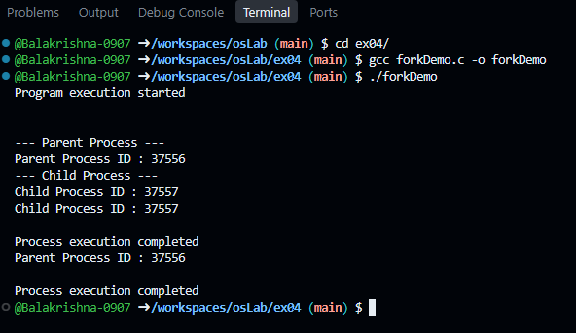

waitDemo.c
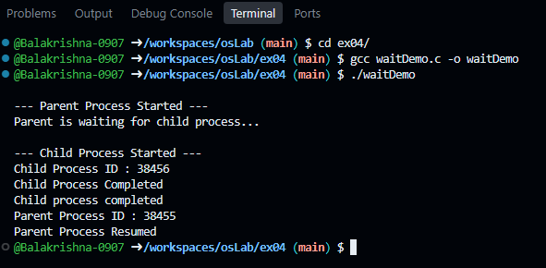

RESULT :
Thus the program is compiled and executed successfully with verified output.
5 | Signal Handling in Linux | 13Aug2026

AIM :
To demonstrate inter-process communication using Linux signals and study signal generation, handling, and process synchronization using:
• signal()
• kill()
• raise()
• alarm()
• pause()

CONTEXT:
Inter-Process Communication (IPC) is the set of mechanisms that allow processes to communicate (using Shared memory, Pipes, Sockets, Signals) and synchronize with each other while running.
We explore, Signal: It is a software interrupt used by the Linux operating system to notify a process that a specific event has occurred. Signals can be generated by the operating system, the user, or another process.

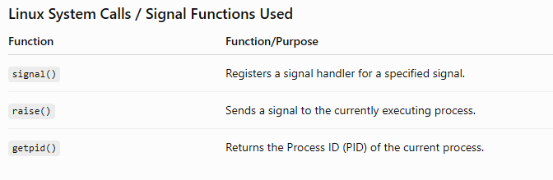
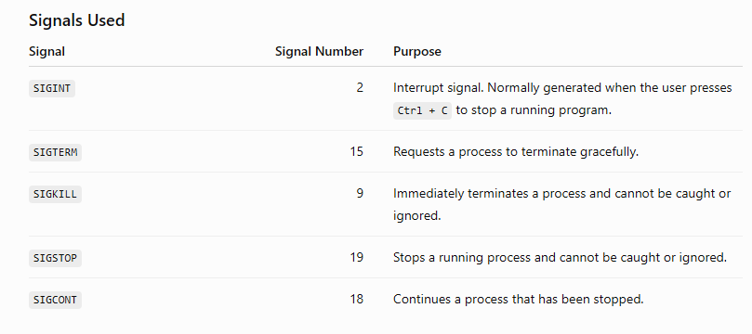

SOURCE CODE :
#include <stdio.h>
#include <signal.h>
#include <unistd.h>

// Signal handler function, executes whenever the registered signal occurs.
void handler(int signal_number)
{
printf("\nSignal received successfully\n");
printf("Signal Number : %d\n", signal_number);
}

int main()
{
//Register SIGINT handler.

signal(SIGINT, handler);

printf("Current Process ID: %d\n", getpid());
printf("Generating SIGINT using raise()\n");

//raise() sends SIGINT signal to the same process.

raise(SIGINT);

printf("\nProgram execution completed\n");

return 0;
}

HOW TO EXECUTE:
Compile (in Terminal): gcc signal_raise.c -o signal_raise
Run: ./signal_raise

OUTPUT :

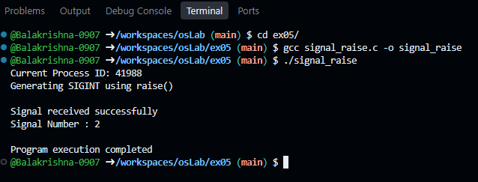

RESULT :
Thus the program is compiled and executed successfully with verified output
6 | Inter-Process Communication Using Pipes and FIFO

AIM :
To implement inter-process communication between processes using:
1.​ Unnamed pipes (pipe())
2.​ Named pipes / FIFO (mkfifo())
and exchange data between related and unrelated processes.

CONTEXT:
This program demonstrates Inter-Process Communication (IPC) using an unnamed pipe in the Linux operating system.
We explore, Pipe: It is a communication mechanism that allows two related processes (a parent and its child) to exchange data.

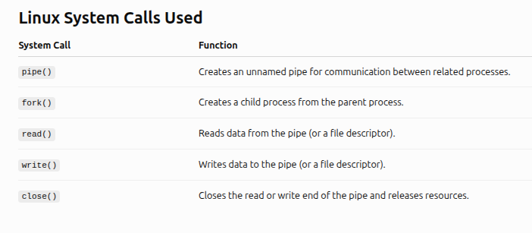

SOURCE CODE :
#include <stdio.h>
#include <unistd.h> //
#include <string.h> //
#include <fcntl.h> // ??

int main()
{
int fd[2];
pid_t pid;
char message[] = "Hello from Parent Process";
char buffer[100];

// Create pipe, fd[0] -> Reading end, fd[1] -> Writing end

if (pipe(fd) == -1)
{
printf("Pipe creation failed\n");
return 1;
}

pid = fork(); // Create child process

if (pid < 0)
{
printf("Process creation failed\n");
return 1;
}

// Child Process: Reads data from pipe
else if (pid == 0)
{
close(fd[1]); // Child does not write
read(fd[0], buffer, sizeof(buffer));

printf("\nChild received message:\n");
printf("%s\n", buffer);

close(fd[0]);
}
// Parent Process: Writes data into pipe

else
{
close(fd[0]); // Parent does not read
write(fd[1], message, strlen(message) + 1);

printf("Parent sent message\n");

close(fd[1]);
}
return 0;
}

HOW TO EXECUTE:
Compile (in Terminal): gcc exp6.c -o exp6
Run: ./exp6

OUTPUT :

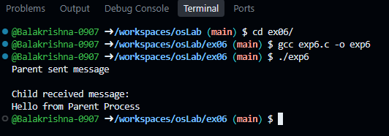

RESULT :
Thus the program is compiled and executed successfully with verified output.
7 | Inter-Process Communication Using Shared Memory

AIM :
To demonstrate inter-process communication between processes using shared memory segments and implement operations to create, access, modify, and release shared memory resources.

CONTEXT:
Inter-Process Communication (IPC) is the set of mechanisms that allow processes to communicate (using Shared memory, Pipes, Sockets, Signals) and synchronize with each other while running.
We explore, Shared memory: It is one of the fastest IPC mechanisms because multiple processes can directly access the same region of memory without repeatedly transferring data between them.

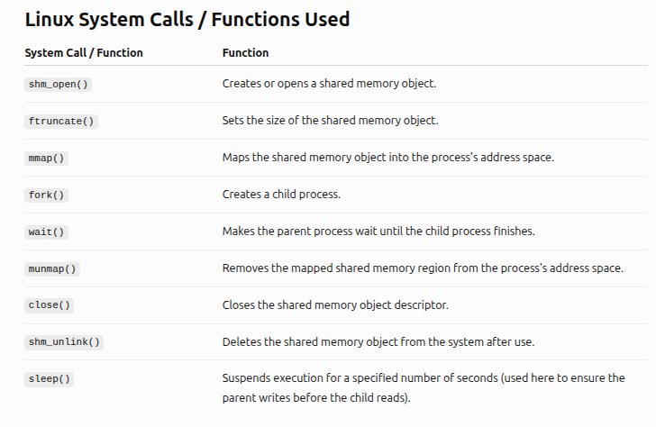
SOURCE CODE :
#include <stdio.h>
#include <stdlib.h>
#include <string.h>
#include <fcntl.h>
#include <sys/mman.h>
#include <sys/unistd.h>
#include <sys/types.h>
#include <sys/wait.h>

int main()
{
// Name of the shared memory object
const char *name = "/my_shm";

// Size of the shared memory block (in bytes)
const int SIZE = 4096;

int shm_fd;
void *ptr;

/*
1. Create the shared memory object
O_CREAT: Create object if it doesn't exist
O_RDWR: Open for reading and writing
0666: Read/Write permissions for User, Group, and Others
*/

shm_fd = shm_open(name, O_CREAT | O_RDWR, 0666);

if (shm_fd == -1)
{
perror("shm_open failed");
return 1;
}

//Configure the size of the shared memory segment
if (ftruncate(shm_fd, SIZE) == -1)
{
perror("ftruncate failed");
return 1;
}

//Map the shared memory object into memory
ptr = mmap(0, SIZE, PROT_READ | PROT_WRITE, MAP_SHARED, shm_fd, 0);

if (ptr == MAP_FAILED)
{
perror("mmap failed");
return 1;
}

//Fork a child process
pid_t pid = fork();

if (pid < 0)
{
perror("Fork failed");
return 1;
}

else if (pid == 0)
{
//Child process reads the data from the shared memory segment
sleep(1); // Simple delay to ensure the parent writes first

printf("\nChild: Read data from shared memory: \"%s\"\n", (char *)ptr);

munmap(ptr, SIZE); // Clean up memory mapping in child
close(shm_fd);
}

else
{
//Parent process writes data into the shared memory segment
const char *message = "Hello from the Shared Memory!";

// Copying data into the memory mapped region
sprintf(ptr, "%s", message);

printf("Parent: Wrote data to shared memory: \"%s\"\n", message);

// Wait for child to finish reading before cleaning up resource
wait(NULL);

munmap(ptr, SIZE); // Clean up and release shared memory resources

close(shm_fd);

shm_unlink(name); // Deletes the shared memory segment from system
}

return 0;
}

HOW TO EXECUTE:
Compile (in Terminal): gcc exp7.c -o exp7
Run: ./exp7

OUTPUT :

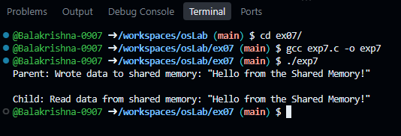

RESULT :
Thus the program is compiled and executed successfully with verified output.
8 | CPU Scheduling Algorithms

AIM :
To simulate CPU scheduling algorithms (FCFS, SJF, Priority, Round Robin) and compare their performance. Students can evaluate waiting time, turnaround time, and scheduling efficiency (Process management)

CONTEXT:
This program demonstrates the First Come, First Served (FCFS) CPU scheduling algorithm, one of the simplest process scheduling algorithms used by operating systems. The process that arrives first is allocated the CPU first and runs until completion (non-preemptive scheduling).

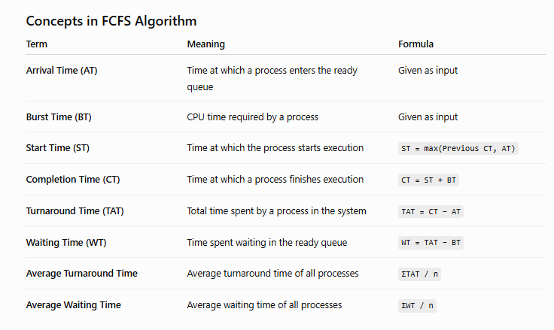

SOURCE CODE :
#include <stdio.h>

struct Process
{
int id;
int arrival_time;
int burst_time;
int completion_time;
int turnaround_time;
int waiting_time;
};

int main()
{
int n;
float total_wt = 0, total_tat = 0;

printf("Enter number of processes: ");

if (scanf("%d", &n) != 1 || n <= 0)
{
printf("Invalid number of processes.\n");
return 1;
}

struct Process p[n];

// Read user inputs
for (int i = 0; i < n; i++)
{
p[i].id = i + 1;
printf("Enter Arrival Time and Burst Time for Process %d: ", p[i].id);
scanf("%d %d", &p[i].arrival_time, &p[i].burst_time);
}

// Sort processes based on Arrival Time (Bubble Sort)
for (int i = 0; i < n - 1; i++)
{
for (int j = 0; j < n - i - 1; j++)
{
if (p[j].arrival_time > p[j + 1].arrival_time)
{
struct Process temp = p[j];
p[j] = p[j + 1];
p[j + 1] = temp;
}
}
}

// FCFS Scheduling Calculations
int current_time = 0;

for (int i = 0; i < n; i++)
{
// If CPU is idle waiting for the next process to arrive
if (current_time < p[i].arrival_time)
{
current_time = p[i].arrival_time;
}

p[i].completion_time = current_time + p[i].burst_time;
p[i].turnaround_time = p[i].completion_time - p[i].arrival_time;
p[i].waiting_time = p[i].turnaround_time - p[i].burst_time;

current_time = p[i].completion_time;

total_wt += p[i].waiting_time;
total_tat += p[i].turnaround_time;
}

// Print Results Matrix
printf("\n%-10s %-10s %-10s %-12s %-12s %-10s\n",
"Process", "Arrival", "Burst", "Completion", "Turnaround", "Waiting");

for (int i = 0; i < n; i++)
{
printf("P%-9d %-10d %-10d %-12d %-12d %-10d\n",
p[i].id,
p[i].arrival_time,
p[i].burst_time,
p[i].completion_time,
p[i].turnaround_time,
p[i].waiting_time);
}
printf("\nAverage Turnaround Time = %.2f", total_tat / n);
printf("\nAverage Waiting Time = %.2f\n", total_wt / n);

return 0;
}
HOW TO EXECUTE:
Compile (in Terminal): gcc exp8.c -o exp8
Run: ./exp8

OUTPUT :

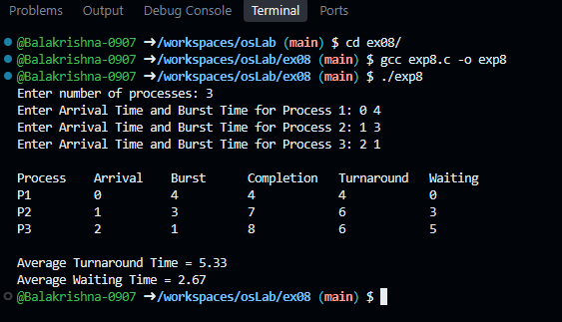

RESULT :
Thus the program is compiled and executed successfully with verified output
9 | Memory Management – Page Replacement Algorithms

AIM :
To simulate page replacement algorithms (FIFO, LRU, and Optimal) (Memory management)

CONTEXT:
FIFO (First-In, First-Out) Page Replacement Algorithm, which is one of the page replacement techniques used by an operating system for virtual memory management.
When the CPU requests a page that is not currently in the available memory frames, a page fault occurs. If all memory frames are occupied, the operating system must decide which page to remove to make room for the new page. The FIFO algorithm replaces the page that has been in memory the longest (the oldest page).

SOURCE CODE :
#include <stdio.h> // Standard input/output library

int main()
{
// Array to store page reference string (maximum 100 pages)
int pages[100];

// Array to represent memory frames (maximum 50 frames)
int frames[50];

int n, f; // n = number of pages, f = number of frames
int i, j; // Loop variables
int pageFaults = 0; // Counts total page faults
int index = 0; // Points to the next frame to be replaced (FIFO pointer)
int found; // Flag to check whether page is already in memory

// Read number of page references
printf("Enter number of pages: ");
scanf("%d", &n);

// Read page reference string
printf("Enter page reference string:\n");
for (i = 0; i < n; i++)
{
scanf("%d", &pages[i]);
}

// Read number of available frames
printf("Enter number of frames: ");
scanf("%d", &f);

// Initially all frames are empty
for (i = 0; i < f; i++)
{
frames[i] = -1;
}

// Display heading
printf("\nPage\tFrames\n");

// Process each page in the reference string
for (i = 0; i < n; i++)
{
// Assume page is not present
found = 0;

// Search all frames to check if page already exists
for (j = 0; j < f; j++)
{
// Page found in memory
if (frames[j] == pages[i])
{
found = 1;
break; // No need to continue searching
}
}

// If page is not found, page fault occurs
if (!found)
{
// Replace the oldest page using FIFO
frames[index] = pages[i];

// Move pointer to next frame
index = (index + 1) % f;

// Increase page fault count
pageFaults++;
}

// Print current page
printf("%d\t", pages[i]);

// Display contents of all frames
for (j = 0; j < f; j++)
{
// Empty frame
if (frames[j] == -1)
printf("- ");

// Occupied frame
else
printf("%d ", frames[j]);
}

// Display if page fault occurred
if (!found)
printf("(Page Fault)");

printf("\n");
}

// Display final statistics
printf("\nTotal Page Faults = %d\n", pageFaults);

// Hits = Total Pages - Page Faults
printf("Total Page Hits = %d\n", n - pageFaults);

return 0;
}

HOW TO EXECUTE:
Compile (in Terminal): gcc exp9.c -o exp9
Run: ./exp9

OUTPUT :

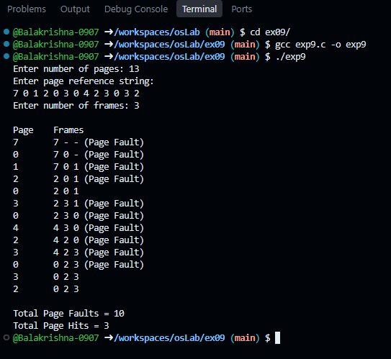

RESULT :
Thus the program is compiled and executed successfully with verified output.
10 | Linux File Permissions and File Information

AIM :
To study Linux file permissions and retrieve file metadata using stat() and related system calls.

CONTEXT:
Metadata: Metadata is data that describes another piece of data.

This program demonstrates how to retrieve and display file metadata in the Linux operating system using the stat() system call. It accepts a filename from the user, obtains information about the file, and displays following details:

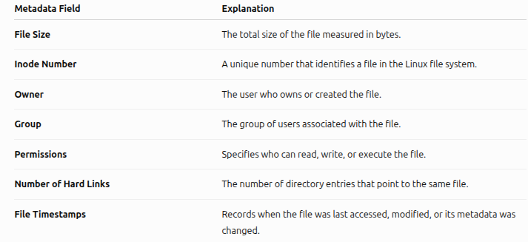

SOURCE CODE :
#include <stdio.h> // printf(), perror()
#include <stdlib.h> // exit()
#include <sys/stat.h> // stat(), struct stat
#include <unistd.h> // POSIX functions
#include <pwd.h> // getpwuid()
#include <grp.h> // getgrgid()
#include <time.h> // ctime()

int main()
{
// Variable to store file information
struct stat fileStat;

// Array to store the filename entered by the user
char filename[100];

// Read filename
printf("Enter filename: ");
scanf("%s", filename);

// Get file information
if (stat(filename, &fileStat) == -1)
{
perror("Error");
return 1;
}

printf("\n===== File Information =====\n");

// File size in bytes
printf("File Size : %ld bytes\n", fileStat.st_size);

// Inode number
printf("Inode Number : %ld\n", fileStat.st_ino);

// Number of hard links
printf("Hard Links : %ld\n", fileStat.st_nlink);

// User ID (Owner)
printf("Owner UID : %d\n", fileStat.st_uid);

// Group ID
printf("Group GID : %d\n", fileStat.st_gid);

// Owner name
printf("Owner Name : %s\n", getpwuid(fileStat.st_uid)->pw_name);

// Group name
printf("Group Name : %s\n", getgrgid(fileStat.st_gid)->gr_name);

// File permissions
printf("\nPermissions : ");

printf((S_ISDIR(fileStat.st_mode)) ? "d" : "-");

printf((fileStat.st_mode & S_IRUSR) ? "r" : "-");
printf((fileStat.st_mode & S_IWUSR) ? "w" : "-");
printf((fileStat.st_mode & S_IXUSR) ? "x" : "-");

printf((fileStat.st_mode & S_IRGRP) ? "r" : "-");
printf((fileStat.st_mode & S_IWGRP) ? "w" : "-");
printf((fileStat.st_mode & S_IXGRP) ? "x" : "-");

printf((fileStat.st_mode & S_IROTH) ? "r" : "-");
printf((fileStat.st_mode & S_IWOTH) ? "w" : "-");
printf((fileStat.st_mode & S_IXOTH) ? "x" : "-");

printf("\n");

// Last access time
printf("Last Access : %s", ctime(&fileStat.st_atime));

// Last modification time
printf("Last Modification : %s", ctime(&fileStat.st_mtime));

// Last status change
printf("Last Status Change : %s", ctime(&fileStat.st_ctime));

return 0;
}

HOW TO EXECUTE:

Compile (in Terminal): gcc file_info.c -o file_info
Run: ./file_info

OUTPUT :

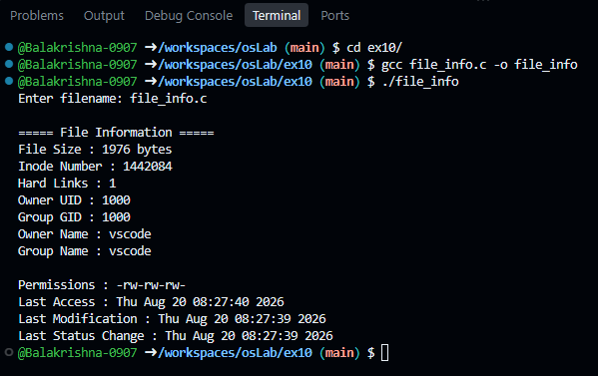

RESULT :
Thus the program is compiled and executed successfully with verified output.

