**SRI CHANDRASEKHARENDRA SARASWATHI VISWA MAHAVIDYALAYA**

**(UNIVERSITY ESTABLISHED under section 3 of UGC Act 1956)**

**ENATHUR,** **KANCHIPURAM – 631 561**



**OBJECT ORIENTED PROGRAMMING LAB**

**LABORATORY RECORD**

**Name :** Balakrishna R

**Reg. No :** 112514025

**Class :** I Year B.Sc. (Cyber Security)

**Subject :** UCYF231P60 - Object Oriented Programming Lab

**SRI CHANDRASEKHARENDRA SARASWATHI**

**VISWA MAHAVIDYALAYA**

**(University Established under section 3 of UGC Act 1956)**



**BONAFIDE CERTIFICATE**

**This is to certify that this is the bonafide record of work done by**

**Mr./~~Ms.~~ Balakrishna R, with Reg.No 112514025 of I Year B.Sc. (Cyber Security) in the Object Oriented Programming Lab during the year 2025.**

**Staff-in-charge** **Head of the Department**

**Submitted for the Practical Examination held on ________________________**

**Internal Examiner** **External Examiner.**

**INDEX**

| **SNo.** | **Date** | **Title** | **Page** | **Sign** |
| --- | --- | --- | --- | --- |
| 1 | 25-07-2025 | Classes & Objects | 4 |  |
| 2 | 30-07-2025 | Friend Function | 8 |  |
| 3 | 06-08-2025 | Inline Function | 10 |  |
| 4 | 08-08-2025 | Array Implementation | 12 |  |
| 5 | 20-08-2025 | Multiple Inheritance | 23 |  |
| 6 | 29-08-2025 | This Pointer | 25 |  |
| 7 | 10-09-2025 | Friend Class | 26 |  |
| 8 | 17-09-2025 | Function Overloading | 28 |  |
| 9 | 03-10-2025 | Operator Overloading | 31 |  |
| 10 | 10-10-2025 | String Manipulation | 33 |  |

| **1** | **CLASSES AND OBJECTS** | 25-07-2025 |
| --- | --- | --- |

**AIM :**

Write a C++ Program to display Employee details Using Classes and Objects.

**ALGORITHM :**

**Step 1:** Start

**Step 2:** Declare variables:

num (integer) → to store number of employees

For each employee, store:

empID (integer)

name (string)

department (string)

salary (float)

**Step 3:** Display message — “Enter number of employees:”

**Step 4:** Read num

**Step 5:** i = 1

**Step 6:** Display message — “Enter details for employee i:”

Input empID

Input name

Input department

Input salary

**Step 7:** i = i+1

**Step 8:** if i <= num goto Step 6, else continue

**Step 9:** j = 1

**Step 10:** Display message — “--- Employee Details ---”

Display empID

Display name

Display department

Display salary

**Step 11:** j = j + 1

**Step 12:** if j <= num goto Step 10, else continue

**Step 13:** Stop

**FLOWCHART :**

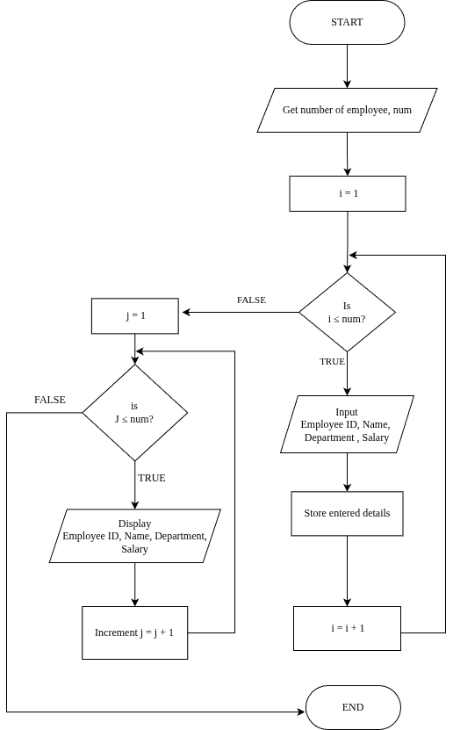

**UML DIAGRAM :**

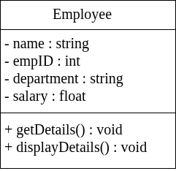

**SOURCE CODE :**

<https://github.com/Balakrishna0907/OOPS_Record/blob/1c139d73419ce24536cc9d4c50167ae27a8a3b48/EmpClass.cpp>

**OUTPUT :**

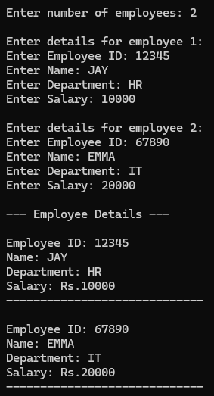

**RESULT :**

Thus the program is compiled and executed successfully with verified output.

| **2** | **FRIEND FUNCTION** | 30-07-2025 |
| --- | --- | --- |

**AIM :**

Write a C++ Program to find the Mean Value Using Friend Function.

**ALGORITHM :**

**Step 1:** Start the program

**Step 2:** Read values num1, num2

**Step 3:** mean = num1 + num2

**Step 4:** Display mean

**Step 5:** Stop

**FLOWCHART :**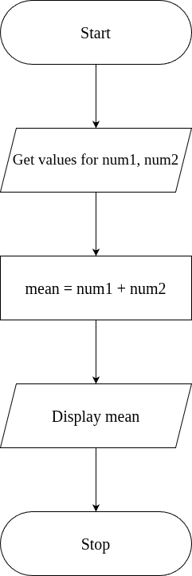

**UML DIAGRAM :**

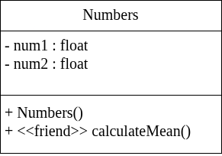

**SOURCE CODE :**

<https://github.com/Balakrishna0907/OOPS_Record/blob/1c139d73419ce24536cc9d4c50167ae27a8a3b48/FriendFnMean.cpp>

**OUTPUT :**

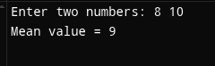

**RESULT :**

Thus the program is compiled and executed successfully with verified output.

| **3** | **INLINE FUNCTION** | 06-08-2025 |
| --- | --- | --- |

**AIM :**

Write a C++ Program to Implement Inline Function.

**ALGORITHM :**

**Step 1:** Start

**Step 2:** Define an inline function square(int n) that returns n * n.

**Step 3:** In main(), declare an integer variable num.

**Step 4:** Read the value of num from the user.

**Step 5:** Call the inline function square(num) and store/print the result.

**Step 6:** Display the square of the given number.

**Step 7:** Stop

**FLOWCHART :**

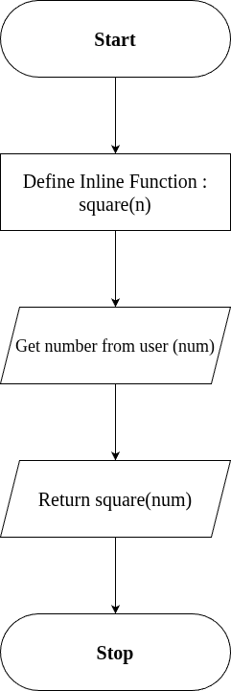

**SOURCE CODE :**

<https://github.com/Balakrishna0907/OOPS_Record/blob/1c139d73419ce24536cc9d4c50167ae27a8a3b48/InlineFn.cpp>

**OUTPUT :**

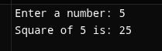

**RESULT :**

Thus the program is compiled and executed successfully with verified output.

| 4 | **ARRAY IMPLEMENTATION** | 08-08-2025 |
| --- | --- | --- |

**AIM :**

Write a C++ Program to Implement Arrays.

**ALGORITHM :**

**Step 1 :** Start the Program

**Step 2 :** Create an Object "myArray" of Class "Array"

**Step 3 :** Display menu as below and get "choice"

1. Insert

2. Remove

3. Search

4. Display

5. Exit

**Step 4 :** If (choice >= 6) go to step -, Else Continue

**Step 5 :** If (choice = 1)

Get value n from user

set i = 0

Check for condition, i < n

On true; get Value for Insert (value)

call myArray.insert(value)

Increment i, i = i + 1

Else; break loop

elseif (choice = 2)

get index to Remove (index)

call myArray.remove(index)

elseif (choice = 3)

get value to search (value)

call myArray.search (value)

elseif (choice = 4)

call myArray.display()

elseif (choice = 5)

go to step 7

**Step 6:** Display "Invalid choice"

**Step 7:** Stop

**ALGORITHM FOR INSERT FUNCTION :**

**Step 1:** Start the program.

**Step 2:** Prompt the user to enter an element to insert into the array.

→ Input: element

**Step 3:** Check the current size of the array.

→ Condition: if size < 100

**Step 4:**

If the condition is TRUE (size < 100):

a) Insert the element into the array at position arr[size].

b) Increment the size of the array by 1.

→ size = size + 1

If the condition is FALSE (size >= 100):

a) Display the message:

→ “Array is full. Cannot insert more elements.”

**Step 5:** Stop the program.

**ALGORITHM FOR REMOVE FUNCTION :**

**Step 1:** Start

**Step 2:** Get index from the user.

**Step 3:** Check the condition, (index < 0 || index >= size)

On true; Go to Step 4

   Else; Go to Step 5

**Step 4:** Print "Invalid index", then Go to Step 10

**Step 5:** Set i = index

**Step 6:** Check the condition, i < size - 1

On true; Go to Step 7

   Else; Go to Step 8

**Step 7:** Shift the elements to the left by one position:

    arr[i] = arr[i + 1]

    Repeat this step until all elements after the deleted index are shifted.

**Step 8:** Decrease the array size by one:

     size = size - 1

**Step 9:** Print "Element deleted at index" followed by the value of index.

**Step 10:** Stop

**ALGORITHM FOR SEARCH FUNCTION :**

**Step 1:** Start

**Step 2:** Initialize i = 0

**Step 3:** Check the condition, i < size

On true; go to Step 4

   Else; go to Step 8

**Step 4:** Check if the current array element matches the search key, arr[i] == key

On true; go to Step 7

   Else go to Step 5

**Step 5:** Increment i by 1, i = i + 1

**Step 6:** Go back to Step 3 (Repeat the checking process for the next element)

**Step 7:** Print "Element found at index" followed by the value of i

   Go to Step 9

**Step 8:** Print "Element not found

**Step 9:** Stop

**ALGORITHM FOR DISPLAY FUNCTION :**

**Step 1:** Start the program.

**Step 2:** Check if the array size is equal to 0, condition (size == 0)

On true; Print "Array is empty".

Go to Step 8 (Stop).

Else; Continue to the next step.

**Step 3:** Print "Array elements:" to indicate that array elements will be displayed.

**Step 4:** Initialize a variable i = 0 (loop counter).

**Step 5:** Check the condition if (i < size).

On true; Print the element arr[i].

Increment i by 1 (i = i + 1).

Go back to Step 5 and repeat until i < size becomes False.

Else; Exit the loop.

**Step 6:** After printing all elements, end the loop.

**Step 7:** Stop the program.

**FLOWCHART :**

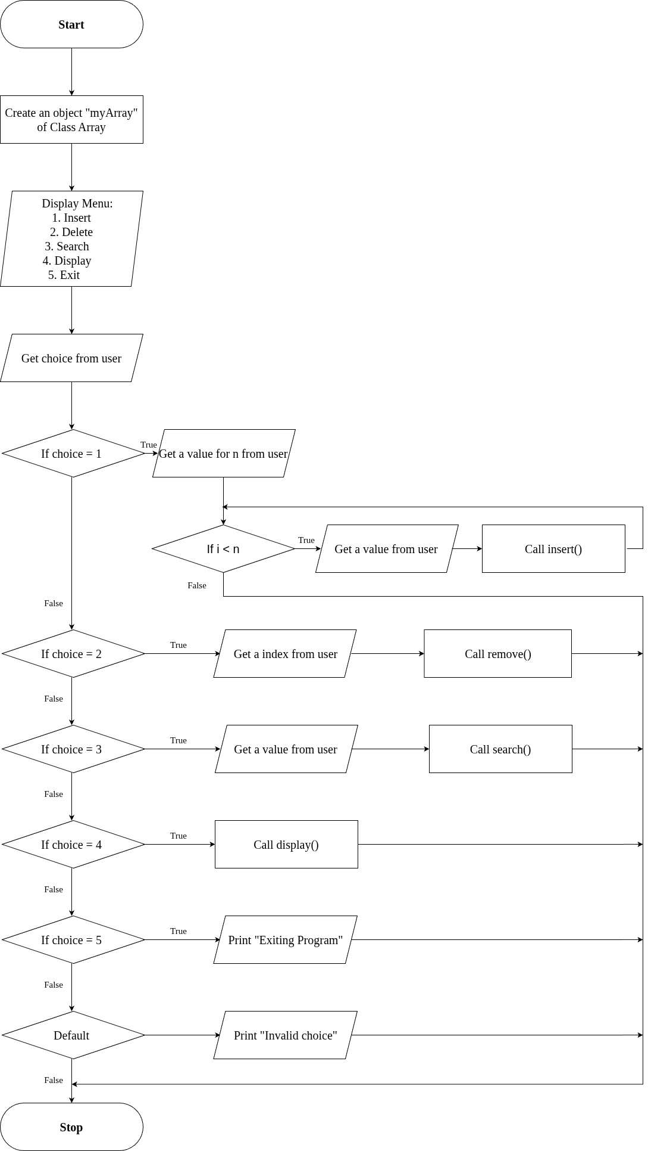**FLOWCHART FOR INSERT FUNCTION :**

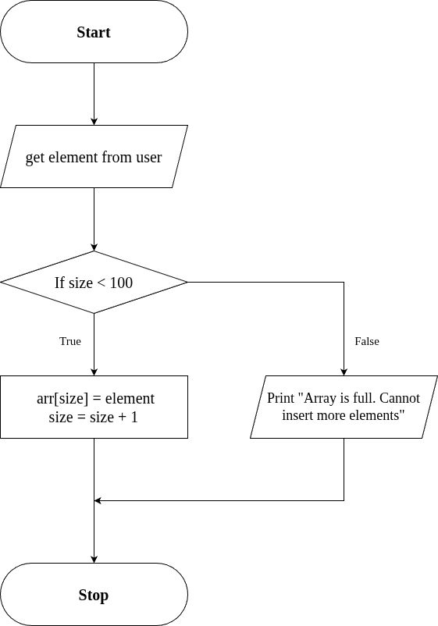

**FLOWCHART FOR REMOVE FUNCTION :**

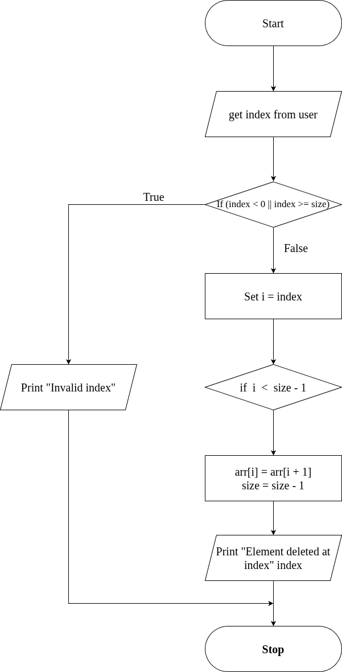

**FLOWCHART FOR SEARCH FUNCTION :**

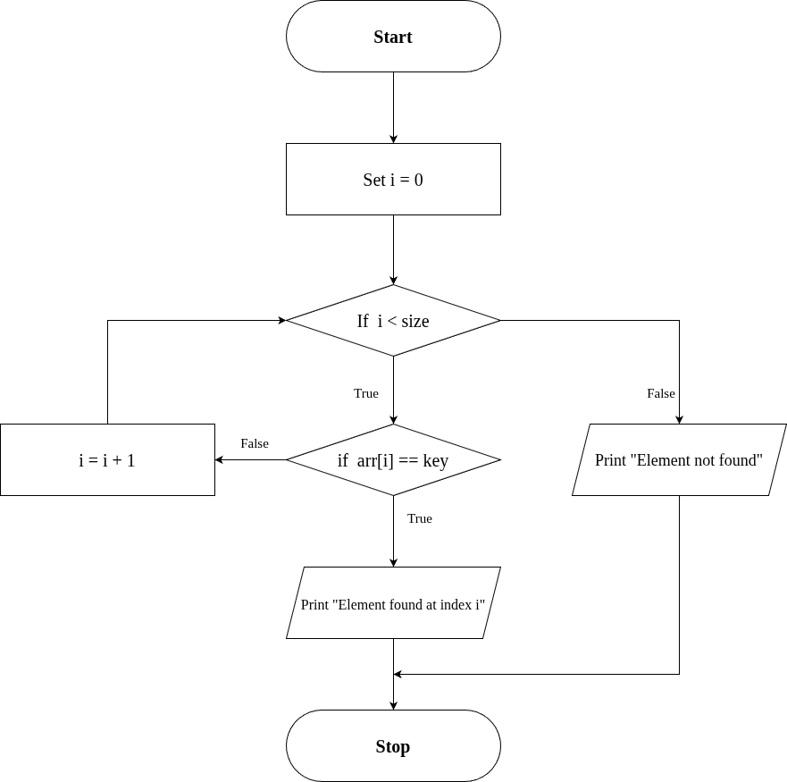

**FLOWCHART FOR DISPLAY FUNCTION :**

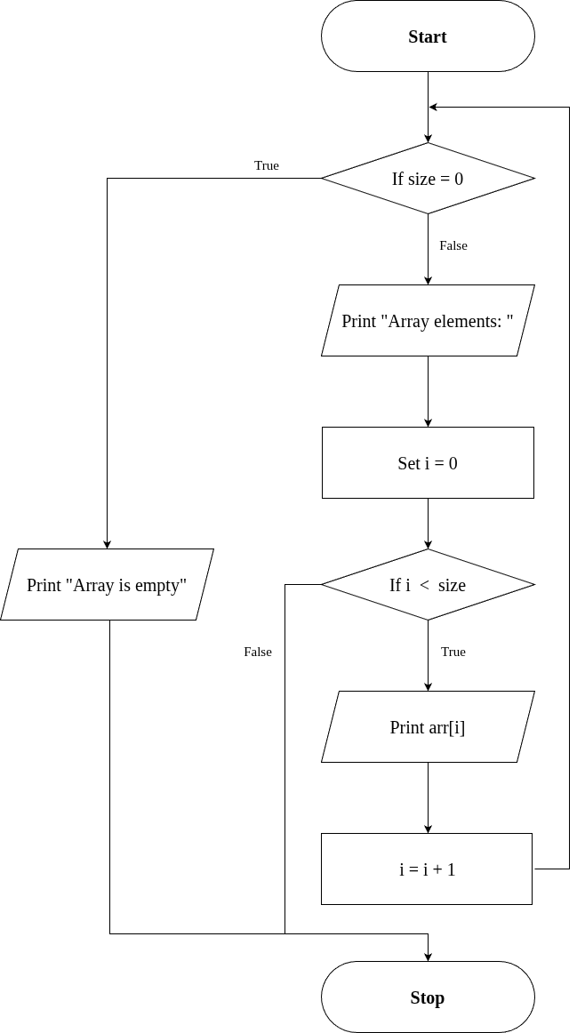

**SOURCE CODE :**

<https://github.com/Balakrishna0907/OOPS_Record/blob/1c139d73419ce24536cc9d4c50167ae27a8a3b48/ArrayImpl.cpp>

**OUTPUT :**

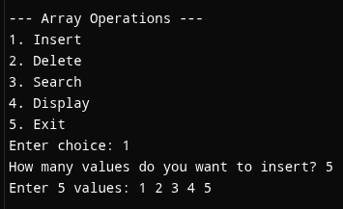

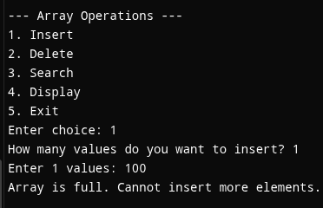

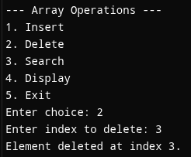

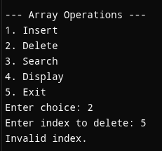

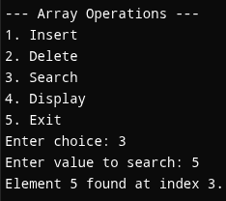

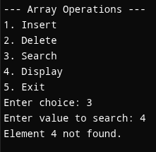

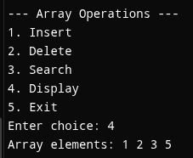

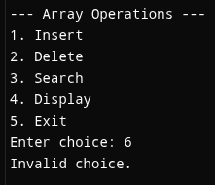

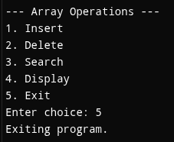

**RESULT :**

Thus the program is compiled and executed successfully with verified output.

| **5** | **MULTIPLE INHERITANCE** | 20-08-2025 |
| --- | --- | --- |

**AIM :**

Write a C++ Program to implement Multiple Inheritance.

**ALGORITHM :**

**Step 1:** Start the program.

**Step 2:** Define the base class "Engine"

  → Declare a protected data member engineCC (integer).

  → Define a public member function getEngineInfo() that:

   • Accepts user input for engineCC.

**Step 3:** Define the base class "Body"

  → Declare protected data members color and type (string).

  → Define a public member function getBodyInfo() that:

   • Takes input for type (SUV/Sedan/Hatchback/etc)

**Step 4:** Define the derived class "Car" that inherits publicly from both "Engine" and "Body".

  → Define a public member function showDetails() that:

   • Displays engineCC, color, and type.

**Step 5:** In the main() function:

  1. Create an object obj of class Car.

  2. Call obj.getEngineInfo() to input engine details.

  3. Call obj.getBodyInfo() to input body details.

  4. Call obj.showDetails() to display all vehicle details.

**Step 6:** End the program.

**UML DIAGRAM :**

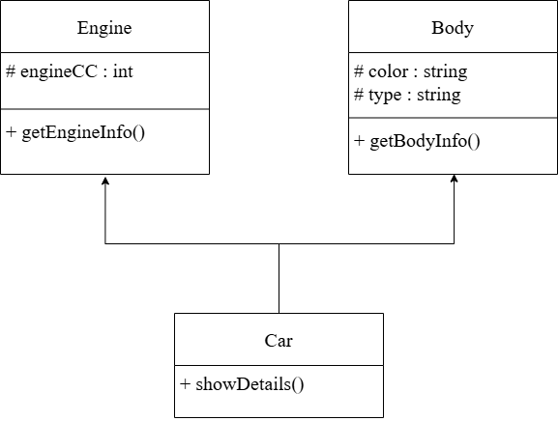

**SOURCE CODE :**

<https://github.com/Balakrishna0907/OOPS_Record/blob/1c139d73419ce24536cc9d4c50167ae27a8a3b48/MultipleInheritance.cpp>

**OUTPUT :**

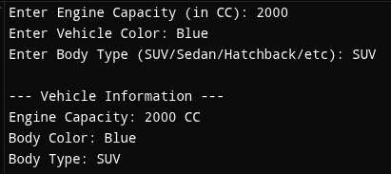

**RESULT :**

Thus the program is compiled and executed successfully with verified output.

| **6** | **THIS POINTER** | 29-08-2025 |
| --- | --- | --- |

**AIM :**

Write a C++ Program To Implement This Pointer.

**ALGORITHM :**

**Step 1:** Start the program

**Step 2:** Create a class Sample with data members a and b

**Step 3:** Define setData(int a, int b) member function → Use this->a = a and this->b = b to assign values

**Step 4:** Define display() function to print the values of a and b

**Step 5:** In main(), create an object obj of class Sample

**Step 6:** Call obj.setData(10, 20)

**Step 7:** Call obj.display() to show stored values

**Step 8:** Stop the program

**UML DIAGRAM :**

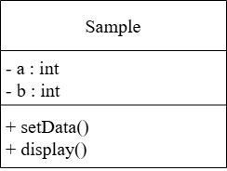

**SOURCE CODE :**

<https://github.com/Balakrishna0907/OOPS_Record/blob/1c139d73419ce24536cc9d4c50167ae27a8a3b48/ThisPointer.cpp>

**OUTPUT :**



**RESULT :**

Thus the program is compiled and executed successfully with verified output.

| **7** | **FRIEND CLASS** | 10-09-2025 |
| --- | --- | --- |

**AIM :**

Write a C++ Program to Implement Friend class.

**ALGORITHM :**

**Step 1:** Start.

**Step 2:** Define class Auditor as a forward declaration so it can be referenced in class BankAccount.

**Step 3:** Define class BankAccount:

1. Declare a private string variable (name) and double variable (balance).

2. Define a constructor to initialize (name) and (balance).

3. Implement deposit() and widthrawl() public functions.

4. Declare Auditor as a friend class using the friend class keyword.

**Step 4:** Defines class Auditor:

1. Implement a public member function showAccount that takes an object of class BankAccount as a parameter.

[Accesses and displays the private variables (name) and (balance) of BankAccount using the reference to the object.]

**Step 5:** Defines main function.

1. Creates object (official) of class Auditor and object (acc) of class BankAccount.

2. Call acc.deposit() and acc.widthrawl() to modify the balance.

3. Call official.showAccount(acc) to display the account details( name and balance ) using the auditor object.

**Step 6:** End.

**UML DIAGRAM :**

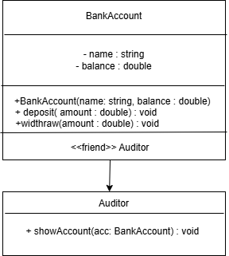

**SOURCE CODE :**

<https://github.com/Balakrishna0907/OOPS_Record/blob/1c139d73419ce24536cc9d4c50167ae27a8a3b48/FriendClass.cpp>

**OUTPUT :**

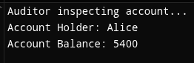

**RESULT :**

Thus the program is compiled and executed successfully with verified output.

| 8 | **FUNCTION OVERLOADING** | 17-09-2025 |
| --- | --- | --- |

**AIM :**

Write a C++ Program to Implement Function overloading.

**ALGORITHM :**

**Step 1:** Start.

**Step 2:** Define a class named Calculator.

**Step 3:** Inside the class, define three overloaded functions named add:

1. Function-1: int add(int a, int b)

-> Computes and returns the sum of two integers.

2. Function-2: int add(int a, int b, int c)

-> Computes and returns the sum of three integers.

3. Function-3: double add(double a, double b)

-> Computes and returns the sum of two double values.

**Step 4:** In the main() function:

1. Create an object (calc) of class Calculator.

2. Call and display the result of the overloaded functions:

if parameters are of type int and only 2 parameters:

-> Call calc.add(int , int)

else if parameterrs are of type int and only 3 parameters:

-> Call calc.add(int , int , int)

else if parameters are of type double:

-> Call calc.add(double , double)

else:

Display: Input parameters are wrong.

**Step 5:** Display each result using cout.

**Step 6:** End.

**FLOWCHART :**

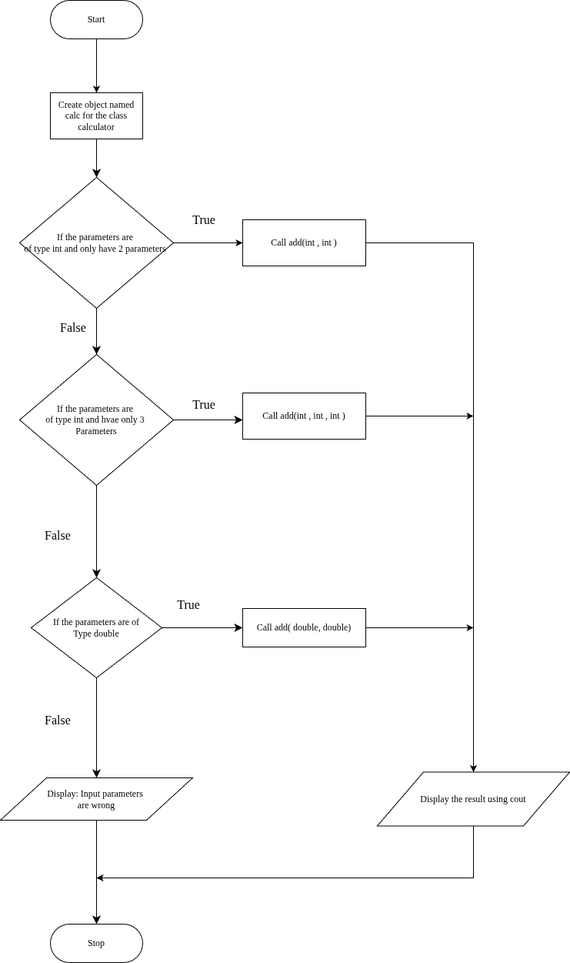

**UML DIAGRAM :**

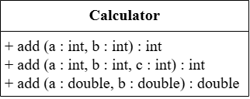

**SOURCE CODE :**

<https://github.com/Balakrishna0907/OOPS_Record/blob/1c139d73419ce24536cc9d4c50167ae27a8a3b48/FnOverloading.cpp>

**OUTPUT :**

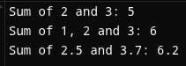

**RESULT :**

Thus the program is compiled and executed successfully with verified output.

| **9** | **OPERATOR OVERLOADING** | 03-10-2025 |
| --- | --- | --- |

**AIM :**

Write a C++ Program to Implement Operator Overloading.

**ALGORITHM :**

**Step 1:** Start the program.

**Step 2:** Define a class named “Point”.

**Step 3:** Inside the classes, declare two private data members : ‘x’ and ‘y’.

**Step 4:** Create a constructor Point(int a=0,int b =0)to initialize ‘x’ and ‘y’.

**Step 5:** Define an overloaded + operator function :

* Take another object of type point as a parameter.
* Add the ‘x’ and ‘y’ values of both objects.
* Return a new Point object containing the sum.

**Step 6:** Define and display() function to print the ‘x’ and ‘y’ values.

**Step 7:** In main() function:

1. Create two objects of Class “Point”: p1(2,3) and p2(4,5).
2. Use the overloaded + operator to add the two objects: p3=p1+p2.
3. Display the result using p3.display().

**Step 8:** Stop the program.

**UML DIAGRAM :**

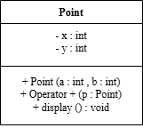

**SOURCE CODE :**

<https://github.com/Balakrishna0907/OOPS_Record/blob/1c139d73419ce24536cc9d4c50167ae27a8a3b48/OperOverloading.cpp>

**OUTPUT :**



**RESULT :**

Thus the program is compiled and executed successfully with verified output.

| **10** | **STRING MANIPULATION** | 10-10-2025 |
| --- | --- | --- |

**AIM :**

Write a C++ Program to Implement String Concepts.

**ALGORITHM :**

**Step 1:** Start

**Step 2:** Declare string variables (str1, str2, fullName, etc.)

**Step 3:** Initialize str1 = "Hello", str2 = "World"

**Step 4:** Concatenate str1 and str2 (using '+' operator)→ store in (combined)

**Step 5:** Display the combined string

**Step 6:** Prompt user to enter full name

**Step 7:** Read full name using getline()

**Step 8:** Display the full name

**Step 9:** Find and display the length of the full name (using "length()" library function)

**Step 10:** Extract and display the first 5 characters (using "substr()" library function)

**Step 11:** Compare two strings ("Apple" and "Banana") (using "==" operator)

**Step 12:** Display comparison result

**Step 13:** Replace "C++" with "Python" in a sentence (using "replace()" library function)

**Step 14:** Display modified sentence

**Step 15:** Loop through and display each character of full name

**Step 16:** End

**FLOWCHART:**

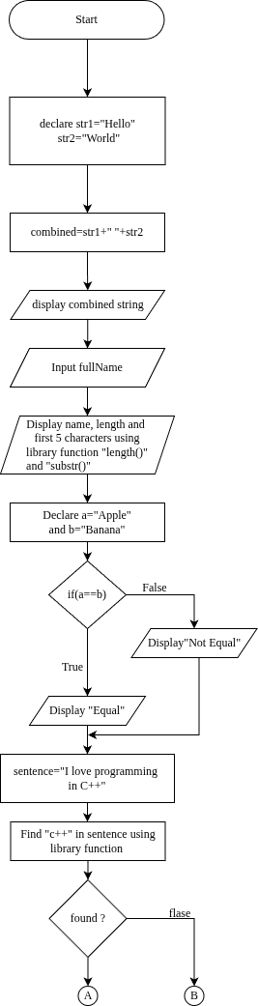

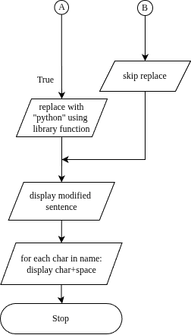

**SOURCE CODE :**

<https://github.com/Balakrishna0907/OOPS_Record/blob/1c139d73419ce24536cc9d4c50167ae27a8a3b48/StringManipulation.cpp>

**OUTPUT :**

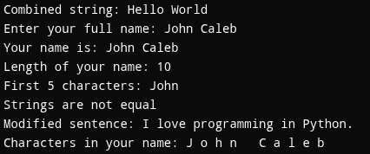

**RESULT :**

Thus the program is compiled and executed successfully with verified output.