Table of Contents

HBASE-Introduction 2
Comparison of HBASE and RDBMS 2
Comparison of HBASE and HDFS 3
Comparison of HBASE and NoSQL 4
When should we prefer HBASE over other database 5
When not to use HBASE 5
HBASE ARCHITECTURE 6
HMaster 6
RegionServer 6
Region 7
ZooKeeper 7
-ROOT- Table 8
.META. Table 8
Data Modelling 10
Htable 10
ColumnFamily 10
ColumnQualifierName (CQN) 10
RowKey 10
TimeStamp 10
cell 11
Steps to execute the DDL and DML statements in HBASE shell 12
DDL in HBASE 13
DML in HBASE 17
JAVA API for HBASE 22
HBASE_MR Integration 34

For Mr.Gopal Krishna(Kelly Technologies)
Documented by :-Sailaja Vedantam

HBASE-Introduction
HBASE- Hadoop DataBASE that runs on top of Hadoop.It is a Database which is an open source ,non-relational ,distributed ,NoSQL(Not Only SQL) database modeled after Google's BigTable and written in Java.It is developed as part of Apache Software Foundation's (AFS) Apache Hadoop project and runs on HDFS(Hadoop Distributed FileSystem)
Hadoop can perform only batch processing, and data will be accessed only in a sequential manner leading to low latency.HBASE internally uses Hash tables and provides random access, and it stores the data in HDFS files that are indexed (sorted) by their key for faster lookups thus providing high latency compared to HDFS.

Comparison of HBASE and RDBMS
HBASE | RDBMS
Column-oriented,Open Sourced, Distributed and versioned database storage system | Row Oriented,Tabular Structured Data
Does not have a query language like SQL and uses API's and Map Reduce for accessing data | Uses structured query language like SQL to access the data
Can handle Structured and semi-structured data | Can handle Structured data
Designed to store De-Normalized data and is a Non Relation database | Designed to store Normalized data and is a Relational database
Stores data in key,value pairs
Multidimentional database (RowKey,ColumnFamily) | Two dimensional database
Flexible Schema- as Columns can be easily added for specific ColumnFamilies | Fixed Schema
HBase internally uses Hash tables and provides random access, and it stores the data in HDFS files that are indexed (sorted) by their key for faster lookups. | Randomness cause of indexing
Cannot be used for Transaction Processing | Can be used for Transaction processing
Easily Scalable- Scaling out by adding new servers to the cluster by Horizontal scalability (both storage and processing) using commodity hardware as it is based on distributed computing architecture. | Difficult to scale.-Scaling up by upgrading the servers by Horizontal Scalability.
Doesn't directly support JOINS or Aggregations | Supports JOINS,Aggregations using SQL
Used for Online Analytical Processing | Used for Online Transaction Process OLTP
Runs on top of HDFS
Can handle huge volume of data | Can handle Limited amount of data at a time

Comparison of HBASE and HDFS
HBASE | HDFS
HBase is a distributed, column oriented database and stores data in key/value pairs | HDFS is a distributed file system and stores data in form of flat files
Random reads and writes | Sequential file access .Random writes are not possible as it allows to Write once read many times.
Suitable for Low Latency operations by providing access to the specific row data from the big volume | Suitable for High Latency operations through batch processing
Random access of rows through their row keys | Designed for batch processing and hence doesn’t have a concept of random reads/writes
Offline access i.e; batch access through map-reduce queries | Designed for batch processing
Addresses Hadoop's Architecture failure i.e; Single Point of Failure (SPOF) with ZooKeeper
Runs on top of HDFS and uses HDFS for storage
W.r.t. Performance HBASE is slow than HDFS as HBASE has to read the KeyValues, returning the most current row or specified timestamps, etc.

Comparison of HBASE and NoSQL
HBASE | NoSQL
HBASE is a NoSql database
Datastores in Key,Value pair | By Default Value is stored in Key,Value pair
Horizontal Scalability | Horizontal Scalability
Non Relational DB,No ACID properties | Non Relational DB,No ACID properties
Can handle FileSystem Format only | Can handle Structured, SemiStructured, Unstructured data
HBASE uses MapReduce for processing the data | Can perform basic CRUD operations.Complex aggregations are tough to handle so we need to integrate with solutions like Hadoop for complex processing .
Used for Online Analytical Processing | Used for Online Transaction Process OLTP
HBase permits two types of access: random access of rows through their row keys and offline or batch access through map-reduce queries | Random access of data is possible
Integrated with Big Data technology stack only . | Can be integrated with Big Data technology stack
Master slave model to address parallel processing

When should we prefer HBASE over other database
- When each row is slightly different in the schema.
- When each row can have different number of column and most of the columns may have NULL values.
- When we can’t add columns fast enough and most of them are NULL in each row
- If we need key based access to data when storing or retrieving
- When we have to perform high write throughput , low latency reads and need to perform range based large data scans.
- Where applications has CP requirement of the CAP requirement
- Consistency (all nodes see same data at same time) ,Availability (guarantee that every request receives response whether its success or failure) and are Partition tolerant (system continues to operate despite of arbitary data loss or failure ) i.e; HBASE distributed system addresses Consistency and Partition Tolerant requirement of the Applications
- Applications with fast read and writes and scalability

When not to use HBASE
- When we need to handle transactions and relational analytics.
- When Applications need data to be rolled up,aggregated or analyzed across row.

HBASE ARCHITECTURE

HBASE Architecture consists of HMaster,Region Server,Regions,Zookeeper
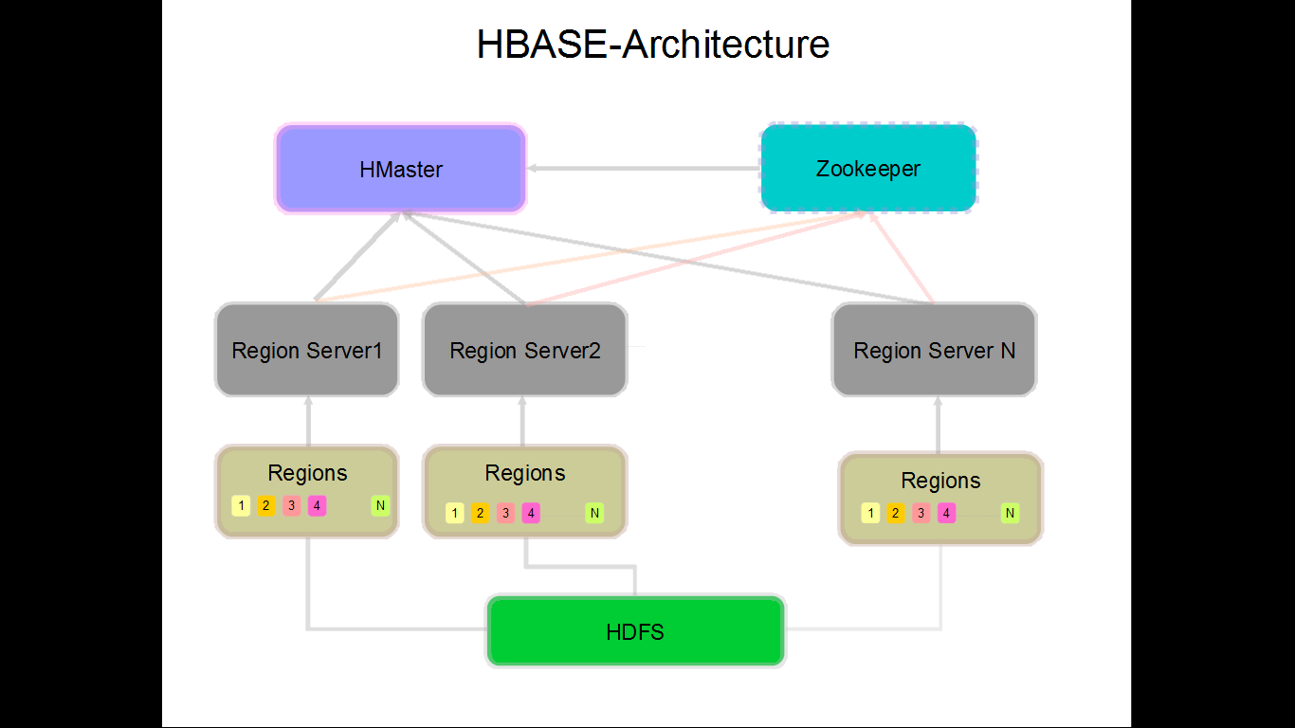

HMaster
Below are the key responsibilities of HMaster
- To store the Meta data information of the HBASE tables using -ROOT- and .META. Files
- To bootstrap RegionServer ie;starting Region Server
- RegionServer failover/fault tolerance and backup mechanism is handled by HMASTER
- HMASTER should be part of a Hadoop Node
- Interface for creating, deleting, updating tables

RegionServer
- Regionservers do not run any job like TaskTrackers . They just store data and are responsible for serving and managing regions.
- Each Region Server is responsible to serve a set of Regions(one or more).However each Region can be associated to only on Region Server
- Region Server should be part of Hadoop Node
- Region Server should be only on Data Node

Region
- Regions are a subset of the table’s data, and they are essentially a contiguous, sorted range of rows that are stored together.
- Each Region is assigned to a Region Server on startup and the master can decide to move a Region from one Region Server to another as the result of a load balance operation.
- Mapping of a Region to Region Server is handled by HMaster
- Intially there will be one region for one table. When region grows too large its gets splits into two and this information will be reported to HMASTER.
- Each Region is 1GB by default

ZooKeeper
- Hadoop Architecture is Single Point of Failure since it has only one Name Node and no backup or failure mechanism to address it.In HBASE ZooKeeper addresses the SPOF.
- Zookeeper cannot be compared to Secondary Name Node
- ZooKeeper is like HIVE,SQOOP,PIG component.
- Zookeeper is used to achieve coordination of distributed nodes between components of Hadoop.Plays important role in distributed clustered environment.
- As part of HBASE we may or may not have ZooKeeper
- HBase by default manages a ZooKeeper cluster. It gets started and stopped as part of the HBase start/stop process. But, you can also manage the ZooKeeper ensemble independent of HBase and just point HBase at the cluster it should use.
- Zookeeper is used in other stacks for distributed coordination.It is not restricted to HBASE.
- Each Region Server is connected to Zookeeper.HMaster keeps track of these connections.Zookeeper maintains heartbeats with timeout.On timeout Master declares RegionServer as dead and starts recovery process by reassigning regions to different active RegionServer
- ZooKeeper stores the .META. File

-ROOT- Table
- -ROOT- Table keeps track of .META. Table

.META. Table
- META table, holds the location of the all the regions in the cluster/system.
- The .META. table structure is as follows: - Key: region start key,region id- Values: RegionServer
- ZooKeeper stores the location of the META table.
- The client gets the Region server that hosts the META table from ZooKeeper.
- The client will query the Region server that hosts .META. table to get the region server corresponding to the row key it wants to access.
- The client caches region server(thats has the row key) information along with the META table location.
- It will get the Row from the corresponding Region Server
Reference :-https://www.mapr.com/blog/in-depth-look-hbase-architecture

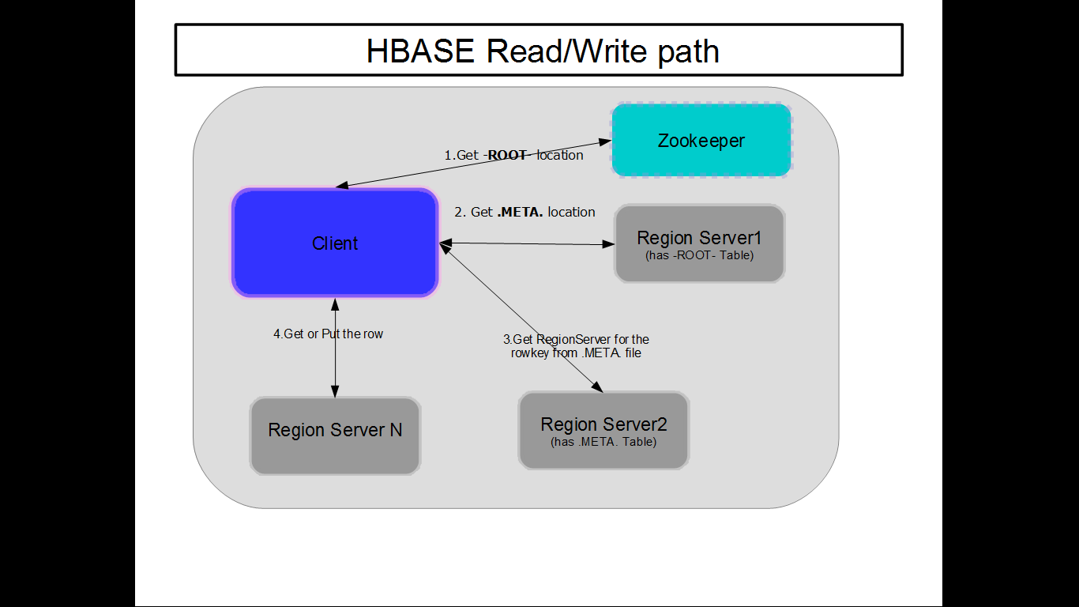
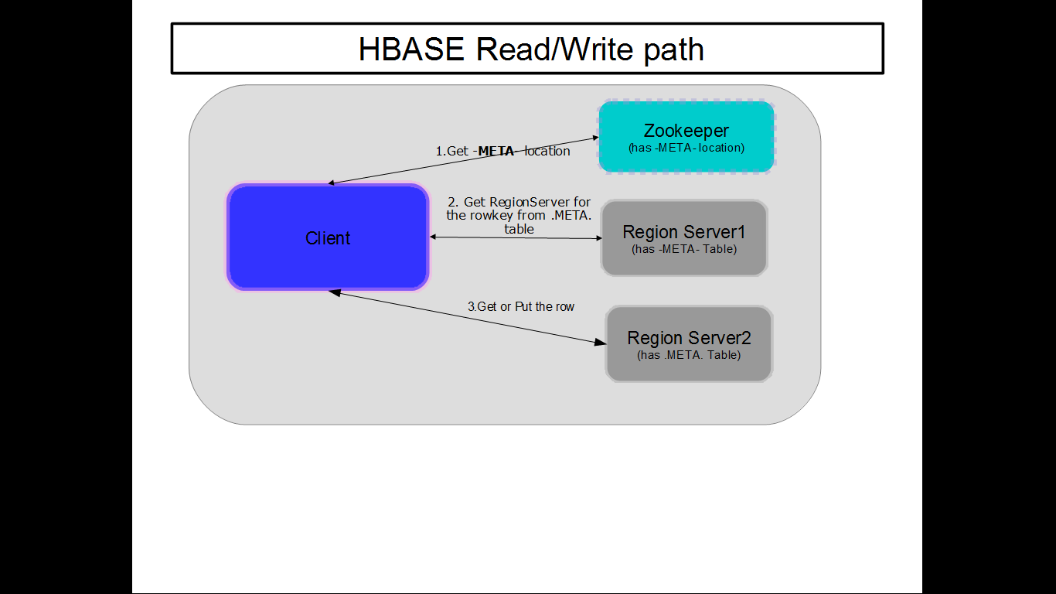

Data Modelling

HTable

HBase tables are more like logical collection of rows stored in separate partitions called Regions

ColumnFamily

Data within a row is grouped by Column Family.
- As Column families also impact the physical arrangement of data stored in Hbase ,we need to define the ColumnFamily up front and they are not easily modified.
- Each Column Family has one or more Columns and these Columns in a family are stored together in a low level storage file known as Hfile
- Every row in a table has the same column families, although a row need not store data in all its families

ColumnQualifierName (CQN)

Data within a Column Family is tagged under ColumnQualifier/Column.
- No need to specify Column qualifiers in advance.Column qualifiers need not be consistent between rows.
- Column qualifiers do not have a data type and are always treated as a byte[ ](bytearray).

RowKey

A row is one instance of data in a table and is identified by a rowkey.
- Rowkeys are unique in a Table and are always treated as a byte[](bytearray).
- Row keys do not have a data type.

TimeStamp

Values within a cell are versioned. Versions are identified by their version number, which by default is the timestamp of when the cell was written.
- If a timestamp is not specified during a write, the current timestamp is used.
- If the timestamp is not specified for a read, the latest one is returned.
- The number of cell value versions retained by HBase is configured for each column family.
- The default number of cell versions is three.

cell

A combination of row key, column family, and column qualifier uniquely identifies a cell.
- In HBASE table ,the entity that contains the data is called a cell
- The data stored in a cell is referred to as that cell’s value. Values
also do not have a data type and are always treated as a byte[ ](bytearray).

Sample table structure in HBASE

Table1:-SW_TECH
A table SW_TECH in HBase consisting of two column families, Database and Programming Language, each having two columns.Database ColumnFamily comprises of SQL column and NoSQL column. Programming Language Column Family comprises of Web Programming and Software Programming Columns.
Software Technologies Table content :-SW_TECH

 | Column Family-DB (Database) |  | Column Family-PRG_LNG (Programming Language)
RowKey | CQN-SQL | CQN-NoSQL | CQN-Web_PRG | CQN-SW_PRG
'0001 | MySQL | Cassandra | HTML | C
'0002 | Oracle | MongoDB | JavaScript | C++
'0003 | Sybase | HBASE | VBScript | Java

Table2:-CUST_DET
A CUST_DET table in HBase consisting of two column families CustomerName(with 3 columns i.e; First Name,MiddleName,LastName),Shipping Address(with 2 columns i.e;Address1,Address2 ) and CustomerPersonalInformation (with 2 columns i.e;Gender,Age). The entity that contains the data is called a cell. The rows are sorted based on the row keys.

Customer Details Table content :-CUST_DET
 | Column Family-CUST_NAME |  |  | Column Family-SHIP_ADDRESS |  | Column Family-CUST_PERSONAL_INFO
RowKey | CQN-FIRST_NAME | CQN-MIDDLE_NAME | CQN-LAST_NAME | CQN-ADD1 | CQN-ADD2 | CQN-GENDER | CQN-AGE
'0001 | Krishna | Kanth | Ch | 123-A | KPHB colony,Hyderabad | M | 25
'0002 | Raju |  | M | SV Apartment,BFM layout |  | M | 27
'0003 | Sandhya | Rani | A | H.No-155,First Floor | Street-10,DharamKarm Road,Ameerpet | F | 29

Steps to execute the DDL and DML statements in HBASE shell
    - Access VMWare WorkStation >> PowerOn this virtual machine
    - login into the ubuntu by providing the username and password
    - Open Ubuntu Terminal Applications >> Accessories >> Terminal
    - On ubuntu terminal login with username and password
    - mrinmoyroot@ubuntu: su root
    - password:pwd
    - Ensure HMASTER is running by executing the jps command
root@ubuntu:/home/mrinmoy# jps
943 DataNode
1461 NameNode
1352 JobTracker
1683 TaskTracker
1572 SecondaryNameNode
2276 Jps
1840 QuorumPeerMain
    - We need to kill the ZooKeeper and also start the HMASTER on this cluster
root@ubuntu:/home/mrinmoy# kill 1840
    - root@ubuntu:/usr/lib/hbase/bin# ./start-hbase.sh
starting master, logging to /usr/lib/hbase/bin/../logs/hbase-root-master-ubuntu.out
root@ubuntu:/usr/lib/hbase/bin# jps
943 DataNode
2765 Hmaster
1461 NameNode
1352 JobTracker
1683 TaskTracker
2907 Jps
1572 SecondaryNameNode

DDL in HBASE
Let us consider to create and insert data into the table Software Technologies , Table1 “SW_TECH” mentioned above.

create - Creates a table.
If we provide just table name we will get error as below.
We need to provide at least one column family while creating the table in HBASE.
hbase(main):002:0> create 'SW_TECH','CF_DB'
ERROR: Table must have at least one column family
Syntax:- create '<<tablename>>','<<columnfamily>>'
hbase(main):002:0> create 'SW_TECH','CF_DB'
0 row(s) in 1.2160 seconds

list - Lists all the tables in HBASE.
Syntax:- list
TABLE
Chaitanya
DEPT_HBASE
DHW
DUMMY1
DUMMY2
EMP_HBASE Employee Gopal NewTable RK SW_TECH TEMP_HBASE company_det htab48 order
x
16 row(s) in 0.0910 seconds
Syntax:- list '<<tablename>>'
hbase(main):004:0> list 'SW_TECH'
TABLE
SW_TECH
1 row(s) in 0.0770 seconds

disable - Disables a table from making any changes to the data.
Before making any alternation to the table. We need to disable the table.
Syntax:- disable '<<tablename>>'
hbase(main):026:0> disable 'x'
0 row(s) in 2.0720 seconds

is_disabled - Verifies whether a table is disabled. Will return true if the
table is disabled from performing any DML operations on the table.
Syntax:- is_disable '<<tablename>>'
hbase(main):009:0> is_disabled 'SW_TECH'
false
0 row(s) in 0.0130 seconds

enable - Enables a table. If table is in enabled mode then we cannot
alter the table. However we can perform DML operations on the table.
Syntax:- enable '<<tablename>>'
hbase(main):004:0> enable 'SW_TECH'
1 row(s) in 0.0770 seconds

is_enabled - Verifies whether a table is enabled. Will return true, if the table is in enabled mode.
Syntax:- is_enable '<<tablename>>'
hbase(main):007:0> is_enabled 'SW_TECH'
true
0 row(s) in 0.0090 seconds

describe - Provides the description of a table.
Syntax:- describe '<<tablename>>'

hbase(main):006:0> describe 'SW_TECH'
DESCRIPTION ENABLED
{NAME => 'SW_TECH', FAMILIES => [{NAME => 'CF_DB', BLOOMFILTER => 'NONE', REPLICATION_SCOPE => '0', COMPRES true
SION => 'NONE', VERSIONS => '3', TTL => '2147483647', BLOCKSIZE => '65536', IN_MEMORY => 'false', BLOCKCACH
E => 'true'}]}
1 row(s) in 0.0570 seconds

alter - Alters a table. (Add new Column Family,Version etc)
If the table is not disabled. We will get an error.
Lets try to add new Column Family CF_PRG_LNG to the table 'SW_TECH'
Syntax:- alter '<<tablename>>', {NAME=>>'<<columnfamily>>'}

hbase(main):010:0> alter 'SW_TECH', {NAME=>>'CF_PRG_LNG'}
ERROR: Table SW_TECH is enabled. Disable it first before altering.
Here is some help for this command:
Alter column family schema; pass table name and a dictionary
specifying new column family schema. Dictionaries are described
on the main help command output. Dictionary must include name
of column family to alter. For example,
To change or add the 'f1' column family in table 't1' from defaults
to instead keep a maximum of 5 cell VERSIONS, do:
hbase> alter 't1', NAME => 'f1', VERSIONS => 5
To delete the 'f1' column family in table 't1', do:
hbase> alter 't1', NAME => 'f1', METHOD => 'delete'
or a shorter version:
hbase> alter 't1', 'delete' => 'f1'
You can also change table-scope attributes like MAX_FILESIZE
MEMSTORE_FLUSHSIZE, READONLY, and DEFERRED_LOG_FLUSH.
For example, to change the max size of a family to 128MB, do:
hbase> alter 't1', METHOD => 'table_att', MAX_FILESIZE => '134217728'
You can also remove a table-scope attribute:
hbase> alter 't1', METHOD => 'table_att_unset', NAME => 'MAX_FILESIZE'
There could be more than one alteration in one command:
Steps to alter table i.e; Add new columnfamily 'CF_PRG_LNG' to the
table 'SW_TECH'
hbase(main):012:0> disable 'SW_TECH'
0 row(s) in 2.0870 seconds

hbase(main):013:0> is_enabled 'SW_TECH'
false
0 row(s) in 0.0230 seconds

hbase(main):014:0> is_disabled 'SW_TECH'
true
0 row(s) in 0.0150 seconds
hbase(main):015:0> alter 'SW_TECH',{NAME=>>'CF_PRG_LNG'}

exists - Verifies whether a table exists.
Syntax:- alter '<<tablename>>', {NAME=>>'<<columnfamily>>'}
hbase(main):005:0> exists 'SW_TECH'
Table SW_TECH does exist
0 row(s) in 0.0700 seconds

drop - Drops a table from HBase.
To drop a table it should be enabled.
hbase(main):025:0> drop 'x'
ERROR: Table x is enabled. Disable it first.'
Here is some help for this command:
Drop the named table. Table must first be disabled. If table has
more than one region, run a major compaction on .META.: hbase> major_compact ".META."

Follow the below steps to drop table 'x'
hbase(main):026:0> disable 'x'
0 row(s) in 2.0720 seconds
hbase(main):027:0> drop 'x'
0 row(s) in 1.2850 seconds

drop_all - Drops the tables matching the ‘regex’ given in the command.
Syntax:- drop_all '<<regex>>'
We are trying to delete all the tables starting with 'DUMMY'
hbase(main):004:0> drop_all 'DUMMY'

DML in HBASE
put - Puts a cell value at a specified column in a specified row in a particular table.
Syntax:- put '<<tablename>>' ,'<<rowkey>>' ,'<<columnfamily>:<columnqualifiername>>','<<value>>'hbase(main):009:0> put 'SW_TECH','0001','CF_DB:SQL','MySQL'
0 row(s) in 0.0700 seconds
hbase(main):010:0> put 'SW_TECH','0002','CF_DB:SQL','Oracle'
0 row(s) in 0.0150 seconds
hbase(main):011:0> put 'SW_TECH','0003','CF_DB:SQL','Sybase'
0 row(s) in 0.0280 seconds

Tabular representation of above command execution result :- SW_TECH
 | Column Family-DB (Database)
RowKey | CQN-SQL | CQN-NoSQL
'0001 | MySQL | Cassandra
'0002 | Oracle | MongoDB
'0003 | Sybase | HBASE

Let us check the content of the SW_TECH table for the inserted data
using scan
hbase(main):012:0> scan 'SW_TECH'
ROW COLUMN+CELL
0001 column=CF_DB:SQL, timestamp=1445672486706, value=MySQL
0002 column=CF_DB:SQL, timestamp=1445672512365, value=Oracle
0003 column=CF_DB:SQL, timestamp=1445672524619, value=Sybase
3 row(s) in 0.0600 seconds

get - Fetches the contents of row or a cell based on the attributes provided.
- To retrieve the data related to a specific row mention the rowkey.
Syntax:- get '<<tablename>>','<<rowkey>>'
- To retrieve the data related to a specific row and specific columnfamily mention the rowkey and columnfamily.
Syntax:- get '<<tablename>>','<<rowkey>>','<<columnfamily>>'
get 'SW_TECH','0002','CF_DB'
COLUMN CELL
CF_DB:NoSQL timestamp=1445672741320, value=MongoDB
CF_DB:SQL timestamp=1445672512365, value=Oracle
2 row(s) in 0.1160 seconds

Tabular representation of above command :-SW_TECH
 | Column Family-DB (Database)
RowKey | CQN-SQL | CQN-NoSQL
'0001 | MySQL | Cassandra
'0002 | Oracle | MongoDB
'0003 | Sybase | HBASE

To retrieve data of specific row and column data of specific version
Syntax:- get '<<tablename>>','<<rowkey>>', {COLUMN=>'<<columnfamily>>:<<CQN>>',VERSIONS=><<versionnumber>>}
Tabular representation of above command :-SW_TECH
 | Column Family-DB (Database)
RowKey | CQN-SQL | CQN-NoSQL
'0001 | MySQL | Cassandra
'0002 | Oracle | MongoDB
'0003 | Sybase | HBASE

hbase(main):052:0> get 'SW_TECH','0003',{COLUMN=>>'CF_DB:SQL',VERSIONS=>3}
COLUMN CELL
CF_DB:SQL timestamp=1445675026048, value=Sybase_0.5
CF_DB:SQL timestamp=1445675023657, value=Sybase_0.4
CF_DB:SQL timestamp=1445675021083, value=Sybase_0.3
3 row(s) in 0.0290 seconds

delete - Deletes a cell value in a table.
Lets scan the content of the 'SW_TECH'.We have 3 rows of data with 6 columns data.
hbase(main):026:0> scan 'SW_TECH'
ROW COLUMN+CELL
0001 column=CF_DB:NoSQL, timestamp=1445672721490, value=Cassandra
0001 column=CF_DB:SQL, timestamp=1445672486706, value=MySQL
0002 column=CF_DB:NoSQL, timestamp=1445672741320, value=MongoDB
0002 column=CF_DB:SQL, timestamp=1445672512365, value=Oracle
0003 column=CF_DB:NoSQL, timestamp=1445672759483, value=HBase
0003 column=CF_DB:SQL, timestamp=1445672524619, value=Sybase
3 row(s) in 0.0930 seconds

Syntax:- delete '<<tablename>>','<<ColumnFamily>>:<<CQN>>'
hbase(main):028:0> delete 'SW_TECH','0003','CF_DB:SQL'
0 row(s) in 0.0120 seconds

Tabular representation of above command :-SW_TECH
 | Column Family-DB (Database)
RowKey | CQN-SQL | CQN-NoSQL
'0001 | MySQL | Cassandra
'0002 | Oracle | MongoDB
'0003 | Sybase | HBASE

Now let's scan again and see the content of SW_TECH table.We have 3 rows with 5 columns data
hbase(main):029:0> scan 'SW_TECH'
ROW COLUMN+CELL
0001 column=CF_DB:NoSQL, timestamp=1445672721490, value=Cassandra
0001 column=CF_DB:SQL, timestamp=1445672486706, value=MySQL
0002 column=CF_DB:NoSQL, timestamp=1445672741320, value=MongoDB
0002 column=CF_DB:SQL, timestamp=1445672512365, value=Oracle
0003 column=CF_DB:NoSQL, timestamp=1445672759483, value=HBase
3 row(s) in 0.0680 seconds

deleteall - Deletes all the cells in a given row.
hbase(main):004:0> put 'SW_TECH','0003','CF_DB:NoSQL','HBASE'
0 row(s) in 0.0430 seconds
hbase(main):005:0> scan 'SW_TECH'
ROW COLUMN+CELL
0001 column=CF_DB:NoSQL, timestamp=1445672721490, value=Cassand
ra
0001 column=CF_DB:SQL, timestamp=1445672486706, value=MySQL
0002 column=CF_DB:NoSQL, timestamp=1445672741320, value=MongoDB
0002 column=CF_DB:SQL, timestamp=1445672512365, value=Oracle
0003 column=CF_DB:NoSQL, timestamp=1445698895561, value=HBASE
0003 column=CF_DB:SQL, timestamp=1445675026048, value=Sybase_0.
5
3 row(s) in 0.0560 seconds

Syntax:- delete '<<tablename>>','<<rowkey>>'
hbase(main):006:0> deleteall 'SW_TECH','0003'
0 row(s) in 0.0200 seconds

Tabular Representation of the above command :-SW_TECH
 | Column Family-DB (Database)
RowKey | CQN-SQL | CQN-NoSQL
'0001 | MySQL | Cassandra
'0002 | Oracle | MongoDB
'0003 | Sybase | HBASE

After delete lets scan the SW_TECH table. Since we have deleted rowkey 0003 we are left with 2 rows only.
hbase(main):007:0> scan 'SW_TECH'
ROW COLUMN+CELL
0001 column=CF_DB:NoSQL, timestamp=1445672721490, value=Cassand
ra
0001 column=CF_DB:SQL, timestamp=1445672486706, value=MySQL
0002 column=CF_DB:NoSQL, timestamp=1445672741320, value=MongoDB
0002 column=CF_DB:SQL, timestamp=1445672512365, value=Oracle
2 row(s) in 0.0380 seconds

scan - Scans and returns the table data.
Syntax:- scan '<<tablename>>'
hbase(main):007:0> scan 'SW_TECH'
ROW COLUMN+CELL
0001 column=CF_DB:NoSQL, timestamp=1445672721490, value=Cassand
ra
0001 column=CF_DB:SQL, timestamp=1445672486706, value=MySQL
0002 column=CF_DB:NoSQL, timestamp=1445672741320, value=MongoDB
0002 column=CF_DB:SQL, timestamp=1445672512365, value=Oracle
2 row(s) in 0.0380 seconds

count - Counts and returns the number of rows in a table.
Syntax:- count '<<tablename>>'
hbase(main):005:0> count 'SW_TECH'
0 row(s) in 0.0280 seconds
hbase(main):006:0> count 'EMP_HBASE'
5 row(s) in 0.0480 seconds

truncate - Disables, drops, and recreates a specified table.
hbase(main):009:0> scan 'RK'
ROW COLUMN+CELL
row1 column=Hadoop:echosys1, timestamp=1357824008072, value=Map
Reduce
row2 column=Hadoop:echosys2, timestamp=1357824029147, value=Apa
che PIG
row3 column=Hadoop:echosys3, timestamp=1357824043192, value=Hiv
e
row4 column=Hadoop:echosys4, timestamp=1357824058518, value=Sqo
op
row5 column=Hadoop:echosys5, timestamp=1357824071877, value=HBa
se
row6 column=Hadoop:echosys6, timestamp=1357824084803, value=HDFS
6 row(s) in 0.1200 seconds

Syntax:- truncate '<<tablename>>'
hbase(main):010:0> truncate 'RK'
Truncating 'RK' table (it may take a while):
- Disabling table...
- Dropping table...
- Creating table...
0 row(s) in 4.8160 seconds

Though we have truncated the table.HBASE re-creates the table with zero rows.
hbase(main):011:0> scan 'RK'
ROW COLUMN+CELL 0 row(s) in 0.0450 seconds
hbase(main):012:0>

JAVA API for HBASE
Using Java Code we will try to perform CRUD operation of HBASE tables
We are going to use Eclipse IDE for developing the HBASE-Java API code.
- In Eclipse File> New>>Java Project
Provide the Project Name :- TestHBase
- Click on Project Name>Src> New >Class
Provide the Java Class Name :- HBaseCreateTable
- Right click the src folder and Build Path > Configure Build Path
- Using External Jar file tab ,provide the HBASE jar files and click OK

Create table in HBASE using java code
import java.io.IOException;
import org.apache.hadoop.hbase.HBaseConfiguration;
import org.apache.hadoop.hbase.HColumnDescriptor;
import org.apache.hadoop.hbase.HTableDescriptor;
import org.apache.hadoop.hbase.MasterNotRunningException;
import org.apache.hadoop.hbase.ZooKeeperConnectionException;
import org.apache.hadoop.hbase.client.HBaseAdmin;

public class HBaseCreateTable {
public static void main(String[] args) throws IOException {
//provide the Table Name
String tableName = "DEPT_TABLE";
// provide the Column Family Names
String[] familys = { "DEPT_DET", "DEPT_LOC", "DEPT_HIERARCHY" };
// Configuration based on hbase-site.xml
org.apache.hadoop.conf.Configuration hConf = HBaseConfiguration
.create();
hConf.set("hbase.root.dir", "localhost.localdomain:54310/hbase");
hConf.set("hbase.zookeeper.quorum", "localhost");

try {
HBaseAdmin admin = new HBaseAdmin(hConf);
//check if table already exists
if (admin.tableExists(tableName)) {
System.out.println("table already exists!");
} else {
// if the table doesn't exist in the database,only then create the table
HTableDescriptor tableDesc = new HTableDescriptor(tableName);
//iterate the ColumnFamily list provided above
for (int i = 0; i < familys.length; i++) {
tableDesc.addFamily(new HColumnDescriptor(familys[i]));
}
admin.createTable(tableDesc);
System.out.println("create table " + tableName + " ok.");
}
}catch (MasterNotRunningException mnre) {
mnre.printStackTrace();
} catch (ZooKeeperConnectionException zkce) {
zkce.printStackTrace();
} catch (Exception e) {
e.printStackTrace();
} finally {

}

}
}

Eclipse Output showing the Table got created
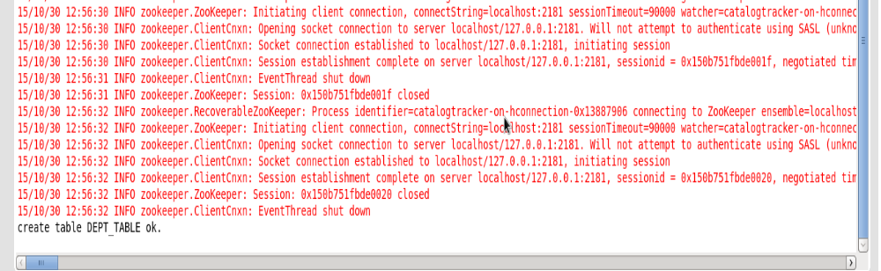

Let us access HBASE shell and verify if the table DEPT_TABLE got created.
hbase> list
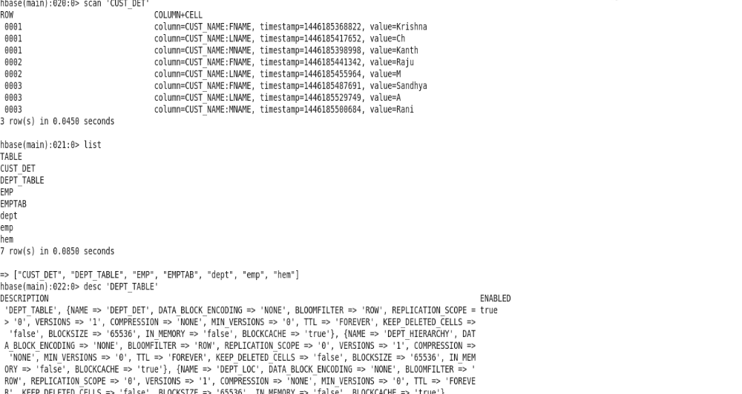
hbase > desc 'DEPT_TABLE'

Delete a HBASE table using java code
Create table TEMP_TABLE in the HBASE so that we can delete this table using java code
> hbase shell
> create 'TEMP_TABLE','xmldata'
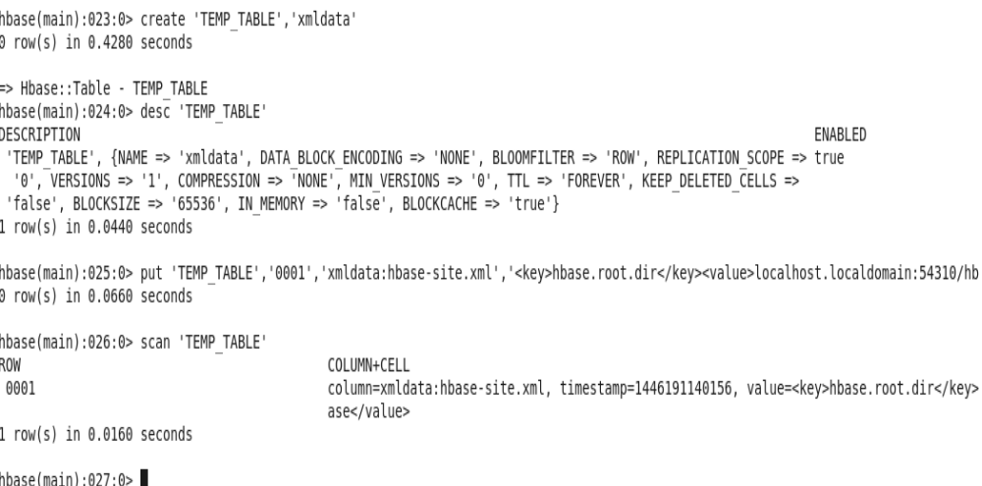
> desc 'TEMP_TABLE'

We are going to use Eclipse IDE for developing the HBASE-Java API code.
- In Eclipse File> New>>Java Project
Provide the Project Name :- TestHBase
- Click on Project Name>Src> New >Class
Provide the Java Class Name :- HBaseDeleteTable
- Right click the src folder and Build Path > Configure Build Path
- Using External Jar file tab ,provide the HBASE jar files and click OK

import java.io.IOException;

import org.apache.hadoop.hbase.HBaseConfiguration;
import org.apache.hadoop.hbase.MasterNotRunningException;
import org.apache.hadoop.hbase.ZooKeeperConnectionException;
import org.apache.hadoop.hbase.client.HBaseAdmin;
//This class will delete the HBASE table
public class HBaseDeleteTable {

public static void main(String[] args) throws IOException {
String tableName = "TEMP_TABLE";// mention the table name that need to be deleted
try {
org.apache.hadoop.conf.Configuration hConf = HBaseConfiguration.create();
hConf.set("hbase.root.dir", "localhost.localdomain:54310/hbase");
hConf.set("hbase.zookeeper.quorum", "localhost");
HBaseAdmin hadmin = new HBaseAdmin(hConf);
// We need to disable table to make any structural changes
hadmin.disableTable(tableName);
// As table is in disable state we can execute DML statements
hadmin.deleteTable(tableName);
System.out.println("deleted table " + tableName);
// We can write the code here to describe the table/ select from table
// which will throw execption as the table does not exist
} catch (MasterNotRunningException mnre) {
mnre.printStackTrace();
} catch (ZooKeeperConnectionException zkce) {
zkce.printStackTrace();
} catch (Exception e) {
e.printStackTrace();
}
}
}

- Check the HBASE for the 'TEMP_TABLE' using below command
- desc 'TEMP_TABLE'
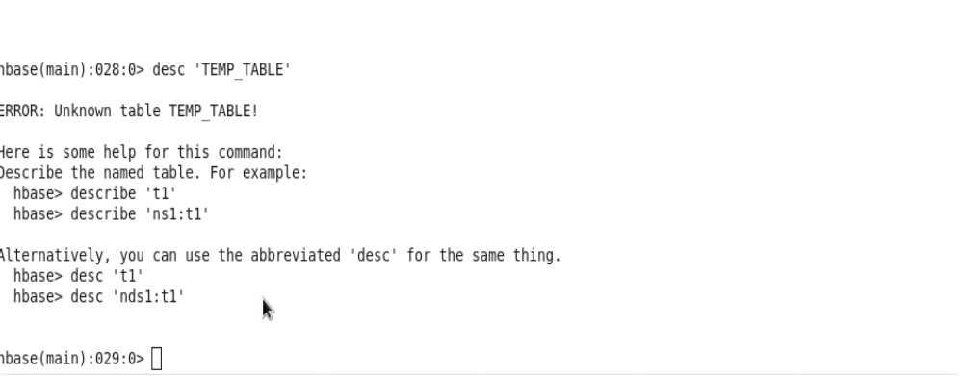
- we will get ERROR unknow table TEMP_TABLE.

Scan Table for first 3 rows using Java Code
We are going to use Eclipse IDE for developing the HBASE-Java API code.
- In Eclipse File> New>>Java Project
Provide the Project Name :- TestHBase
- Click on Project Name>Src> New >Class
Provide the Java Class Name :- HBaseScanClient
- Right click the src folder and Build Path > Configure Build Path
- Using External Jar file tab ,provide the HBASE jar files and click OK
- In the code provide the TableName,Column Family,CQN.
- Compile the Java Code and Run as Java Application.
import java.io.IOException;
import org.apache.hadoop.conf.Configuration;
import org.apache.hadoop.hbase.HBaseConfiguration;
import org.apache.hadoop.hbase.MasterNotRunningException;
import org.apache.hadoop.hbase.ZooKeeperConnectionException;
import org.apache.hadoop.hbase.client.HTable;
import org.apache.hadoop.hbase.client.Result;
import org.apache.hadoop.hbase.client.ResultScanner;
import org.apache.hadoop.hbase.client.Scan;
import org.apache.hadoop.hbase.util.Bytes;

public class HBaseScanClient {

public static void main(String[] arg) throws IOException {
try {
Configuration config = HBaseConfiguration.create();
config.set("hbase.rootdir", "localhost.localadmin:54310/hbase");
config.set("hbase.zookeeper.quorum", "localhost");
// provide the table name which we need to scan
HTable custTable = new HTable(config, "CUST_DET");

for (int i = 0; i < 3; i++) {
// provide the ColumnFamilyName
byte[] colfamily = Bytes.toBytes("CUST_NAME");
// provide the ColumnQualifierName
byte[] colqualname = Bytes.toBytes("FNAME");

Scan scan = new Scan();
scan.addColumn(colfamily, colqualname);
ResultScanner rs = custTable.getScanner(scan);
for (Result r = rs.next(); r != null; r = rs.next()) {
// valueObj will have all the 3 rows related FirstName's of
// the Customer
byte[] valueObj = r.getValue(colfamily, colqualname);
String value = new String(valueObj);
System.out.println(value);
}
}

custTable.close();
} catch (MasterNotRunningException e) {
e.printStackTrace();
} catch (ZooKeeperConnectionException e) {
e.printStackTrace();
} catch (Exception e) {
e.printStackTrace();
}

}
}

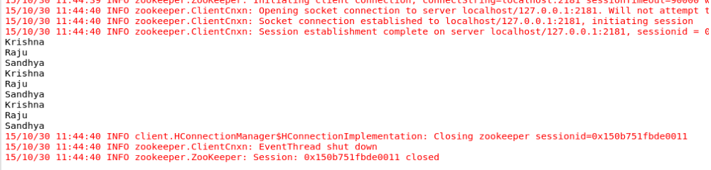
Eclipse Output showing the Column “firstname” of the CUST_DET table :-

Using Java Code scan and retrieve whole table content
We are going to use Eclipse IDE for developing the HBASE-Java API code.
- In Eclipse File> New>>Java Project
Provide the Project Name :- TestHBase
- Click on Project Name>Src> New >Class
Provide the Java Class Name :- HbaseScanTable
- Right click the src folder and Build Path > Configure Build Path
- Using External Jar file tab ,provide the HBASE jar files and click OK
- Provide the Table Name only in the code
- Compile the Java Code and Run as Java Application.

import java.io.IOException;

import org.apache.hadoop.hbase.HBaseConfiguration;
import org.apache.hadoop.hbase.KeyValue;
import org.apache.hadoop.hbase.MasterNotRunningException;
import org.apache.hadoop.hbase.ZooKeeperConnectionException;
import org.apache.hadoop.hbase.client.HTable;
import org.apache.hadoop.hbase.client.Result;
import org.apache.hadoop.hbase.client.ResultScanner;
import org.apache.hadoop.hbase.client.Scan;

public class HBaseScanTable {
public static void main(String[] args) throws IOException {
try {
org.apache.hadoop.conf.Configuration hConf = HBaseConfiguration.create();
hConf.set("hbase.root.dir", "localhost.localdomain:54310/hbase");
hConf.set("hbase.zookeeper.quorum", "localhost");
// Provide the table name that we need to scan
HTable table = new HTable(hConf, "CUST_DET");
System.out.println("getting all records of Customer Information table ");

Scan s = new Scan();
ResultScanner rs = table.getScanner(s);
// we are retrieving the whole table data here i.e; all records of table
for (Result res : rs) {
for (KeyValue kv : res.raw()) {
System.out.print(new String(kv.getRow())) + " ");
System.out.print(new String(kv.getFamily()) + ":");
System.out.print(new String(kv.getQualifier())) + " ");
System.out.print(kv.getTimestamp() + " ");
System.out.println(new String(kv.getValue()));
}//for
}//for
} catch (MasterNotRunningException e) {
e.printStackTrace();
} catch (ZooKeeperConnectionException e) {
e.printStackTrace();
} catch (Exception e) {
e.printStackTrace();
}
}
}

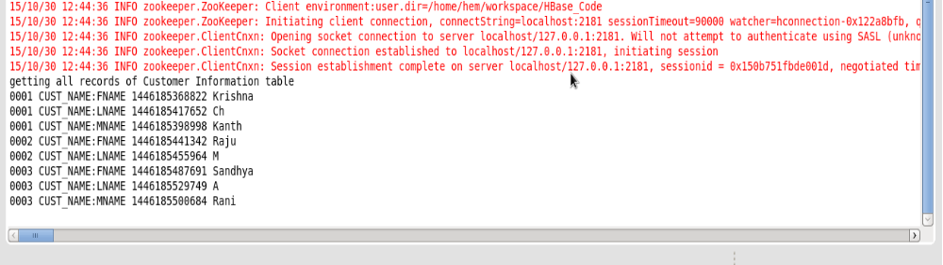
Eclipse Output Showing the content of the CUST_DET table

Using Java Code scan and retrieve Rowkey based table content
We are going to use Eclipse IDE for developing the HBASE-Java API code.
- In Eclipse File> New>>Java Project
Provide the Project Name :- TestHBase
- Click on Project Name>Src> New >Class
- Provide the Java Class Name :- HbaseGetRowData
- Right click the src folder and Build Path > Configure Build Path
- Using External Jar file tab ,provide the HBASE jar files and click OK
- Provide the Table Name and Rowkey in the code
- Compile the Java Code and Run as Java Application.

import java.io.IOException;

import org.apache.hadoop.hbase.HBaseConfiguration;
import org.apache.hadoop.hbase.KeyValue;
import org.apache.hadoop.hbase.MasterNotRunningException;
import org.apache.hadoop.hbase.ZooKeeperConnectionException;
import org.apache.hadoop.hbase.client.Get;
import org.apache.hadoop.hbase.client.HTable;
import org.apache.hadoop.hbase.client.Result;
import org.apache.hadoop.hbase.util.Bytes;

public class HBaseGetRowData {
public static void main(String[] args) throws IOException {
try {
org.apache.hadoop.conf.Configuration hConf = HBaseConfiguration.create();
hConf.set("hbase.root.dir", "localhost.localdomain:54310/hbase");
hConf.set("hbase.zookeeper.quorum", "localhost");
// Provide the table name
HTable table = new HTable(hConf, "CUST_DET");
System.out.println("getting Customer Information of Row 0001");
// We want to retrieve the data pertaining to RowKey =0001
Get get = new Get(Bytes.toBytes("0001"));
Result rs = table.get(get);
for (KeyValue kv : rs.raw()) {
System.out.print(new String(kv.getRow()) + " ");
System.out.print(new String(kv.getFamily()) + ":");
System.out.print(new String(kv.getQualifier()) + " ");
System.out.print(kv.getTimestamp() + " ");
System.out.println(new String(kv.getValue()));
}

} catch (MasterNotRunningException e) {
e.printStackTrace();
} catch (ZooKeeperConnectionException e) {
e.printStackTrace();
} catch (Exception e) {
e.printStackTrace();
}

}
}

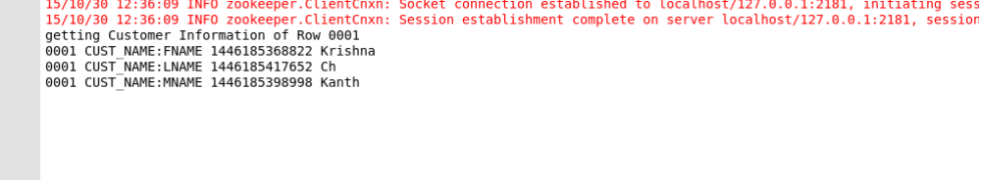
Eclipse Output showing the RowKey “0001” data of the CUST_DET table :-

Using Java code to retrieve table content for a
specific ColumnFamily:ColumnQualifierName
We are going to use Eclipse IDE for developing the HBASE-Java API code.
- In Eclipse File> New>>Java Project
Provide the Project Name :- TestHBase
- Click on Project Name>Src> New >Class
Provide the Java Class Name :- HbaseReadTableNew
- Right click the src folder and Build Path > Configure Build Path
- Using External Jar file tab ,provide the HBASE jar files and click OK
- Provide the Table Name only in the code
- Compile the Java Code and Run as Java Application.
import java.io.IOException;

import org.apache.hadoop.hbase.HBaseConfiguration;
import org.apache.hadoop.hbase.client.HTable;
import org.apache.hadoop.hbase.client.Result;
import org.apache.hadoop.hbase.client.ResultScanner;
import org.apache.hadoop.hbase.client.Scan;
import org.apache.hadoop.hbase.util.Bytes;

public class HbaseReadTableNew {
public static void main(String[] args) throws IOException {
org.apache.hadoop.conf.Configuration hConf = HBaseConfiguration.create();
hConf.set("hbase.root.dir", "localhost.localdomain:54310/hbase");
hConf.set("hbase.zookeeper.quorum", "localhost");
// Provide the table name from which we want to retrieve the data
HTable table = new HTable(hConf, "CUST_DET");
Scan scan = new Scan();
ResultScanner resultScanner = table.getScanner(scan);
System.out.println("Customer Information");
try {
for (Result rr = resultScanner.next(); rr != null; rr = resultScanner.next()) {
//provide the ColumnFamilyName and ColumnQualifierName
String fname = Bytes.toString(rr.getValue(Bytes.toBytes("CUST_NAME"), Bytes.toBytes("FNAME")));

String mname = Bytes.toString(rr.getValue(Bytes.toBytes("CUST_NAME"), Bytes.toBytes("MNAME")));

String lname = Bytes.toString(rr.getValue(Bytes.toBytes("CUST_NAME"), Bytes.toBytes("LNAME")));

System.out.println(lname + " " + fname + " " + mname);
}
} finally {
resultScanner.close();
}

}
}

Compile the Java Code and Run as Java Application.
Eclipse Output showing the all the columns data of the ColumnFamily
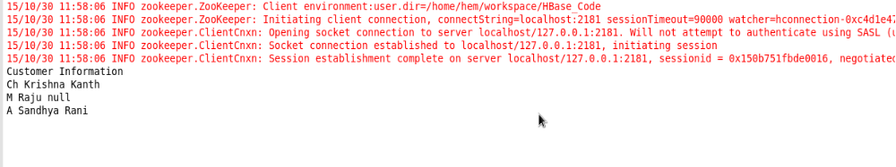
”CUST_NAME” of the CUST_DET table :-

Using Java code insert data into RowKey “0004” of the table “CUST_DET”
We are going to use Eclipse IDE for developing the HBASE-Java API code.
- In Eclipse File> New>>Java Project
Provide the ProjectName :- TestHBase
- Click on Project Name>Src> New >Class
Provide the Java Class Name :- HbaseInsertData
- Right click the src folder and Build Path > Configure Build Path
- Using External Jar file tab ,provide the HBASE jar files and click OK
- Provide the Table Name , RowKey,Column Family, Column Qualifier Name and Value in the code
- Compile the Java Code and Run as Java Application.

import java.io.IOException;

import org.apache.hadoop.hbase.HBaseConfiguration;
import org.apache.hadoop.hbase.MasterNotRunningException;
import org.apache.hadoop.hbase.ZooKeeperConnectionException;
import org.apache.hadoop.hbase.client.HTable;
import org.apache.hadoop.hbase.client.Put;
import org.apache.hadoop.hbase.util.Bytes;

public class HBaseInsertData {
public static void main(String[] args) throws IOException {
try {
org.apache.hadoop.conf.Configuration hConf = HBaseConfiguration.create();
hConf.set("hbase.root.dir", "localhost.localdomain:54310/hbase");
hConf.set("hbase.zookeeper.quorum", "localhost");
// provide the table name where we want to insert data
HTable table = new HTable(hConf, "CUST_DET"); System.out.println("inserting Customer Information");
// we are inserting rowkey "0004" into the CUST_DET table
Put put = new Put(Bytes.toBytes("0004"));
// provide the ColumnFamilyName and ColumnQualifierName and Value
put.add(Bytes.toBytes("CUST_NAME"), Bytes.toBytes("FNAME"), Bytes.toBytes("RamKrishna"));
table.put(put);
System.out.println("insert recored ");
} catch (MasterNotRunningException e) {
e.printStackTrace();
} catch (ZooKeeperConnectionException e) {
e.printStackTrace();
} catch (Exception e) {
e.printStackTrace();
}
}
}

- HBASE Shell commands to view the content of 'CUST_DET'
- Execute the command scan 'CUST_DET' in hbase shell
- We can see that RowKey 0004 related data is inserted.
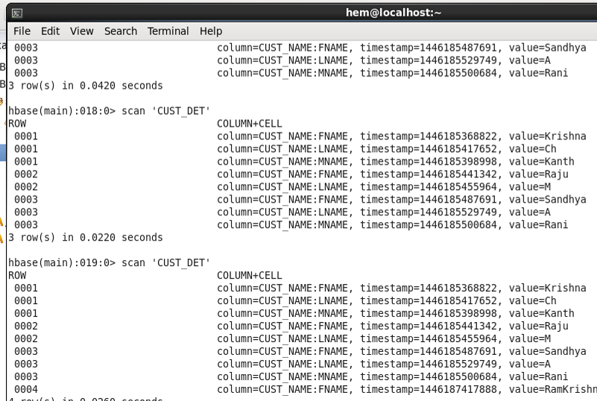

HBASE_MR Integration
Details steps are provided in this attached document. 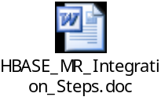
Using Java code we will try to Integrate HBASE and MapReduce
Problem Statement:-
Input files has StudentName,Age,Gender,Marks
Write processing logic using MapReduce code, find the student who scored maximum mark and store the student details in the scholarship details table of HBASE.
We are going to use Eclipse IDE for developing the HBASE-Java API code.
- In Eclipse File> New>>Java Project
Provide the Project Name :- TestHBase
- Click on Project Name>Src> New >Class
Provide the Java Class Name :- HbaseReadTableNew
- Provide the Table Name,ColumnFamily , ColumnQualifierName, Rowkey to create the Scholarship_details table.
- Using the input data process the data using MapReduce and store the student details who scored maximum marks into the Scholarship details
- Compile the Java Code and Run Configuration.
- Provide the Input file name in the Arguments section of the Run Configuration. Students_marks.txt and click Apply and Run to execute the java code.
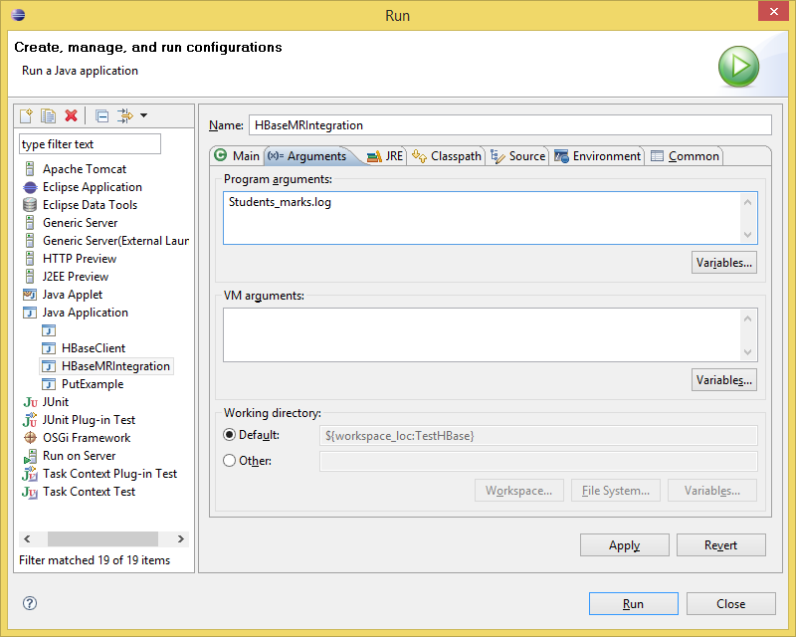

- Ensure that the Students_marks.txt is in the root path of the Java Project.

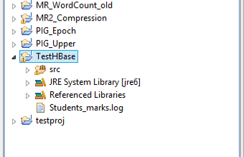

import java.io.IOException;

import org.apache.hadoop.conf.Configuration;
import org.apache.hadoop.fs.Path;
import org.apache.hadoop.hbase.HColumnDescriptor;
import org.apache.hadoop.hbase.HTableDescriptor;
import org.apache.hadoop.hbase.client.HBaseAdmin;
import org.apache.hadoop.hbase.client.Put;
import org.apache.hadoop.hbase.mapreduce.TableOutputFormat;
import org.apache.hadoop.hbase.mapreduce.TableReducer;
import org.apache.hadoop.hbase.util.Bytes;
import org.apache.hadoop.io.NullWritable;
import org.apache.hadoop.io.Text;
import org.apache.hadoop.mapreduce.Job;
import org.apache.hadoop.mapreduce.Mapper;
import org.apache.hadoop.mapreduce.lib.input.FileInputFormat;
import org.apache.hadoop.mapreduce.lib.input.TextInputFormat;

public class HBaseMRIntegration {
static private String TABLE_NAME = "SCHOLARSHIP_DET13";
static private String COL_FAMILY = "STUDENT_DET";
static private String COL_NAME = "STUDENT_NAME";
static private String COLUMN_AGE = "AGE";
static private String COLUMN_GENDER = "GENDER";
static private String COLUMN_MARKS = "MARKS";

public static class AgePartitionerMapper extends
Mapper<Object, Text, Text, Text> {
public void map(Object objkey, Text txtval, Context ctxt)
throws IOException, InterruptedException {

String[] tokens = txtval.toString().split("\t");
String strgender = tokens[2].toString();
String stroutval = tokens[0] + "\t" + tokens[1] + "\t" + tokens[3];
Text outkeytxt = new Text(strgender);
Text outvaltxt = new Text(stroutval);
ctxt.write(new Text(outkeytxt), new Text(outvaltxt));
}
}

// Here the 3rd argument is NullWritable
public static class AgePartitionerReducer extends
TableReducer<Text, Text, NullWritable> {
@Override
public void reduce(Text key, Iterable<Text> values, Context context)
throws IOException, InterruptedException {
int maxScore = Integer.MIN_VALUE;

String name = " ";
String age = " ";
String gender = " ";
int score = 0;
for (Text val : values) {
String[] valTokens = val.toString().split("\t");
score = Integer.parseInt(valTokens[2]);
if (score > maxScore) {
name = valTokens[0];
age = valTokens[1];
gender = key.toString();
maxScore = score;
}// if
}// for
int i = 0;
//Based on the MapReduce processed data insert data into the Table
Put put = new Put(Bytes.toBytes(age.toString()
+ String.valueOf(maxScore)));
put.add(Bytes.toBytes(COL_FAMILY), Bytes.toBytes(COL_NAME), Bytes
.toBytes(String.valueOf(name)));
put.add(Bytes.toBytes(COL_FAMILY), Bytes.toBytes(COLUMN_AGE), Bytes
.toBytes(String.valueOf(age)));
put.add(Bytes.toBytes(COL_FAMILY), Bytes.toBytes(COLUMN_GENDER),
Bytes.toBytes(String.valueOf(gender)));
put.add(Bytes.toBytes(COL_FAMILY), Bytes.toBytes(COLUMN_MARKS),
Bytes.toBytes(String.valueOf(maxScore)));
context.write(NullWritable.get(), put);
}
}

public static void main(String args[]) throws Exception {
if (args.length < 1) {
System.err.println("Usage: HBaseCalSum <path> ");
System.exit(-1);
}

Configuration conf = new Configuration();
conf.set("hbase.root.dir", "localhost.localdomain:54310/hbase");
conf.set("hbase.zookeeper.quorum", "localhost");
// set the TableOutputFormat provide the Table Name.
conf.set(TableOutputFormat.OUTPUT_TABLE, TABLE_NAME);

HBaseAdmin admin = new HBaseAdmin(conf);

//if table already exists provide an alert "table already exist"
if (admin.tableExists(TABLE_NAME)) {
System.out.println("table already exists!");
} else {
//else create new table with the provided Tablename,columnfamily
HTableDescriptor tableDesc = new HTableDescriptor(TABLE_NAME);
tableDesc.addFamily(new HColumnDescriptor(COL_FAMILY));
admin.createTable(tableDesc);
System.out.println("create table " + TABLE_NAME + " ok.");
}
String input = args[0];
Job job = new Job(conf, "HBASE_MR_Integration_" + input);
job.setJarByClass(HBaseMRIntegration.class);
job.setMapperClass(AgePartitionerMapper.class);
job.setReducerClass(AgePartitionerReducer.class);

job.setMapOutputKeyClass(Text.class);
job.setMapOutputValueClass(Text.class);

job.setInputFormatClass(TextInputFormat.class);
// The Output Format is Table
job.setOutputFormatClass(TableOutputFormat.class);
// We are providing only FileInputFormat and not FileOutputFormat
FileInputFormat.addInputPath(job, new Path(input));

int retJob = job.waitForCompletion(true) ? 0 : 1;
System.exit(retJob);
}
}

- Let us check if the table got created in HBASE and also if the MapReduce processed data is stored in the HBASE Table.

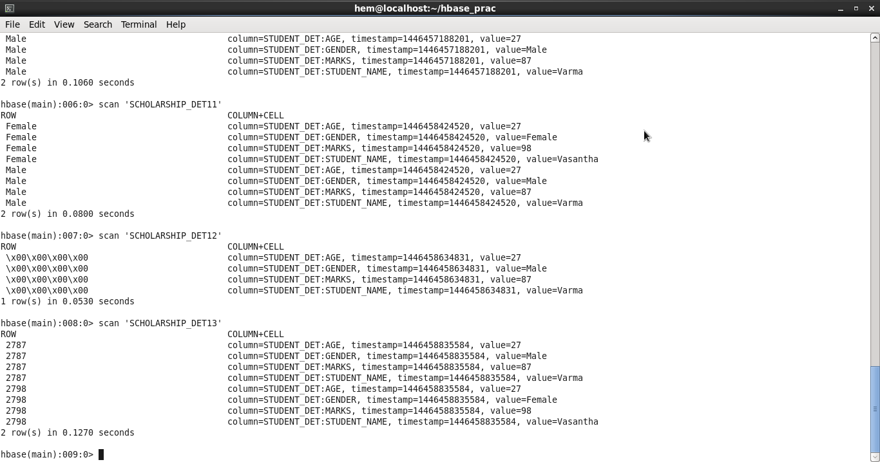
References:-
- Java API code. - reference https://autofei.wordpress.com/2012/04/02/java-example-code-using-hbase-data-model-operations/
- https://github.com/sleberknight/basic-hbase-examples
- https://github.com/sleberknight/basic-hbase-examples/tree/master/src/main/java/com/nearinfinity/explore/hbase

