**RESUME**

**Personal Details:**

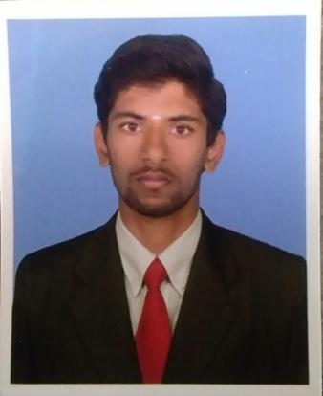Name :Balakrishnan A

Father Name :Anbu C

Email :balakrishnan3377@gmail.com

Mobile no :8012706024

Date of Birth :09.06.2000

Nationality :Indian

Marital status :Single

Languages Known :English and Tamil.

# Educational Qualification:

|  |  |  |  |  |  |
| --- | --- | --- | --- | --- | --- |
| Course | Institution | Board/ University |  | Year of passing | % secured |
| B.Tech  (Information Technology) | Sona College of Technology | Anna University | 2021(pursing) | | 7.4(CGPA) |
| HSC | Kongu Matric Hr. Sec. School | State Board | 2017 | | 86.4% |
| SSLC | Sri vinayagavidhyalaya matric Hr. Sec. School | State Board | 2015 | | 95.4% |

**Projects:**

**Project Title :** Aware of Expiry Products.

**Project Description :** To develop an application that notifys a message that **“your**

**product has expired. Don’t use that”.** This application was

developed by using Image processing and Android studio.

**Project Title :** Customized online retail shopping

**Project Description :** To develop an application in which you can sell or buy a product which you want,which was developed by using Android studio.

**Technical Skills:**

* Programming Languages:
* C
* C++
* Java(Basics)
* Python.
* Other Software: Microsoft word,powerpoint,Excel.

# Co-Curricular Activities:

* Participated in **“Coding”** Competition Conducted By Kumaraguru College of Technology,Coimbatore.
* Participated in **“Error Recovery”** Competition conducted by Coimbatore Institute of Technology,Coimbatore.
* Participated in **“Database Management Systems”**(DBMS),Exam Conducted by National programme on Technology Enhanced Learning(NPTEL) and scored 66% with **Elite** Certification .
* Participated in **“Programming and Data Structures in C”,**Exam Conducted by National programme on Technology Enhanced Learning(NPTEL) and scored 52%.

**Extra-Curricular Activities:**

* Organized various Inter and Intra level Symposiums for the Department of Information technology at Sona college of Technology(SCT),Salem.
* Sucessfully completed **Advanced Cpp** test organized at Sona college of Technology offered by **Spoken Tutorial Project, IIT Bombay.**

# Internship:

* Undergone Three months Internship on Artificial Intelligence in Python at Smartbridge & developed the project **“AI Enabled weed recognition system.”**

**Interpersonal skills:**

* Adaptability
* Quick Learner
* Punctuality

**Declaration:**

I hereby declare that all the information above are true and correct to my knowledge and belief.

Your’s truly,

1. Balakrishnan