1.HOME PAGE OF CRXDE LITE

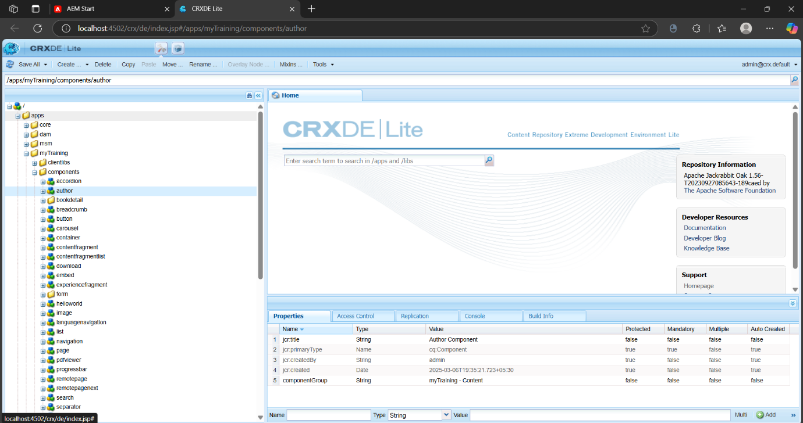

2.CREATION OF author COMPONENT

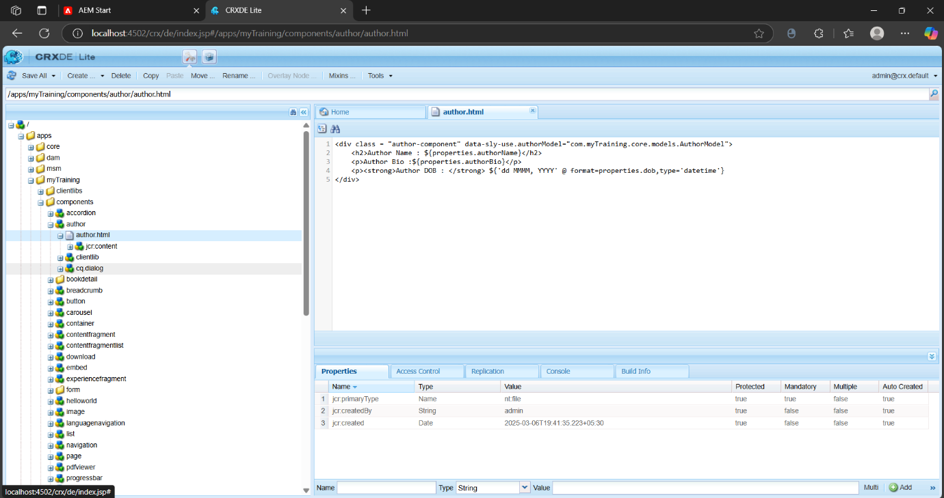

3.ADDING .html AND .css FILES TO THE COMPONENT

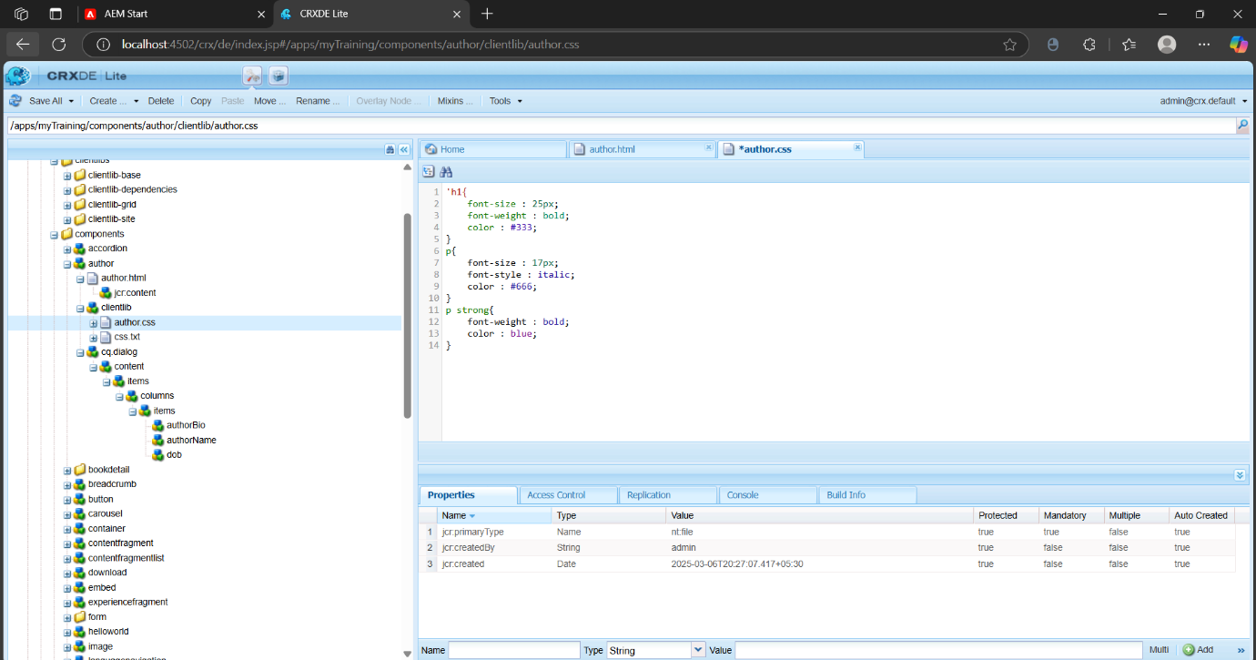

4.ADDING authorName , authorBio, dob NODES

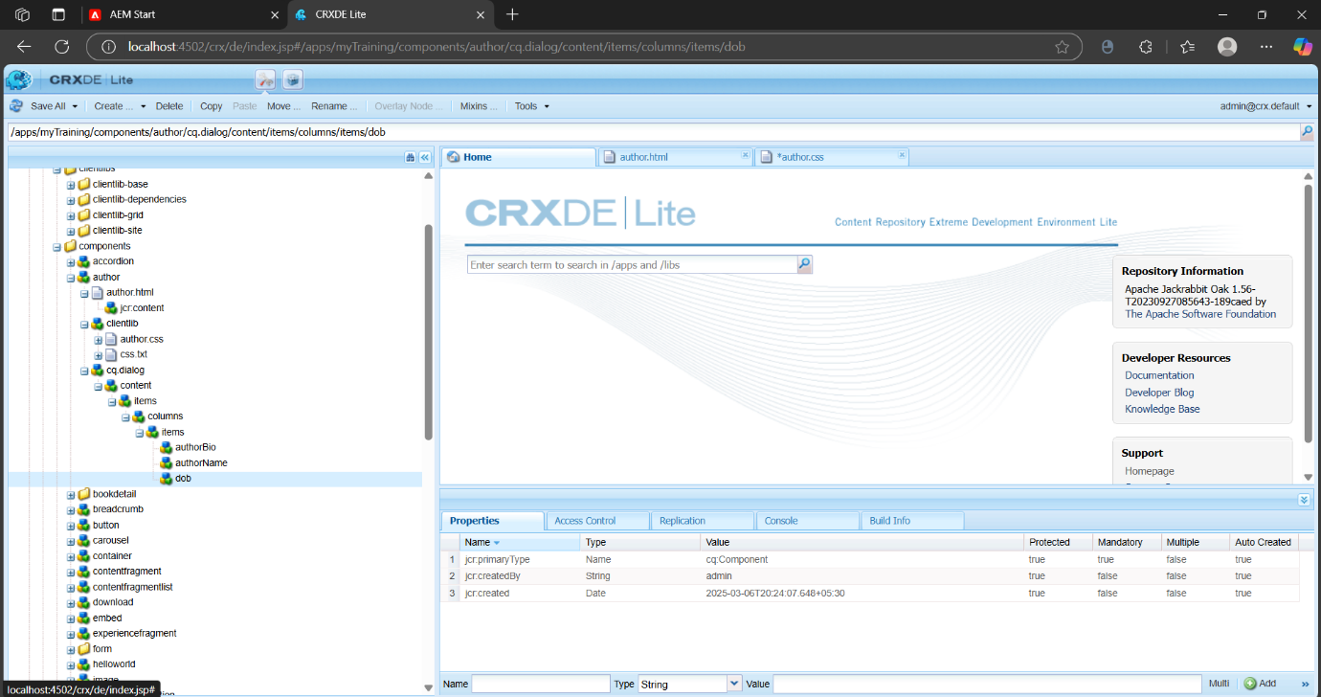

5.OUTPUT PAGES

