DAY – 5 TASK

1.Header :

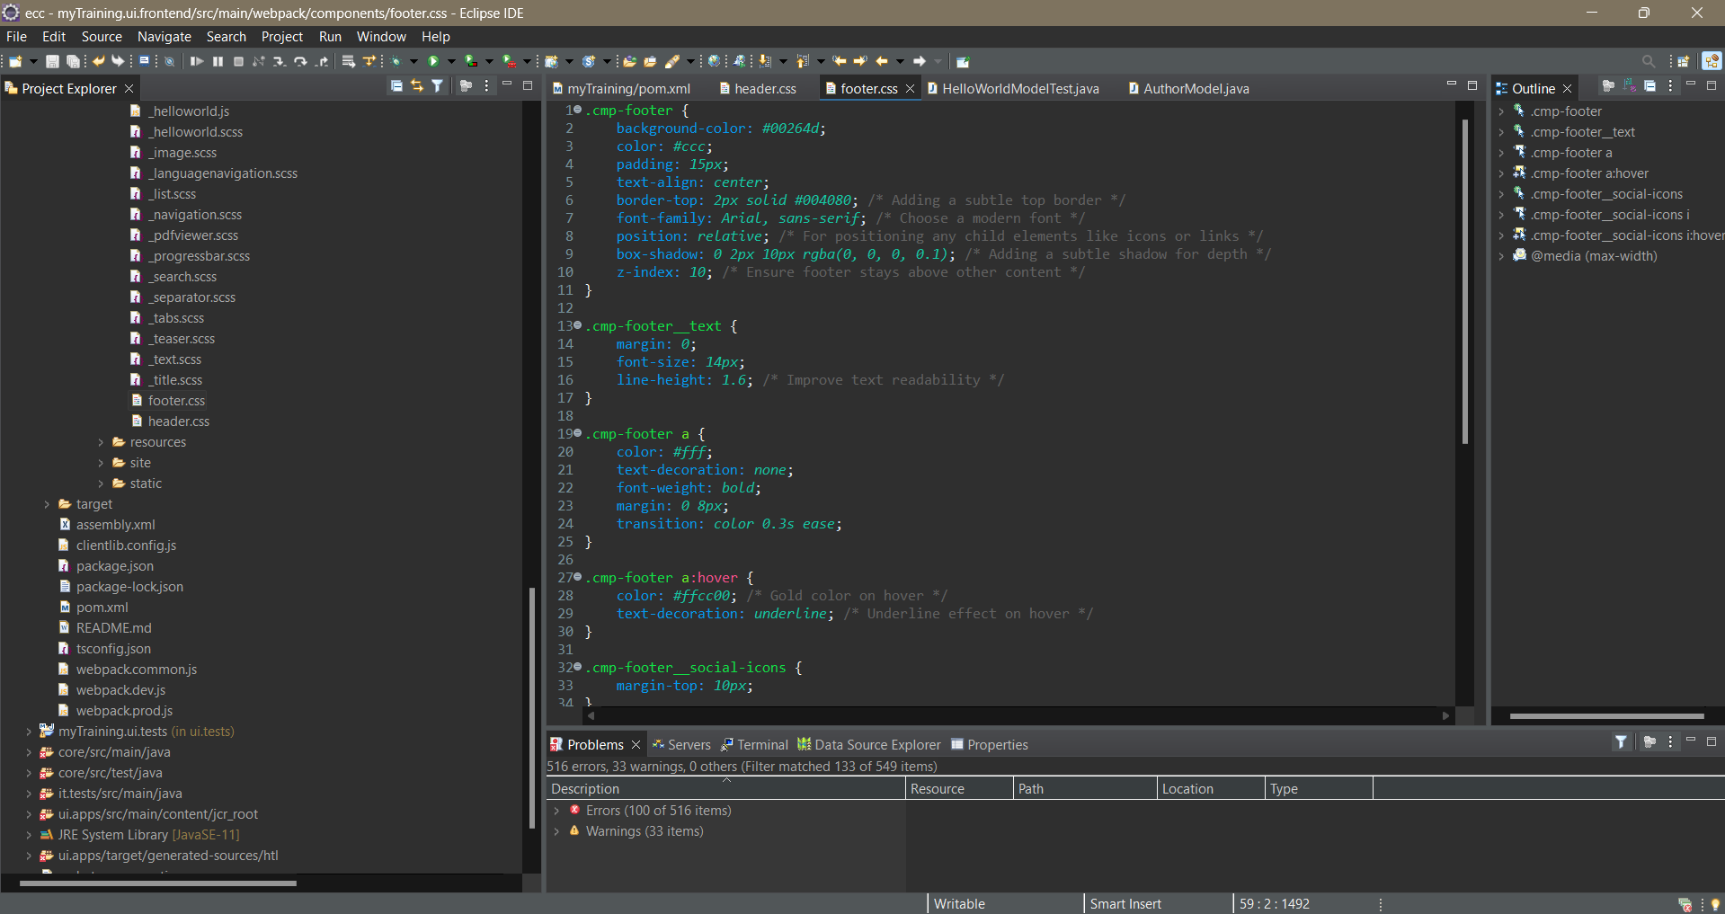

2.Footer:

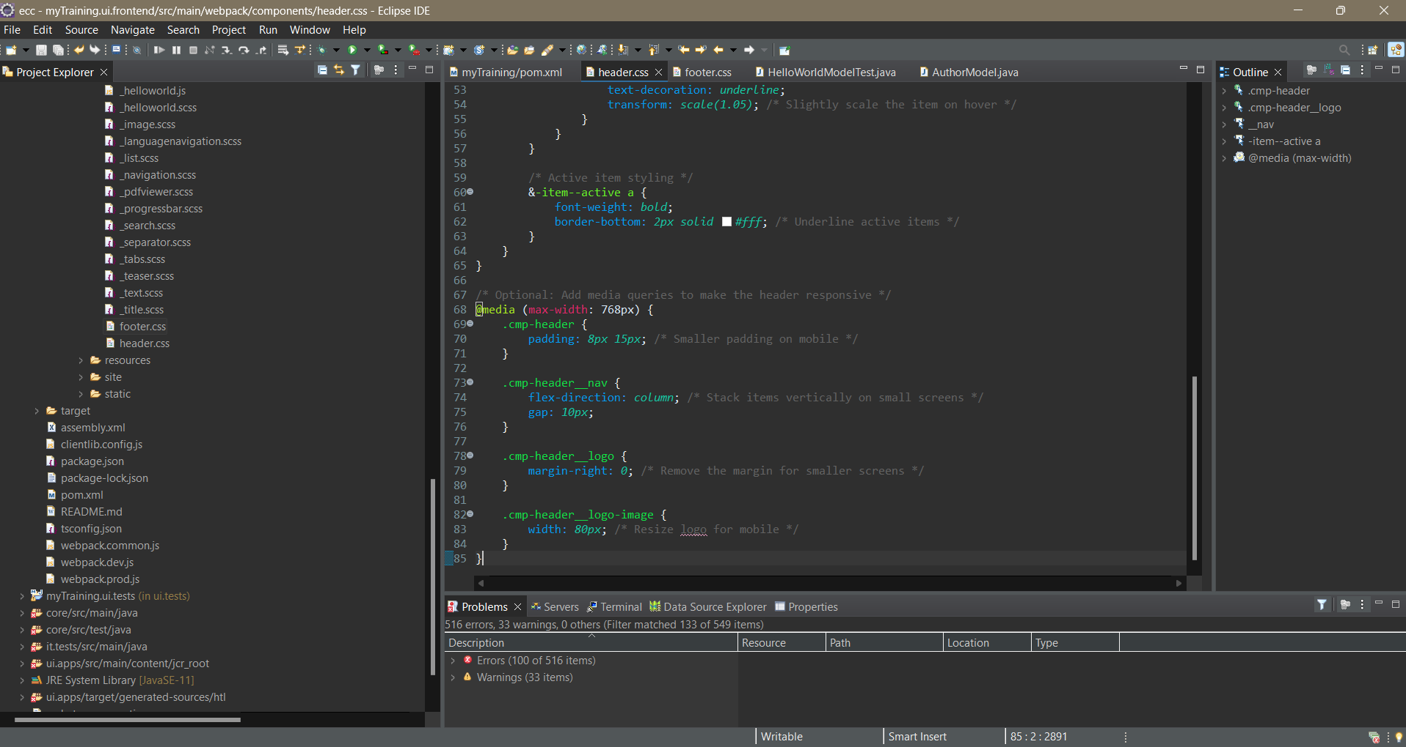

3.CUSTOM PAGE PROPERTY

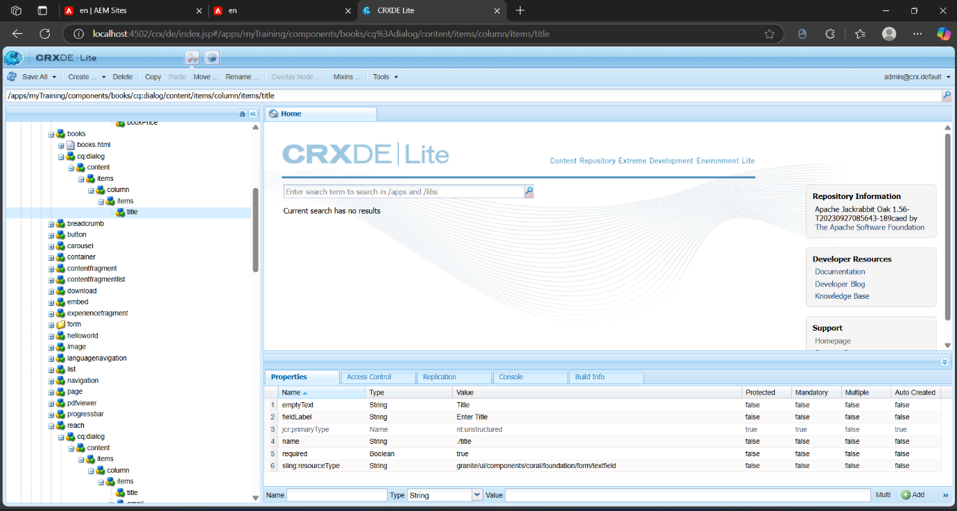

4.Add properties to components

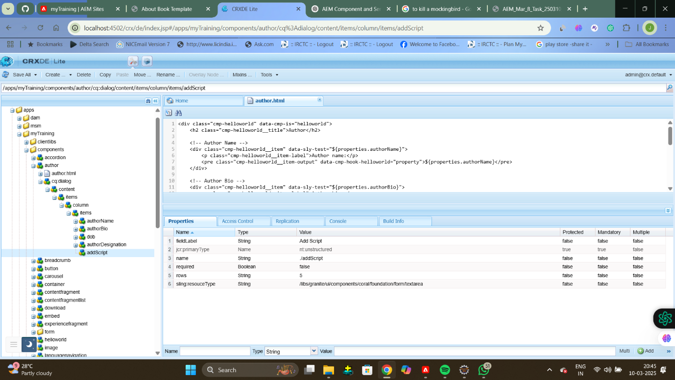

5.Update to Author Component

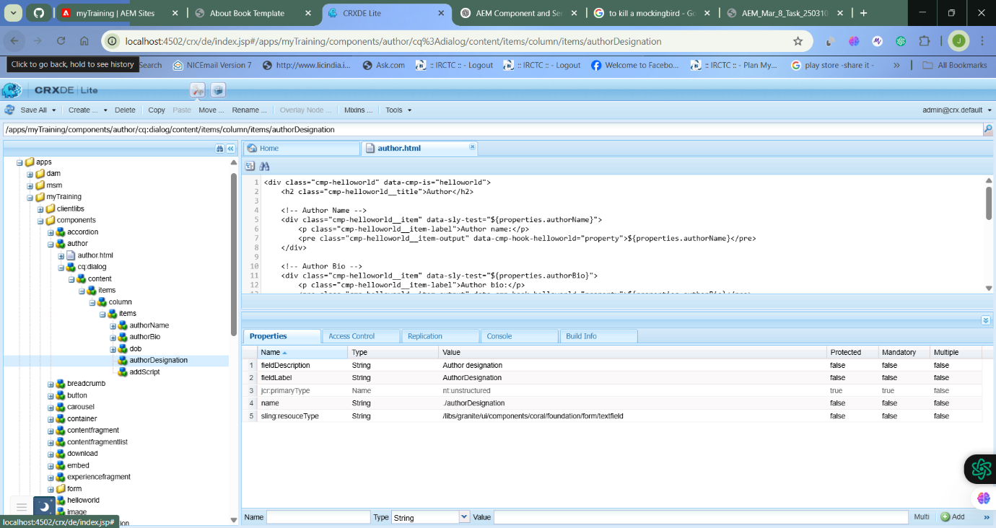

6.AUTHOR DETAILS COMPONENT

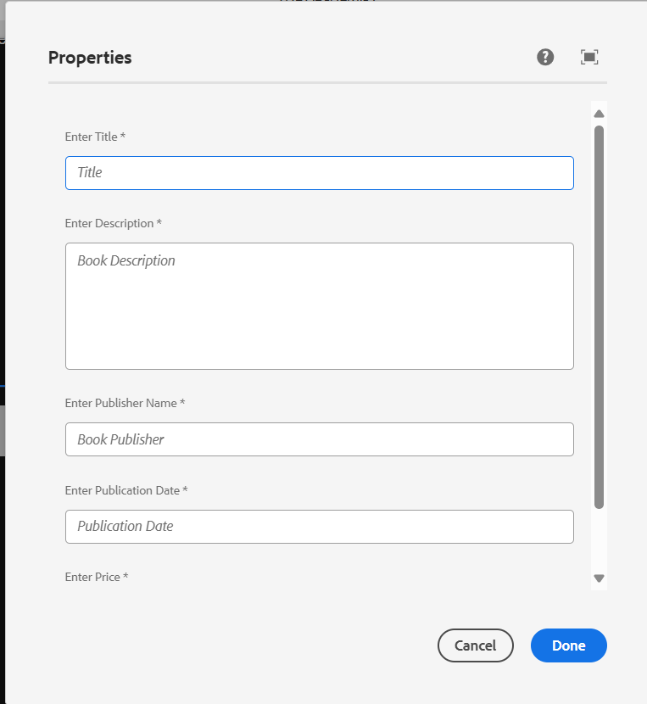

7. BOOK PAGE

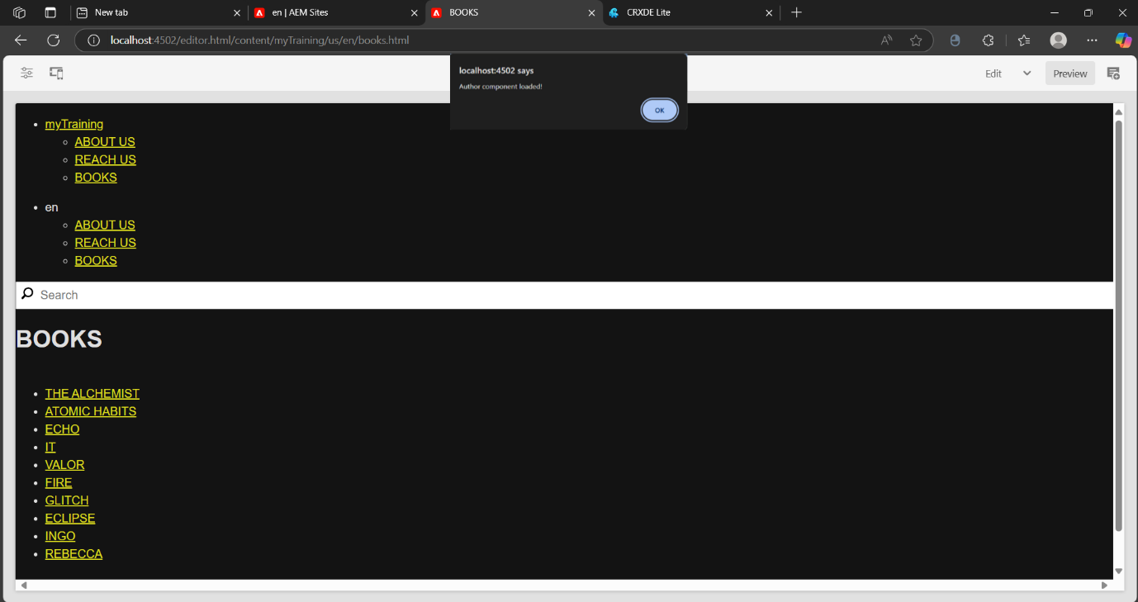

8.Book page

