DAY-6 AEM TASK

**STEP1: Creating Author Template**

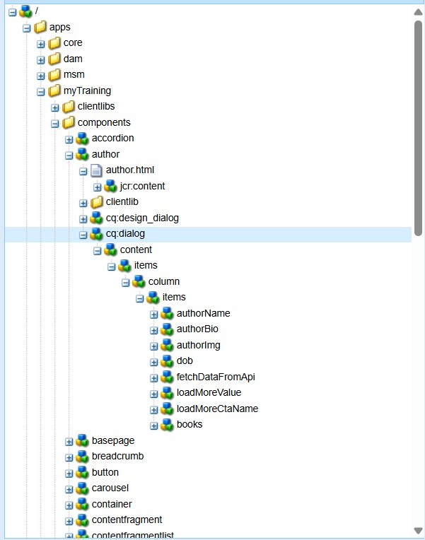

**STEP2: Adding components to author component to call from third party API and displaying them as cards** .

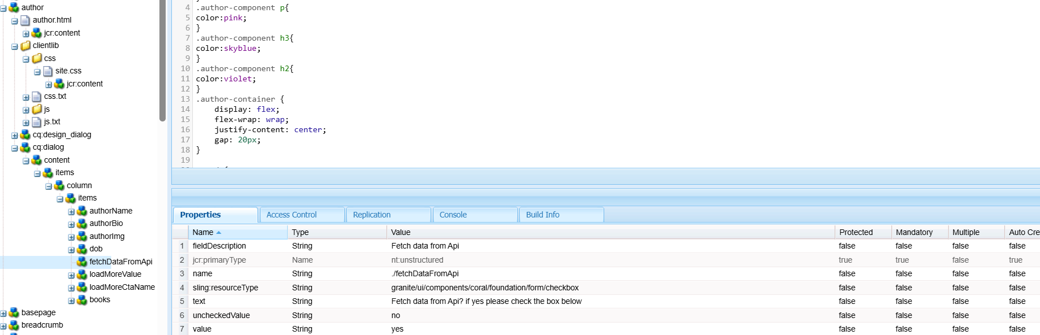

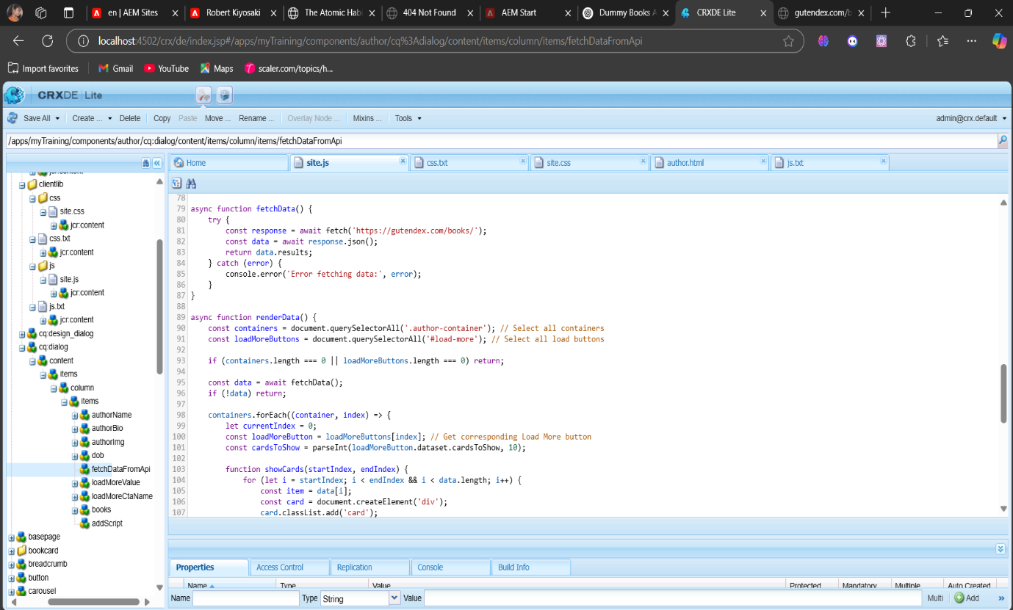

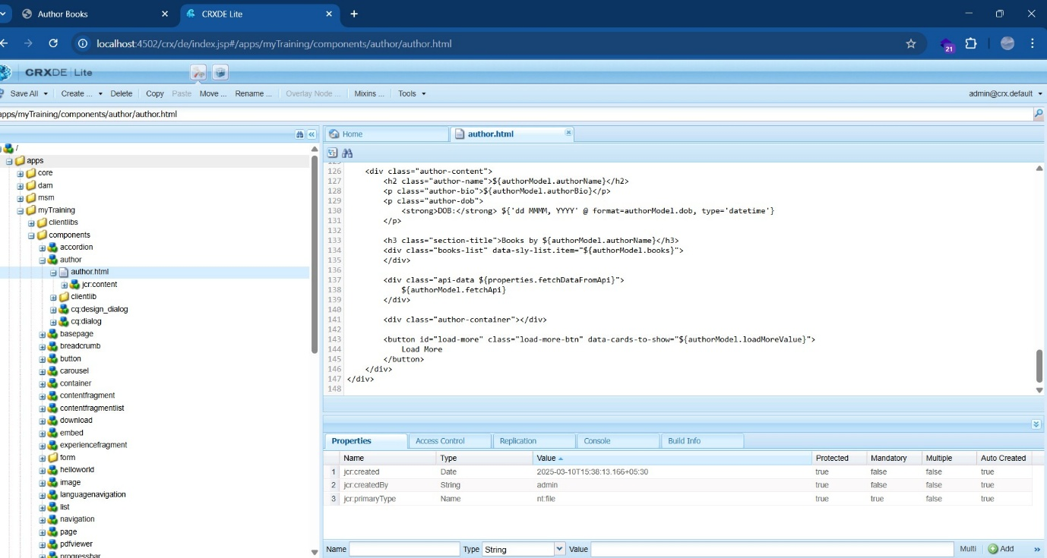

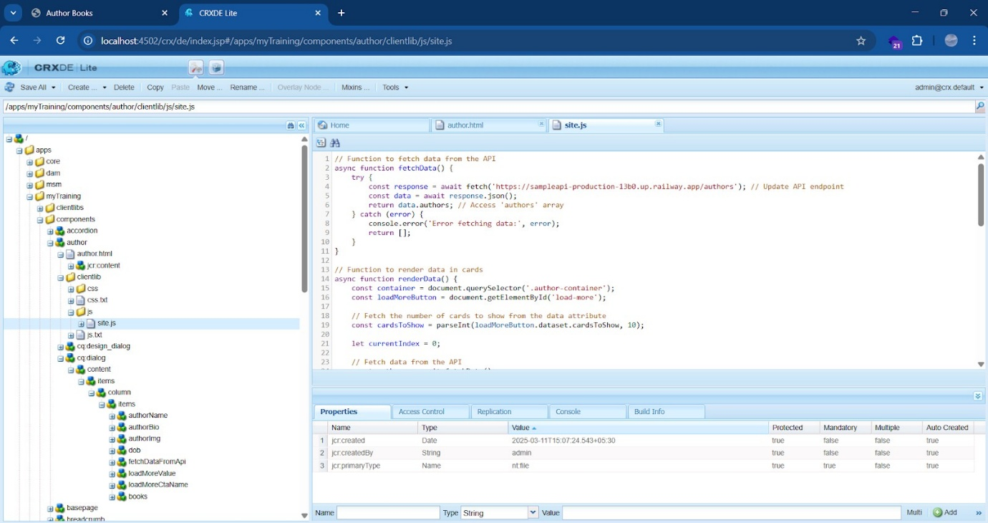

**3.AUTHOR COMPONENT IN TEMPLATE**

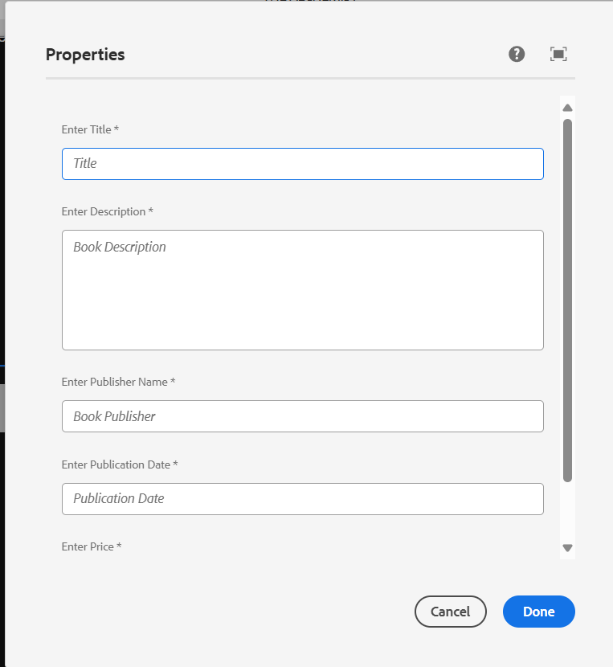

**4.AUTHOR MODEL FILE FOR IMPLEMENTATION**

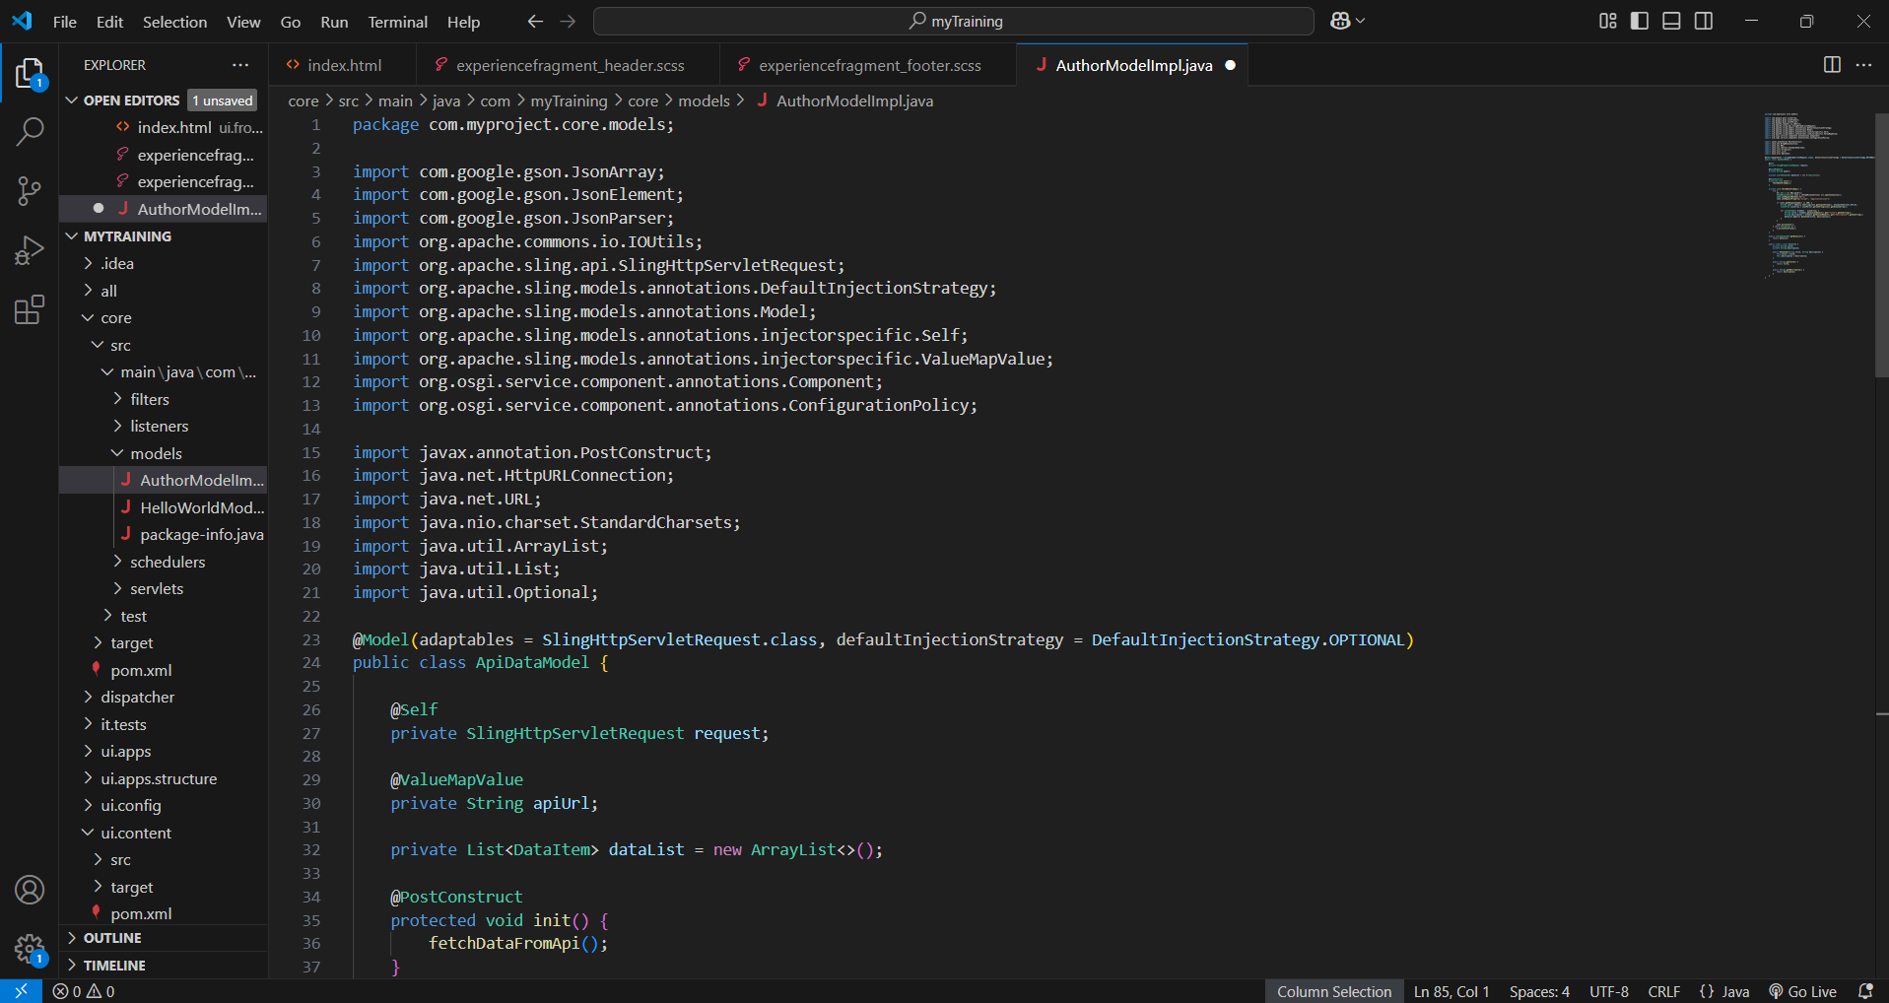

**5. BOOK PAGE COMPONENT IN THE CARD VIEW**

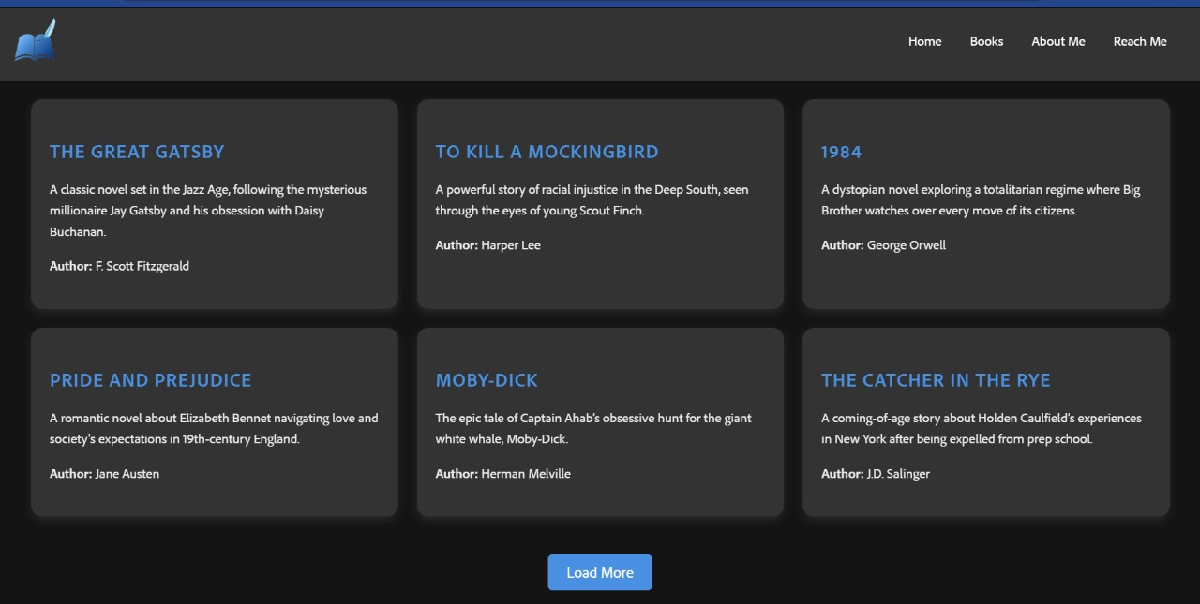

**6.CUSTOM CONFIGURATION FILE**

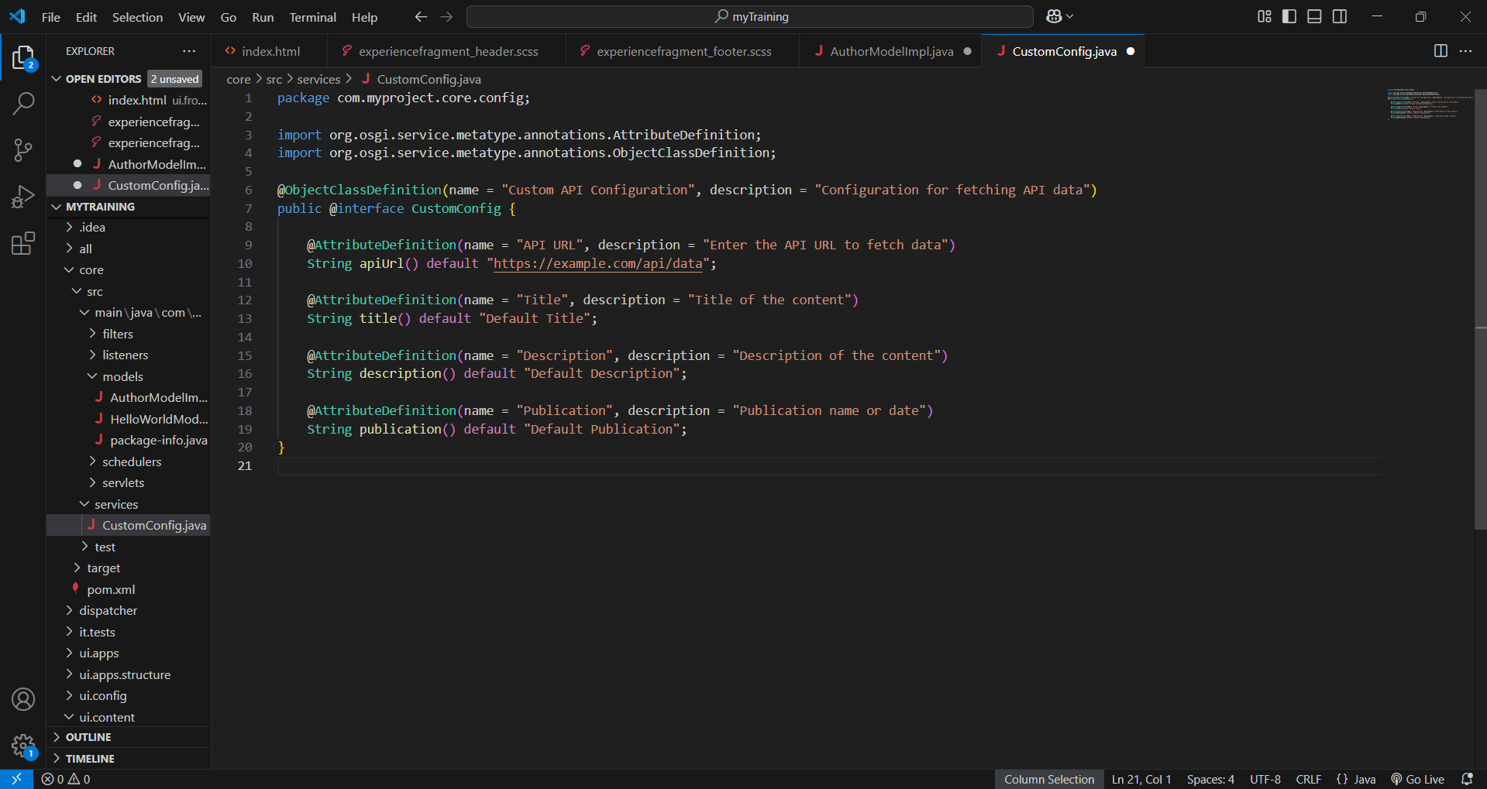

**7. SERVICES AND ITS IMPLEMENTATION FILES**

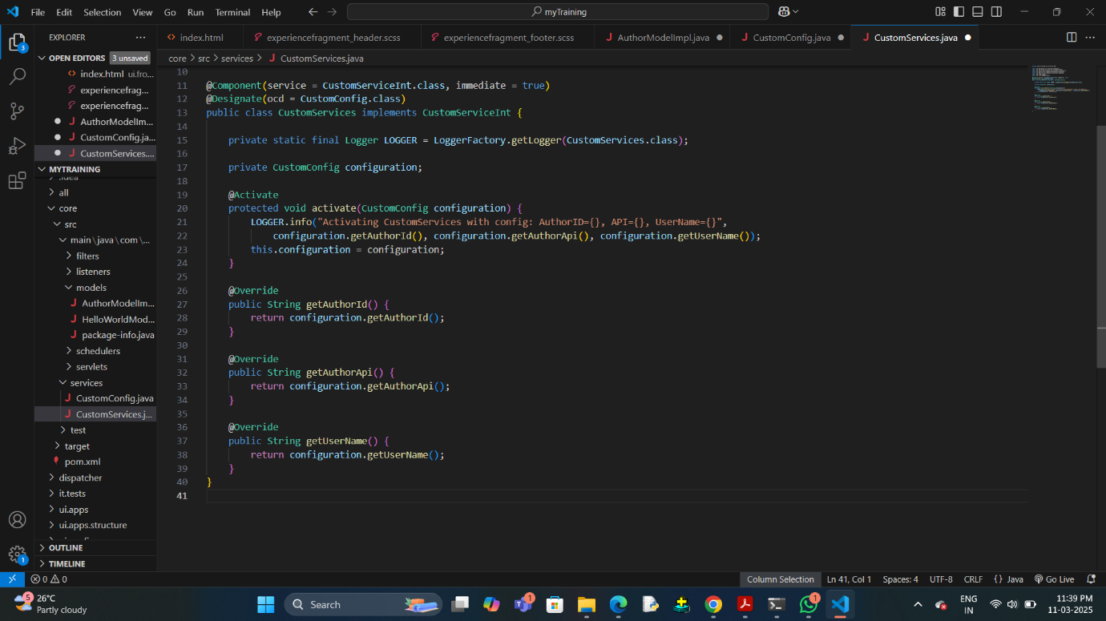

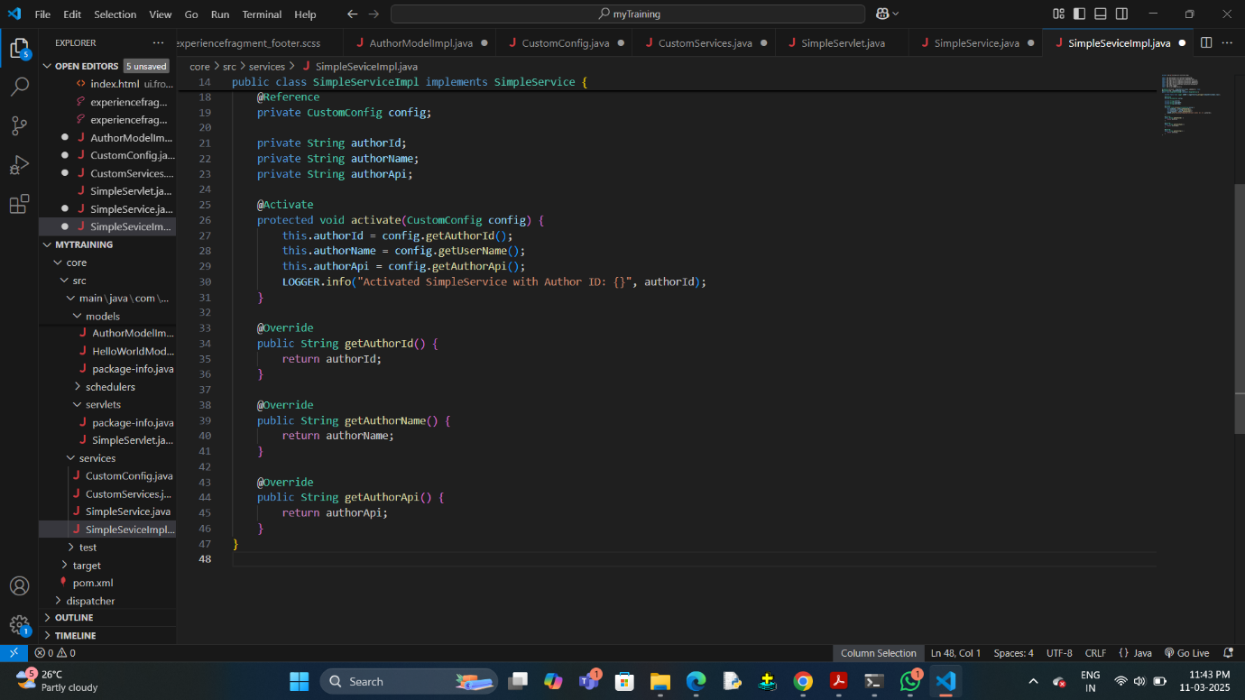

**8. SERVLET FILES**

