Final Report

Introduction:
Self-consistency(Wang et al,2023) is a technique where an AI model generates multiple responses for the same query using different reasoning paths via sampling methods like temperature-based decoding. It then selects the final answer using aggregation techniques such as majority voting, weighted sum techniques (normalized, unnormalized), weighted average techniques.
What I wanted to test: The "Modern Small Model" Hypothesis
The Gap: The original paper (Wang et al., 2023) demonstrated self-consistency on large-scale models ranging from 137 to 540 billion parameters, which are now several generations behind current models.
My research question: Modern 8-billion parameter models (like Llama 3 8B or Mistral 7B) have been trained far more efficiently and are already excellent at math. Do these highly optimized, modern small models still benefit from self-consistency, or have improved training methods made this technique obsolete? This project tests(Wei et al., 2022; Wang et al., 2023) whether a prompting strategy from 2022 still holds value in 2026's open-source landscape.
Method:
I evaluated self-consistency on GSM8K (Cobbe et al., 2021), a benchmark of 1,319 grade-school math word problems requiring multi-step arithmetic reasoning. Each problem has a unique numerical answer, making it suitable for majority voting. I used the full test split for evaluation.
Models. I test four instruction-tuned language models spanning different model families, training recipes, and parameter scales: Gemma-2B-it (2.6B parameters, Google), Phi-3-mini-4k-instruct (3.8B, Microsoft), Mistral-7B-Instruct-v0.3 (7.2B, Mistral AI), and Gemma-2-9B-it (9B, Google). Unlike the original paper, which varied scale within a single model family (LaMDA), I deliberately chose models from different families to examine whether self-consistency effectiveness depends on parameter count or base reasoning capability. All models are used off-the-shelf without any fine-tuning.
Prompting. Following Wang et al. (2023) and Wei et al. (2022), I used 8-shot chain-of-thought prompting for all experiments. The same set of 8 manually written exemplars from Wei et al. (2022) was used across all models and all test questions. Each exemplar consists of a math word problem paired with a step-by-step natural language reasoning chain ending with "The answer is X." For each test question, I constructed the prompt by concatenating all 8 exemplars followed by the test question, with the model generating its response after the "A:" cue.
Decoding Strategies. For each model, I ran two decoding strategies. The greedy baseline uses standard greedy decoding (temperature = 0) with a single output per question, following the chain-of-thought prompting approach of Wei et al. (2022). For self-consistency, I sampled 40 reasoning paths per question using temperature sampling (T = 0.7) with a stop sequence at the next "Q:" to prevent hallucinated follow-up questions. I then parsed the numerical answer from each path by searching for the pattern "The answer is X" and extracted the first number following this phrase, with a fallback to the last number in the output if the template phrase is absent. The final self-consistency answer was determined by unweighted majority vote over the parsed answers, following Table 1 of Wang et al. (2023) which shows majority voting performs comparably to probability-weighted aggregation.
Ablation over number of paths. To reproduce the paper's Figure 2 (Wang et al. ,2023), I evaluated self-consistency accuracy at m = 1, 5, 10, 15, 20, 30, and 40 sampled paths by subsampling from the 40 stored reasoning paths per question, without requiring additional model inference.
Infrastructure: All experiments were conducted using vLLM for efficient batched inference on a single NVIDIA A100 40GB GPU via Google Colab Pro. Greedy decoding runs complete in approximately 3–5 minutes per model. Self-consistency runs with n = 40 take approximately 20 minutes for the 3–4B models and 2 hours for the 7–9B models, reflecting the 40x increase in generated sequences.
Results:
I’ve introduced the concept of headroom (100% minus greedy accuracy) to analyze SC effectiveness across model families. “Headroom” just means “how much room for improvement exists.”
Table 1 shows the greedy accuracy, self-consistency accuracy, gain, and headroom for all four models.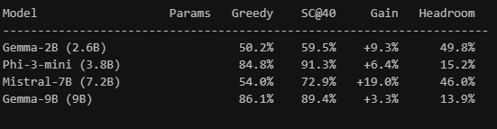
The above table can be visualized in terms of a bar chart as shown below:
Plot-1
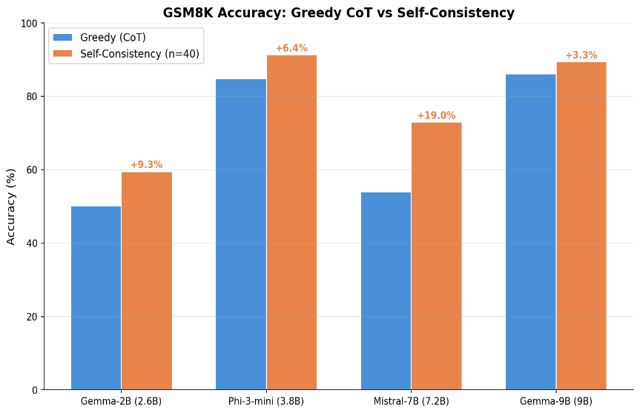
The bar chart shows that self-consistency improves accuracy across all four models, with gains ranging from +3.3% (Gemma-9B) to +19.0% (Mistral-7B). Mistral had the highest gains observed with a 19.0% improvement from the recorded greedy baseline. The plot also emphasizes its validity with modern LLM models.

Headroom versus Gain:
Plot-3
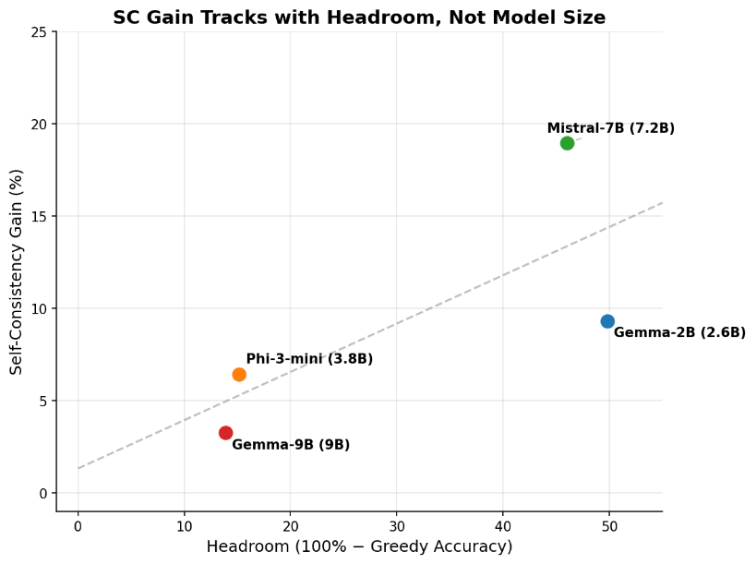
SC gain correlates with headroom rather than model size. Headroom sets the ceiling on how much SC could help. Base capability determines how much of that ceiling SC actually reaches. The original paper's scale-based finding was a special case where both factors moved together.
The below graph shows the ablation plots for m = 1, 5, 10, 15, 20, 30, 40.
Plot-2
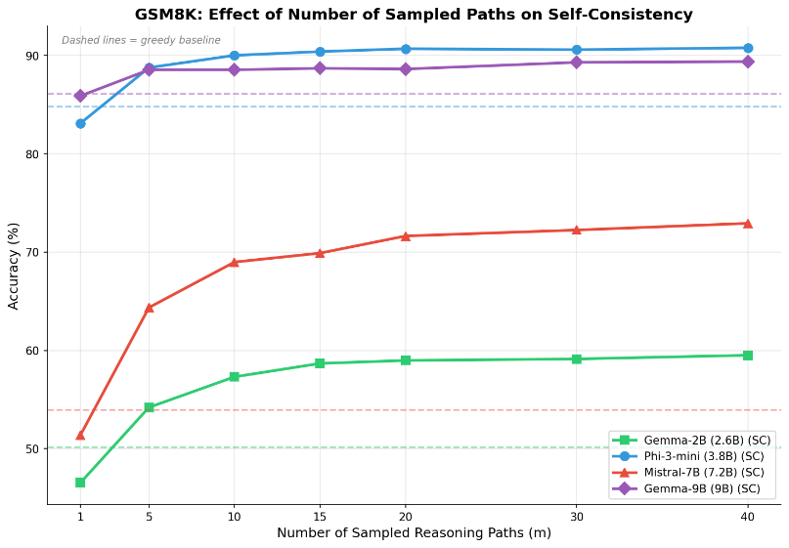
When the greedy baseline accuracy is already high, SC gains are modest — Phi-3-mini and Gemma-9B, both above 84% greedy accuracy, show gains of only +6.4% and +3.3% respectively. SC gains do make a difference for lower baselines values as we can observe from Mistral-7B and Gemma-2b. Additionally, most of the self-consistency improvement is captured within 10-20 sampled reasoning paths, consistent with the paper's Figure 2. Most of the gains can be captured within a range of 10-20 sampled reasoning paths.

Headroom Analysis: It is observed from Plot-3 that Gemma-2B and Mistral-7B have nearly identical headroom (~50% vs ~46%), but Mistral gets double the SC gain (+19.0% vs +9.3%). This adds nuance to the headroom story — headroom is necessary but not sufficient. Mistral at 7.2B has enough reasoning capacity that when it's wrong, it sometimes produces correct reasoning paths among the diverse samples. Gemma-2B at 2.6B is often just consistently wrong — sampling 40 paths from a weak model gives 40 wrong answers, and majority voting over wrong answers still gives a wrong answer.
This actually mirrors the original paper's Figure 4 (right panel) — very small models get minimal SC gain despite having lots of headroom. The model needs to be "good enough" that correct reasoning paths exist in the sampling distribution for SC to find them.
Inference Cost:
Self-consistency requires generating 40 reasoning paths per question compared to a single path for greedy decoding, representing a 40× increase in the number of generated sequences. The below table summarizes the wall-clock runtime for all experiments on a single NVIDIA A100 40GB GPU using vLLM for batched inference.
Model | Params | Greedy Time | SC Time(n=40) | Slowdown | Accuracy Gain
Gemma-2B | 2.6B | 48s | 35 min | ~44x | 9.30%
Phi-3-mini | 3.8B | ~ 3 min | ~ 20 min | ~ 7x | 6.40%
Mistral-7B | 7.2B | 2 min 17s | 1h 37 min | ~42x | 19.00%
Gemma-9B | 9B | 3 min 31s | 2h 22 min | ~40x | 3.30%

The observed slowdown closely matches the theoretical 40× increase in generated sequences, as vLLM's continuous batching optimizations benefit both greedy and self-consistency runs equally. The Phi-3-mini slowdown figure is approximate due to a split execution across sequential and batched runs.

Whether the extra time is worth it depends on the model. For Mistral-7B, spending 40 times longer on inference buys a 19-point jump — from 54% to 73% — which is a big deal. For Gemma-9B, spending that same 40 times longer only gets you an extra 3.3 points, because the model is already at 86% and there just aren't many questions left to fix. The takeaway is straightforward: self-consistency helps most when the model is decent but still makes a lot of mistakes. If the model is already strong, you're paying a lot for very little improvement.

The original paper notes that practitioners can try a smaller number of paths (e.g., 5 or 10) as a starting point to capture most of the gains while limiting compute overhead. This ablation results confirm this: across all four models, the majority of the self-consistency improvement is realized by m=10-15 paths, with diminishing returns beyond m=20. For Mistral-7B, for example, m=10 achieves 69.0% accuracy compared to 72.9% at m=40, capturing roughly 79% of the total gain at only 25% of the sampling cost.
Resource Usage:
All experiments were conducted on Google Colab Pro using a single NVIDIA A100 40GB GPU. Models were served using vLLM with bf16 precision and gpu_memory_utilization set to 0.9, allocating approximately 36GB of the available 40GB for model weights and KV cache. No model quantization was used. The table below summarizes the throughput characteristics observed during self-consistency runs.
Model | Params | Input Throughput | Output Throughput | Total SC Completions
Gemma-2B | 2.6B | 21,423 tok/s | 2,899 tok/s | 52,760
Phi-3-mini | 3.8B | ~8,000 tok/s | ~1,200 tok/s | 52,760
Mistral-7B | 7.2B | 8,087 tok/s | 1,275 tok/s | 52,760
Gemma-9B | 9B | 5,237 tok/s | 768 tok/s | 52,760

Output throughput — the bottleneck in autoregressive generation — scales roughly inversely with model size. Gemma-2B generates ~2,899 output tokens per second, while Gemma-9B produces only ~768, a 3.8× reduction for a 3.5× increase in parameters. This reflects the memory-bandwidth-bound nature of the decode phase: each generated token requires reading the full model weights from GPU memory, so larger models produce fewer tokens per second regardless of GPU compute capacity.
The total number of completions across all experiments was 52,760 per model (1,319 questions × 40 paths) for self-consistency plus 1,319 for greedy decoding. The aggregate GPU time across all four models was approximately 5 hours for self-consistency runs and approximately 10 minutes for greedy baselines.
Discussion on the findings:
SC gains require both headroom and sufficient base capability. Models with strong mathematical reasoning capability, such as Gemma-9B and Phi-3-mini, have limited headroom, resulting in small SC gains. Take the case of Gemma-2B, there exists plenty of headroom (100 - Greedy Accuracy -> 100 – 50.2 49.8 %) but the model can’t produce correct paths to vote on which results in a modest gain. The sweet spot is a model like Mistral-7B that is mediocre but recovers from a lot of fixable mistakes resulting in a large SC gain.

Conclusion:
Self-consistency remains an effective decoding strategy for modern small language models in 2026, improving accuracy across all four models tested. However, its effectiveness depends on two factors: the model must have sufficient headroom (room for improvement over greedy decoding), and it must possess enough base reasoning capability to produce correct answers among its sampled paths. For practitioners, the key implication is that self-consistency offers the greatest return on models that are competent but imperfect reasoners, and that 10-20 sampled paths capture most of the benefit at a fraction of the compute cost of 40 paths.

References:
Wang, X., Wei, J., Schuurmans, D., Le, Q., Chi, E.H., Narang, S., Chowdhery, A., & Zhou, D. (2023). Self-Consistency Improves Chain of Thought Reasoning in Language Models. Published as a conference paper at ICLR 2023. arXiv:2203.11171.
Wei, J., Wang, X., Schuurmans, D., Bosma, M., Ichter, B., Xia, F., Chi, E., Le, Q., & Zhou, D. (2022). Chain-of-Thought Prompting Elicits Reasoning in Large Language Models. Conference on Neural Information Processing Systems (NeurIPS). arXiv:2201.11903.
Cobbe, K., Kosaraju, V., Bavarian, M., Chen, M., Jun, H., Kaiser, L., Plappert, M., Tworek, J., Hilton, J., Nakano, R., Hesse, C., & Schulman, J. (2021). Training Verifiers to Solve Math Word Problems. arXiv:2110.14168.
Kwon, W., Li, Z., Zhuang, S., Sheng, Y., Zheng, L., Yu, C.H., Gonzalez, J., Zhang, H., & Stoica, I. (2023). Efficient Memory Management for Large Language Model Serving with PagedAttention. Proceedings of the ACM SIGOPS 29th Symposium on Operating Systems Principles.

Appendix
A.1 Few-Shot Exemplars
The following 8 chain-of-thought exemplars from Wei et al. (2022) were used as the prompt prefix for all experiments across all four models:
Q: There are 15 trees in the grove. Grove workers will plant trees in the grove today. After they are done, there will be 21 trees. How many trees did the grove workers plant today? A: We start with 15 trees. Later we have 21 trees. The difference must be the number of trees they planted. So, they must have planted 21 - 15 = 6 trees. The answer is 6.
Q: If there are 3 cars in the parking lot and 2 more cars arrive, how many cars are in the parking lot? A: There are 3 cars in the parking lot already. 2 more arrive. Now there are 3 + 2 = 5 cars. The answer is 5.
Q: Leah had 32 chocolates and her sister had 42. If they ate 35, how many pieces do they have left in total? A: Leah had 32 chocolates and Leah's sister had 42. That means there were originally 32 + 42 = 74 chocolates. 35 have been eaten. So in total they still have 74 - 35 = 39 chocolates. The answer is 39.
Q: Jason had 20 lollipops. He gave Denny some lollipops. Now Jason has 12 lollipops. How many lollipops did Jason give to Denny? A: Jason had 20 lollipops. Since he only has 12 now, he must have given the rest to Denny. The number of lollipops he has given to Denny must have been 20 - 12 = 8 lollipops. The answer is 8.
Q: Shawn has five toys. For Christmas, he got two toys each from his mom and dad. How many toys does he have now? A: He has 5 toys. He got 2 from mom, so after that he has 5 + 2 = 7 toys. Then he got 2 more from dad, so in total he has 7 + 2 = 9 toys. The answer is 9.
Q: There were nine computers in the server room. Five more computers were installed each day, from monday to thursday. How many computers are now in the server room? A: There are 4 days from monday to thursday. 5 computers were added each day. That means in total 4 * 5 = 20 computers were added. There were 9 computers in the beginning, so now there are 9 + 20 = 29 computers. The answer is 29.
Q: Michael had 58 golf balls. On tuesday, he lost 23 golf balls. On wednesday, he lost 2 more. How many golf balls did he have at the end of wednesday? A: Michael initially had 58 balls. He lost 23 on Tuesday, so after that he has 58 - 23 = 35 balls. On Wednesday he lost 2 more so now he has 35 - 2 = 33 balls. The answer is 33.
Q: Olivia has $23. She bought five bagels for $3 each. How much money does she have left? A: She bought 5 bagels for $3 each. This means she spent 5 * $3 = $15 on the bagels. She had $23 in beginning, so now she has $23 - $15 = $8. The answer is 8.
A.2 Additional Figures
Figure A1: Self-Consistency — Questions Fixed vs Broken
[Plot 4 — breakdown bar chart]
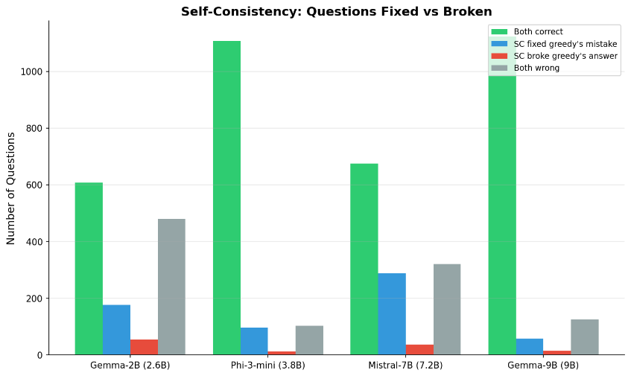
This figure shows how many questions self-consistency fixed versus broke compared to greedy decoding. Across all four models, SC fixes substantially more questions than it breaks. The fix-to-break ratios are: Gemma-2B (177 fixed, 54 broke, 3.3:1), Phi-3-mini (97 fixed, 12 broke, 8.1:1), Mistral-7B (287 fixed, 37 broke, 7.8:1), and Gemma-9B (57 fixed, 14 broke, 4.1:1). This confirms that self-consistency is reliably helpful rather than noisy across all models tested.
Figure A2: Consistency Percentage vs Accuracy
[Plot 5 — consistency vs accuracy scatter]
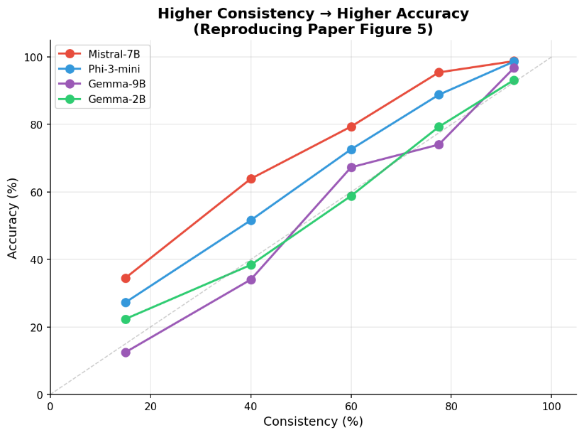
This figure reproduces Figure 5 from Wang et al. (2023). For each question, consistency is defined as the percentage of sampled paths that agree with the majority-voted answer. Higher consistency correlates with higher accuracy across all four models, confirming the paper's finding that consistency can serve as an uncertainty estimate — low consistency indicates the model is unsure and likely incorrect.

A.3 Glossary
CoT (Chain-of-Thought): A prompting technique where the model is shown step-by-step reasoning examples, encouraging it to show its work rather than jumping directly to an answer.
SC (Self-Consistency): A decoding strategy that samples multiple reasoning paths and selects the most frequent answer via majority voting.
Greedy Decoding: A decoding strategy that always picks the highest-probability token at each step, producing a single deterministic output.
Majority Voting: Selecting the answer that appears most frequently among multiple sampled outputs.
Headroom: The gap between a model's greedy accuracy and 100%, representing the maximum possible improvement self-consistency could provide. Introduced in this report, not a term from the original paper.
GSM8K: A benchmark dataset of 1,319 grade-school math word problems requiring multi-step arithmetic reasoning, created by Cobbe et al. (2021).
Few-shot Prompting: Providing a small number of solved examples in the prompt to guide the model's response format and reasoning approach, without any training or fine-tuning.
vLLM: An open-source library for efficient large language model inference, using PagedAttention for optimized memory management and continuous batching for high throughput.

