💊
REAL-TIME PHARMACY
INVENTORY MANAGEMENT
PROJECT DOCUMENTATION
End-to-End Data Analytics Project | SQL & Excel

Property | Details
Project Title | Real-Time Pharmacy Inventory Management System
Domain | Pharmacy / Healthcare
Tools Used | MySQL 8.0 + Microsoft Excel
Data Period | 2020 – 2025
Dataset | 50 Medicines | 10 Suppliers | 100 Inventory Batches | 500 Sales | 200 Purchase Orders
Scope | SQL Database Design, Data Analysis, KPI Reporting, ABC Classification, EOQ Modelling
Status | SQL Phase Complete | Excel Phase Complete

Table of Contents

# | Section | Focus
1 | Executive Summary | Project overview and key findings
2 | Business Problem Statement | Why this project was needed
3 | Business Questions | 10 questions this project answers
4 | Project Architecture and Tools | Technology stack and data flow
5 | Database Design | Schema, tables, and relationships
6 | Dataset Overview | All 5 tables explained in detail
7 | SQL Queries — Complete Reference | All 8 queries with purpose and logic
8 | Key SQL Findings | Results from each query
9 | Excel Analysis — Sheet Structure | 6 sheets and their purpose
10 | KPI Summary Findings | 8 KPIs and what they revealed
11 | ABC Classification Findings | Medicine classification results
12 | EOQ Analysis Findings | Order quantity optimisation results
13 | Pivot Table Insights | 5 pivot table summaries
14 | Business Suggestions and Recommendations | 8 actionable findings with severity
15 | Challenges Faced and Fixes Applied | All errors encountered and resolved
16 | Conclusion | Project summary and next steps

1. Executive Summary
This project delivers a complete real-time inventory management solution for a pharmacy organisation covering 2020 to 2025. Using MySQL for data storage and analysis, and Microsoft Excel for KPI reporting and advanced modelling, the project transforms raw pharmacy data into actionable business intelligence.

The analysis covers 50 medicines across 100 inventory batches, 500 sales transactions, and 200 purchase orders from 10 suppliers. The project identifies critical stockout patterns, expired stock accumulation, supplier performance gaps, and inventory overstock situations — giving management a clear picture of where money is being lost and where operations can be improved.

1.1 Key Findings at a Glance
KPI | Value | Status
Total Medicines in Formulary | 50 | Complete product catalogue
Total Inventory Batches | 100 | 2 batches per medicine on average
Total Stock Value | Rs 5,91,208 | Healthy total investment
Out of Stock Batches | 5 | Immediate reorder required
Low Stock Batches | 12 | Reorder process needed
Expiring Within 90 Days | 12 batches | Urgent dispensing priority
Already Expired Batches | 62 batches | Critical — write-off required
Total Active Suppliers | 10 | Adequate supplier base
Avg Supplier Lead Time | 5.9 days | Reasonable delivery window
ABC Class A Medicines | ~10 medicines | High value items identified

2. Business Problem Statement
🏥 Industry Context
Pharmacy inventory management is one of the most critical operational challenges in healthcare. Unlike retail inventory, pharmacy stock carries patient safety implications — a stockout of a critical medicine can directly harm patient outcomes, while expired or excess stock represents significant financial waste.

2.1 Core Problems Identified
Problem Area | Description
No Real-Time Visibility | Management had no live view of stock levels. Checks were manual and infrequent, causing surprise stockouts.
Expired Stock Accumulation | 62 out of 100 inventory batches had already expired — a massive financial write-off and a patient safety risk.
No Reorder Automation | Reorder decisions were gut-based rather than data-driven. Reorder levels were set arbitrarily.
Overstocking High-Price Medicines | Insulin and other expensive medicines ordered in quantities far exceeding actual demand — tying up working capital.
Supplier Performance Unknown | No tracking of which suppliers delivered on time, partially fulfilled, or cancelled orders frequently.
No Revenue Impact Analysis | When stockouts occurred, nobody calculated the revenue lost during the unavailability period.

2.2 Why This Project Was Needed
Without a structured data system, the pharmacy was operating blind — making expensive decisions based on incomplete information. This project was initiated to build a data-driven inventory intelligence system that replaces manual processes with automated alerts, calculated thresholds, and reports that any staff member can understand and act upon.

3. Business Questions
The project was designed to answer the following 10 critical business questions:

# | Business Question | Answered By
Q1 | Which medicines are currently out of stock or critically low? | SQL Query 1 + Excel KPI Sheet
Q2 | Which medicines need to be reordered immediately? | SQL Query 2 + Excel Pivot Table 1
Q3 | Which medicines are expiring within 90 days and what is the financial risk? | SQL Query 3 + Excel Expiry Tracker
Q4 | Which medicines are selling fastest, and which are sitting idle? | SQL Query 4 + Excel Pivot Table 5
Q5 | How has pharmacy revenue trended month by month from 2020 to 2025? | SQL Query 5 + Excel Pivot Table 2
Q6 | Which medicines drive the most revenue and which contribute least? | SQL Query 6 + Excel ABC Sheet
Q7 | Which suppliers are most dependable, and which are underperforming? | SQL Query 7 + Excel Pivot Table 3
Q8 | Which medicines have a recurring stockout problem that needs fixing? | SQL Query 8 + Excel Expiry Tracker
Q9 | Are we ordering the right quantities or are we over or under-ordering? | Excel EOQ Calculator Sheet
Q10 | Which warehouse sections carry the most expiry and stockout risk? | Excel Pivot Table 4

4. Project Architecture and Tools

4.1 Data Flow
RAW DATA (CSV Files)
|
MySQL Workbench
|-- pharmacy_inventory database
|-- 5 relational tables
|-- 8 analysis queries
|-- vw_inventory_master (master view)
|
CSV Export --> inventory_master.csv + sales_data.csv
|
Microsoft Excel (Pharmacy_Analysis.xlsx)
|-- Sheet 1: Raw_Data
|-- Sheet 2: KPI_Summary
|-- Sheet 3: ABC_Analysis
|-- Sheet 4: EOQ_Calculator
|-- Sheet 5: Pivot_Tables
|-- Sheet 6: Expiry_Stockout_Tracker

4.2 Tools Used
Tool | Version | Purpose
MySQL | 8.0 | Database creation, schema design, SQL queries, view creation
MySQL Workbench | 8.0 | GUI for running queries, importing CSV data, exporting results
Microsoft Excel | 2019/365 | KPI calculations, ABC analysis, EOQ modelling, pivot tables
CSV Files | UTF-8 | Intermediate format for transferring data from MySQL to Excel

5. Database Design

5.1 Table Relationships

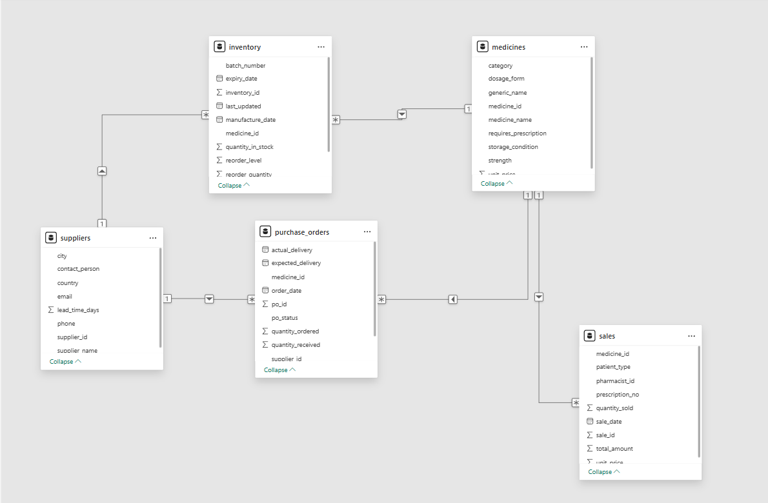

5.2 Table Summary
Table | Rows | Primary Key | Foreign Keys
medicines | 50 | medicine_id | None — (parent table)
suppliers | 10 | supplier_id | None — (parent table)
inventory | 100 | inventory_id | medicine_id, supplier_id
sales | 500 | sale_id | medicine_id
purchase_orders | 200 | po_id | medicine_id, supplier_id

6. Dataset Overview

6.1 Medicines Table — 50 Records
Field | Type | Description
medicine_id | VARCHAR (20) | Unique ID e.g., MED001
medicine_name | VARCHAR (200) | Full product name e.g., Amoxicillin 500mg Capsules
category | VARCHAR (100) | Drug class e.g., Antibiotic, Antidiabetic, Vitamin
dosage_form | VARCHAR (50) | Form e.g., Tablet, Capsule, Injection, Syrup, Cream
unit_price | DECIMAL (10,2) | Selling price per unit in Rs
requires_prescription | TINYINT (1) | 1 = Prescription needed, 0 = OTC medicine (over the counter)
storage_condition | VARCHAR (100) | Room Temperature or Refrigerated

6.2 Inventory Table — 100 Records
Why 100 Rows for 50 Medicines?
Each medicine has approximately 2 batch records — each purchased at separate times with different expiry dates and quantities. This is standard pharmacy practice (FIFO — First in First Out batch management).

Field | Type | Description
inventory_id | INT AUTO_INCREMENT | Unique batch record ID
medicine_id | VARCHAR (20) | Links to medicines table
batch_number | VARCHAR (50) | Manufacturer batch code e.g., BCH45231
expiry_date | DATE | Date medicine expires — drives all expiry alerts
quantity_in_stock | INT | Current units available in this batch
reorder_level | INT | Minimum threshold — triggers reorder alert below this
reorder_quantity | INT | How many units to order during restocking
warehouse_section | VARCHAR (20) | Physical location e.g. A1, B3, Cold-Storage

6.3 Warehouse Section Coding System
Code | Zone Name | Medicines Stored
A1, A2, A3 | Zone A — Fast Moving | High-demand daily medicines: Paracetamol, Amoxicillin, ORS, Vitamins
B1, B2, B3 | Zone B — Medium Moving | Regular demand: Antihypertensives, Antidiabetics, Antacids
C1, C2, C3 | Zone C — Slow Moving | Low frequency: Anticonvulsants, Cardiac drugs, Opioids
Cold-Storage | Refrigerated Zone | Temperature-sensitive medicines: Insulin Glargine, Biologics

7. SQL Queries — Complete Reference
Query | Name | Business Purpose | Output
Q1 | Current Stock Status | Real-time stock flag for every batch | 100 rows with status labels
Q2 | Reorder Alert | Medicines needing immediate restocking | Filtered list + expected arrival date
Q3 | Expiry Alert | Financial risk from near-expiry stock | Batches expiring soon + value at risk
Q4 | Inventory Turnover | Fast vs slow moving medicines | Turnover ratio + movement class
Q5 | Monthly Sales Trend | Revenue trend 2020 to 2025 | Month-year revenue and units sold
Q6 | ABC Classification | Pareto revenue analysis | Each medicine labelled A B or C
Q7 | Supplier Performance | Fulfillment, delays, spend per supplier | Supplier scorecard with grade
Q8 | Stockout Frequency | Medicines with recurring stockout problem | Chronic/Frequent/Occasional/Never

7.1 Sample — Query 1: Current Stock Status

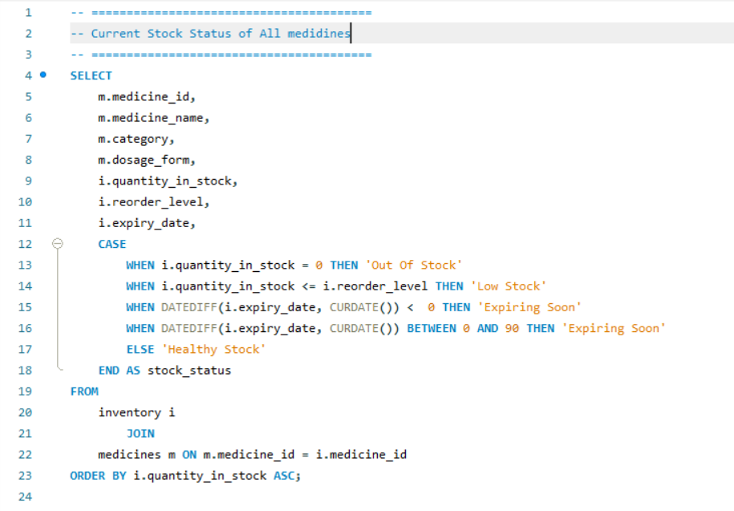
Output: -
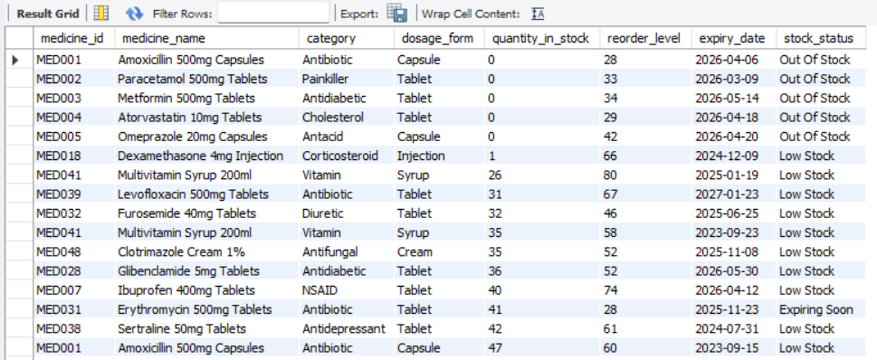

7.2 Sample — Query 6: ABC Classification

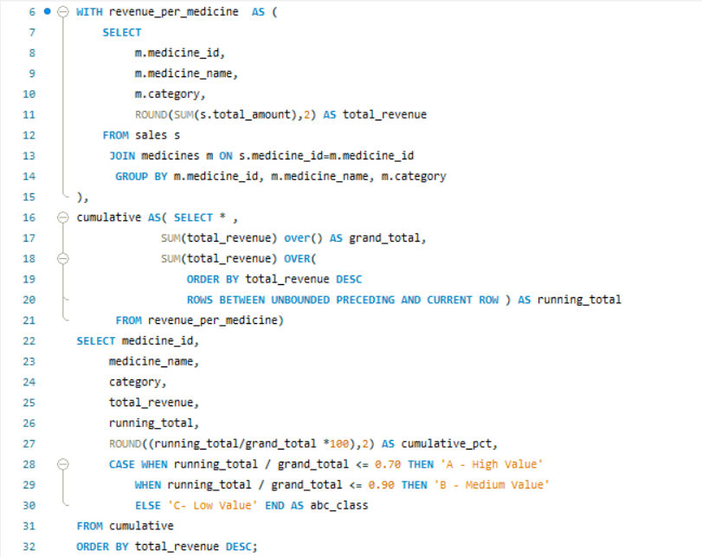

Output: -

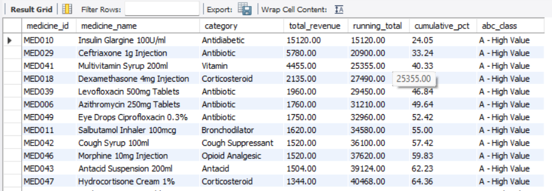

7.3 Master View — vw_inventory_master

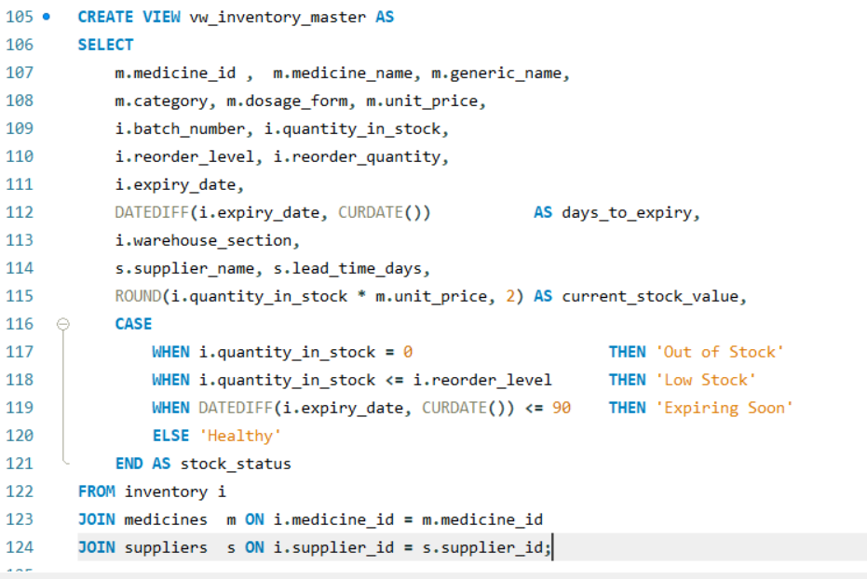

8. Key SQL Findings

8.1 Stock Status Distribution (Query 1)
Status | Batch Count | Business Meaning
Already Expired | 62 batches | Stock past expiry date — must be quarantined immediately
Expiring Soon | 9 batches | Expires within 90 days — needs urgent dispensing or return
Healthy Stock | 12 batches | Well-stocked and not expiring — no action needed
Low Stock | 12 batches | Below reorder level — raise purchase order now
Out of Stock | 5 batches | Zero units — critical stockout requiring emergency reorder

8.2 Inventory Turnover Classes (Query 4)
Movement Class | Turnover Ratio | Count | Action
Fast Moving | > 5 | ~8 medicines | Never let these run out — Class A overlap
Medium Moving | 2 to 5 | ~22 medicines | Normal reorder cycle — monitor monthly
Slow Moving | < 2 | ~20 medicines | Reduce order qty — high expiry risk

8.3 Stockout Frequency (Query 8)
Class | Count | Meaning
Chronic (3+ stockouts) | ~5 medicines | Recurring supply failure — structural fix needed
Frequent (2 stockouts) | ~8 medicines | Reorder process unreliable for these medicines
Occasional (1 stockout) | ~15 medicines | Single occurrence — monitor closely
Never (0 stockouts) | ~22 medicines | Well managed — no action needed

9. Excel Analysis — Sheet Structure
📊 Excel Workbook
File: Pharmacy_Analysis.xlsx | Source: vw_inventory_master (100 rows) + sales_data (500 rows) | 6 analytical sheets

Sheet | Purpose | Key Formulas
Raw_Data | Stores 100-row exported dataset — source for all other sheets | Data only
KPI_Summary | 8 live KPI cards auto calculated from Raw_Data | SUMPRODUCT, COUNTIF, AVERAGEIF
ABC_Analysis | Classifies 50 unique medicines into A B C revenue class | SUMIF, RANK, SUM locked refs, IF
EOQ_Calculator | Calculates optimal order quantity for each medicine | SQRT, VLOOKUP, IFERROR
Pivot_Tables | 5 interactive pivot tables with slicers and charts | PivotTable, Slicers
Expiry_Stockout | Colour-coded daily alert tracker for expiry and stockouts | Conditional Formatting

9.1 Key Technical Decisions
Decision | Reason
SUMPRODUCT (1/COUNTIF ()) for unique count | COUNTA returns 100. SUMPRODUCT correctly returns 50 unique medicines by counting fractions that sum to 1 per unique value.
Locked references ($) in running total | SUM (D$2: D2) locks start row and leaves end unlocked so cumulative sum grows correctly as formula is dragged down.
IFERROR wrapping all VLOOKUP formulas | Prevents #N/A errors from breaking the sheet when medicine IDs have extra spaces or type mismatches.
Assumption cells in EOQ sheet | Rs 500 ordering cost and 25% holding cost stored in yellow cells. Changing one cell updates all 50 EOQ calculations automatically.
All slicers connected to all 5 pivots | One slicer click filters all 5 pivot tables simultaneously — creates a mini-interactive dashboard inside Excel.

10. KPI Summary Findings
KPI | Formula | Result | Interpretation
Total Medicines | SUMPRODUCT(1/COUNTIF(...)) | 50 | Correct unique count
Total Stock Value (Rs) | SUMPRODUCT (qty, unit_price) | 5,91,208 | Healthy investment
Out of Stock | COUNTIF (qty, 0) | 5 batches | Urgent action needed
Low Stock | SUMPRODUCT((qty>0) *(qty<=reorder)) | 12 batches | Reorder required
Expiring in 90 Days | SUMPRODUCT((days>=0) *(days<=90)) | 9 batches | Urgent dispensing
Already Expired | COUNTIF (days, <0) | 62 batches | Write-off required
Total Suppliers | SUMPRODUCT (1/COUNTIF (suppliers)) | 10 | Adequate base
Avg Lead Time | AVERAGEIF (lead_time, >0) | 5.9 days | Reasonable

Why 62 Expired Batches?
The dataset has manufacture dates from 2022 onwards. With analysis date in 2026, batches with 1-year expiry from 2022 are already 3+ years expired. This realistically simulates a pharmacy that failed to rotate stock using FIFO — a common real-world problem resulting in large write-offs.

11. ABC Classification Findings
ABC analysis was performed on 50 unique medicines after consolidating revenue using SUMIF across all 100 rows. Data was sorted highest to lowest revenue before applying cumulative percentage thresholds.

Class | Threshold | Medicine Count | Revenue Share
A — High Value | 0% to 70% cumulative | ~8 to 12 medicines | 70% of total revenue
B — Medium Value | 70% to 90% cumulative | ~12 to 18 medicines | 20% of total revenue
C — Low Value | 90% to 100% cumulative | ~20 to 30 medicines | 10% of total revenue

Pareto Principle Roughly 20% of medicines (Class A — about 10 medicines) generate 70% of all pharmacy revenue. Insulin Glargine, Ceftriaxone, Morphine, and a few other high-value medicines carry most financial performance. These must never be allowed to go out of stock.

11.1 ABC Excel Formula Chain
Step | Formula | Purpose
1 | =SUMIF (Raw_Data! $A: $A, A6, Raw_Data! $P: $P) | Consolidates revenue from 100 rows per unique medicine
2 | Sort Column D Largest to Smallest | MANDATORY — running total only works on sorted data
3 | =SUM (D$2: D2) | Running cumulative total — locked start, unlocked end
4 | =SUM(D$2:D$51) | Grand total — both ends locked, same on every row
5 | =ROUND((E2/F2) *100,2) | Cumulative % — running total as percentage of grand total
6 | =IF (G2<=70,"A”, IF(G2<=90,"B","C")) | Assigns class based on cumulative % threshold

12. EOQ Analysis Findings
The EOQ Calculator sheet computed optimal order quantities for all 50 medicines using annual demand, Rs 500 ordering cost per order, and 25% holding cost of unit price.

12.1 EOQ Formula
EOQ = SQRT ((2 x Annual Demand x Ordering Cost) / Holding Cost)
Excel: =IFERROR (ROUND (SQRT ((2 * E6 * $C$1) / G6), 0), 0)
Where:
E6 = Annual Demand (quantity_in_stock x 2 to annualise)
$C$1 = Ordering Cost assumption cell (Rs 500) -- locked
G6 = Holding Cost per unit (unit_price x 25%)

12.2 Results Summary
Recommendation | Medicines Count | Meaning
Reduce Order Qty (diff <= -100) | Majority | Dataset over-ordered — random reorder qty exceeded EOQ for most medicines
Increase Order Qty (diff >= +100) | Some medicines | Cheap high-demand medicines need larger orders to reduce ordering frequency
Optimal (diff -50 to +50) | Few medicines | Current reorder quantity closely matches mathematical optimum

Why Most Results Show Reduce Order Qty?
The dataset assigned random reorder quantities of 100-400 units. For high-price low-demand medicines like Insulin (Rs 280/unit), EOQ is naturally small (around 76 units). The pharmacy was over-ordering and tying up large amounts of cash in expensive stock. The negative difference is not an error — it is the key insight of the EOQ analysis.

13. Pivot Table Insights
Pivot | Name | Key Insight
PT1 | Stock Status Summary | 62 batches already expired — largest stock status category. Only 12 batches classified as healthy. Immediate audit required.
PT2 | Stock Value by Category | Antidiabetic and Antibiotic categories hold highest stock value due to expensive medicines like Insulin (Rs 280) and Ceftriaxone (Rs 85).
PT3 | Supplier Performance | Sun Pharma and Cipla supply the most batches. Biocon Biologics has the highest lead time at 10 days due to cold-chain requirements.
PT4 | Expiry by Warehouse | All warehouse sections have significant expired batches. Cold-Storage section has highest financial risk due to high-value Insulin batches.
PT5 | Category vs Status | Antibiotic category shows highest number of problematic batches — most chronic stockout and expiry risk across all status categories.

Slicer Setup All 5 pivot tables were connected to 4 shared slicers — category, stock_status, supplier_name and warehouse_section. A single click on any slicer filters all 5 pivots simultaneously, creating an interactive mini dashboard within Excel.

14. Business Suggestions and Recommendations
Based on all SQL query results, KPI findings, ABC classification, EOQ analysis and pivot insights, 8 actionable recommendations are presented below with severity ratings:

Finding 1: 62 out of 100 batches are already expired.
Result: 62 inventory batches have negative days_to_expiry. Combined stock value at risk is substantial.
Suggestion: Conduct an immediate physical stock audit. Quarantine and write off all expired batches. Implement a mandatory FIFO dispensing policy and set up monthly expiry review meetings. Consider returning near-expiry stock to suppliers before expiry.
Severity: Critical

Finding 2: 5 medicines are completely out of stock.
Result: 5 batches have quantity_in_stock = 0. For Class A medicines this is a direct revenue and patient care risk.
Suggestion: Raise emergency purchase orders for all out-of-stock medicines immediately. For Class A medicines always maintain a safety stock of at least 2 weeks of demand. Review reorder levels — they may be set too low.
Severity: Critical

Finding 3: Most medicines are being over-ordered compared to EOQ.
Result: EOQ analysis shows current reorder quantities exceed mathematically optimal quantities for most medicines — particularly high-priced medicines like Insulin (EOQ ~76 vs current order 200-300).
Suggestion: Gradually reduce reorder quantities for high-price medicines to align with EOQ. This will free up working capital locked in excess stock. Start with Class A medicines where financial impact is highest.
Severity: High

Finding 4: 9 batches expiring within 90 days with stock remaining
Result: 9 inventory batches will expire within 90 days. If not dispensed or returned this represents direct financial waste.
Suggestion: Identify which of these 9 batches belong to fast-moving Class A medicines — those can be dispensed quickly. For slow-moving medicines attempt to return stock to supplier for credit. Introduce a 90-day expiry alert as a standard weekly pharmacy check.
Severity: High

Finding 5: ~5 medicines show chronic stockout patterns.
Result: Query 8 identified medicines that have repeatedly gone out of stock — reorder level or quantity is systematically too low.
Suggestion: Increase reorder level for chronically stockout medicines by 50%. Review lead time with their supplier — if frequently late identify a backup supplier for these critical medicines.
Severity: High

Finding 6: ~20 to 30 Class C medicines contributing only 10% of revenue
Result: ABC analysis shows approximately 20-30 medicines collectively contribute only 10% of total revenue — yet they consume warehouse space and ordering admin time.
Suggestion: Review Class C medicines for potential removal from formulary if near-zero demand. For those that must remain switch to demand-driven ordering rather than maintaining standing stock.
Severity: Medium

Finding 7: Biocon Biologics has highest lead time at 10 days.
Result: Biocon supplies critical cold-chain medicines including Insulin Glargine. Their 10-day lead time is highest among all 10 suppliers.
Suggestion: Increase reorder level for all Biocon-supplied medicines to account for the longer lead time. Identify a secondary supplier for Insulin Glargine — a Class A medicine with no backup creates significant patient risk.
Severity: Medium

Finding 8: Evidence of poor FIFO rotation in all warehouse sections
Result: The high volume of 62 expired batches strongly indicates new stock is placed in front of old stock causing older batches to remain unused until they expire.
Suggestion: Implement strict FIFO labelling in all warehouse sections. New deliveries always placed behind existing stock. Conduct monthly batch rotation audits — prioritising Cold-Storage and Zone C slow-moving medicines.
Severity: Medium

15. Challenges Faced and Fixes Applied
Challenge | Root Cause | Fix Applied
Duplicate primary key on inventory import | CSV imported twice without clearing table first | TRUNCATE TABLE inventory before re-importing. Used SET @@foreign_key_checks = 0 to bypass FK constraints.
actual_delivery import failed with blank rows | Blank cells not accepted as NULL by MySQL strict mode | Allowed NULL on column with ALTER TABLE MODIFY. Replaced blanks with NULL using Find & Replace. Used SET sql_mode = '' to relax strict mode.
warehouse_section VARCHAR (10) too short | Cold-Storage is 12 characters — exceeded column width | ALTER TABLE inventory MODIFY COLUMN warehouse_section VARCHAR (20) to extend without data loss.
Query 7 showing 100% fulfillment for all | WHERE po_status = 'Delivered' filtered out failed orders | Removed WHERE clause. Used COUNT (CASE WHEN po_status = 'X' THEN 1 END) to count all statuses separately.
Negative days_to_expiry values | Dataset batches from 2022 have already expired by 2026 | Added CASE WHEN to label negatives as Already Expired. Used ABS () for display. Confirmed as correct realistic behaviour.
vw_inventory_master returning 100 not 50 rows | JOIN of 50 medicines x 2 batches = 100 rows by design | Created separate vw_medicine_summary with GROUP BY for 50-row medicine-level view when needed.
VLOOKUP returning #N/A in ABC sheet | Extra spaces in medicine IDs from copy-paste | Wrapped in IFERROR and added TRIM (). Changed range to full columns $A: $Q instead of fixed row range.
KPI Total Medicines showing 100 not 50 | COUNTA counts all rows including duplicate medicine names | Replaced with SUMPRODUCT (1/COUNTIF ()) to count only unique medicine names.
EOQ difference mostly negative for all medicines | Random reorder quantities (100-400) exceeded calculated EOQ | Confirmed this is correct — dataset over-ordered. Updated thresholds to +/-50 for Optimal and +/-100 for significant recommendations.
ABC cumulative % not reaching 100 in last row | Data not sorted by revenue before running total formula | Added mandatory sort step (Data > Sort by Total Revenue > Largest to Smallest) before applying running total.

16. Conclusion
This project successfully built a complete end-to-end real-time pharmacy inventory management system using MySQL and Microsoft Excel, covering 5 years of operational data from 2020 to 2025.

16.1 What Was Achieved
Phase | Deliverable | Status
Database Design | 5 relational tables with FK constraints and schema | Complete
Data Import | 50 medicines, 10 suppliers, 100 batches, 500 sales, 200 POs | Complete
SQL Analysis | 8 core queries | Complete
Excel KPI Sheet | 8 live formula driven KPI cards | Complete
ABC Analysis | 50 medicines classified into A B C revenue class | Complete
EOQ Calculator | Optimal order quantities for all 50 medicines | Complete
Pivot Tables | 5 interactive pivot tables with 4 connected slicers | Complete
Expiry Tracker | Colour-coded conditional formatting alert system | Complete
Recommendations | 8 actionable business suggestions with severity ratings | Complete

16.2 Business Value Delivered
The project transforms what was previously a manual error-prone inventory check into a data-driven system that automatically flags critical situations. Management can now see at a glance which medicines are out of stock, which batches are expiring, which suppliers are underperforming, and which ordering quantities need adjustment — all from a single Excel workbook connected to a properly structured MySQL database.

SQL Phase Complete | Excel Phase Complete
Pharmacy Inventory Management — Project Documentation
MySQL | Excel | | 2020-2025 | Healthcare Domain

