Do the below programs in anonymous function & IIFE

1.Print odd numbers in an array

public class OddEvenInArrayExample{

public static void main(String args[]){

int a[]={1,2,5,6,3,7,9,2};

System.out.println("Odd Numbers:");

for(int i=0;i<a.length;i++){

if(a[i]%2!=0){

System.out.println(a[i]);

}

}

}}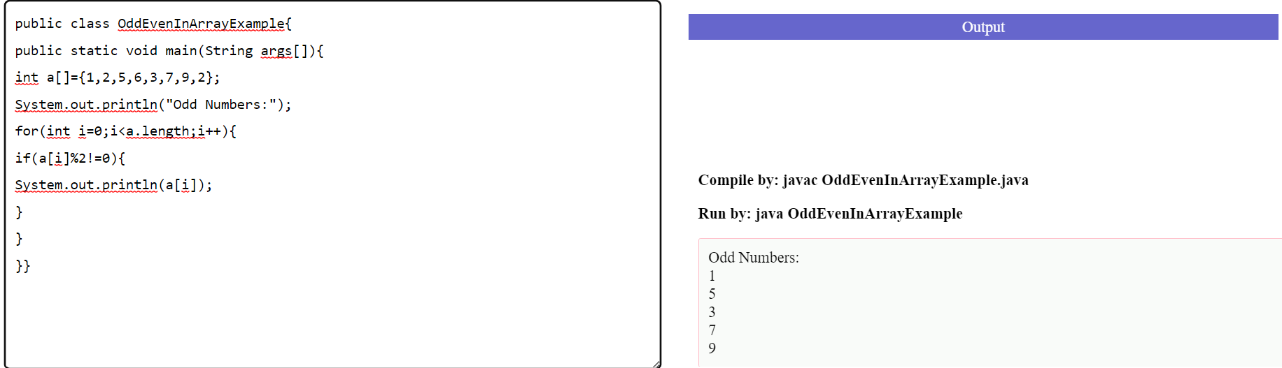

2. Convert all the strings to title caps in a string array

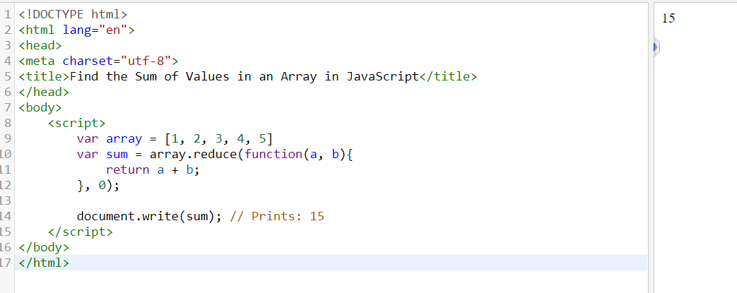

3.