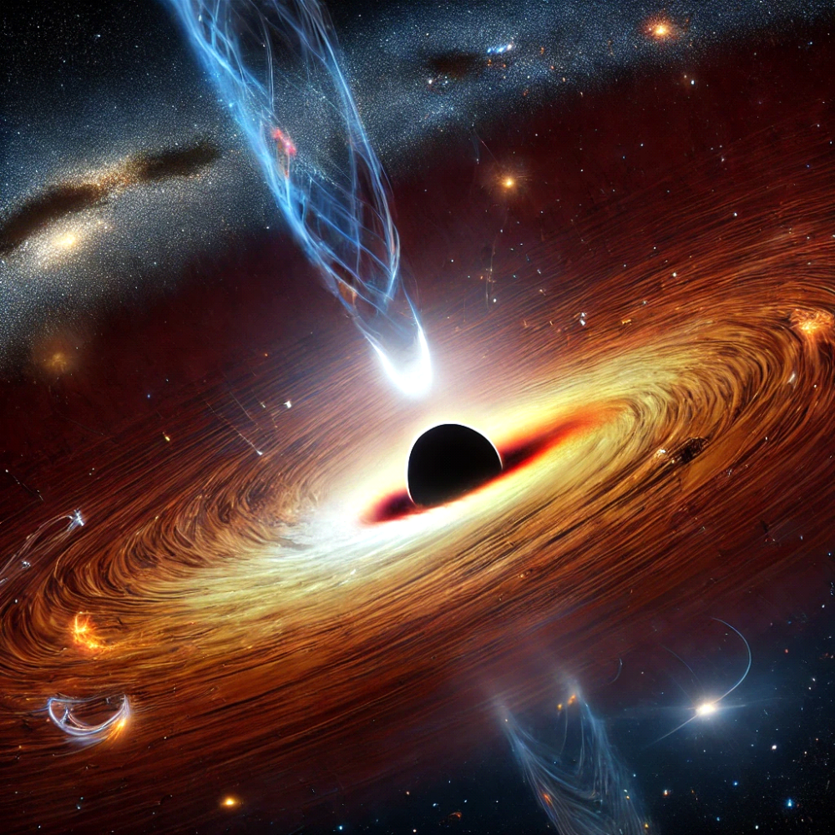
Prompt - Imagine a colossal black hole at the center of a distant galaxy, warping space and time. Surrounding it is a brilliant accretion disk glowing with sea.
AI used - ChatGPT

