IOT_PHASE3: PUBLIC TRANSPORT OPTIMIZATION
TEAM MEMBER: BALAMURUGAN S (822721106008)
Project Title: Public Transport Optimization
Project Description: This project involves integrating IOT Sensors into public transportation vehicles to monitor ridership, track locations, and predict perfect arrival times. The goal is to provide real -time transit information to the public through a public platform, enhancing the efficiency and quality of public transportation services. This project includes defining Objectives, designing the IOT sensor system, developing the real-time transit information platform, and integrating them using IOT technology and python.
SOFTWARE REQUIREMENT:
- TinkerCad used for Simulation Process
CONNECTION DETAILS:
BETWEEN ARDUINO UNO & ULTRASONIC SENSOR:
S.NO | ARDUINO UNO | ULTRASONIC SENSOR
1 | 5V | VCC
2 | DIGITAL PIN 3 | TRIGGER
3 | DIGITAL PIN 2 | ECHO PIN
4 | GND | GND

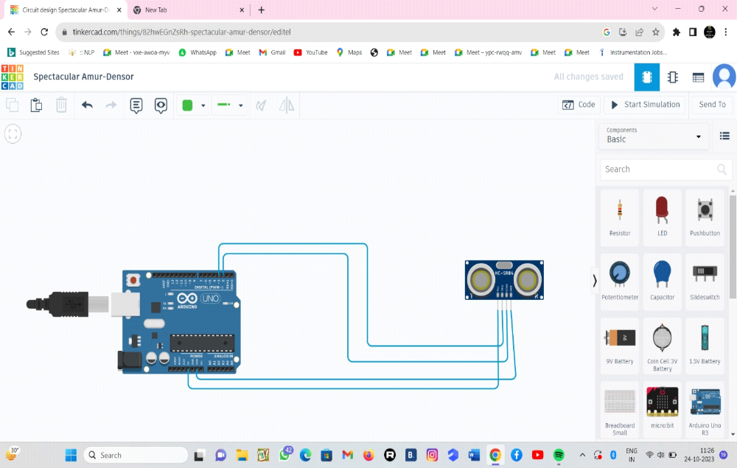
BETWEEN ARDUINO UNO & LED:
S.NO | ARDUINO UNO | LCD
1 | 5V | VCC
2 | FDA PIN | SBA PIN
3 | SCL PIN | SCL PIN
4 | GND | GND

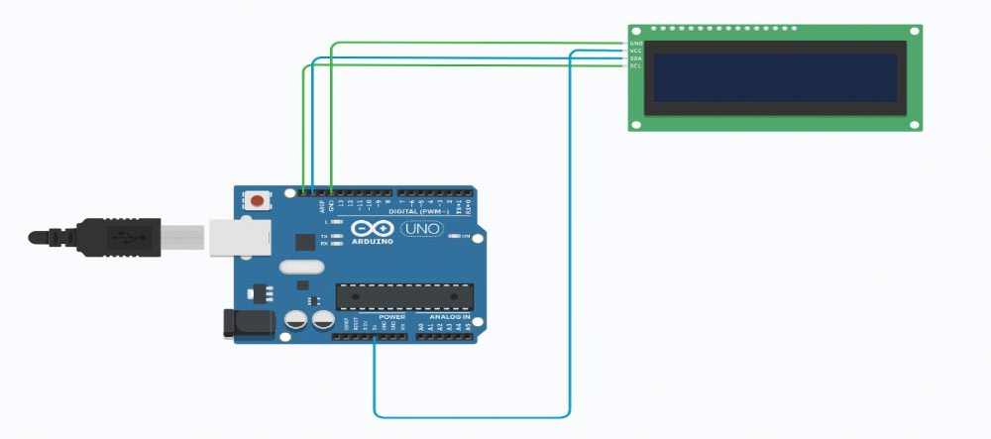
AFTER SIMULATION PROCESS:
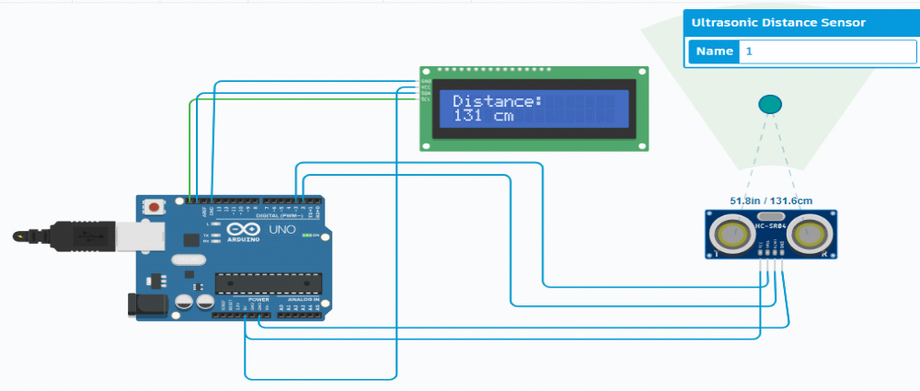
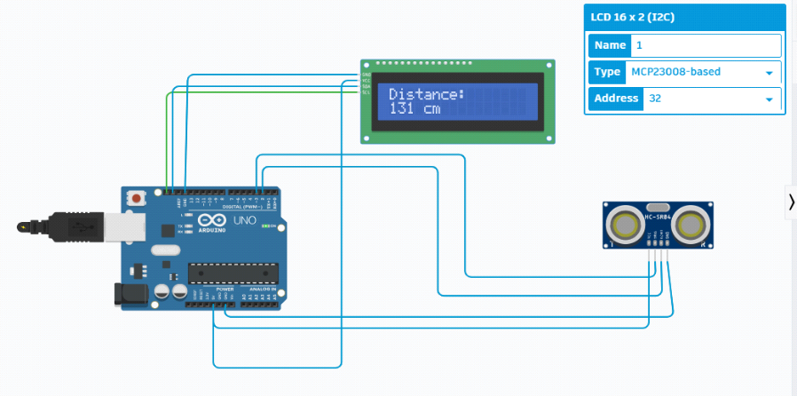
C++ CODE FOR SIMULATION PROCESS:
#include <LiquidCrystal_I2C.h>
LiquidCrystal_I2C lcd(0x20, 16, 2); // Format -> (Address,Width,Height )
#define echoPin 2 // attach pin D2 Arduino to Echo pin of Sensor module
#define trigPin 3 // attach pin D3 Arduino to Trig pin of Sensor module
long duration; // Declare variable to store echo time duration
int distance; // Declare variable to store the result (distance)
void setup()
{
lcd.init(); // initialize the lcd
lcd.backlight(); // Turn on the Backlight
pinMode(trigPin,OUTPUT); // Sets the trigPin as an OUTPUT
pinMode(echoPin, INPUT); // Sets the echoPin as an INPUT
// Serial Communication is starting with 9600 of baudrate speed
Serial.begin(9600);
// The text to be printed in serial monitor Serial.println("Distance measurement using Arduino Uno");
delay(500);
}
void loop()
{
digitalWrite(trigPin, LOW);
delayMicroseconds(2);
digitalWrite(trigPin, HIGH);
delayMicroseconds(10);
digitalWrite(trigPin, LOW);
duration = pulseIn(echoPin, HIGH);
distance = duration * 0.0344 / 2;
Serial.print("Distance: ");
Serial.print(distance);
Serial.println(" cm");
lcd.clear(); // Clear the display buffer
lcd.setCursor(0, 0); // Set cursor for "Distance:" (Column, Row)
lcd.print("Distance:"); // print "Distance:" at (0, 0)
lcd.setCursor(0,1); // Set cursor for output value (0, 1)
lcd.print(distance); // print Output in cm at (0, 1)
lcd.setCursor(4, 1); // move cursor to (4, 1)
lcd.print("cm"); // print "cm" at (4, 1)
delay(100);
}

