

Hospital Management System

Pet Project Documentation | Cohort code: INTEPS23SFDCPR0001

**Submitted by:**

M. Ajay –(2273261)

Arivazaghan V. –(2273232)

Balamurugan T –(2273515)

Charulatha GS –(2273484)

Gunjan Kumar Sah –(2273394)

**Purpose of the Document:**  
  
This document aims to identify the business requirements for the project Hospital Management Application. This document also provides the proposed solution for the same.

***Project Requirement:***  
  
1. Finding Doctors  
2. Booking Appointment  
3. Patient Registration  
4. Department and Specialties  
5. Medical Expense Details  
6. Patient testimonials

PROJECT FUNCTIONAL AND TECHNICAL DETAILS

Scenario 1: Create below custom objects and fields with various data types and relationships.

List of Custom Objects

1. 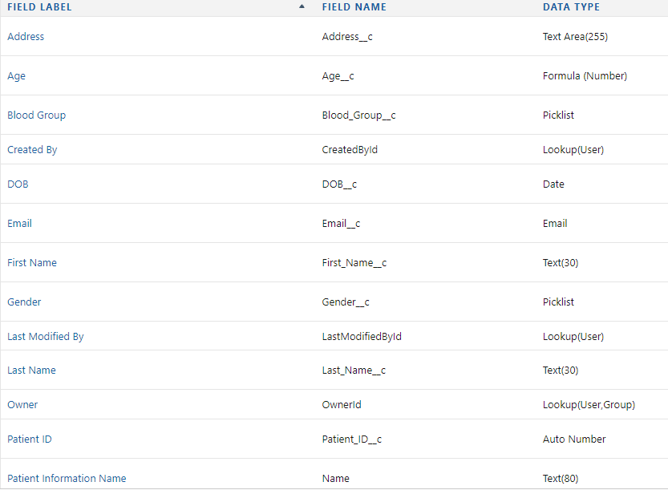Patient Information
2. Doctor

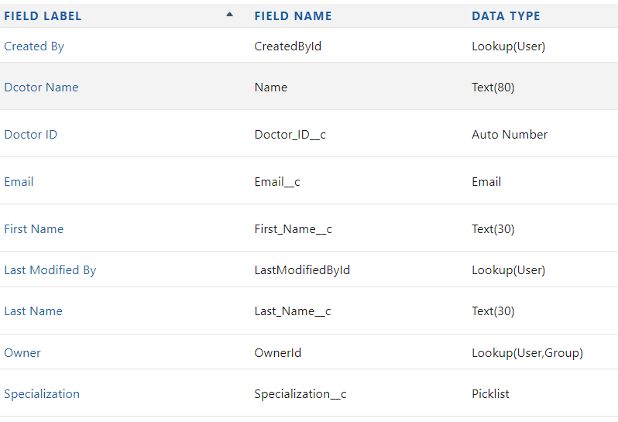

1. 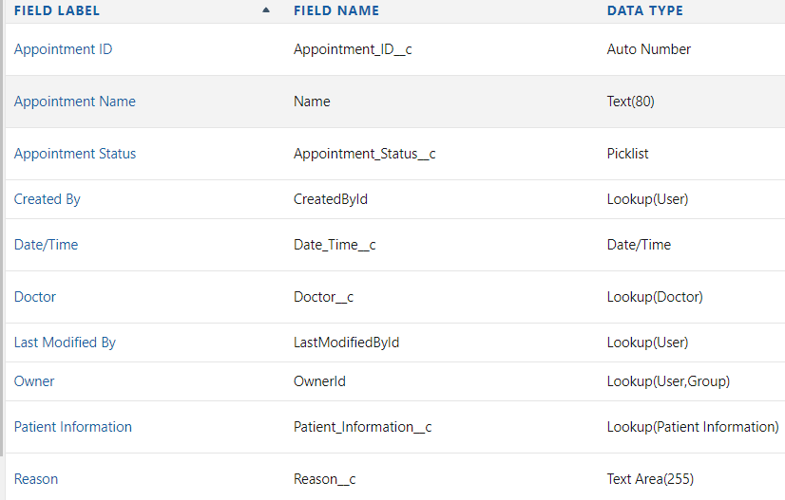Appointment
2. Medical Expense

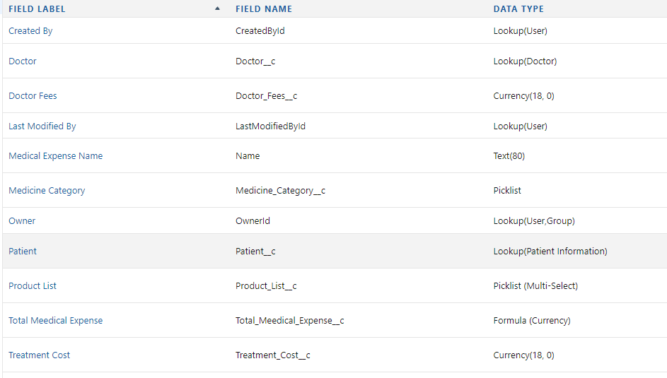

Scenario 2: create the below profiles.

* Doctor
* Hospital Admin
* Bill Manager

VALIDATION RULE

Scenario 3:

Create a Validation Rule to Validate that the Email Address is in the right format.

1. First Go to Patient Object.

2. Go To Validation Rule

3. Click On New

4. Rule Name - Email Address Validation

5. Tick the active Checkbox

6. NOT (REGEX(Email__c , "[a-zA-Z0-9._%+-] +@[a-zA-Z0-9.-]+. [a-zA-Z] (2.)"))

Write This Code in the Error Condition Formula Section (Match the Field name according to your field names)

7. Error Message - Email ID Should Be in Correct Format

Scenario 4:

Create a Validation rule to Ensure that the Date OF Birth of the patient Is not a Future Date

1. First Go to Patient Object.

2. Go To Validation Rule

3. Click On New 4. Rule Name - DOB Validation

5. Tick the active Checkbox

6. AND( NOT(ISBLANK( DOB__c )),

DOB__c > TODAY ())

Write This Code in the Error Condition Formula Section (Match the Field name according to your field names

7. Error Message - Give Correct Date of Birth