2023



Media Bazaar Project

ProjectPlanning

This document presents the project plan for creating an IT management systemfor Media Bazaar, child company of Jupiter. The target audience is comprised of employees across all departments and functions.

Group1-1:CodeCraft

1

Jupiter

2/8/2022

**Contents**

**Contents**

ProjectDefinition 3

Background 3

Our Team 3

Clientcommunication 3

Problemdefinition 3

Projectgoal 3

Expectedresult 4

Deliverables 4

Non-deliverables 4

Constraints 4

Phasing 5

Project structureorganization 7

RiskAssessment 7

# Project Definition

## Background

The company Media Bazaar is attempting to open a store in Eindhoven. Daughter company of Jupiter, Media Bazaar is in dire need of a administrative software to help manage the store. Our client, Sachin Bhardwaj, has tasked our team to create the necessary solution. There are many competitors similar to our team, who are developing similar software, so our efforts will be placed towards delivering the highest quality of the product.

## Our Team

Our team is comprised of four active and flexible software development students, by the names of: Bakalov Ivan, Atanasov Dimitar, Balan Mihai, Angelov Pavel. The team is represented by the appointed team leader, Mihai, which can be contacted on his email, [501909@student.fontys.nl](mailto:501909@student.fontys.nl).

## Client communication

We have established with our client that we are going to communicate using outlook email. We are also going to have regular 30 minute meetings in which we discuss requirements, changes of plan and confirm what we are going to do

## Problem definition

The problems that need fixing mostly concern outdated methods of working. The main problems are:

* Work assignment (using online calendars)
* Attendance and other evidence (using excel worksheets)
* Inefficient methods of work distribution across departments
* Little to no internet presence

## Project goal

The goal of the project is to create a system to manage the inner workings of the store in a much easier and more intuitive manner, relative to the current way of working. The system would also allow certain actions to be performed remotely, reducing the time spent by employees commuting and the overall cost of the processes.

## Expected result

The final product would be a desktop application that can be used by employees to perform diverse administrative operations on site or remotely regarding the human resources, the stock, the departments.

## Deliverables

Our team will be delivering two products: a desktop application and a web application (a website). A database will also be delivered for deployment on Media Bazaar’s server of choice.

We will also be delivering our project plan and our URS document.

## Non-deliverables

Our team will not be delivering the source code of the application. This decision was made with the nature of the project in mind. The client has asked for expandable software and we will be needing the source code for further development.

The client will also not receive all of our documentation files, unless explicitly requested.

The client will not receive the test data, performance measurements and other technical details of development.

Further consultation on this matter is required. The “Deliverables” and “Non-Deliverables” parts of the plan are subject to change over time.

## Git Repository

https://git.fhict.nl/I501909/media-bazaar

## Constraints

The project could have limitations regarding time. Because of our experience level, tasks may take longer than expected.

Since our client has explicitly mentioned he values functionality over all, the design of the application may be lacking in some area.

With a very little number of testers, accessibility and usability issues may go undetected.

We are planning to use C# as our main programming language. The desktop application will be done with the use of Windows Forms. The web side of the application will be done with the use of .NET Core Razorpages framework, as well as HTML, CSS and JavaScript for the design. For the data, we will be using Microsoft Sql Server.

## Phasing

## 

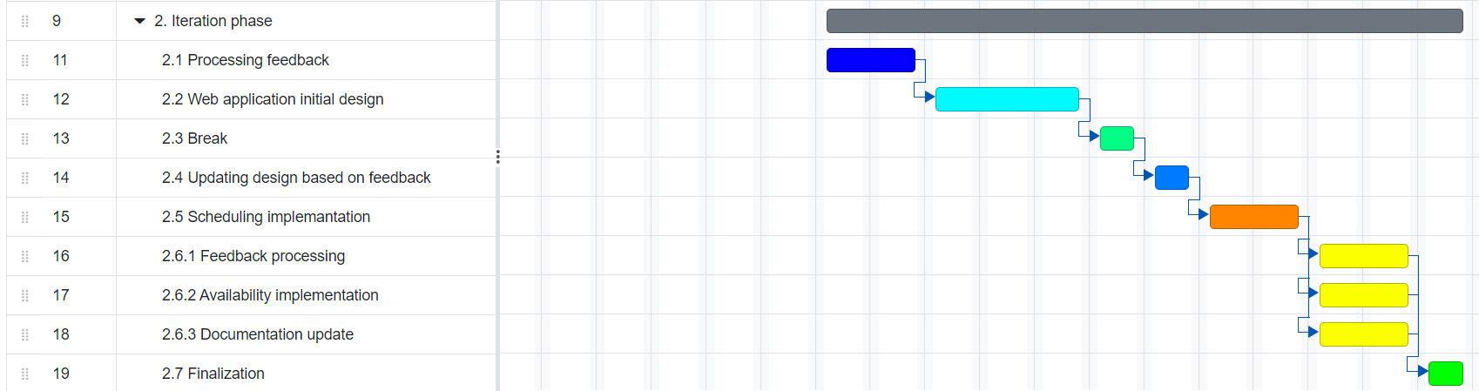

# Project structureorganization

## RiskAssessment

1. Projectteammisunderstandingrequirements.

This can easily happen due to a misread or due to impropercommunication.Eventhoughwetriedtobeasthoroughaspossiblethesethings can still happen. To prevent it we will discuss the informationthoroughlywiththewholegroupbeforeusingit.

1. Personalissues

Personal events can impact a team member’s capacity to work. Thisincludesfamilymatters,healthissuesandothers.

1. Communicationgetscutoff

This can happen in multiple ways like when the means ofcommunication get cut off. This is why we established multiple means ofcommunication.

1. Materialgetslost.

Whensomeoneintheteamlosestheirworkduetoanunforeseenaccident.

1. Failuretofollowmethodology.

Whenwedon'tfollowtheplanandfallbehindorwerushaheadandmisssomething.

1. Misuseofversioncontrolenvironment.

Someone uploads a inadequate of the project and everything stopsworking.

|  |  |  |  |
| --- | --- | --- | --- |
| Risk | Possibility | Impact | Mitigation |
| 1 | unlikely | veryhigh | To prevent it we will discuss theinformationwiththewholegroupbeforeusingit. |
| 2 | possible | Medium -High | This can be avoided by making sure no oneis ever overloaded with work and can takeonadditionalresponsibilities. |
| 3 | veryunlikely | veryhigh | Havingmultiplemeansofcommunicationsetupand meetinginperson. |
| 4 | unlikely | high | Havingbackupsofeverything. |
| 5 | unlikely | mild | This can be prevented by constantlyretrospecting and wondering whether wearestillontherighttrack. |
| 6 | very veryunlikely | medium | Making sure we know what we are doing,only uploading working and tested piecesoftheproject. |