This is a Title
This is text. Religion and politics Often make some people Lose all perspective and Give way to ranting and raving and Carrying on like emotional children. They either refuse to discuss it with reason, Or else they prefer argumentum ad hominum, Which is a hell of a way to conduct a discussion. Well, anyhow, not long ago, I was talking about the elections, And how the campaigns were ignoring the issues, And sticking instead to invective and personal crap That had nothing to do with the substantive problems of running a government, Which is all true, as you know If you followed the speeches and so-called debates of the candidates. Anyhow, one of the guys I was talking with Said not a word in the whole conversation Except at the end when he suddenly chuckled And said we were all full of shit, And why didn't we go live in Russia or China If that was the way we all hated the United States Of America. Next thing you know the whole blooming discussion Was more like a brawl, And the epithets flew thick and fast, And the noise was incredible. Someone said "son of a bitch", And I think he said "bastard". I couldn't be sure, it was all so confusing. Well, anyhow, I was attempting To get it all back on a rational level. I tried, for example, to talk to the one who had started it all, And I asked him just what did he mean we were all full of shit. Was he making a statement of fact as he knew it, And where was his documentation to back up his claim? I think Socrates would've been proud of the way I refuted his argument. That is, I tried to refute it, But all he could offer by way of rebuttal was more of the same About how we were all full of shit. But he wouldn't say why, He just kept on repeating it, That and the part about Russia and China And communist dupes, and I'll have to confess That I got a bit angry and told him to stuff his ideas up his ass, Which you don't have to tell me is hardly a way To convince anyone in an argument. Then he got salty and threatened to give me A punch in the mouth if I didn't shut up, And I really got hot, And the others did too, And we all beat the shit out of mister conservative. And, after all, he had only himself to be blamed. This is still a free country, And anyone telling a fellow like me, "Brother, you're full of shit", Better be good and ready To answer politely When asked if he'd care to say why.

This is an Image.
This is title after image caption
Another text. I like to creep around my home and act like a goblin. I don’t know why but I just enjoy doing this. Maybe it’s my way of dealing with stress or something but I just do it about once every week. Generally I’ll carry around a sack and creep around in a sort of crouch-walking position making goblin noises, then I’ll walk around my house and pick up various different “trinkets” and put them in my bag while saying stuff like “I’ll be having that” and laughing maniacally in my goblin voice (“trinkets” can include anything from shit I find on the ground to cutlery or other utensils). The other day I was talking with my neighbours and they mentioned hearing weird noises like what I wrote about and I was just internally screaming the entire conversation. I’m 99% sure they don’t know it’s me but god that 1% chance is seriously weighing on my mind.

Это очень длинный заголовок после разрыва страницы. Также он состоит из двух предложений – со специальными знаками
- Элмент1
- Элемент2
- Элемент3
5.1 Нумерованный заголовок
5.2 Нумерованный заголовок
5.3 Нумерованный заголовок
Lorem Ipsum is simply dummy text of the printing and typesetting industry. Lorem Ipsum has been the industry's standard dummy text ever since the 1500s, when an unknown printer took a galley of type and scrambled it to make a type specimen book. It has survived not only five centuries, but also the leap into electronic typesetting, remaining essentially unchanged. It was popularised in the 1960s with the release of Letraset sheets containing Lorem Ipsum passages, and more recently with desktop publishing software like Aldus PageMaker including versions of Lorem Ipsum.
Where does it come from?
Contrary to popular belief, Lorem Ipsum is not simply random text. It has roots in a piece of classical Latin literature from 45 BC, making it over 2000 years old. Richard McClintock, a Latin professor at Hampden-Sydney College in Virginia, looked up one of the more obscure Latin words, consectetur, from a Lorem Ipsum passage, and going through the cites of the word in classical literature, discovered the undoubtable source. Lorem Ipsum comes from sections 1.10.32 and 1.10.33 of "de Finibus Bonorum et Malorum" (The Extremes of Good and Evil) by Cicero, written in 45 BC. This book is a treatise on the theory of ethics, very popular during the Renaissance. The first line of Lorem Ipsum, "Lorem ipsum dolor sit amet..", comes from a line in section 1.10.32.
The standard chunk of Lorem Ipsum used since the 1500s is reproduced below for those interested. Sections 1.10.32 and 1.10.33 from "de Finibus Bonorum et Malorum" by Cicero are also reproduced in their exact original form, accompanied by English versions from the 1914 translation by H. Rackham.
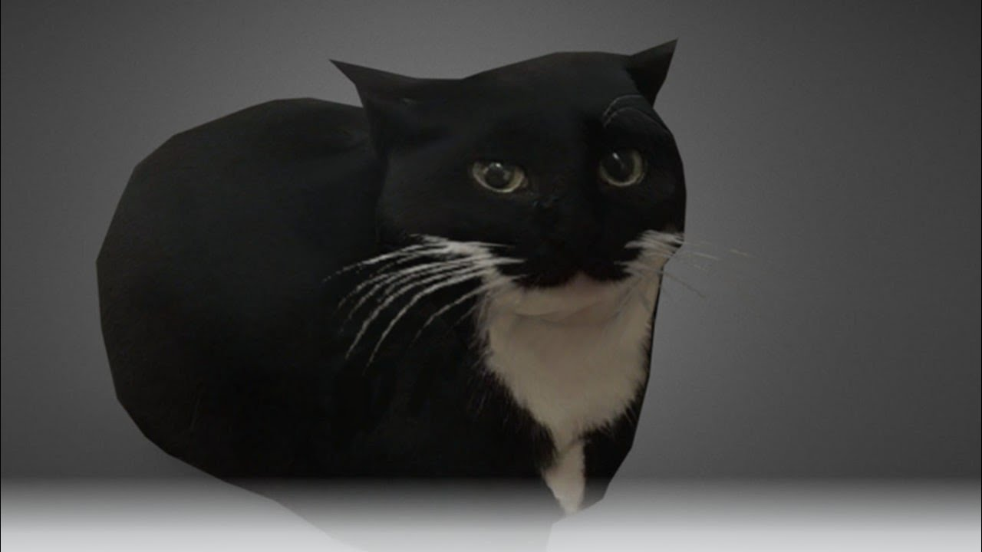
Заголовок после картинки
Давно выяснено, что при оценке дизайна и композиции читаемый текст мешает сосредоточиться. Lorem Ipsum используют потому, что тот обеспечивает более или менее стандартное заполнение шаблона, а также реальное распределение букв и пробелов в абзацах, которое не получается при простой дубликации "Здесь ваш текст.. Здесь ваш текст.. Здесь ваш текст.." Многие программы электронной вёрстки и редакторы HTML используют Lorem Ipsum в качестве текста по умолчанию, так что поиск по ключевым словам "lorem ipsum" сразу показывает, как много веб-страниц всё ещё дожидаются своего настоящего рождения. За прошедшие годы текст Lorem Ipsum получил много версий. Некоторые версии появились по ошибке, некоторые - намеренно (например, юмористические варианты).
1 | 2 | 3 | 4
5 | 6 | 7 | 8
9 | 10 | 11 | 12

Title after a table
Есть много вариантов Lorem Ipsum, но большинство из них имеет не всегда приемлемые модификации, например, юмористические вставки или слова, которые даже отдалённо не напоминают латынь. Если вам нужен Lorem Ipsum для серьёзного проекта, вы наверняка не хотите какой-нибудь шутки, скрытой в середине абзаца. Также все другие известные генераторы Lorem Ipsum используют один и тот же текст, который они просто повторяют, пока не достигнут нужный объём. Это делает предлагаемый здесь генератор единственным настоящим Lorem Ipsum генератором. Он использует словарь из более чем 200 латинских слов, а также набор моделей предложений. В результате сгенерированный Lorem Ipsum выглядит правдоподобно, не имеет повторяющихся абзацей или "невозможных" слов.
Заголовок перед концом дока

