C:\Users\balanirmal.KGISL\Documents\logo.png

**Android**

# Index

1.Introduction 4

2.Splash screen Creation 10

2.1 Splashscreen.java 10

2.2 activity_splash.xml 10

3.Navigation Drawer (Menus) creation 12

3.1 Navigation.java 12

3.2 activity_navigation.xml 15

3.3 app_bar_navigation.xml 16

3.4 content_navigation.xml 17

3.5 nav_header_navigation.xml 18

3.6 activity_navigation_drawer.xml 19

3.7 navigation.xml 20

4.Login and Registration creation 21

4.1 Open your project’s build.gradle(Module : App) file 21

4.2Code for MainActivity.java file. 21

4.3 Code for activity_main.xml layout file. 25

4.4 Code for LoginActivity.java file. 27

4.5 Code for activity_login.xml layout file. 33

4.6 Code for AndroidManifest.xml file. 36

5.Crud operations 39

5.1 Create mysql database 39

5.2 db_config.php 39

5.3 addEmp.php 39

5.4 getEmp.php 40

5.5 getAllEmp.php 40

5.6 updateEmp.php 41

5.7 deleteEmp.php 42

5.8 Android Studio Project: 43

5.8.1 AndroidManifest.xml file 43

5.8.2 activity_main.xml 44

5.8.3 MainActivity.java 46

5.8.4 Constant.java 47

5.8.5 BackgroundWorker.java 48

5.8.6 activity_view.xml 52

5.8.7 list_item.xml 53

5.8.8 ViewActivity.java 54

5.8.9 activity_edit.xml 61

5.8.10 EditActivity.java 63

# 1.Introduction

* Android is a software package and linux based operating system for mobile devices such as tablet computers and smartphones.
* We follow some steps to create a new project in android studio.

**Step 1**

* Click file menu -> choose new->new project

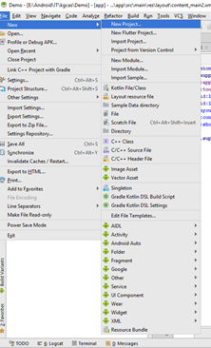

**Step 2:**

* We want to give application name and click next

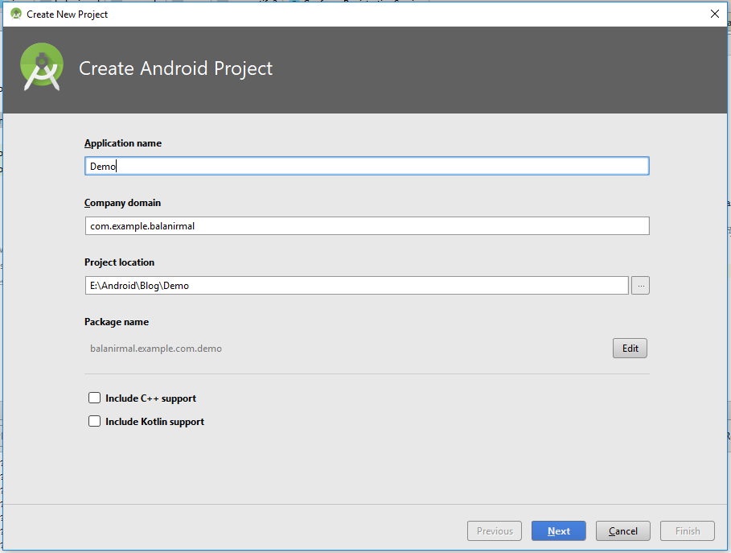

**Step 3:**

* We want to choose phone and tablet and click next

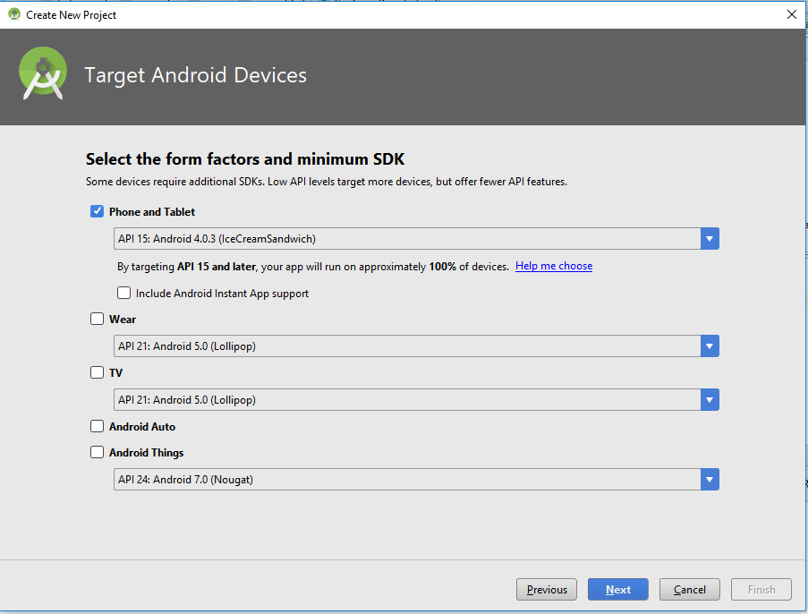

**Step 5:**

* we choose empty activity and click next

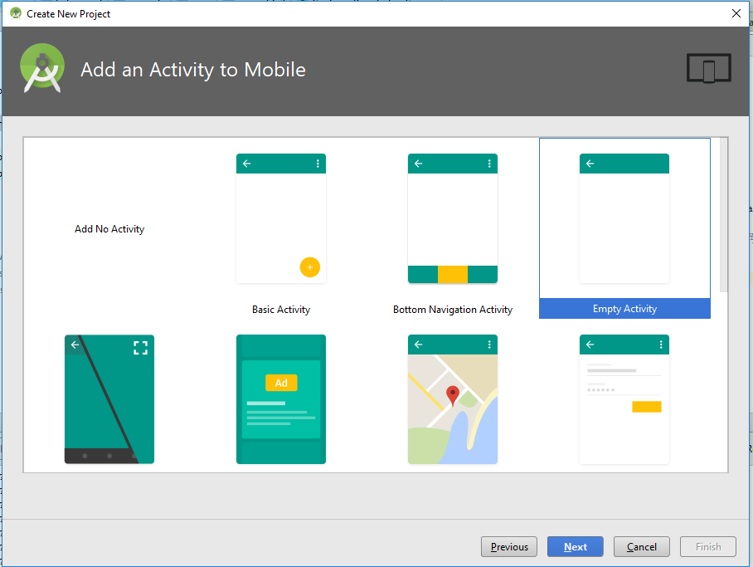

**Step 6:**

* We want to give a activity name and click finish

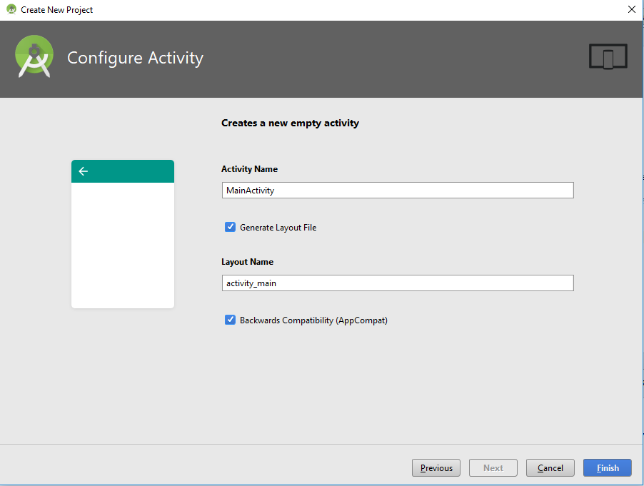

**Step 7:**

* After your project creation it shows like below

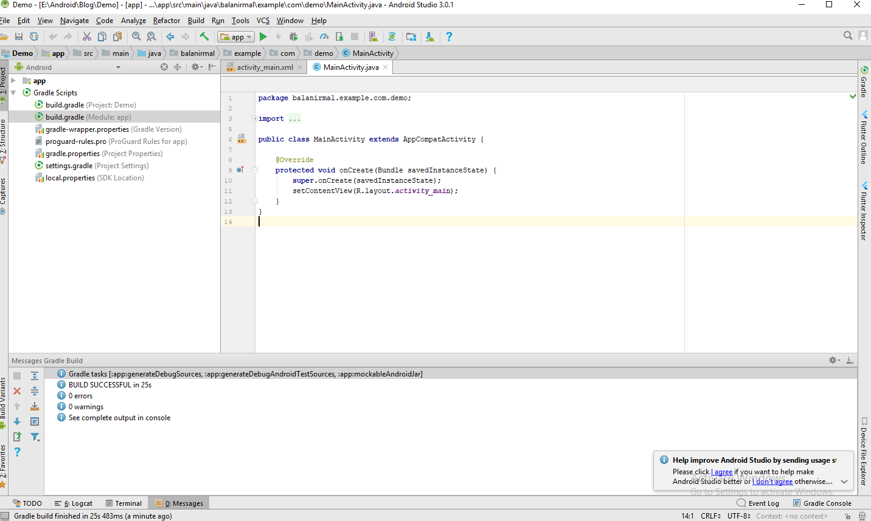

**Step 8:**

* We want to design our layout file (app-> res-> layout) and java file.

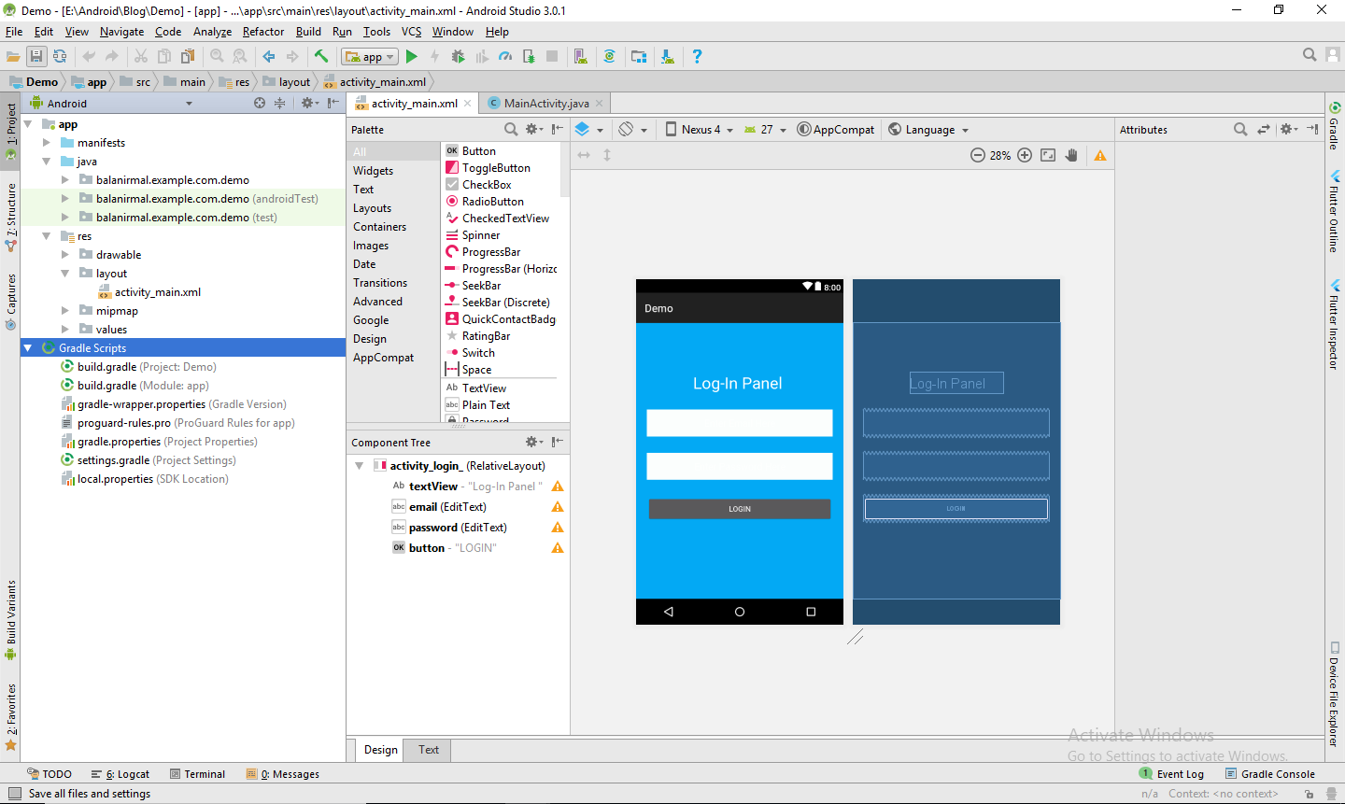

**Step 9:**

* After that we need to run a program so press run button.

E:\Android\IT\kgcas\Capture9.PNG

**Step 10:**

* It shows the list of devices and emulators name. we can choose any one in the given list.

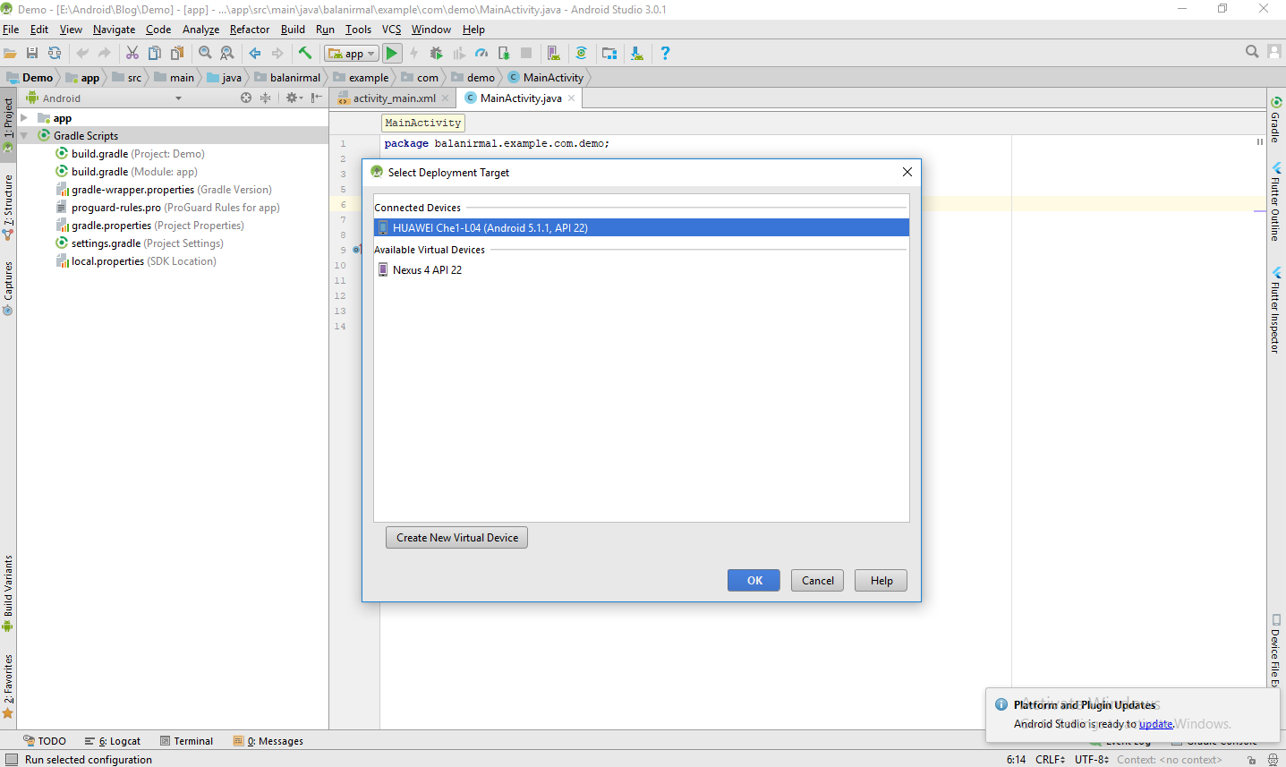

**Step 11:**

* Finally we got an output

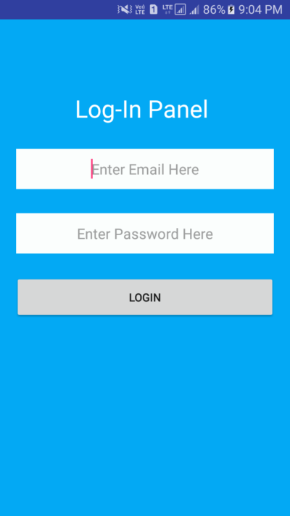

# 2.Splash screen Creation

### 2.1 Splashscreen.java

package com.example.balanirmal.cricdemo;  
  
import android.app.Activity;  
import android.content.Intent;  
import android.os.Bundle;  
import android.os.Handler;  
  
public class Splash extends Activity {  
 private static int Time=2000;  
 protected void onCreate(Bundle savedInstanceState) {  
 super.onCreate(savedInstanceState);  
 setContentView(R.layout.activity_splash);  
 new Handler().postDelayed(new Runnable() {  
 @Override  
 public void run() {  
 Intent i=new Intent(Splash.this,Main2Activity.class);  
 startActivity(i);  
 finish();  
 }  
 },Time);  
  
 }  
}

### 

### 2.2 activity_splash.xml

<?xml version="1.0" encoding="utf-8"?>  
<RelativeLayout xmlns:android="http://schemas.android.com/apk/res/android"  
 xmlns:tools="http://schemas.android.com/tools"  
 android:layout_width="match_parent"  
 android:layout_height="match_parent"  
 android:background="@drawable/demm"  
 xmlns:app="http://schemas.android.com/apk/res-auto"  
 tools:context=".Splash">  
  
</RelativeLayout>

**Output for splash screen:**



# 

# 3.Navigation Drawer (Menus) creation

### 3.1 Navigation.java

package balanirmal.example.com.navigation;  
  
import android.os.Bundle;  
import android.support.design.widget.FloatingActionButton;  
import android.support.design.widget.Snackbar;  
import android.view.View;  
import android.support.design.widget.NavigationView;  
import android.support.v4.view.GravityCompat;  
import android.support.v4.widget.DrawerLayout;  
import android.support.v7.app.ActionBarDrawerToggle;  
import android.support.v7.app.AppCompatActivity;  
import android.support.v7.widget.Toolbar;  
import android.view.Menu;  
import android.view.MenuItem;  
  
public class Navigation extends AppCompatActivity  
 implements NavigationView.OnNavigationItemSelectedListener {  
  
 @Override  
 protected void onCreate(Bundle savedInstanceState) {  
 super.onCreate(savedInstanceState);  
 setContentView(R.layout.activity_navigation);  
 Toolbar toolbar = (Toolbar) findViewById(R.id.toolbar);  
 setSupportActionBar(toolbar);  
  
 FloatingActionButton fab = (FloatingActionButton) findViewById(R.id.fab);  
 fab.setOnClickListener(new View.OnClickListener() {  
 @Override  
 public void onClick(View view) {  
 Snackbar.make(view, "Replace with your own action", Snackbar.LENGTH_LONG)  
 .setAction("Action", null).show();  
 }  
 });  
  
 DrawerLayout drawer = (DrawerLayout) findViewById(R.id.drawer_layout);  
 ActionBarDrawerToggle toggle = new ActionBarDrawerToggle(  
 this, drawer, toolbar, R.string.navigation_drawer_open, R.string.navigation_drawer_close);  
 drawer.addDrawerListener(toggle);  
 toggle.syncState();  
  
 NavigationView navigationView = (NavigationView) findViewById(R.id.nav_view);  
 navigationView.setNavigationItemSelectedListener(this);  
 }  
  
 @Override  
 public void onBackPressed() {  
 DrawerLayout drawer = (DrawerLayout) findViewById(R.id.drawer_layout);  
 if (drawer.isDrawerOpen(GravityCompat.START)) {  
 drawer.closeDrawer(GravityCompat.START);  
 } else {  
 super.onBackPressed();  
 }  
 }  
  
 @Override  
 public boolean onCreateOptionsMenu(Menu menu) {  
 // Inflate the menu; this adds items to the action bar if it is present.  
 getMenuInflater().inflate(R.menu.navigation, menu);  
 return true;  
 }  
  
 @Override  
 public boolean onOptionsItemSelected(MenuItem item) {  
 // Handle action bar item clicks here. The action bar will  
 // automatically handle clicks on the Home/Up button, so long  
 // as you specify a parent activity in AndroidManifest.xml.  
 int id = item.getItemId();  
  
 //noinspection SimplifiableIfStatement  
 if (id == R.id.action_settings) {  
 return true;  
 }  
  
 return super.onOptionsItemSelected(item);  
 }  
  
 @SuppressWarnings("StatementWithEmptyBody")  
 @Override  
 public boolean onNavigationItemSelected(MenuItem item) {  
 // Handle navigation view item clicks here.  
 int id = item.getItemId();  
  
 if (id == R.id.nav_camera) {  
 // Handle the camera action  
 } else if (id == R.id.nav_gallery) {  
  
 } else if (id == R.id.nav_slideshow) {  
  
 } else if (id == R.id.nav_manage) {  
  
 } else if (id == R.id.nav_share) {  
  
 } else if (id == R.id.nav_send) {  
  
 }  
  
 DrawerLayout drawer = (DrawerLayout) findViewById(R.id.drawer_layout);  
 drawer.closeDrawer(GravityCompat.START);  
 return true;  
 }  
}

### 

### 3.2 activity_navigation.xml

<?xml version="1.0" encoding="utf-8"?>  
<android.support.v4.widget.DrawerLayout xmlns:android="http://schemas.android.com/apk/res/android"  
 xmlns:app="http://schemas.android.com/apk/res-auto"  
 xmlns:tools="http://schemas.android.com/tools"  
 android:id="@+id/drawer_layout"  
 android:layout_width="match_parent"  
 android:layout_height="match_parent"  
 android:fitsSystemWindows="true"  
 tools:openDrawer="start">  
  
 <include  
 layout="@layout/app_bar_navigation"  
 android:layout_width="match_parent"  
 android:layout_height="match_parent" />  
  
 <android.support.design.widget.NavigationView  
 android:id="@+id/nav_view"  
 android:layout_width="wrap_content"  
 android:layout_height="match_parent"  
 android:layout_gravity="start"  
 android:fitsSystemWindows="true"  
 app:headerLayout="@layout/nav_header_navigation"  
 app:menu="@menu/activity_navigation_drawer" />  
  
</android.support.v4.widget.DrawerLayout>

### 

### 3.3 app_bar_navigation.xml

<?xml version="1.0" encoding="utf-8"?>  
<android.support.design.widget.CoordinatorLayout xmlns:android="http://schemas.android.com/apk/res/android"  
 xmlns:app="http://schemas.android.com/apk/res-auto"  
 xmlns:tools="http://schemas.android.com/tools"  
 android:layout_width="match_parent"  
 android:layout_height="match_parent"  
 tools:context="balanirmal.example.com.navigation.Navigation">  
  
 <android.support.design.widget.AppBarLayout  
 android:layout_width="match_parent"  
 android:layout_height="wrap_content"  
 android:theme="@style/AppTheme.AppBarOverlay">  
  
 <android.support.v7.widget.Toolbar  
 android:id="@+id/toolbar"  
 android:layout_width="match_parent"  
 android:layout_height="?attr/actionBarSize"  
 android:background="?attr/colorPrimary"  
 app:popupTheme="@style/AppTheme.PopupOverlay" />  
  
 </android.support.design.widget.AppBarLayout>  
  
 <include layout="@layout/content_navigation" />  
  
 <android.support.design.widget.FloatingActionButton  
 android:id="@+id/fab"  
 android:layout_width="wrap_content"  
 android:layout_height="wrap_content"  
 android:layout_gravity="bottom|end"  
 android:layout_margin="@dimen/fab_margin"  
 app:srcCompat="@android:drawable/ic_dialog_email" />  
  
</android.support.design.widget.CoordinatorLayout>

### 3.4 content_navigation.xml

<?xml version="1.0" encoding="utf-8"?>  
<android.support.constraint.ConstraintLayout xmlns:android="http://schemas.android.com/apk/res/android"  
 xmlns:app="http://schemas.android.com/apk/res-auto"  
 xmlns:tools="http://schemas.android.com/tools"  
 android:layout_width="match_parent"  
 android:layout_height="match_parent"  
 app:layout_behavior="@string/appbar_scrolling_view_behavior"  
 tools:context="balanirmal.example.com.navigation.Navigation"  
 tools:showIn="@layout/app_bar_navigation">  
  
 <TextView  
 android:layout_width="wrap_content"  
 android:layout_height="wrap_content"  
 android:text="Hello World!"  
 app:layout_constraintBottom_toBottomOf="parent"  
 app:layout_constraintLeft_toLeftOf="parent"  
 app:layout_constraintRight_toRightOf="parent"  
 app:layout_constraintTop_toTopOf="parent" />  
  
</android.support.constraint.ConstraintLayout>

### 

### 

### 3.5 nav_header_navigation.xml

<?xml version="1.0" encoding="utf-8"?>  
<LinearLayout xmlns:android="http://schemas.android.com/apk/res/android"  
 xmlns:app="http://schemas.android.com/apk/res-auto"  
 android:layout_width="match_parent"  
 android:layout_height="@dimen/nav_header_height"  
 android:background="@drawable/side_nav_bar"  
 android:gravity="bottom"  
 android:orientation="vertical"  
 android:paddingBottom="@dimen/activity_vertical_margin"  
 android:paddingLeft="@dimen/activity_horizontal_margin"  
 android:paddingRight="@dimen/activity_horizontal_margin"  
 android:paddingTop="@dimen/activity_vertical_margin"  
 android:theme="@style/ThemeOverlay.AppCompat.Dark">  
  
 <ImageView  
 android:id="@+id/imageView"  
 android:layout_width="wrap_content"  
 android:layout_height="wrap_content"  
 android:paddingTop="@dimen/nav_header_vertical_spacing"  
 app:srcCompat="@mipmap/ic_launcher_round" />  
  
 <TextView  
 android:layout_width="match_parent"  
 android:layout_height="wrap_content"  
 android:paddingTop="@dimen/nav_header_vertical_spacing"  
 android:text="Android Studio"  
 android:textAppearance="@style/TextAppearance.AppCompat.Body1" />  
  
 <TextView  
 android:id="@+id/textView"  
 android:layout_width="wrap_content"  
 android:layout_height="wrap_content"  
 android:text="android.studio@android.com" />  
  
</LinearLayout>

### 3.6 activity_navigation_drawer.xml

<?xml version="1.0" encoding="utf-8"?>  
<menu xmlns:android="http://schemas.android.com/apk/res/android"  
 xmlns:tools="http://schemas.android.com/tools"  
 tools:showIn="navigation_view">  
  
 <group android:checkableBehavior="single">  
 <item  
 android:id="@+id/nav_camera"  
 android:icon="@drawable/ic_menu_camera"  
 android:title="Import" />  
 <item  
 android:id="@+id/nav_gallery"  
 android:icon="@drawable/ic_menu_gallery"  
 android:title="Gallery" />  
 <item  
 android:id="@+id/nav_slideshow"  
 android:icon="@drawable/ic_menu_slideshow"  
 android:title="Slideshow" />  
 <item  
 android:id="@+id/nav_manage"  
 android:icon="@drawable/ic_menu_manage"  
 android:title="Tools" />  
 </group>  
  
 <item android:title="Communicate">  
 <menu>  
 <item  
 android:id="@+id/nav_share"  
 android:icon="@drawable/ic_menu_share"  
 android:title="Share" />  
 <item  
 android:id="@+id/nav_send"  
 android:icon="@drawable/ic_menu_send"  
 android:title="Send" />  
 </menu>  
 </item>  
  
</menu>

### 3.7 navigation.xml

<?xml version="1.0" encoding="utf-8"?>  
<menu xmlns:android="http://schemas.android.com/apk/res/android"  
xmlns:app="http://schemas.android.com/apk/res-auto">  
<item  
 android:id="@+id/action_settings"  
 android:orderInCategory="100"  
 android:title="@string/action_settings"  
 app:showAsAction="never" />  
</menu>

**Output for navigation drawer (Menus) creation**

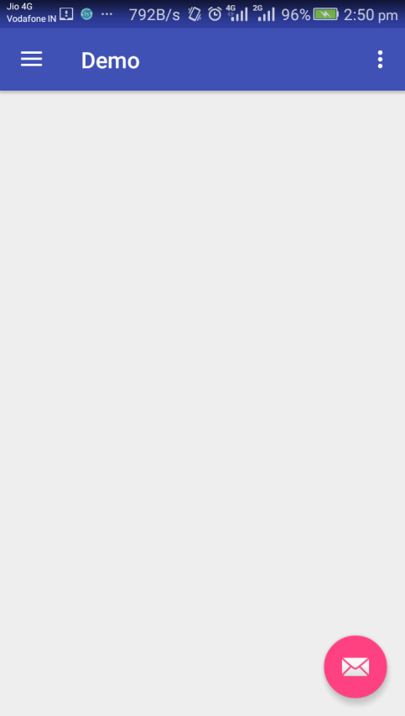 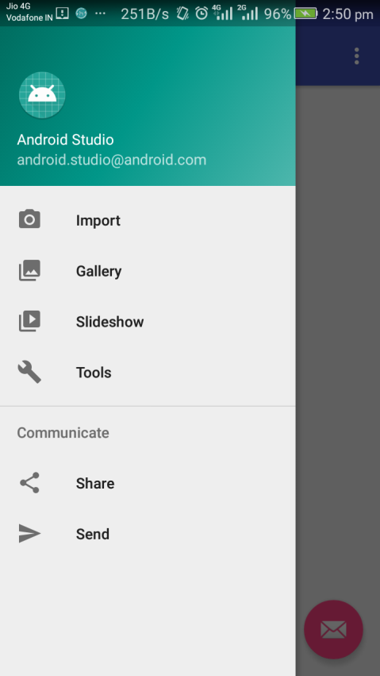

# 

# 

# 4.Login and Registration creation

4.1 Open your project’s build.gradle(Module : App) file **.**

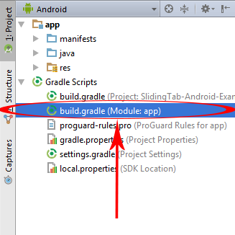

### ****4.2Code for MainActivity.java file.****

package balanirmal.example.com.login;  
  
import android.content.Intent;  
import android.support.v7.app.AppCompatActivity;  
import android.os.Bundle;  
import java.io.BufferedInputStream;  
import java.io.IOException;  
import java.io.InputStream;  
import java.net.HttpURLConnection;  
import java.net.URL;  
import java.util.ArrayList;  
import java.util.List;  
import org.apache.http.HttpEntity;  
import org.apache.http.HttpResponse;  
import org.apache.http.NameValuePair;  
import org.apache.http.ParseException;  
import org.apache.http.client.ClientProtocolException;  
import org.apache.http.client.HttpClient;  
import org.apache.http.client.entity.UrlEncodedFormEntity;  
import org.apache.http.client.methods.HttpPost;  
import org.apache.http.impl.client.DefaultHttpClient;  
import org.apache.http.message.BasicNameValuePair;  
import org.apache.http.util.EntityUtils;  
import android.os.AsyncTask;  
import android.os.Bundle;  
import android.text.TextUtils;  
import android.view.View;  
import android.widget.Button;  
import android.widget.EditText;  
import android.widget.Toast;  
  
public class MainActivity extends AppCompatActivity {  
  
 Button register , login ;  
 EditText name, email , password ;  
 String RegisterURL = "https://wwwdemoappcom.000webhostapp.com/insert-registration-data.php" ;  
 Boolean CheckEditText ;  
 String Response;  
 HttpResponse response ;  
 String NameHolder, EmailHolder, PasswordHolder ;  
  
 @Override  
 protected void onCreate(Bundle savedInstanceState) {  
 super.onCreate(savedInstanceState);  
 setContentView(R.layout.activity_main);  
  
 register = (Button)findViewById(R.id.button);  
 login = (Button)findViewById(R.id.button2);  
  
 name = (EditText)findViewById(R.id.name);  
 email = (EditText)findViewById(R.id.email);  
 password = (EditText)findViewById(R.id.password);  
  
 register.setOnClickListener(new View.OnClickListener() {  
 @Override  
 public void onClick(View view) {  
  
  
 GetCheckEditTextIsEmptyOrNot();  
  
 if(CheckEditText){  
  
 SendDataToServer(NameHolder, EmailHolder, PasswordHolder);  
  
 }  
 else {  
  
 Toast.makeText(MainActivity.this, "Please fill all form fields.", Toast.LENGTH_LONG).show();  
  
 }  
  
  
 }  
 });  
  
 login.setOnClickListener(new View.OnClickListener() {  
 @Override  
 public void onClick(View view) {  
  
 Intent intent = new Intent(MainActivity.this, Login_Activity.class);  
 startActivity(intent);  
  
 }  
 });  
 }  
  
 public void GetCheckEditTextIsEmptyOrNot(){  
  
 NameHolder = name.getText().toString();  
 EmailHolder = email.getText().toString();  
 PasswordHolder = password.getText().toString();  
  
 if(TextUtils.isEmpty(NameHolder) || TextUtils.isEmpty(EmailHolder) || TextUtils.isEmpty(PasswordHolder))  
 {  
  
 CheckEditText = false;  
  
 }  
 else {  
  
 CheckEditText = true ;  
 }  
  
 }  
  
 public void SendDataToServer(final String name, final String email, final String password){  
 class SendPostReqAsyncTask extends AsyncTask<String, Void, String> {  
 @Override  
 protected String doInBackground(String... params) {  
  
 String QuickName = name ;  
 String QuickEmail = email ;  
 String QuickPassword = password;  
  
 List<NameValuePair> nameValuePairs = new ArrayList<NameValuePair>();  
  
 nameValuePairs.add(new BasicNameValuePair("name", QuickName));  
 nameValuePairs.add(new BasicNameValuePair("email", QuickEmail));  
 nameValuePairs.add(new BasicNameValuePair("password", QuickPassword));  
  
 try {  
 HttpClient httpClient = new DefaultHttpClient();  
  
 HttpPost httpPost = new HttpPost(RegisterURL);  
  
 httpPost.setEntity(new UrlEncodedFormEntity(nameValuePairs));  
  
 HttpResponse response = httpClient.execute(httpPost);  
  
 HttpEntity entity = response.getEntity();  
  
  
 } catch (ClientProtocolException e) {  
  
 } catch (IOException e) {  
 }  
 return "Data Submit Successfully";  
 }  
  
 @Override  
 protected void onPostExecute(String result) {  
 super.onPostExecute(result);  
  
 Toast.makeText(MainActivity.this, "Data Submit Successfully", Toast.LENGTH_LONG).show();  
  
 }  
 }  
 SendPostReqAsyncTask sendPostReqAsyncTask = new SendPostReqAsyncTask();  
 sendPostReqAsyncTask.execute(name, email, password);  
 }  
  
}

### ****4.3 Code for activity_main.xml layout file.****

<?xml version="1.0" encoding="utf-8"?>  
<RelativeLayout xmlns:android="http://schemas.android.com/apk/res/android"  
 xmlns:tools="http://schemas.android.com/tools"  
 android:id="@+id/activity_main"  
 android:layout_width="match_parent"  
 android:layout_height="match_parent"  
 android:background="#03A9F4"  
 android:padding="20dp"  
 tools:context=".MainActivity">  
  
  
 <TextView  
 android:text="Register Here"  
 android:layout_width="wrap_content"  
 android:layout_height="wrap_content"  
 android:id="@+id/textView"  
 android:textColor="#ffffff"  
 android:textSize="30dp"  
 android:gravity="center"  
 android:layout_alignParentTop="true"  
 android:layout_centerHorizontal="true"  
 android:layout_marginTop="30dp"  
 />  
  
 <EditText  
 android:layout_width="fill_parent"  
 android:layout_height="50dp"  
 android:inputType="textPersonName"  
 android:ems="10"  
 android:layout_below="@+id/textView"  
 android:layout_centerHorizontal="true"  
 android:layout_marginTop="30dp"  
 android:id="@+id/name"  
 android:gravity="center"  
 android:background="#fbfefd"  
 android:hint="Enter Name Here"  
 />  
  
 <EditText  
 android:layout_width="fill_parent"  
 android:layout_height="50dp"  
 android:inputType="textEmailAddress"  
 android:ems="10"  
 android:layout_marginTop="30dp"  
 android:id="@+id/email"  
 android:gravity="center"  
 android:background="#fbfefd"  
 android:hint="Enter Email Here"  
 android:layout_below="@+id/name"  
 android:layout_alignParentLeft="true"  
 android:layout_alignParentStart="true" />  
  
 <EditText  
 android:layout_width="fill_parent"  
 android:inputType="textPassword"  
 android:layout_marginTop="30dp"  
 android:ems="10"  
 android:id="@+id/password"  
 android:gravity="center"  
 android:background="#fbfefd"  
 android:hint="Enter Password Here"  
 android:layout_height="50dp"  
 android:layout_centerVertical="true"  
 android:layout_alignParentLeft="true"  
 android:layout_alignParentStart="true" />  
  
 <Button  
 android:text="REGISTER"  
 android:layout_width="fill_parent"  
 android:layout_height="wrap_content"  
 android:layout_below="@+id/password"  
 android:layout_centerHorizontal="true"  
 android:layout_marginTop="30dp"  
 android:id="@+id/button"  
 />  
  
 <Button  
 android:text="Already Register! Login From Here"  
 android:layout_width="fill_parent"  
 android:layout_height="wrap_content"  
 android:layout_below="@+id/button"  
 android:layout_centerHorizontal="true"  
 android:id="@+id/button2"  
 android:layout_marginTop="10dp"/>  
  
</RelativeLayout>

### 

### ****4.4 Code for LoginActivity.java file.****

package balanirmal.example.com.login;  
  
  
import android.app.ProgressDialog;  
import android.content.Intent;  
import android.os.AsyncTask;  
import android.support.v7.app.AppCompatActivity;  
import android.os.Bundle;  
import android.text.TextUtils;  
import android.view.View;  
import android.widget.Button;  
import android.widget.EditText;  
import android.widget.Toast;  
import java.io.BufferedReader;  
import java.io.BufferedWriter;  
import java.io.InputStreamReader;  
import java.io.OutputStream;  
import java.io.OutputStreamWriter;  
import java.io.UnsupportedEncodingException;  
import java.net.HttpURLConnection;  
import java.net.URL;  
import java.net.URLEncoder;  
import java.util.HashMap;  
import java.util.Map;  
import javax.net.ssl.HttpsURLConnection;  
  
public class Login_Activity extends AppCompatActivity {  
  
 Button login ;  
 ProgressDialog progressDialog;  
 EditText email, password ;  
 String EmailHolder, PasswordHolder ;  
 boolean CheckEditText ;  
 String ServerLoginURL = "https://wwwdemoappcom.000webhostapp.com/android-login.php";  
 public static final String UserEmail = "";  
 String finalResult ;  
 HashMap<String,String> hashMap = new HashMap<>();  
 URL url;  
 String FinalHttpData = "";  
 BufferedWriter bufferedWriter ;  
 LoginParseClass loginParseClass = new LoginParseClass();  
 BufferedReader bufferedReader ;  
 OutputStream outputStream ;  
 StringBuilder stringBuilder = new StringBuilder();  
 String Result ;  
  
 @Override  
 protected void onCreate(Bundle savedInstanceState) {  
 super.onCreate(savedInstanceState);  
 setContentView(R.layout.activity_login_);  
  
 login = (Button)findViewById(R.id.button);  
  
 email = (EditText) findViewById(R.id.email);  
  
 password = (EditText)findViewById(R.id.password);  
  
 login.setOnClickListener(new View.OnClickListener() {  
 @Override  
 public void onClick(View view) {  
  
 GetCheckEditTextIsEmptyOrNot();  
  
 if(CheckEditText){  
  
 LoginFunction(EmailHolder,PasswordHolder);  
  
 }  
 else {  
  
 Toast.makeText(Login_Activity.this, "Please fill all form fields.", Toast.LENGTH_LONG).show();  
  
 }  
  
  
  
 }  
 });  
 }  
  
 public void GetCheckEditTextIsEmptyOrNot(){  
  
 EmailHolder = email.getText().toString();  
 PasswordHolder = password.getText().toString();  
  
 if(TextUtils.isEmpty(EmailHolder) || TextUtils.isEmpty(PasswordHolder))  
 {  
  
 CheckEditText = false;  
  
 }  
 else {  
  
 CheckEditText = true ;  
 }  
  
 }  
  
 public void LoginFunction(final String email, final String password){  
  
 class LoginFunctionClass extends AsyncTask<String,Void,String> {  
  
 @Override  
 protected void onPreExecute() {  
 super.onPreExecute();  
  
 progressDialog = ProgressDialog.show(Login_Activity.this,"Loading Data",null,true,true);  
 }  
  
 @Override  
 protected void onPostExecute(String httpResponseMsg) {  
  
 super.onPostExecute(httpResponseMsg);  
  
 progressDialog.dismiss();  
  
 if(httpResponseMsg.equalsIgnoreCase("Data Matched")){  
  
 finish();  
  
 Intent intent = new Intent(Login_Activity.this, MainActivity.class);  
  
  
 startActivity(intent);  
 }else{  
 Toast.makeText(Login_Activity.this,httpResponseMsg,Toast.LENGTH_LONG).show();  
 }  
 }  
  
 @Override  
 protected String doInBackground(String... params) {  
  
 hashMap.put("email",params[0]);  
  
 hashMap.put("password",params[1]);  
  
 finalResult = loginParseClass.postRequest(hashMap);  
  
 return finalResult;  
 }  
 }  
  
 LoginFunctionClass loginFunctionClass = new LoginFunctionClass();  
 loginFunctionClass.execute(email,password);  
 }  
  
 public class LoginParseClass {  
  
 public String postRequest(HashMap<String, String> Data) {  
  
 try {  
 url = new URL(ServerLoginURL);  
  
 HttpURLConnection httpURLConnection = (HttpURLConnection) url.openConnection();  
  
 httpURLConnection.setReadTimeout(12000);  
  
 httpURLConnection.setConnectTimeout(12000);  
  
 httpURLConnection.setRequestMethod("POST");  
  
 httpURLConnection.setDoInput(true);  
  
 httpURLConnection.setDoOutput(true);  
  
 outputStream = httpURLConnection.getOutputStream();  
  
 bufferedWriter = new BufferedWriter(  
  
 new OutputStreamWriter(outputStream, "UTF-8"));  
  
 bufferedWriter.write(FinalDataParse(Data));  
  
 bufferedWriter.flush();  
  
 bufferedWriter.close();  
  
 outputStream.close();  
  
 if (httpURLConnection.getResponseCode() == HttpsURLConnection.HTTP_OK) {  
  
 bufferedReader = new BufferedReader(  
 new InputStreamReader(  
 httpURLConnection.getInputStream()  
 )  
 );  
 FinalHttpData = bufferedReader.readLine();  
 }  
 else {  
 FinalHttpData = "Something Went Wrong";  
 }  
 } catch (Exception e) {  
 e.printStackTrace();  
 }  
  
 return FinalHttpData;  
 }  
  
 public String FinalDataParse(HashMap<String, String> hashMap2) throws UnsupportedEncodingException {  
  
 for(Map.Entry<String, String> map_entry : hashMap2.entrySet()){  
  
 stringBuilder.append("&");  
  
 stringBuilder.append(URLEncoder.encode(map_entry.getKey(), "UTF-8"));  
  
 stringBuilder.append("=");  
  
 stringBuilder.append(URLEncoder.encode(map_entry.getValue(), "UTF-8"));  
  
 }  
 Result = stringBuilder.toString();  
 return Result ;  
 }  
 }  
  
}

### 

### 4.5 ****Code for activity_login.xml layout file.****

<?xml version="1.0" encoding="utf-8"?>  
<RelativeLayout xmlns:android="http://schemas.android.com/apk/res/android"  
 xmlns:tools="http://schemas.android.com/tools"  
 android:id="@+id/activity_login_"  
 android:layout_width="match_parent"  
 android:layout_height="match_parent"  
 android:background="#03A9F4"  
 android:padding="20dp"  
 tools:context="com.android_examples.androidloginregistration_android_examplescom.Login_Activity">  
  
 <TextView  
 android:text="Log-In Panel "  
 android:layout_width="wrap_content"  
 android:layout_height="wrap_content"  
 android:id="@+id/textView"  
 android:textColor="#ffffff"  
 android:textSize="30dp"  
 android:gravity="center"  
 android:layout_alignParentTop="true"  
 android:layout_centerHorizontal="true"  
 android:layout_marginTop="70dp"  
 />  
  
 <EditText  
 android:layout_width="fill_parent"  
 android:layout_height="50dp"  
 android:inputType="textEmailAddress"  
 android:ems="10"  
 android:layout_below="@+id/textView"  
 android:layout_centerHorizontal="true"  
 android:layout_marginTop="30dp"  
 android:id="@+id/email"  
 android:gravity="center"  
 android:background="#fbfefd"  
 android:hint="Enter Email Here"  
  
 />  
  
 <EditText  
 android:layout_width="fill_parent"  
 android:layout_height="50dp"  
 android:inputType="textPassword"  
 android:ems="10"  
 android:layout_marginTop="30dp"  
 android:id="@+id/password"  
 android:gravity="center"  
 android:background="#fbfefd"  
 android:hint="Enter Password Here"  
 android:layout_below="@+id/email"  
 android:layout_alignParentLeft="true"  
 android:layout_alignParentStart="true" />  
  
 <Button  
 android:text="LOGIN"  
 android:layout_width="fill_parent"  
 android:layout_marginTop="30dp"  
 android:layout_height="wrap_content"  
 android:id="@+id/button"  
 android:layout_centerVertical="true"  
 android:layout_below="@+id/password" />  
  
</RelativeLayout>

### 

### ****4.6 Code for AndroidManifest.xml file**.**

<?xml version="1.0" encoding="utf-8"?>  
<manifest xmlns:android="http://schemas.android.com/apk/res/android"  
 package="balanirmal.example.com.login">  
 <uses-permission android:name="android.permission.INTERNET" />  
 <uses-permission android:name="android.permission.ACCESS_NETWORK_STATE" />  
 <uses-permission android:name="android.permission.ACCESS_WIFI_STATE" />  
  
 <application  
 android:allowBackup="true"  
 android:icon="@mipmap/ic_launcher"  
 android:label="@string/app_name"  
 android:roundIcon="@mipmap/ic_launcher_round"  
 android:supportsRtl="true"  
 android:theme="@style/AppTheme">  
 <activity android:name=".MainActivity">  
 <intent-filter>  
 <action android:name="android.intent.action.MAIN" />  
  
 <category android:name="android.intent.category.LAUNCHER" />  
 </intent-filter>  
 </activity>  
 <activity android:name=".Login_Activity"/>  
 </application>  
  
</manifest>

**Output for Login and Register pages**

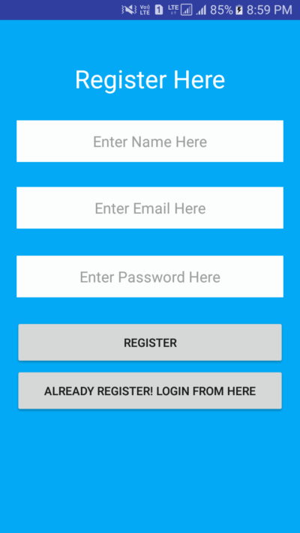 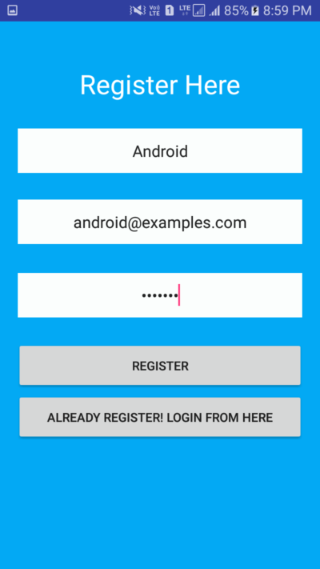

 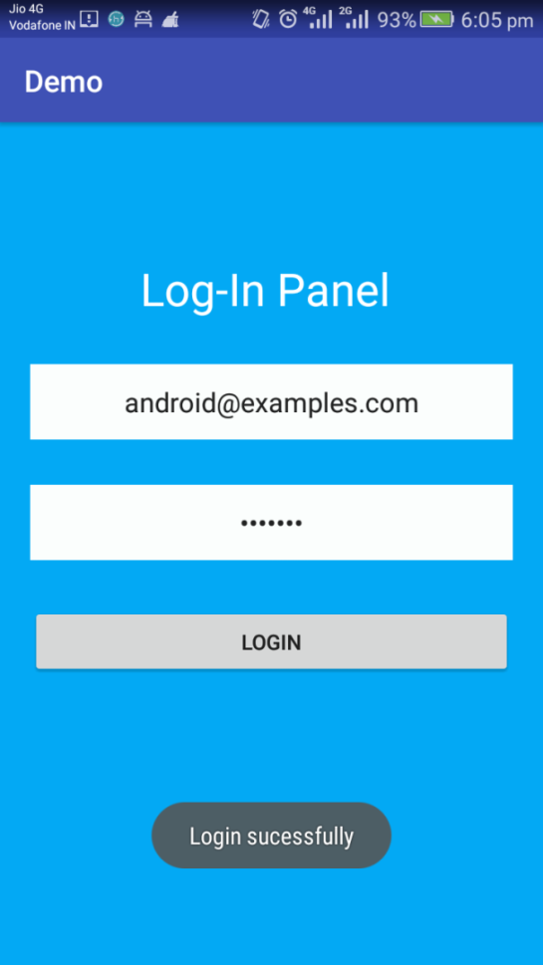

# 5.Crud operations

### 5.1 Create mysql database

CREATE DATABASE android_mysql;

**Create table**

CREATE TABLE IF NOT EXISTS employee(id int(11) primary key auto_increment,name varchar(100) not null,designation varchar(50) not null,salary int(50) not null,created_at datetime NOT NULL DEFAULT CURRENT_TIMESTAMP);

### 5.2 db_config.php

<?php

define('HOST','localhost');

define('USER','root');

define('PASS','');

define('DB','android_mysql');

$con = mysqli_connect(HOST,USER,PASS,DB) or die('Unable to Connect');

### 5.3 addEmp.php

<?php require_once('db_config.php');

$name = $_REQUEST ['name'];

$desg = $_REQUEST ['designation'];

$sal = $_REQUEST ['salary'];

$sql = "INSERT INTO `employee` (`name`, `designation`, `salary`) VALUES ('$name','$desg','$sal')"; if(mysqli_query($con,$sql)){

echo 'Employee Added Successfully';

}else{

echo 'Could Not Add Employee';

}

//Closing the database

mysqli_close($con);

?>

### 5.4 getEmp.php

<?php

$id = $_GET['id'];

require_once('db_config.php');

$sql = "SELECT * FROM employee WHERE id=$id";

$r = mysqli_query($con,$sql);

$result = array();

$row = mysqli_fetch_array($r);

array_push($result,array(

"id"=>$row['id'],

"name"=>$row['name'],

"desg"=>$row['designation'],

"salary"=>$row['salary']

));

echo json_encode(array('result'=>$result));

mysqli_close($con);

### 5.5 getAllEmp.php

<?php

require_once(''db_config.php');

$sql = "SELECT * FROM employee";

$r = mysqli_query($con,$sql);

$result = array();

while($row = mysqli_fetch_array($r)){

array_push($result,array(

"id"=>$row['id'],

"name"=>$row['name'],

"designation"=>$row['designation'],

"salary"=>$row['salary']

));

}

echo json_encode(array('result'=>$result));

mysqli_close($con);

### 5.6 updateEmp.php

<?php

if($_SERVER['REQUEST_METHOD']=='POST'){

$id = $_POST['id'];

$name = $_POST['name'];

$desg = $_POST['desg'];

$sal = $_POST['salary'];

require_once(db_config.php);

$sql = "UPDATE employee SET name = '$name', designation = '$desg', salary = '$sal' WHERE id = $id;";

if(mysqli_query($con,$sql)){

echo 'Employee Updated Successfully';

}else{

echo 'Could Not Update Employee Try Again';

}

mysqli_close($con);

}

### 

### 5.7 deleteEmp.php

<?php

if(isset($_POST['id'])){

$id = $_POST['id'];

require_once(db_config.php ');

$sql = "DELETE FROM employee WHERE id=$id;";

if(mysqli_query($con,$sql)){

echo 'Employee Deleted Successfully';

}else{

echo 'Could Not Delete Employee Try Again';

}

mysqli_close($con);

}else{

echo 'Sending Bad Request';

}

### 

### 

### 5.8 Android Studio Project:

#### 5.8.1 AndroidMainfest.xml file

<?xml version="1.0" encoding="utf-8"?>  
<manifest xmlns:android="http://schemas.android.com/apk/res/android"  
 package="comandroid_mysql_crud.androidphpmysqlcrud">  
 <uses-permission android:name="android.permission.INTERNET" />  
 <application  
 android:allowBackup="true"  
 android:icon="@mipmap/ic_launcher"  
 android:label="@string/app_name"  
 android:roundIcon="@mipmap/ic_launcher_round"  
 android:supportsRtl="true"  
 android:theme="@style/AppTheme">  
 <activity android:name=".MainActivity">  
 <intent-filter>  
 <action android:name="android.intent.action.MAIN" />  
 <category android:name="android.intent.category.LAUNCHER" />  
 </intent-filter>  
 </activity>  
 <activity android:name=".ViewActivity">  
 <intent-filter>  
 <action android:name="android.intent.action.MAIN" />  
 <category android:name="android.intent.category.LAUNCHER" />  
 </intent-filter>  
 </activity>  
 <activity android:name=".EditActivity">  
 <intent-filter>  
 <action android:name="android.intent.action.MAIN" />  
 <category android:name="android.intent.category.LAUNCHER" />  
 </intent-filter>  
 </activity>  
 </application>  
</manifest>

#### 

#### 5.8.2 activity_main.xml

<?xml version="1.0" encoding="utf-8"?>  
<android.support.constraint.ConstraintLayout xmlns:android="http://schemas.android.com/apk/res/android"  
 xmlns:app="http://schemas.android.com/apk/res-auto"  
 xmlns:tools="http://schemas.android.com/tools"  
 android:layout_width="match_parent"  
 android:layout_height="match_parent"  
 android:padding="22dp"  
 tools:context="comandroid_mysql_crud.androidphpmysqlcrud.MainActivity">  
 <LinearLayout  
 android:layout_width="match_parent"  
 android:layout_height="match_parent"  
 android:orientation="vertical"  
 android:padding="11dp">  
 <TextView  
 android:layout_width="match_parent"  
 android:layout_height="wrap_content"  
 android:text="Android PHP MySQL CRUD"  
 android:textAlignment="center"  
 android:textColor="#e21ace41"  
 android:textSize="22dp" />  
 <TextView  
 android:layout_width="match_parent"  
 android:layout_height="wrap_content"  
 android:text="FreeProjectCode.com"  
 android:textAlignment="center"  
 android:textColor="#e2f209df"  
 android:textSize="20dp" />  
 <EditText  
 android:id="@+id/name"  
 android:layout_width="match_parent"  
 android:layout_height="wrap_content"  
 android:hint="Name" />  
 <EditText  
 android:id="@+id/designation"  
 android:layout_width="match_parent"  
 android:layout_height="wrap_content"  
 android:hint="Designation" />  
 <EditText  
 android:id="@+id/salary"  
 android:layout_width="match_parent"  
 android:layout_height="wrap_content"  
 android:hint="Salary" />  
 <Button  
 android:id="@+id/btn_add"  
 android:onClick="createEmployee"  
 android:layout_width="match_parent"  
 android:layout_height="wrap_content"  
 android:textColor="#fff"  
 android:background="#e21ace41"  
 android:text="Add Employee"/>  
  
 <Button  
 android:id="@+id/btn_list"  
 android:onClick="employeeList"  
 android:layout_width="match_parent"  
 android:layout_height="wrap_content"  
 android:textColor="#fff"  
 android:layout_marginTop="11dp"  
 android:background="#e2152099"  
 android:text="Employee List"/>  
 </LinearLayout>  
</android.support.constraint.ConstraintLayout>

#### 

#### 5.8.3 MainActivity.java

package comandroid_mysql_crud.androidphpmysqlcrud;  
  
import android.content.Intent;  
import android.support.v7.app.AppCompatActivity;  
import android.os.Bundle;  
import android.util.Log;  
import android.view.View;  
import android.widget.Button;  
import android.widget.EditText;  
import android.widget.Toast;  
import java.util.HashMap;  
  
import balanirmal.example.com.demo.R;  
  
public class MainActivity extends AppCompatActivity {  
  
 private EditText mName, mDesignation, mSalary;  
 private Button mBtnAdd;  
 @Override  
 protected void onCreate(Bundle savedInstanceState) {  
 super.onCreate(savedInstanceState);  
 setContentView(R.layout.activity_main);  
 mName = (EditText) findViewById(R.id.name);  
 mDesignation = (EditText) findViewById(R.id.designation);  
 mSalary = (EditText) findViewById(R.id.salary);  
 mBtnAdd = (Button) findViewById(R.id.btn_add);  
 }  
 public void createEmployee(View view){  
 String name = mName.getText().toString();  
 String designation = mDesignation.getText().toString();  
 String salary = mSalary.getText().toString();  
 HashMap<String, String> requestedParams = new HashMap<>();  
 requestedParams.put("name", name);  
 requestedParams.put("designation", designation);  
 requestedParams.put("salary", salary);  
 Log.d("HashMap", requestedParams.get("name"));  
 Toast.makeText(getApplicationContext(), "Success!!! Employee Added Name: " + requestedParams.get("name"), Toast.LENGTH_LONG).show();  
  
  
 PostRequestHandler postRequestHandler = new PostRequestHandler(Constant.CREATE_URL, requestedParams);  
 postRequestHandler.execute();  
  
 employeeList(view);  
 }  
  
 public void employeeList(View view) {  
 Intent intent = new Intent(MainActivity.this, ViewActivity.class);  
 startActivity(intent);  
 }  
}

#### 5.8.4 Constant.java

package com.example.balanirmal.cricdemo;  
  
public class Constant {  
 private static final String BASE_PATH = "https://wwwdemoappcom.000webhostapp.com/";  
  
 public static final String CREATE_URL = BASE_PATH + "addEmp.php";  
 public static final String READ = BASE_PATH + "getAllEmp.php";  
 public static final String UPDATE = BASE_PATH + "updateEmp.php";  
 public static final String DELETE = BASE_PATH + "deleteEmp.php";  
 public static final String GET_METHOD = "GET";  
 static final String POST_METHOD = "POST";  
}

#### 5.8.5 BackgroundWorker.java

package com.example.balanirmal.cricdemo;  
  
  
import android.util.Log;  
  
import java.io.BufferedReader;  
import java.io.BufferedWriter;  
import java.io.IOException;  
import java.io.InputStreamReader;  
import java.io.OutputStream;  
import java.io.OutputStreamWriter;  
import java.io.UnsupportedEncodingException;  
import java.net.HttpURLConnection;  
import java.net.MalformedURLException;  
import java.net.URL;  
import java.net.URLEncoder;  
import java.util.HashMap;  
import java.util.Map;  
  
public class BackgroundWorker {  
 // Make a POST Request Handler  
 public String postRequestHandler(String requestUrl, HashMap<String, String> requestedDataParams) throws UnsupportedEncodingException {  
  
 // Set an Empty URL obj in system  
 URL url;  
  
  
 // Set a String Builder to store result as string  
 StringBuilder stringBuilder = new StringBuilder();  
  
 try {  
 // Now Initialize URL  
 url = new URL(requestUrl);  
  
 // Make a HTTP url connection  
 HttpURLConnection connection = (HttpURLConnection) url.openConnection();  
  
 // Set Method Type  
 connection.setRequestMethod(Constant.POST_METHOD);  
 // Set Connection Time  
 connection.setConnectTimeout(10000);  
 connection.setReadTimeout(10000);  
 // set Input output ok  
 connection.setDoInput(true);  
 connection.setDoOutput(true);  
 // Remove Caches  
 //connection.setUseCaches(false);  
 //connection.setDefaultUseCaches(false);  
  
  
 // Creating a url as String with params  
 StringBuilder url_string = new StringBuilder();  
  
 boolean ampersand = false;  
 for (Map.Entry<String, String> params : requestedDataParams.entrySet() ){  
 if (ampersand)  
 url_string.append("&");  
 else  
 ampersand = true;  
  
 url_string.append(URLEncoder.encode(params.getKey(), "UTF-8"));  
 url_string.append("=");  
 url_string.append(URLEncoder.encode(params.getValue(), "UTF-8"));  
 }  
 Log.d("Final Url===", url_string.toString());  
  
  
  
 //Creating an output stream  
 OutputStream outputStream = connection.getOutputStream();  
  
 // Write Output Steam  
 BufferedWriter bufferedWriter = new BufferedWriter(new OutputStreamWriter(outputStream, "UTF-8"));  
 bufferedWriter.write(url_string.toString());  
  
 bufferedWriter.flush();  
 bufferedWriter.close();  
 outputStream.close();  
  
 // Log.d("Response===", connection.getResponseMessage());  
  
 if (connection.getResponseCode() == HttpURLConnection.HTTP_OK){  
 BufferedReader bufferedReader = new BufferedReader(new InputStreamReader(connection.getInputStream()));  
  
 // Local String  
 String result;  
 while ((result = bufferedReader.readLine()) != null) {  
 stringBuilder.append(result);  
 }  
 // Log.d("Result===", result);  
  
 }  
 } catch (MalformedURLException e) {  
 e.printStackTrace();  
 } catch (IOException e) {  
 e.printStackTrace();  
 }  
  
 return stringBuilder.toString();  
 }  
  
 // Get Request Handler  
 public String getRequestHandler(String requestUrl){  
 // To Store response  
 StringBuilder stringBuilder = new StringBuilder();  
  
 try {  
 URL url = new URL(requestUrl);  
 // Open Connection  
 HttpURLConnection connection = (HttpURLConnection) url.openConnection();  
 BufferedReader bufferedReader = new BufferedReader(new InputStreamReader(connection.getInputStream()));  
  
 // Local  
 String result;  
 while ((result = bufferedReader.readLine()) != null) {  
 stringBuilder.append(result + "\n");  
 }  
  
 } catch (MalformedURLException e) {  
 e.printStackTrace();  
 } catch (IOException e) {  
 e.printStackTrace();  
 }  
  
 return null;  
 }  
}

Make PostRequestHandler class to handle your post request in Background.

**PostRequestHandler.java**

package com.example.balanirmal.cricdemo;  
  
//PostRequestHandler.java  
  
import android.os.AsyncTask;  
  
import java.io.UnsupportedEncodingException;  
import java.util.HashMap;  
  
  
class PostRequestHandler extends AsyncTask<Void, Void, String> {  
 // Request URL  
 String url;  
 // Key, Value pair  
 HashMap<String, String> requestedParams;  
  
 PostRequestHandler(String url, HashMap<String, String> params){  
 this.url = url;  
 this.requestedParams = params;  
 }  
  
 @Override  
 protected void onPreExecute() {  
 super.onPreExecute();  
 }  
  
 @Override  
 protected String doInBackground(Void... voids) {  
  
 // Now Send a post request  
 BackgroundWorker backgroundWorker = new BackgroundWorker();  
 try {  
 String s = backgroundWorker.postRequestHandler(url, requestedParams);  
 return s.toString();  
 } catch (UnsupportedEncodingException e) {  
 e.printStackTrace();  
 }  
  
 return null;  
 }  
  
 @Override  
 protected void onPostExecute(String s) {  
 super.onPostExecute(s);  
 }  
}

#### 5.8.6 activity_view.xml

<?xml version="1.0" encoding="utf-8"?>  
<RelativeLayout xmlns:android="http://schemas.android.com/apk/res/android"  
 xmlns:tools="http://schemas.android.com/tools"  
 android:layout_width="match_parent"  
 android:layout_height="match_parent"  
 tools:context="comandroid_mysql_crud.androidphpmysqlcrud.ViewActivity">  
  
 <RelativeLayout  
 android:layout_width="match_parent"  
 android:layout_height="match_parent"  
 android:orientation="vertical">  
 <Button  
 android:layout_width="match_parent"  
 android:layout_height="wrap_content"  
 android:layout_marginBottom="11dp"  
 android:layout_marginTop="11dp"  
 android:background="#e21bd721"  
 android:onClick="addEmployee"  
 android:text="Add New Employee"  
 android:layout_alignParentBottom="true"  
 android:textColor="#fff" />  
  
 <ListView  
 android:id="@+id/list"  
 android:layout_width="match_parent"  
 android:layout_height="wrap_content" />  
  
 </RelativeLayout>  
  
</RelativeLayout>

#### 5.8.7 list_item.xml

<?xml version="1.0" encoding="utf-8"?>  
<LinearLayout xmlns:android="http://schemas.android.com/apk/res/android"  
 android:layout_width="fill_parent"  
 android:layout_height="wrap_content"  
 android:orientation="vertical">  
  
 <TextView  
 android:id="@+id/id"  
 android:layout_width="0dp"  
 android:layout_height="0dp"  
 android:visibility="invisible"/>  
  
 <TextView  
 android:id="@+id/name"  
 android:layout_width="fill_parent"  
 android:layout_height="wrap_content"  
 android:paddingBottom="2dip"  
 android:paddingTop="6dip"  
 android:textColor="@color/colorPrimaryDark"  
 android:textSize="16sp"  
 android:textStyle="bold" />  
  
 <TextView  
 android:id="@+id/designation"  
 android:layout_width="fill_parent"  
 android:layout_height="wrap_content"  
 android:paddingBottom="2dip"  
 android:textColor="@color/colorAccent" />  
  
 <TextView  
 android:id="@+id/salary"  
 android:layout_width="wrap_content"  
 android:layout_height="wrap_content"  
 android:textColor="#5d5d5d"  
 android:textStyle="bold" />  
  
</LinearLayout>

#### 5.8.8 ViewActivity.java

package comandroid_mysql_crud.androidphpmysqlcrud;  
  
import android.content.Intent;  
import android.support.v7.app.AppCompatActivity;  
import android.os.Bundle;  
import android.app.ProgressDialog;  
import android.os.AsyncTask;  
import android.util.Log;  
import android.view.View;  
import android.widget.AdapterView;  
import android.widget.ListAdapter;  
import android.widget.ListView;  
import android.widget.SimpleAdapter;  
import android.widget.TextView;  
import android.widget.Toast;  
  
import org.json.JSONArray;  
import org.json.JSONException;  
import org.json.JSONObject;  
  
import java.util.ArrayList;  
import java.util.HashMap;  
  
import balanirmal.example.com.demo.R;  
  
public class ViewActivity extends AppCompatActivity {  
 private String TAG = MainActivity.class.getSimpleName();  
  
 private ProgressDialog pDialog;  
 private ListView lv;  
  
 ArrayList<HashMap<String, String>> contactList;  
  
 private String id, name, designation, salary;  
  
 @Override  
 protected void onCreate(Bundle savedInstanceState) {  
 super.onCreate(savedInstanceState);  
 setContentView(R.layout.activity_view);  
  
 contactList = new ArrayList<>();  
  
 lv = (ListView) findViewById(R.id.list);  
  
 new Handler().execute();  
  
 // OnItem Click  
 lv.setOnItemClickListener(new AdapterView.OnItemClickListener() {  
 @Override  
 public void onItemClick(AdapterView<?> adapterView, View view, int i, long l) {  
 //Employee employee = (Employee) adapterView.getItemAtPosition(i);  
 Intent intent = new Intent(ViewActivity.this, EditActivity.class);  
  
 id = ((TextView) view.findViewById(R.id.id)).getText().toString();  
 name = ((TextView) view.findViewById(R.id.name)).getText().toString();  
 designation = ((TextView) view.findViewById(R.id.designation)).getText().toString();  
 salary = ((TextView) view.findViewById(R.id.salary)).getText().toString();  
  
  
  
  
  
  
 intent.putExtra("ID", id);  
 intent.putExtra("NAME", name);  
 intent.putExtra("DESIGNATION", designation);  
 intent.putExtra("SALARY", salary);  
  
 startActivity(intent);  
 }  
 });  
  
 }  
  
 public void addEmployee(View view) {  
 Intent intent = new Intent(ViewActivity.this, MainActivity.class);  
 startActivity(intent);  
 }  
  
 /**  
 * Async task class to get json by making HTTP call  
 */  
 private class Handler extends AsyncTask<Void, Void, Void> {  
  
 private ListAdapter adapter;  
  
 @Override  
 protected void onPreExecute() {  
 super.onPreExecute();  
 // Showing progress dialog  
 pDialog = new ProgressDialog(ViewActivity.this);  
 pDialog.setMessage("Please wait...");  
 pDialog.setCancelable(false);  
 pDialog.show();  
  
 }  
  
 @Override  
 protected Void doInBackground(Void... arg0) {  
 JsonParser sh = new JsonParser();  
  
 // Making a request to url and getting response  
 String jsonStr = sh.convertJson(Constant.READ);  
  
 Log.e(TAG, "Response from url: " + jsonStr);  
  
 if (jsonStr != null) {  
 try {  
 JSONObject jsonObj = new JSONObject(jsonStr);  
  
 // Getting JSON Array node  
 JSONArray employeeArray = jsonObj.getJSONArray("result");  
  
 // looping through All Contacts  
 for (int i = 0; i < employeeArray.length(); i++) {  
 JSONObject c = employeeArray.getJSONObject(i);  
  
 String id = c.getString("id");  
 String name = c.getString("name");  
 String designation = c.getString("designation");  
 String salary = c.getString("salary");  
  
  
 // tmp hash map for single contact  
 HashMap<String, String> employee = new HashMap<>();  
  
 // adding each child node to HashMap key => value  
 employee.put("id", id);  
 employee.put("name", name);  
 employee.put("designation", designation);  
 employee.put("salary", salary);  
  
 // adding contact to contact list  
 contactList.add(employee);  
 }  
 } catch (final JSONException e) {  
 Log.e(TAG, "Json parsing error: " + e.getMessage());  
 runOnUiThread(new Runnable() {  
 @Override  
 public void run() {  
 Toast.makeText(getApplicationContext(),  
 "Json parsing error: " + e.getMessage(),  
 Toast.LENGTH_LONG)  
 .show();  
 }  
 });  
  
 }  
 } else {  
 Log.e(TAG, "Couldn't get json from server.");  
 runOnUiThread(new Runnable() {  
 @Override  
 public void run() {  
 Toast.makeText(getApplicationContext(),  
 "Couldn't get json from server. Check LogCat for possible errors!",  
 Toast.LENGTH_LONG)  
 .show();  
 }  
 });  
  
 }  
  
 return null;  
 }  
  
 @Override  
 protected void onPostExecute(Void result) {  
 super.onPostExecute(result);  
 // Dismiss the progress dialog  
 if (pDialog.isShowing())  
 pDialog.dismiss();  
 /**  
 * Updating parsed JSON data into ListView  
 * */  
 ListAdapter adapter = new SimpleAdapter(  
 ViewActivity.this, contactList,  
 R.layout.list_item, new String[]{"id", "name", "designation",  
 "salary"}, new int[]{R.id.id, R.id.name,  
 R.id.designation, R.id.salary});  
  
 lv.setAdapter(adapter);  
  
  
 }  
  
 }  
  
  
}

Make a json Parser class to parse json data from URL

**JsonParser.java**

package comandroid_mysql_crud.androidphpmysqlcrud;  
  
import android.util.Log;  
  
import java.io.BufferedInputStream;  
import java.io.BufferedReader;  
import java.io.IOException;  
import java.io.InputStream;  
import java.io.InputStreamReader;  
import java.net.HttpURLConnection;  
import java.net.MalformedURLException;  
import java.net.ProtocolException;  
import java.net.URL;  
  
public class JsonParser {  
 private static final String TAG = JsonParser.class.getSimpleName();  
  
 public String convertJson(String reqUrl) {  
 String response = null;  
 try {  
 URL url = new URL(reqUrl);  
 HttpURLConnection conn = (HttpURLConnection) url.openConnection();  
 conn.setRequestMethod("GET");  
 // read the response  
 InputStream in = new BufferedInputStream(conn.getInputStream());  
 response = convertStreamToString(in);  
 } catch (MalformedURLException e) {  
 Log.e(TAG, "MalformedURLException: " + e.getMessage());  
 } catch (ProtocolException e) {  
 Log.e(TAG, "ProtocolException: " + e.getMessage());  
 } catch (IOException e) {  
 Log.e(TAG, "IOException: " + e.getMessage());  
 } catch (Exception e) {  
 Log.e(TAG, "Exception: " + e.getMessage());  
 }  
 return response;  
 }  
  
 private String convertStreamToString(InputStream is) {  
 BufferedReader reader = new BufferedReader(new InputStreamReader(is));  
 StringBuilder sb = new StringBuilder();  
  
 String line;  
 try {  
 while ((line = reader.readLine()) != null) {  
 sb.append(line).append('\n');  
 }  
 } catch (IOException e) {  
 e.printStackTrace();  
 } finally {  
 try {  
 is.close();  
 } catch (IOException e) {  
 e.printStackTrace();  
 }  
 }  
 return sb.toString();  
 }  
}

#### 

#### 5.8.9 activity_edit.xml

<?xml version="1.0" encoding="utf-8"?>  
<android.support.constraint.ConstraintLayout xmlns:android="http://schemas.android.com/apk/res/android"  
 xmlns:app="http://schemas.android.com/apk/res-auto"  
 xmlns:tools="http://schemas.android.com/tools"  
 android:layout_width="match_parent"  
 android:layout_height="match_parent"  
 tools:context="comandroid_mysql_crud.androidphpmysqlcrud.EditActivity">  
  
 <LinearLayout  
 android:layout_width="match_parent"  
 android:layout_height="match_parent"  
 android:orientation="vertical"  
 android:padding="11dp">  
  
 <TextView  
 android:layout_width="match_parent"  
 android:layout_height="wrap_content"  
 android:text="Android PHP MySQL CRUD"  
 android:textAlignment="center"  
 android:textColor="#e21ace41"  
 android:textSize="22dp" />  
  
 <TextView  
 android:layout_width="match_parent"  
 android:layout_height="wrap_content"  
 android:text="FreeProjectCode.com"  
 android:textAlignment="center"  
 android:textColor="#e2f209df"  
 android:textSize="20dp" />  
  
  
 <EditText  
 android:id="@+id/id"  
 android:layout_width="0dp"  
 android:layout_height="0dp"  
 android:hint="Id"  
 android:visibility="invisible" />  
  
 <EditText  
 android:id="@+id/name"  
 android:layout_width="match_parent"  
 android:layout_height="wrap_content"  
 android:hint="Name" />  
  
 <EditText  
 android:id="@+id/designation"  
 android:layout_width="match_parent"  
 android:layout_height="wrap_content"  
 android:hint="Designation" />  
  
 <EditText  
 android:id="@+id/salary"  
 android:layout_width="match_parent"  
 android:layout_height="wrap_content"  
 android:hint="Salary" />  
  
 <Button  
 android:id="@+id/btn_update"  
 android:layout_width="match_parent"  
 android:layout_height="wrap_content"  
 android:background="#e21ace41"  
 android:onClick="updateEmployee"  
 android:text="Edit Employee"  
 android:textColor="#fff" />  
  
 <Button  
 android:id="@+id/btn_list"  
 android:layout_width="match_parent"  
 android:layout_height="wrap_content"  
 android:layout_marginTop="11dp"  
 android:background="#c28c27a6"  
 android:onClick="listEmployee"  
 android:text="Show Employee List"  
 android:textColor="#fff" />  
  
 <Button  
 android:id="@+id/btn_delete"  
 android:layout_width="match_parent"  
 android:layout_height="wrap_content"  
 android:layout_marginTop="11dp"  
 android:background="#e2d11527"  
 android:onClick="deleteEmployee"  
 android:text="Delete Employee"  
 android:textColor="#fff" />  
  
  
  
 </LinearLayout>  
  
</android.support.constraint.ConstraintLayout>

#### 5.8.10 EditActivity.java

package comandroid_mysql_crud.androidphpmysqlcrud;  
  
import android.content.Intent;  
import android.support.v7.app.AppCompatActivity;  
import android.os.Bundle;  
import android.util.Log;  
import android.view.View;  
import android.widget.Button;  
import android.widget.EditText;  
import android.widget.Toast;  
  
import java.util.HashMap;  
  
import balanirmal.example.com.demo.R;  
  
public class EditActivity extends AppCompatActivity {  
  
 private EditText mId, mName, mDesignation, mSalary;  
 private Button mBtnAdd;  
   
 @Override  
 protected void onCreate(Bundle savedInstanceState) {  
 super.onCreate(savedInstanceState);  
 setContentView(R.layout.activity_edit);  
  
 // Initialize EditText View  
 mId = (EditText) findViewById(R.id.id);  
 mName = (EditText) findViewById(R.id.name);  
 mDesignation = (EditText) findViewById(R.id.designation);  
 mSalary = (EditText) findViewById(R.id.salary);  
 mBtnAdd = (Button) findViewById(R.id.btn_add);  
  
 Intent intent = getIntent();  
 Bundle bundle = intent.getExtras();  
  
 if (bundle != null){  
 mId.setText(bundle.getString("ID"));  
 mName.setText(bundle.getString("NAME"));  
 mDesignation.setText(bundle.getString("DESIGNATION"));  
 mSalary.setText(bundle.getString("SALARY"));  
 }  
  
 }  
  
  
 public void updateEmployee(View view) {  
 String id = mId.getText().toString();  
 String name = mName.getText().toString();  
 String designation = mDesignation.getText().toString();  
 String salary = mSalary.getText().toString();  
  
 HashMap<String, String> requestedParams = new HashMap<>();  
 requestedParams.put("id", id);  
 requestedParams.put("name", name);  
 requestedParams.put("designation", designation);  
 requestedParams.put("salary", salary);  
 Log.d("HashMap", requestedParams.get("id"));  
 Toast.makeText(getApplicationContext(), "Success!! Employee Updated ID : " + requestedParams.get("id"), Toast.LENGTH_LONG).show();  
  
 PostRequestHandler postRequestHandler = new PostRequestHandler(Constant.UPDATE, requestedParams);  
 postRequestHandler.execute();  
  
 listEmployee(view);  
 }  
  
 public void deleteEmployee(View view) {  
 String id = mId.getText().toString();  
 HashMap<String, String> requestedParams = new HashMap<>();  
 requestedParams.put("id", id);  
 Log.d("HashMap", requestedParams.get("id"));  
 Toast.makeText(getApplicationContext(), "Success!! Employee Deleted ID : " + requestedParams.get("id"), Toast.LENGTH_LONG).show();  
  
  
 PostRequestHandler postRequestHandler = new PostRequestHandler(Constant.DELETE, requestedParams);  
 postRequestHandler.execute();  
  
 listEmployee(view);  
 }  
  
 public void listEmployee(View view) {  
 Intent intent = new Intent(EditActivity.this, ViewActivity.class);  
 startActivity(intent);  
 }  
}

**Output of CRUD operations**

**1)Create 2)Update**

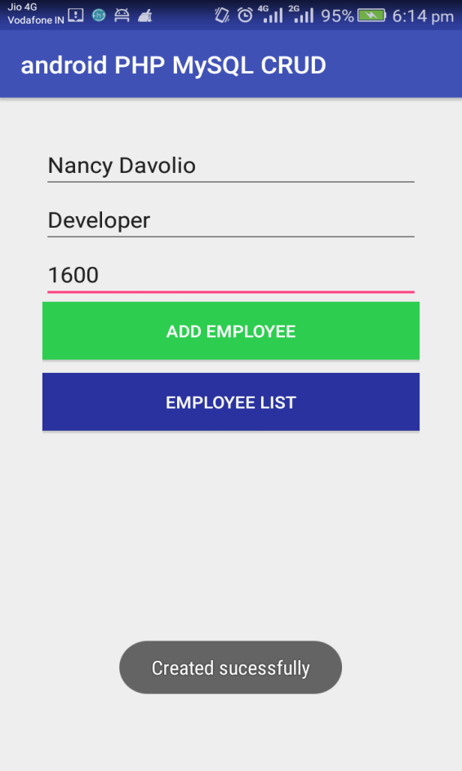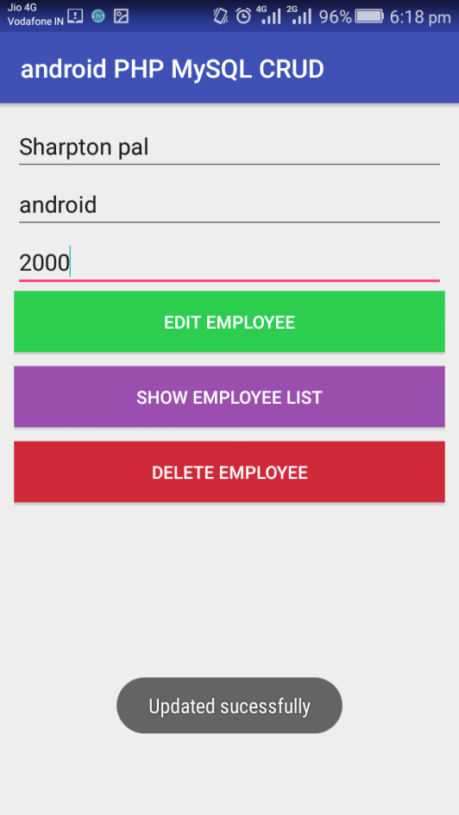

**3)View 4)Delete**

