**1) Rating bar**

**i) activity_main**

*<?***xml version="1.0" encoding="utf-8"***?>*<**RelativeLayout xmlns:android="http://schemas.android.com/apk/res/android"  
 xmlns:app="http://schemas.android.com/apk/res-auto"  
 xmlns:tools="http://schemas.android.com/tools"  
 android:layout_width="match_parent"  
 android:layout_height="match_parent"  
 tools:context="balanirmal.example.com.rating.MainActivity"**>  
  
  
 <**RatingBar  
 android:id="@+id/ratingBar"  
 android:layout_width="wrap_content"  
 android:layout_height="wrap_content"  
 android:layout_alignParentTop="true"  
 android:layout_centerHorizontal="true"  
 android:layout_marginTop="78dp"** />  
  
 <**Button  
 android:id="@+id/button"  
 android:layout_width="wrap_content"  
 android:layout_height="wrap_content"  
 android:layout_alignEnd="@+id/ratingBar"  
 android:layout_alignParentBottom="true"  
 android:layout_alignRight="@+id/ratingBar"  
 android:layout_marginBottom="161dp"  
 android:layout_marginEnd="63dp"  
 android:layout_marginRight="63dp"  
 android:text="Button"** />  
</**RelativeLayout**>

**ii) MainActivity**

**package** balanirmal.example.com.rating;  
  
**import** android.support.v7.app.AppCompatActivity;  
**import** android.os.Bundle;  
**import** android.view.View;  
**import** android.widget.Button;  
**import** android.widget.RatingBar;  
**import** android.widget.Toast;  
  
**public class** MainActivity **extends** AppCompatActivity {  
  
 @Override  
 **protected void** onCreate(Bundle savedInstanceState) {  
 **super**.onCreate(savedInstanceState);  
 setContentView(R.layout.***activity_main***);  
 **final** RatingBar rating=(RatingBar)findViewById(R.id.***ratingBar***);  
 Button button=(Button)findViewById(R.id.***button***);  
 button.setOnClickListener(**new** View.OnClickListener() {  
 @Override  
 **public void** onClick(View v) {  
 String rate=String.*valueOf*(rating.getRating());  
 Toast.*makeText*(getApplicationContext(),rate,Toast.***LENGTH_SHORT***).show();  
 }  
 });  
 }  
}

**Output**

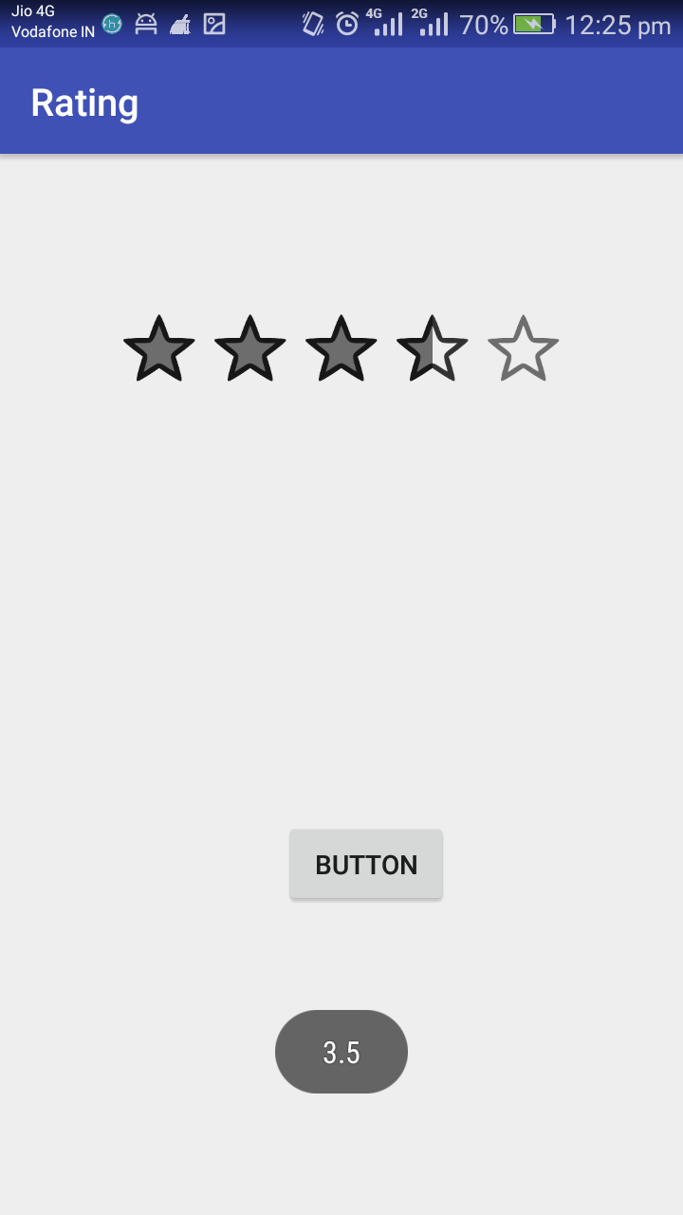

**2.Checkbox**

**i) activity_main2**

*<?***xml version="1.0" encoding="utf-8"***?>*<**android.support.constraint.ConstraintLayout xmlns:android="http://schemas.android.com/apk/res/android"  
 xmlns:app="http://schemas.android.com/apk/res-auto"  
 xmlns:tools="http://schemas.android.com/tools"  
 android:layout_width="match_parent"  
 android:layout_height="match_parent"  
 tools:context="Main2Activity"**>  
  
  
 <**CheckBox  
 android:id="@+id/checkBox"  
 android:layout_width="wrap_content"  
 android:layout_height="wrap_content"  
 android:layout_marginLeft="144dp"  
 android:layout_marginTop="68dp"  
 android:text="Pizza"  
 app:layout_constraintStart_toStartOf="parent"  
 app:layout_constraintTop_toTopOf="parent"** />  
  
 <**CheckBox  
 android:id="@+id/checkBox2"  
 android:layout_width="wrap_content"  
 android:layout_height="wrap_content"  
 android:layout_marginLeft="144dp"  
 android:layout_marginTop="28dp"  
 android:text="Coffee"  
 app:layout_constraintStart_toStartOf="parent"  
 app:layout_constraintTop_toBottomOf="@+id/checkBox"** />  
  
 <**CheckBox  
 android:id="@+id/checkBox3"  
 android:layout_width="wrap_content"  
 android:layout_height="wrap_content"  
 android:layout_marginLeft="144dp"  
 android:layout_marginTop="28dp"  
 android:text="Burger"  
 app:layout_constraintStart_toStartOf="parent"  
 app:layout_constraintTop_toBottomOf="@+id/checkBox2"** />  
  
 <**Button  
 android:id="@+id/button"  
 android:layout_width="wrap_content"  
 android:layout_height="wrap_content"  
 android:layout_marginLeft="144dp"  
 android:layout_marginTop="184dp"  
 android:text="Order"  
 app:layout_constraintStart_toStartOf="parent"  
 app:layout_constraintTop_toBottomOf="@+id/checkBox3"** />  
  
</**android.support.constraint.ConstraintLayout**>

**ii) Main2Activity**

**package** balanirmal.example.com.rating;  
  
**import** android.support.v7.app.AppCompatActivity;  
**import** android.os.Bundle;  
**import** android.view.View;  
**import** android.widget.Button;  
**import** android.widget.CheckBox;  
**import** android.widget.Toast;  
  
**public class** Main2Activity **extends** AppCompatActivity {  
 CheckBox **pizza**,**coffe**,**burger**;  
 Button **buttonOrder**;  
 @Override  
 **protected void** onCreate(Bundle savedInstanceState) {  
 **super**.onCreate(savedInstanceState);  
 setContentView(R.layout.***activity_main2***);  
 **pizza**=(CheckBox)findViewById(R.id.***checkBox***);  
 **coffe**=(CheckBox)findViewById(R.id.***checkBox2***);  
 **burger**=(CheckBox)findViewById(R.id.***checkBox3***);  
 **buttonOrder**=(Button)findViewById(R.id.***button***);  
  
 *//Applying the Listener on the Button click* **buttonOrder**.setOnClickListener(**new** View.OnClickListener(){  
  
 @Override  
 **public void** onClick(View view) {  
 **int** totalamount=0;  
 StringBuilder result=**new** StringBuilder();  
 result.append(**"Selected Items:"**);  
 **if**(**pizza**.isChecked()){  
 result.append(**"\nPizza 100Rs"**);  
 totalamount+=100;  
 }  
 **if**(**coffe**.isChecked()){  
 result.append(**"\nCoffe 50Rs"**);  
 totalamount+=50;  
 }  
 **if**(**burger**.isChecked()){  
 result.append(**"\nBurger 120Rs"**);  
 totalamount+=120;  
 }  
 result.append(**"\nTotal: "**+totalamount+**"Rs"**);  
 *//Displaying the message on the toast* Toast.*makeText*(getApplicationContext(), result.toString(), Toast.***LENGTH_LONG***).show();  
 }  
  
 });  
 }  
}

**Output**

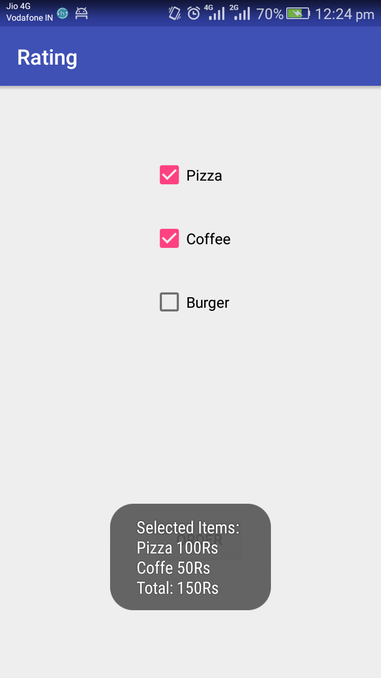

**3.Spinner**

**i) activity_main3**

*<?***xml version="1.0" encoding="utf-8"***?>*<**RelativeLayout xmlns:android="http://schemas.android.com/apk/res/android"  
 xmlns:app="http://schemas.android.com/apk/res-auto"  
 xmlns:tools="http://schemas.android.com/tools"  
 android:layout_width="match_parent"  
 android:layout_height="match_parent"  
 tools:context="balanirmal.example.com.rating.Main3Activity"**>  
  
 <**Spinner  
 android:id="@+id/spinner"  
 android:layout_width="match_parent"  
 android:layout_height="wrap_content"  
 android:layout_alignParentTop="true"  
 android:layout_centerHorizontal="true"  
 android:layout_marginTop="146dp"** />  
</**RelativeLayout**>

**ii) Main3Activity**

**package** balanirmal.example.com.rating;  
  
**import** android.support.v7.app.AppCompatActivity;  
**import** android.os.Bundle;  
**import** android.view.View;  
**import** android.widget.AdapterView;  
**import** android.widget.ArrayAdapter;  
**import** android.widget.Spinner;  
**import** android.widget.Toast;  
  
**public class** Main3Activity **extends** AppCompatActivity **implements** AdapterView.OnItemSelectedListener {  
String[] **banknames**={**"IOB"**,**"SBI"**,**"HDFC"**};  
 @Override  
 **protected void** onCreate(Bundle savedInstanceState) {  
 **super**.onCreate(savedInstanceState);  
 setContentView(R.layout.***activity_main3***);  
 Spinner spin=(Spinner)findViewById(R.id.***spinner***);  
 spin.setOnItemSelectedListener(**this**);  
 ArrayAdapter aa=**new** ArrayAdapter(**this**,android.R.layout.***simple_spinner_item***,**banknames**);  
 aa.setDropDownViewResource(android.R.layout.***simple_spinner_dropdown_item***);  
spin.setAdapter(aa);  
  
 }  
  
 @Override  
 **public void** onItemSelected(AdapterView<?> parent, View view, **int** position, **long** id) {  
 Toast.*makeText*(getApplicationContext(), **banknames**[position], Toast.***LENGTH_LONG***).show();  
 }  
  
 @Override  
 **public void** onNothingSelected(AdapterView<?> parent) {  
  
 }  
}

**Output**

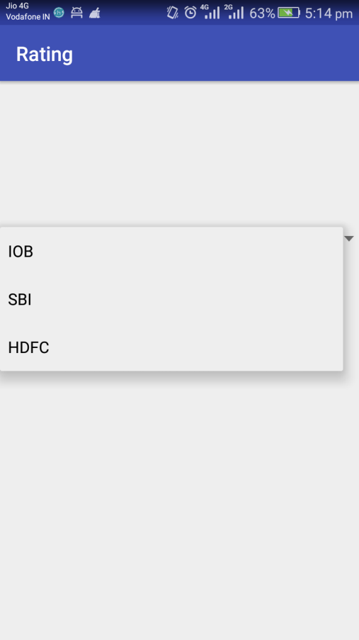 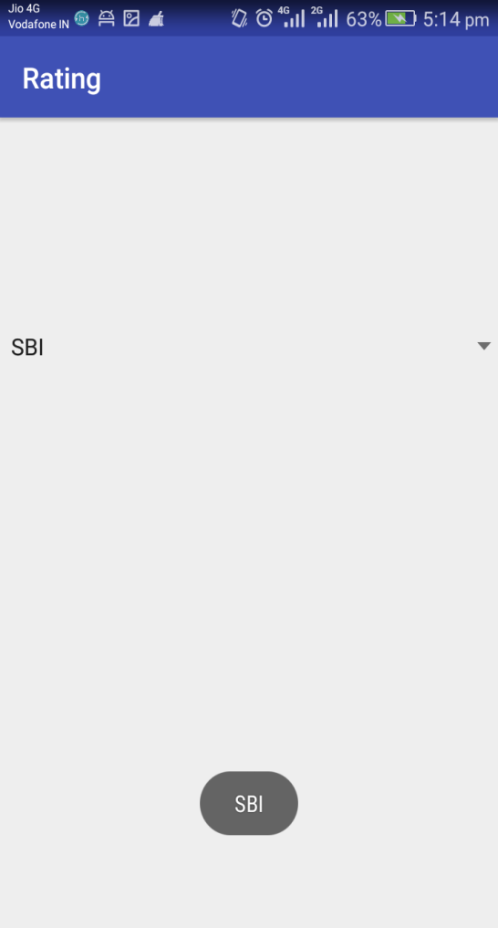

**4.ListView**

**i) activity_main4**

*<?***xml version="1.0" encoding="utf-8"***?>*<**RelativeLayout xmlns:android="http://schemas.android.com/apk/res/android"  
 xmlns:app="http://schemas.android.com/apk/res-auto"  
 xmlns:tools="http://schemas.android.com/tools"  
 android:layout_width="match_parent"  
 android:layout_height="match_parent"  
 tools:context="balanirmal.example.com.rating.Main4Activity"**>  
 <**ListView  
 android:id="@+id/listView"  
 android:layout_width="match_parent"  
 android:layout_height="fill_parent"** />  
  
</**RelativeLayout**>

**ii)mylist.xml**

*<?***xml version="1.0" encoding="utf-8"***?>*<**TextView xmlns:android="http://schemas.android.com/apk/res/android"  
 android:id="@+id/textView"  
 android:layout_width="wrap_content"  
 android:layout_height="wrap_content"  
 android:text="Medium Text"  
 android:textStyle="bold"  
 android:textAppearance="?android:attr/textAppearanceMedium"  
 android:layout_marginLeft="10dp"  
 android:layout_marginTop="5dp"  
 android:padding="2dp"  
 android:textColor="#4d4d4d"** />

**iii)Strings.xml**

<**resources**>  
 <**string name="app_name"**>Rating</**string**>  
  
 <**string-array name="array_technology"**>  
 <**item**>Android</**item**>  
 <**item**>Java</**item**>  
 <**item**>Php</**item**>  
 <**item**>Hadoop</**item**>  
 <**item**>Sap</**item**>  
 <**item**>Python</**item**>  
 <**item**>Ajax</**item**>  
 <**item**>C++</**item**>  
 <**item**>Ruby</**item**>  
 <**item**>Rails</**item**>  
 <**item**>.Net</**item**>  
 <**item**>Perl</**item**>  
 </**string-array**>  
 </**resources**>

**iv) Main4Activity**

**package** balanirmal.example.com.rating;  
  
**import** android.support.v7.app.AppCompatActivity;  
**import** android.os.Bundle;  
**import** android.view.View;  
**import** android.widget.AdapterView;  
**import** android.widget.ArrayAdapter;  
**import** android.widget.ListView;  
**import** android.widget.TextView;  
**import** android.widget.Toast;  
  
**public class** Main4Activity **extends** AppCompatActivity {  
ListView **listview**;  
TextView **textview**;  
String[] **listitem**;  
  
 @Override  
 **protected void** onCreate(Bundle savedInstanceState) {  
 **super**.onCreate(savedInstanceState);  
 setContentView(R.layout.***activity_main4***);  
 **listview**=(ListView)findViewById(R.id.***listView***);  
 **textview**=(TextView)findViewById(R.id.***textView***);  
 **listitem**=getResources().getStringArray(R.array.***array_technology***);  
 **final** ArrayAdapter<String> adapter = **new** ArrayAdapter<String>(**this**,  
 android.R.layout.***simple_list_item_1***, android.R.id.***text1***, **listitem**);  
 **listview**.setAdapter(adapter);  
 **listview**.setOnItemClickListener(**new** AdapterView.OnItemClickListener() {  
 @Override  
 **public void** onItemClick(AdapterView<?> parent, View view, **int** position, **long** id) {  
 String value=adapter.getItem(position);  
 Toast.*makeText*(getApplicationContext(),value,Toast.***LENGTH_SHORT***).show();  
 }  
 });  
 }  
}

**Output**

