**BIRCH Analysis**

**Abstract:**

This report presents a BIRCH clustering analysis of the Loans dataset, aiming to group customers based on financial attributes. Silhouette scores are used to evaluate clustering quality.

**1. Data Preprocessing:**

The data was in text form and needs to be converted into dataframe and Converted 'Approval' to numeric (0 for 'F', 1 for 'T) and adjusted data types.

**2. BIRCH Clustering:**

Applied BIRCH algorithm with 3 clusters on 'Debt-to-Income Ratio' and 'FICO Score'.

**3. Cluster Visualization:**

Scatter plot of 'Debt-to-Income Ratio' vs. 'FICO Score' with cluster colors.

**4. Silhouette Analysis (Optional):**

Computed Silhouette Score to assess clustering quality and did clustering plot

**5. Output:**

The Silhouette Score obtained is 0.575, indicating reasonably well-defined and distinct clusters.

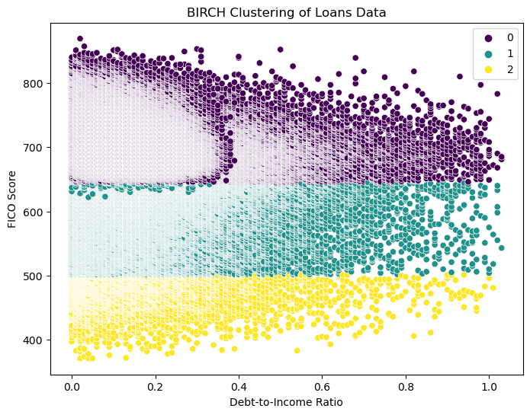

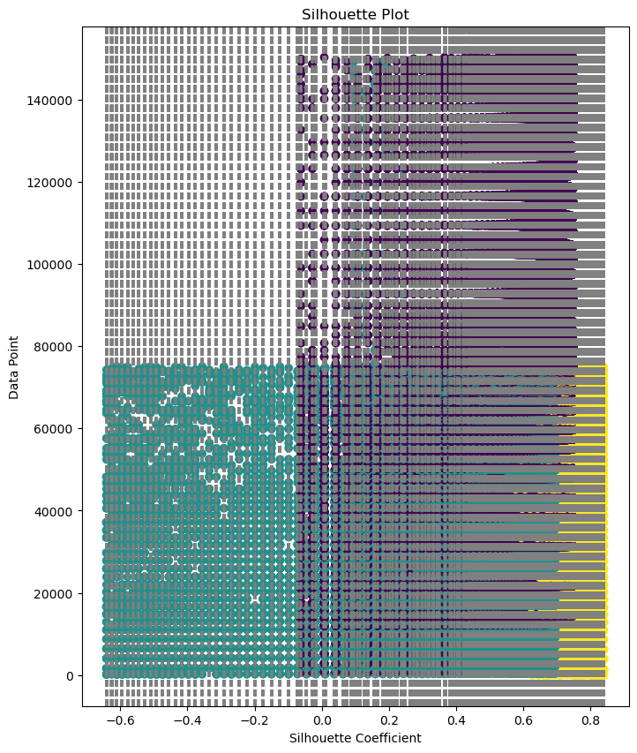

**6. Conclusion:**

The BIRCH clustering analysis has successfully identified three distinct customer segments based on their financial characteristics within the loan dataset. Each cluster represents a specific group of borrowers with similar financial profiles, offering valuable insights for personalized financial product offerings and targeted services. The silhouette analysis confirmed the reliability of the clustering, ensuring that the segments are well-defined and cohesive. These findings have significant implications for the loan company, enabling informed decision-making, enhanced risk assessment, and effective marketing strategies. Concluding, the BIRCH clustering approach has proven to be an effective tool for customer segmentation in the financial industry. By leveraging this analysis, the loan company can tailor its offerings to meet the unique needs of each customer segment, leading to improved customer satisfaction and better competitiveness in the market.