Ideation Phase
Brainstorm & Idea Prioritization Template

Date | 03 November 2025
Team ID | NM2025TMID01840
Project Name | Educational Organisation using ServiceNow
Maximum Marks | 4 Marks

Step 1: Team Gathering, Collaboration, and Problem Statement Selection
- All five team members gathered virtually to initiate ideation on possible real-world problems that can be solved using low-code platforms.
- After evaluating common administrative inefficiencies in schools, the team chose the problem statement:
“How might we automate student admissions and academic performance tracking in educational institutions using ServiceNow?”

Step 2: Brainstorming, Idea Listing, and Grouping
Raw Ideas Collected:
- Auto-generation of admin number
- Digital admission form
- Auto-fill form data from existing tables
- Pincode-based area detection
- Auto-calculation of student total & percentage
- Visual status flow of admission
- Parent contact tracking
- Conditional form field disabling 9. Role-based access control
- Cloud-access from anywhere
- Automate result declaration
- Quick reporting system
- Future integration with email/SMS notifications

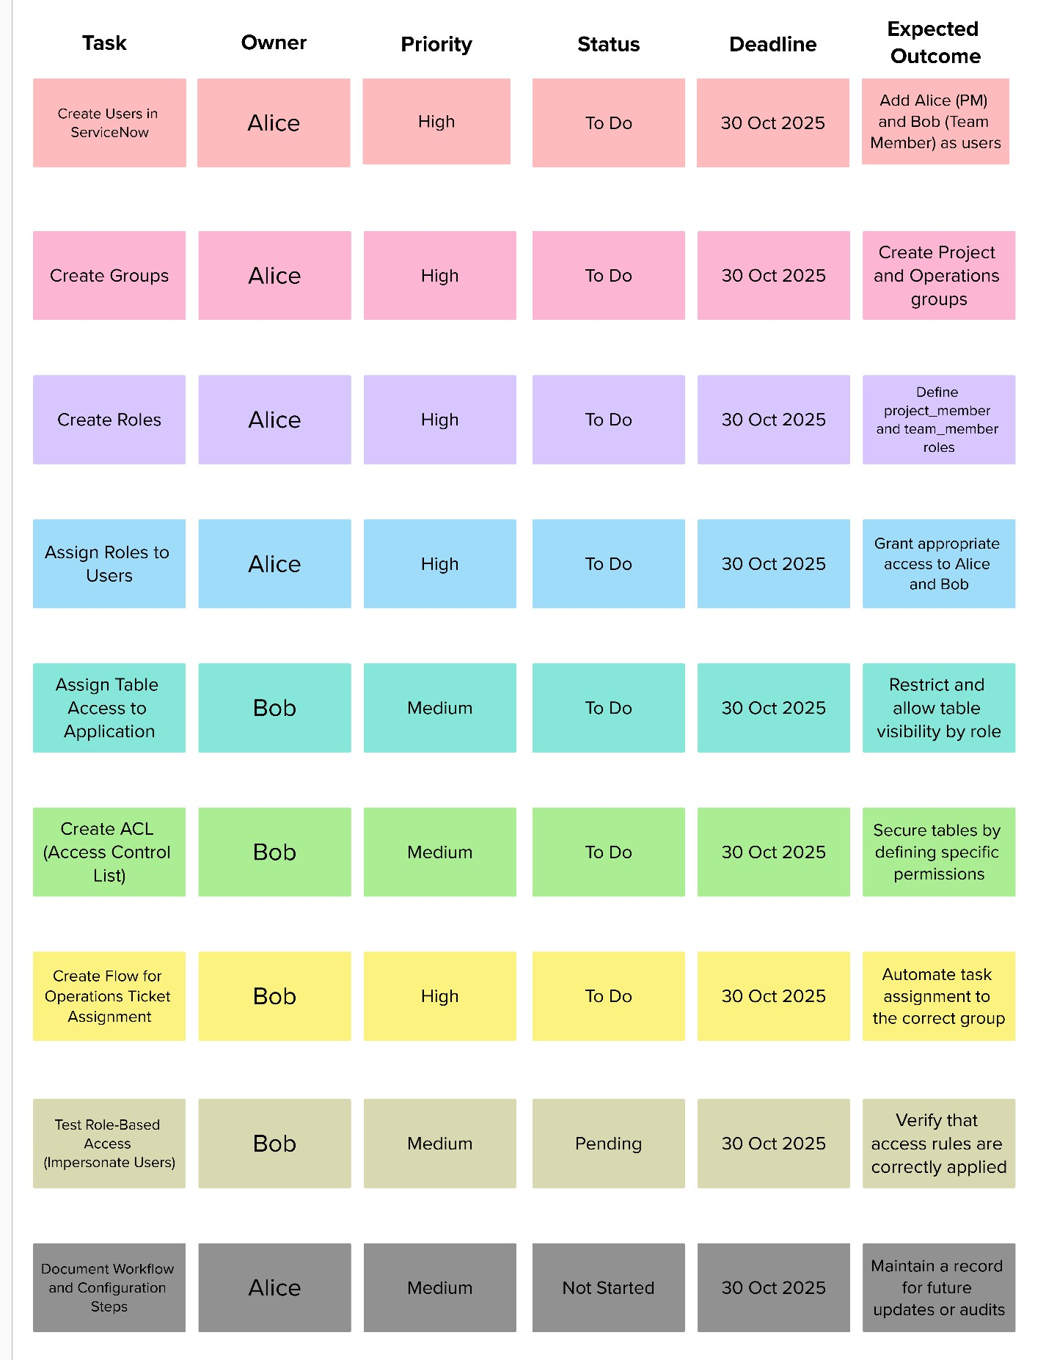

Grouped Ideas:
  - Admissions Automation
  - Auto-generated admin number
  - Pre-filled form fields
  - School & purpose selection
  - Performance Tracking
  - Subject marks input
  - Auto calculation of total, percentage, result
  - Workflow & UX
  - Status-based flow
  - Field disabling for safety
  - Area update using pincode
  - Scalability
  - Role-based access
  - Notifications
  - Reporting features

Step 3: Idea Prioritization

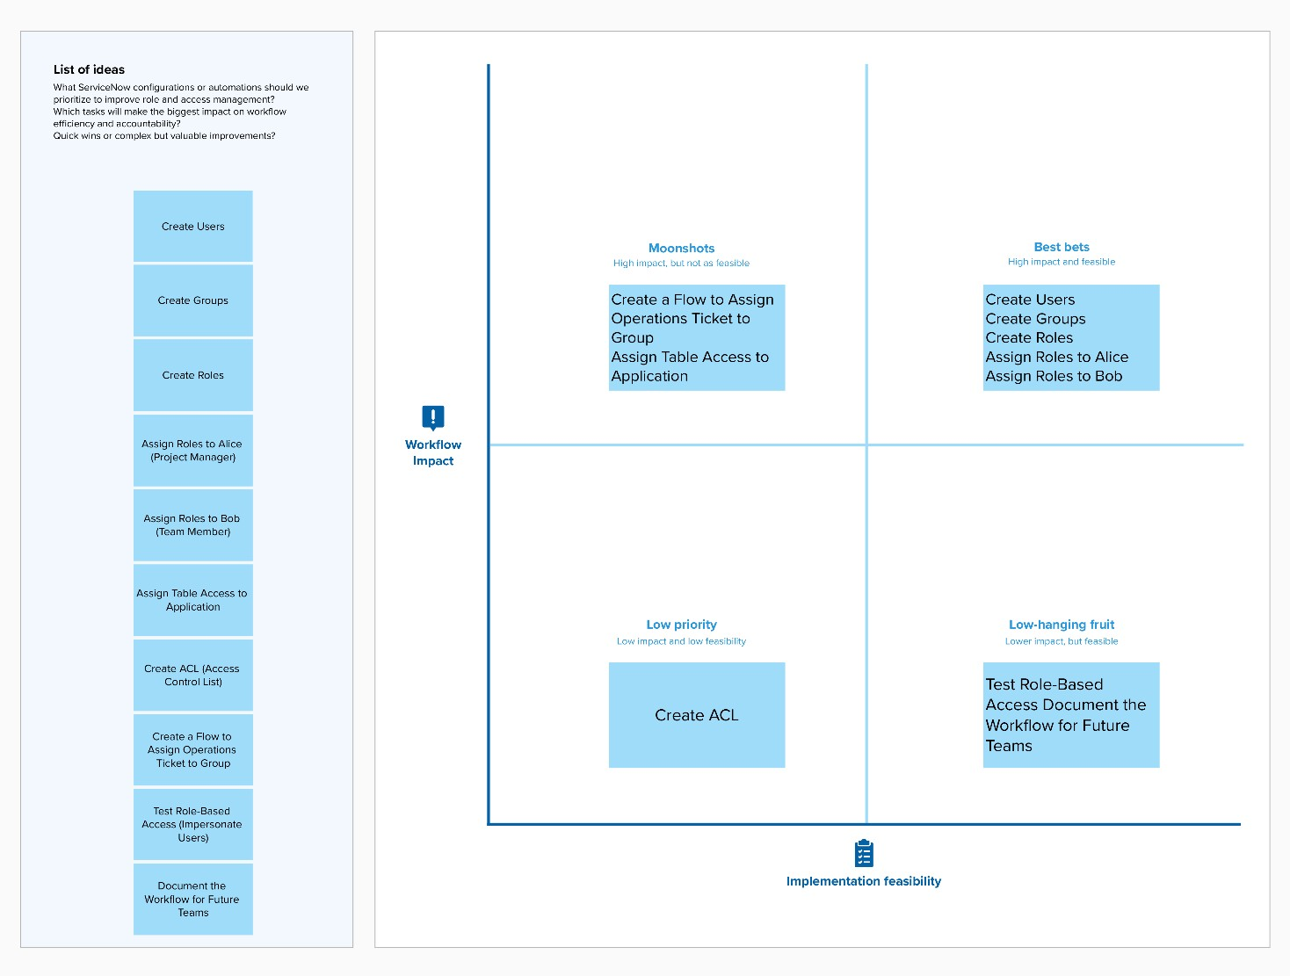

Idea Group | Priority | Reason for Priority
Admissions  Automation | High | Core to system functionality, reduces time
Performance  Tracking | High | Automates academic evaluation, boosts accuracy
Workflow & UX | Medium | Enhances usability, but can be improved later
Scalability Features | Low | Useful in future scope, not immediate  MVP need

