Postman Collections:

✅1: After created Employee Record, Postman successful leave request, this image confirms the integration between Postman and leave-service. A leave request is submitted by sending a POST request to /leaves endpoint. Status is initially set to PENDING.

✅2: H2 database view, leave entry stored, the leave-service is using H2 in-memory DB, confirmed by the SQL console. The leave is persisted with PENDING state until Kafka consumer updates it.

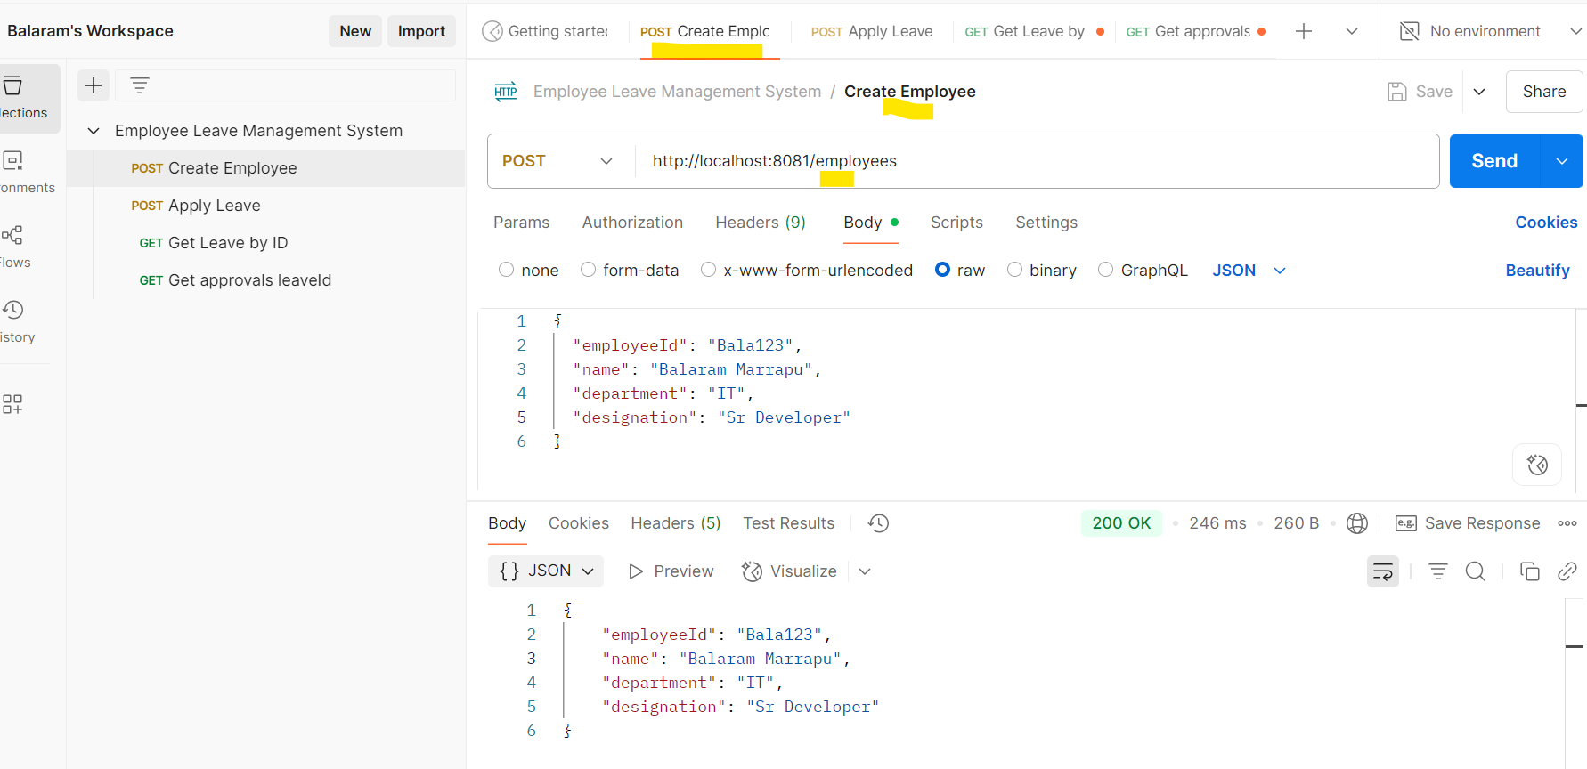

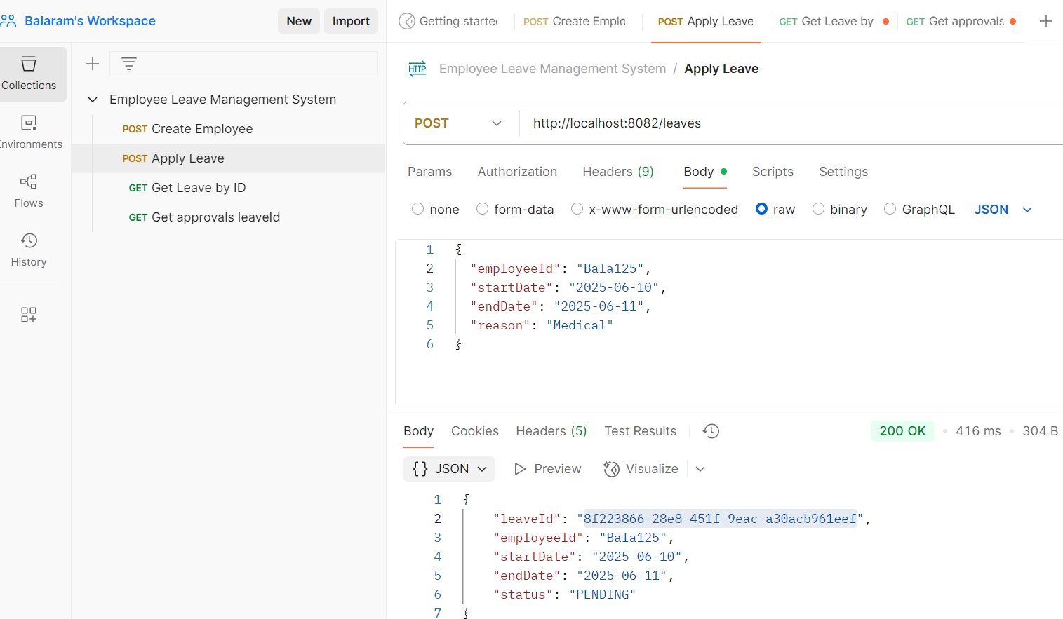

✅ 3: Kafka listener (approval-service) startup log, Shows the Kafka consumer subscribing to the 'leave-events' topic using groupId 'approval-group'. It processes requests sent from leave-service.

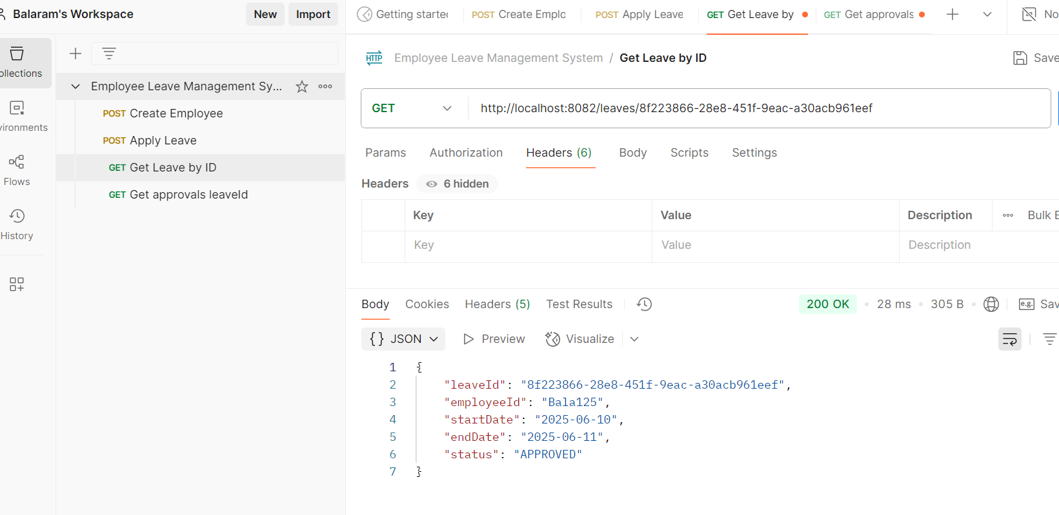

✅4: Approval-service processes leave and sends status, based on leave duration, it approves or rejects, stores in DB, and publishes to 'approval-events-v2' topic.

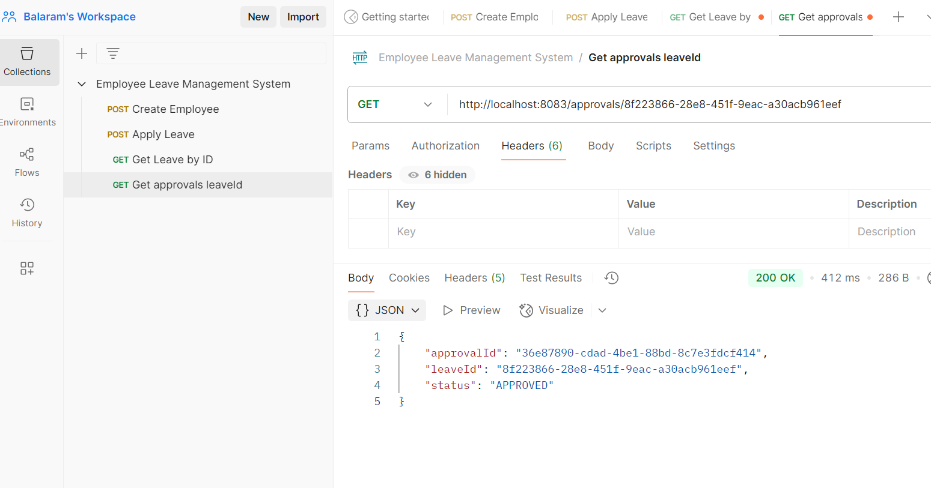

H2-Databases:

http://localhost:8081/h2-console/login.do?jsessionid=228288cd4dc7b2a8184d2c875c45fbdb

✅ 5: Updated leave status in DB via Kafka, leave-service receives the approval decision from Kafka, updates the original leave request's status.

✅ 6: Leave request unit test – Demonstrates the LeaveController JUnit test using MockMvc, validating endpoint behavior, Kafka interaction, and data persistence.

✅ 7: Approval-service unit test – Tests that the ApprovalEntity is saved and published correctly after processing a Kafka event.

✅ Screenshot 9: ApprovalEntity class – Part of approval-service, used to persist approval decisions to H2 database.

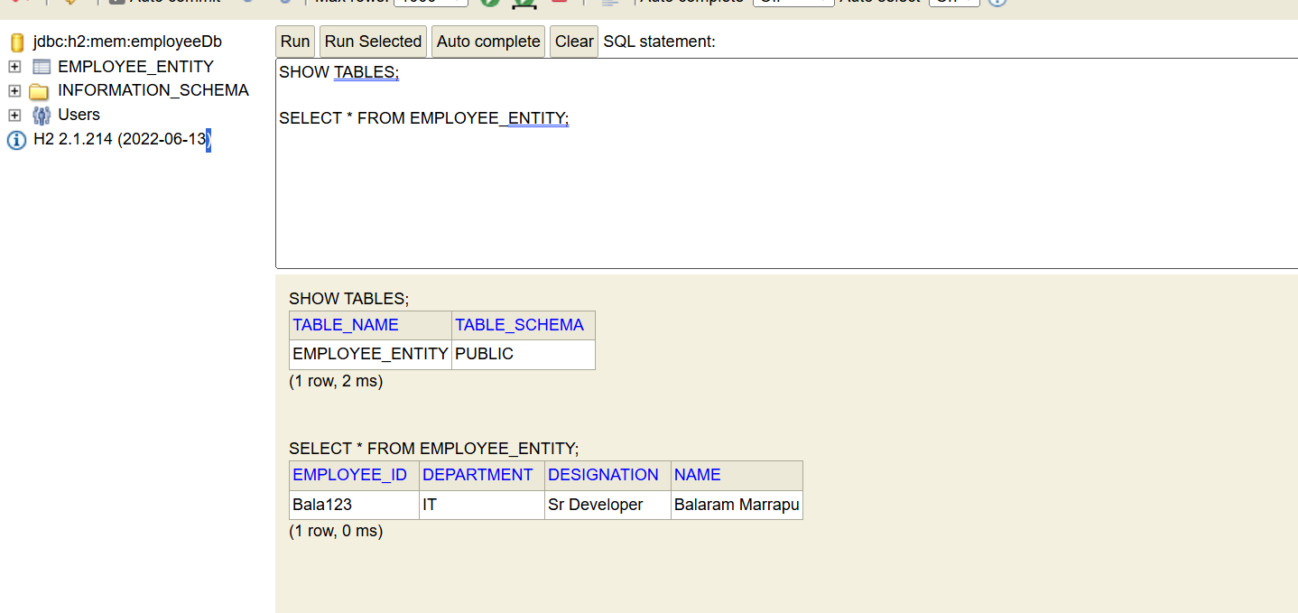

http://localhost:8082/h2-console/login.do?jsessionid=4ee288d0b57f542da406bc869b30fe74

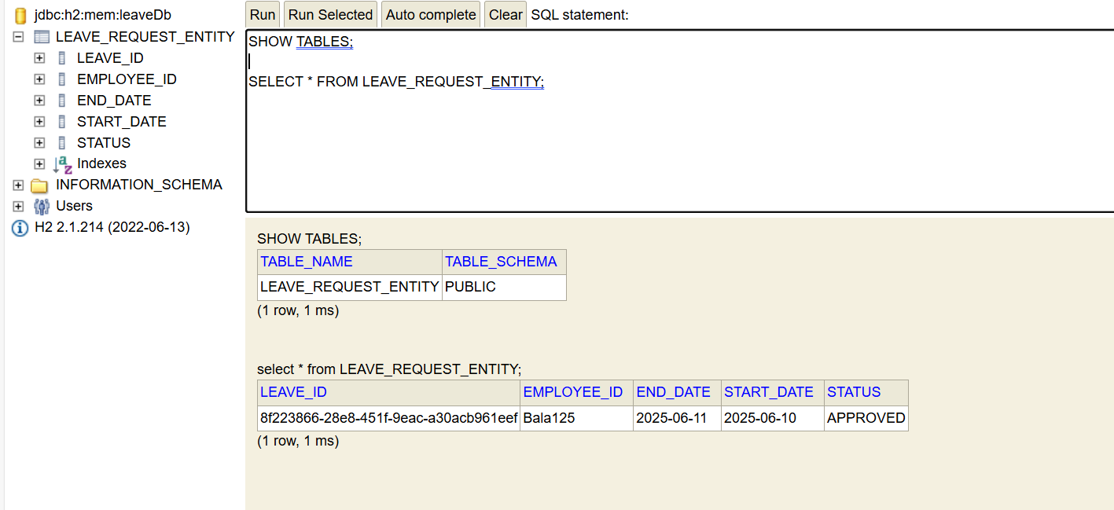

http://localhost:8083/h2-console/login.do?jsessionid=f837c29e534e5022cfdc770316208b58

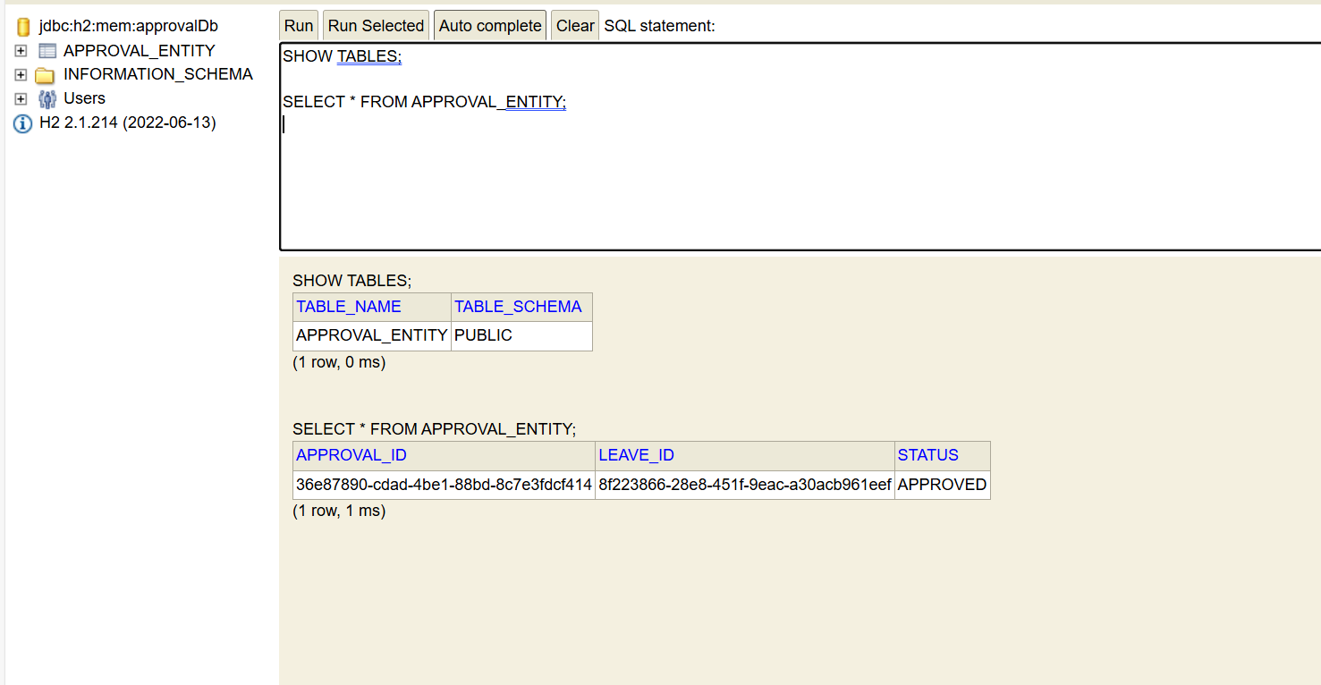

✅ Screenshot 8: Docker containers running – Verifies Kafka and Zookeeper are up via Docker Desktop with mapped ports 9092 and 2181.

✅ Screenshot 10: LeaveEventConsumer – Kafka listener in approval-service listening to 'leave-events' and publishing to 'approval-events-v2'.

✅ Screenshot 11: ApprovalEventConsumer – Kafka listener in leave-service that updates status based on messages from approval-service.

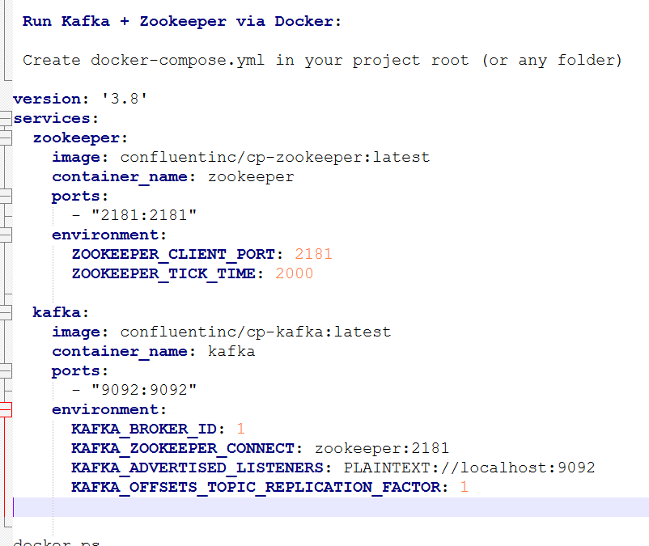

Start the Kafka + Zookeeper services

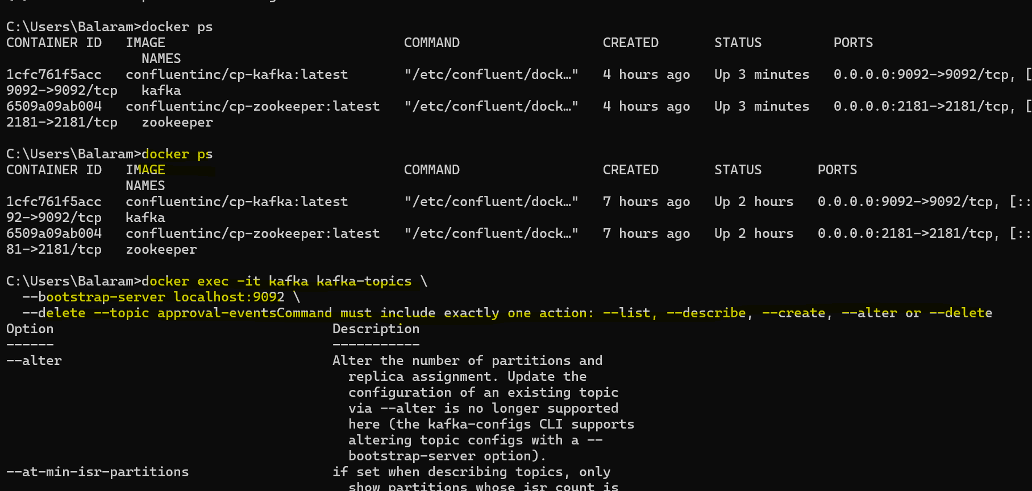

Restart or Stop when needed

Stop containers:

**Restart after reboot** (same folder):

