**MACHINE LEARNING‑BASED EFFECTIVE FINE‑GRAINED WEATHER FORECASTING MODEL**

**OBJECTIVE:**

The primary goal of this project is to determine and predict the weather condition and forecasting to determine how the atmosphere evolves in the future. Using LSTM, regression models (Random Forest, SVR, Decision Tree, Linear Regression and Ridge Regression) we will predict the weather condition according to that.

**ABSTRACT:**

It is well-known that numerical weather prediction (NWP) models require considerable computer power to solve complex mathematical equations to obtain a forecast based on current weather conditions. In this article, we propose a novel light weight data-driven weather forecasting model by exploring temporal modelling approaches of More specifically Standard Linear Regression (SR), Ridge Regression (RR), Support Vector Regression (SVR), and Random Forest Regressor (RF), Decision Tree Regressor (DT) are implemented as the classical machine learning approaches, and Autoregressive Integrated Moving Average (ARIMA) is implemented as the statistical forecasting approaches. Furthermore, Weather information is captured by time-series data and LSTM is to predict future data. Our experiment shows that the proposed lightweight model produces better results.

**Keywords** · Machine Learning Algorithms (Random Forest, Support Vector Regressor, Linear Regression, Ridge and Decision Tree) with LSTM Time-series data analysis.

**INTRODUCTION**

Weather forecasting and Prediction is the process of predicting the state of the atmosphere based on the temperature values and specific time and locations. Numerical weather prediction (NWP) utilizes computer algorithms to provide a forecast based on current weather conditions.

Machine learning models and time-series forecasting are used for predicting and seeing the data according to the time and atmosphere parameters and it will built the models on its superior performance.

Weather forecasts are made by collecting as much data as possible about the current state of the atmosphere (particularly the temperature, humidity and wind) and using understanding of atmospheric processes (through meteorology) to determine how the atmosphere evolves in the future.

**LITERATURE REVIEW**

**[1]** **Basak D, Pal S, Patranabis D (2007) “Support vector regression.” Neural Inf Process Lett Rev 11(10):203–224**

Instead of minimizing the observed training error, Support Vector Regression (SVR) attempts to minimize the generalization error bound so as to achieve generalized performance. The idea of SVR is based on the computation of a linear regression function in a high dimensional feature space where the input data are mapped via a nonlinear function. SVR has been applied in various fields – time series and financial (noisy and risky) prediction, approximation of complex engineering analyses, convex quadratic programming and choices of loss functions, etc. In this paper, an attempt has been made to review the existing theory, methods, recent developments and scopes of SVR.

**[2] Kavitha S, Varuna S, Ramya R (2016) “A comparative analysis on linear regression and support vector regression.” In: 2016 online international conference on green engineering and technologies (IC-GET), November 2016, pp 1–5.**

In business, consumer’s interest, behavior, product profits are the insights required to predict the future of business with the current data or historical data. These insights can be generated with the statistical techniques for the purpose of forecasting. The statistical techniques can be evaluated for the predictive model based on the requirements of the data. The prediction and forecasting are done widely with time series data. Most of the applications such as weather forecasting, finance and stock market combine historical data with the current streaming data for better accuracy. However the time series data is analyzed with regression models. In this paper, linear regression and support vector regression model is compared using the training data set in order to use the correct model for better prediction and accuracy.

**[3]**. **Sanchez-Fernandez M, de-Prado-Cumplido M, Arenas-Garcia J, Perez-Cruz F (2004) “SVM multi regression for nonlinear channel estimation in multiple-input multiple-output systems.” IEEE Trans Signal Process 52(8):2298–2307.**

This paper addresses the problem of multiple-input multiple-output (MIMO) frequency nonselective channel estimation. We develop a new method for multiple variable regression estimation based on Support Vector Machines (SVMs): a state-of-the-art technique within the machine learning community for regression estimation. We show how this new method, which we call M-SVR, can be efficiently applied. The proposed regression method is evaluated in a MIMO system under a channel estimation scenario, showing its benefits in comparison to previous proposals when nonlinearities are present in either the transmitter or the receiver sides of the MIMO system.

**[4]**. **Sharaf A, Roy SR (2018) “Comparative analysis of temperature prediction using regression methods and back propagation neural network.” In: 2018 2nd international conference on trends in electronics and informatics (ICOEI), May 2018, pp 739–742.**

Weather forecasting is very important for our day to day life as the prediction of climatic parameters like temperature, humidity, rainfall, etc. is important for agriculture, forestry, commercial companies etc. It is known that the climatic conditions are irregular in nature and may be often unpredictable. In previous years most of the work was done on finding a linear equation to predict climatic parameters. It is now known that climatic conditions are nonlinear in nature and thus Artificial Neural Network is now considered to be an efficient nonlinear method for weather prediction. In this paper a comparative analysis has been done between regression methods and nonlinear method like artificial neural network to analyze the difference between the performance of linear and nonlinear models for prediction of temperature.

**SCOPE:**

* Our Models can be used for predicting the temperature
* It can be helpful for the people, agriculture field, farmers if we predict weather according to the parameters (Temperature, humidity, wind etc.)
* Weather forecasting of wind, precipitations and humidity is essential for preventing and controlling wildfires.
* Military weather forecasters present weather conditions to the war fighter community.
* Air Force Weather provides weather forecasting for the Air Force and the Army. Air Force forecasters cover air operations in both wartime and peacetime operations and provide Army support. Military and civilian forecasters actively cooperate in analyzing and creating weather forecast products.

**EXISTING METHOD**

In existing system, Observational data collected by Doppler radar, Radiosonde, weather satellites, buoys and other instruments are fed into computerized NWS numerical forecast models. The models use equations, along with past weather data, to provide forecast guidance to our meteorologists.

**DISADVANTAGES:**

* The primary problem with Numerical Weather Prediction (NWP) models is it takes a long time to produce its results.
* Forecasts are Never Completely Accurate.
* Forecasts are never 100% and it is almost impossible to predict the future with certainty.
* Problems concern availability, timeliness, and quality of observational data.

**PROPOSED METHOD**

We propose this system which uses Machine Learning Algorithms like SVR, Random Forests, Decision Tree, Ridge, Linear Regression and ARIMA for Weather Prediction. These techniques can determine the possibility of weather condition. Due to limitation in to get live data we done forecasting on the old data.

**FLOW CHART:**

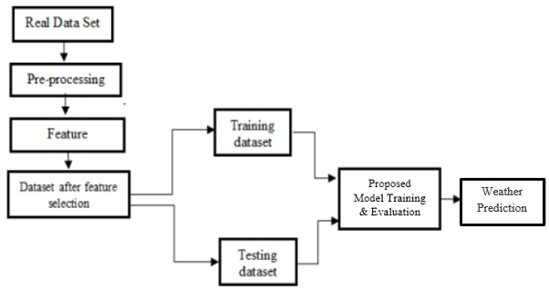

**ADVANTAGES:**

* Reduce weather-related losses and enhance societal benefits.
* Protection of life and property.
* Public health and safety.
* Avoid forest fires.
* Farmers to know when to apply the pests and chemicals to avoid the crop wastage.

**APPLICATIONS:**

* A major part of modern weather forecasting is the severe weather alerts and advisories, which the national weather service issue in the case that severe or hazardous weather is expected. This is done to protect life and property.
* The aviation industry is especially sensitive to the weather, accurate weather forecasting is essential considering the fact that a greater number of plane crashes so to avoid accidents it is useful.
* Farmers rely on weather forecasts to decide what work to do on any particular day.
* Military weather forecasters present weather conditions to the war fighters, community.

**HARDWARE & SOFTWARE REQUIREMENTS**

# HARDWARE CONFIGURATION:

# Processor - I3/Intel Processor

# RAM - 4GB (min)

# Hard Disk - 128 GB

# Key Board - Standard Windows Keyboard

# Mouse - Two or Three Button Mouse

# Monitor - LCD

**SOFTWARE CONFIGURATION:**

* Operating System : Windows 7+
* Server side Script : Python 3.6+
* IDE : PyCharm IDE
* Libraries Used : Pandas, Numpy, scikit-learn, stats-model, seaborn, Matplotlib.

**ARCHITECTURE**

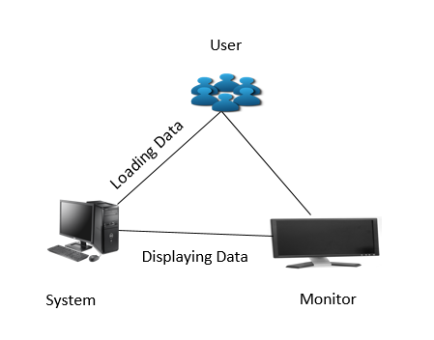

**SOFTWARE INSTALLATION FOR THIS PROJECTS:**

Installing Python:

1. To download and install Python visit the official website of Python <https://www.python.org/downloads/> and choose your version.

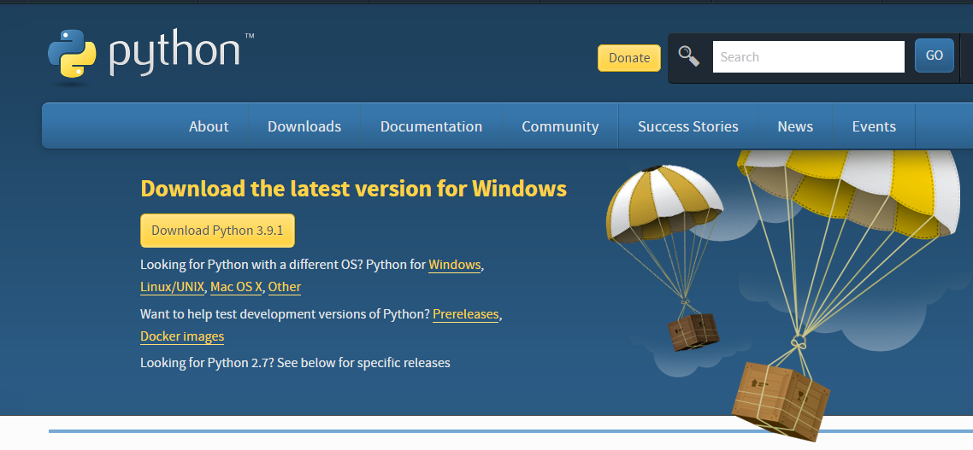

1. Once the download is complete, run the exe for install Python. Now click on Install Now.
2. You can see Python installing at this point.
3. When it finishes, you can see a screen that says the Setup was successful. Now click on "Close".

Installing PyCharm:

1. To download PyCharm visit the website <https://www.jetbrains.com/pycharm/download/> and Click the "DOWNLOAD" link under the Community Section.

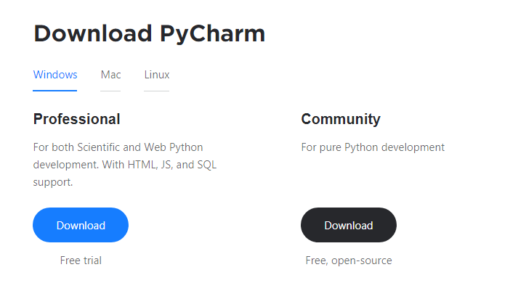

1. Once the download is complete, run the exe for install PyCharm. The setup wizard should have started. Click “Next”.
2. On the next screen, Change the installation path if required. Click “Next”.
3. On the next screen, you can create a desktop shortcut if you want and click on “Next”.
4. Choose the start menu folder. Keep selected Jet Brains and click on “Install”.
5. Wait for the installation to finish.
6. Once installation finished, you should receive a message screen that PyCharm is installed. If you want to go ahead and run it, click the “Run PyCharm Community Edition” box first and click “Finish”.
7. After you click on "Finish," the Following screen will appear.

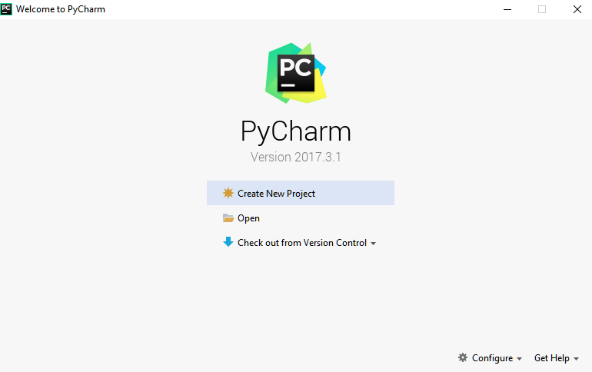

9. You need to install some packages to execute your project in a proper way.

10. Open the command prompt/ anaconda prompt or terminal as administrator.

11. The prompt will get open, with specified path, type “pip install package name” which you want to install (like Numpy, pandas, seaborn, scikit-learn, matplotlib.pyplot)

Ex: pip install numpy

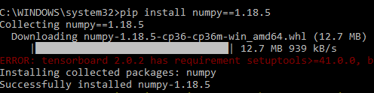

**MODULES**

**System**

**User**

**1. System:**

**1.1 Store Dataset:**

The System stores the dataset given by the user.

**1.2 Model Training:**

The system takes the data from the user and fed that data to the selected model.

**1.3 Model Predictions:**

The system takes the data given by the user and predict the output based on the given data.

**1.4 Graph:**

For the visualization purpose and forecasting using ARIMA we have used the graphical representation.

**2. User:**

**2.1 Load Dataset:**

The user can load the dataset he/she want to work on.

**2.2 View Dataset:**

The User can view the preprocessed train test split dataset.

**2.3 Select model:**

User can apply the model to the dataset for accuracy/performance.

**2.4 View Result:**

User can evaluate the model performance and predict the desired output.

**ALGORITHMS**

## LSTM

It is special kind of recurrent neural network that is capable of learning long term dependencies in data. This is achieved because the recurring module of the model has a combination of four layers interacting with each other.

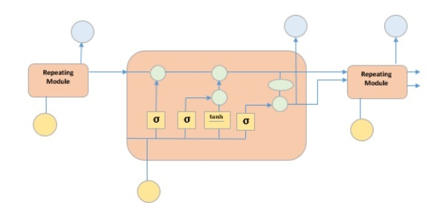

The picture above depicts four neural network layers in yellow boxes, point wise operators in green circles, input in yellow circles and cell state in blue circles. An LSTM module has a cell state and three gates which provides them with the power to selectively learn, unlearn or retain information from each of the units. The cell state in LSTM helps the information to flow through the units without being altered by allowing only a few linear interactions. Each unit has an input, output and a forget gate which can add or remove the information to the cell state. The forget gate decides which information from the previous cell state should be forgotten for which it uses a sigmoid function. The input gate controls the information flow to the current cell state using a point-wise multiplication operation of ‘sigmoid’ and ‘tanh’ respectively. Finally, the output gate decides which information should be passed on to the next hidden state.

**Random Forest Regression:**

Random forests  or  random decision forests are an ensemble learning method for classification, regression and other tasks that operate by constructing a multitude of decision trees at training time and outputting the class that is the mode of the classes (classification) or mean/average prediction (regression) of the individual trees. Random decision forests correct for decision trees' habit of over fitting to their training set. Random forests generally outperform decision trees, but their accuracy is lower than gradient boosted trees. However, data characteristics can affect their performance.

Every decision tree has high variance, but when we combine all of them together in parallel then the resultant variance is low.

In the case of a classification problem, the final output is taken by using the majority voting classifier. In the case of a regression problem, the final output is the mean of all the outputs. A Random Forest is an ensemble technique capable of performing both regression and classification tasks.

**Support Vector Regressor:**

Support Vector Regression is **a supervised learning algorithm that is used to predict discrete values**. Support Vector Regression uses the same principle as the SVMs. The basic idea behind SVR is to find the best fit line. In SVR, the best fit line is the hyperplane that has the maximum number of points.

Unlike other Regression models that try to minimize the error between the real and predicted value, the SVR tries to fit the best line within a threshold value. The threshold value is the distance between the hyperplane and boundary line. The fit time complexity of SVR is more than quadratic with the number of samples which makes it hard to scale to datasets with more than a couple of 10000 samples.

**Simple Linear Regression:**

**Regression models** describe the relationship between variables by fitting a line to the observed data. Linear regression models use a straight line, while logistic and nonlinear regression models use a curved line. Regression allows you to estimate how a [dependent variable](https://www.scribbr.com/methodology/types-of-variables/#independent-vs-dependent) changes as the independent variable(s) change.

**Simple linear regression** is used to estimate the relationship between**two**[quantitative variables](https://www.scribbr.com/methodology/types-of-variables/#quantitative-vs-categorical).

Simple linear regression is used to find out the best relationship between a single input variable (predictor, independent variable, input feature and input parameter) & output variable (predicted, dependent variable, output feature and output parameter) provided that both variables are continuous in nature. This relationship represents how an input variable is related to the output variable and how it is represented by a straight line.

**Ridge Regression:**

Ridge [regression](https://www.mygreatlearning.com/blog/what-is-regression/) is a model tuning method that is used to analyses any data that suffers from multi-collinearity. This method performs L2 regularization. When the issue of multi-collinearity occurs, least-squares are unbiased, and variances are large, this results in predicted values to be far away from the actual values.

Lambda is the penalty term. λ given here is denoted by an alpha parameter in the ridge function. So, by changing the values of alpha, we are controlling the penalty term. Higher the values of alpha, bigger is the penalty and therefore the magnitude of coefficients is reduced. It shrinks the parameters. Therefore, it is used to prevent multi-collinearity. It reduces the model complexity by coefficient shrinkage.

**Decision Tree:**

A tree has many analogies in real life, and turns out that it has influenced a wide area of machine learning, covering both classification and regression. In decision analysis, a decision tree can be used to visually and explicitly represent decisions and decision making. As the name goes, it uses a tree-like model of decisions. Though a commonly used tool in data mining for deriving a strategy to reach a particular goal.

A decision tree is drawn upside down with its root at the top. In the image on the left, the bold text in black represents a condition/internal node, based on which the tree splits into branches/ edges. The end of the branch that doesn’t split anymore is the decision/leaf, in this case, whether the passenger died or survived, represented as red and green text respectively.

Although, a real dataset will have a lot more features and this will just be a branch in a much bigger tree, but you can’t ignore the simplicity of this algorithm. The feature importance is clear and relations can be viewed easily. This methodology is more commonly known as learning decision tree from data and above tree is called Classification tree as the target is to classify passenger as survived or died. Regression trees are represented in the same manner, just they predict continuous values like price of a house. In general, Decision Tree algorithms are referred to as CART or Classification and Regression Trees.

**ARIMA:**

ARIMA is a very popular technique for time series modeling. It describes the correlation between data points and takes into account the difference of the values. An improvement over ARIMA is SARIMA (or seasonal ARIMA). A detailed explanation of Arima, parameters (p,q,d), plots (ACF PACF) are very important and we will look at ARIMA in a bit more detail in the following section.

ARIMA is a very popular statistical method for time series forecasting. ARIMA stands for Auto-Regressive Integrated Moving Averages. ARIMA models work on the following assumptions –The data series is stationary, which means that the mean and variance should not vary with time. A series can be made stationary by using log transformation or differencing the series. The data provided as input must be a Univariate series, since arima uses the past values to predict the future values. ARIMA has three components – AR (autoregressive term), I (differencing term) and MA (moving average term). Let us understand each of these components – AR term refers to the past values used for forecasting the next value. The AR term is defined by the parameter ‘p’ in arima. The value of ‘p’ is determined using the PACF plot. MA term is used to define number of past forecast errors used to predict the future values. The parameter ‘q’ in arima represents the MA term. ACF plot is used to identify the correct ‘q’ value. Order of differencing specifies the number of times the differencing operation is performed on series to make it stationary. Test like ADF and KPSS can be used to determine whether the series is stationary and help in identifying the d value.

The general steps to implement an ARIMA model are:

1. **Load the data:** The first step for model building is of course to load the dataset
2. **Pre-processing:** Depending on the dataset, the steps of pre-processing will be defined. This will include creating timestamps, converting the dtype of date/time column, making the series Univariate, etc.
3. **Make series stationary:** In order to satisfy the assumption, it is necessary to make the series stationary. This would include checking the stationarity of the series and performing required transformations
4. **Determine d value:** For making the series stationary, the number of times the difference operation was performed will be taken as the d value
5. **Create ACF and PACF plots:** This is the most important step in ARIMA implementation. ACF PACF plots are used to determine the input parameters for our ARIMA model
6. **Determine the p and q values:** Read the values of p and q from the plots in the previous step
7. **Fit ARIMA model:** Using the processed data and parameter values we calculated from the previous steps, fit the ARIMA model
8. **Predict values on validation set:** Predict the future values
9. **Calculate RMSE:** To check the performance of the model, check the RMSE value using the predictions and actual values on the validation set

Although ARIMA is a very powerful model for forecasting time series data, the data preparation and parameter tuning processes end up being really time consuming. Before implementing ARIMA, you need to make the series stationary, and determine the values of p and q using the plots we discussed above. Auto ARIMA makes this task really simple for us as it eliminates steps 3 to 6 we saw in the previous section. Below are the steps you should follow for implementing auto ARIMA:

1. **Load the data**: This step will be the same. Load the data into your notebook.
2. **Pre-processing data**: The input should be Univariate, hence drop the other columns.
3. **Fit Auto ARIMA**: Fit the model on the Univariate series.
4. **Predict values on validation set**: Make predictions on the validation set.
5. **Calculate RMSE**: Check the performance of the model using the predicted values against the actual values.

**SYSTEM DESIGN**

**UML DIAGRAMS**

UML stands for Unified Modeling Language. UML is a standardized general-purpose modeling language in the field of object-oriented software engineering. The standard is managed, and was created by, the Object Management Group.

The goal is for UML to become a common language for creating models of object oriented computer software. In its current form UML is comprised of two major components: a Meta-model and a notation. In the future, some form of method or process may also be added to; or associated with, UML.

The Unified Modeling Language is a standard language for specifying, Visualization, Constructing and documenting the artifacts of software system, as well as for business modeling and other non-software systems.

The UML represents a collection of best engineering practices that have proven successful in the modeling of large and complex systems.

The UML is a very important part of developing objects oriented software and the software development process. The UML uses mostly graphical notations to express the design of software projects.

**GOALS:**

The Primary goals in the design of the UML are as follows:

1. Provide users a ready-to-use, expressive visual modeling Language so that they can develop and exchange meaningful models.
2. Provide extendibility and specialization mechanisms to extend the core concepts.
3. Be independent of particular programming languages and development process.
4. Provide a formal basis for understanding the modeling language.
5. Encourage the growth of OO tools market.
6. Support higher level development concepts such as collaborations, frameworks, patterns and components.
7. Integrate best practices.

**USE CASE DIAGRAM:**

A use case diagram in the Unified Modeling Language (UML) is a type of behavioral diagram defined by and created from a Use-case analysis. Its purpose is to present a graphical overview of the functionality provided by a system in terms of actors, their goals (represented as use cases), and any dependencies between those use cases. The main purpose of a use case diagram is to show what system functions are performed for which actor. Roles of the actors in the system can be depicted.



**CLASS DIAGRAM:**

In software engineering, a class diagram in the Unified Modeling Language (UML) is a type of static structure diagram that describes the structure of a system by showing the system's classes, their attributes, operations (or methods), and the relationships among the classes. It explains which class contains information.



**SEQUENCE DIAGRAM:**

A sequence diagram in Unified Modeling Language (UML) is a kind of interaction diagram that shows how processes operate with one another and in what order. It is a construct of a Message Sequence Chart. Sequence diagrams are sometimes called event diagrams, event scenarios, and timing diagrams.



**COLLABORATION DIAGRAM:**

In collaboration diagram the method call sequence is indicated by some numbering technique as shown below. The number indicates how the methods are called one after another. We have taken the same order management system to describe the collaboration diagram. The method calls are similar to that of a sequence diagram. But the difference is that the sequence diagram does not describe the object organization whereas the collaboration diagram shows the object organization.



**DEPLOYMENT DIAGRAM**

Deployment diagram represents the deployment view of a system. It is related to the component diagram. Because the components are deployed using the deployment diagrams. A deployment diagram consists of nodes. Nodes are nothing but physical hardware used to deploy the application.



**ACTIVITY DIAGRAM:**

Activity diagrams are graphical representations of workflows of stepwise activities and actions with support for choice, iteration and concurrency. In the Unified Modeling Language, activity diagrams can be used to describe the business and operational step-by-step workflows of components in a system. An activity diagram shows the overall flow of control.



**COMPONENT DIAGRAM**

A component diagram, also known as a UML component diagram, describes the organization and wiring of the physical **c**omponents in a system. Component diagrams are often drawn to help model implementation details and double-check that every aspect of the system's required functions is covered by planned development.



**ER DIAGRAM:**

An Entity–relationship model (ER model) describes the structure of a database with the help of a diagram, which is known as Entity Relationship Diagram (ER Diagram). An ER model is a design or blueprint of a database that can later be implemented as a database. The main components of E-R model are: entity set and relationship set.

An ER diagram shows the relationship among entity sets. An entity set is a group of similar entities and these entities can have attributes. In terms of DBMS, an entity is a table or attribute of a table in database, so by showing relationship among tables and their attributes, ER diagram shows the complete logical structure of a database. Let’s have a look at a simple ER diagram to understand this concept.

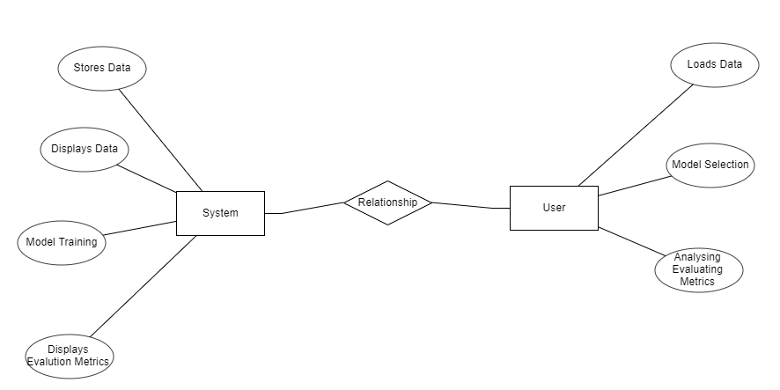

**DFD DIAGRAM:**

A Data Flow Diagram (DFD) is a traditional way to visualize the information flows within a system. A neat and clear DFD can depict a good amount of the system requirements graphically. It can be manual, automated, or a combination of both. It shows how information enters and leaves the system, what changes the information and where information is stored. The purpose of a DFD is to show the scope and boundaries of a system as a whole. It may be used as a communications tool between a systems analyst and any person who plays a part in the system that acts as the starting point for redesigning a system.

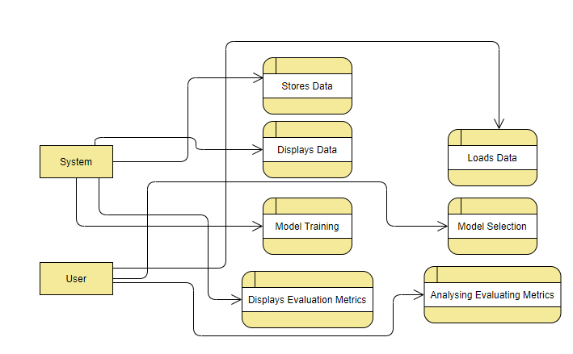

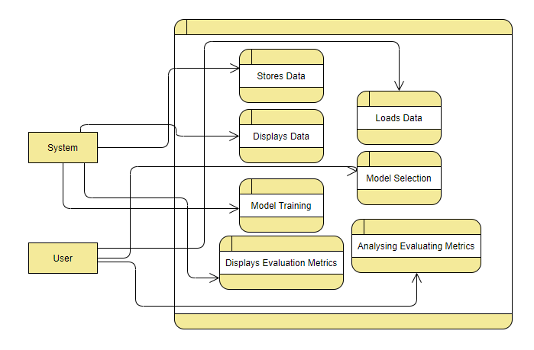

# INTRODUCTION TO PYTHON

**Python**

### What Is A Script?

Up to this point, I have concentrated on the interactive programming capability of Python.  This is a very useful capability that allows you to type in a program and to have it executed immediately in an interactive mode

**Scripts are reusable**

Basically, a script is a text file containing the statements that comprise a Python program.  Once you have created the script, you can execute it over and over without having to retype it each time.

**Scripts are editable**

Perhaps, more importantly, you can make different versions of the script by modifying the statements from one file to the next using a text editor.  Then you can execute each of the individual versions.  In this way, it is easy to create different programs with a minimum amount of typing.

**You will need a text editor**

Just about any text editor will suffice for creating Python script files.

You can use Microsoft Notepad, Microsoft WordPad, Microsoft Word, or just about any word processor if you want to.

**Difference between a script and a program**

**Script:**

Scripts are distinct from the core code of the application, which is usually written in a different language, and are often created or at least modified by the end-user. Scripts are often interpreted from source code or byte code, whereas the applications they control are traditionally compiled to native machine code.

**Program:**

The program has an executable form that the computer can use directly to execute the instructions.

The same program in its human-readable source code form, from which executable programs are derived (e.g., compiled)

**Python**

What is Python? Chances you are asking yourself this. You may have found this book because you want to learn to program but don’t know anything about programming languages. Or you may have heard of programming languages like C, C++, C#, or Java and want to know what Python is and how it compares to “big name” languages. Hopefully I can explain it for you.

**Python concepts**

If you're not interested in the how is and why is of Python, feel free to skip to the next chapter. In this chapter I will try to explain to the reader why I think Python is one of the best languages available and why it’s a great one to start programming with.

• Open source general-purpose language.

• Object Oriented, Procedural, Functional

• Easy to interface with C/ObjC/Java/Fortran

• Easy-ish to interface with C++ (via SWIG)

• Great interactive environment

Python is a high-level, interpreted, interactive and object-oriented scripting language. Python is designed to be highly readable. It uses English keywords frequently where as other languages use punctuation, and it has fewer syntactical constructions than other languages.

* **Python is Interpreted** − Python is processed at runtime by the interpreter. You do not need to compile your program before executing it. This is similar to PERL and PHP.
* **Python is Interactive** − you can actually sit at a Python prompt and interact with the interpreter directly to write your programs.
* **Python is Object-Oriented** − Python supports Object-Oriented style or technique of programming that encapsulates code within objects.
* **Python is a Beginner's Language** − Python is a great language for the beginner-level programmers and supports the development of a wide range of applications from simple text processing to WWW browsers to games.

**History of Python**

Python was developed by Guido van Rossum in the late eighties and early nineties at the National Research Institute for Mathematics and Computer Science in the Netherlands.

Python is derived from many other languages, including ABC, Modula-3, C, C++, Algol-68, Smalltalk, and UNIX shell and other scripting languages.

Python is copyrighted. Like Perl, Python source code is now available under the GNU General Public License (GPL).

Python is now maintained by a core development team at the institute, although Guido van Rossum still holds a vital role in directing its progress.

**Python Features**

Python's features include −

* **Easy-to-learn** − Python has few keywords, simple structure, and a clearly defined syntax. This allows the student to pick up the language quickly.
* **Easy-to-read** − Python code is more clearly defined and visible to the eyes.
* **Easy-to-maintain** − Python's source code is fairly easy-to-maintain.
* **A broad standard library** − Python's bulk of the library is very portable and cross-platform compatible on UNIX, Windows, and Macintosh.
* **Interactive Mode** − Python has support for an interactive mode which allows interactive testing and debugging of snippets of code.
* **Portable** − Python can run on a wide variety of hardware platforms and has the same interface on all platforms.
* **Extendable** − you can add low-level modules to the Python interpreter. These modules enable programmers to add to or customize their tools to be more efficient.
* **Databases** − Python provides interfaces to all major commercial databases.
* **GUI Programming** − Python supports GUI applications that can be created and ported to many system calls, libraries and windows systems, such as Windows MFC, Macintosh, and the X Window system of Unix.
* **Scalable** − Python provides a better structure and support for large programs than shell scripting.

Apart from the above-mentioned features, Python has a big list of good features, few are listed below −

* It supports functional and structured programming methods as well as OOP.
* It can be used as a scripting language or can be compiled to byte-code for building large applications.
* It provides very high-level dynamic data types and supports dynamic type checking.
* IT supports automatic garbage collection.
* It can be easily integrated with C, C++, COM, ActiveX, CORBA, and Java.

**Dynamic vs Static**

Types Python is a dynamic-typed language. Many other languages are static typed, such as C/C++ and Java. A static typed language requires the programmer to explicitly tell the computer what type of “thing” each data value is.

For example, in C if you had a variable that was to contain the price of something, you would have to declare the variable as a “float” type.

This tells the compiler that the only data that can be used for that variable must be a floating point number, i.e. a number with a decimal point.

If any other data value was assigned to that variable, the compiler would give an error when trying to compile the program.

Python, however, doesn’t require this. You simply give your variables names and assign values to them. The interpreter takes care of keeping track of what kinds of objects your program is using. This also means that you can change the size of the values as you develop the program. Say you have another decimal number (a.k.a. a floating point number) you need in your program.

With a static typed language, you have to decide the memory size the variable can take when you first initialize that variable. A double is a floating point value that can handle a much larger number than a normal float (the actual memory sizes depend on the operating environment).

If you declare a variable to be a float but later on assign a value that is too big to it, your program will fail; you will have to go back and change that variable to be a double.

With Python, it doesn’t matter. You simply give it whatever number you want and Python will take care of manipulating it as needed. It even works for derived values.

For example, say you are dividing two numbers. One is a floating point number and one is an integer. Python realizes that it’s more accurate to keep track of decimals so it automatically calculates the result as a floating point number

**Variables**

Variables are nothing but reserved memory locations to store values. This means that when you create a variable you reserve some space in memory.

Based on the data type of a variable, the interpreter allocates memory and decides what can be stored in the reserved memory. Therefore, by assigning different data types to variables, you can store integers, decimals or characters in these variables.

**Standard Data Types**

The data stored in memory can be of many types. For example, a person's age is stored as a numeric value and his or her address is stored as alphanumeric characters. Python has various standard data types that are used to define the operations possible on them and the storage method for each of them.

Python has five standard data types −

* Numbers
* String
* List
* Tuple
* Dictionary

## Python Numbers

Number data types store numeric values. Number objects are created when you assign a value to them

## Python Strings

Strings in Python are identified as a contiguous set of characters represented in the quotation marks. Python allows for either pairs of single or double quotes. Subsets of strings can be taken using the slice operator ([ ] and [:]) with indexes starting at 0 in the beginning of the string and working their way from -1 at the end.

## Python Lists

Lists are the most versatile of Python's compound data types. A list contains items separated by commas and enclosed within square brackets ([]). To some extent, lists are similar to arrays in C. One difference between them is that all the items belonging to a list can be of different data type.

The values stored in a list can be accessed using the slice operator ([ ] and [:]) with indexes starting at 0 in the beginning of the list and working their way to end -1. The plus (+) sign is the list concatenation operator, and the asterisk (*) is the repetition operator.

## Python Tuples

A tuple is another sequence data type that is similar to the list. A tuple consists of a number of values separated by commas. Unlike lists, however, tuples are enclosed within parentheses.

The main differences between lists and tuples are: Lists are enclosed in brackets ([ ]) and their elements and size can be changed, while tuples are enclosed in parentheses (( )) and cannot be updated. Tuples can be thought of as **read-only** lists.

## Python Dictionary

Python's dictionaries are kind of hash table type. They work like associative arrays or hashes found in Perl and consist of key-value pairs. A dictionary key can be almost any Python type, but are usually numbers or strings. Values, on the other hand, can be any arbitrary Python object.

Dictionaries are enclosed by curly braces ({ }) and values can be assigned and accessed using square braces ([]).

**Different modes in python**

Python has two basic modes: normal and interactive.

The normal mode is the mode where the scripted and finished .py files are run in the Python interpreter.

Interactive mode is a command line shell which gives immediate feedback for each statement, while running previously fed statements in active memory. As new lines are fed into the interpreter, the fed program is evaluated both in part and in whole

**Some Python Libraries:**

1. Pandas
2. Numpy
3. Pymysql
4. Random

**Pandas:**

* Pandas provide us with many Series and Data Frames. It allows you to easily organize, explore, represent, and manipulate data.
* Smart alignment and indexing featured in Pandas offer you a perfect organization and data labeling.
* Pandas has some special features that allow you to handle missing data or value with a proper measure.
* This package offers you such a clean code that even people with no or basic knowledge of programming can easily work with it.
* It provides a collection of built-in tools that allows you to both read and write data in different web services, data-structure, and databases as well.
* Pandas can support JSON, Excel, CSV, HDF5, and many other formats. In fact, you can merge different databases at a time with Pandas.

**Numpy:**

* Arrays of Numpy offer modern mathematical implementations on huge amount of data. Numpy makes the execution of these projects much easier and hassle-free.
* Numpy provides masked arrays along with general array objects. It also comes with functionalities such as manipulation of logical shapes, discrete Fourier transform, general linear algebra, and many more.
* While you change the shape of any N-dimensional arrays, Numpy will create new arrays for that and delete the old ones.
* This python package provides useful tools for integration. You can easily integrate Numpy with programming languages such as C, C++, and FORTRAN code.
* Numpy provides such functionalities that are comparable to MATLAB. They both allow users to get faster with operations.

**Pymysql:**

* PyMySQL is a database connector for Python, libraries to enable Python programs to talk to a MySQL server.
* Access to the port settings through Python properties.
* PyMySQL is a pure Python MySQL driver, first written as a rough port of the MySQL-Python driver.
* PyMySQL meets all of criterion for a driver.
* It is fully open source, hosted on Github, released on Pypi, is actively maintained.
* It is written in pure Python so is eventlet-monkeypatch compatible, and is fully Python 3 compatible.

**Random:**

* The random module is a built-in module to generate the pseudo-random variables.
* It can be used perform some action randomly such as to get a random number, selecting a random elements from a list, shuffle elements randomly, etc.
* Generate random numbers for various distributions including integer and floats.
* Random Sampling and choose elements from the population.
* Functions of the random module.
* Shuffle the sequence data. Seed the random generator.
* Generate random strings and passwords.

**Python class and objects**

These are the building blocks of OOP. Class creates a new object. This object can be anything, whether an abstract data concept or a model of a physical object, e.g. a chair. Each class has individual characteristics unique to that class, including variables and methods. Classes are very powerful and currently “the big thing” in most programming languages. Hence, there are several chapters dedicated to OOP later in the book.

The class is the most basic component of object-oriented programming. Previously, you learned how to use functions to make your program do something.

Now will move into the big, scary world of Object-Oriented Programming (OOP). To be honest, it took me several months to get a handle on objects.

When I first learned C and C++, I did great; functions just made sense for me.

Having messed around with BASIC in the early ’90s, I realized functions were just like subroutines so there wasn’t much new to learn.

However, when my C++ course started talking about objects, classes, and all the new features of OOP, my grades definitely suffered.

Once you learn OOP, you’ll realize that it’s actually a pretty powerful tool. Plus many Python libraries and APIs use classes, so you should at least be able to understand what the code is doing.

One thing to note about Python and OOP: it’s not mandatory to use objects in your code in a way that works best; maybe you don’t need to have a full-blown class with initialization code and methods to just return a calculation. With Python, you can get as technical as you want.

As you’ve already seen, Python can do just fine with functions. Unlike languages such as Java, you aren’t tied down to a single way of doing things; you can mix functions and classes as necessary in the same program. This lets you build the code

Objects are an encapsulation of variables and functions into a single entity. Objects get their variables and functions from classes. Classes are essentially a template to create your objects.

Here’s a brief list of Python OOP ideas:

• The class statement creates a class object and gives it a name. This creates a new namespace.

• Assignments within the class create class attributes. These attributes are accessed by qualifying the name using dot syntax: ClassName.Attribute.

• Class attributes export the state of an object and its associated behavior. These attributes are shared by all instances of a class.

• Calling a class (just like a function) creates a new instance of the class.

This is where the multiple copies part comes in.

• Each instance gets ("inherits") the default class attributes and gets its own namespace. This prevents instance objects from overlapping and confusing the program.

• Using the term self identifies a particular instance, allowing for per-instance attributes. This allows items such as variables to be associated with a particular instance.

**Inheritance**

First off, classes allow you to modify a program without really making changes to it.

To elaborate, by sub classing a class, you can change the behavior of the program by simply adding new components to it rather than rewriting the existing components.

As we’ve seen, an instance of a class inherits the attributes of that class.

However, classes can also inherit attributes from other classes. Hence, a subclass inherits from a superclass allowing you to make a generic superclass that is specialized via subclasses.

The subclasses can override the logic in a superclass, allowing you to change the behavior of your classes without changing the superclass at all.

Operator Overloads

Operator overloading simply means that objects that you create from classes can respond to actions (operations) that are already defined within Python, such as addition, slicing, printing, etc.

Even though these actions can be implemented via class methods, using overloading ties the behavior closer to Python’s object model and the object interfaces are more consistent to Python’s built-in objects, hence overloading is easier to learn and use.

User-made classes can override nearly all of Python’s built-in operation methods

**Exceptions**

I’ve talked about exceptions before but now I will talk about them in depth. Essentially, exceptions are events that modify program’s flow, either intentionally or due to errors.

They are special events that can occur due to an error, e.g. trying to open a file that doesn’t exist, or when the program reaches a marker, such as the completion of a loop.

Exceptions, by definition, don’t occur very often; hence, they are the "exception to the rule" and a special class has been created for them. Exceptions are everywhere in Python.

Virtually every module in the standard Python library uses them, and Python itself will raise them in a lot of different circumstances.

Here are just a few examples:

• Accessing a non−existent dictionary key will raise a Key Error exception.

• Searching a list for a non−existent value will raise a Value Error exception

. • Calling a non−existent method will raise an Attribute Error exception.

• Referencing a non−existent variable will raise a Name Error exception.

• Mixing data types without coercion will raise a Type Error exception.

One use of exceptions is to catch a fault and allow the program to continue working; we have seen this before when we talked about files.

This is the most common way to use exceptions. When programming with the Python command line interpreter, you don’t need to worry about catching exceptions.

Your program is usually short enough to not be hurt too much if an exception occurs.

Plus, having the exception occur at the command line is a quick and easy way to tell if your code logic has a problem.

However, if the same error occurred in your real program, it will fail and stop working. Exceptions can be created manually in the code by raising an exception.

It operates exactly as a system-caused exceptions, except that the programmer is doing it on purpose. This can be for a number of reasons. One of the benefits of using exceptions is that, by their nature, they don’t put any overhead on the code processing.

Because exceptions aren’t supposed to happen very often, they aren’t processed until they occur.

Exceptions can be thought of as a special form of the if/elif statements. You can realistically do the same thing with if blocks as you can with exceptions.

However, as already mentioned, exceptions aren’t processed until they occur; if blocks are processed all the time.

Proper use of exceptions can help the performance of your program.

The more infrequent the error might occur, the better off you are to use exceptions; using if blocks requires Python to always test extra conditions before continuing.

Exceptions also make code management easier: if your programming logic is mixed in with error-handling if statements, it can be difficult to read, modify, and debug your program.

User-Defined Exceptions

I won’t spend too much time talking about this, but Python does allow for a programmer to create his own exceptions.

You probably won’t have to do this very often but it’s nice to have the option when necessary.

However, before making your own exceptions, make sure there isn’t one of the built-in exceptions that will work for you.

They have been "tested by fire" over the years and not only work effectively, they have been optimized for performance and are bug-free.

Making your own exceptions involves object-oriented programming, which will be covered in the next chapter

. To make a custom exception, the programmer determines which base exception to use as the class to inherit from, e.g. making an exception for negative numbers or one for imaginary numbers would probably fall under the Arithmetic Error exception class.

To make a custom exception, simply inherit the base exception and define what it will do.

**Python modules**

Python allows us to store our code in files (also called modules). This is very useful for more serious programming, where we do not want to retype a long function definition from the very beginning just to change one mistake. In doing this, we are essentially defining our own modules, just like the modules defined already in the Python library.

To support this, Python has a way to put definitions in a file and use them in a script or in an interactive instance of the interpreter. Such a file is called a module; definitions from a module can be imported into other modules or into the main module.

**Testing code**

As indicated above, code is usually developed in a file using an editor.

To test the code, import it into a Python session and try to run it.

Usually there is an error, so you go back to the file, make a correction, and test again.

This process is repeated until you are satisfied that the code works. T

he entire process is known as the development cycle.

There are two types of errors that you will encounter. Syntax errors occur when the form of some command is invalid.

This happens when you make typing errors such as misspellings, or call something by the wrong name, and for many other reasons. Python will always give an error message for a syntax error.

**Functions in Python**

It is possible, and very useful, to define our own functions in Python. Generally speaking, if you need to do a calculation only once, then use the interpreter. But when you or others have need to perform a certain type of calculation many times, then define a function.

You use functions in programming to bundle a set of instructions that you want to use repeatedly or that, because of their complexity, are better self-contained in a sub-program and called when needed. That means that a function is a piece of code written to carry out a specified task.

## To carry out that specific task, the function might or might not need multiple inputs. When the task is carried out, the function can or cannot return one or more values.

## There are three types of functions in python:

## help(),min(),print().

## Python Namespace

Generally speaking, a **namespace** (sometimes also called a context) is a naming system for making names unique to avoid ambiguity. Everybody knows a name spacing system from daily life, i.e. the naming of people in first name and family name (surname).

An example is a network: each network device (workstation, server, printer,) needs a unique name and address. Yet another example is the directory structure of file systems.

The same file name can be used in different directories, the files can be uniquely accessed via the pathnames. Many programming languages use namespaces or contexts for identifiers. An identifier defined in a namespace is associated with that namespace.

This way, the same identifier can be independently defined in multiple namespaces. (Like the same file names in different directories) Programming languages, which support namespaces, may have different rules that determine to which namespace an identifier belongs.

Namespaces in Python are implemented as Python dictionaries, this means it is a mapping from names (keys) to objects (values). The user doesn't have to know this to write a Python program and when using namespaces.

Some namespaces in Python:

* **global names** of a module
* **local names** in a function or method invocation
* **built-in names**: this namespace contains built-in functions (e.g. abs(), cmp(), ...) and built-in exception names

**Garbage Collection**

Garbage Collector exposes the underlying memory management mechanism of Python, the automatic garbage collector. The module includes functions for controlling how the collector operates and to examine the objects known to the system, either pending collection or stuck in reference cycles and unable to be freed.

**Python XML Parser**

XML is a portable, open source language that allows programmers to develop applications that can be read by other applications, regardless of operating system and/or developmental language.

What is XML? The Extensible Markup Language XML is a markup language much like HTML or SGML.

This is recommended by the World Wide Web Consortium and available as an open standard.

XML is extremely useful for keeping track of small to medium amounts of data without requiring a SQL-based backbone.

XML Parser Architectures and APIs the Python standard library provides a minimal but useful set of interfaces to work with XML.

The two most basic and broadly used APIs to XML data are the SAX and DOM interfaces.

Simple API for XML SAX: Here, you register callbacks for events of interest and then let the parser proceed through the document.

This is useful when your documents are large or you have memory limitations, it parses the file as it reads it from disk and the entire file is never stored in memory.

Document Object Model DOM API : This is a World Wide Web Consortium recommendation wherein the entire file is read into memory and stored in a hierarchical tree − based form to represent all the features of an XML document.

SAX obviously cannot process information as fast as DOM can when working with large files. On the other hand, using DOM exclusively can really kill your resources, especially if used on a lot of small files.

SAX is read-only, while DOM allows changes to the XML file. Since these two different APIs literally complement each other, there is no reason why you cannot use them both for large projects.

**Python Web Frameworks**

A web framework is a code library that makes a developer's life easier when building reliable, scalable and maintainable web applications.

## Why are web frameworks useful?

Web frameworks encapsulate what developers have learned over the past twenty years while programming sites and applications for the web. Frameworks make it easier to reuse code for common HTTP operations and to structure projects so other developers with knowledge of the framework can quickly build and maintain the application.

Common web framework functionality

Frameworks provide functionality in their code or through extensions to perform common operations required to run web applications. These common operations include:

1. URL routing
2. HTML, XML, JSON, and other output format templating
3. Database manipulation
4. Security against Cross-site request forgery (CSRF) and other attacks
5. Session storage and retrieval

Not all web frameworks include code for all of the above functionality. Frameworks fall on the spectrum from executing a single use case to providing every known web framework feature to every developer. Some frameworks take the "batteries-included" approach where everything possible comes bundled with the framework while others have a minimal core package that is amenable to extensions provided by other packages.

## Comparing web frameworks

There is also a repository called [compare-python-web-frameworks](https://github.com/mattmakai/compare-python-web-frameworks) where the same web application is being coded with varying Python web frameworks, templating engines and object.

## Web framework resources

* When you are learning how to use one or more web frameworks it's helpful to have an idea of what the code under the covers is doing.
* Frameworks is a really well done short video that explains how to choose between web frameworks. The author has some particular opinions about what should be in a framework. For the most part I agree although I've found sessions and database ORMs to be a helpful part of a framework when done well.
* What is a web framework? Is an in-depth explanation of what web frameworks are and their relation to web servers?
* Django vs Flash vs Pyramid: Choosing a Python web framework contains background information and code comparisons for similar web applications built in these three big Python frameworks.
* This fascinating blog post takes a look at the code complexity of several Python web frameworks by providing visualizations based on their code bases.
* Python’s web frameworks benchmarks  is a test of the responsiveness of a framework with encoding an object to JSON and returning it as a response as well as retrieving data from the database and rendering it in a template. There were no conclusive results but the output is fun to read about nonetheless.
* What web frameworks do you use and why are they awesome? is a language agnostic Reddit discussion on web frameworks. It's interesting to see what programmers in other languages like and dislike about their suite of web frameworks compared to the main Python frameworks.
* This user-voted question & answer site asked "What are the best general purpose Python web frameworks usable in productions” The votes aren't as important as the list of the many frameworks that are available to Python developers.

## Web frameworks learning checklist

1. Choose a major Python web framework (Django or Flask are recommended) and stick with it. When you're just starting it's best to learn one framework first instead of bouncing around trying to understand every framework.
2. Work through a detailed tutorial found within the resources links on the framework's page.
3. Study open source examples built with your framework of choice so you can take parts of those projects and reuse the code in your application.
4. Build the first simple iteration of your web application then go to the [deployment](https://www.fullstackpython.com/deployment.html) section to make it accessible on the web.

**2. SYSTEM STUDY**

**2.1 FEASIBILITY STUDY**

The feasibility of the project is analyzed in this phase and business proposal is put forth with a very general plan for the project and some cost estimates. During system analysis the feasibility study of the proposed system is to be carried out. This is to ensure that the proposed system is not a burden to the company. For feasibility analysis, some understanding of the major requirements for the system is essential.

Three key considerations involved in the feasibility analysis are

* ECONOMICAL FEASIBILITY
* TECHNICAL FEASIBILITY
* SOCIAL FEASIBILITY

**ECONOMICAL FEASIBILITY**

This study is carried out to check the economic impact that the system will have on the organization. The amount of fund that the company can pour into the research and development of the system is limited. The expenditures must be justified. Thus the developed system as well within the budget and this was achieved because most of the technologies used are freely available. Only the customized products had to be purchased.

### TECHNICAL FEASIBILITY

This study is carried out to check the technical feasibility, that is, the technical requirements of the system. Any system developed must not have a high demand on the available technical resources. This will lead to high demands on the available technical resources. This will lead to high demands being placed on the client. The developed system must have a modest requirement, as only minimal or null changes are required for implementing this system.

**SOCIAL FEASIBILITY**

The aspect of study is to check the level of acceptance of the system by the user. This includes the process of training the user to use the system efficiently. The user must not feel threatened by the system, instead must accept it as a necessity. The level of acceptance by the users solely depends on the methods that are employed to educate the user about the system and to make him familiar with it. His level of confidence must be raised so that he is also able to make some constructive criticism, which is welcomed, as he is the final user of the system.

### SYSTEM TESTING

The purpose of testing is to discover errors. Testing is the process of trying to discover every conceivable fault or weakness in a work product. It provides a way to check the functionality of components, sub-assemblies, assemblies and/or a finished product It is the process of exercising software with the intent of ensuring that the

Software system meets its requirements and user expectations and does not fail in an unacceptable manner. There are various types of test. Each test type addresses a specific testing requirement.

**TYPES OF TESTS**

**Unit testing**

Unit testing involves the design of test cases that validate that the internal program logic is functioning properly, and that program inputs produce valid outputs. All decision branches and internal code flow should be validated. It is the testing of individual software units of the application .it is done after the completion of an individual unit before integration. This is a structural testing, that relies on knowledge of its construction and is invasive. Unit tests perform basic tests at component level and test a specific business process, application, and/or system configuration. Unit tests ensure that each unique path of a business process performs accurately to the documented specifications and contains clearly defined inputs and expected results.

**Integration testing**

Integration tests are designed to test integrated software components to determine if they actually run as one program. Testing is event driven and is more concerned with the basic outcome of screens or fields. Integration tests demonstrate that although the components were individually satisfaction, as shown by successfully unit testing, the combination of components is correct and consistent. Integration testing is specifically aimed at exposing the problems that arise from the combination of components.

**Functional test**

Functional tests provide systematic demonstrations that functions tested are available as specified by the business and technical requirements, system documentation, and user manuals.

Functional testing is centered on the following items:

Valid Input : identified classes of valid input must be accepted.

Invalid Input : identified classes of invalid input must be rejected.

Functions : identified functions must be exercised.

Output : identified classes of application outputs must be exercised.

Systems/Procedures: interfacing systems or procedures must be invoked.

Organization and preparation of functional tests is focused on requirements, key functions, or special test cases. In addition, systematic coverage pertaining to identify Business process flows; data fields, predefined processes, and successive processes must be considered for testing. Before functional testing is complete, additional tests are identified and the effective value of current tests is determined.

**SYSTEM TEST**

System testing ensures that the entire integrated software system meets requirements. It tests a configuration to ensure known and predictable results. An example of system testing is the configuration oriented system integration test. System testing is based on process descriptions and flows, emphasizing pre-driven process links and integration points.

**White Box Testing**

White Box Testing is a testing in which in which the software tester has knowledge of the inner workings, structure and language of the software, or at least its purpose. It is purpose. It is used to test areas that cannot be reached from a black box level.

**Black Box Testing**

Black Box Testing is testing the software without any knowledge of the inner workings, structure or language of the module being tested. Black box tests, as most other kinds of tests, must be written from a definitive source document, such as specification or requirements document, such as specification or requirements document. It is a testing in which the software under test is treated, as a black box .you cannot “see” into it. The test provides inputs and responds to outputs without considering how the software works.

**6.1 Unit Testing:**

Unit testing is usually conducted as part of a combined code and unit test phase of the software lifecycle, although it is not uncommon for coding and unit testing to be conducted as two distinct phases.

**Test strategy and approach**

Field testing will be performed manually and functional tests will be written in detail.

**Test objectives**

* All field entries must work properly.
* Pages must be activated from the identified link.
* The entry screen, messages and responses must not be delayed.

**Features to be tested**

* Verify that the entries are of the correct format
* No duplicate entries should be allowed
* All links should take the user to the correct page.

# 6.2 Integration Testing

Software integration testing is the incremental integration testing of two or more integrated software components on a single platform to produce failures caused by interface defects.

The task of the integration test is to check that components or software applications, e.g. components in a software system or – one step up – software applications at the company level – interact without error.

**Test Results:** All the test cases mentioned above passed successfully. No defects encountered.

**6.3 Acceptance Testing**

User Acceptance Testing is a critical phase of any project and requires significant participation by the end user. It also ensures that the system meets the functional requirements.

**Test Results:** All the test cases mentioned above passed successfully. No defects encountered.

**OUTPUT SCREENSHOTS WITH DESCRIPTION**

**Home Page:**



* **After Uploading the Dataset**

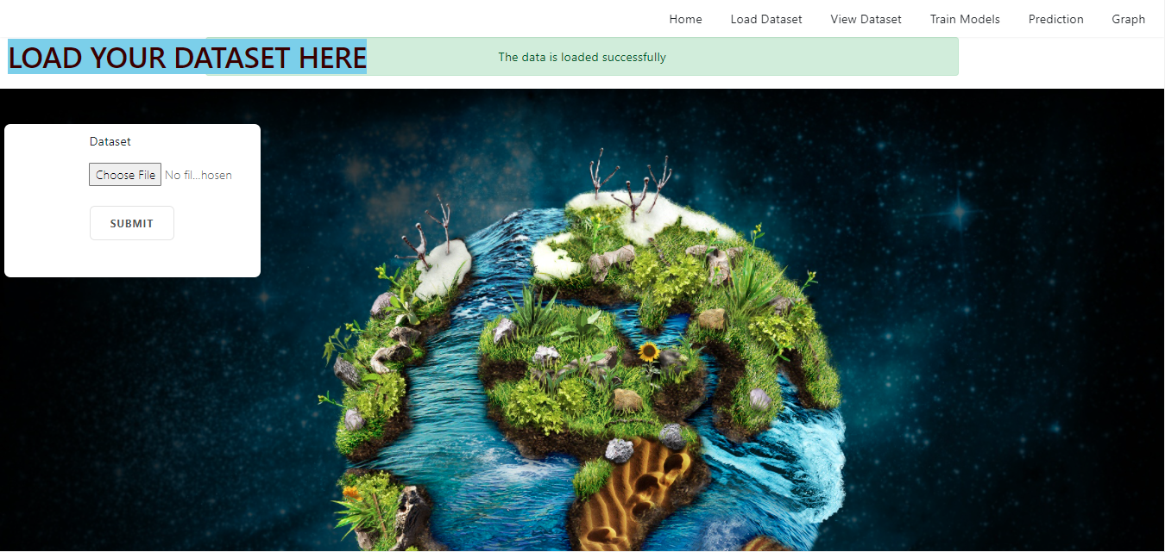

* **View the Dataset**

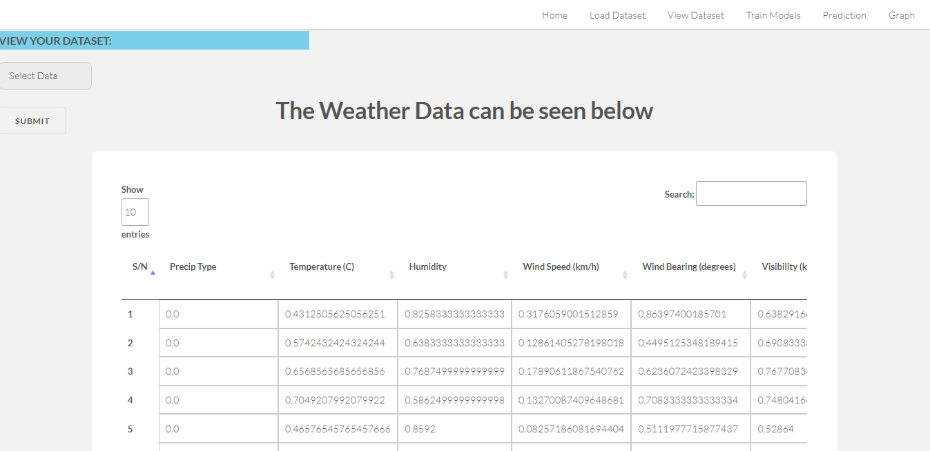

* **Train the Models**

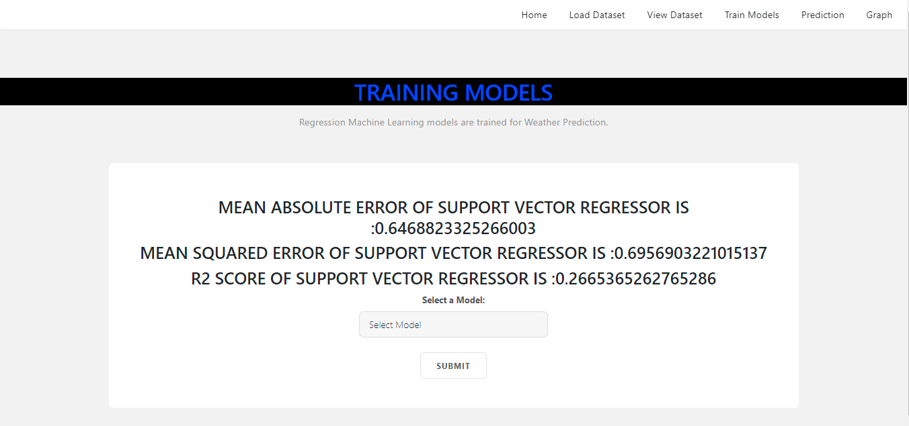

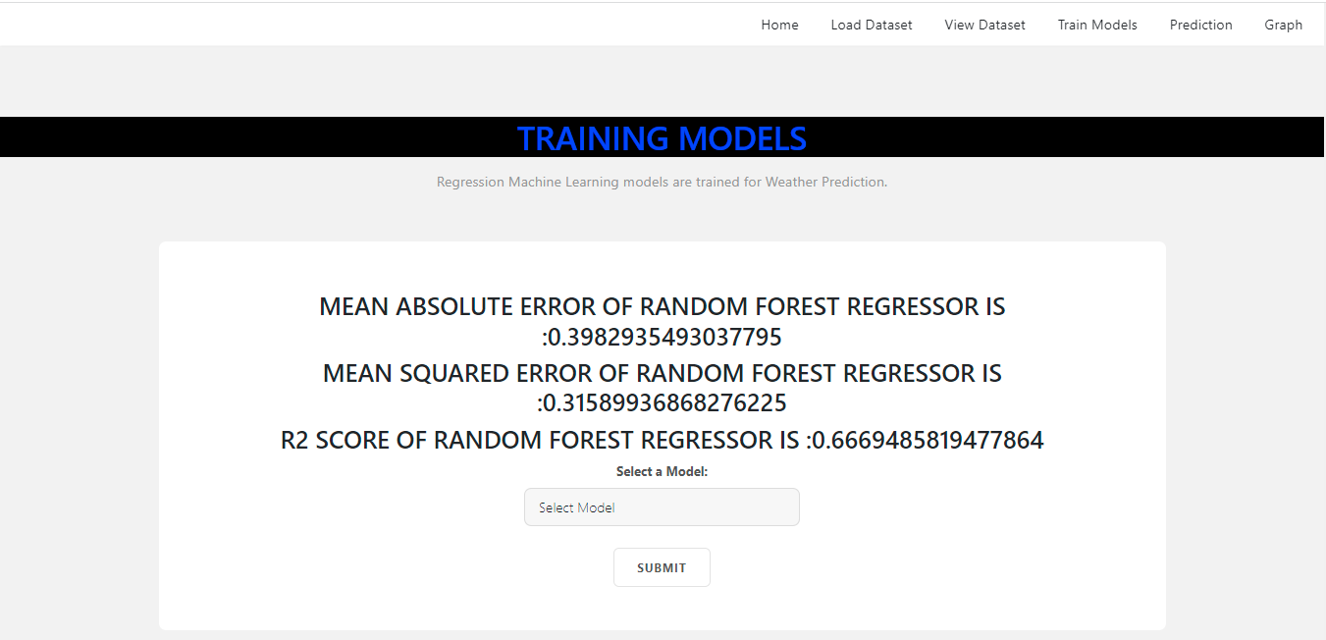

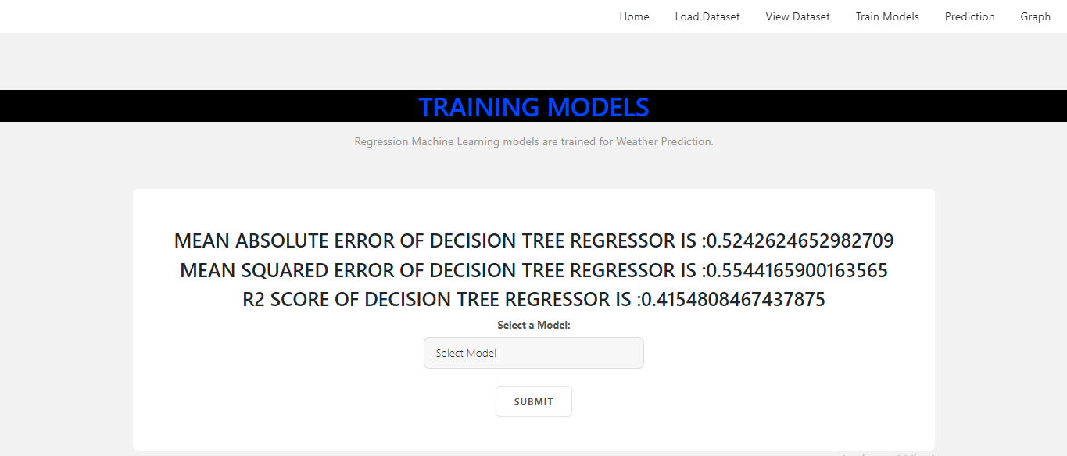

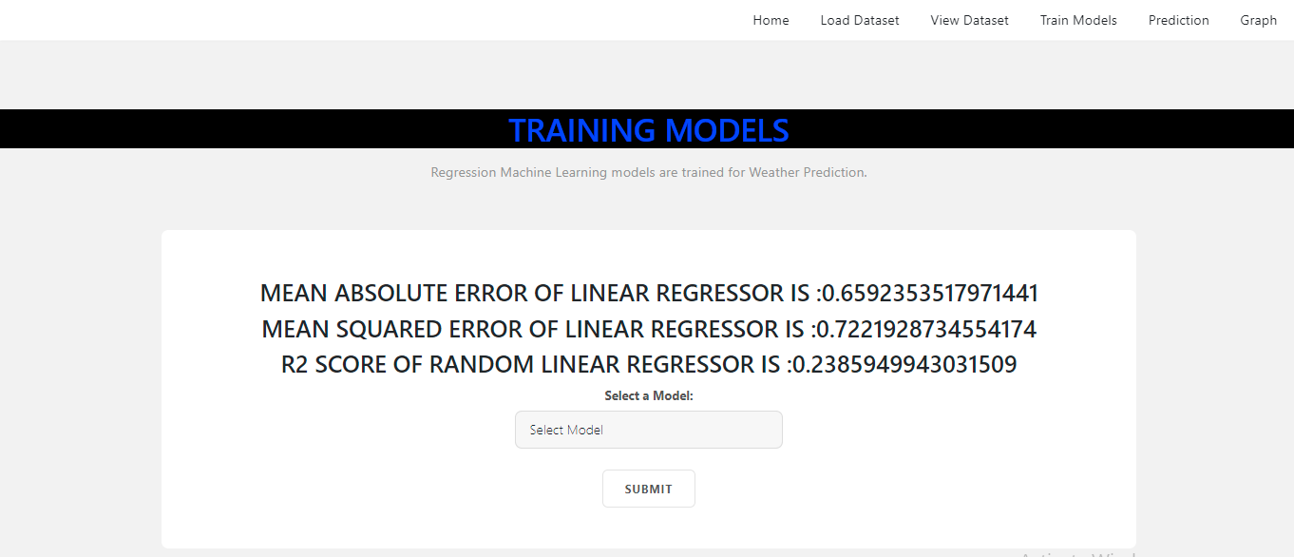

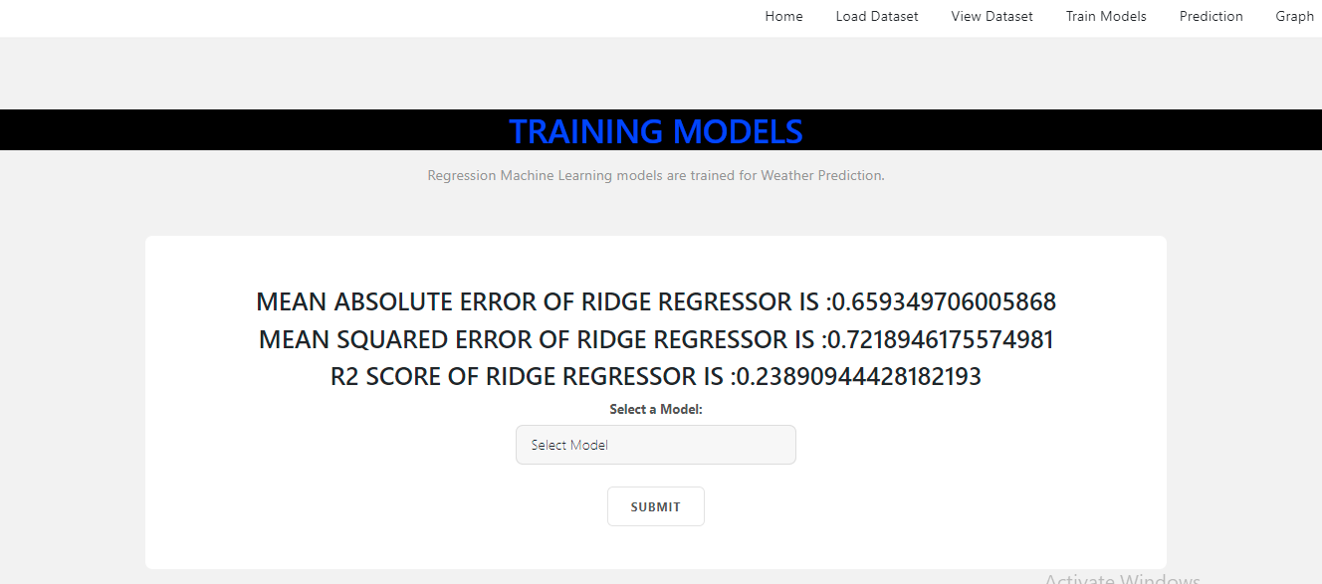

**PREDICTION**

* **Weather is Cloudy:**

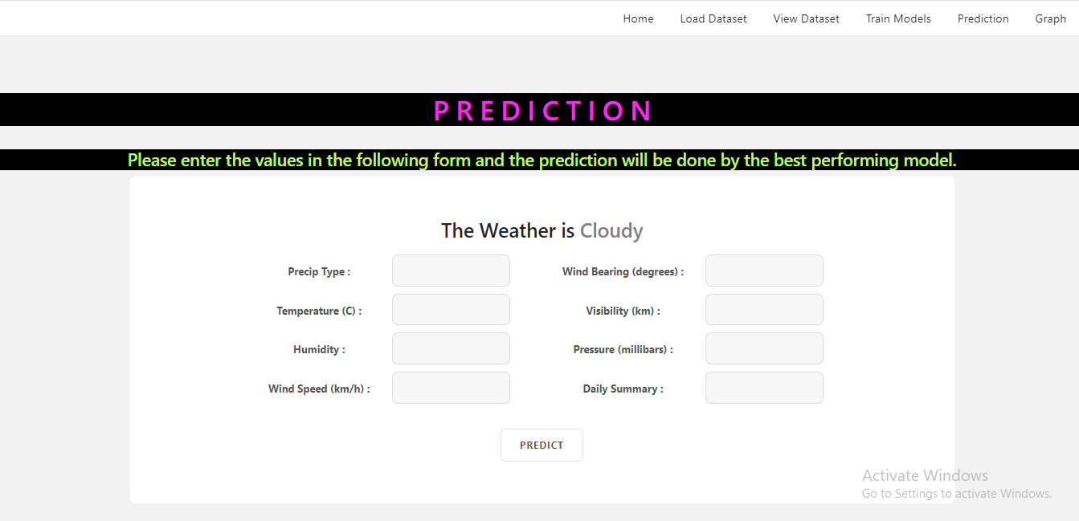

* **Weather is Foggy:**

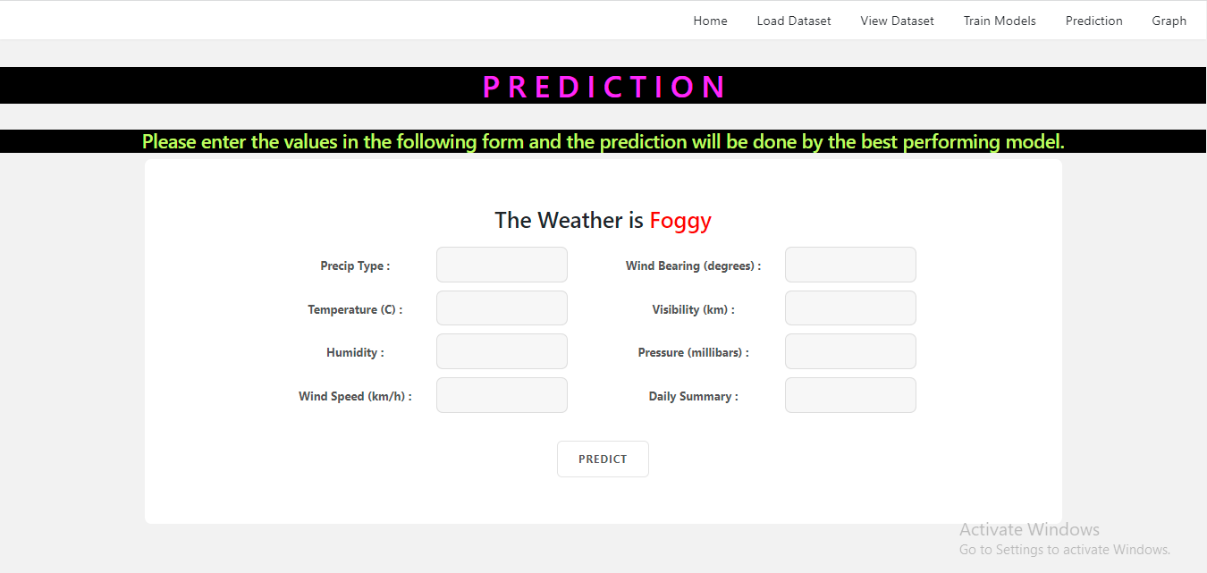

* **Weather is Overcast:**

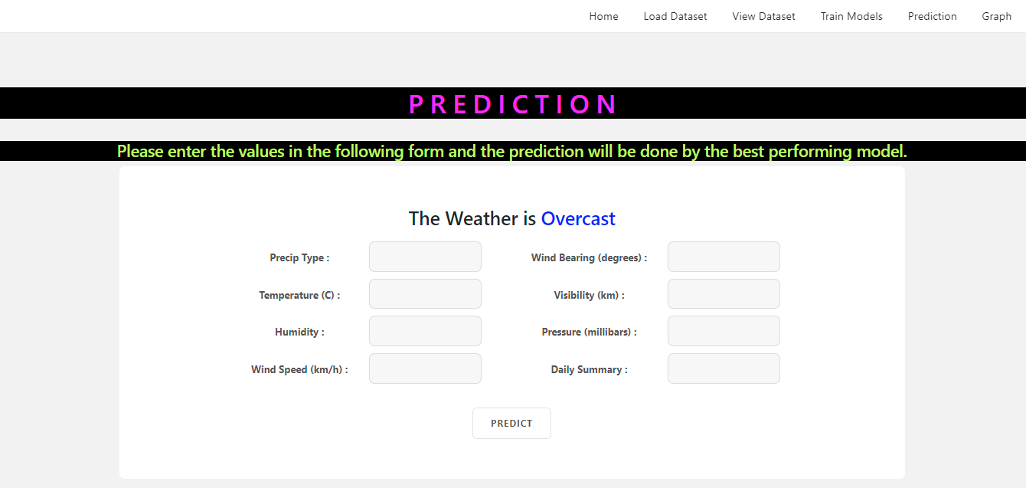

* **Weather is Rainy:**

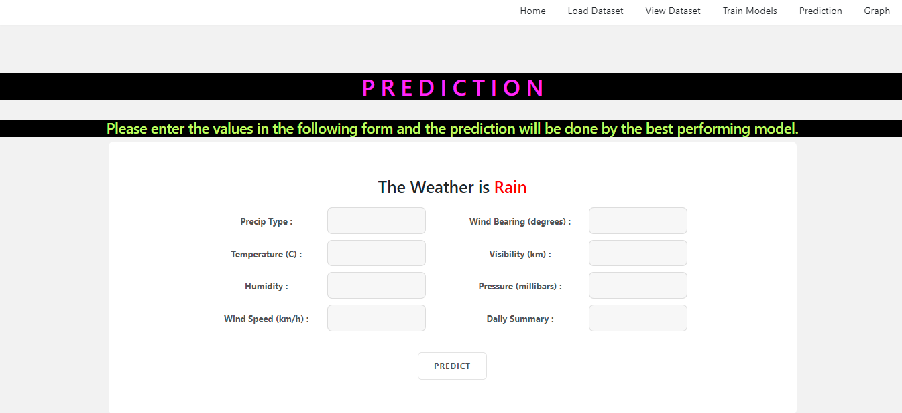

* **ARIMA Graph:**
  + 1. **Humidity vs Time:**

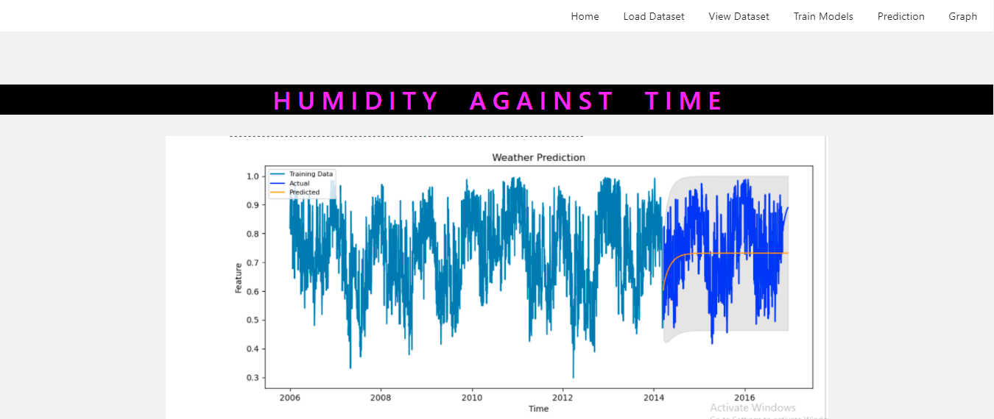

* + 1. **Temperature vs Time:**

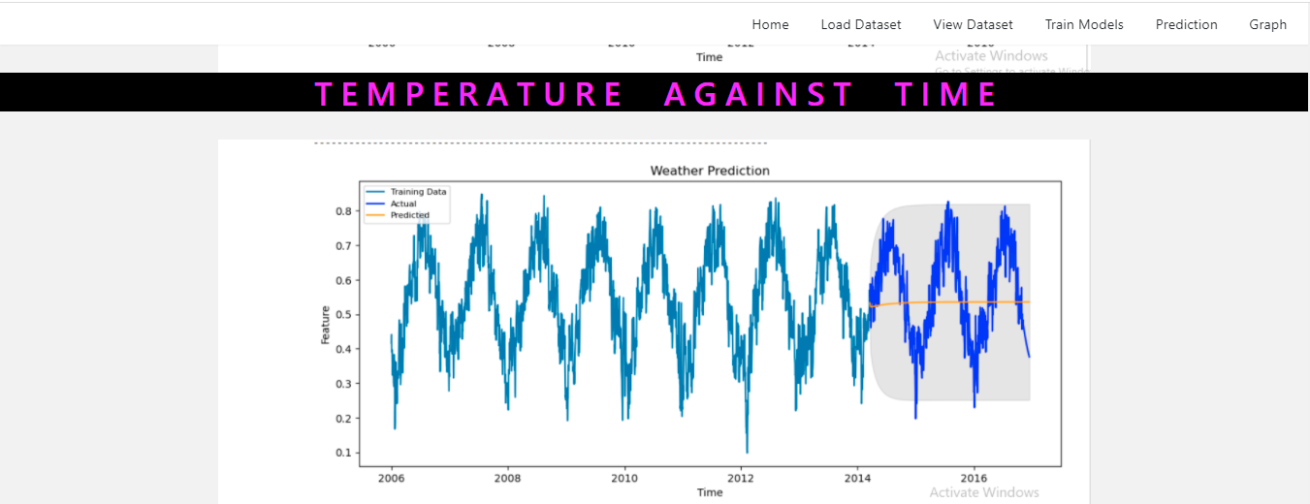

* + 1. **Wind vs Time:**

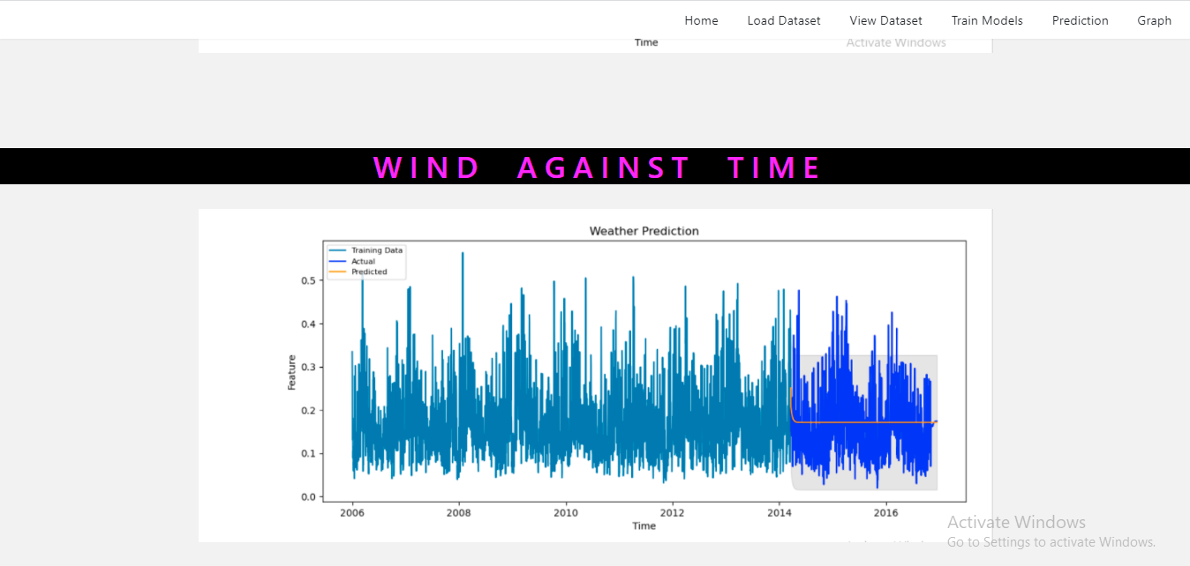

**CONCLUSION:**

In this application, we have successfully implemented Weather forecasting/ prediction model using Support Vector Regressor, Random Forest, Simple Linear Regression, Ridge Regression and Decision Tree with the MAE, MSE and R2 Score. ARIMA is used to forecast the data of past 10 years and through graph we are analyzing the result, LSTM is to predict next 30 days data using past data and a flask based web application is developed to predict the weather.

**FUTURE SCOPE:**

The Forecasting can be improved potentially by using the live weather data with its parameters and algorithms specially made for weather prediction (Sunny, Overcast, Rainy, Foggy).

**REFERENCES:**

**[1] Jafar Abo Nada; Mohammad Rasmi Al-Mosa, 2018 International Arab Conference on Information Technology (ACIT), A Proposed Wireless Intrusion Detection Prevention and Attack System**

**[2] Kinam Park; Youngrok Song; Yun-Gyung Cheong, 2018 IEEE Fourth International Conference on Big Data Computing Service and Applications (BigDataService), Classification of Attack Types for Intrusion Detection Systems Using a Machine Learning Algorithm**

**[3] S. Bernard, L. Heutte and S. Adam “On the Selection of Decision Trees in Random Forests” Proceedings of International Joint Conference on Neural Networks, Atlanta, Georgia, USA, June 14-19, 2009, 978-1-4244-3553- 1/09/$25.00 ©2009 IEEE**

**[4] A. Tesfahun, D. Lalitha Bhaskari, ” Intrusion Detection using Random Forests Classifier with SMOTE and Feature Reduction” 2013 International Conference on Cloud & Ubiquitous Computing & Emerging Technologies, 978-0- 4799-2235-2/13 $26.00 © 2013 IEEE**

**[5] Le, T.-T.-H., Kang, H., & Kim, H. (2019).The Impact of PCA-Scale Improving GRU Performance for Intrusion Detection. 2019 International Conference on Platform Technology and Service (PlatCon). Doi:10.1109/platcon.2019.8668960**

**[6] Anish Halimaa A, Dr K.Sundarakantham: Proceedings of the Third International Conference on Trends in Electronics and Informatics (ICOEI 2019) 978-1-5386-9439-8/19/$31.00 ©2019 IEEE “MACHINE LEARNING BASED INTRUSION DETECTION SYSTEM.”**

**[7] Mengmeng Ge, Xiping Fu, Naeem Syed, Zubair Baig, Gideon Teo, Antonio Robles-Kelly (2019). Deep LearningBased Intrusion Detection for IoT Networks, 2019 IEEE 24th Pacific Rim International Symposium on Dependable Computing (PRDC), pp. 256-265, Japan.**

**[8] R. Patgiri, U. Varshney, T. Akutota, and R. Kunde, ’’An Investigation on Intrusion Detection System Using Machine Learning” 978-1-5386-9276-9/18/$31.00 c2018IEEE.**